Leo Dracos | NEA |

NEA PROJECT
  - Further Math’s Graphs Revision Tool/Solver

Contents
1 Analysis 3
1.1 Introduction 3
1.2 Research 3
1.2.1 Existing Graphical Dijkstra’s Solver 3
1.2.2 Existing Adjacency Matrix Dijkstra’s Solver 4
1.3 Questionnaire 5
1.4 Interview 8
1.5 Looking at questions 9
1.6 Modelling 11
1.6.1 Process diagram 11
1.6.2 UI design 12
1.6.3 Data Table 13
1.6.4 Leaderboard example 14
1.6.5 Walkthrough of question 14
Requirements 16
2 Design 18
2.1 Overview 18
2.2 Database ERD 19
2.3 Class Diagram 20
2.4 Login Section 22
2.4.1 Flowchart 22
2.4.2 Pseudocode and SQL queries 23
2.4.3 UI Design for login and create new account pages 25
2.5 Account Management section 27
2.5.1 UI design 27
2.5.2 Flowchart 28
2.5.3 28
2.5.4 SQL 29
2.6 Revision section 31
2.6.1 Flowchart 31
2.6.2 UI Design 33
2.6.3 Pseudocode and SQL 34
2.6.4 Data Structures 42
2.7 Draw section 48
2.7.1 Flowchart 48
2.7.2 UI Design 49
2.7.3 Pseudocode algorithms 49
2.7.4 Data Structures 50
2.8 Leaderboard section 57
2.8.1 UI design 57
2.8.2 Pseudocode and OOP classes 57
2.8.3 SQL 58
3 Testing 59
4 evaluation 78
4.1 Client Requirements 78
4.2 Client Feedback 85
4.3 Whole system evaluation 86
4.4 Future Improvements 87
5 Appendix 88
5.1 RAG rated requirements 88
5.2 Code Listing 90
5.3 Technical Solution 100

Analysis

Introduction

For my NEA project I am going to develop a graphical revision tool and questions solver for further math, it will be based around the Decision 1 paper questions on Graphs and the algorithms around them like Dijkstra’s, Prim’s, Kruskal’s and route inspection. The program is going to be a way for further math students to revise and check what the answers would be on graphs inputted by the user or created by the program.
I have decided to create this for my project as I have found, as a further math student myself, that there is a lack of variety in questions on graphs and algorithms and it is also very tedious having to use multiple sources to find different questions and then also having to attempt to find the mark scheme for these questions, this causes revision to become very repetitive and boring and this makes completing revision very tedious and not enjoyable. I see my program becoming a useful tool for people to use to actively revise and better understand the D1 algorithm questions and therefore help improve their grade. I want to make my program enjoyable to use so I will use my client research to find ways to do this. For my clients I intend to use my fellow further math students to help me come up with more ideas about functions they would like to see in this project and how they would like it to be executed.
I see the end user of my project being further math’s students who are in need of useful revision tools, or teachers who may struggle to find challenging questions, or mark schemes for completed questions.

Research

For my research I have studied existing websites which are similar to what I am wanting to make, I have also created a questionnaire which I got my peers to answer, and I am also going to have an interview with a further math’s student to see what specific ideas they would like to see implemented as well as how they would like the programs UI to be laid out.

Existing Graphical Dijkstra’s Solver

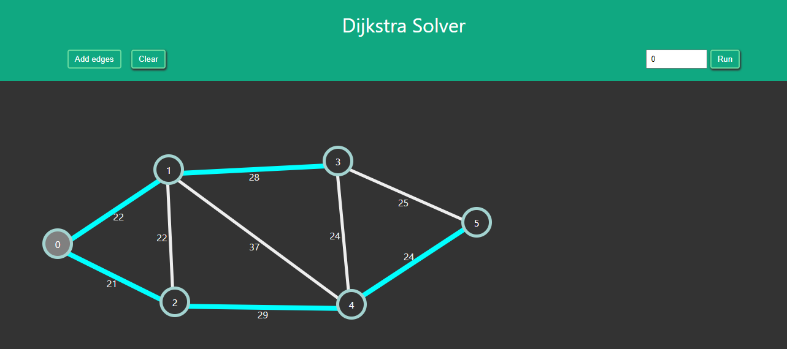
I found a website which is a Dijkstra’s algorithm solver where the user graphically inputs nodes and edges and can alter the weights of the edges and then choose the starting node and it will show the shortest route from the starting route to every other node.

In this application I
found the use of a
graphical interface to
input the graphs very
useful and easy to use,
so I am going to
develop something
like this with the
ability to add nodes
and edges with a GUI.

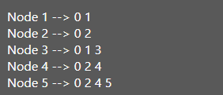
I also found that the information output by the
program was very basic as it only output the path from
the start node to each other node and not the shortest
distance between them. I believe in my program I will need
it to output the shortest distance from the start node to
Example of the outputted answer
each other node.
I also noticed that the method of inputting a graph was tedious as
The user had to first place their nodes then switch the mode to “Add edges”
To then place edges between the nodes, and if you made a mistake there was no way to simply undo your error apart from clearing the entire graph and starting from scratch. In my program I want this system to be more seamless and flow better, I will try doing this by not needing different modes to place nodes and edges, and implement an undo button so the user can undo simple mistakes without having to start over completely.
In this program there was also no way to save graphs that you had made, which I believe would be a good feature to add to my program as this was an inconvenience to me whilst I was testing this program.

Existing Adjacency Matrix Dijkstra’s Solver

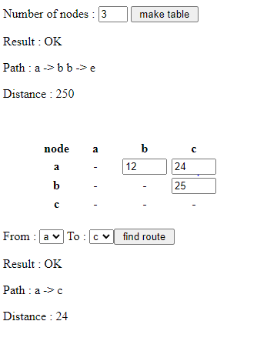
In this second application an adjacency matrix is used to display
the graph which I found very difficult and confusing to use and
if you want to include a high number of nodes it takes a long
time to fill in the matrix, therefore I am going to avoid using
this in my program as I see a graphical solution being much
more user friendly and convenient for my end user.

However, in this program the problem with outputting the
shortest distance was solved by it being output. But there was
another problem which was that you could only view one path
from the start node to another at a time and the program
wouldn’t just output them all at once, in my program I will
output all the distances at the same time as it is more
Example of the application being used
convenient for the user.

I then presented both applications I have looked at to some peers to see which they preferred and what aspects of each they saw as useful or something that I could include in my program. Every student I showed both two to prefer the graphical version as they stated, “it was much easier to use and understand” and because of this it made it much more user friendly and every student said they would have preferred to use the graphical one if they had to decide between the two. They also stated that on the graphical application the fact it didn’t output an actual shortest distance was not convenient so my program will have to output all the shortest distances.

Questionnaire

I created a questionnaire which had meaningful questions to get ideas from my target audience of the things they would like to see in my project. I handed this questionnaire out to my peers in my further math class for them to complete.
- When inputting graphs would you like there to be a graphical way of doing this or using tables?
- Which algorithms would you like the program to be able to use?
- How should the user input their answer into the program? i.e. complete a question on paper and compare with answer or input answer into the program.
- What information would you like the mark scheme to present?
- How should the question system work? Would you like endless questions or do a set amount like 5 at a time?
- Should users be able to have personal accounts?
- Would you like to be able to save graphs or specific questions?
- Would you like different difficulty questions?
- Would some form of point or score system make revising more enjoyable?
- Along with a point or score system should a leaderboard be included to show different users’ scores?
- Should users be able to view their personal statistics, what should be included?

These were the responses I received:
- Every person that completed the questions said that they wanted to input graphs graphically instead of using some form of adjacency matrix system.
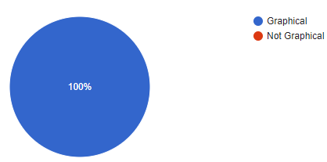

- When asked which algorithms they would like the program to be able to use every user selected Dijkstra’s however only 40% chose Prim’s, Kruskal’s
and Route inspection so I will prioritise developing the program to use Dijkstra’s and Prim’s as they are the most different algorithms.
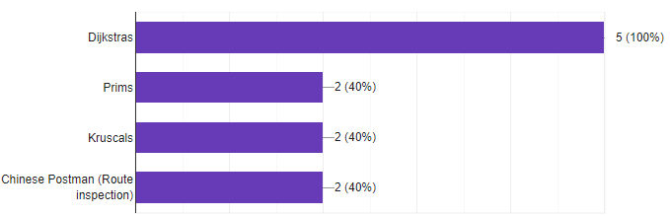

- When asked what information they would like to see on the mark schemes most answers were similar as I received feedback like, “The shortest distance from the start node to each other node”, this seemed like the most important information users required.
- Then when asked how the answer would be inputted I had mixed responses as 60% of participants said they would like to be able to complete the question on the program which will then mark it for them and output a score, however 40% said that they wouldn’t mind completing the question separately like on paper however they said “doing it in the app would be nice” so this is something which I could include.
- Every person said they would like to see a type of .
account system where each user can have a personal account which they could customise in some way.
- Every person said that being able to save specific questions you struggled with or graphs that you have already completed would be beneficial.
- Every person said they would like to be able to pick from different difficulty questions like easy, medium, and hard where each would represent exam questions that would have different amounts of marks and nodes.
- When they were asked what type of questioning system they like would like to see like endless questions or you can chose out of a set amount of questions like 5 40% of people said they would like to see both implemented and then 40% said they would like to see just endless questions, this tells me that every person wants an endless question system and a few wanted a set amount so I will focus on making the questions endless.
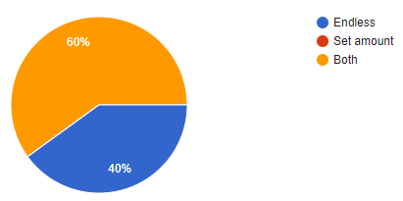

- Every person said they thought some form of point system along with a leaderboard would make revising on this program more enjoyable so this will be something I am going to include for students to be able to compete with each other on how many points they can score.
- All the participants stated that a way of viewing their stats would be beneficial as it would show them areas to improve and the areas in which they need more or less revision.
- My clients gave some examples of statistics they would like to see about their personal accounts, these included their average score on each type of question and difficulty, their total points as well as their points for each type of question, how many questions they got correct and incorrect and also a ‘highest streak’ which would record the number of questions they had gotten correct in a row.

Interview

I wrote questions that I used to interview a further math student on ideas she would like to see implemented into the program, or ideas she deems important as well as ideas of how the GUI should look.
- What do you think about this GUI design(draft 1, see in 1.6.2)?
Summary- They liked the tab bar however they thought that there should be something to indicate what user is logged in, they recommended to maybe put the user’s username at the top of the screen along with a profile picture which the user could choose or set.

- What colour scheme should be used?
Summary- They said a monotone sleek colour scheme should be used like grey but there should be hints of bright colours to make it more appealing to look at.

- Could any other features be included that aren’t already?
Summary- There should be an Account page where the user can view all of their personal details as well as alter them, they should be able to change their username and password as well as their profile picture which they could select from their own files. They also said that an undo button would be very useful when they are creating their own graphs in case they make a mistake instead of having to start from scratch.

- What type of extra information do you think the mark scheme should include compared to an exam mark scheme?
Summary- They think a pop up screen should appear so the main page doesn’t feel too cluttered which would show the basic information like the distance from the starting node to each node.

- How should the different difficulty of questions be decided?
Summary- The easy questions should be like the 5 mark questions with 8 nodes and should give the user 100 points, the medium ones should be based on 6 mark questions with 9 nodes and give the user 200 points, the hard ones should be based on 7 mark questions and have 10 nodes and be worth 300 points.

- What do you think about implementing follow up questions?
Summary- They thought it would be a good idea to include some simple questions that might alter the graph or ask about definitions like in the actual exam however they said this wouldn’t be a top priority for them as these questions are usually quite simple and easy to answer so don’t need much revision.

Looking at questions
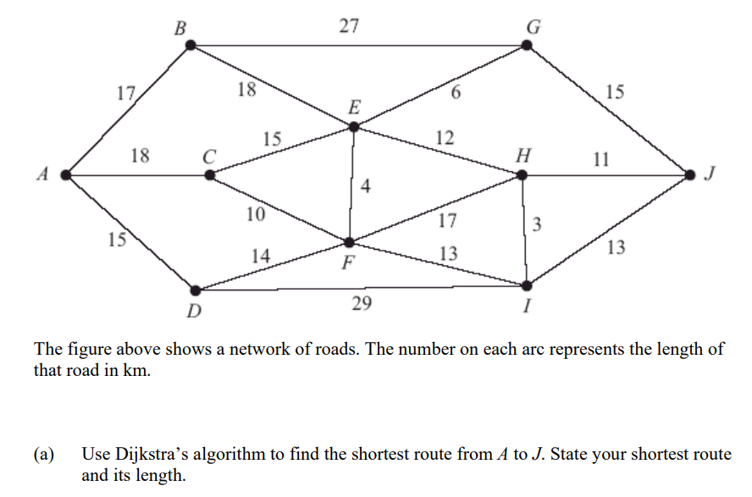
I have looked at multiple questions from exams on different algorithms. I looked at the way questions were worded, how many marks each were awarded, the difficulty of the question, the follow up questions and the mark schemes.
Question Example
Most questions were worded very similarly stating a network above and that it represents either a road or some type of route and then continues to ask the student to find the shortest route between two nodes and state the shortest route. Typically, questions are 5-7 marks depending on the content of the questions, they all include 8-10 nodes and then some can include algebra and make the weight in x’s which adds extra marks. Also, each node has 2-6 arcs connecting it to other nodes and the weight of each arc varies usually from 10-20 however sometimes goes below 10 and above 20 therefore I will make the weights mostly 10-20 but make there be a few values outside of that range to replicate the real exam questions as closely as possible. The follow up questions can be where a node is removed and you need to find a new fastest route or it may ask the definitions of specific terms like a path, or to find another fastest route that includes a specific node.
Mark Scheme Example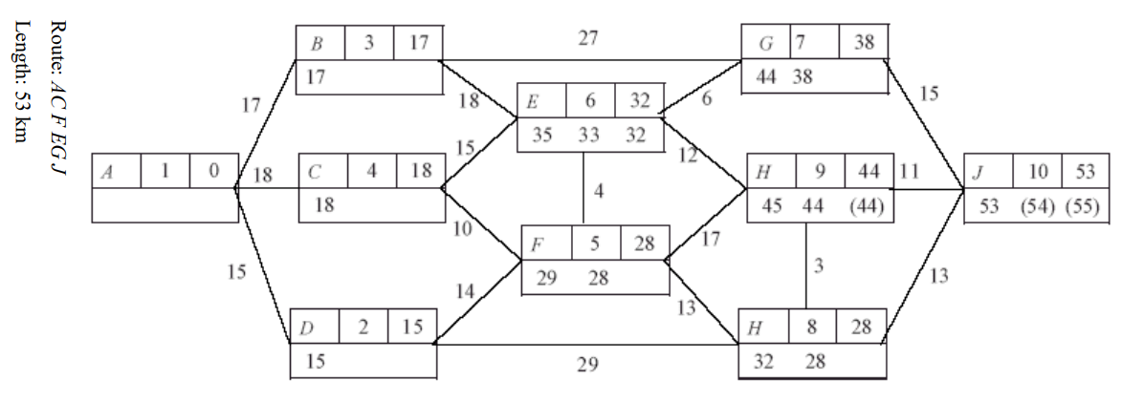
The mark schemes do not give any information about how the question is completed and just shows a completed graph with no added information, I will try to somewhat replicate this by outputting the shortest distances to each node in a pop up screen like my client specified.

Modelling

Process diagram
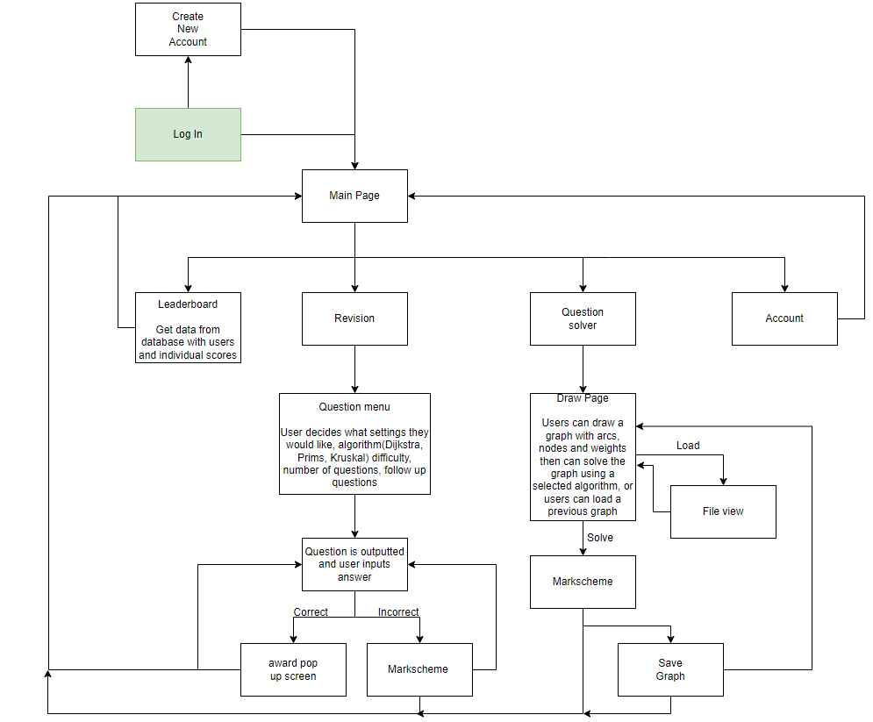My process diagram represents how my pages are going to be laid out and which ones are going to be linked. From completing this I have decided I want my Main Page to be designed in a way where there are tabs on the left side of the page and they can be selected to display the individual pages in the center of the screen, I will represent this on an annotated UI design.

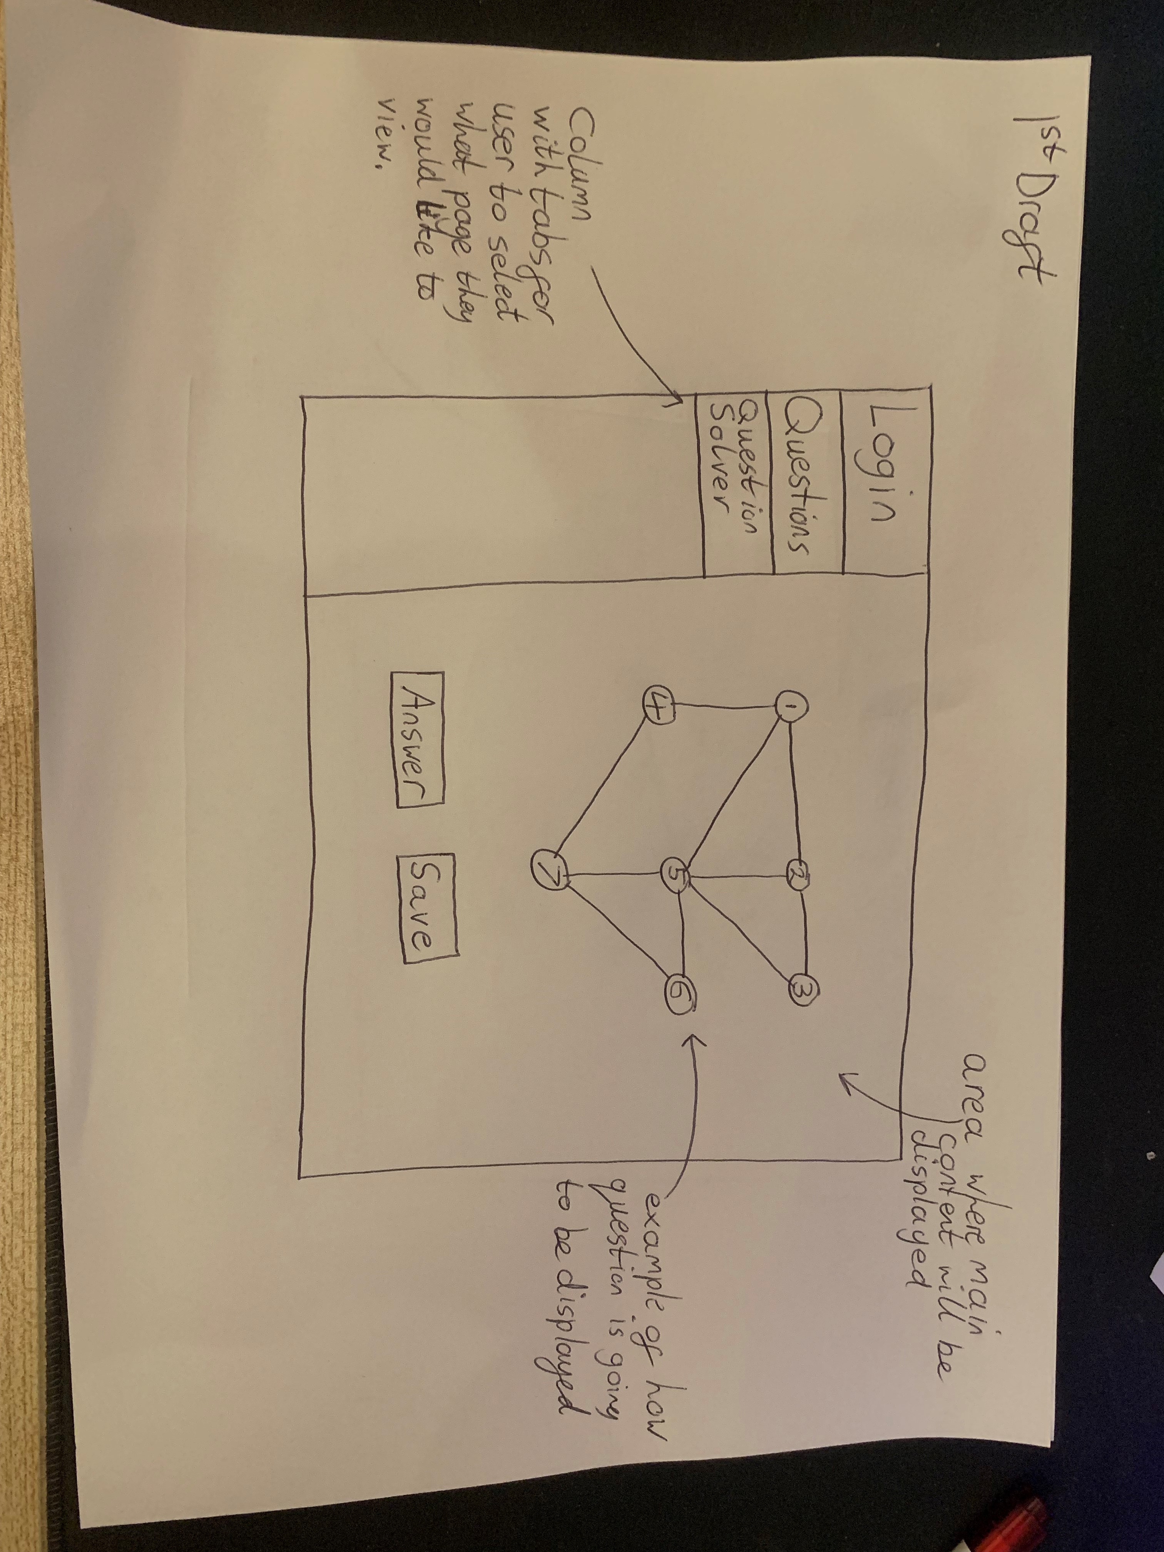
UI design
First Draft

This is the first draft of my UI design that I made after some of my initial analysis, I then showed this to my client in the interview that I did, and they gave me some things to change as well as add.

Second Draft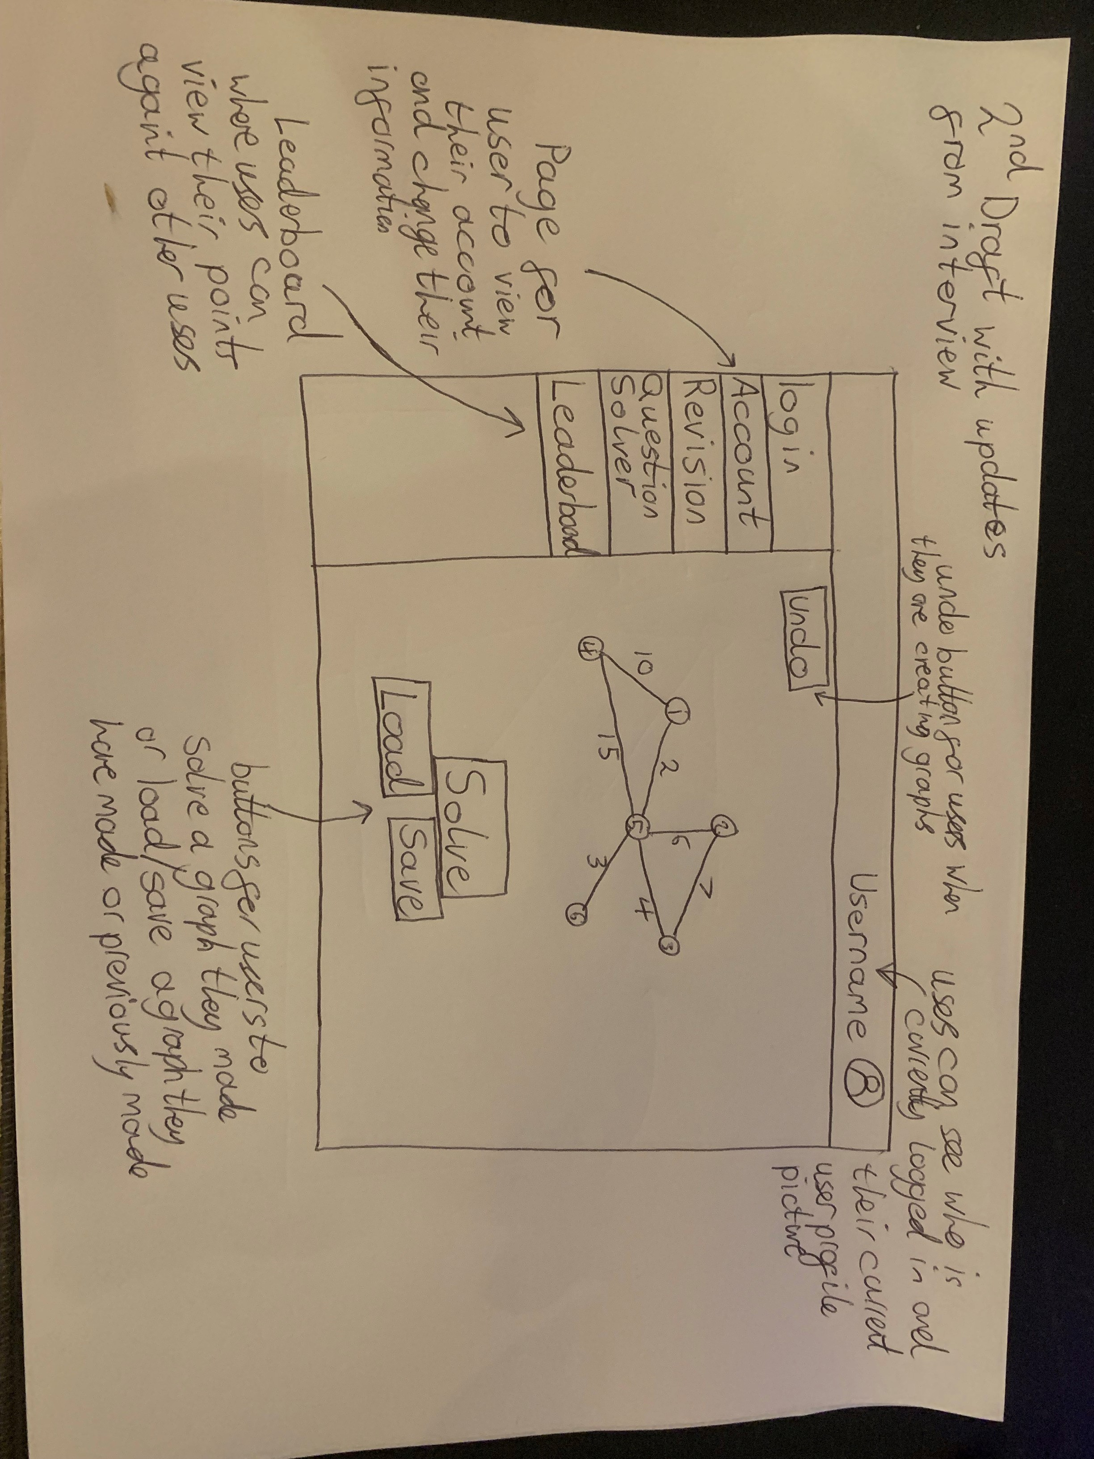
I have annotated all the changes that I have made from my interview that my client said I should make as well as added features that were brought up in my questionnaire. This will be my final design and after speaking to my client they stated that they were happy with this design and they would like it to be sleek looking by using grey tones and make it look modern with slight amounts of bright colors which was specified in the interview.

Data Table
Question Type | Points awarded
Easy | 100
Medium | 200
Hard | 300
FollowUp question | 50
This table represents the points which will be awarded to the user depending on what type of question the user has completed.

Leaderboard example
Place | Username | Total points | Highest streak
1 | Username1 | 1400 | 5
2 | Username2 | 800 | 1
3 | Username3 | 400 | 2
The leaderboard is going to display the users and their total points along with their highest streak, they will be ordered by their total points. If a user does not have any points yet, then they will not be displayed on the leaderboard

Walkthrough of question
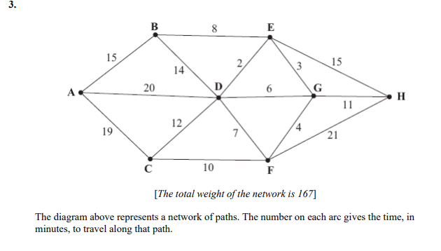Completing this exam question using Dijkstra's algorithm:
- Start at node A labelling it as the first node visited with distance 0 and decide out of the 3 connecting arcs (B,D,C) which has the lowest distance from A which would be B and label it as the second node visited with distance 15 , then note on D and C the current lowest distance to them from the start node A which would be C-19, D-20
- Now look from both A and B at all the connecting nodes (C,D,E) and label the new shortest distance from your start node A, using only visited nodes, to the other nodes (C-19, D-20, E-23), this would be C so you would label that as the third node visited and have distance 19
- Now look from A,B,C at all connected nodes (D,F,E) and label them with the shortest distance from the start node A using only visited nodes (D-20, E-23, F-29), the shortest distance would be to D so label this as the fourth node visited with distance 20
- Now look from A,B,C,D at the connected nodes (E,G,F) and label them with the shortest distance from the start node A using only visited nodes (E-22, G-26, F-27), the shortest distance is E so label it as the fifth node visited with distance 22
- Now look from A,B,C,D,E at the connected nodes (G,H,F) and label them with the shortest distance from the start node A using only visited nodes (G-25, F-27, H-37), the shortest distance is G so label it as the sixth node visited with distance 25
- Now look from A,B,C,D,E,G at the connected nodes (H,F) and label them with the shortest distance from the start node A using only visited nodes (H-36, F-27), the shortest distance is F so label it as the seventh node visited with distance 27
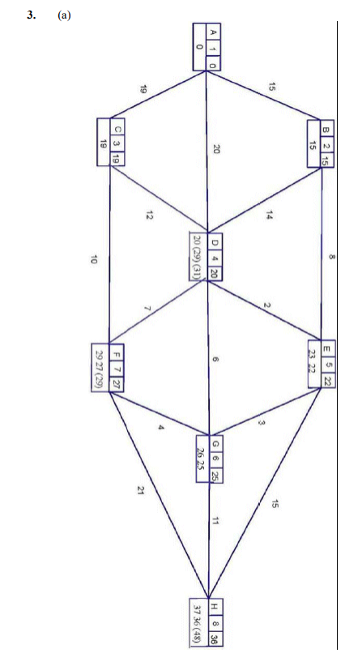
- Now look from A,B,C,D,E,G,F at the connected nodes (H) and label them with the shortest distance from the start node A using only visited nodes (H-36), the shortest distance is H so label it as the eighth node visited with distance 36
- All nodes are now visited and labelled with the shortest distance to get to them from the starting node

My program is going to have to Compute this algorithm so that it can create and solve graphs using Dijkstra's algorithm.

Requirements
From my research I have gotten these requirements:

- To be able to produce exam style graph questions for users to complete and get marked
  - Have different difficulty of questions
1.1.1 Easy – based on average 5 mark question with 8 nodes
1.1.2 Medium – based on average 6 mark question with 9 nodes
1.1.3 Hard - based on average 7 mark question with 10 nodes
  - To be able to produce a mark scheme for Dijkstra’s which will output the length from the start node to each other node
  - To be able to produce a mark scheme for prim’s which will output the minimum spanning tree
  - To be able to produce follow up questions based on the ones I identified in my analysis by looking at existing questions
  - Have each different difficulty of questions grant the user a different amount of points to go towards their overall score like 50,100, 200, 300
- For the program to be able to perform multiple different algorithms like Dijkstra's, Prim’s and Kruskal's and use them to solve questions and produce a mark scheme
- Be able to input your own graph which will be solved and a mark scheme for it will be outputted
  - Create an undo button for users to be able to undo arcs or nodes
    - Implement user defined stack data type
- To be able to display the graphs graphically instead of as an identity matrix
- An endless questions mode where there is a way of creating different questions endlessly along with their mark schemes
- For students to be able to create personal accounts stored using a database
  - To be able to save specific questions or inputted graphs in a database
  - To be able to gain a point score from completing questions which can be represented in a leaderboard against other user's accounts
  - Allow users to be able to update their account details like username, password and profile picture
- Make the GUI similar to what my user identified they would like it to look like in the interview
  - Make there a column of tabs on the left-hand side for the user to select what page they would like to be on
  - Make it sleek and simple with monotone colours with a hint of bright colours
- For my clients to be able to view their accounts statistics like their average score, points earned and number of questions correct to be able to better target their revision on question types they score lower on
  - To be able to record a highest streak for each type of question for the user which can be altered if a new highest streak is achieved

Design

Overview
My Further Math revision application is developed using the C# programming language and the WPF framework which uses C# and XAML to create a user-friendly GUI. My program has 2 main functionalities, the revision side where the program randomly generates exam style graph questions for the user to complete using different algorithms and then gives them points to compete with other users scores, the other side of the program allows users to create their own graphs and apply different algorithms to them.
My programs main key components are:
- Randomly generating graphs for further math revision
- Database system to store users accounts and data
- Users being able to draw their own graphs and apply further math algorithms to them
- Account management for users to be able to alter their account details and view their statistics
- Leaderboard for users to view their scores against others
I will develop this application by making use of object-oriented programming to make my classes for my graphs and my functions for my algorithms, using OOP is ideal for this application as it will allow me to utilize the same classes and functions for multiple areas in the application for example the revision aspect will use the same classes as the user made graphs. This allows me to not have to repeat code and once the classes are set up will make programming much easier.
I will use SQL to develop and query my database, I will use DDL to set up the database by creating tables and setting up relationships. I will store my users' details as well as their scores and number of right and wrong questions for different difficulties and algorithms which will then be displayed in the leaderboard against other users.
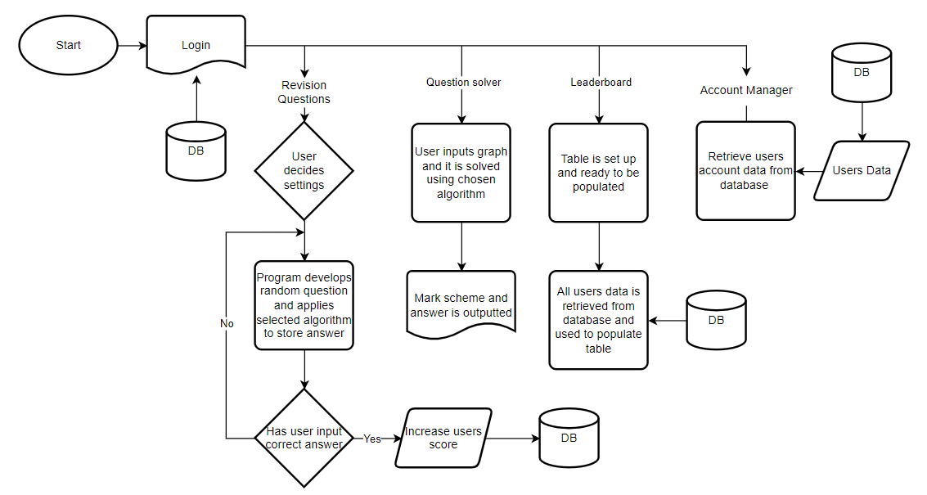This flowchart helps break down the application into its main sections so it can be more easily visualized. Its main chunks are the Login/Create account page which involves the database, the revision page, the question solver page, the leaderboard and the account manager.

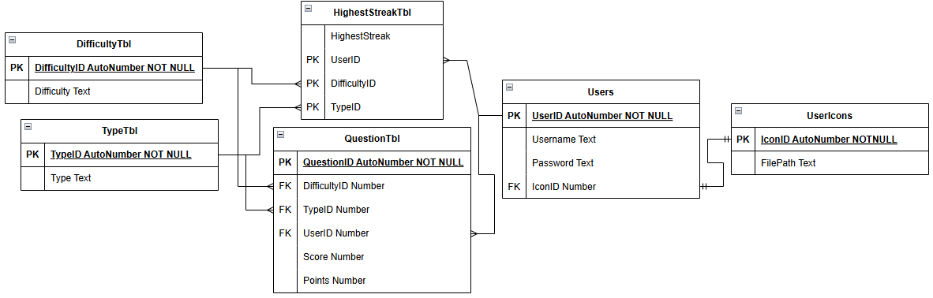
Database ERD

This ERD represents the relationships between my tables in my database. In total I will have 6 tables. Users and UserIcons will have a one to one relationship, linked by the IconID key. Users and HighestStreakTbl will have a one to many relationship, linked by the UserID key, this will be the same for Users and QuestionTbl. Highest streak then has a one to many relationship with both DifficultyTbl and TypeTbl. QuestionTbl also has a one to many relationship with DifficultyTbl and TypeTbl. QuestionTbl also uses a composite key which is made up using the foreign keys from the DifficultyTbl, TypeTbl and Users tables.

Class Diagram
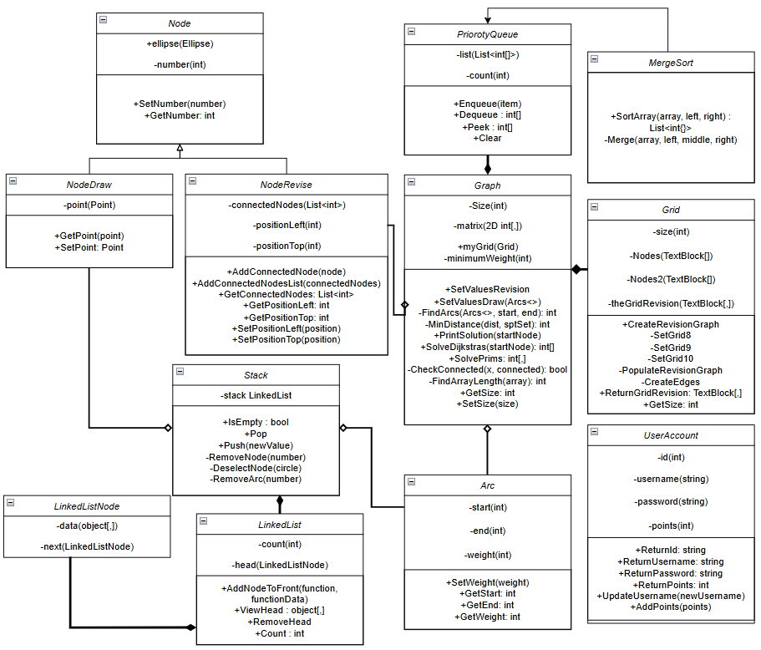
All of my classes have been encapsulated by making all of their variables private and only being able to access them by using public functions.
When the program is first ran the UserAccount class is instantiated to hold the details about the user once they have logged in or created an account. It holds the data about the user that would be stored in the database so all the data from the database is transferred into the class so it can be more easily accessed.
When the Graph class is instantiated, it also instantiates the Grid class. This is a composition relationship as the Grid class is never instantiated without a Graph class being made. The Graph class has algorithms like Dijkstra’s and Prim’s programmed into subroutines which utilize the PriorotyQueue which gives them a composite relationship since if the graph is destroyed so is the PriorotyQueue. The PriorotyQueue is sorted into priority by using a merge sort therefore they have a direct association. It also has the matrix itself which is implemented using an adjacency matrix. The Grid Class creates the values and layouts which will be placed into the matrix grid.
The Node class is the parent to the NodeDraw and NodeRevise classes which inherit properties and functions. They are both used when graphs are created either in the Revise or Draw page.
Both the Arc and NodeRevise have an aggregation relationship with Graph as they can be instantiated in the Graph class but can also exist on their own. These three classes together are used to display the graphs to the user and hold the information about each object on the canvas.
The Stack is made using a LinkedList which is made using the LinkedListNode and each of these classes have a composition relationship as if the stack is destroyed then all of them are
NodeDraw and Arc have an aggregation relationship with Stack as the stack is used for the undo button on the Draw page which both the Arc and NodeDraw class are used to allow the user to draw on the canvas.

Login Section

Flowchart
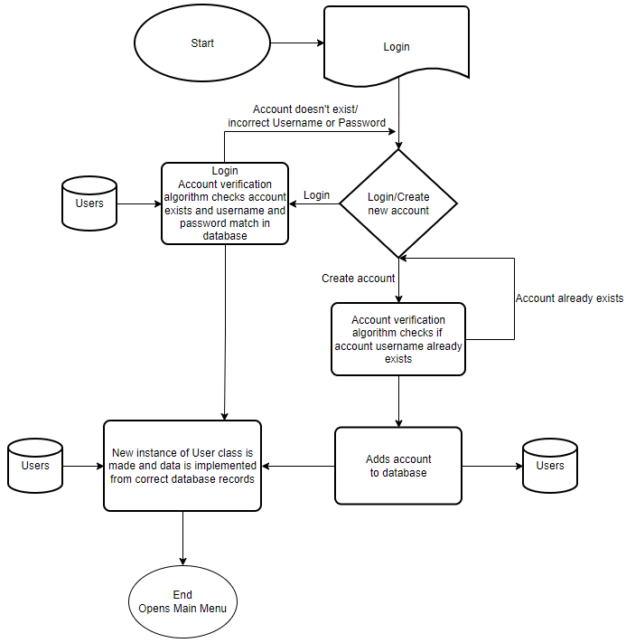
This flowchart represents the layout of the login/ create new user pages and how the process begins and loops until a correct login is entered, or a new account is entered with valid details. This is performed by using different pages to output the information to the user depending on if they are logging in or creating a new account. I used SQL queries along with algorithms to check whether the user’s account exists in the database and to create valid accounts without duplication.

Pseudocode and SQL queries

Check if username and password combination exist
SELECT username,password FROM Users WHERE username ='Username.Text' AND password ='Password.Text'
reader ← cmd.ExecuteReader() // executes the SQL statement
int count ← 0
while reader.Read() //Checks if SQL statement returns a value meaning it is valid
count = count + 1
endwhile
if count = 1
CreateUser() //uses SQL queries to retrieve user data and instantiate a UserAccount
SetIcon()
//UI elements get changed to user’s details
OUTPUT(“Log in successful”)
else
OUTPUT("username or password incorrect, Try again!")

This SQL query checks if there is a record where the username and password that the user has entered is correct. In the pseudocode the SQL query is then executed and the records that are returned are put into the reader variable. Then a while loop is started, which iterates through all the records returned, however since duplicate accounts are not allowed count must equal one if a valid account was found with the username and password combination. If count is set to one, then the CreateUser function is called and then some UI elements are changed to display the user’s details. If count does not equal to one then a valid account is not found, so a message is outputted to the user to tell them to try again.

CreateUser Function
SELECT UserID FROM Users WHERE username ='Username.Text' AND password = 'Password.Text'
SELECT points FROM Users WHERE username ='Username.Text' AND password =' Password.Text'
User ← new UserAccount(id, Username.Text, Password.Text, points)
These 2 SQL statements retrieve the user’s data that hasn't already been inputted by the user when they logged in. The two statements return the values for the user’s UserID and the user’s points when the Username and Password are equal the ones inputted by the user. These values are then passed into variables and then used to instantiate a new instance of the UserAccount class which is used to store the values of the user who is currently logged in.

SetIcon function
SELECT UserIcons.FilePath FROM Users, UserIcons WHERE Users.IconID = UserIcons.IconID AND Users.username = 'User.ReturnUsername() '
This SQL query returns the file location of the profile picture set by this user which is then converted to an image and displayed on the screen with the user's username.

Check if username already exists and input it into database
SELECT Count(username) FROM Users WHERE username ='Username.Text'
INSERT INTO Users ([username], [password], [IconID]) VALUES ('Username.Text ', 'Password.Text', 1)
Count ← SQL SELECT query //returns the value from the above SQL query
if Count != 0
OUTPUT("username already exists!")
else
INSERT INTO query //the Insert into query is ran and the new user's data is added into the database
OUTPUT("Account created!")
Endif

The Select SQL query returns the number of records where the username is equal to the one that the user is trying to input. If there is already an account which exists with this username then a popup will tell the user to choose a different username. If there aren't any accounts with that username then the account is inserted into the database using the Insert Into query which creates a new record in the database and sets the username and password equal to the ones that the user specified.

UI Design for login and create new account pages
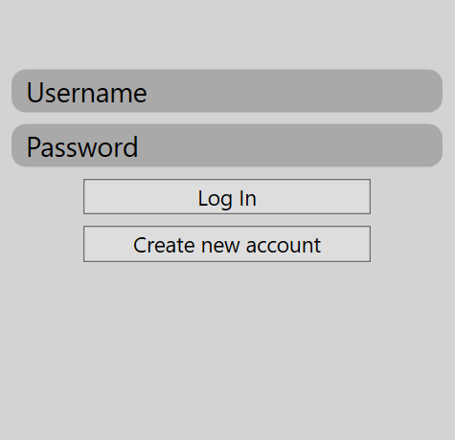
The user login page needs to have 2 fields for users to input their username and their password. The login button will then call the functions which use the algorithm to check if the account is valid by using the SQL statements talked about above. If the user does not have an account they can select the Create New button which will open up a new page to create a new account.
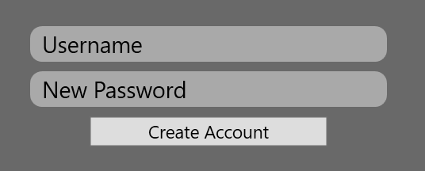
The Create new account page also needs to have 2 fields for users to input their new account details. The button to create the new account needs to call the subroutines and SQL queries which check if the username already exists and if it does then a pop up will occur telling the user they need to input a different username. However if the details are valid then the new account is added into the database with SQL queries and then a subroutine is called to create a new instance of the UserAccount class.

Account Management section

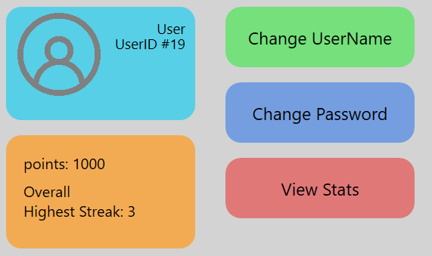
UI design
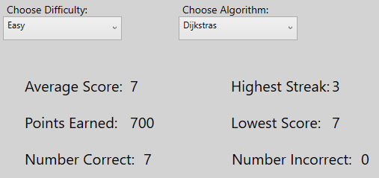
My UI will be designed in the way my user specified in my client requirements. It will be simple and sleek but also include minimal amounts of bright colour to not make the page boring. For this page each button will be a bright colour to brighten up the page. This UI is also very simple in design as there is very minimal things on the page apart from the buttons that need to be there. If the user hovers their mouse over the user icon, they will be able to select it and change their icon.

This will be the UI design for the statistics page. There will be two boxes for the user to select which difficulty and algorithm they want to view. They will be able to view their average score, highest streak, points earned, lowest score, number correct and number incorrect. The users will be able to select Easy, Medium and Hard difficulty, and Dijkstra’s. Prim’s and follow up questions.

Flowchart
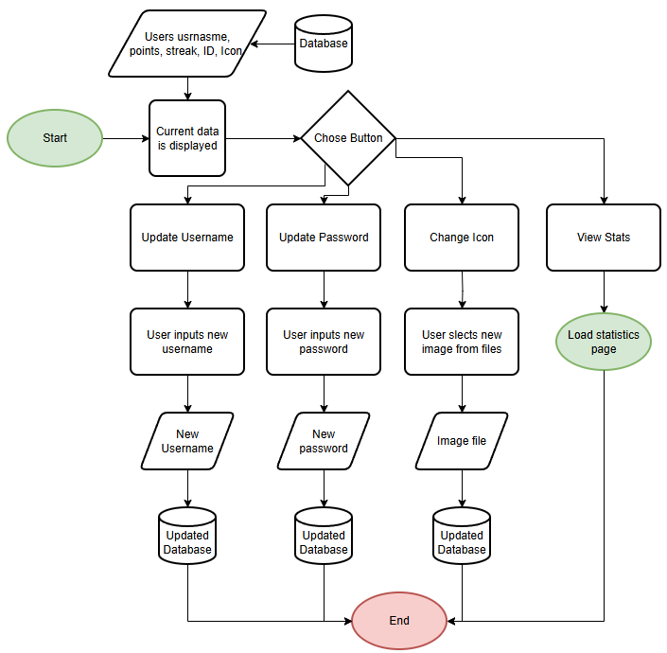
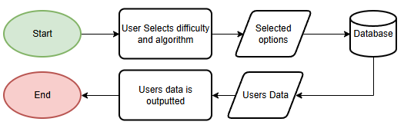
This is the flowchart for the account management page. When the page is opened the database is accessed to retrieve the users data so it can be displayed on the page. The user then has to select one of the buttons on the page which will then open up a new window or page. For the update username and password buttons a window will appear which allows then to update their data which is then updated in the database. For the update icon the users files are opened and they are able to select an image file which is then set as their new icon in the database. If the user selects the view statistics button, a new page is opened in which they can view their statistics. This is the flowchart for the statistics page. The user is able to select the algorithm and difficulty they want and then the database returns the requested data and that is displayed to the user.

SQL
These 3 SQL statements are used when the user is updating their icon. The first one is used to place the new image file into the database. The second statement is used by iterating through each record in the UserIcons table until a match is made with the file path returned to the file path the user inserted, the variable ‘i’ is then stored as the new IconID. The update statement then sets the new IconID to the users IconID in the Users table to link them together correctly.
These SQL statements are used to update the users username. The Select statement uses aggregate SQL to return the number of users who have the username the user is trying to change theirs to. If a value > 0 is returned then that username is in use so they cannot use that username. Once they have selected a valid username the update statement is used to update the users username in the database.
This update statement is used in the same way the update username one was used as it just updated the password of the user in the database.
This select statement uses aggregate SQL to return the average of the users scores for a specific difficulty and algorithm. It does this by linking 4 tables together using primary keys and foreign keys. It finds each record with the selected difficulty, algorithm and users details and then finds an average score from all of these records.
This statement works in the same way as the one above however it uses the SUM command to find the sum of all the points from each record it returns.
This statement works in the same way as the one above however it uses the MIN command to return the users lowest score out of each record returned.
This statement works in the same way as the one above however it uses the COUNT command to count every record where the points is not equal to 0 which therefore means the user got the question correct so that it can count the number of correct questions.
This statement works in the same way as the one above however it uses the COUNT command to count every record where the points is equal to 0 which therefore means the user got the question incorrect so that it can count the number of incorrect questions.
This statement works the same as the above however it uses the MAX command to return the highest high streak the user has achieved.
SELECT AVG(Score) FROM QuestionTbl, Users, DifficultyTbl, TypeTbl WHERE Users.UserID = QuestionTbl.UserID AND QuestionTbl.DifficultyID = DifficultyTbl.DifficultyID AND QuestionTbl.TypeID = TypeTbl.TypeID AND Users.username = '" + username + "' AND Users.password = '" + password + "' AND DifficultyTbl.Difficulty = '" + difficulty + "' AND TypeTbl.Type = '" + algorithm + "'
UPDATE Users SET [password] = '" + Password.Text + "' WHERE UserID = " + id + "
SELECT FilePath FROM UserIcons WHERE IconID = " + i + " ;
UPDATE Users SET IconID = " + iconID + " WHERE UserID = " + User.ReturnId() + "
INSERT INTO UserIcons ([FilePath]) VALUES ('" + FilePath + "')
UPDATE Users SET username = '" + Username.Text + "' WHERE UserID = " + id + "
SELECT Count(username) FROM Users WHERE username ='" + Username.Text + "'
SELECT SUM(Points) FROM QuestionTbl, Users, DifficultyTbl, TypeTbl WHERE Users.UserID = QuestionTbl.UserID AND QuestionTbl.DifficultyID = DifficultyTbl.DifficultyID AND QuestionTbl.TypeID = TypeTbl.TypeID AND Users.username = '" + username + "' AND Users.password = '" + password + "' AND DifficultyTbl.Difficulty = '" + difficulty + "' AND TypeTbl.Type = '" + algorithm + "'
SELECT MIN(Score) FROM QuestionTbl, Users, DifficultyTbl, TypeTbl WHERE Users.UserID = QuestionTbl.UserID AND QuestionTbl.DifficultyID = DifficultyTbl.DifficultyID AND QuestionTbl.TypeID = TypeTbl.TypeID AND Users.username = '" + username + "' AND Users.password = '" + password + "' AND DifficultyTbl.Difficulty = '" + difficulty + "' AND TypeTbl.Type = '" + algorithm + "'
SELECT Count(Points) FROM QuestionTbl, Users, DifficultyTbl, TypeTbl WHERE Users.UserID = QuestionTbl.UserID AND QuestionTbl.DifficultyID = DifficultyTbl.DifficultyID AND QuestionTbl.TypeID = TypeTbl.TypeID AND Users.username = '" + username + "' AND Users.password = '" + password + "' AND DifficultyTbl.Difficulty = '" + difficulty + "' AND TypeTbl.Type = '" + algorithm + "' AND QuestionTbl.Points <> 0
SELECT Count(Points) FROM QuestionTbl, Users, DifficultyTbl, TypeTbl WHERE Users.UserID = QuestionTbl.UserID AND QuestionTbl.DifficultyID = DifficultyTbl.DifficultyID AND QuestionTbl.TypeID = TypeTbl.TypeID AND Users.username = '" + username + "' AND Users.password = '" + password + "' AND DifficultyTbl.Difficulty = '" + difficulty + "' AND TypeTbl.Type = '" + algorithm + "' AND QuestionTbl.Points = 0
SELECT Max(HighestStreak) FROM HighestStreakTbl, Users, DifficultyTbl, TypeTbl WHERE HighestStreakTbl.UserID = Users.UserID AND HighestStreakTbl.DifficultyID = DifficultyTbl.DifficultyID AND HighestStreakTbl.TypeID = TypeTbl.TypeID AND Users.username = '" + username + "' AND Users.password = '" + password + "' AND DifficultyTbl.Difficulty = '" + difficulty + "' AND TypeTbl.Type = '" + algorithm + "'

Revision section

Flowchart
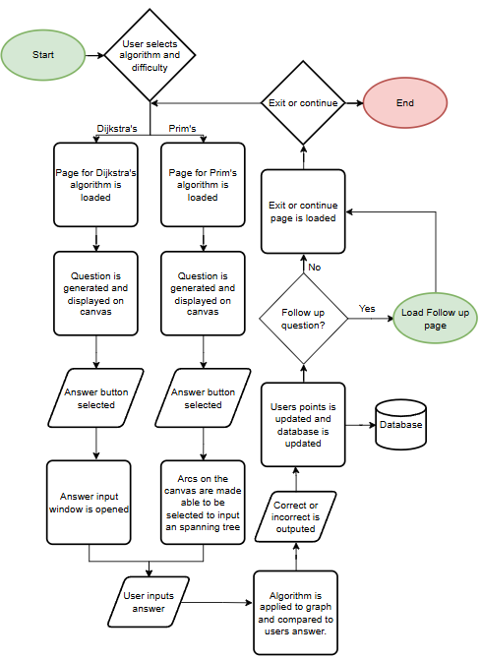
This flowchart represents the flow of data and pages as the user revises. They begin by selecting which algorithm they would like to revise and what difficulty, the program then loads the page specific to the algorithm they selected. The program then creates a graph which is displayed on the canvas. The user then selects the answer button and either a window is shown for the user to input their answers or the arcs on the graph are altered so that they can be selected by the user to input a minimum spanning tree. The program then uses the corresponding algorithm to find the answer to the question which is then compared with the users answer to check I they are correct. Depending on the difficulty of the question a certain number of points will be added to the user's account and then the database will be updated with this data. A new page is then loaded which asks the user if they would like to continue and do more questions with these settings or exit. If they continue then the program loops and generates a new question.
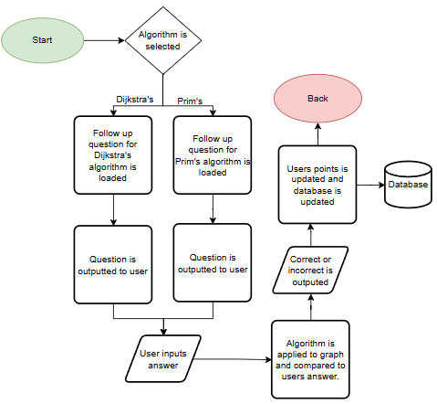
This flowchart represents the process of creating and outputting a follow up question to the user if they select to complete a follow up question. First the program works out which algorithm is being used so it knows which type of question to output, then the question is randomly generated from a set layout for the user to complete. The user then inputs their answer which is marked by the program which uses the needed algorithm to calculate the answer which is then compared with the users.

UI Design
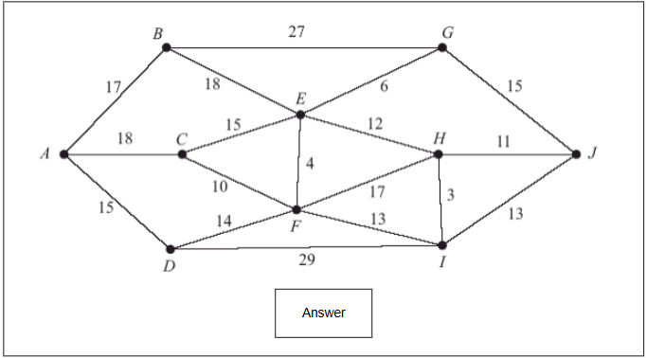
My graphs are going to be output in the way shown above. The UI is going to be simple and only include the graph and a button for the user to answer the question. The graph will be output by drawing lines and ellipses onto a canvas then using text blocks for the weights. When the user selects the answer button on a Dijkstra’s question a pop-up window will appear which input boxes for each node for the user to input the shortest distance to each node. For the Prim’s questions once the answer button has been selected the user will be able to select arcs on the existing graph to create the minimum spanning tree. Once the answer has been inputted a pop-up will appear the show if the user got the answer correct or not. If the question was correct and the user selects to do a follow up question another window will appear which will display the question.
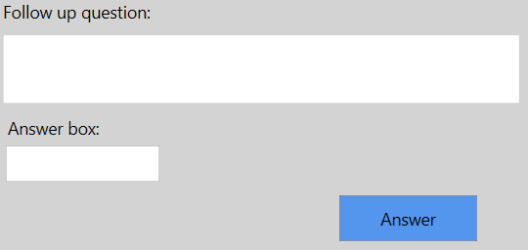
This is how the follow up question window will look. Once the user inputs an answer and selects the answer button, the corresponding algorithm will be used to find the answer to the question which will then be compared with the users answer to output either correct or incorrect. The user will then be taken to a page to choose to either continue answering questions or exit the revision page.

Pseudocode and SQL
Dijkstra’s algorithm
I use the Dijkstra’s algorithm to solve the randomly generated graphs to get the shortest path from the start node to each other node so that the solution can be compared with the users inputted answer, this is used to mark the users input and return the user a score. The algorithm will use a priority queue and loops to decide which arcs will be used to create the shortest distance from the start node to each other node.

public int[] SolveDijkstras2(int startNode)
PriorotyQueue priorotyQueue ← new PriorotyQueue();
int[] minimumDistances ← new int[size];
for int i ← 1 to size
int[] array = new int[2];
array[1] ← ∞;
array[2] ← i;
if i = startNode
array[1] ← 0;
EndIF
priorotyQueue.Enqueue(array);
EndFor
while priorotyQueue.Count > 0
int[] currentNode ← priorotyQueue.Dequeue();
minimumDistances [currentNode[2]] ← currentNode[1];
List<int> neighbours ← FindNeighbours(currentNode[2]);
int distanceAtCurrent ← currentNode[1];
foreach int neighbour in neighbours
int distanceCurrentToNeighbour;
int distanceAtNeighbour ← 0;
int[] neighbourData ← new int[2];
foreach int[] node in priorotyQueue.list
if node[2] = neighbour
distanceAtNeighbour ← node[1];
neighbourData ← node;
EndIf
EndForeach
if matrix[neighbour, currentNode[2]] != 0)
distanceCurrentToNeighbour ← matrix[neighbour, currentNode[2]];
elseIf
distanceCurrentToNeighbour ← matrix[currentNode[2], neighbour];
EndIf
int newDistance ← distanceAtCurrent + distanceCurrentToNeighbour;

if newDistance < distanceAtNeighbour
priorotyQueue.list.Remove(neighbourData);
neighbourData[0] = newDistance;
priorotyQueue.Enqueue(neighbourData);
EndIf
EndForeach
EndWhile
return minimumDistances;
EndSubroutine
This algorithm performs Dijkstra’s algorithm by starting by initializing a priority queue and an array minimumDistances where each node’s distance is set to infinity, except the start node which is set to 0. Each node which is represented by an array which holds the distance and node number, is then enqueued in the priority queue. The algorithm dequeues the node with the smallest distance. For each node it finds its neighbors and calculates the distance to each neighbor. If a shorter distance to a neighbor is found the neighbor’s distance is updated. This loops until there are no nodes left in the priority queue. The adjacency matrix is used to find the distance between nodes.

Prim’s algorithm
I use the Prim’s algorithm to solve the randomly generated graphs to find the minimum spanning tree for that specific graph so that it can be compared to the one the user inputs, this will be done to mark the users input correctly and output the user a mark. My algorithm uses 3 separate subroutines to perform Prim’s find a minimum spanning tree. It does this by starting at the selected starting node and adding edges which are connected to the current spanning tree by selecting the current minimum weight edge.
public int[,] SolvePrims()
int[] connected ← new int[size];
connected[0] ← 0;
for int i ← 1 to size
connected[i] ← -1;
endfor
int[,] startAndEndNodes ← new int[size-1,2];
bool completed ← false;
int lowestWeight ← ∞;
int x;
int y;
int count ← 0;
while completed = false
Count ← count+1;
lowestWeight ← ∞;
x ← -1;
y ← -1;

for i ← 0 to size
if CheckConnected(i, connected) = true
for j ← 0 to size
if !CheckConnected(j, connected) = true
if matrix[j, i] < lowestWeight AND matrix[j,i] != 0
lowestWeight ← matrix[j, i];
x ← j;
y ← i;
endif
endif
endfor
endif
endfor
If lowestWeight != ∞
connected[count] ← x;
startAndEndNodes[count - 1, 0] ← x;
startAndEndNodes[count - 1, 1] ← y;
endif
If FindArrayLength(connected) = size
completed = true;
endif
endwhile
return startAndEndNodes;
EndSubroutine
This subrotine uses nested loops and nested iteration to find a minimum spanning tree from an inputted graph which is modeled using an adjacency matrix. It uses the two other subroutines, CheckConnected and FindArrayLength, to check whether nodes are connected to the current spanning tree and to find the number of currently occupied indexes in an array. The Prims algorithm can begin at any node and adds this node to the spanning tree, it then loops through all the nodes in the graph and checks if they are directly connected to our current spanning tree and if they are it gets the distance from our current spanning tree to that node and compares each distance and adds the minimum distance node and arc to our spanning tree, it then keeps looping this process until every node is connected to our spanning tree by using the minimum distances to create a minimum spanning tree.

private bool CheckConnected(int x, int[] connected)
for i ← 0 to connected.Length
if (x == connected[i])
return true;
endif
endfor
return false;
EndSubroutine
This subroutine is used to check if a node is directly connected to our current spanning tree so that if it is, the algorithm can continue to retrieve the distance to this node and potentially add it to the spanning tree.

private int FindArrayLength(int[] array)
int count ← 0;
for i ← 0 to array.Length
if array[i] != -1
Count ← count + 1
endif
endfor
return count;
EndSubroutine
This subroutine is used to find the number of currently occupied spaces in an array.

Merge Sort
I use this merge sort algorithm to sort my priority queue by sorting the queue in order of ascending distances. This algorithm works by using recursion on the SortArray subroutine so split the list into multiple smaller lists until each list is only made up of one element which is the base case. The Merge subroutine is then called to merge each list back together in ascending order of distances until the List is completely merged back together in the correct order.
public static List<int[]> SortArray(List<int[]> array, int left, int right)
if left < right
int middle ← left + (right - left) / 2;
SortArray(array, left, middle);
SortArray(array, middle + 1, right);
Merge(array, left, middle, right);
EndIf
return array;
EndSubroutine

private static void Merge(List<int[]> array, int left, int middle, int right)
int leftArrayLength ← middle - left + 1;
int rightArrayLength ← right - middle;
List<int[]> leftTempArray ← new List<int[]>(leftArrayLength);
List<int[]> rightTempArray ← new List<int[]>(rightArrayLength);
int leftPointer;
int rightPointer;

for leftPointer ← 0 to leftArrayLength
leftTempArray.Add(array[left + leftPointer]);
EndFor
for rightPointer ← 0 to rightArrayLength
rightTempArray.Add(array[middle + 1 + rightPointer]) ;
EndFor
leftPointer ← 0;
rightPointer← 0;
int mergedIndex ← left;
while leftPointer < leftArrayLength && rightPointer < rightArrayLength
if leftTempArray[leftPointer][0] <= rightTempArray[rightPointer][0]
array[mergedIndex++] = leftTempArray[leftPointer++];
else
array[mergedIndex++] = rightTempArray[rightPointer++];
EndIf
EndWhile
while leftPointer < leftArrayLength
array[mergedIndex++] ← leftTempArray[leftPointer++];
EndWhile
while rightPointer < rightArrayLength
array[mergedIndex++] = rightTempArray[rightPointer++];
EndWhile
EndSubroutine

SQL
Add question record
INSERT INTO QuestionTbl (DifficultyID, TypeID, UserID, Score, Points) VALUES (@difficulty, @type, @userID, @score, @points
This insert statement is used to input new records into the QuestionTbl once a user has completed a question and it has been marked. This statement is used whenever a regular Dijkstra’s or Prim’s question is completed or when a follow up question is completed.
Select Difficulty
SELECT DifficultyID FROM DifficultyTbl WHERE Difficulty = '"+difficulty+"'
This select statement is used to match the questions difficulty with the specific DifficultyID so that the question record can be inputted correctly
Select Type
SELECT TypeID FROM TypeTbl WHERE Type = '"+type+ "'
This select statement is used to match the questions type with the specific TypeID so that the question record can be inputted correctly
Check current streak
SELECT HighestStreak From HighestStreakTbl, DifficultyTbl, TypeTbl WHERE UserID = " + User.ReturnId() + " AND DifficultyTbl.DifficultyID = HighestStreakTbl.DifficultyID AND TypeTbl.TypeID = HighestStreakTbl.TypeID AND DifficultyTbl.Difficulty = '"+difficulty + "' AND TypeTbl.Type = '" +algorithm + "'

This select statement links 3 tables together and finds the users highest streak for a particular difficulty and algorithm so that it can then be compared to the streak they have achieved to see if it needs to be updated
Delete current streak
DELETE FROM HighestStreakTbl WHERE UserID = " +User.ReturnId() + " AND DifficultyID = " + GetDifficulty() + " AND TypeID = " + GetType() + "

This delete statement is used to remove the current highest streak so that the new one can be inputted into the tablethis insert statement is used to insert a new record into the highest streak table when a new highest streak is reached
INSERT INTO HighestStreakTbl(HighestStreak, UserID, DifficultyID, TypeID) VALUES (" + currentStreak + ", " + User.ReturnId() + ", " + GetDifficulty() + ", " + GetType() + ")

Data Structures
Graph
I have used a graph data structure to represent the graphs used in both Dijkstra’s and Prim’s algorithms. I have implemented the graph by using an adjacency matrix which I made using a 2D integer array and each index in the array is the distance to travel directly from one node to another, the nodes are represented by the x and y axis. I have used my graph data structure to randomly generate graphs by randomly creating distances between nodes in a specific layout which is based on certain exam questions. I have also created Node and Arc classes which are used when the graphs are getting drawn onto the canvas.
When a Graph is instantiated, it instantiates a Grid class which is then used to randomly generate values for each index in the array which is then returned to the Graph class and entered into the matrix which then represents an undirected graph with connected nodes and arcs
This Constructor is called when a graph is instantiated which instantiates a Grid public Graph(string difficulty)
myGrid ← new Grid(difficulty)
EndSubroutine

In the grid class, the distances between the nodes is randomly generated. This pseudocode randomly generates values between 10 and 20 but uses a cooldown variable as well as the above and below variables to randomly space out a few values outside of that range to vary the graphs more and make them more like the exam questions, it does this by only allowing a value outside of the range to be created a maximum of every fourth value by using the cooldown variable, then the above and below variables count the number of values above or below the basic range and only allows there to be 3 values above and 3 blow the range
public void CreateRevisionGraph()
if difficulty = "Easy"
size ← 8
else if difficulty = "Medium"
size ← 9;
else if difficulty = "Hard"
size ← 10
else
size ← random(8, 11)
endif
theGridRevision ← new int[size, size];

int bellow ← 0;
int above ← 0;
int min;
int max;
int cooldown ← 0;
int value;
for i ← 0 to size
for j ← 0 to size
if i >= i
theGridRevision[i, j] ← 0;
else
if cooldown > 0
min ← 10;
max ← 21;
cooldown ← cooldown – 1;
else
min ← 1;
max ← 31;
if bellow >= 3
min ← 10;
endif
if (above >= 3)
max ← 21;
endif
endif
value ← random(min, max);
if value < 10
bellow ← bellow + 1;
cooldown ← 3;
else if value > 20
above ← above + 1;
cooldown ← 3;
endif
theGridRevision[i, j] ← value;
endif
endfor
endfor
EndSubroutine

After the values are created and the layout is setup, the array which holds all the values for the graph is passed back into the graph class and the adjacency matrix is filled with values to represent an exam style graph.
public void SetValuesRevision()
try
size ← myGrid.GetSize();
catch { }
matrix ← new int[size, size];

for i ← 0 to size
for j ← I to size
if j = i
matrix[i, j] ← 0;
else if i < j
matrix[i, j] ← myGrid.ReturnGridRevision()[i, j];
matrix[j, i] ← matrix[i, j];
EndIf

EndFor
EndFor
EndSubroutnine

public NodeRevise[] GetNodeArray()
NodeRevise[] nodeArray ← new NodeRevise[size];
for i ← 0 to size
nodeArray[i] ← new NodeRevise(i);
nodeArray[i].ellipse.Height ← 30;
nodeArray[i].ellipse.Width ← 30;
nodeArray[i].ellipse.Stroke ← Brushes.Black;
nodeArray[i].ellipse.Fill ← Brushes.Black;
nodeArray[i].AddConnectedNodesList(FindAllConnectedNodes(nodeArray[i].GetNumber()));
EndFor
return nodeArray;
EndSubroutine

public List<Arc> GetArcList(NodeRevise[] nodeArray)
List<Arc> arcList ← new List<Arc>();
for currentNode ← 0 to nodeArray.Length
for i ← 0 to nodeArray[currentNode].GetConnectedNodes()
if !CheckArcExists(arcList, currentNode, nodeArray[currentNode].GetConnectedNodes()[i]))
int start ← currentNode;
int end ← nodeArray[currentNode].GetConnectedNodes()[i];
int weight ← matrix[start, end];
Arc arc ← new Arc(start, end);
arc.GetLine().Stroke ← Brushes.Black;
arc.GetLine().StrokeThickness ← 5;
arc.GetLine().IsHitTestVisible ← false;
arc.SetWeight(weight);
arcList.Add(arc);
EndIf
EndFor
EndFor
return arcList;
EndSubroutine
The GetNodeArray and GetArcList subroutines are both used to get the nodes and arcs and place them into an array so that they can then be more easily drawn onto the canvas so that they can be laid out like an exam style question

PriorotyQueue
I use a priority queue in my implementation of Dijkstra’s algorithm. It is used to queue each node in priority of shortest distance. The queue is made up of a list of integer arrays which hold the priority value and the node index. Each time an object is added or removed from queue it is sorted by using a merge sort which splits down each object into single object arrays recursively and then compares each of these arrays to form a sorted array which is in order of distance.
class PriorotyQueue
List<int[]> list;
int Count{ get { return list.Count; } }

public PriorotyQueue()
list ← new List<int[]>();
EndSubroutine

public void Enqueue(int[] x)
list.Add(x);
list ← MergeSort.SortArray(list, 0, list.Count-1);
EndSubroutine

public int[] Dequeue()
int[] min ← Peek();
list.RemoveAt(0);
list ← MergeSort.SortArray(list, 0, list.Count - 1);
return min;
EndSubroutine

public int[] Peek()
if (Count = 0) MessageBox.Show("Queue is empty.");
return list[0];
EndSubroutine

public void Clear()
list.Clear();
EndSubroutine
EndClass

The Enqueue and Dequeue functions are used to add and remove items from the queue. The peek function is used to return what is at the front of the queue but not remove it. The merge sort algorithm is then used every time an object is Enqueued or Dequeued to sort the queue into ascending order of distances.

Draw section

Flowchart
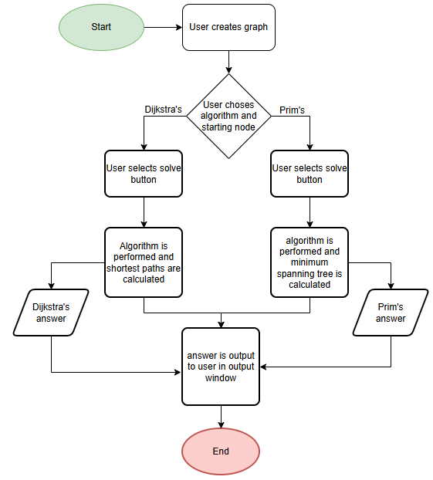
This flowchart represents the flow of data and the users' inputs for the draw page whilst the user is using the draw page to perform an algorithm on a graph. The users begin by creating a graph on the canvas by drawing nodes and arcs and then they set the weights for each arc. They are then able to select an algorithm to use as well as the node for the algorithm the begin on. The selected algorithm is then performed and the answer is outputted to the user. For Dijkstra's the answer will be outputted in a pop up window and for prims the minimum spanning tree will be outputted onto the graph the user has drawn. The user is then able to clear the canvas and draw another graph

UI Design
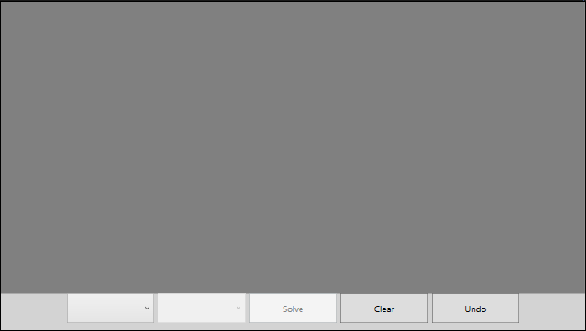My UI is going to be designed in the way shown above by having most of the page allocated to the canvas for the user to draw their graphs and the bottom of the page used for the algorithm selection and selecting the start node as well as the undo and clear buttons.
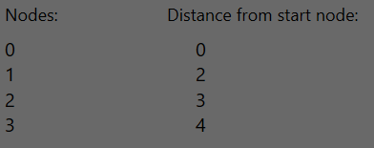
This is an example of how the Dijkstra’s pop up window will appear. It will be made up of 2 columns, the node number and the distance from the chosen starting node to that node.

Pseudocode algorithms
Dijkstra’s
Refer to revise section Dijkstra’s algorithm as they are implemented in exactly the same way
Prim’s
Refer to revise section Prim’s algorithm as they are implemented in exactly the same way

Data Structures
Stack
I use a stack data structure to control the undo button’s function. The stack is made up of a linked list in which each node holds the [function, functionData] to create a stack of functions. When a new object is drawn to the canvas, or the user clicks a node to select a node, that function is then pushed onto the stack and each function has its own identifying value so that each function can be identified. When the undo button is pressed the object at the top of the stack if popped off and the function is identified along with the function data which is then used to revert the changes made to the canvas.
LinkedList stack;
public Stack()
stack ← new LinkedList();
EndSubroutine

public bool IsEmpty()
if stack.Count() != 0
return false;
else
return true;
EndIf
EndSubroutine

public void Pop()
if IsEmpty() = false
if stack.ViewHead()[0,0] = 1
RemoveNode(stack.ViewHead()[0,1]);
else if stack.ViewHead()[0, 0] = 2
DeselectNode(stack.ViewHead()[0, 1]);
else if stack.ViewHead()[0, 0] = 3
RemoveArc(stack.ViewHead()[0, 1]);
EndIf
stack.RemoveHead();
else
Console.WriteLine("The stack is empty");
EndIf
EndSubroutine

public void Push(object[,] newValue)
stack.AddNodeToFront(newValue[0,0], newValue[0,1]);
EndSubroutine

private void RemoveNode(int number)
DrawView page ← DrawView.Instance;
Ellipse node ← page.canvas.Children[number-2];
NodeDraw nodeDraw ← node.Tag;

page.canvas.Children.RemoveAt(number-1);
page.canvas.Children.RemoveAt(number-2);
for i ← 0 to page.startNodeList.Items.Count
Button button ← page.startNodeList.Items[i];
if int.Parse(button.Content) = nodeDraw.GetNumber()
page.startNodeList.Items.RemoveAt(nodeDraw.GetNumber());
EndIf
EndFor
EndSubroutine

private void DeselectNode(Ellipse circle)
DrawView page ← DrawView.Instance;
circle.Fill ← Brushes.Black;
page.startNode ← null;
page.start ← new int();
page.canvasClickable ← true;
EndSubroutine

private void RemoveArc(int number)
DrawView page ← DrawView.Instance;

Line line ← page.canvas.Children[number - 2];
TextBox weight ← page.canvas.Children[number - 1];
Arc arc ← weight.Tag;

page.canvas.Children.RemoveAt(number - 1);
page.canvas.Children.RemoveAt(number - 2);
page.endNode ← null;
page.end ← new int();
page.arcList.RemoveAt(page.arcList.Count - 1);

for i ← 0 to page.canvas.Children.Count
if page.canvas.Children[i] is Ellipse
Ellipse circle ← page.canvas.Children[i];
NodeDraw node ← circle.Tag;
If node.GetNumber() = arc.GetStart()
circle.Fill ← Brushes.Blue;
page.startNode ← circle;
page.start ← node.GetNumber();
EndIf
EndIf
EndFor
EndSubroutine

Linked List
I use this linked list as a dynamic data structure for my stack so that it can be dynamic in length and easily add and remove objects from the stack. The list is made up of nodes which hold the individual data and these nodes each have a pointer which points to the next node in the list so that you can traverse the list. When a new node is added to the list the head of the list is changed to the new object and the pointer on that object is set to the old head so that the list stays connected. Also when a node is removed the head becomes the current heads pointer and then that node is removed from the list.
public LinkedListNode(int function, object functionData)
data ← new object[1, 2];
data[0,0] ← function;
data[0,1] ← functionData;
next ← null;
EndSubroutine

int count;
LinkedListNode head;

public LinkedList()
head ← null;
count ← 0;
EndSubroutine

public void AddNodeToFront(int function, object functionData)
LinkedListNode node ← new LinkedListNode(function, functionData);
node.next ← head;
head ← node;
count++;
EndSubroutine

public object[,] ViewHead()
return head.data;
EndSubroutine

public void RemoveHead()
head ← head.next;
count--;
EndSubroutine

public int Count()
return count;
EndSubroutine
Graph
The graph data structure used here is the same one used in the revise section however these are the only subroutines specific to the draw section. This is used to setup the adjacency matrix so that Dijkstra’s and Prim’s can be easily performed on the data. It does this by iterating through the nodes and finding all the arcs connected to a node and then population the adjacency matrix with this data.
public void SetValuesDraw(List<Arc> Arcs)
matrix ← new int[size, size];
for i ← 0 to size
for j ← i to size
int? arcNum ← FindArc(Arcs, i, j);
if arcNum != null
if j == i
matrix[i, j] ← 0;
else if i < j
matrix[i, j] ← Arcs[(int)arcNum].GetWeight();
matrix[j, i] ← matrix[i, j];
EndIf
EndIf
EndFor
EndFor
EndSubroutine

private int? FindArc(List<Arc> Arcs, int start, int end)
for m ← 0 to Arcs.Count
if Arcs[m].GetStart() = start && Arcs[m].GetEnd() = end
return m;
else if Arcs[m].GetStart() = end && Arcs[m].GetEnd() = start
return m;
EndIf
EndFor
return null;
EndSubroutine

Leaderboard section

UI design
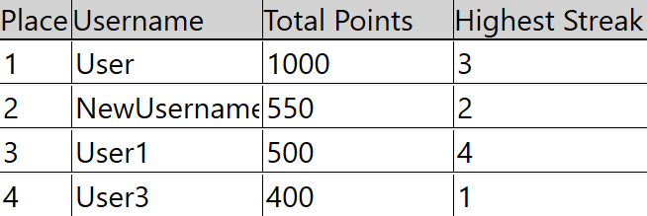My leaderboard will be laid out in the way shown above. It will have 4 columns labelled place, username, total points and highest streak. Each row will be a different user and the row will show their accounts statistics. The leaderboard will be ordered by total points and the user with the highest points will be at the top of the leaderboard in place 1.

Pseudocode and OOP classes
User Struct
I use a struct named user to hold the data for each user. The struct holds each users username, highest streak, points and place in the leaderboard. These structs are added into an array and then that array is placed into leaderboard. Each column in the leaderboard is then binded to the variables in the user struct to display the data correctly.
struct UserData
private string username;
private int streak;
private double points;
private int place;

public string Username { get { return username; } }
public int Streak { get { return streak; } }
public double Points { get { return points; } }
public int Place { get { return place; } }

public void SetName(string name)
username ← name;
EndSubroutine
public void SetStreak(int str)
streak ← str;
EndSubroutine
public void SetPoints(double point)
points ← point;
EndSubroutine
public void SetPlace(int place)
this.place ← place;
EndSubroutine
EndSubroutine

SQL
This select statement is used to retrieve the username and total points for each user so that they can then be added into the database. It links the users table and the QuestionTbl together by using the UserID and then uses aggregate SQL SUM to get the total sum of all their points. The data is then ordered by the total points in descending order.
SELECT Max(HighestStreak) FROM Users, HighestStreakTbl WHERE Users.UserID = HighestStreakTbl.UserID AND Users.username = '" + name + "'
SELECT Users.Username, SUM(QuestionTbl.Points) FROM Users, QuestionTbl WHERE Users.UserID = QuestionTbl.UserID GROUP BY Users.Username ORDER BY SUM(Points) DESC

This select statement retrieves the MAX highest streak so it can be added into the leaderboard. It links the Users and HighestStreakTbl tables together by using the UserID primary key and then uses the aggregate SQL MAX to only return the largest vale out of all of their highest streaks.

Testing

Test Data
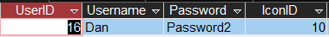used in tests 2,5,6

 | Test | Data entered | Reason for choice | Expected result | Actual result | Corrective action required? | Time Stamp
 | Login/Create New Account Page
1 | Creating new account with normal data | Normal data  Username = “Leo”  Password = “Password1” | To ensure the SQL insert statement and select statement work correctly | A new record should be added to the User table with UserID = (new integer) username = “Leo”, password = “Password1”, IconID = “10” | New record was added to User table with correct data | None | 00:36
2 | Creating new account with erroneous data | Erroneous data Username = “Dan” Password = “Password2” | To ensure the sql statements work and users cant have duplicate usernames | A record with username = “Dan” should be found and a messageBox should pop up displaying this to the user, and nothing added to the database | Error message appeared and nothing was added to the database | None | 01:16
3 | Creating new account presence check | Erroneous data Username = “” Password = “” | To ensure the user must input a value for both fields | MessageBox pop up to say data is not valid, nothing is added to database | Error message appeared and nothing was added to the database | None | 01:52
4 | Login with Erroneous data | Username = “Dan”  Password =”Password1” | To check if the statement correctly works with incorrect pairings | Message box saying “username or password is incorrect” | Message box appeared saying “username or password is incorrect” | None | 02:10
5 | Login with Normal Data | Normal data  Username = “Leo”  Password = “Password1” | To ensure the Select statement correctly works to allow users to log in | a message box should appear to say “logged in” | Message box appeared stating the user had logged in | None | 02:46
6 | Create Account with erroneous data, username with a space | Username =  “te st”  Password=  “password” | To check that the CheckValidName subroutine works correctly | Messagebox saying "Data is not valid", nothing is added to database | Message box appeared saying data wasn’t valid and nothing was added to the database | None | 03:04
7 | Create account with erroneous data, password with a space | Username =  “test”  Password=  “pa ssw ord” | To check that the CheckValidName subroutine works correctly | Messagebox saying "Data is not valid", nothing is added to database | Message box appeared stating data wasn’t valid and nothing was added to database | None | 03:37
8 | Create new account with erroneous password length | Username = “newaccount”  Password = “test” | To check that CheckValidName doesn’t allow passwords under a length of 5 | Messagebox saying "Password length is invalid", nothing added into the database | Message box appeared saying password length is invalid and nothing was added to the database | None | 03:50
9 | Create new account with boundary password length | Username = “newaccount”  Password = “valid” | To check that CheckValidName allows passwords of length 5 or greater | A new record should be added to the User table with UserID = (new integer) username = “newaccount”, password = “valid”, IconID = “10” | New record added into user table with correct data | None | 04:17

Test Data
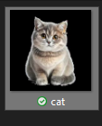 Used in tests 11,12
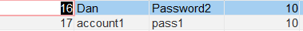Used in tests 1-10
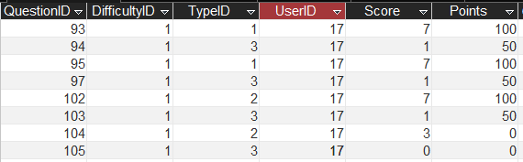Used in tests 13,14,15,18
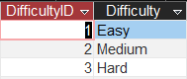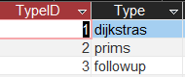Used in tests 13-18
 | Test | Data entered | Reason for choice | Expected result |  | Actual result |  |  | Corrective action required? | Time Stamp
 | Account Management Page
1 | To make sure all correct data is displayed for logged in account | Username =”account1” password =”pass1” | To make sure the data is correctly loaded |  | userID =17  Username = “account1”  Points=450  Streak=2 |  | All correct data was displayed | None |  | 05:10
2 | Make sure username can be updated with normal data | Username = “NewUsername” | To make sure that the select and update statement and the CheckValidName all work correctly |  | Message box saying Successfully updated username and record username field should have been updated to NewUsername |  | Correct pop up box appeared and database was updated correctly | None |  | 05:40
3 | Attempt to update username with erroneous duplicate username | Username = “Dan” | To make sure the sql statements and dont allow duplicate usernames |  | Message box saying "invalid username, try another" and nothing changed to the database |  | Correct pop up box appeared and nothing was changed in the database | None |  | 06:16
4 | Attempt to update username with erroneous data, with a space | Username = “Leo ” | To make sure the CheckValidName statement works correctly and doesn’t allow any spaces |  | Message box saying "invalid username, try another" and nothing changed to the database |  | Correct pop up box appeared and nothing was changed in the database | None |  | 06:38
5 | Attempt to update username, presence check | Username = “” | To make sure that the user cannot enter nothing |  | Message box saying "invalid username, try another" and nothing changed to the database |  | Correct pop up box appeared and nothing was changed in the database | None |  | 06:57
6 | Make sure password can be updated with normal data | password = “NewPassword” | To make sure that the update statement works correctly |  | Message box saying Successfully updated password and record password field should have been updated to NewPassword |  | Correct pop up box appeared and database was updated correctly | None |  | 07:15
7 | Attempt to update password with erroneous data | password = “test” | To make sure the CheckValidPassword nakes sure the length is >= 5 |  | Message box saying “Password length is invalid” and nothing is updated in the database |  | Correct pop up box appeared and nothing was changed in the database | None |  | 07:44
8 | Attempt to update password with boundary data | password = “valid” | To make sure the CheckValidPassword statement works correctly and allows lengths of 5 |  | Message box saying Successfully updated password and record password field should have been updated to valid |  | Correct pop up box appeared and database was updated correctly | None |  | 08:12
9 | Attempt to update password with erroneous data | password = “val id” | To make sure the CheckValidPassword statement works correctly and doesn’t allow any spaces |  | Message box saying "invalid password, try another" and nothing changed to the database |  | Correct pop up box appeared and nothing was changed in the database | None |  | 08:39
10 | Attempt to update password with erroneous data, presence check | password = “” | To make sure the user cannot enter nothing |  | Message box saying "invalid password, try another" and nothing changed to the database |  | Correct pop up box appeared and nothing was changed in the database | None |  | 08:58
11 | Attempt to update user Icon with valid image | Upload Cat image | To make sure that the user can update their user Icon |  | Icon updated to cat image, users IconID updated to uniqueID and new UserIcons record with IconID = uniqueID |  | Correct pop up box appeared and image was changed correctly in the program and the database was updated correctly | None |  | 09:14
12 | Attempt to update user Icon with invalid file | Upload text file named test data | To make sure that the file is checked and error handling is performed correctly |  | Error message saying “Invalid image, try another”, nothing added into UserIcons |  | Correct error message appeared and nothing was added to the database | None |  | 10:10
13 | Attempt to display statistics with erroneous inputs, presence check | Difficulty = “”  Algorithm = “” | To make sure that all the error handling works correctly |  | Average score= -  HighestStreak=-  Points earned =-  Lowest score = -  Number correct = 0  Number Incorrect = 0 |  | All error handling was done correctly and data was displayed correctly | None |  | 10:36
14 | Make sure all statistics are correctly displayed | Difficulty = “Easy”  Algorithm = “Dijkstras” | To make sure that all data is retrieved and processed correctly from the database |  | Average score=7  HighestStreak=2  Points earned =200  Lowest score = 7  Number correct = 2  Number Incorrect = 0 |  | All data was displayed correctly | None |  | 10:58
15 | Make sure all statistics are correctly displayed | Difficulty = “Easy”  Algorithm = “Prims” | To make sure that all data is retrieved and processed correctly from the database |  | Average score=5  HighestStreak=1  Points earned =100  Lowest score = 3  Number correct = 1  Number Incorrect = 1 |  | All data was displayed correctly | None |  | 11:20
16 | Make sure all statistics are correctly displayed | Difficulty = “Easy”  Algorithm = “Followup” | To make sure that all data is retrieved and processed correctly from the database |  | Average score=0.75  HighestStreak=-  Points earned =150  Lowest score = 0  Number correct = 3  Number Incorrect = 1 |  | All data was displayed correctly | None |  | 11:33
17 | Users statistics get updated to be displayed | User completes 1 Easy Dijkstras question to increase points | To make sure that update queries work after completing questions and all new data is correctly displayed |  | Average score= 7  HighestStreak=2  Points earned =300  Lowest score = 7  Number correct = 3  Number Incorrect = 0 |  | All data was updated by correct amount and displayed correctly | None |  | 11:49

Test Data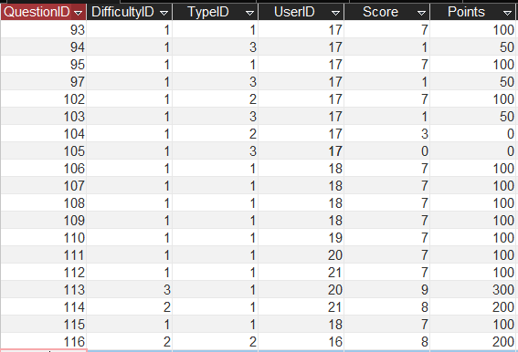
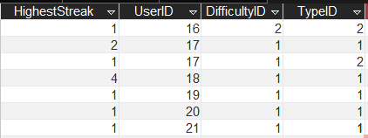
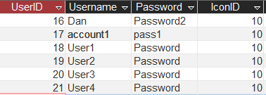 Used in tests 1,2,3,4. (Records will be added to these tables so the test data will be changed throughout testing)

 | Test | Data entered | Reason for choice | Expected result |  | Actual result |  |  | Corrective action required? | Time Stamp
 | Leaderboard Page
1 | Make sure all data is initially displayed correctly | N/A | To make sure that all the SQL statements work correctly and the structs are displayed in the correct order |  | Leaderboard in correct order:  Account1:550:2  User1:500:4  User3:400:1  User4:300:1  Dan:200:1  User2:100:1 |  | Leaderboard order and data was correct | None |  | 13:16
2 | User gains points to move up position in table | User2 gain 200 points by completing 2 easy dijkstras question | To make sure all sql update queries work correctly and leaderboard is updated |  | Account1:550:2  User1:500:4  User3:400:1  User4:300:1  User2:300:2  Dan:200:1  2 new question records added  (difficultyID:1 TypeID:1 UserID:19, Score:7, Points:100)  A new Highest streak record added (streak:2 UserID:19 DifficultyID:1 TypeID:1) |  | Leaderboard order and data was updated correctly and all records were added into database correctly | None |  | 13:49
3 | User changes username to be displayed on leaderboard | New username = “User2Test” | To make sure all sql update queries work correctly and leaderboard is updated |  | User2 username is updated to User2Test and displayed correctly in leaderboard |  | Username was updated and displayed correctly in database | None |  | 15:36
Test Data
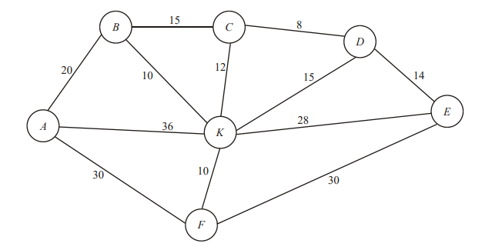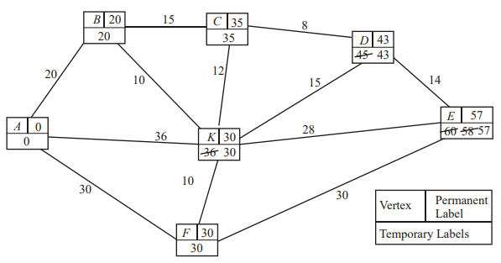Used in test 1
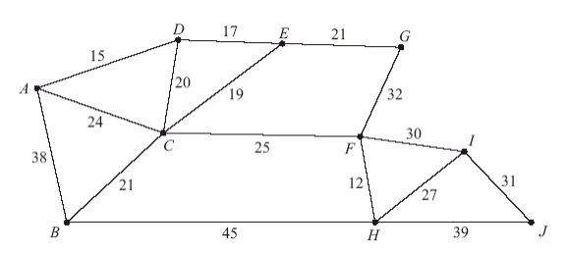
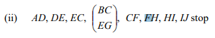 Used in test 4
 | Test | Data entered | Reason for choice | Expected result |  | Actual result |  | Corrective action required? | Time Stamp
 | Draw Page
1 | User enters normal connected graph with weighted arcs to test dijkstras algorithm | Enter exam question graph and select dijkstras and starting node 0 | To make sure that my dijjkstras algorithm performs correctly and finds the shortest distance to each node |  | Correct answer specified in exam markscheme |  | The answer that my program output was the same as the answer from the mark scheme | None | 16:18
2 | User enters connected graph with all weights at 0 to test dijkstras, presence check | Enter 4 node graph with all arcs weights at 0 and select dijkstras algorithm and starting node 0 | To make sure that the algorithm performs correctly when all weights are set to 0 |  | Distance to each node from starting node  0=0  1=No Path  2=No Path  3=No Path |  | Correct answer was output | None | 17:41
3 | User enters unconnected graph to test dijkstras | Enter 3 nodes without any arcs and select Dijkstras and 0 starting node | To make sure that the algorithm performs correctly if the graph has nodes that arn’t connected |  | Distance to each node from starting node  0=0  1=No Path  2=No Path |  | Correct answer was output | None | 18:22
4 | User enters normal connected graph with weighted arcs to test Prims algorithm | Enter exam question graph and select Prims and starting node 0 | To make sure that my Prims algorithm performs correctly and finds the minimum spanning tree |  | Correct answer specified in exam marscheme |  | The answer that my program output was the same as the answer from the mark scheme | None | 18:46
5 | User enters connected graph with all weights at 0 to test Prims, presence check | Enter 4 node graph with all arcs weights at 0 and select Prims algorithm and starting node 0 | To make sure that the algorithm performs correctly when all weights are set to 0 |  | Error message saying “your graph has an error” |  | The correct error message was output | None | 20:10
6 | User enters unconnected graph to test Prims | Enter 4 nodes with 1 node not connected and other weights set to 1 then select prims and 0 starting node | To make sure that the algorithm performs correctly if the graph has nodes that arn’t connected |  | Error message saying “your graph has an error”, The algorithm will output a minimum spanning tree which wont include the unconnected node |  | Correct error message was output and the minimum spanning tree did not include the invalid node | None | 20:37
7 | Testing the undo button performs in correct order | Enter 2 nodes and an arc and then a 3rd node and another arc then undo till graph is empty | To make sure that the undo button correctly undoes the users inputs in order |  | Order of removal:  2nd arc, selecting 3rd node, 3rd node, 1st arc, selecting 1st node, 2nd node, 1st node |  | All operations were undone in the correct order | None | 21:12
8 | Testing dijkstras with erroneous weights | Enter a 3 node graph with 3 arcs and each weight will be letters and select Dijkstras and 0 starting node | To make sure that the algorithm still performs correctly if erroneous data is inputted |  | Distance to each node from starting node  0=0  1=No Path  2=No Path |  | The correct answer was output | None | 21:52
9 | Testing Prims with erroneous weights | Enter a 3 node graph with 3 arcs and each weight will be letters and select Prims and 0 starting node | To make sure that the algorithm still performs correctly if erroneous data is inputted |  | Error message saying “your graph has an error”, no minimum spanning tree will be outputted |  | Correct error message was output and there was no minimum spanning tree output | None | 22:19
Test Data
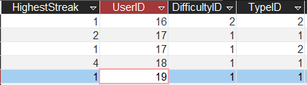 Used for test 11
 | Test | Data entered | Reason for choice | Expected result |  |  | Actual result | Corrective action required? |  | Time Stamp
 | Revise Page
1 | Inputting erroneous data into the setup | Difficulty =  Algorithm= | To make sure the program handles the exception of nothing being inputted |  | Messagebox saying input a difficulty and algorithm | Correct error message was output |  |  | None | 22:44
2 | Testing that the corresponding graph is created when normal data is inputted | Difficulty = easy  Algorithm = Dijkstras  Include followup question = yes | To make sure that the options the user inputs corresponds correctly to the question which is created |  | A graph will be created with 8 nodes and when the answer button is selected there will be an input window and if the answer is correct there will be a follow up question | Correct graph was output and the correct answer box was shown, therefore correct algorithm. Follow up question was also shown correctly after question was completed |  |  | None | 23:03
3 | User inputs erroneous data for answer for dijkstras question, presence check | No input for all boxes | To make sure the program handles the exception of nothing being inputted |  | Pop up box saying input valid answer | Correct error message was output |  |  | None | 23:40
4 | User inputs correct answer for dijkstras question | Input correct Answer | To make sure the SQL insert statements all perform correctly and that follow-up question is loaded |  | Pop up box appears saying correct and user is taken to followup question, new question record is inputted to database with difficultyID=1 TypeID=1 Score=7 Points=100 | Correct pop up box appeared and follow up question was output and the record was added to the database correctly |  |  | None | 23:57
5 | Testing the followup questions correspond correctly with the algorithm | N/A | To make sure that the followup question is created and it corresponds to the dijkstras algorithm |  | One of 2 possible questions will appear:  “Node x is removed, find the new shortest distance”, “Define the term path” | The correct follow up question appeared |  |  | None | 24:42
6 | User inputs incorrect answer for dijkstras follow up question 1, erroneous data input | User inputs incorrect new shortest distance, input “x” | To make sure that the error handling is performed correctly |  | Message box saying “Input a valid answer” | Correct error message appeared |  |  | None | 25:09
7 | User inputs correct answer for dijkstras follow up question 1, normal data input | User inputs correct new shortest distance which will be found using online solver | To make sure that the answer is marked correctly and that the algorithm performs correctly once a node is removed and the sql queries work correctly |  | Message box saying “correct”, question record added to questionTbl with TypeID = 3, Score = 1, points = 50 | Correct pop up box appeared and record was added to database correctly |  |  | None | 25:34
8 | Testing that the corresponding graph is created when normal data is inputted | Difficulty = medium  Algorithm = Prims  Include follow up question = yes | To make sure that the options the user inputs corresponds correctly to the question which is created |  | A graph will be created with 9 nodes and when the answer button is the user is able to select arcs to create a minimum spanning tree | Correct graph was created and user was able to select arcs meaning correct algorithm was selected |  |  | None | 27:03
9 | User inputs correct answer for Prims question | Input correct minimum spanning tree | To make sure the SQL insert statements all perform correctly and that follow-up question is loaded |  | Pop up box appears saying correct and user is taken to follow up question, new question record is inputted to database with difficultyID=2 TypeID=2 Score=8 Points=200 | Correct pop up box appeared and follow up question appeared and record was added into database correctly |  |  | None | 27:36
10 | Testing the followup questions correspond correctly with the algorithm | N/A | To make sure that the followup question is created and it corresponds to the prims algorithm |  | One of 2 possible questions will appear:  “Find the minimum spanning trees weight”, “Define the term minimum spanning tree” | Correct follow up question appeared |  |  | None | 28:37
11 | User inputs incorrect answer for Prims follow up question 1, erroneous data input | User inputs incorrect minimum spanning tree weight, input “x” | To make sure that the error handling is performed correctly |  | Message box saying “Input a valid answer” | Correct error message appeared |  |  | None | 28:56
12 | User inputs correct answer for Prims follow up question 1, normal data input | User inputs correct minimum spanning tree weight | To make sure that the answer is marked correctly and that the weight is correctly calculated and the sql queries work correctly |  | Message box saying “correct”, question record added to questionTbl with TypeID = 3, Score = 1, points = 50 | Correct pop up box appeared and correct record was added to the database |  |  | None | 29:22
13 | Testing that the corresponding graph is created when normal data is inputted | Difficulty = hard  Algorithm = Dijkstras  Include followup question = no | To make sure that the options the user inputs corresponds correctly to the question which is created |  | A graph will be created with 10 nodes and when the answer button is selected there will be an input window | Correct graph was created and correct answer box appeared meaning correct algorithm was used |  |  | None | 30:25
14 | User gets a new highest streak | User2 gets a new highest streak for easy dijkstras questions | To make sure that the sql queries correctly identify when a highest streak is made and that it is correctly inputted into database |  | New Highest streak record inputted with HighestStreak = 3, difficultyID=1, TypeID=1 | Streak was recorded correctly and record was updated correctly whilst maintaining database integrity with composite key |  |  | None | 30:56

evaluation

Client Requirements
- To be able to produce exam style graph questions for users to complete and get marked
  - Have different difficulty of questions
1.1.1 Easy – based on average 5 mark question with 8 nodes
1.1.2 Medium – based on average 6 mark question with 9 nodes
1.1.3 Hard - based on average 7 mark question with 10 nodes
  - To be able to produce a mark scheme which will output the length from the start node to each other node
  - To be able to produce follow up questions based on the ones I identified in my analysis by looking at existing questions
  - Have each different difficulty of questions grant the user a different amount of points to go towards their overall score like 50,100, 200, 300
- For the program to be able to perform multiple different algorithms like Dijkstra's, Prim’s and Kruskal's and use them to solve questions and produce a mark scheme
- Be able to input your own graph which will be solved and a mark scheme for it will be outputted
  - Create an undo button for users to be able to undo arcs or nodes
  - Implement user defined stack data type
- To be able to display the graphs graphically instead of as an identity matrix
- An endless questions mode where there is a way of creating different questions endlessly along with their mark schemes
- For students to be able to create personal accounts stored using a database
  - To be able to save specific questions or inputted graphs in a database
  - To be able to gain a point score from completing questions which can be represented in a leaderboard against other user's accounts
  - Allow users to be able to update their account details like username, password and profile picture
- Make the GUI similar to what my user identified they would like it to look like in the interview
  - Make there a column of tabs on the left-hand side for the user to select what page they would like to be on
  - Make it sleek and simple with monotone colours with a hint of bright colours
- For my clients to be able to view their accounts statistics like their average score, points earned and number of questions correct, to be able to better target their revision on question types they score lower on
  - To be able to record a highest streak for each type of question for the user which can be altered if a new highest streak is achieved

RAG rating for how well the requirement was met:
Green – Requirement has been completely met and is fully working with no errors
Amber – Requirement is partially complete, i.e. one part may not be complete or working
Red – Requirement is not completed or not working at all
# | Objective | How it was met? | How well was it met? | How could it be improved?
1 | 1 | I created a ‘Revise’ page for users to select what type of question they want to revise which generates a graph with random weights | Green | No improvements needed
2 | 1a | I created pre-determined graph shapes which have 8/9/10 nodes, depending on the difficulty, which gets randomly generated weights | Green | No improvements needed
3 | 1.b | I programed Dijkstra’s algorithm using a priority queue which is performed on the graph then outputs a score for the user depending on how many distances they go correct | Green | No improvements needed
4 | 1c | I created 2 follow up questions for each type for question which is outputted to the user if they get the question correct | Green | No improvements needed
5 | 1d | I Created a subroutine which links the difficulty of the question to a certain amount of points which is then inputted into the database | Green | No improvements needed
6 | 2 | I programmed both Dijkstra’s and Prim’s algorithms using various methods like a priority queue and nested loops, and then if a user creates their own graph these algorithms are performed to the graph to output the related mark scheme | Amber | I could implement Kruskal’s algorithm which could then be implemented into the revision questions
7 | 3 | I used a Canvas along with my own Graph data structure made up of Nodes and Arcs which the user can draw on the canvas to create their own graphs and then select an algorithm which will output the solution for that graph | Green | No improvements needed
8 | 3a | I used a user defined Stack data structure which holds the order of the users inputs and then pops these off the stack to undo their inputs on the canvas | Green | No improvements needed
9 | 3b | I created a user defined stack which uses a 2D object array to hold the users inputs | Green | No improvements needed
10 | 4 | I created user defined Graph, Node and Arc data structures which hold the data of the graph itself as well as the Ellipse and Lines used to be drawn on the canvas | Green | No improvements needed
11 | 5 | I created a page where users can select the type of question they want and then thew program generates a new graph with randomly generated weights each time they complete a question and question until they choose to exit | Green | No improvements needed
12 | 6 | I created a UserAccount class which holds the users ID, username, password, points and streak which is all retrieved from the database | Green | No improvements needed
13 | 6a | I did not complete this requirement | Red | Attempt to store the canvas’ data into a database table and allow the users to store and load graphs which they have previously created and saved
14 | 6b | I created a database which holds the data of each question the user completes and then that used with aggregate SQL to calculate a total score which is then displayed into a database and ordered by total points | Green | No improvements needed
15 | 6c | I created a page for users to update username, password and profile picture by using SQL Update and Insert statements | Green | No improvements needed
16 | 7 | I used C# WPF functions and XAML to create a sleek and simple GUI which replicates what the user specified they wanted it to look like | Green | No improvements needed
17 | 7a | I created a collection of radio buttons which allows the user to select which page they would like to be on by selecting the button which is situated in a column on the left hand side of the page | Green | No improvements needed
18 | 7b | I mainly used different shades of grey and then different bright colours for specific buttons to brighten up some of the pages, I also made most buttons or boxes have rounded edges to add to the sleek style | Green | No improvements needed
19 | 8 | I created a ‘stats page which uses aggregate SQL to perform queries on the different tables in the database to output data like the average score and highest streak for each question type | Green | No improvements needed
20 | 8a | I created a table in the database which uses a composite primary key to record the highest streak for each user and each type of question | Green | No improvements needed

Client Feedback

Client program test walkthrough:
- Attempt to create a new account then login
- Access account management page and change account’s data
- Use Draw page to create graphs and then apply different algorithms
- User Revise page to practice and complete questions on different algorithms and try different difficulty modes and follow up questions
- View leaderboard and user statistics pages
I gave my finished program to two of the further math students I used in my research to help me structure the majority of my requirements. I gave them the program itself as well as the test walkthrough I structured above.
The first thing my clients pointed out was the simple modern design, they liked how each page didn’t feel cluttered and the space in each page was used well as buttons and icons felt well spaced out to make the application appealing to look at as well as easy to use. They also stated how they liked the use of colour accents in places like the account page as they said it ‘brightens up the program’ and makes it seem more ‘friendly to use’ and also stopped the program from looking boring.
My clients then created a new account and logged into that account. They said they liked how simple everything was to do and how there wasn’t any confusion in how to complete any tasks.
They then used the menu bar to go to the Draw page, they said they liked how easy the menu bar was and how it made navigating the program very easy to use and that it aligned well with what they imagined initially when setting the client requirements. On the draw page they said that it was ‘unique’ and that they thought it would definitely make revision ‘more fun’. They also stated how easy it was to use and that the undo button was extremely useful as if they made a small error in their graph, it made it so easy to fix.
They used the revision page to complete a variety of questions, and they said that they really liked how each question was randomly generated along with the implementation of the follow up questions. They said it made revising easier as everything was in one place and there were endless questions so there was no need to go searching for questions online. They also said how it makes marking much easier as there is no need to go searching for mark schemes and attempting to mark your own answers. The only change they said should be made is how the user must press the answer button before being able to input an answer as especially for the prim’s questions they said it was confusing where they needed to input their answer until they realized you had to press the answer button first.
They then said the account page gave them more customization over their account which they really liked. They also liked the statistics page as they said ‘it would make it easier to pinpoint revision’ as they can see where they are struggling more, and which question types have the lowest average score.
They then viewed the leaderboard which they said added a ‘competitive element encouraging revision’ as they would want to try and beat their friends which would then encourage them to do more revision.
Overall, both clients thoroughly liked the entire program as it was ‘easy to use and navigate’ and had a ‘simple self-explanatory interface’. They thought it would be very useful to use when revising as it makes revision much simpler and more enjoyable. The only feedback the users gave in terms of things to be changed was the way in which the user enters their answer in the revision page as they said it was not ‘explicitly obvious’ how to input an answer so they said maybe once the answer is created the answer box should appear straight away or allow them to input it without having to press any additional buttons.

Whole system evaluation
Overall, I am very happy with how my project has turned out, I have learned a lot of new skills spanning from OOP to database skills to creating an appealing UI. I feel like my final program has really matched what my clients wanted and what they specified in my analysis, this was further solidified in my client feedback in which they sated mainly positive comments on how they liked the program. One of the large challenges to me was creating my user defined graph data structure and then having to visualize this onto the GUI as well as linking this together with my stack data structure which was used in my undo button. This challenge really helped me improve my OOP skills by having to create multiple user defined data structures as well as using things like inheritance which i had never used before. It also really helped me improve my GUI skills as it was something I had not really had any experience in, and I feel confident now that I can create an appealing easy to use GUI. The other big challenge I came across was having to create the Dijkstra’s and Prim’s algorithms and making them work with my graph data structure. The other large challenge I faced was learning how to setup and manage a larger database than any i had used in the past. This caused me to learn how to use composite keys as well as setting up relationships between tables. I also had to learn how to write more complex SQL statements which linked multiple tables as well as using aggregate SQL. Overall, I think completing this entire project has really improved my programming skills in many areas and also helped improve my problem solving skills in many areas.

Future Improvements
I would like to add a couple functionalities to improve the program. The main one would be being able to save questions after you have completed them or being able to save graphs that you have made so that you could come back to them later. I originally wanted to implement this idea, however I never got round to developing a way for the graphs to be stored in the database and then loaded from the database and displayed with the same layout as before. This could improve not only the revision aspect but also the usability factor as if a user is struggling on a question they could save the question and potentially review it later on, it would also remove the task of having to constantly have to re-create the same graph if you were testing the same graph for different things.
Another thing to implement in the future would be more algorithms, in my original analysis I specified two more algorithms which I could implement which were Kruskal’s and the Chinese Postman algorithm (route inspection). I could implement these algorithms in both the revision and draw pages and this could further improve the way students could use my program to revise as, like my client mentioned, there would be no need to have to search through different sources for different types of questions as they would all be on the same program.
Another improvement I would make would be the way that the user inputs their answers to the revision questions. My client specified how the way the user must click answer to then input their answer and then click answer again was confusing. Because of this I would try to make it more like the way the answers are inputted in an actual exam, for example for Dijkstra’s having the answer box directly on each node, and for prims the user doesn’t have to select anything to start selecting arcs. Along with making the revision page easier to use I would also like to add a small amount of question dialog before the question to imitate the same way that the exam may ask you the question to again replicate how the question would appear in the real exam

Appendix

RAG rated requirements
Green – Requirement has been completely met and is fully working with no errors
Amber – Requirement is partially complete, i.e. one part may not be complete or working
Red – Requirement is not completed or not working at all

Number | Requirement | Rating
1 | To be able to produce exam style graph questions for users to complete and get marked. | GREEN
1.2 | Have different difficulty of questions. | GREEN
1.3 | To be able to produce a mark scheme for Dijkstra’s which will output the length from the start node to each other node. | GREEN
1.4 | To be able to produce a mark scheme for prim’s which will output the minimum spanning tree. | GREEN
1.4 | To be able to produce follow up questions based on the ones I identified in my analysis by looking at existing questions. | GREEN
1.5 | Have each different difficulty of questions grant the user a different amount of points to go towards their overall score like 50,100, 200, 300. | GREEN
2 | For the program to be able to perform multiple different algorithms like Dijkstra's, Prim’s and Kruskal's and use them to solve questions and produce a mark scheme. | AMBER
3 | Be able to input your own graph which will be solved and a mark scheme for it will be outputted. | GREEN
3.1 | Create an undo button for users to be able to undo arcs or nodes. | GREEN
3.1.1 | Implement user defined stack data type. | GREEN
4 | To be able to display the graphs graphically instead of as an identity matrix. | GREEN
5 | An endless questions mode where there is a way of creating different questions endlessly along with their mark schemes. | GREEN
6 | For students to be able to create personal accounts stored using a database. | GREEN
6.1 | To be able to save specific questions or inputted graphs in a database. | RED
6.2 | To be able to gain a point score from completing questions which can be represented in a leaderboard against other user's accounts. | GREEN
6.3 | Allow users to be able to update their account details like username, password and profile picture. | GREEN
7 | Make the GUI similar to what my user identified they would like it to look like in the interview. | GREEN
7.1 | Make there a column of tabs on the left-hand side for the user to select what page they would like to be on. | GREEN
7.2 | Make it sleek and simple with monotone colours with a hint of bright colours. | GREEN
8 | For my clients to be able to view their accounts statistics like their average score, points earned and number of questions correct to be able to better target their revision on question types they score lower on. | GREEN
8.1 | To be able to record a highest streak for each type of question for the user which can be altered if a new highest streak is achieved. | GREEN

Code Listing
Grade A skill
Grade B skill
Grade C skill
Coding Style
Page Title | Subroutine | Page Number | Complex Code
Login Page | Log_In_Btn_Click | 156 | Group B:  Single table SQL SELECT username and password.
Login Page | CreateUser | 158 | Group A:  Two table aggregate SELECT SUM(points) query.  Coding Style:  Try Catch to catch exceptions if database query fails.
Login Page | CreateUser | 158 | Group A:  Two table aggregate SELECT MAX(HighestStreak) query.  Coding Style:  Try Catch to catch exceptions if database query fails.
Login Page | CreateUser | 159 | Group B:  Single table SQL SELECT UserID.  All retrieved data used to instantiate class using OOP.
Login Page | SetIcon | 159 | Group B:  Two table SELECT query.
CreateAccount Window | Create_Account_Btn_Click | 198 | Group A:  Aggregate SQL SELECT COUNT(username) query.
CreateAccount Window | Create_Account_Btn_Click | 199 | Group B:  SQL INSERT query to create new User record.
Account Page | ImageCustomiseClick | 136 | Group B:  INSERT SQL query to create new UserIcon.  SQL SELECT filepath query.  SQL UPDATE query to update users IconID.  Coding Style:  Try Catch to catch exceptions of user inputting incorrect file format.
ChangeUsername Window | Update_Username_Btn_Click | 195 | Group B:  SQL UPDATE query to update users username.  Used OOP to update encapsulated UserAccount username variable.
ChangeUsername Window | CheckValidName | 196 | Group A:  Aggregate SQL SELECT COUNT(username) query.
ChangePassword Window | Update_Password_Btn_Click | 194 | Group B:  SQL UPDATE query to update users password.  Used OOP to update encapsulated UserAccount password variable.
Stats Page | GetAverageScore | 186 | Group A:  Aggregate SQL SELECT AVG(Score) query linking 4 tables.  Coding Style:  Try Catch used to catch exception if database query fails.
Stats page | GetPointsEarned | 187 | Group A:  Aggregate SQL SELECT SUM(Points) query linking 4 tables.  Coding Style:  Try Catch used to catch exception if database query fails.
Stats Page | GetLowestScore | 188 | Group A:  Aggregate SQL SELECT MIN(Score) query linking 4 tables.  Coding Style:  Try Catch used to catch exception if database query fails.
Stats Page | GetNumOfCorrect | 189 | Group A:  Aggregate SQL SELECT COUNT(Points) query linking 4 tables.  Coding Style:  Try Catch used to catch exception if database query fails.
Stats Page | GetNumOfIncorrect | 190 | Group A:  Aggregate SQL SELECT COUNT(Points) query linking 4 tables.  Coding Style:  Try Catch used to catch exception if database query fails.
Stats Page | GetStreak | 191 | Group A:  Aggregate SQL SELECT MAX(HighestStreak) query linking 4 tables.  Coding Style:  Try Catch used to catch exception if database query fails.
Revise Page | ReviseView constructor | 162 | Group B:  Use of OOP classes to create graphs and setup data.  Coding Style:  Try Catch used to catch exceptions when first opening page.
Revise Page | N/A | 162 | Group A:  User defined Graph data structure is created and used throughout page.
Revise Page | SetupArcs | 164 | Group A:  Dynamic creation of OOP class, dynamically creation of Arc class
Revise Page | AnswerPrimsButton | 174 | Group B:  2D arrays used in marking of users input answer.
Revise Page | AnswerPrimsButton | 174 | Group A:  Dynamic creation of OOP class, dynamically creation of Arc class
Revise Page | UpdateUserData | 207 | Group B:  Uses OOP to update objects encapsulated variables.
Revise Page | AddQuestionRecord | 177 | Group B:  SQL INSERT query to insert new question record into table.
Revise Page | GetDifficulty | 181 | Group B:  Switch Case used to return correct value to be passed into SQL query.  SQL SELECT query from one table.
Revise Page | GetType | 182 | Group B:  SQL SELECT TypeID query used for one table.
Revise Page | UpdateUserPoints | 182 | Group B:  SQL UPDATE query used to update user points.
InputAnswer Window | N/A | 204 | Group A:  User defined Graph data structure used throughout window
InputAnswer Window | InputAnswer constructor | 204 | Coding Style:  Try Catch used to catch exceptions if there is no current streak.
InputAnswer Window | Answer | 205 | Group A:  Dijkstra’s algorithm is used to solve graph.  Coding Style:  Try Catch used to catch exception of invalid user inputs
InputAnswer Window | UpdateUserData | 207 | Group B:  Uses OOP to update objects encapsulated variables.
FollowUpQuestions Window | N/A | 200 | Group A:  User Defined Graph data structure used throughout window.
FollowUpQuestions Window | CreateQuestion | 201 | Group A:  Graph is altered by removing a node and altering the matrix then using Dijkstra’s algorithm to solve.
ContinueOrExit Page | InsertStreak | 141 | Group B:  SQL DELETE and INSERT queries used to delete and insert highest streak records.  Coding Style:  Try Catch used to catch exceptions from SQL query
ContinueOrExit Page | CheckCurrentStreak | 141 | Group A:  SQL SELECT query linking 3 tables to retrieve users highest streak.  Coding Style:  Try Catch used to catch exceptions if database query fails.
Draw Page | N/A | 142 | Group A:  User defined Graph and Stack data structures used throughout page.
Draw Page | Click | 143 | Group A:  Dynamic creation of OOP, dynamic creation of NodeDraw class
Draw Page | Click | 145 | Group B:  2D arrays used to hold data of function for stack undo button.
Draw Page | FindNodeNumber | 145 | Group C:  Linear search to iterate through all canvas objects.
Draw Page | Node_MouseDown | 146 | Group B:  2D arrays used to hold data of function for stack undo button.
Draw Page | Node_MouseDown | 146 | Group A:  Dynamic creation of OOP, dynamic creation of NodeDraw class
Draw Page | DrawArc | 148 | Group B:  2D arrays used to hold data of function for stack undo button.
Draw Page | DrawArc | 147 | Group A:  Dynamic creation of OOP, dynamic creation of Arc and NodeDraw class
Draw Page | Weight_TextChanged | 148 | Coding Style:  Try Catch used to catch exceptions if user inputs invalid data type
Draw Page | SolveClick | 149 | Group A:  Graph is populated with data from canvas
Draw Page | OutputPrims | 149 | Group B:  2D array used to store MST which is used to output answer to user.  I also used a foreach loop to loop through each arc in the list and nested for loops to correctly output the answer.
Draw Page | Node_MouseDown | 146 | Group A:  Dynamic creation of OOP, creates NodeDraw class on every user click on a node.
Leaderboard Page | SetupUserData | 153 | Group B:  Dynamic creation of OOP, dynamically creating UserData struct to store each users data
Leaderboard Page | SetupUserData | 153 | Group A:  Cross table aggregate SQL SELECT query
Leaderboard Page | SetupUserData | 154 | Group A:  Cross table aggregate SQL used to SELECT
Leaderboard Page | SetupUserData | 154 | Coding Style:  Try Catch used to prevent exceptions from database query
Graph class | GetNodeArray | 102 | Grade A:  Dynamic creation of OOP, dynamically generating NodeRevise class
Graph Class | GetArcList | 103 | Grade A:  Dynamic creation of OOP, dynamically generating Arc class
Graph Class | SolveDijkstras | 107 | Grade A:  Using Dijkstra’s algorithm to find the shortest distance from a chosen start node to every other node. Using a user defined priority queue to perform Dijkstra's. Nested loops and multi dimensional arrays used in the algorithm.
Graph class | SolvePrims | 109 | Grade A:  Using Prim’s algorithm to find a minimum spanning tree from a graph. Uses nested iteration and selection and multi dimensional arrays.
Graph class | SetValuesRevision | 101 | Grade A:  Creation of user defined graph data structure using an adjacency matrix using a multi dimensional array
Graph class | SetValuesDraw | 105 | Grade A:  Creation of user defined graph data structure using an adjacency matrix using a multi dimensional array
Grid Class | CreateRevisionGraph | 114 | Grade A:  Creation of user defined graph data structure using an adjacency matrix using a multi dimensional array
LinkedList Class | AddNodeToFront | 121 | Grade A:  Creation of user defined Linked List
MergeSort Class | SortArray | 123 | Grade A:  User defined merge sort algorithm using recursion
MergeSort Class | Merge | 123 | Grade A:  User defined merge sort algorithm
NodeDraw Class | N/A | 125 | Grade A:  Inheritance used to inherit variables and functions from Node class
NodeRevise Class | N/A | 126 | Grade A:  Inheritance used to inherit variables and functions from Node class
PriorotyQueue Class | N/A | 127 | Grade A:  User defined priority queue, items sorted into priority by using merge sort algorithm
Stack Class | N/A | 128 | Grade A:  User defined stack data structure created using a linked list used for undo button
Stack Class | RemoveNode | 130 | Grade A:  Dynamic creation of NodeDraw class
Stack Class | RemoveArc | 131 | Grade A:  Dynamic creation of Arc and NodeDraw class
UserAccount Class | ReturnPoints | 133 | Grade A:  Cross table aggregate SQL used to SELECT SUM.  Coding Style:  Try catch used to catch excetion of invalid database query

Technical Solution
Classes
Arc
public class Arc
{
private Line line;
private int start;
private int end;
private int weight;

public Arc(int s, int e)
{
line = new Line();
start = s;
end = e;
}
public void SetWeight(int weight){ this.weight = weight; }
public int GetStart(){ return start; }
public int GetEnd() { return end; }
public int GetWeight() { return weight; }
public Line GetLine() { return line; }
}
Graph
public class Graph
{
private testttt.MVVM.Classes.Grid myGrid;
private int size;
private int[,] matrix;
private int minimumWeight;
public Graph(string difficulty)
{
myGrid = new Grid(difficulty);
}
//creates values in the grid
public void CreateRevisionGraph()
{
myGrid.CreateRevisionGraph();
}
//sets up values into the adjacency matrix
public void SetValuesRevision()
{
try
{
size = myGrid.GetSize();
}
catch { }
matrix = new int[size, size];

for (int i = 0; i < size; i++)
{
for (int j = i; j < size; j++)
{
if (j == i)
{
matrix[i, j] = 0;
}
else if (i < j)
{
matrix[i, j] = myGrid.ReturnGridRevision()[i, j];
matrix[j, i] = matrix[i, j];
}

}
}
}
//used for follow up question to remove all connections to a node
public void RemoveNode(int node)
{
for (int i = 0; i < size; i++)
{
matrix[node, i] = 0;
matrix[i, node] = 0;
}
}
public NodeRevise[] GetNodeArray()
{
NodeRevise[] nodeArray = new NodeRevise[size];
//creates each node to be placed on canvas
for (int i = 0; i < size; i++)
{
//creates node and ellipse and specifies which nodes it is connected to
nodeArray[i] = new NodeRevise(i);
nodeArray[i].ellipse.Height = 30;
nodeArray[i].ellipse.Width = 30;
nodeArray[i].ellipse.Stroke = Brushes.Black;
nodeArray[i].ellipse.Fill = Brushes.Black;
nodeArray[i].AddConnectedNodesList(FindAllConnectedNodes(nodeArray[i].GetNumber()));
}
return nodeArray;
}
public List<Arc> GetArcList(NodeRevise[] nodeArray)
{
List<Arc> arcList = new List<Arc>();
for (int currentNode = 0; currentNode < nodeArray.Length; currentNode++)
{
//creates arcs and lines to be drawn on canvas
for (int i = 0; i < nodeArray[currentNode].GetConnectedNodes().Count; i++)
{
if (!CheckArcExists(arcList, currentNode, nodeArray[currentNode].GetConnectedNodes()[i]))
{
//sets up arc data
int start = currentNode;
int end = nodeArray[currentNode].GetConnectedNodes()[i];
int weight = matrix[start, end];
Arc arc = new Arc(start, end);
arc.GetLine().Stroke = Brushes.Black;
arc.GetLine().StrokeThickness = 5;
arc.GetLine().IsHitTestVisible = false;
arc.SetWeight(weight);
arcList.Add(arc);
}
}

}
return arcList;
}
//checks if selected arc has already been created so thgat there are no duplicates
private bool CheckArcExists(List<Arc> arcList, int start, int end)
{
for (int i = 0; i < arcList.Count; i++)
{
if (arcList[i].GetStart() == start && arcList[i].GetEnd() == end)
{
return true;
}
else if (arcList[i].GetStart() == end && arcList[i].GetEnd() == start)
{
return true;
}
else
{
return false;
}
}
return false;
}
//finds all nodes connected to passed in node
private List<int> FindAllConnectedNodes(int nodeNumber)
{
List<int> connectedNodes = new List<int>();
for (int i = nodeNumber; i < size; i++)
{
if (matrix[nodeNumber, i] != 0)
{
connectedNodes.Add(i);
}
}
return connectedNodes;
}
//sets up the initial matrix then fills in all data from arcs
public void SetValuesDraw(List<Arc> Arcs)
{
matrix = new int[size, size];

for (int i = 0; i < size; i++)
{
for (int j = i; j < size; j++)
{
int? arcNum = FindArc(Arcs, i, j);
if (arcNum != null)
{
if (j == i)
{
matrix[i, j] = 0;
}
else if (i < j)
{
matrix[i, j] = Arcs[(int)arcNum].GetWeight();
matrix[j, i] = matrix[i, j];
}
}
}
}
}
//returns the arc number which joins the 2 nodes
private int? FindArc(List<Arc> Arcs, int start, int end)
{
for (int m = 0; m < Arcs.Count; m++)
{
if (Arcs[m].GetStart() == start && Arcs[m].GetEnd() == end)
{
return m;
}
else if (Arcs[m].GetStart() == end && Arcs[m].GetEnd() == start)
{
return m;
}
}
return null;
}
//outputs dijkstras algorithm answer into debug window and opens dijkstras answer window
public void PrintSolution(int startNode)
{
int[] dist = SolveDijkstras(startNode);
Debug.Write("Vertex Distance " + "from Source\n");
for (int i = 0; i < size; i++)
{
if (dist[i] == int.MaxValue)
{
Debug.Write(i + " \t\t " + "error" + "\n");
}
else
{
Debug.Write(i + " \t\t " + dist[i] + "\n");
}
}

try
{
Window window = new Answer(dist, size);
window.Show();
}
catch
{

};
}
//performs dijkstra's algorithm using a prioroty queue
public int[] SolveDijkstras(int startNode)
{
PriorotyQueue priorotyQueue = new PriorotyQueue();
int[] minimumDistances = new int[size];
for (int i = 0; i < size; i++)
{
int[] array = new int[2];
array[0] = int.MaxValue;
array[1] = i;
if (i == startNode)
array[0] = 0;
priorotyQueue.Enqueue(array);
}

while (priorotyQueue.Count > 0)
{
int[] currentNode = priorotyQueue.Dequeue();// uses queue to select next node
minimumDistances[currentNode[1]] = currentNode[0];
List<int> neighbours = FindNeighbours(currentNode[1]);
int distanceAtCurrent = currentNode[0];
foreach (int neighbour in neighbours)//iterates through each neighbour of selected node
{
int distanceCurrentToNeighbour;
int distanceAtNeighbour = 0;
int[] neighbourData = new int[2];
foreach (int[] node in priorotyQueue.list)
{
if (node[1] == neighbour)//finds which neighbour is being selected and sets distances to correct values
{
distanceAtNeighbour = node[0];
neighbourData = node;
}
}
if (matrix[neighbour, currentNode[1]] != 0)
{
distanceCurrentToNeighbour = matrix[neighbour, currentNode[1]];//finds distance between 2 selected nodes
}
else
{
distanceCurrentToNeighbour = matrix[currentNode[1], neighbour];
}
int newDistance = distanceAtCurrent + distanceCurrentToNeighbour;//calculates new distance

if (newDistance < distanceAtNeighbour)
{
priorotyQueue.list.Remove(neighbourData);
neighbourData[0] = newDistance;
priorotyQueue.Enqueue(neighbourData);
}
}
}

return minimumDistances;
}
//finds all nodes connected to selected node
private List<int> FindNeighbours(int node)
{
List<int> list = new List<int>();
for (int i = 0; i < size; i++)
{
if (matrix[i, node] > 0)
list.Add(i);
else if (matrix[node, i] > 0)
list.Add(i);
}
return list;
}
//performs Prims algorithm to find a minimum spanning tree
public int[,] SolvePrims()
{
minimumWeight = 0;
int[] connected = new int[size];
connected[0] = 0;
for (int i = 1; i < size; i++)
{
connected[i] = -1;//sets up initial values to -1
}
int[,] startAndEndNodes = new int[size - 1, 2];
bool completed = false;

int lowestWeight = int.MaxValue;
int x;
int y;
int count = 0;

while (completed == false)
{
count++;
lowestWeight = int.MaxValue;
x = -1;
y = -1;

for (int i = 0; i < size; i++) // Iterate over all nodes to find the smallest edge connecting to the MST
{
if (CheckConnected(i, connected))// If node is already in MST
{
for (int j = 0; j < size; j++)
{
if (!CheckConnected(j, connected))// If node is not in MST
{
// Check if the edge has the smallest weight
if (matrix[j, i] < lowestWeight && (matrix[j, i] != 0 || matrix[i, j] != 0))
{
lowestWeight = matrix[j, i];
x = j;
y = i;
}
}
}
}
}

if (lowestWeight != int.MaxValue)
{
connected[count] = x;
startAndEndNodes[count - 1, 0] = x;
startAndEndNodes[count - 1, 1] = y;
minimumWeight += matrix[x, y];
}

if (FindArrayLength(connected) == size)
{
completed = true;
}
// Error handling if the count exceeds size there is an issue with the graph
if (count > size)
{
MessageBox.Show("your graph has an error");
return startAndEndNodes;
}
}
for (int i = 0; i < count; i++)
{
for (int j = 0; j < 2; j++)
{
Debug.Write(startAndEndNodes[i, j]);
}
Debug.WriteLine("");

}
return startAndEndNodes;
}
//checks if a node is connected to the MST
private bool CheckConnected(int x, int[] connected)
{
for (int i = 0; i < connected.Length; i++)
{
if (x == connected[i])
return true;
}
return false;
}
//Finds number of currently occupied spaces in array
private int FindArrayLength(int[] array)
{
int count = 0;
for (int i = 0; i < array.Length; i++)
{
if (array[i] != -1)
count++;
}
return count;
}
public int GetSize()
{
return size;
}
public void SetSize(int size)
{
this.size = size;
}
public int ReturnMinimumWeight()
{
return minimumWeight;
}
}
Grid
public class Grid
{
private int size;
private int[,] theGridRevision;
private string difficulty;

public Grid(string difficulty)
{
this.difficulty = difficulty;
}
public void CreateRevisionGraph()
{
//sets up all random values for the graph
Random random = new Random();
if (difficulty == "Easy")
{
size = 8;
}
else if (difficulty == "Medium")
{
size = 9;
}
else if (difficulty == "Hard")
{
size = 10;
}
else
{
size = random.Next(8, 11);
}

theGridRevision = new int[size, size];

int bellow = 0;
int above = 0;
int min;
int max;
int cooldown = 0;
int value;
for (int i = 0; i < size; i++)// uses variables to allow even spacing for values above and bellow 10-21
{
for (int j = 0; j < size; j++)
{
if (i >= j)
{
theGridRevision[i, j] = 0;
}
else
{
if (cooldown > 0)
{
min = 10;
max = 21;
cooldown--;
}
else
{
min = 1;
max = 31;
if (bellow >= 3)
{
min = 10;
}
if (above >= 3)
{
max = 21;
}
}

value = random.Next(min, max);

if (value < 10)
{
bellow++;
cooldown = 3;
}
else if (value > 20)
{
above++;
cooldown = 3;
}

theGridRevision[i, j] = value;
}
}
}
if (size == 8)
{
SetGrid8();
}
else if (size == 9)
{
SetGrid9();
}
else if (size == 10)
{
SetGrid10();
}
}
//sets up correct layouts to be displayed on graph
private void SetGrid8()
{
//row 1
for (int i = 4; i < size; i++)
{
theGridRevision[0, i]= 0;
}
//row2
for (int i = 2; i < size; i++)
{
if (i != 3 && i != 4)
{
theGridRevision[1, i]= 0;
}
}
//row3
for (int i = 4; i < size; i++)
{
if (i != 5)
{
theGridRevision[2, i] = 0;
}
}
//row4
theGridRevision[3, 7] = 0;
//row5
theGridRevision[4, 5] = 0;
}
private void SetGrid9()
{
//row 1
for (int i = 3; i < size; i++)
{
theGridRevision[0, i] = 0;
}
//row2
for (int i = 2; i < size; i++)
{
if (i != 3 && i != 4)
{
theGridRevision[1, i] = 0;
}
}
//row3
for (int i = 3; i < size; i++)
{
if (i != 3 && i != 5)
{
theGridRevision[2, i] = 0;
}
}
//row4
for (int i = 6; i < size; i++)
{
theGridRevision[3, i] = 0;
}
//row5
for (int i = 5; i < size; i++)
{
if (i != 6 && i != 8)
{
theGridRevision[4, i] = 0;
}
}
//row6
theGridRevision[5, 6] = 0;
//row7
theGridRevision[6, 7] = 0;
}
private void SetGrid10()
{
//row1
for (int i = 4; i < size; i++)
{
theGridRevision[0, i] = 0;
}
//row2
for (int i = 2; i < size; i++)
{
if (i != 3 && i != 4)
{
theGridRevision[1, i] = 0;
}
}
//row3
for (int i = 4; i < size; i++)
{
if (i != 5)
{
theGridRevision[2, i] = 0;
}
}
//row4
for (int i = 7; i < size; i++)
{
theGridRevision[3, i] = 0;
}
//row5
for (int i = 5; i < size; i++)
{
if (i != 6 && i != 7)
{
theGridRevision[4, i] =0;
}
}
//row6
for (int i = 7; i < size; i++)
{
if (i != 8)
{
theGridRevision[5, i] = 0;
}
}
//row7
theGridRevision[6, 9] = 0;
//row8
theGridRevision[7, 8] = 0;
}
public int[,] ReturnGridRevision()
{
return theGridRevision;
}
public int GetSize()
{
return size;
}
}
LinkedList
internal class LinkedList
{
private int count;
private LinkedListNode head;
public LinkedList()
{
head = null;
count = 0;
}
public void AddNodeToFront(int function, object functionData)
{
// adds a new node to front of list by altering head of list and new heads next node
LinkedListNode node = new LinkedListNode(function, functionData);
node.SetNext(head);
head = node;
count++;
}
public object[,] ViewHead()
{
return head.ReturnData();
}
public void RemoveHead()
{
head = head.ReturnNext();
count--;
}
public int Count()
{
return count;
}
}
LinkedListNode
internal class LinkedListNode
{
private object[,] data;
private LinkedListNode next;
public LinkedListNode(int function, object functionData)
{
//sets up nodes data
data = new object[1, 2];
data[0,0] = function;
data[0,1] = functionData;
next = null;
}
public LinkedListNode ReturnNext()
{
return next;
}
public object[,] ReturnData()
{
return data;
}
public void SetNext(LinkedListNode node)
{
next = node;
}
}
MergeSort
internal class MergeSort
{
public static List<int[]> SortArray(List<int[]> array, int left, int right)
{
// Base case if left index is less than right index, continue sorting
if (left < right)
{
int middle = left + (right - left) / 2;
// Recursively sort the left and right halves
SortArray(array, left, middle);
SortArray(array, middle + 1, right);
//merges the halves
Merge(array, left, middle, right);
}
return array;
}
private static void Merge(List<int[]> array, int left, int middle, int right)
{
int leftArrayLength = middle - left + 1;
int rightArrayLength = right - middle;
List<int[]> leftTempArray = new List<int[]>(leftArrayLength);
List<int[]> rightTempArray = new List<int[]>(rightArrayLength);
int leftPointer;
int rightPointer;
//copys elements into temp arrays
for (leftPointer = 0; leftPointer < leftArrayLength; ++leftPointer)
leftTempArray.Add(array[left + leftPointer]);//creates left hand side

for (rightPointer = 0; rightPointer < rightArrayLength; ++rightPointer)
rightTempArray.Add(array[middle + 1 + rightPointer]) ;//creates right hand side

leftPointer = 0;
rightPointer = 0;
int mergedIndex = left;
while (leftPointer < leftArrayLength && rightPointer < rightArrayLength)
{
//compares first element of each array with eachother to merge sort
if (leftTempArray[leftPointer][0] <= rightTempArray[rightPointer][0])
{
array[mergedIndex++] = leftTempArray[leftPointer++];
}
else
{
array[mergedIndex++] = rightTempArray[rightPointer++];
}
}
while (leftPointer < leftArrayLength)//used to input left over variables if whole right side is complete
{
array[mergedIndex++] = leftTempArray[leftPointer++];
}
while (rightPointer < rightArrayLength)//used to input left over variables if whole left side is complete
{
array[mergedIndex++] = rightTempArray[rightPointer++];
}
}
}
Node
public class Node
{
//data and functions needed in both children classes
public Ellipse ellipse;
private int number;

public void SetNumber(int number)
{ this.number = number; }

public int GetNumber()
{ return number; }
}
NodeDraw
public class NodeDraw : Node // inheritance
{
private Point point;
public NodeDraw()
{

}
public Point GetPoint()
{
return point;
}
public void SetPoint(Point point)
{
this.point = point;
}
}
NodeRevise
public class NodeRevise : Node//inheritance
{
private List<int> connectedNodes;
private int positionLeft;
private int positionTop;
public NodeRevise(int num)
{
SetNumber(num);
ellipse = new Ellipse();
}

public void AddConnectedNode(int node)
{ connectedNodes.Add(node); }

public void AddConnectedNodesList(List<int> connectedNodes)
{ this.connectedNodes = connectedNodes; }

public List<int> GetConnectedNodes()
{ return connectedNodes; }

public int GetPositionLeft()
{ return positionLeft; }

public int GetPositionTop()
{ return positionTop; }

public void SetPositionLeft(int position)
{ positionLeft = position; }

public void SetPositionTop(int position)
{ positionTop = position; }
}
PriorotyQueue
public class PriorotyQueue
{
public List<int[]> list;// [value,node]
public int Count { get { return list.Count; } }
public PriorotyQueue()
{
list = new List<int[]>();
}
public void Enqueue(int[] x)
{
//uses merge sort to sort list into correct order to be used for dijkstra's algorithm
list.Add(x);
list = MergeSort.SortArray(list, 0, list.Count-1);
}

public int[] Dequeue()
{
//uses merge sort to sort into correct order
int[] min = Peek();
list.RemoveAt(0);
list = MergeSort.SortArray(list, 0, list.Count - 1);
return min;
}

public int[] Peek()
{
if (Count == 0) MessageBox.Show("Queue is empty.");
return list[0];
}

public void Clear()
{
list.Clear();
}
}
Stack
internal class Stack
{
//uses linked list to make it dynamic length
private LinkedList stack { get; set; }

public Stack()
{
stack = new LinkedList();
}

public bool IsEmpty()
{
if (stack.Count() != 0)
return false;
else
return true;
}

//pops item off stack and performs correct undo cunction
public void Pop()
{
if (IsEmpty() == false)
{
if ((int)stack.ViewHead()[0,0] == 1)
{
RemoveNode((int)stack.ViewHead()[0,1]);
}
else if((int)stack.ViewHead()[0, 0] == 2)
{
DeselectNode((Ellipse)stack.ViewHead()[0, 1]);
}
else if((int)stack.ViewHead()[0, 0] == 3)
{
RemoveArc((int)stack.ViewHead()[0, 1]);
}

stack.RemoveHead();
}
else
Console.WriteLine("The stack is empty");
}

public void Push(object[,] newValue)
{
stack.AddNodeToFront((int)newValue[0,0], newValue[0,1]);
}

private void RemoveNode(int number)
{
//removes node off canvas
DrawView page = DrawView.Instance;
Ellipse node = (Ellipse)page.canvas.Children[number-2];
NodeDraw nodeDraw = (NodeDraw)node.Tag;

page.canvas.Children.RemoveAt(number-1);
page.canvas.Children.RemoveAt(number-2);
for (int i = 0; i < page.startNodeList.Items.Count; i++)
{
Button button = (Button)page.startNodeList.Items[i];
if (int.Parse((string)button.Content) == (nodeDraw.GetNumber()))
{
page.startNodeList.Items.RemoveAt(nodeDraw.GetNumber());
}
}
}

private void DeselectNode(Ellipse circle)
{
//stops node from being selected when trying to add an arc
DrawView page = DrawView.Instance;
circle.Fill = Brushes.Black;
page.SetStartNode(null);
page.SetStart(new int());
page.SetCanvasClickable(true);
}

private void RemoveArc(int number)
{
//removes the arc from the canvas
DrawView page = DrawView.Instance;

Line line = (Line)page.canvas.Children[number - 2];
TextBox weight = (TextBox)page.canvas.Children[number - 1];
Arc arc = (Arc)weight.Tag;

page.canvas.Children.RemoveAt(number - 1);
page.canvas.Children.RemoveAt(number - 2);
page.SetEndNode(null);
page.SetEnd(new int());
page.arcList.RemoveAt(page.arcList.Count - 1);

for (int i = 0; i < page.canvas.Children.Count; i++)
{
if (page.canvas.Children[i] is Ellipse)
{
Ellipse circle = (Ellipse)page.canvas.Children[i];
NodeDraw node = (NodeDraw)circle.Tag;
if(node.GetNumber() == arc.GetStart())
{
circle.Fill = Brushes.Blue;
page.SetStartNode(circle);
page.SetStart(node.GetNumber());
}
}
}
}
}
UserAccount
public class UserAccount
{
//holds users data so it can be more easily retreived
private int id;
private string username;
private string password;
private int points;
private int highestStreak;

public UserAccount(int id, string name, string pass, int points, int streak)
{
this.id = id;
this.username = name;
this.password = pass;
this.points = points;
this.highestStreak = streak;
}

public int ReturnId()
{
return id;
}
public string ReturnUsername()
{
return username;
}
public string ReturnPassword()
{
return password;
}
public int ReturnPoints()
{
try
{
//returns users points
OleDbConnection conn = new OleDbConnection(@"Provider=Microsoft.Ace.Oledb.12.0;Data Source=C:\Users\Leo\OneDrive - Barnsley College\Documents\NEA_db.accdb");
conn.Open();
OleDbCommand cmd = new OleDbCommand();
cmd.Connection = conn;
cmd.CommandText = "SELECT Sum(Points) FROM QuestionTbl, Users WHERE Users.UserID = QuestionTbl.UserID AND Users.username = '" + username + "' AND Users.password = '" + password + "'";
return int.Parse(cmd.ExecuteScalar().ToString());
}
catch
{
return 0;
}
}
public void UpdateUsername(string newUsername)
{
username = newUsername;
}
public void UpdatePassword(string newPassword)
{
password = newPassword;
}
public void AddPoints(int points)
{
this.points += points;
}
public int ReturnStreak()
{
return highestStreak;
}
public void UpdateStreak(int streak)
{
highestStreak = streak;
}
}
Main Pages
Account Page
public partial class AccountView : UserControl
{
private UserAccount User;
public static AccountView Instance { get; private set; }
public AccountView()
{
InitializeComponent();
Instance = this;
LoginView loginView = LoginView.Instance;
User = LoginView.Instance.ReturnUser();
UsernameLbl.Content = User.ReturnUsername();
UserIDLbl.Content = "UserID #"+User.ReturnId();
PointsLbl.Content = "points: "+User.ReturnPoints();
StreakLbl.Content = "Overall \nHighest Streak: " + User.ReturnStreak();
UserIcon.Source = loginView.SetIcon();
}

private void ImageCustomiseEnter(object sender, MouseEventArgs e)
{
ImageCustomise.Opacity = 0.4;
pen.Opacity = 1;
}

private void ImageCustomiseLeave(object sender, MouseEventArgs e)
{
ImageCustomise.Opacity = 0;
pen.Opacity = 0;
}

private string FilePath;
private void ImageCustomiseClick(object sender, RoutedEventArgs e)
{
//opens my connection
OleDbConnection conn = new OleDbConnection(@"Provider=Microsoft.Ace.Oledb.12.0;Data Source=C:\Users\Leo\OneDrive - Barnsley College\Documents\NEA_db.accdb");
conn.Open();
OleDbCommand cmd = new OleDbCommand();
bool validInput = true;

try
{
//lets user select a file
OpenFileDialog files = new OpenFileDialog();
files.ShowDialog();
files.OpenFile();
FilePath = files.FileName;

//checks the file
if (!TestImageValid(File.ReadAllBytes(FilePath)))
{
MessageBox.Show("Invalid Image, select another");
FilePath = "";
validInput = false;
}
}
catch { MessageBox.Show("Invalid Image, select another"); }
if(validInput)
{
//puts the filepath in the db
cmd.CommandText = "INSERT INTO UserIcons ([FilePath]) VALUES ('" + FilePath + "')";
cmd.Connection = conn;
cmd.ExecuteNonQuery();

//Update Users Icon ID
//Obtain new records IconID
int iconID = 0;
bool found = false;
for (int i = 1; i < int.MaxValue; i++)
{

cmd.CommandText = "SELECT FilePath FROM UserIcons WHERE IconID = " + i + " ;";
OleDbDataReader reader = cmd.ExecuteReader();
reader.Read();
try
{
string fp = (reader.GetString(0));
if (fp == FilePath)
{
iconID = i;
found = true;
reader.Close();
break;
}
} catch { }
reader.Close();
}

//update records icon id
cmd.CommandText = "UPDATE Users SET IconID = " + iconID + " WHERE UserID = " + User.ReturnId() + " ";
cmd.ExecuteNonQuery();
conn.Close();

//update userIcon images
UserIcon.Source = LoginView.Instance.SetIcon();
Image img = (Image)MainWindow.Instance.Username_Image.Children[1];
img.Source = LoginView.Instance.SetIcon();
}
}

//opens pages when user selects buttons
private void ChangeUsernameBtn_Click(object sender, RoutedEventArgs e)
{
UserAccount user = LoginView.Instance.ReturnUser();
Window changeUsername = new ChangeUsername();
changeUsername.Show();
UsernameLbl.Content = user.ReturnUsername();
MainWindow.Instance.UsernameLBL.Content = user.ReturnUsername();
}

private void ChangePassword_Click(object sender, RoutedEventArgs e)
{
Window changePassword = new ChangePassword();
changePassword.Show();
}

private void ViewStats_Click(object sender, RoutedEventArgs e)
{
MainViewModel.Instance.CurrentView = MainViewModel.Instance.StatsVM;
}

public UserAccount ReturnUser()
{
return User;
}
}
ContinueOrExit Page
public partial class ContinueOrExitView : UserControl
{
public static ContinueOrExitView Instance { get; private set; }
private int currentStreak;

public ContinueOrExitView()
{
InitializeComponent();
Instance = this;
}

private void Continue(object sender, RoutedEventArgs e)
{
//if user selects continue, attempts to input new streak and goes back t revise page
if(ReviseView.Instance.ReturnAlgorithm() == "Dijkstras")
{
currentStreak = InputAnswer.Instance.ReturnCurrentStreak();
}
else
{
currentStreak = ReviseView.Instance.ReturnCurrentStreak();
}
InsertStreak();
MainViewModel.Instance.CurrentView = MainViewModel.Instance.ReviseVM;
}

private void Exit(object sender, RoutedEventArgs e)
{
//user selects exit, streak is inputted
if (ReviseView.Instance.ReturnAlgorithm() == "Dijkstras")
{
currentStreak = InputAnswer.Instance.ReturnCurrentStreak();
}
else
{
currentStreak = ReviseView.Instance.ReturnCurrentStreak();
}
InsertStreak();
if (ReviseView.Instance.ReturnAlgorithm() == "Dijkstras")
{
InputAnswer.Instance.SetCurrentStreak(0);
}
else
{
ReviseView.Instance.SetCurrentStreak(0);
}
currentStreak = 0;
MainViewModel.Instance.CurrentView = MainViewModel.Instance.SetupReviseVM;
}

private void InsertStreak()
{
//checks if current streak is greater than or less than current highest
if (CheckCurrentStreak())
{
OleDbConnection conn = new OleDbConnection(@"Provider=Microsoft.Ace.Oledb.12.0;Data Source=C:\Users\Leo\OneDrive - Barnsley College\Documents\NEA_db.accdb");
conn.Open();
OleDbCommand cmd = new OleDbCommand();
cmd.Connection = conn;
try
{
//deletes old record
cmd.CommandText = "DELETE FROM HighestStreakTbl WHERE UserID = " + LoginView.Instance.UserReturnID() + " AND DifficultyID = " + ReviseView.Instance.GetDifficulty() + " AND TypeID = " + ReviseView.Instance.GetType(ReviseView.Instance.ReturnAlgorithm()) + "";
cmd.ExecuteNonQuery();
}
catch (Exception ex) { }
//inserts new record
cmd.CommandText = "INSERT INTO HighestStreakTbl(HighestStreak, UserID, DifficultyID, TypeID) VALUES (" + currentStreak + ", " + LoginView.Instance.UserReturnID() + ", " + ReviseView.Instance.GetDifficulty() + ", " + ReviseView.Instance.GetType(ReviseView.Instance.ReturnAlgorithm()) + ")";
cmd.ExecuteNonQuery();
}
}

private bool CheckCurrentStreak()
{
//checks if current streak is higher
OleDbConnection conn = new OleDbConnection(@"Provider=Microsoft.Ace.Oledb.12.0;Data Source=C:\Users\Leo\OneDrive - Barnsley College\Documents\NEA_db.accdb");
conn.Open();
OleDbCommand cmd = new OleDbCommand();
cmd.Connection = conn;
cmd.CommandText = "SELECT HighestStreak From HighestStreakTbl, DifficultyTbl, TypeTbl WHERE UserID = " + LoginView.Instance.UserReturnID() + " AND DifficultyTbl.DifficultyID = HighestStreakTbl.DifficultyID AND TypeTbl.TypeID = HighestStreakTbl.TypeID AND DifficultyTbl.Difficulty = '"+ ReviseView.Instance.ReturnDifficulty() + "' AND TypeTbl.Type = '" + ReviseView.Instance.ReturnAlgorithm() + "' ";
int streak = 0;
try
{
streak = int.Parse(cmd.ExecuteScalar().ToString());
}
catch (Exception ex) { }
if (streak >= currentStreak)
{
return false;
}
else
{
return true;
}
}

public int ReturnCurrentStreak()
{
return currentStreak;
}

}
Draw Page
public partial class DrawView : UserControl
{
private Graph myGraph;
private Stack stack = new Stack();

private bool canvasClickable = true;

private int start;
private Ellipse startNode = null;
private int end;
private Ellipse endNode;

public List<Arc> arcList = new List<Arc>();

public static DrawView Instance { get; private set; }

public DrawView()
{
InitializeComponent();
Instance = this;
myGraph = new Graph("x");
}

public Graph ReturnGraph() { return myGraph; }

private void Click(object sender, MouseButtonEventArgs e)
{
//user clicks on canvas and gets mouse position and initialises an ellipse on the canvas at that point
if (canvasClickable)
{
NodeDraw node = new NodeDraw();
//gets mouse position
node.SetPoint(Mouse.GetPosition(canvas));

//creates elipse
Ellipse Circle = new Ellipse();
Circle.Height = 30;
Circle.Width = 30;
Circle.Stroke = Brushes.Black;
Circle.Fill = Brushes.Black;
Circle.MouseDown += Node_MouseDown;
node.ellipse = Circle;
node.SetNumber(FindNodeNumber());
Circle.Tag = node;

//creates a label which displays the nodes number
Label label = new Label();
label.Content = (FindNodeNumber()).ToString();
label.FontSize = 15;
label.Background = Brushes.Transparent;
label.Foreground = Brushes.White;
label.IsHitTestVisible = false;

canvas.Children.Add(Circle);
canvas.Children.Add(label);

//sets positions
Canvas.SetLeft(Circle, node.GetPoint().X - 9);
Canvas.SetTop(Circle, node.GetPoint().Y - 6);
Canvas.SetLeft(label, node.GetPoint().X - 8);
Canvas.SetTop(label, node.GetPoint().Y - 6);

myGraph.SetSize((canvas.Children.Count / 2));

//adds buttons to drop down box to select start Circle
Button NodeListButton = new Button();
NodeListButton.Content = (FindNodeNumber()-1).ToString();
startNodeList.Items.Add(NodeListButton);

object[,] stackData = new object[1, 2];
stackData[0, 0] = 1;//1 = node added
stackData[0, 1] = canvas.Children.Count;
stack.Push(stackData);
}
else
{
canvasClickable = true;
}
}

//finds the nodes number through iterating the objects on the canvas
private int FindNodeNumber()
{
int size = 0;
for (int i = 0; i < canvas.Children.Count; i++)
{
try
{
if (canvas.Children[i] is Ellipse)
{
size++;
}
}
catch { }
}
return size;
}

//when a user clicks on 2 nodes it creates an arc
private void Node_MouseDown(object sender, MouseButtonEventArgs e)
{
canvasClickable = false;

if (startNode == null)
{
//highlights node blue to indicate an arc can be drawn
Ellipse Circle = (Ellipse)sender;
Circle.Fill = Brushes.Blue;
NodeDraw node = (NodeDraw)Circle.Tag;
startNode = Circle;
start = node.GetNumber();
object[,] stackData = new object[1, 2];
stackData[0, 0] = 2;//2 = node selected
stackData[0, 1] = Circle;
stack.Push(stackData);
}
else
{
// joins an arc between 2 nodes
Ellipse Circle = (Ellipse)sender;
Circle.Fill = Brushes.Blue;
NodeDraw node = (NodeDraw)Circle.Tag;
endNode = Circle;
end = node.GetNumber();
DrawArc(startNode, endNode, start, end);
startNode.Fill = Brushes.Black;
endNode.Fill = Brushes.Black;
startNode = null;
endNode = null;

}
}

//creates an arc between 2 nodes
private void DrawArc(Ellipse startPoint, Ellipse endPoint, int startNode, int endNode)
{
NodeDraw node1 = (NodeDraw)startPoint.Tag;
NodeDraw node2 = (NodeDraw)endPoint.Tag;
Point point1 = node1.GetPoint();
Point point2 = node2.GetPoint();

TextBox weight = new TextBox();
weight.FontSize = 15;
weight.Text = "0";
weight.Width = 40;
weight.TextChanged += Weight_TextChanged;

Arc arc = new Arc(startNode, endNode);
weight.Tag = arc;

arc.GetLine().X1 = point1.X + 5; arc.GetLine().Y1 = point1.Y + 4;
arc.GetLine().X2 = point2.X + 5; arc.GetLine().Y2 = point2.Y + 4;
arc.GetLine().Stroke = Brushes.Black;
arc.GetLine().StrokeThickness = 5;
arc.GetLine().IsHitTestVisible = false;

arcList.Add(arc);
canvas.Children.Add(arc.GetLine());
canvas.Children.Add(weight);
Canvas.SetLeft(weight, point1.X + ((point2.X - point1.X) / 2) - 10);
Canvas.SetTop(weight, point1.Y + ((point2.Y - point1.Y) / 2));

object[,] stackData = new object[1, 2];
stackData[0, 0] = 3;//3 = arc made
stackData[0, 1] = canvas.Children.Count;
stack.Push(stackData);
}

//updates arc class weight
private void Weight_TextChanged(object sender, TextChangedEventArgs e)
{
int count = 0;
TextBox weight = (TextBox)sender;
for (int i = 0; i < arcList.Count; i++)
{
if (weight.Tag == arcList[i])
{
count = i;
}
}
try
{
arcList[count].SetWeight(int.Parse(weight.Text));
}
catch { }
}

private void SolveClick(object sender, RoutedEventArgs e)
{
Label label = (Label)Algorithm.SelectedItem;
string algorithm = label.Content.ToString();
myGraph.SetSize(FindNodeNumber());
myGraph.SetValuesDraw(arcList);
if (algorithm == "Dijkstra's")
{
Button temp = (Button)startNodeList.SelectedItem;
int startSolveNode = int.Parse(temp.Content.ToString());
myGraph.PrintSolution(startSolveNode);
}
else
{
OutputPrims(myGraph.SolvePrims());
}
}

private void OutputPrims(int[,] nodes)
{
//outputs MST
foreach(Arc arc in arcList)
{
arc.GetLine().Stroke = Brushes.Black;
}
for (int i = 0; i < nodes.Length/2; i++)
{
for (int j = 0; j < arcList.Count; j++)
{
if ((arcList[j].GetStart() == nodes[i, 0] && arcList[j].GetEnd() == nodes[i, 1]) || (arcList[j].GetEnd() == nodes[i, 0] && arcList[j].GetStart() == nodes[i, 1]))
{
arcList[j].GetLine().Stroke = Brushes.Red;
}
}
}
}

private void ComboBox_SelectionChanged(object sender, SelectionChangedEventArgs e)
{
startNodeList.IsEnabled = true;
}
private void startNodeList_SelectionChanged(object sender, SelectionChangedEventArgs e)
{
SolveButton.IsEnabled = true;
}

private void ClearButton_Click(object sender, RoutedEventArgs e)
{
canvas.Children.Clear();
canvasClickable = true;
myGraph = new Graph("x");
startNode = null;
arcList = new List<Arc>();
Algorithm.SelectedIndex = -1;
startNodeList.SelectedIndex = -1;
startNodeList.IsEnabled = false;
SolveButton.IsEnabled = false;
startNodeList.Items.Clear();
stack = new Stack();
}

private void UndoButton_Click(object sender, RoutedEventArgs e)
{
stack.Pop();
}

public void SetCanvasClickable(bool canvasClickable)
{
this.canvasClickable = canvasClickable;
}

public void SetStart(int start)
{
this.start = start;
}

public void SetEnd(int end)
{
this.end = end;
}

public void SetStartNode(Ellipse ellipse)
{
startNode = ellipse;
}

public void SetEndNode(Ellipse ellipse)
{
endNode = ellipse;
}
}
Leaderboard Page
public partial class LeaderboardView : UserControl
{
struct UserData
{
//struct used to put all users data into a struct and then into the table
private string username;
private int streak;
private double points;
private int place;

//each variable is bound to a column in the table
public string Username { get { return username; } }
public int Streak { get { return streak; } }
public double Points { get { return points; } }
public int Place { get { return place; } }

public void SetName(string name)
{
username = name;
}
public void SetStreak(int str)
{
streak = str;
}
public void SetPoints(double point)
{
points = point;
}
public void SetPlace(int place)
{
this.place = place;
}
}

public LeaderboardView()
{
InitializeComponent();
List<UserData> data = new List<UserData>();
SetupUserData(data);
SetUpLeaderboard(data);
}

private void SetupUserData(List<UserData> data)
{
//all structs are created and placed in an array
int count = 1;
OleDbConnection conn = new OleDbConnection(@"Provider=Microsoft.Ace.Oledb.12.0;Data Source=C:\Users\Leo\OneDrive - Barnsley College\Documents\NEA_db.accdb");
conn.Open();
OleDbCommand cmd = new OleDbCommand();
cmd.Connection = conn;
cmd.CommandText = "SELECT Users.Username, SUM(QuestionTbl.Points) AS TotalPoints FROM Users, QuestionTbl WHERE Users.UserID = QuestionTbl.UserID GROUP BY Users.Username ORDER BY SUM(Points) DESC";
OleDbDataReader reader = cmd.ExecuteReader();
while (reader.Read())
{
UserData userData = new UserData();
string name = reader.GetString(0);
userData.SetName(name);
try
{
userData.SetPoints(reader.GetDouble(1));
userData.SetPlace(count);
count++;
}
catch
{
userData.SetPoints(0);
userData.SetStreak(0);
userData.SetPlace(count);
count++;
}

try
{
OleDbCommand cmd2 = new OleDbCommand();
cmd2.Connection = conn;
cmd2.CommandText = "SELECT Max(HighestStreak) FROM Users, HighestStreakTbl WHERE Users.UserID = HighestStreakTbl.UserID AND Users.username = '" + name + "'";
int temp = int.Parse(cmd2.ExecuteScalar().ToString());
userData.SetStreak(temp);
data.Add(userData);
}
catch
{
userData.SetStreak(0);
data.Add(userData);
}
}
}

private void SetUpLeaderboard(List<UserData> data)
{
for (int i = 0; i < data.Count; i++)
{
//struct array is placed in table
dataGrid.Items.Add(data[i]);
}

}
}
Login Page
public partial class LoginView : UserControl
{
public static LoginView Instance { get; private set; }
private Window window = new CreateAccount();
private UserAccount User;

public LoginView()
{
InitializeComponent();
Instance = this;
try
{
User = AccountView.Instance.ReturnUser();
}
catch { }
}

private void Log_In_Btn_Click(object sender, RoutedEventArgs e)
{
OleDbConnection conn = new OleDbConnection(@"Provider=Microsoft.Ace.Oledb.12.0;Data Source=C:\Users\Leo\OneDrive - Barnsley College\Documents\NEA_db.accdb");
conn.Open();
OleDbCommand cmd = new OleDbCommand();

cmd.Connection = conn;
//checks if username and password combination exists
cmd.CommandText = "SELECT username,password FROM Users WHERE username ='" + Username.Text + "' AND password ='" + Password.Text + "'";
OleDbDataReader reader = cmd.ExecuteReader();
int count = 0;
while (reader.Read())
{
count++;
}
if (count == 1)
{
conn.Close();
CreateUser();

MainWindow.Instance.Account_btn.IsEnabled = true;
MainWindow.Instance.Revise_btn.IsEnabled = true;
MainWindow.Instance.Draw_btn.IsEnabled = true;
MainWindow.Instance.Leaderboard_btn.IsEnabled = true;
MainWindow.Instance.Username_Image.Visibility = Visibility.Visible;
Image img = (Image)MainWindow.Instance.Username_Image.Children[1];
img.Source = SetIcon();
Label username = (Label)MainWindow.Instance.Username_Image.Children[0];
username.Content = User.ReturnUsername();
MessageBox.Show("Log In Succesful!");
MainWindow.Instance.Account_btn.Opacity = 1;
MainWindow.Instance.Revise_btn.Opacity = 1;
MainWindow.Instance.Draw_btn.Opacity = 1;
MainWindow.Instance.Leaderboard_btn.Opacity = 1;
}
else
{
conn.Close();
MessageBox.Show("username or password incorrect, Try again!");
}
}

//instantiates a user class
private void CreateUser()
{
OleDbConnection conn = new OleDbConnection(@"Provider=Microsoft.Ace.Oledb.12.0;Data Source=C:\Users\Leo\OneDrive - Barnsley College\Documents\NEA_db.accdb");
conn.Open();
//returns all data from db about user to create a User class
OleDbCommand cmd = new OleDbCommand();
cmd.Connection = conn;
cmd.CommandText = "SELECT SUM(points) FROM QuestionTbl, Users WHERE QuestionTbl.UserID = Users.UserID AND Users.username ='" + Username.Text + "' AND Users.password ='" + Password.Text + "'";
OleDbDataReader reader = cmd.ExecuteReader();
double points = 0;
try
{
reader.Read();
points = reader.GetDouble(0);
reader.Close();
}
catch
{
reader.Close() ;
Debug.WriteLine("Error occured");
}
cmd.CommandText = "SELECT Max(HighestStreak) FROM Users, HighestStreakTbl WHERE username ='" + Username.Text + "' AND password ='" + Password.Text + "' AND Users.UserID = HighestStreakTbl.UserID";
int streak;
try
{
reader = cmd.ExecuteReader();
reader.Read();
streak = reader.GetInt32(0);
reader.Close();
}
catch
{
reader.Close();
streak = 0;
Debug.WriteLine("Error occured");
}
cmd.CommandText = "SELECT UserID FROM Users WHERE username ='" + Username.Text + "' AND password ='" + Password.Text + "'";
reader = cmd.ExecuteReader();
reader.Read();
int id = reader.GetInt32(0);
reader.Close();
User = new UserAccount(id, Username.Text, Password.Text, (int)points, streak);
conn.Close();
}

private void Create_Account_Btn_Click(object sender, RoutedEventArgs e)
{
window.Show();
}

//returns image from database
public BitmapImage SetIcon()
{
try
{
//finds users set icon
OleDbConnection conn = new OleDbConnection(@"Provider=Microsoft.Ace.Oledb.12.0;Data Source=C:\Users\Leo\OneDrive - Barnsley College\Documents\NEA_db.accdb");
conn.Open();
OleDbCommand cmd = new OleDbCommand();
cmd.Connection = conn;
cmd.CommandText = "SELECT UserIcons.FilePath FROM Users, UserIcons WHERE Users.IconID = UserIcons.IconID AND Users.username = '" + User.ReturnUsername() + "' ";
OleDbDataReader reader = cmd.ExecuteReader();
reader.Read();
string filePath = reader.GetString(0);
byte[] imageData = ((byte[])File.ReadAllBytes(filePath));
return ConvertByteSource(imageData);
}
catch
{//if no user defined image, uses basic image
byte[] image = ((byte[])File.ReadAllBytes(@"Images/DefaultUserImage.png"));
return ConvertByteSource(image);
}
}

public void HideWindow()
{
window.Hide();
}

public UserAccount ReturnUser()
{
return User;
}

public void UserAddPoints(int points)
{
User.AddPoints(points);
}

public int UserReturnStreak()
{
return User.ReturnStreak();
}

public void UserUpdateStreak(int streak)
{
User.UpdateStreak(streak);
}

public int UserReturnID()
{
return User.ReturnId();
}

public void UserUpdatePassword(string password)
{
User.UpdatePassword(password);
}

public void UserUpdateUsername(string username)
{
User.UpdateUsername(username);
}
}
Revise Page
public partial class ReviseView : UserControl
{
public static ReviseView Instance { get; private set; }
private Graph myGraph;
private NodeRevise[] nodeArray;
private List<Arc> arcList;
private string difficulty;
private string algorithm;
private bool includeFollowUpQuestion;
private int currentStreak;

public ReviseView()
{
Instance = this;
try
{
currentStreak = ContinueOrExitView.Instance.ReturnCurrentStreak();
}
catch
{
currentStreak = 0;
}
InitializeComponent();
GetSelectedValues();
myGraph = new Graph(difficulty);

myGraph.CreateRevisionGraph();
myGraph.SetValuesRevision();
nodeArray = myGraph.GetNodeArray();
arcList = myGraph.GetArcList(nodeArray);
PlaceNodes();
SetupArcs();
}

private void GetSelectedValues()
{
//retreives users selected values from last page
difficulty = SetupReviseView.Instance.ReturnDifficulty();
algorithm = SetupReviseView.Instance.ReturnAlgorithm();
includeFollowUpQuestion = SetupReviseView.Instance.ReturnIncludeFollowUpQuestion();
}

private void PlaceNodes()
{
//places nodes on canvas with label to show node number
for (int i = 0; i < nodeArray.Length; i++)
{
Label label = new Label();
label.Content = nodeArray[i].GetNumber().ToString();
label.FontSize = 15;
label.Background = Brushes.Transparent;
label.Foreground = Brushes.White;
label.IsHitTestVisible = false;

canvas.Children.Add(nodeArray[i].ellipse);
Canvas.SetZIndex(nodeArray[i].ellipse, 1);
canvas.Children.Add(label);
Canvas.SetZIndex(label, 1);
if (nodeArray.Length == 8)
{
SetNodes8(label, nodeArray[i].ellipse, i);
}
else if (nodeArray.Length == 9)
{
SetNodes9(label, nodeArray[i].ellipse, i);
}
else if (nodeArray.Length == 10)
{
SetNodes10(label, nodeArray[i].ellipse, i);
}

}
}

private void SetupArcs()
{
for (int arcNumber = 0; arcNumber < arcList.Count; arcNumber++)
{
//retreives set positions for each arc and places it
Arc arc = arcList[arcNumber];
//point1
int setLeft1 = nodeArray[arc.GetStart()].GetPositionLeft()+13;
int setTop1 = nodeArray[arc.GetStart()].GetPositionTop()+13;
//point2
int setLeft2 = nodeArray[arc.GetEnd()].GetPositionLeft()+13;
int setTop2 = nodeArray[arc.GetEnd()].GetPositionTop()+13;
DrawArc(setLeft1, setTop1, setLeft2, setTop2, arc);
}
}

private void DrawArc(int setLeft1, int setTop1, int setLeft2, int setTop2, Arc arc)
{
//places arcs at set positions
Line line = arc.GetLine();
line.X1 = setLeft1;
line.Y1 = setTop1;
line.X2 = setLeft2;
line.Y2 = setTop2;
Line line2 = arc.GetLine();
canvas.Children.Add(line);
Canvas.SetZIndex(line,0);

TextBlock weight = new TextBlock();
weight.FontSize = 15;
weight.Text = arc.GetWeight().ToString();
weight.Width = 30;
weight.TextAlignment = TextAlignment.Center;
weight.Background = Brushes.WhiteSmoke;
canvas.Children.Add(weight);
Canvas.SetLeft(weight, setLeft1 + ((setLeft2 - setLeft1) / 2) - 15);
Canvas.SetTop(weight, setTop1 + ((setTop2 - setTop1) / 2)-10);
Canvas.SetZIndex(weight, 1);
}

//places nodes in correct points depending on question difficulty
private void SetNodes8(Label label, Ellipse ellipse, int nodeNumber)
{
switch (nodeNumber)
{//need to make node class have position for arcs
case 0:
Canvas.SetLeft(ellipse, 65);
Canvas.SetTop(ellipse, 180);
Canvas.SetLeft(label, 65+5);
Canvas.SetTop(label, 180);
nodeArray[nodeNumber].SetPositionLeft(65);
nodeArray[nodeNumber].SetPositionTop(180);
break;
case 1:
Canvas.SetLeft(ellipse, 245);
Canvas.SetTop(ellipse, 60);
Canvas.SetLeft(label, 245 + 5);
Canvas.SetTop(label, 60);
nodeArray[nodeNumber].SetPositionLeft(245);
nodeArray[nodeNumber].SetPositionTop(60);
break;
case 2:
Canvas.SetLeft(ellipse, 245);
Canvas.SetTop(ellipse, 300);
Canvas.SetLeft(label, 245 + 5);
Canvas.SetTop(label, 300);
nodeArray[nodeNumber].SetPositionLeft(245);
nodeArray[nodeNumber].SetPositionTop(300);
break;
case 3:
Canvas.SetLeft(ellipse, 245);
Canvas.SetTop(ellipse, 180);
Canvas.SetLeft(label, 245 + 5);
Canvas.SetTop(label, 180);
nodeArray[nodeNumber].SetPositionLeft(245);
nodeArray[nodeNumber].SetPositionTop(180);
break;
case 4:
Canvas.SetLeft(ellipse, 425);
Canvas.SetTop(ellipse, 60);
Canvas.SetLeft(label, 425 + 5);
Canvas.SetTop(label, 60);
nodeArray[nodeNumber].SetPositionLeft(425);
nodeArray[nodeNumber].SetPositionTop(60);
break;
case 5:
Canvas.SetLeft(ellipse, 425);
Canvas.SetTop(ellipse, 300);
Canvas.SetLeft(label, 425 + 5);
Canvas.SetTop(label, 300);
nodeArray[nodeNumber].SetPositionLeft(425);
nodeArray[nodeNumber].SetPositionTop(300);
break;
case 6:
Canvas.SetLeft(ellipse, 425);
Canvas.SetTop(ellipse, 180);
Canvas.SetLeft(label, 425 + 5);
Canvas.SetTop(label, 180);
nodeArray[nodeNumber].SetPositionLeft(425);
nodeArray[nodeNumber].SetPositionTop(180);
break;
case 7:
Canvas.SetLeft(ellipse, 605);
Canvas.SetTop(ellipse, 180);
Canvas.SetLeft(label, 605 + 5);
Canvas.SetTop(label, 180);
nodeArray[nodeNumber].SetPositionLeft(605);
nodeArray[nodeNumber].SetPositionTop(180);
break;
}
}

private void SetNodes9(Label label, Ellipse ellipse, int nodeNumber)
{
switch (nodeNumber)
{//need to make node class have position for arcs
case 0:
Canvas.SetLeft(ellipse, 65);
Canvas.SetTop(ellipse, 180);
Canvas.SetLeft(label, 65 + 5);
Canvas.SetTop(label, 180);
nodeArray[nodeNumber].SetPositionLeft(65);
nodeArray[nodeNumber].SetPositionTop(180);
break;
case 1:
Canvas.SetLeft(ellipse, 195);
Canvas.SetTop(ellipse, 60);
Canvas.SetLeft(label, 195 + 5);
Canvas.SetTop(label, 60);
nodeArray[nodeNumber].SetPositionLeft(195);
nodeArray[nodeNumber].SetPositionTop(60);
break;
case 2:
Canvas.SetLeft(ellipse, 195);
Canvas.SetTop(ellipse, 300);
Canvas.SetLeft(label, 195 + 5);
Canvas.SetTop(label, 300);
nodeArray[nodeNumber].SetPositionLeft(195);
nodeArray[nodeNumber].SetPositionTop(300);
break;
case 3:
Canvas.SetLeft(ellipse, 325);
Canvas.SetTop(ellipse, 180);
Canvas.SetLeft(label, 325 + 5);
Canvas.SetTop(label, 180);
nodeArray[nodeNumber].SetPositionLeft(325);
nodeArray[nodeNumber].SetPositionTop(180);
break;
case 4:
Canvas.SetLeft(ellipse, 325);
Canvas.SetTop(ellipse, 60);
Canvas.SetLeft(label, 325 + 5);
Canvas.SetTop(label, 60);
nodeArray[nodeNumber].SetPositionLeft(325);
nodeArray[nodeNumber].SetPositionTop(60);
break;
case 5:
Canvas.SetLeft(ellipse, 325);
Canvas.SetTop(ellipse, 300);
Canvas.SetLeft(label, 325 + 5);
Canvas.SetTop(label, 300);
nodeArray[nodeNumber].SetPositionLeft(325);
nodeArray[nodeNumber].SetPositionTop(300);
break;
case 6:
Canvas.SetLeft(ellipse, 475);
Canvas.SetTop(ellipse, 60);
Canvas.SetLeft(label, 475 + 5);
Canvas.SetTop(label, 60);
nodeArray[nodeNumber].SetPositionLeft(475);
nodeArray[nodeNumber].SetPositionTop(60);
break;
case 7:
Canvas.SetLeft(ellipse, 475);
Canvas.SetTop(ellipse, 300);
Canvas.SetLeft(label, 475 + 5);
Canvas.SetTop(label, 300);
nodeArray[nodeNumber].SetPositionLeft(475);
nodeArray[nodeNumber].SetPositionTop(300);
break;
case 8:
Canvas.SetLeft(ellipse, 605);
Canvas.SetTop(ellipse, 180);
Canvas.SetLeft(label, 605 + 5);
Canvas.SetTop(label, 180);
nodeArray[nodeNumber].SetPositionLeft(605);
nodeArray[nodeNumber].SetPositionTop(180);
break;
}
}

private void SetNodes10(Label label, Ellipse ellipse, int nodeNumber)
{
switch (nodeNumber)
{//need to make node class have position for arcs
case 0:
Canvas.SetLeft(ellipse, 25);
Canvas.SetTop(ellipse, 180);
Canvas.SetLeft(label, 25 + 5);
Canvas.SetTop(label, 180);
nodeArray[nodeNumber].SetPositionLeft(25);
nodeArray[nodeNumber].SetPositionTop(180);
break;
case 1:
Canvas.SetLeft(ellipse, 155);
Canvas.SetTop(ellipse, 60);
Canvas.SetLeft(label, 155 + 5);
Canvas.SetTop(label, 60);
nodeArray[nodeNumber].SetPositionLeft(155);
nodeArray[nodeNumber].SetPositionTop(60);
break;
case 2:
Canvas.SetLeft(ellipse, 155);
Canvas.SetTop(ellipse, 300);
Canvas.SetLeft(label, 155 + 5);
Canvas.SetTop(label, 300);
nodeArray[nodeNumber].SetPositionLeft(155);
nodeArray[nodeNumber].SetPositionTop(300);
break;
case 3:
Canvas.SetLeft(ellipse, 225);
Canvas.SetTop(ellipse, 180);
Canvas.SetLeft(label, 225 + 5);
Canvas.SetTop(label, 180);
nodeArray[nodeNumber].SetPositionLeft(225);
nodeArray[nodeNumber].SetPositionTop(180);
break;
case 4:
Canvas.SetLeft(ellipse, 375);
Canvas.SetTop(ellipse, 60);
Canvas.SetLeft(label, 375 + 5);
Canvas.SetTop(label, 60);
nodeArray[nodeNumber].SetPositionLeft(375);
nodeArray[nodeNumber].SetPositionTop(60);
break;
case 5:
Canvas.SetLeft(ellipse, 375);
Canvas.SetTop(ellipse, 300);
Canvas.SetLeft(label, 375 + 5);
Canvas.SetTop(label, 300);
nodeArray[nodeNumber].SetPositionLeft(375);
nodeArray[nodeNumber].SetPositionTop(300);
break;
case 6:
Canvas.SetLeft(ellipse, 375);
Canvas.SetTop(ellipse, 180);
Canvas.SetLeft(label, 375 + 5);
Canvas.SetTop(label, 180);
nodeArray[nodeNumber].SetPositionLeft(375);
nodeArray[nodeNumber].SetPositionTop(180);
break;
case 7:
Canvas.SetLeft(ellipse, 515);
Canvas.SetTop(ellipse, 130);
Canvas.SetLeft(label, 515 + 5);
Canvas.SetTop(label, 130);
nodeArray[nodeNumber].SetPositionLeft(515);
nodeArray[nodeNumber].SetPositionTop(130);
break;
case 8:
Canvas.SetLeft(ellipse, 515);
Canvas.SetTop(ellipse, 230);
Canvas.SetLeft(label, 515 + 5);
Canvas.SetTop(label, 230);
nodeArray[nodeNumber].SetPositionLeft(515);
nodeArray[nodeNumber].SetPositionTop(230);
break;
case 9:
Canvas.SetLeft(ellipse, 635);
Canvas.SetTop(ellipse, 180);
Canvas.SetLeft(label, 635 + 5);
Canvas.SetTop(label, 180);
nodeArray[nodeNumber].SetPositionLeft(635);
nodeArray[nodeNumber].SetPositionTop(180);
break;
}
}

//allows users to input their answer
private void Button_Click(object sender, RoutedEventArgs e)
{
Window window;
if(algorithm == "Dijkstras")
{
window = new InputAnswer(myGraph.GetSize(), myGraph, includeFollowUpQuestion);
window.Show();
}
else
{
//if algorithm == prims the answer button function is changed and arcs are able to be selected
AnswerPrims();
AnswerButton.Click -= Button_Click;
AnswerButton.Click += AnswerPrimsButton;
instructions.Visibility = Visibility.Visible;
}

}

private void AnswerPrimsButton(object sender, RoutedEventArgs e)
{
//finds users answer and compares it to algorithms answer
int[,] selectedArcs = new int[NumberOfSelectedArcs(), 2];
int[,] selectedArcsAlternative = new int[NumberOfSelectedArcs(), 2];
int count = 0;
for (int i = 0; i < arcList.Count; i++)
{

Line line = arcList[i].GetLine();
Arc arc = arcList[i];
if (line.Stroke == Brushes.Red)
{
selectedArcs[count, 0] = arc.GetStart();
selectedArcs[count, 1] = arc.GetEnd();
selectedArcsAlternative[count, 0] = arc.GetEnd();
selectedArcsAlternative[count, 1] = arc.GetStart();
count++;
}
}

int[,] answer = myGraph.SolvePrims();

bool Correct = true;
bool match;
int NumOfCorrect = 0;
for (int i = 0; i < selectedArcs.Length / 2; i++)
{
match = false;
int max = 0;
if ((selectedArcs.Length / 2) > myGraph.GetSize() - 1)
{
max = 7;
}
else max = selectedArcs.Length / 2;
for (int j = 0; j < max; j++)
{

if (((selectedArcs[i, 0] == answer[j, 0] && selectedArcs[i, 1] == answer[j, 1]) || (selectedArcs[i, 1] == answer[j, 0] && selectedArcs[i, 0] == answer[j, 1])))
{
match = true;
NumOfCorrect++;
}
}
if (match == false)
{
Correct = false;
NumOfCorrect--;
}
}
if (NumOfCorrect < 0)
{
NumOfCorrect = 0;
}
if (Correct == true && selectedArcs.Length / 2 >= myGraph.GetSize() - 1)
{
//if question is correct, current streak is increased, question record is inserted and follow up question is loaded if selected to
currentStreak++;
MessageBox.Show("correct");
AddQuestionRecord(NumOfCorrect, true, algorithm);
UpdateUserData(true);
if (includeFollowUpQuestion)
{
Window window = new FollowUpQuestions(algorithm, myGraph);
window.Show();
}
else
{
MainViewModel.Instance.CurrentView = MainViewModel.Instance.ContinueOrExitVM;
}
}
else
{
currentStreak = 0;
MessageBox.Show("Inncorect, you scored " + NumOfCorrect + "/" + (myGraph.GetSize() - 1));
AddQuestionRecord(NumOfCorrect, false, algorithm);
UpdateUserData(false);
MainViewModel.Instance.CurrentView = MainViewModel.Instance.ContinueOrExitVM;
}
}

private void UpdateUserData(bool correct)
{
//updates user data in class
LoginView.Instance.UserAddPoints(GetPoints(correct, algorithm));
if(currentStreak > LoginView.Instance.UserReturnStreak())
{
LoginView.Instance.UserUpdateStreak(currentStreak);
}
}

public void AddQuestionRecord(int score, bool correct, string type)
{
//inserts new record into database
OleDbConnection conn = new OleDbConnection(@"Provider=Microsoft.Ace.Oledb.12.0;Data Source=C:\Users\Leo\OneDrive - Barnsley College\Documents\NEA_db.accdb");
conn.Open();
OleDbCommand cmd = new OleDbCommand();
cmd.Connection = conn;
cmd.CommandText = "INSERT INTO QuestionTbl (DifficultyID, TypeID, UserID, Score, Points) VALUES (@difficulty, @type, @userID, @score, @points)";
cmd.Parameters.AddWithValue("@difficulty", GetDifficulty());
cmd.Parameters.AddWithValue("@type", GetType(type));
cmd.Parameters.AddWithValue("@userID", LoginView.Instance.UserReturnID());
cmd.Parameters.AddWithValue("@score", score);
cmd.Parameters.AddWithValue("@points", GetPoints(correct, type));
cmd.ExecuteNonQuery();
conn.Close();
}

private int NumberOfSelectedArcs()
{
//finds number of arcs user selected
int amount = 0;
for (int i = 0; i < arcList.Count; i++)
{
Line line = arcList[i].GetLine();
if (line.Stroke == Brushes.Red)
{
amount++;
}
}
return amount;
}

private void AnswerPrims()
{
//makes it able to select arcs
for (int i = 0; i < canvas.Children.Count; i++)
{
if (canvas.Children[i] is TextBox)
{
TextBox box = (TextBox)canvas.Children[i];
box.IsHitTestVisible = false;
}
if (canvas.Children[i] is Line)
{
Line line = (Line)canvas.Children[i];
line.IsHitTestVisible = true;
line.MouseDown += Line_MouseDown;
}
}
}

private void Line_MouseDown(object sender, MouseButtonEventArgs e)
{
//if arc is selected it turns red
Line line = (Line)sender;
if (line.Stroke == Brushes.Red)
{
line.Stroke = Brushes.Black;
}
else
{
line.Stroke = Brushes.Red;
}

}

//returns the amount of points awarded depending on the difficulty of the question
private int GetPoints(bool correct, string type)
{
if (correct)
{
if (GetType(type) == 3)
{
return 50;
}
else
{
switch (myGraph.GetSize())
{
case 8:
return 100;
case 9:
return 200;
case 10:
return 300;
default:
return 0;

}
}
}
else
{
return 0;
}
}

public int GetDifficulty()
{
//finds the difficulty for the insert statement
string difficulty;
switch (myGraph.GetSize())
{
case 8:
difficulty = "Easy";
break;
case 9:
difficulty = "Medium";
break;
case 10:
difficulty = "Hard";
break;
default:
difficulty = "Error";
break;
}
OleDbConnection conn = new OleDbConnection(@"Provider=Microsoft.Ace.Oledb.12.0;Data Source=C:\Users\Leo\OneDrive - Barnsley College\Documents\NEA_db.accdb");
conn.Open();
OleDbCommand cmd = new OleDbCommand();
cmd.Connection = conn;
cmd.CommandText = "SELECT DifficultyID FROM DifficultyTbl WHERE Difficulty = '"+difficulty+"' ";
//cmd.Parameters.AddWithValue("@difficulty", difficulty);
OleDbDataReader reader = cmd.ExecuteReader();
reader.Read();
//conn.Close();
return reader.GetInt32(0);
}

public int GetType(string type)
{
//finds the algorithm for the insert statement
OleDbConnection conn = new OleDbConnection(@"Provider=Microsoft.Ace.Oledb.12.0;Data Source=C:\Users\Leo\OneDrive - Barnsley College\Documents\NEA_db.accdb");
conn.Open();
OleDbCommand cmd = new OleDbCommand();
cmd.Connection = conn;
cmd.CommandText = "SELECT TypeID FROM TypeTbl WHERE Type = '"+ type.ToLower() + "'";
//cmd.Parameters.AddWithValue("@type", algorithm.ToLower());
OleDbDataReader reader = cmd.ExecuteReader();
reader.Read();
//conn.Close();
return reader.GetInt32(0);
}

//Updates the users points in the DB
private void UpdateUserPoints(int points, int ID)
{
OleDbConnection conn = new OleDbConnection(@"Provider=Microsoft.Ace.Oledb.12.0;Data Source=C:\Users\Leo\OneDrive - Barnsley College\Documents\NEA_db.accdb");
conn.Open();
OleDbCommand cmd = new OleDbCommand();
cmd.Connection = conn;
cmd.CommandText = "UPDATE Users SET points = " + points + " WHERE UserID = " + ID + " ";
cmd.ExecuteNonQuery();
conn.Close();
}

public string ReturnDifficulty()
{
return difficulty;
}

public string ReturnAlgorithm()
{
return algorithm;
}

public int ReturnCurrentStreak()
{
return currentStreak;
}

public void SetCurrentStreak(int streak)
{
currentStreak = streak;
}
}
SetupRevise Page
public partial class SetupReviseView : UserControl
{
public static SetupReviseView Instance { get; private set; }
private string difficulty;
private string algorithm;
privte bool includeFollowUpQuestion;
public SetupReviseView()
{
Instance = this;
InitializeComponent();
}

private void Button_Click(object sender, RoutedEventArgs e)
{
//allows user to select what question types they want
Label diff = (Label)Difficulty.SelectedValue;
Label alg = (Label)Algorithm.SelectedValue;
try
{
difficulty = diff.Content.ToString();
algorithm = alg.Content.ToString();
}
catch
{
MessageBox.Show("Select a difficulty and algorithm");
return;
}
if(followUpQuestionBox.IsChecked == true)
{
includeFollowUpQuestion = true;
}
else
{
includeFollowUpQuestion = false;
}
MainViewModel.Instance.CurrentView = MainViewModel.Instance.ReviseVM;
}

public string ReturnDifficulty()
{
return difficulty;
}

public string ReturnAlgorithm()
{
return algorithm;
}

public bool ReturnIncludeFollowUpQuestion()
{
return includeFollowUpQuestion;
}
}
Stats Page
public partial class StatsView : UserControl
{
public StatsView()
{
InitializeComponent();
}

private void GetAverageScore()
{
try
{
//retreives avreage score for user from database
double score;
UserAccount user = LoginView.Instance.ReturnUser();
string username = user.ReturnUsername();
string password = user.ReturnPassword();
Label label1 = difficultyBox.SelectedItem as Label;
Label label2 = algorithmBox.SelectedItem as Label;
string difficulty = label1.Content as string;
string algorithm = label2.Content as string;
OleDbConnection conn = new OleDbConnection(@"Provider=Microsoft.Ace.Oledb.12.0;Data Source=C:\Users\Leo\OneDrive - Barnsley College\Documents\NEA_db.accdb");
conn.Open();
OleDbCommand cmd = new OleDbCommand();
cmd.Connection = conn;
cmd.CommandText = "SELECT AVG(Score) FROM QuestionTbl, Users, DifficultyTbl, TypeTbl WHERE Users.UserID = QuestionTbl.UserID AND QuestionTbl.DifficultyID = DifficultyTbl.DifficultyID AND QuestionTbl.TypeID = TypeTbl.TypeID AND Users.username = '" + username + "' AND Users.password = '" + password + "' AND DifficultyTbl.Difficulty = '" + difficulty + "' AND TypeTbl.Type = '" + algorithm + "' ";
score = double.Parse(cmd.ExecuteScalar().ToString());
avgScoreBox.Text = score.ToString();
}
catch
{
avgScoreBox.Text = "-";
}
}

private void GetPointsEarned()
{
try
{
//retreives total points for user from database
double points = 0;
UserAccount user = LoginView.Instance.ReturnUser();
string username = user.ReturnUsername();
string password = user.ReturnPassword();
Label label1 = difficultyBox.SelectedItem as Label;
Label label2 = algorithmBox.SelectedItem as Label;
string difficulty = label1.Content as string;
string algorithm = label2.Content as string;
OleDbConnection conn = new OleDbConnection(@"Provider=Microsoft.Ace.Oledb.12.0;Data Source=C:\Users\Leo\OneDrive - Barnsley College\Documents\NEA_db.accdb");
conn.Open();
OleDbCommand cmd = new OleDbCommand();
cmd.Connection = conn;
cmd.CommandText = "SELECT SUM(Points) FROM QuestionTbl, Users, DifficultyTbl, TypeTbl WHERE Users.UserID = QuestionTbl.UserID AND QuestionTbl.DifficultyID = DifficultyTbl.DifficultyID AND QuestionTbl.TypeID = TypeTbl.TypeID AND Users.username = '" + username + "' AND Users.password = '" + password + "' AND DifficultyTbl.Difficulty = '" + difficulty + "' AND TypeTbl.Type = '" + algorithm + "' ";
points = double.Parse(cmd.ExecuteScalar().ToString());
pointsEarnedBox.Text = points.ToString();
}
catch
{
pointsEarnedBox.Text = "-";
}
}

private void GetLowestScore()
{
try
{
//retreives lowest score for user from database
int score = 0;
UserAccount user = LoginView.Instance.ReturnUser();
string username = user.ReturnUsername();
string password = user.ReturnPassword();
Label label1 = difficultyBox.SelectedItem as Label;
Label label2 = algorithmBox.SelectedItem as Label;
string difficulty = label1.Content as string;
string algorithm = label2.Content as string;
OleDbConnection conn = new OleDbConnection(@"Provider=Microsoft.Ace.Oledb.12.0;Data Source=C:\Users\Leo\OneDrive - Barnsley College\Documents\NEA_db.accdb");
conn.Open();
OleDbCommand cmd = new OleDbCommand();
cmd.Connection = conn;
cmd.CommandText = "SELECT MIN(Score) FROM QuestionTbl, Users, DifficultyTbl, TypeTbl WHERE Users.UserID = QuestionTbl.UserID AND QuestionTbl.DifficultyID = DifficultyTbl.DifficultyID AND QuestionTbl.TypeID = TypeTbl.TypeID AND Users.username = '" + username + "' AND Users.password = '" + password + "' AND DifficultyTbl.Difficulty = '" + difficulty + "' AND TypeTbl.Type = '" + algorithm + "' ";
score = int.Parse(cmd.ExecuteScalar().ToString());
lowestScoreBox.Text = score.ToString();
}
catch
{
lowestScoreBox.Text = "-";
}
}

private void GetNumOfCorrect()
{
try
{
//retreives number of correct questions for user from database
int NumOfCorrect = 0;
UserAccount user = LoginView.Instance.ReturnUser();
string username = user.ReturnUsername();
string password = user.ReturnPassword();
Label label1 = difficultyBox.SelectedItem as Label;
Label label2 = algorithmBox.SelectedItem as Label;
string difficulty = label1.Content as string;
string algorithm = label2.Content as string;
OleDbConnection conn = new OleDbConnection(@"Provider=Microsoft.Ace.Oledb.12.0;Data Source=C:\Users\Leo\OneDrive - Barnsley College\Documents\NEA_db.accdb");
conn.Open();
OleDbCommand cmd = new OleDbCommand();
cmd.Connection = conn;
cmd.CommandText = "SELECT Count(Points) FROM QuestionTbl, Users, DifficultyTbl, TypeTbl WHERE Users.UserID = QuestionTbl.UserID AND QuestionTbl.DifficultyID = DifficultyTbl.DifficultyID AND QuestionTbl.TypeID = TypeTbl.TypeID AND Users.username = '" + username + "' AND Users.password = '" + password + "' AND DifficultyTbl.Difficulty = '" + difficulty + "' AND TypeTbl.Type = '" + algorithm + "' AND QuestionTbl.Points <> 0 ";
NumOfCorrect = int.Parse(cmd.ExecuteScalar().ToString());
correctBox.Text = NumOfCorrect.ToString();
}
catch
{
correctBox.Text = "0";
}
}

private void GetNumOfIncorrect()
{
try
{
//retreives number of incorrect questions for user from database

int NumOfIncorrect = 0;
UserAccount user = LoginView.Instance.ReturnUser();
string username = user.ReturnUsername();
string password = user.ReturnPassword();
Label label1 = difficultyBox.SelectedItem as Label;
Label label2 = algorithmBox.SelectedItem as Label;
string difficulty = label1.Content as string;
string algorithm = label2.Content as string;
OleDbConnection conn = new OleDbConnection(@"Provider=Microsoft.Ace.Oledb.12.0;Data Source=C:\Users\Leo\OneDrive - Barnsley College\Documents\NEA_db.accdb");
conn.Open();
OleDbCommand cmd = new OleDbCommand();
cmd.Connection = conn;
cmd.CommandText = "SELECT Count(Points) FROM QuestionTbl, Users, DifficultyTbl, TypeTbl WHERE Users.UserID = QuestionTbl.UserID AND QuestionTbl.DifficultyID = DifficultyTbl.DifficultyID AND QuestionTbl.TypeID = TypeTbl.TypeID AND Users.username = '" + username + "' AND Users.password = '" + password + "' AND DifficultyTbl.Difficulty = '" + difficulty + "' AND TypeTbl.Type = '" + algorithm + "' AND QuestionTbl.Points = 0 ";
NumOfIncorrect = int.Parse(cmd.ExecuteScalar().ToString());
incorrectBox.Text = NumOfIncorrect.ToString();
}
catch
{
incorrectBox.Text = "0";
}
}

private void GetStreak()
{
try
{
//retreives highest streak for user from database
int streak = 0;
UserAccount user = LoginView.Instance.ReturnUser();
string username = user.ReturnUsername();
string password = user.ReturnPassword();
Label label1 = difficultyBox.SelectedItem as Label;
Label label2 = algorithmBox.SelectedItem as Label;
string difficulty = label1.Content as string;
string algorithm = label2.Content as string;
OleDbConnection conn = new OleDbConnection(@"Provider=Microsoft.Ace.Oledb.12.0;Data Source=C:\Users\Leo\OneDrive - Barnsley College\Documents\NEA_db.accdb");
conn.Open();
OleDbCommand cmd = new OleDbCommand();
cmd.Connection = conn;
cmd.CommandText = "SELECT Max(HighestStreak) FROM HighestStreakTbl, Users, DifficultyTbl, TypeTbl WHERE HighestStreakTbl.UserID = Users.UserID AND HighestStreakTbl.DifficultyID = DifficultyTbl.DifficultyID AND HighestStreakTbl.TypeID = TypeTbl.TypeID AND Users.username = '" + username + "' AND Users.password = '" + password + "' AND DifficultyTbl.Difficulty = '" + difficulty + "' AND TypeTbl.Type = '" + algorithm + "' ";
streak = int.Parse(cmd.ExecuteScalar().ToString());
streakBox.Text = streak.ToString();
}
catch
{
streakBox.Text = "-";
}

}

private void Button_Click(object sender, RoutedEventArgs e)
{
GetAverageScore();
GetPointsEarned();
GetLowestScore();
GetNumOfCorrect();
GetNumOfIncorrect();
GetStreak();
}
}
Windows
Answer Window
public partial class Answer : Window
{
private int[] dist;
private int size;
public Answer(int[] dist, int size)
{
InitializeComponent();
this.dist = dist;
this.size = size;
PopulateNode();
}

private void PopulateNode()
{
//fills in table to display answer to dijkstra's
for (int i = 0; i < size; i++)
{
Node.Content += i + "\n";
if (dist[i] == int.MaxValue)
{
Distance.Content += "No Path" + "\n";
}
else { Distance.Content += dist[i] + "\n"; }
}
}
}
ChangePassword Window
public partial class ChangePassword : Window
{
public ChangePassword()
{
InitializeComponent();
}

private void Button_Click(object sender, RoutedEventArgs e)
{
this.Close();
}

private bool CheckValidPassword()
{
//checks that the password is a valid format
char[] password = Password.Text.ToCharArray();
if (password.Length < 5)
{
MessageBox.Show("Password length is invalid");
return false;
}
foreach (char c in password)
{
if ((int)c == 32)
{
return false;
}
}
return true;
}

private void Update_Password_Btn_Click(object sender, RoutedEventArgs e)
{
if (Password.Text != "" && CheckValidPassword())
{
//updates users password in database
OleDbConnection conn = new OleDbConnection(@"Provider=Microsoft.Ace.Oledb.12.0;Data Source=C:\Users\Leo\OneDrive - Barnsley College\Documents\NEA_db.accdb");
conn.Open();
OleDbCommand cmd = new OleDbCommand();
cmd.Connection = conn;
int id = LoginView.Instance.UserReturnID();
cmd.CommandText = "UPDATE Users SET [password] = '" + Password.Text + "' WHERE UserID = " + id + " ";
cmd.ExecuteNonQuery();
conn.Close();
LoginView.Instance.UserUpdatePassword(Password.Text);
MessageBox.Show("Sucsessfully updated password");
this.Close();
}
else
{
MessageBox.Show("invalid password, try another");
}
}
}
ChangeUsername Window
public partial class ChangeUsername : Window
{
public ChangeUsername()
{
InitializeComponent();
}

private void Button_Click(object sender, RoutedEventArgs e)
{
this.Close();
}

private void Update_Username_Btn_Click(object sender, RoutedEventArgs e)
{
//updates the users username in the database
if (Username.Text != "" && CheckValidName())
{
OleDbConnection conn = new OleDbConnection(@"Provider=Microsoft.Ace.Oledb.12.0;Data Source=C:\Users\Leo\OneDrive - Barnsley College\Documents\NEA_db.accdb");
conn.Open();
OleDbCommand cmd = new OleDbCommand();
cmd.Connection = conn;
int id = LoginView.Instance.UserReturnID();
cmd.CommandText = "UPDATE Users SET username = '" + Username.Text + "' WHERE UserID = " + id + " ";
cmd.ExecuteNonQuery();
conn.Close();
LoginView.Instance.UserUpdateUsername(Username.Text);
MessageBox.Show("Sucsessfully updated username");
MainWindow.Instance.UsernameLBL.Content = Username.Text;
AccountView.Instance.UsernameLbl.Content = Username.Text;
this.Close();
}
else
{
MessageBox.Show("invalid username, try another");
}
}

private bool CheckValidName()
{
//makes sure the username is in a valid format
char[] username = Username.Text.ToCharArray();
foreach (char c in username)
{
if((int)c == 32)
{
return false;
}
}
OleDbConnection conn = new OleDbConnection(@"Provider=Microsoft.Ace.Oledb.12.0;Data Source=C:\Users\Leo\OneDrive - Barnsley College\Documents\NEA_db.accdb");
conn.Open();
OleDbCommand cmd = new OleDbCommand();
cmd.Connection = conn;
cmd.CommandText = "SELECT Count(username) FROM Users WHERE username ='" + Username.Text + "'";
int Count = (int)cmd.ExecuteScalar();

if(Count == 0)
{
return true;
}
else
{
return false;
}
}
}
CreateAccount Window
public partial class CreateAccount : Window
{
public CreateAccount()
{
InitializeComponent();
}

private void Button_Click(object sender, RoutedEventArgs e)
{
Username.Text = "";
Password.Text = "";
LoginView.Instance.HideWindow();
}

private bool CheckValidName()
{
//makes sure the username and password is valid
char[] username = Username.Text.ToCharArray();
foreach (char c in username)
{
if ((int)c == 32)
{
return false;
}
}

char[] password = Password.Text.ToCharArray();
if(password.Length < 5)
{
MessageBox.Show("Password length is invalid");
return false;
}
foreach (char c in password)
{
if ((int)c == 32)
{
return false;
}
}
return true;
}

private void Create_Account_Btn_Click(object sender, RoutedEventArgs e)
{
//creates new account in the database
if(Username.Text != "" && Password.Text != "" && CheckValidName())
{
//makes sure the username doesnt already existy
OleDbConnection conn = new OleDbConnection(@"Provider=Microsoft.Ace.Oledb.12.0;Data Source=C:\Users\Leo\OneDrive - Barnsley College\Documents\NEA_db.accdb");
conn.Open();
OleDbCommand cmd = new OleDbCommand();
cmd.Connection = conn;
cmd.CommandText = "SELECT Count(username) FROM Users WHERE username ='" + Username.Text + "'";
int Count = (int)cmd.ExecuteScalar();

if (Count != 0)
{
MessageBox.Show("Username or password is invalid, try again");
conn.Close();
}
else
{
OleDbCommand cmd2 = new OleDbCommand();
cmd2.Connection = conn;
cmd2.CommandText = "INSERT INTO Users ([username], [password], [IconID]) VALUES ('" + Username.Text + "', '" + Password.Text + "', 10)";
cmd2.ExecuteNonQuery();
MessageBox.Show("Account created!");
conn.Close();
Username.Text = "";
Password.Text = "";
LoginView.Instance.HideWindow();
}
}
else
{
MessageBox.Show("Data is not valid, try again");
}

}
}
FollowUpQuestion Window
public partial class FollowUpQuestions : Window
{
private string algorithm;
private Graph myGraph;
private string answer;
private int questionType;
public FollowUpQuestions(string algorithm, Graph myGraph)
{
InitializeComponent();
this.algorithm = algorithm;
this.myGraph = myGraph;
CreateQuestion();
}

public FollowUpQuestions(Graph myGraph)
{
InitializeComponent();
this.algorithm = "dijkstras";
this.myGraph = myGraph;
CreateQuestion();
}

private void CreateQuestion()
{
if (algorithm == "dijkstras")
{
//randomly selects between the 2 possible questions for each algorithm
Random random = new Random();
questionType = random.Next(0, 2);
if (questionType == 0)
{
int nodeRemoved = random.Next(1, myGraph.GetSize()-1);
questionBox.Text = "Node " + nodeRemoved + " is removed from the graph. Find the new shortest distance from node 0 to node "+ (myGraph.GetSize()-1);
myGraph.RemoveNode(nodeRemoved);//removes the node from the graph
answer = myGraph.SolveDijkstras(0)[myGraph.GetSize()-1].ToString();//answer is gotten by performing dijkstras on the new graph
}
else if (questionType == 1)
{
questionBox.Text = "Define the term Path";
answer = "A path is a (finite) sequence of edges, such that the end vertex of one edge is the start vertex of the next and in which no vertex appears more than once/no cycles";
}
}
else
{
Random random = new Random();
questionType = random.Next(0, 2);
if (questionType == 0)
{
questionBox.Text = "Find the minimum spanning trees weight";
answer = myGraph.ReturnMinimumWeight().ToString();//finds the MST weight
}
else if (questionType == 1)
{
questionBox.Text = "Define the term minimum spanning tree";
answer = "A tree that includes all vertices of minimum total length";
}
}
}

private void Button_Click(object sender, RoutedEventArgs e)
{
//marks users answer
if (questionType == 0)
{
char[] chars = answerBox.Text.ToCharArray();
foreach (char c in chars)
{
if (!char.IsDigit(c))//if user doesnt input a digit
{
MessageBox.Show("Input a valid answer");
return;
}
}
if (answer == answerBox.Text)
{
MessageBox.Show("CORRECT");
ReviseView.Instance.AddQuestionRecord(1, true, "followup");
}
else
{
MessageBox.Show("INCORRECT, the correct answer was "+ answer);
ReviseView.Instance.AddQuestionRecord(0, false, "followup");
}
MainViewModel.Instance.CurrentView = MainViewModel.Instance.ContinueOrExitVM;
this.Close();
}
else
{
yesButton.Visibility = Visibility.Visible;
noButton.Visibility = Visibility.Visible;
AnswerLbl.Visibility = Visibility.Visible;
correctAnswerBox.Visibility = Visibility.Visible;
correctAnswerLbl.Visibility = Visibility.Visible;
correctAnswerBox.Text = answer;
}

}

private void yesButtonClick(object sender, RoutedEventArgs e)
{
ReviseView.Instance.AddQuestionRecord(1, true, "followup");
MainViewModel.Instance.CurrentView = MainViewModel.Instance.ContinueOrExitVM;
this.Close();
}

private void noButtonClick(object sender, RoutedEventArgs e)
{
ReviseView.Instance.AddQuestionRecord(0, false, "followup");
MainViewModel.Instance.CurrentView = MainViewModel.Instance.ContinueOrExitVM;
this.Close();
}
}
InputAnswerDijkstras Window
public partial class InputAnswer : Window
{
public static InputAnswer Instance { get; private set; }
private int size;
private Graph myGraph;
private int currentStreak;
private bool includeFollowUpQuestions;
public InputAnswer(int size, Graph myGraph, bool includeFollowUpQuestions)
{
InitializeComponent();
Instance = this;
try
{
currentStreak = ContinueOrExitView.Instance.ReturnCurrentStreak();
}
catch
{
currentStreak = 0;
}
this.size = size;
this.myGraph = myGraph;
this.includeFollowUpQuestions = includeFollowUpQuestions;
SetBoxes();
int[] dist = myGraph.SolveDijkstras(0);
}

private void SetBoxes()
{
//displays the boxes where user can input their answer
for (int i = 1; i <= size-1; i++)
{
Label label = new Label();
label.Content = i;
label.FontSize = 17;
VertexStackPanel.Children.Add(label);
}

for (int i = 2; i <= size; i++)
{
TextBox textbox = new TextBox();
textbox.Name = "distance_" + i;
textbox.FontSize = 17;
textbox.Margin = new Thickness(0, 7.5, 0, 0);
DistanceStackPanel.Children.Add(textbox);
}
}

private void Answer(object sender, RoutedEventArgs e)
{
try
{
//users answer is compared with answer
bool correct = true;
int[] dist = myGraph.SolveDijkstras(0);
int NumOfCorrect = 0;
for (int i = 1; i < size; i++)
{
TextBox textbox = (TextBox)DistanceStackPanel.Children[i];
if (dist[i] != int.Parse(textbox.Text))
{
correct = false;
}
else
{
NumOfCorrect++;
}
}

if (correct)
{
currentStreak++;
MessageBox.Show("CORRECT");
ReviseView.Instance.AddQuestionRecord(NumOfCorrect, true, "dijkstras");
UpdateUserData(true);
if (includeFollowUpQuestions)
{
Window window = new FollowUpQuestions(myGraph);
window.Show();
}
else
{
MainViewModel.Instance.CurrentView = MainViewModel.Instance.ContinueOrExitVM;
}
}
else
{
currentStreak = 0;
MessageBox.Show("INCORRECT, you scored " + NumOfCorrect + "/" + size);
ReviseView.Instance.AddQuestionRecord(NumOfCorrect, true, "dijkstras");
UpdateUserData(false);
MainViewModel.Instance.CurrentView = MainViewModel.Instance.ContinueOrExitVM;
}
this.Close();
}
catch
{
MessageBox.Show("Make sure you input valid answers");
return;
}
}

public void UpdateUserData(bool correct)
{
LoginView.Instance.UserAddPoints(GetPoints(correct));
if (currentStreak > LoginView.Instance.UserReturnStreak())
{
LoginView.Instance.UserUpdateStreak(currentStreak);
}
}

private int GetPoints(bool correct)
{
if (correct)
{
switch (myGraph.GetSize())
{
case 8:
return 100;
case 9:
return 200;
case 10:
return 300;
default:
return 0;

}
}
else
{
return 0;
}
}

public int ReturnCurrentStreak()
{
return currentStreak;
}

public void SetCurrentStreak(int streak)
{
currentStreak = streak;
}
}

