Descriptive analysis of the database

# Demographic and socioeconomics of our participants

## Race and ethnicity

|  |  |  |
| --- | --- | --- |
|  | n | val% |
| White | 422 | 63.7 |
| Chinese | 225 | 34.0 |
| Non-Chinese Asian | 15 | 2.3 |

Table 1 Distribution of race among participants

Most of our participants identified as belonging to the white (63.7%), one third identified as Chines (34%) and only 15 participants identified as Asian but non-Chinese (2.3%).

|  |  |  |  |
| --- | --- | --- | --- |
|  | n | val% |  |
| Mainland Chinese | 140 | 62.2 |  |
| Taiwanese | 23 | 10.2 |  |
| Hongkongese | 35 | 15.6 |  |
| Other | 27 | 12.0 |  |

Table 2 Distribution of chinese's races

(field: participants who identified as Chinese)

Among our Chinese participants, two-third (62.2%) identified as belonging to the mainland Chinese, a tenth as Taiwanese (10.2%), a seventh as Honkongese (15.6%), and an eighth as other (12%). The others identified mainly as American Chinese or Asian American (62%-17/27), but also as: Vietnamese Uyghur, Cantonese, Fuzhounese, Chinese Indonesian, Chinese Malaysian, Xiamenese.

## Age

Figure 1 Distribution DOB brackets

Our participants were mainly born between 1995 and 2005 (48%), then between 1985 and 1995 (32%). The older groups are less and less well represented. Only a fifth of our participants were born before 1985.

## Sexe

The distribution of sexe of our sample

|  |  |  |
| --- | --- | --- |
|  | n | val% |
| Male | 288 | 43.5 |
| Female | 368 | 55.6 |
| Transgender | 5 | 0.8 |
| Other | 1 | 0.2 |

|  |  |  |
| --- | --- | --- |
|  | N | val% |
| Less than high school degree | 13 | 2.0 |
| High school graduate | 128 | 19.3 |
| Some college but no degree | 135 | 20.4 |
| Associate degree in college | 41 | 6.2 |
| Bachelor's degree in college | 216 | 32.6 |
| Master's degree | 94 | 14.2 |
| Doctoral degree | 16 | 2.4 |
| Professional degree (JD, MD) | 19 | 2.9 |

## Education

Table 3 distribution of education degree

The vast majority of our sample have at least a high school degree (98%). However almost 40% only have a high school degree or only some college but no degree. This is partly due to the Age distribution of our sample.

|  |  |  |  |
| --- | --- | --- | --- |
|  | n | val% |  |
| Less than high school degree | 3 | 0.9 |  |
| High school graduate | 34 | 9.9 |  |
| Some college but no degree | 43 | 12.5 |  |
| Associate degree in college | 26 | 7.5 |  |
| Bachelor's degree in college | 130 | 37.7 |  |
| Master's degree | 75 | 21.7 |  |
| Doctoral degree | 15 | 4.3 |  |
| Professional degree (JD, MD) | 19 | 5.5 |  |

When considering only those born before 1995, we see that two-third of our sample have at least a bachelor’s degree (69.2), and only a tenth has never been to college (10.8%).

Table 4 distribution of education degree

field: participants born before 1995

|  |
| --- |
| Region |
| 4Tigers and Japan | 33 | 5.0 |  |
| Africa | 2 | 0.3 |  |
| Central Eastern Europe | 77 | 11.7 |  |
| Developping Asia | 62 | 9.4 |  |
| Middle East | 2 | 0.3 |  |
| North America | 4 | 0.6 |  |
| Oceania | 1 | 0.2 |  |
| South America | 1 | 0.2 |  |
| USA | 372 | 56.6 |  |
| Western Europe | 103 | 15.7 |  |

## Country of birth

Our participants indicated having born in 36 different countries. We classified them according to regions of the world.

Table 5 Region of birth of the participants

Even though most of our participants were born in the United-States (56.6%) there are important sample of individuals coming from CEE (11.7%), Developing Asia (China and Vietnam) (9.4%), WE (15.7%) and the 4 tigers and Japan (5%).

However, 63.3% of our participants have indicated that they have been living in the US (63.3%). The racial group that has the least ever lived in the US are the whites and the non-Chinese Asian.

|  |  |  |  |  |
| --- | --- | --- | --- | --- |
| HAS_LIVED_USA | White | Chinese | Non-Chi Asian | Ensemble |
| FALSE | 43.1 | 24.0 | 46.7 | 36.7 |
| TRUE | 56.9 | 76.0 | 53.3 | 63.3 |
| Total | 100.0 | 100.0 | 100.0 | 100.0 |

Table 6 Distribution of the participants according to their race and if they have ever lived in the US

## Revenue

|  |  |  |  |
| --- | --- | --- | --- |
|  | n | val% |  |
| Less than $10,000 | 64 | 9.7 |  |
| $10,000 to $30,000 | 162 | 24.5 |  |
| $30,000 to $50,000 | 121 | 18.3 |  |
| $50,000 to $70,000 | 102 | 15.4 |  |
| $70,000 to $100,000 | 94 | 14.2 |  |
| $100,000 to $200,000 | 85 | 12.8 |  |
| $200,000 to $500,000 | 29 | 4.4 |  |
| $500,000 or more | 5 | 0.8 |  |

More than half of our participants make less than 50 thousand dollars a year. Some of them seemed to make more than 500 000 a year but we suspect this data to be misreported.

Table 7 Distribution of revenues

The distribution of the revenue is linked to the country of birth and the age of our participants.

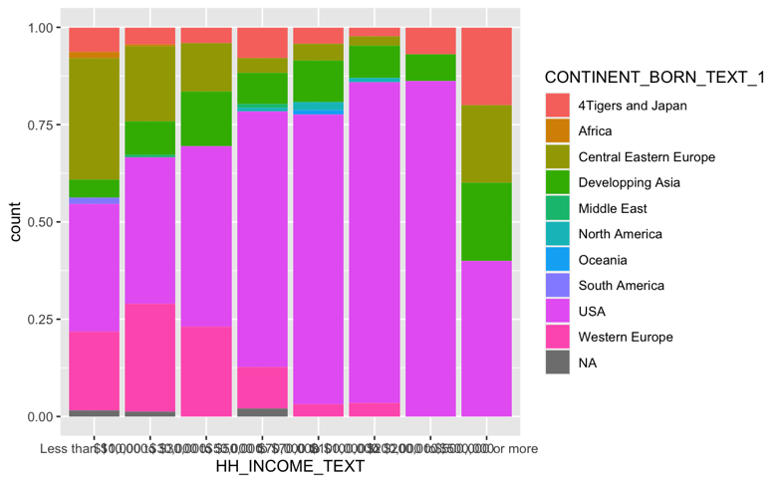As we can see our wealthiest participants were mainly born in the US, then in western Europe. The poorest participants were born in Central and Eastern Europe. Our other biggest groups (Developping Asia and 4 Tigers and Japan) are evenly distributed across income brackets.

Figure 3 Proportion of region of birth according to the income brackets

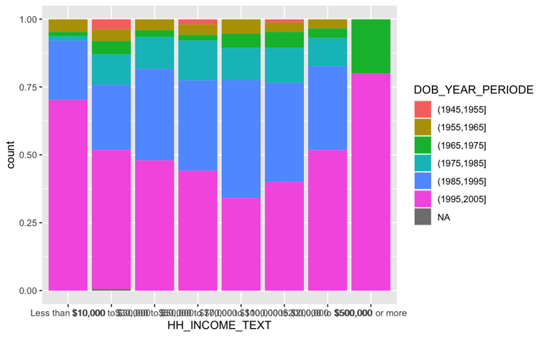With the exception of our wealthiest participants, the wealthier the participants the older they seem to get. This might be because an important part of our young participants are students and so less likely to have an important income.

Figure 2 Proportion of DOB bracket according to income