Descriptive analysis of the database

# Demographic and socioeconomics of our participants

## Race and ethnicity – a white majority and a third of chinese

|  |  |  |
| --- | --- | --- |
|  | n | val% |
| White | 422 | 63.7 |
| Chinese | 225 | 34.0 |
| Non-Chinese Asian | 15 | 2.3 |

Table 1 Distribution of race among participants

Most of our participants identified as belonging to the white (63.7%), one third identified as Chines (34%) and only 15 participants identified as Asian but non-Chinese (2.3%).

|  |  |  |  |
| --- | --- | --- | --- |
|  | n | val% |  |
| Mainland Chinese | 140 | 62.2 |  |
| Taiwanese | 23 | 10.2 |  |
| Hongkongese | 35 | 15.6 |  |
| Other | 27 | 12.0 |  |

Table 2 Distribution of chinese's races

(field: participants who identified as Chinese)

Among our Chinese participants, two-third (62.2%) identified as belonging to the mainland Chinese, a tenth as Taiwanese (10.2%), a seventh as Honkongese (15.6%), and an eighth as other (12%). The others identified mainly as American Chinese or Asian American (62%-17/27), but also as: Vietnamese Uyghur, Cantonese, Fuzhounese, Chinese Indonesian, Chinese Malaysian, Xiamenese.

## Age – a very young sample

Figure 1 Distribution DOB brackets

Our participants were mainly born between 1995 and 2005 (48%), then between 1985 and 1995 (32%). The older groups are less and less well represented. Only a fifth of our participants were born before 1985.

## Sexe – overrepresentation of Female

|  |  |  |
| --- | --- | --- |
|  | n | val% |
| Male | 288 | 43.5 |
| Female | 368 | 55.6 |
| Transgender | 5 | 0.8 |
| Other | 1 | 0.2 |

Table 3 Distribution of sexes

The distribution of sexes of our sample is not random. There is significantly more female among our participants than man. A t-test on this distribution find a significative difference between our sample and a random sample (t ≈ 20; p < 0.001).

|  |  |  |
| --- | --- | --- |
|  | N | val% |
| Less than high school degree | 13 | 2.0 |
| High school graduate | 128 | 19.3 |
| Some college but no degree | 135 | 20.4 |
| Associate degree in college | 41 | 6.2 |
| Bachelor's degree in college | 216 | 32.6 |
| Master's degree | 94 | 14.2 |
| Doctoral degree | 16 | 2.4 |
| Professional degree (JD, MD) | 19 | 2.9 |

## Education – college students and college graduates

Table distribution of education degree

The vast majority of our sample have at least a high school degree (98%). However almost 40% only have a high school degree or only some college but no degree. This is partly due to the Age distribution of our sample.

|  |  |  |  |
| --- | --- | --- | --- |
|  | n | val% |  |
| Less than high school degree | 3 | 0.9 |  |
| High school graduate | 34 | 9.9 |  |
| Some college but no degree | 43 | 12.5 |  |
| Associate degree in college | 26 | 7.5 |  |
| Bachelor's degree in college | 130 | 37.7 |  |
| Master's degree | 75 | 21.7 |  |
| Doctoral degree | 15 | 4.3 |  |
| Professional degree (JD, MD) | 19 | 5.5 |  |

When considering only those born before 1995, we see that two-third of our sample have at least a bachelor’s degree (69.2), and only a tenth has never been to college (10.8%).

Table distribution of education degree

field: participants born before 1995

|  |
| --- |
| Region |
| 4Tigers and Japan | 33 | 5.0 |  |
| Africa | 2 | 0.3 |  |
| Central Eastern Europe | 77 | 11.7 |  |
| Developping Asia | 62 | 9.4 |  |
| Middle East | 2 | 0.3 |  |
| North America | 4 | 0.6 |  |
| Oceania | 1 | 0.2 |  |
| South America | 1 | 0.2 |  |
| USA | 372 | 56.6 |  |
| Western Europe | 103 | 15.7 |  |

## Country of birth – small majority of Americans

Our participants indicated having born in 36 different countries. We classified them according to regions of the world.

Table Region of birth of the participants

Even though most of our participants were born in the United-States (56.6%) there are important sample of individuals coming from CEE (11.7%), Developing Asia (China and Vietnam) (9.4%), WE (15.7%) and the 4 tigers and Japan (5%).

However, 63.3% of our participants have indicated that they have been living in the US (63.3%). The racial group that has the least ever lived in the US are the whites and the non-Chinese Asian.

|  |  |  |  |  |
| --- | --- | --- | --- | --- |
| HAS_LIVED_USA | White | Chinese | Non-Chi Asian | Ensemble |
| FALSE | 43.1 | 24.0 | 46.7 | 36.7 |
| TRUE | 56.9 | 76.0 | 53.3 | 63.3 |
| Total | 100.0 | 100.0 | 100.0 | 100.0 |

Table Distribution of the participants according to their race and if they have ever lived in the US

## Revenue – very disparate incomes

|  |  |  |  |
| --- | --- | --- | --- |
|  | n | val% |  |
| Less than $10,000 | 64 | 9.7 |  |
| $10,000 to $30,000 | 162 | 24.5 |  |
| $30,000 to $50,000 | 121 | 18.3 |  |
| $50,000 to $70,000 | 102 | 15.4 |  |
| $70,000 to $100,000 | 94 | 14.2 |  |
| $100,000 to $200,000 | 85 | 12.8 |  |
| $200,000 to $500,000 | 29 | 4.4 |  |
| $500,000 or more | 5 | 0.8 |  |

More than half of our participants make less than 50 thousand dollars a year. Some of them seemed to make more than 500 000 a year but we suspect this data to be misreported.

Table Distribution of revenues

The distribution of the revenue is linked to the country of birth and the age of our participants.

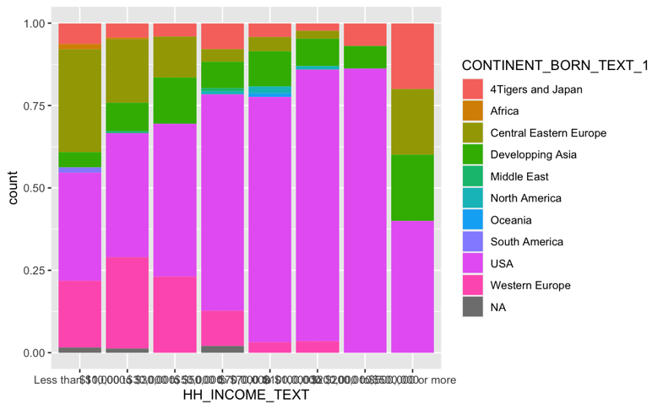As we can see our wealthiest participants were mainly born in the US, then in western Europe. The poorest participants were born in Central and Eastern Europe. Our other biggest groups (Developping Asia and 4 Tigers and Japan) are evenly distributed across income brackets.

Figure 3 Proportion of region of birth according to the income brackets

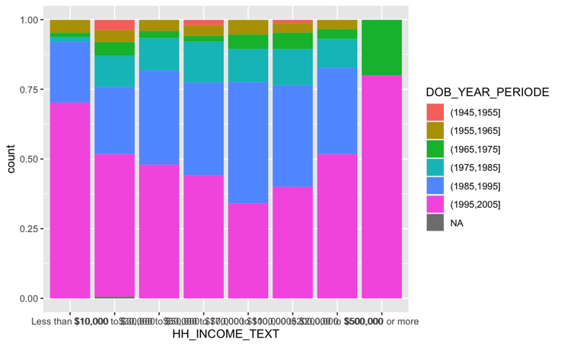Apart from our wealthiest participants, the wealthier the participants the older they seem to get. This might be because an important part of our young participants are students and so less likely to have an important income.

Figure 2 Proportion of DOB bracket according to income

## Proposition of clusturisation for demographic data

Using the seven variables mentioned and analyzed above as qualitative variables we generated a MCA and from it a classification with an HCPC to determine cluster/groups of participants according to an array of demographic variables.

We distinguished seven group with the following characteristic:

|  |  |  |  |  |  |  |  |
| --- | --- | --- | --- | --- | --- | --- | --- |
| Variable/Cluster | 1 | 2 | 3 | 4 | 5 | 6 | 7 |
| Race/Ethnicity | White +  Chinese - | Chinese ++  White -- | Chinese ++  White - - | No C Asian +  Chinese | White | White ++  Chinese - - | White |
| Sex |  |  | Female |  | Trans |  | Male  Female - - |
| DOB | (75, 95] +  (65, 75]  (95, 05] - - | (95, 05] ++ | (85, 95] |  | (45, 55] + |  | (95, 05] + |
| Continent Born | USA ++  Other - | USA ++  Other - | Dev Asia ++  Other - | 4 tig & Jap ++ | NA | W Eur ++  Africa, Mid East  USA - - | CEE ++  USA - - |
| Has Lived USA | True ++  False - - | True ++  False - - | False | False |  | False ++  True - - | False ++  True - - |
| Income | (70k, 100k] + | (100k, 500k] + | (30k, 50k] |  | (10k, 30k] | (10k, 50k] | Less 10k |
| Education | Associate, Bachelor, Master | Col no deg + | Master, doctoral D | Master | Some college |  | High School or less |
| Summary | White rich graduate Americans between 30 and 50y | Young Chinese rich Americans without college degree | Female Graduate and Doctor Chinese in their 30s | Asian from the tigers and Japan | White elder trans | West middle class European | Poor Central European with few education. |

One of the main results of this classification is that there is an important correlation between the continent where our participants were born in, their race/ethnicity, their age, sex,

income and education. Thus, in the analysis it will be important not to analyse demographic indicator alone because they might hide other things – is x due to the eastern European origin or

|  |  |  |
| --- | --- | --- |
| Demo cluster | n | val% |
| 1 (white Am) | 215 | 32.5 |
| 2 (Chinese Am) | 145 | 21.9 |
| 3 (fem Chin Chin) | 60 | 9.1 |
| 4 (Asian Tiger) | 39 | 5.9 |
| 5 (White old Trans) | 19 | 2.9 |
| 6 (W European) | 116 | 17.5 |
| 7 (CE European) | 68 | 10.3 |

the weak income?

The distribution of our participant over these clusters is somewhat like their distribution over the continents they were born in.

# AMBI and Big5: a personality trait analysis of our sample

## Calculation of the personality traits

We calculate personality scale for each of our participants according to their answer in our survey and Yarkoni 2010[1]. For each trait we normalize participants answer between 0 and 1; with 0 being the lowest possible score for a scale, and 1 the highest one.

Because of the number of scale (200), we realized an EFA to resume the information in each scale. Looking to minimize the number of loading variable present in none or more than one factor, and the number of factor without loading variable with more than 0.5 estimate, we decided on producing an EFA with 13 factors. Here is a summary of these factors and the personality traits that build them:

|  |  |  |  |
| --- | --- | --- | --- |
| Traits | Negative | Positive | Summary |
| ULS 1 |  |  |  |
| ULS 2 |  |  |  |
| ULS 3 |  |  |  |
| ULS 4 |  |  |  |
| ULS 5 |  |  |  |
| ULS 6 |  |  |  |
| ULS 7 |  |  |  |
| ULS 8 |  |  |  |
| ULS 9 |  |  |  |
| ULS 10 |  |  |  |
| ULS 11 |  |  |  |
| ULS 12 |  |  |  |
| ULS 13 |  |  |  |

# Covid Misconceptions analysis of our participants

We generated an MFA and a classification with an HCPC to identify clusters of participants according to their Covid-19 misconceptions

## Education - Lower education predicts higher covid misconceptions

Participants with higher levels of education are more likely to be in the first group and those with lower levels of education to be in the third cluster (t ≈ 20, p < .005).

|  |  |  |  |  |
| --- | --- | --- | --- | --- |
| Education/Cluster | 1 | 2 | 3 | All |
| Less than high school degree | 0.7 | 3.6 | 6.6 | 2.0 |
| High school graduate | 16.3 | 27.7 | 18.0 | 19.3 |
| Some college but no degree | 20.2 | 18.1 | 27.9 | 20.4 |
| Associate degree in college | 4.4 | 9.0 | 11.5 | 6.2 |
| Bachelor's degree in college | 35.9 | 27.1 | 24.6 | 32.6 |
| Master's degree | 15.4 | 12.7 | 9.8 | 14.2 |
| Doctoral degree | 3.4 | 0.0 | 1.6 | 2.4 |
| Professional degree (JD, MD) | 3.7 | 1.8 | 0.0 | 2.9 |
| Total | 100.0 | 100.0 | 100.0 | 100.0 |

*Table: Distribution of participants within each cluster according to educational attainment*

This correlation remained significant (t ≈ 3.3, p < .02) after removing young people born from 1995-2005, who are more likely still in school, and who constituted ~48% of our participants.

|  |  |  |  |  |
| --- | --- | --- | --- | --- |
| Degree/Cluster | 1 | 2 | 3 | All |
| No college degree | 18.2 | 31.1 | 40.0 | 23.2 |
| College degree | 46.6 | 41.9 | 42.9 | 45.2 |
| Graduate degree | 35.2 | 27.0 | 17.1 | 31.6 |
| Total | 100.0 | 100.0 | 100.0 | 100.0 |

*Table: Distribution of participants born before 1995 within each cluster according to educational attainment*

## Gender - Men are more likely to possess covid misconceptions

Male-identifying participants were significantly more likely to possess covid misconceptions than any other gender group (t ≈ 2.3, p < .01).

|  |  |  |  |  |
| --- | --- | --- | --- | --- |
| Gender/Cluster | 1 | 2 | 3 | All |
| Male | 37.7 | 55.4 | 52.5 | 43.5 |
| Female | 61.1 | 44.0 | 47.5 | 55.6 |
| Transgender | 0.9 | 0.6 | 0.0 | 0.8 |
| Other | 0.2 | 0.0 | 0.0 | 0.2 |
| Total | 100.0 | 100.0 | 100.0 | 100.0 |

*Table: Distribution of participants within each cluster according to gender identity*

## Income - No influence of income on covid misconceptions

We found no significant influence of income bracket on covid misconceptions among our participants.

|  |  |  |  |  |
| --- | --- | --- | --- | --- |
| Income/Cluster | 1 | 2 | 3 | All |
| Less than $10,000 | 8.7 | 11.4 | 11.5 | 9.7 |
| $10,000 to $30,000 | 20.7 | 33.7 | 26.2 | 24.5 |
| $30,000 to $50,000 | 19.3 | 15.7 | 18.0 | 18.3 |
| $50,000 to $70,000 | 16.1 | 13.3 | 16.4 | 15.4 |
| $70,000 to $100,000 | 15.9 | 10.8 | 11.5 | 14.2 |
| $100,000 to $200,000 | 13.8 | 10.8 | 11.5 | 12.8 |
| $200,000 to $500,000 | 5.1 | 2.4 | 4.9 | 4.4 |
| $500,000 or more | 0.5 | 1.8 | 0.0 | 0.8 |
| Total | 100.0 | 100.0 | 100.0 | 100.0 |

*Table: Distribution of participants within each cluster according to income bracket*

## Age - No influence of age on covid misconceptions

We also found no significant influence of age on covid misconceptions among our participants.

|  |  |  |  |  |
| --- | --- | --- | --- | --- |
| BirthYear/Cluster | 1 | 2 | 3 | All |
| (1945,1955] | 1.4 | 1.8 | 0.0 | 1.4 |
| (1955,1965] | 4.1 | 4.2 | 4.9 | 4.2 |
| (1965,1975] | 4.1 | 4.2 | 1.6 | 3.9 |
| (1975,1985] | 10.4 | 9.0 | 21.3 | 11.0 |
| (1985,1995] | 34.3 | 25.3 | 29.5 | 31.6 |
| (1995,2005] | 45.6 | 55.4 | 42.6 | 47.8 |
| Total | 100.0 | 100.0 | 100.0 | 100.0 |

*Table: Distribution of participants within each cluster according to age*

1. Tal Yarkoni, “The abbreviation of personality, or how to measure 200 personality scales with 200 items”, *Journal of Research in Personality*, Volume 44, Issue 2, 2010, Pages 180-198, <https://doi.org/10.1016/j.jrp.2010.01.002>.