Google Drive for Team Collaboration

Initial Findings and Recommendations

By Leo Heska
September 9, 2013

Summary
The following summary points are explained in the body of this document.

Google Drive is not ready for prime time.
Mastering Google Drive and what come across as its "quirks" is not simple.
Implementing and exercising Google Drive as a production collaboration tool results in users rejecting it as it causes them problems and they perceive it to be flawed and/or suboptimal.
Google Drive's safest, most reliable use is as a personal data store only, with each employee using their own Google Drive instance, not sharing.
If files on Google Drive are shared, they should be locked down, meaning only read-only access should be granted. Google Drive should not be used for generally unfettered file sharing.
This is irrespective of security, as recently heightened.
If used as a general file sharing tool, Google Drive needs to be carefully (defensively) backed up, resulting in increased (doubled, quadrupled, or greater) consumption of hard drive space.

Background and Goals
Offerings and Landscape
Online or "cloud" storage of documents has been available for many years; offsite storage for decades before that. At least dozens and probably hundreds of vendors are willing to store information, for a price. A list of Google Drive competitors may be found at https://en.wikipedia.org/wiki/Google_Drive#Competitors.

Google, Microsoft, Amazon, and Dropbox all provide large amounts of storage, free.
- Amazon's S3 (Simple Storage Service) s robust and functional. Besides the free storage, additional storage is inexpensive. Some client groups do use S3 for some purposes.
Though Dropbox and Microsoft's SkyDrive are in the same league as Google Drive, neither are extensively used by client that I know of.
Google Drive is embraced by client. Client subscribes to Google Apps; employees can use a link provided to them by client, to easily set up an account and gain access to a client-branded Google Drive website.
It's "in the air" or "general knowledge" that client's direction is to use Google Drive, and possibly other Google apps (web- or cloud-based applications). Because of this direction and the fact of client's internal support and encouragement, including an easily available signup link, our group, carrying on an effort involving collaboration between 3 to 5 people working on multiple machines, chose Google Drive as a file sharing tool.

Other methods of sharing are available to us:
- Storing files in a directory on gcsas1, to which we all have access. We avoid this because that box's hard drive space is maxed out already.
Storing files on the primary production machine used for our project. This does work and we do store some files on that machine. However, sometimes we'd like to access files from other machines, and moving/copying files across the network can be slow. Also the production box can run out of memory, and we'd like to limit access to it since it's our production box.
ftp sites, informal drive shares, and other common techniques.
None of those methods are preferable to using a dedicated, supported, and built-for-the-purpose file sharing/collaboration service such as Google Drive.

Needs and Goals
Our group consists of:
- 3 analysts, each with computing experience
A senior analyst, project manager, and a representative of the client's sales team who may from time to time need to access shared files

Our needs include:
- Sharing data files, which generally are too large to email
Sharing code modules which are not text-based and therefore don't lend themselves to management in a SCMS (Source Code Management System)
Sharing documents, including Excel and Word files
With such a small group, our need for automatic version control is not great. We can and do manage versions just by saving files with datestamps in their names.

Nor do we need to be very careful of inadvertent destruction of resources, such as someone deleting a file by mistake. There are only 3 of us who are likely to do that and we can and do protect ourselves by individually keeping separate copies.

One of our goals is to ensure that software that had previously run only on a production machine, can also be run on other machines. In case that one machine fails or becomes unavailable for some other reason, or the workload grows to where one machine is unable to process the work sufficiently fast, we want other machines to be able to do the work.

Evaluation
Initial Choice and Implementation
Our team chose to make use of Google Drive for the reasons mentioned above; basically, this is client's preferred and supported cloud storage solution.

Creating accounts was easy using the client-supplied link. The client support person stated that it could take a few hours for some process to occur once a request was made but we did not notice significant delay.

Once setup was complete it was easy to log on to the Google Apps website and upload a file to Google Drive. Administration of the Google Drive was also easy; it was simple to instruct Google to share a particular folder with particular client employees, identified by their email addresses. It appeared possible to invite and permit non-client personnel to share but we did not.

Once we had shared access to a Google Drive folder we were able to quickly verify that we could upload files to the cloud/to Google Drive, and download both our own and each others'.

Google provides a Microsoft Windows client that enables the Windows file system to treat the Google/cloud drive as a folder. That is, after installing the client:
- You create a (or identify an existing) directory in the Windows file system.
You use the Google Drive client to link that directory to a Google Drive directory.
Then, whenever you drop (or copy or move) a file to the linked local directory on your hard drive, the Google client will detect this, and automatically copy that file to the cloud/to the Google Drive.
The original file remains on your hard drive. It is not moved, but rather copied, to the Google Drive.
This happens automatically, in the background. It is a lightweight process and doesn't consume resources to any extent that I noticed.

In summary, the above functionality means that the Google Drive windows client sets up and supports automated mirroring to the cloud of a local directory.

Initial Findings and Considerations
Besides the just-described "upload synchronization," the Windows Google Drive client synchronizes the other way, too. That is, if I have a file located in a directory on my hard drive, that is synchronized to my Google Drive, or to someone's Google Drive who has shared theirs with me, then:
- If they or anyone else with access to the Google/cloud Drive changes the file in the cloud/on Google Drive, then
That change is automatically made to my local hard drive also.
This creates the following possibilities:
- If I have an Excel spreadsheet in a synchronized drive and somebody changes it on the Google Drive, it will be changed on my hard drive also, without notice or warning.
Similarly, if someone deletes the file from the Google/cloud Drive, that change will be "replicated" to my local hard drive; the file will be deleted from my hard drive.
If all parties keep a file only in their synchronized directories this could result in complete loss of that file.

Our team recognized the implications of the above, and accepted them and continued to use Google Drive, because of Google Drive's nice functionality. Also, ameliorating the above:
- Our team is small. Only three of us are likely to attempt to write, change, delete.
We're careful and reasonably competent.
Since even careful, reasonably competent people make mistakes, we keep important files not only in the directory synchronized with Google Drive. If a file is changed or wiped out we still have the other copy.

We proceeded to use Google Drive for collaboration and file sharing and it more or less worked as we needed it to. Our initial conclusion was that Google Drive may be used for collaboration and file sharing purposes, as long as the above considerations are universally recognized and taken into account.

Further Findings
Thinking in terms of documents, not files

One initial finding may be illustrated as follows:

Create a Google Drive directory, share it. For purposes of this document I'll call the directory TestDirectory. It looks like this on the local filesystem:

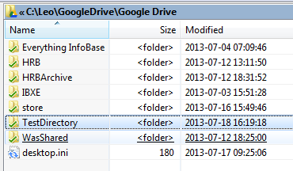

and on the Google Drive web interface it looks like this:
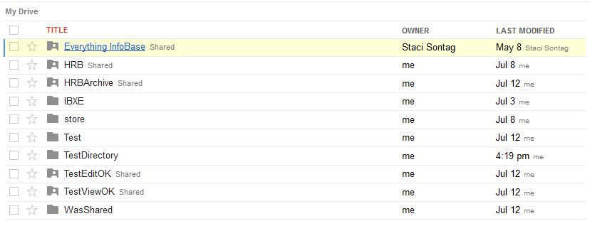

You may notice that the web interface displays more directories than does the Windows filesystem. That's because, using the Google Drive Windows client software, I've set certain cloud directories to not synchronize with the Windows filesystem.

Using the web interface, go to the new directory and verify that it is empty. It looks like this:
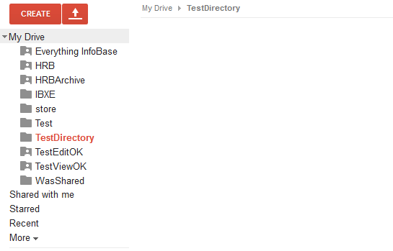

Create a file called test.txt with some text in it, and upload it to the Google Drive.

Now the local/Windows filesystem looks like this:
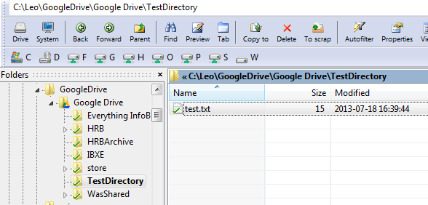

Note that there is a little green checkmark to the left of test.txt; it indicates that the Google Drive client software has auto-synchronized. In this case that means that the file was copied up to the cloud, to the Google Drive.

The web interface picture looks like this:
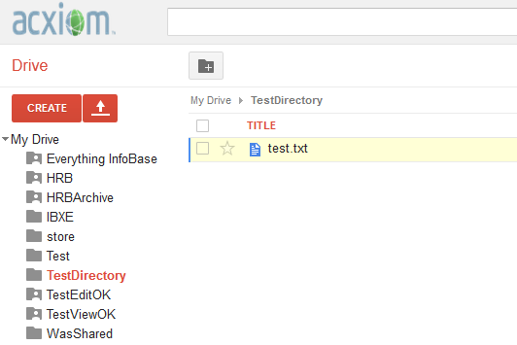
You may notice that in the web view, there's no information about the file's size.

This comes from Google Drive's history as an offshoot of Google Docs. The design philosophy of Google Docs was to get away from thinking of "files" and instead, think about "documents." Timestamps are relevant to both files and documents so the timestamp appears on both interfaces (Windows and web). Things like size in bytes; that's "file thinking," not "cloud thinking" or "document thinking." Size in bytes is primarily relevant to files, not documents, and therefore sizes in bytes are not displayed on the web interface. If there is a way to find file size in bytes via the web interface, I haven't found it.

Using a non-obvious trick, it is possible to find the approximate file size using the web interface:
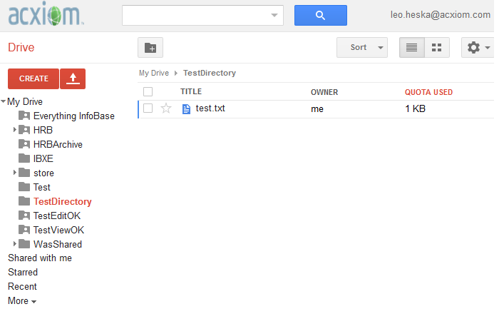

What we see here is that Google is displaying what's important to Google. The file text.txt, size 15 bytes, takes up 1KB of quota. That's important to Google but does not support use cases in which we want to know the exact file size.

The importance of this distinction between conceiving and managing an artifact (a bunch of bytes stored on a disk) as a document versus as a file will become more apparent as follows.

Multiple Identically Named Files In The Same Directory

Now, share the folder TestDirectory with someone. For this example I shared it with a made-up user named Tammy Baxter. I don't show the process here but it's easy; you just specify the e-mail address of the person you want to share with.

The next thing I did was:
- From a separate machine, log on/connect to Google Drive as Tammy Baxter.
Create a separate and different file, with different contents, named test.txt.
Upload that file to Google Drive, to the drive just shared in the previous section (named TestDirectory in this example).
Now there are two different files both located in the same Google Drive directory, both named test.txt. It looks like this:
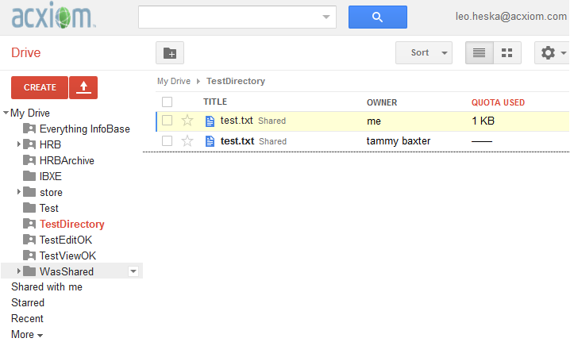

This takes a little getting used to. At first glance many folks don't quite notice what's going on. We are so used to the rule that you can't have more than one file in the same directory with the same name, that we don't even expect to see such a thing.

The next thing you might think is that there is some kind of problem with a screen refresh or the GUI. But there's no problem. What's happening is that again, Google Drive isn't thinking in terms of files, but rather of documents. Of course you can have two documents of the same name in the same place - it happens all the time in the real world. Most people, when filing paper documents, file multiple documents of the same name in the same folder. The documents may or may not be identical; to find out for sure you need to read the document.

OK, we can try to learn and get used to this new concept, that there can be multiple documents with the same name in the same directory. But remember the Google Drive Windows interface? Here's how it now looks:

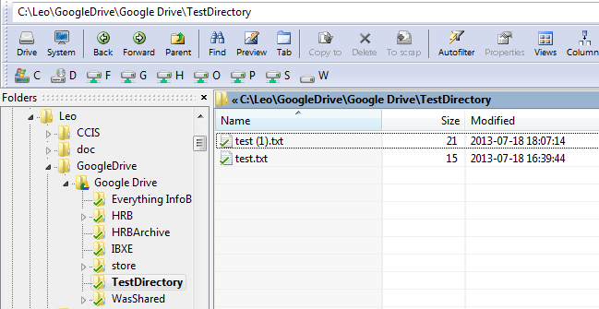

The folks at Google may have decided to re-conceptualize how things are stored, and be thinking in terms of documents, not files. And we may follow their lead in this, and learn to think in these terms. But Windows and the NTFS file system still use the concept of files (as does linux), and their rule is that you may not have more than one file of the same name in the same directory.

As you may see, the best that the Google Drive Windows client can do to handle this contradiction between the two different concepts, is to rename one of the files that's "really" named test.txt.

Note that the second file to be added to the Google Drive (slightly larger, created and uploaded by "Tammy"), is named

test (1).txt

so our current situation is, the same file (test.txt created and uploaded by "Tammy") has two different names in two different places. On Tammy's machine it's named text.txt; on the Google Drive, it's named test (1).txt.

Yet these two files, differently named, act as one for synchronization purposes. If I edit one of them, the Google Drive client software will detect this and synchronize the two files; meaning write the changes to all other directories that are shared with this particular Google Drive directory. Google knows the connection between the two differently-named files, though there is no way for a human to tell that the two files are "the same" just by looking.

When you compare the three data stores, the situation is a bit confusing:
File Name On Leo's | File Name On Google Drive | File Name on Tammy's
test.txt | test.txt
test (1).txt | test.txt | test.txt

Just what the original file named test.txt is named on Tammy's machine is a bit ambiguous, so I've left that blank. However, notice that the two identical files (the file named test.txt that Tammy created and uploaded, and that the Google Drive client synchronized with Leo's hard drive) have different names on the two different machines.

In case you are wondering, more files may be added, with the following result:

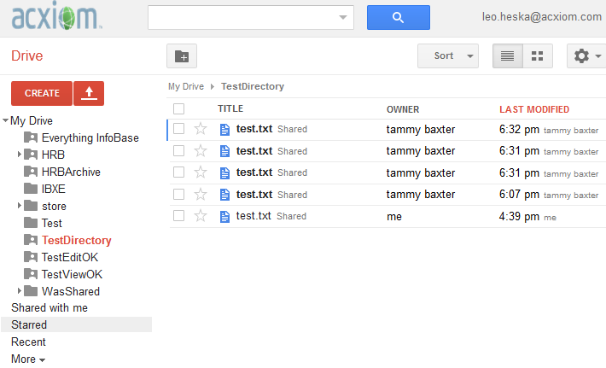

Here we see 5 identically named files (or "documents"), all in the same Google Drive directory.

Here's how it looks from the Windows point of view:
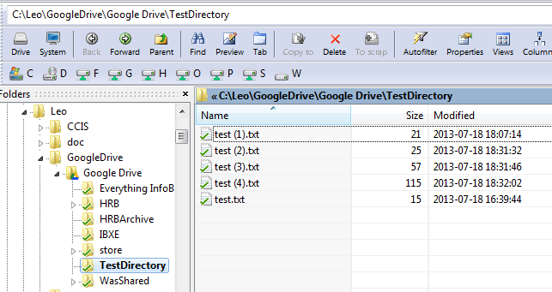

Note that the later the file, the greater the appended number. The times shown in the Windows interface are more precise (they're shown to the second) than the Google Drive web interface shows.

This screen shot of an alternate view taken of the Google Drive web interface shows that you can't see the exact sizes of the multiple files named test.txt:
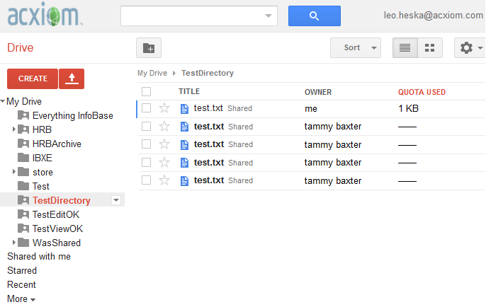

From the Google Drive web interface, all you can tell are approximate (to the minute) times of file uploads and approximate sizes.

This matters to computer users who want to differentiate between files.

Q: How can you tell which of the two files named test.txt, both timestamped 6:31 PM, is which? A: Using the Google Drive web interface, you can't.

The only way to do it is to examine the contents of the files, presumably by looking into them or running a comparison utility. Professionals frequently use the shortcut or trick of differentiating files based on their exact size in bytes and their timestamps - this is not generally possible using the Google Drive web interface. It is possible using the Windows interface.

There is a pattern to the above functionality but once you get several people all adding, deleting, and changing files at the same time, the situation could get very confusing. You might end up using a downlevel/older file without realizing it.

In our small group we addressed this risk by avoiding it. We simply are careful not to store two files of the same name in the same directory. To accomplish this we generally add a date and/or timestamp in to the file name before uploading it to the Google Drive, unless we expect that the file will always remain unique.

A Single Copy Of A File "In" Multiple Directories
The previous section described how there can be multiple identically named files (or in the Google Drive conception, "documents") in the same directory.

It is also possible for a single copy of a file ("document") to be "located" in multiple directories. It works like this.

First, create some sort of directory structure; perhaps like this:

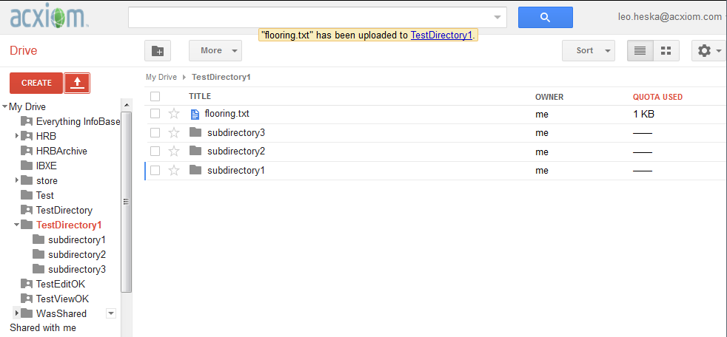

You can see from the yellow-backgrounded message that besides creating the directory TestDirectory1 and subdirectories underneath it named subdirectory1, subdirectory2, and subdirectory3, I also uploaded a file named flooring.txt, that currently is "located" in directory TestDirectory1.

I am writing the word "located" in quotes because this is not really how Google Drive works. It's not that there are files that are located in one place each. Rather, there are documents that fall into categories.

Think of an invoice. It might fall into multiple categories; for example "invoices," "auto repairs," "Cadillac," and "to be paid." This is a classic problem when trying to organize files into directories on a Windows hard drive (or in almost any other filesystem). There are ways around the problem (symbolic links, shortcuts), but they can cause a lot of trouble and confusion, so most people end up using the default filesystem behavior and picking one location for each file.

Google Drive solves this problem very nicely. Thinking in terms of documents, not files, of course it's possible for a document to fall into multiple categories. And Google Drive supports such functionality, like this:

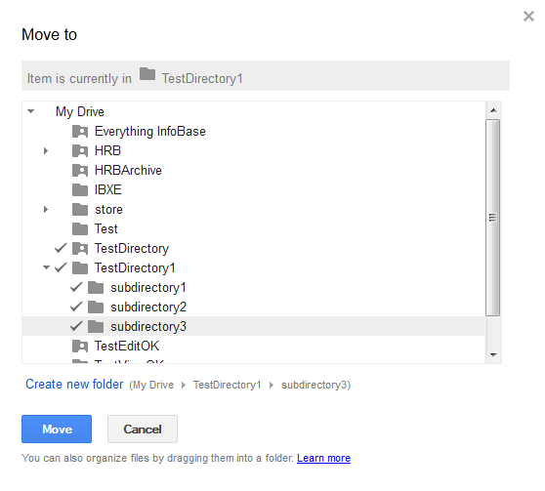
What's happening above is, I'm in the middle of using Google Drive's "Move to" feature to move a document from one place; but rather than move it to one other place, as soon as I click the blue Move button, the document will be "located in" 5 different places:
- TestDirectory
TestDirectory1
TestDirectory1\subdirectory1
TestDirectory1\subdirectory2
TestDirectory1\subdirectory3

You might figure that this is just a copy - that there will actually be 5 copies of the file flooring.txt stored out there on the Google Drive. But this is not so; there's just one copy, and it is "associated with" (or "located in") 5 different locations.

Once the move is done, the Google Drive web interface attempts to indicate what is going on as follows:
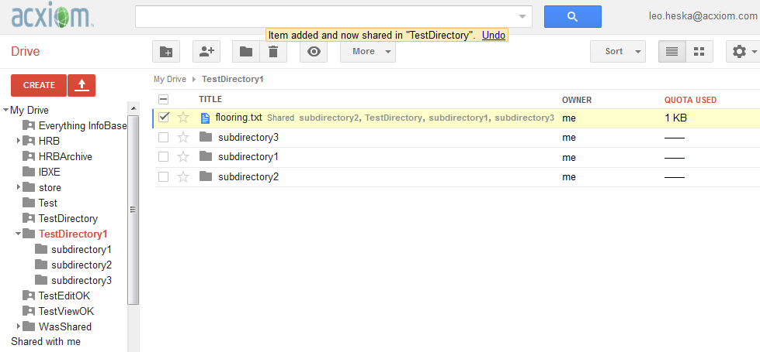

If you look closely you can see that flooring.txt is accompanied by some small text that is meant to indicate that this file is "located in" 4 other places besides TestDirectory1. This takes some getting used to, and most users are fairly likely to just ignore, not pay attention to, or not notice the extra text.

How does this now look in the Windows filesystem? Like this:

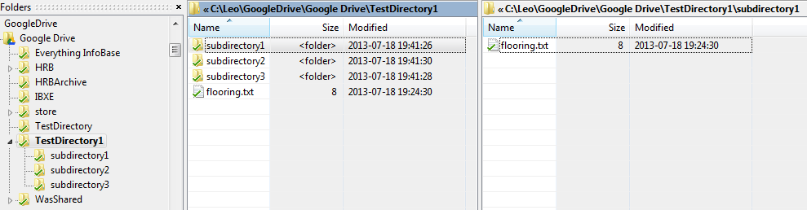

Again, you need to look closely because the screenshot is small, but the file browser in the above snapshot is showing two different directories on the Windows hard drive, simultaneously. And we can see that the identical file is indeed located in two different directories.

Now, suppose a person, for example trying to clean up redundant files, save disk space, or otherwise do some housekeeping, decides to delete one of what appear to be copies?
This is easy to do from the Windows interface - just select one of the "copies" and delete it.

If you delete the "copy" from subdirectory2, Google Drive behaves pretty reasonably; it deletes only that "copy," like this:
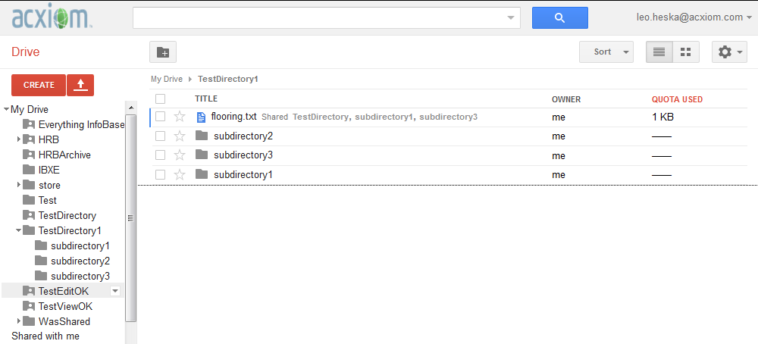

Again, you have to peer closely but it's possible to see that flooring.txt is no longer "located in" or associated with subdirectory2.

So far Google Drive is behaving very much as we would expect and hope. A "delete" on the Windows filesystem simply results in what appears to be a similar delete on Google Drive.

Now suppose that our hypothetical person working on these files, thinking that they really are separate files (which is sure how it seems up till now) decides to change one of them. I did this, editing on my Windows filesystem the "copy" of the file "located" in
Google Drive\TestDirectory1\subdirectory3.

The result, for a little while, looked like this:
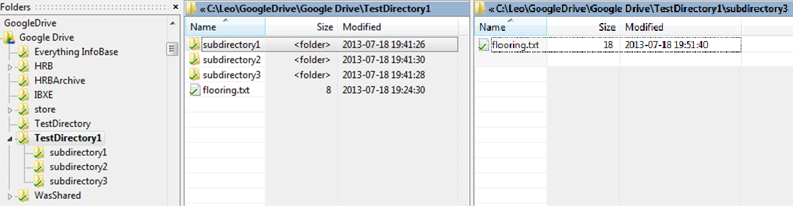

So, just for a little while (while the synchronization to and from Google Drive was pending), all looked well. The new file, shown on the right, located in
Google Drive\TestDirectory1\subdirectory3
shows up just right, with a size of 18 bytes. The file on the left, located in
Google Drive\TestDirectory1
shows its previous timestamp and file size. At this point the person making the changes might figure that all is well and go home for the day or go to lunch. Imagine their surprise when they return to find the following:
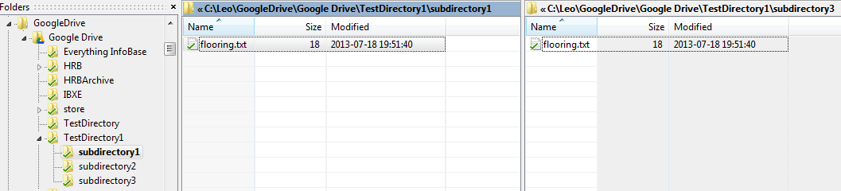

This shows that even though the change was made to just one "copy" of the file (the one "located" in subdirectory3), the following happened:
- After the Google Drive Windows application detected the change, it synchronized the changes, copying the changed file up to the cloud/the Google Drive.
There's really only one file or document on Google Drive/in the cloud; it just happens to be located in multiple locations/directories. So, the changes get made "in all locations."
On the Windows hard drive there really are multiple copies of the file located in separate directories. The screenshot above shows that after the Windows Google Drive client detects that things have changed in the cloud, it obediently, silently, and without warning or notice, changes all the other copies on the hard drive.

Another way of looking at this, from the Windows user's point of view, is:
- They may notice that there are multiple copies of a file in different locations.
Wanting to retain two versions, they change one copy only.
Google Drive and the synchronization utility change all copies.
Desired data are lost.

In the world of software testing, loss or destruction of data is considered a "Severity 1" (worst possible) error. This is an example of a severity one type condition happening in normal practice because the person working on the Windows platform/hard drive did not know about Google Drive's ability to "locate" a single file in multiple directories, and the potential side effects.

Lack Of A linux Client

All these examples have shown Google's web interface and/or Google's Windows client software. Though we did not test Google's Macintosh client software, it does exist and is reputed to work pretty much like the Windows client.

However, there is no linux client for the Google Drive. There's an API for Google Drive and there is an implementation of the API, named grive, available for linux. It does work but the version I tried offers a command line interface only, not a GUI, and the functionality is different from the Windows client. In particular, auto-synchronization is not supported.

Failures Of The Web Interface Using Non-Chrome Browsers
From time to time one encounters situations using Google's web interface where something that is supposed to work, doesn't. Renaming a folder, for example. Such problems are not always reproducible and I don't have screenshots. Fairly often, if Google support does appear (generally in response to a posting on a web site/blog), the first suggestion is "try it using Chrome."

It appears that though Google Drive's web interface generally works well with non-Chrome browsers, Google expects, and primarily/preferentially supports, use of Chrome.

Synchronization Failures
It is fairly common to run across (recent) reports from people who have really embraced Google Drive, for example using it heavily in the classroom. They report that when using Google Drive to manage lots of files (on the order of 30,000 files), fairly often, Google Drive will get part way through a synchronization (perhaps copying half of them up to the cloud) and then, just quit, without warning or notice. The problem only becomes apparent when attempting to use the files that one expected to be located in the cloud (and, possibly, auto-synchronized to other workstations).

Failure To Work With Renamed or Recreated Directories
It appears that just as Google Drive tracks documents without primary regard to their names, it does so with directories as well. Specifically, just because a directory now exists with the very same name, in the same place/on the same device as yesterday, does not mean that Google Drive will recognize this as the same directory.

Specifically, if you delete or rename a directory on your local hard drive, then recreate one of the same name, Google Drive can fail, in one of two ways:
- Google Drive may simply display the error messages "Your Google Drive Folder is missing" or "This is not your original Google Drive folder," sometimes when these statements are false.
Google Drive may, rather than examining the files in the local directory, force a resynchronization of the entire local directory on local fixed disk.

The latter, if it occurs, can take days, if a large amount of data is synchronized.

Worse than that is the following problem. It can happen that Google Drive, in various circumstances encountered in the real world (such as renaming a directory and then naming it back), decides that the directory is the same as the old one, but all the contents are different. When that happens, the effect looks like this:

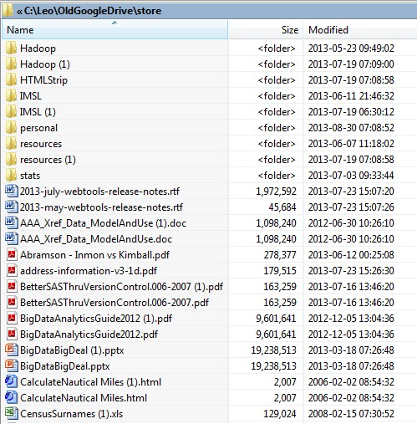

This is a real screenshot taken from a production machine shortly before we abandoned the use of Google Drive. What Google Drive has done, is declare "not quite every" directory and every file, below a certain point, (in this case, "C:\Leo\OldGoogleDrive\Store") to be a duplicate. This seems generally to happen "a drive at a time" meaning that everything synced to Google Drive gets duplicated. Google Drive, behind the scenes and without warning, litters the entire drive with doubles of everything.
Besides doubling the space used on the local hard drive (quite possibly exceeding local capacity), this can cause havoc for various programs (such as compilers data ingestors) that process every file in a subdirectory. Getting rid of all the duplicates can be very difficult, requiring perhaps 1/2 or a full day of work. That's because the fix isn't as simple as finding, then deleting, every file with a (1) in its name. Other programs besides the Google Drive client also use this convention and if you simply delete all files with a (1) in their name, you stand a good chance of deleting a revision of a critical file. The only good solution is to run a duplicate file finder tool. This is not a skill nor a tool that most people have, and it is not 100% straightforward and simple.

Failure To Connect and/or Synchronize
It is fairly common to find that, without any explanation that I have ever been able to find, instead of auto-synchronizing, the local Google Drive client will instead have its icon grayed out, and offer the error message "Unable to Sync" or "Unable to Connect." The only fix I have discovered for this, is to shut down Google Drive and restart it.

Exacerbation of the Above by New Security Policy
Unfortunately the above fix for the fairly frequent problem of "can't connect/can't synchronize" is no longer always possible. The new security policy implemented client-wide calls for two-factor security. In some cases, logging off and back on now requires receiving a text message; an authorization code from Google, sent to an Android or other smart phone/handheld device. When this is impossible (for example when an employee does not have one, or the employee who owns the handheld device is not at work), Google Drive becomes unusable.

Other Miscellaneous Google Drive Errors/Failures
All the above errors have been encountered by members of our team. However, there appear to be other errors caused by/associated with the use of Google Drive. These may be seen at Google's own support page titled "Common errors in Google Drive":

https://support.google.com/drive/answer/2456903?hl=en

Limitations, Cautions
Google Drive, being a cloud storage application, should not be expected to act as a versioning or version-control system. Yet though it may be unreasonable to expect Google Drive to do something it isn't suited or designed for (nor promises), the fact of Google Drive's behavior when storing multiple copies of identically named files in a single directory, actually replicates to a great extent, the behavior of real version control systems. Recall that when a file is repeatedly added to a directory, the result looks something like this:
test (1).txt
test (2).txt
test (3).txt
test (4).txt
test.txt
Those little numbers in parenthesis - they can easily be considered version numbers, because that is in fact what they are. A clever user of Google Drive could make use of this functionality to achieve a rough-and-ready version control system. Just educate the team in the right procedures and standards of usage, and away you go.
Unfortunately Google Drive's behavior in deleting and changing files, which might be described as "erratic," "unexpected," "destructive" or even "disastrous," make this temptation a very dangerous one. Google Drive should not be used as a version control system. Google Drive may, without warning and not as a result of an error, create copies of files with new "version numbers," breaking any system that relies on them.

Conclusions and Recommendations
Conclusions
Google Drive is not ready for prime time
If you trawl the web trying to find out answers to Google Drive questions and quandries, you will find a fair bit of fairly recent comment that this product is "not Google Quality." To prove or disprove this assertion would require extensive testing but our experience, and what testing I've done, says this is correct. There are little quirks, occasional incidental failures, and times when the combination of Google Drive itself and the Windows interface, cause unexpected and undesirable behavior, and in some cases, actual destruction of data.

Combine this with lack of a linux client and other facts previously mentioned - this is not yet a product suitable for wholesale adoption by client as a serious collaboration tool. It simply is too poorly featured and insufficiently robust. Effective use requires a pretty high level of mastery, and that mastery requires figuring out what at first seem to be crazy, and are certainly contrary-to-industry-standard, design features.

It's possible to claim that data destruction as outlined above can only be consistently proven "when the user doesn't know what they're doing," and that users should "just learn to do it right - then they won't have any problems." Unfortunately this prescription fails for two reasons:
- People do occasionally make mistakes.
Much more importantly, the way Google Drive has re-conceived data management is at variance with (literally) tens of millions of person*years of standard practice. Here are two fundamental conceptions of data management, ingrained in most people:
  - A file can be located in only one place at one time.
Only one file of the same name may reside in a directory at one time.
It is not reasonable, nor will it work, to require 100% of Google Drive users to reverse the above concepts, keep the reversed concepts in mind, and figure out how to work in a hybrid system (cloud plus workstation) which embodies both standard and reversed concepts.

Google Drive, if used, should be locked right down
Because of the above, most of the resources I've looked up that seem to know the most about Google Drive, recommend locking it down rather strictly. Basically they recommend that whoever owns a Google Drive directory, grant only read access to that directory. Which makes it impossible to use Google Drive as a shared team resource.

Expect increased fixed disk/hard drive usage
In practice, when access to Google Drives must be shared, no space savings will result; rather, space utilization will be doubled or even quadrupled, since a file may typically be stored in:
- User A's directory on their workstation's hard drive, synchronized with Google Drive,
User A's directory on their workstation's hard drive, not synchronized with Google Drive (this is their backup location in case Google Drive's synchronization trashes out the files in directory 1),
User B's directory on their workstation's hard drive, synchronized with Google Drive,
User B's directory on their workstation's hard drive, not synchronized with Google Drive.

Recommendations
- Use Google Drive as a personal data store only, with each employee using their own Google Drive instance.
If sharing is done, and sharing must be done, grant read (not edit) access only.
If this is impossible, and write, update, and/or delete access must be granted to a group:
  - Keep the group with write permission very small; ideally to just 2 or 3 people.
Ensure that those people are very cautious and really understand the quirks and "alternate fundamental design conceptions" embodied in Google Drive.
Back everything up. Any file shared/synchronized using Google Drive should also be stored in at least one other location.
Invent and follow procedures to detect the "wholesale duplication" problem.
- Keep in mind that use of Google Drive may use up, rather than free up, fixed disk space on employee workstations and/or servers.

Application Programming Interface

