**Computer Network Midterm 2021**

**Question 1: ``Quickies''**

(45%) Answer each of the following questions *briefly, i.e., in at most a few sentences.*

1. (10%) What does it mean for a protocol to be *statefu*l? What does it mean for a protocol to be *stateless*? Give an example one stateful protocol and one stateless protocol.

A protocol is stateful if it maintains information about an on-going connection with the other side(s) over the course of a number of message exchanges. If no such information is maintained, and each new arriving message is handled completely separately from previous messages, the protocol is stateless. HTTP is stateless, FTP is stateful.

1. (10%) List four factors that contribute to the end-to-end delay in a packet-switched network. Which of these are constant and which of these depend on the load in the network?

Ans: - processing delay : load-dependent( or load-independent: all correct)

- queueing delay: load-dependent

- transmission delay: load–indep.

- propagation delay: load-indep.

1. (10%) Suppose a web server has 600 ongoing TCP connections. How many server-side sockets are used? How many server-side port numbers are used? (Hint: remember the server implements fork() as introduced in lectures)

*Ans: If there are 600 ongoing connections, and nothing else happening on the server, there will 601 sockets in use – the single welcoming socket and the 800 sockets in use for server-to-client communication. The ONLY server-sideport number in use at the server will be the single port number associated with the welcoming socket, e.g., port 80 on a web server).*

1. (5%) What is the purpose/use of the UDP checksum?

*Answer: to detect bit error, i.e., flipped bits, in the UDP segment.*

1. (10%) Suppose you would like to urgently deliver 40 terabytes data from Boston to Los Angeles. You have available a 1Gbps dedicated link for data transfer. Would you prefer to transmit the data via this link or instead use Fedex overnight delivery? Explain.

Ans: 40TB * 1000 (converts to Gigabytes) * 1000 (converts to Megabytes) = 40,000,000 / 125 (1Gbps / 8 to put into Megabytes) = 320,000. 320,000 / 86,400 (seconds per day) = ~3.8 days. That is not even close to urgently. That also doesn't include the overhead for the protocols used Fedex is better.

**Question 2: DNS service**

(15%) Suppose you open a startup company “sky” and want to set up your company network. Your network has the following servers:

1. DNS server: “dns1.sky.com” with IP as “140.112.12.40”
2. Web server: “sky.com” with two IP as “140.112.12.55” and “140.112.12.56”. The web server also has a name as “www.sky.com”.
3. Email server: “galaxy.sky.com” with IP as “140.112.12.60”

Your company’s email address is “username@sky.com”.

1. (5%) What resource records (RRs) do you need to provide to the upper-level “.com” Registrar?

*(sky.com, dns1.sky.com, NS)*

*(dns1.sky.com, 140.112.12.40, A)*

1. (10%) What RRs do you need to put in your company’s DNS server?

*(sky.com, 140.112.12.55, A)*

*(sky.com, 140.112.12.56, A)*

*(www.sky.com, sky.com, CNAME)*

*(galaxy.sky.com, 140.112.12.60, A)*

*(sky.com, galaxy.sky.com, MX)*

**Question 3: ``Web''**

(15%) Consider an http client that wants to retrieve a WWW document at a given URL. The IP address of the http server is initially unknown. The WWW object at the URL has one embedded GIF image that resides at the same server as the original object.

* 1. (7%) What transport and application layer protocols besides http are needed in this scenario?

**Ans:** DNS is needed to determine the 32-bit IP address of the server. TCP is used to carry the HTTP request; UDP is used to transport the DNS messages.

* 1. (8%) Suppose that the time needed to contact and receive a reply from any server (for any protocol) is RTT, and the time to transmit the WWW object and GIF image is T. How much time (in RTT and T) is needed from when the user first enters the URL until the complete document is displayed? Assume that non-persistent http is used. Consider the delays of all protocols in your answer, not just those of http.

**Ans:** one RTT to do DNS, one RTT set up 1st TCP connection to WWW server; one RTT+T to get object, one RTT to set up 2nd TCP connection to WWW server, one RTT+T to get GIF image

**Question 4: Caching and delays**

(15%) Consider the networks shown in the figure below. Assume computers in the institution send out 14 requests per second. Each object average size is 100,000 bits. Also assume the internet side delay of a request is 2 seconds. Using M/M/1 queue to model the access delay in the 1.5Mbps access link. That is, The formula for the average response time is E[T]=1/(μ-λ), where λ is the arrival rate of objects to the access link and μ is the service rate of the access link.

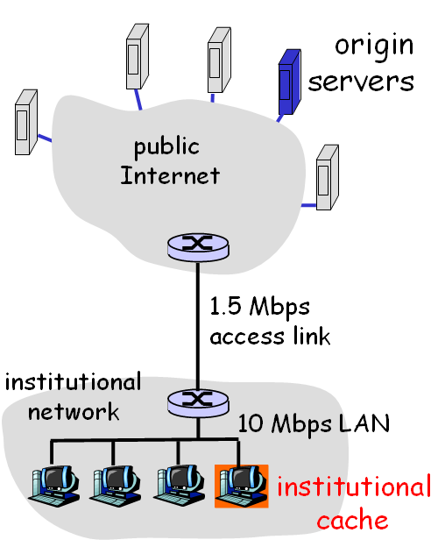

a). (7%) Find the total average response time when no institutional cache is used. [Note: you should also use the M/M/1 queue formula to calculate the delay in internal Ethernet LAN.]

*For the Internet access link: λ=14/sec, μ=1.5Mbps/100,000bit = 15/sec. So the response time on the access link is: E[Taccess] = 1/(μ-λ) = 1 second*

*For the local LAN: λ=14/sec, μ=10Mbps/100,000bit = 100/sec. So the response time on LAN is:*

*E[TLAN] = 1/(μ-λ) = 0.0116 second*

*Thus the total average response time is:*

*E[T] = E[Taccess] + Internet delay + LAN delay = 1 + 2+0.0116 = 3.0116 seconds*

b). (8%) Now suppose the institutional cache is used. The hit rate for the cache is 0.8. Find the total average response time.

*The local LAN delay does not change since its access rate is still 14/sec.*

*80% of requests hit cache and have their response time equal to local LAN delay, which is*

*E[Thit] = E[TLAN] = 0.0116 second.*

*20% of request not hit local cache and go out, thus the arrival rate on the access link is*

*λ=14*0.2 = 2.8/sec, μ is still μ=15/sec*

*The response time on the access link is E[Taccess] = 1/(μ-λ) = 0.0820 second*

*Thus the average response time for requests going out is:*

*E[Tmiss] = E[Taccess] + Internet delay + LAN delay = 0.0820 + 2 + 0.0116 = 2.0936 seconds*