Nama : Leo Saputra Hulu
NIM : 22412041
Prodi : Teknik Informatika
JAWABAN
SCRITP form_tinggiberat.php.
<html>
<head>
<title>Formulir</title>
</head>
<body>
<h1>Formulir</h1>
<form method="post" action="proses.php">
<label for="">Tinggi Badan : </label>
<input type="text" name="bil1" /> <br />
<label for="">Berat Badan : </label>
<input type="text" name="bil2" /> <br />
<input type="submit" name="submit" value="Submit" />

</form>
</body>
</html>

SCRIPT proses_tinggiberat.php

<?php
$tgiBdn = $_POST['bil1'];
$brtBdn = $_POST['bil2'];

if($tgiBdn > 100) {
echo "Tinggi Badan anda : $tgiBdn cm <br> ";
echo "Berat Badan anda : $brtBdn kg <br> ";
if($tgiBdn){
$hasil = ($tgiBdn - 100) - (0.1 * ($tgiBdn - 100));
if(abs($brtBdn - $hasil) <= 2) {
echo "Berat badan Anda termasuk ideal. <br> ";
} else {
echo "Berat badan Anda tidak termasuk ideal. <br> ";
}
echo "Berat Badan Ideal Anda adalah : $hasil <br> ";
}
} else {
echo "Silahkan masukan angka di atas 100cm <br> ";
}
?>

OUTPUT :
Form.php
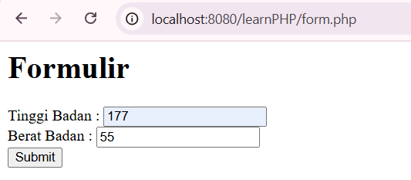
Proses.php


2.
SCRIPT set_tabel.php
<!DOCTYPE html>
<html>
<head>
<title>Set Tabel Perkalian</title>
</head>
<body>
<form action="tampil_tabel.php" method="get">
<label for="nilai">Pilih Nilai:</label>
<select name="nilai" id="nilai">
<?php
for ($i = 1; $i <= 10; $i++) {
echo "<option value='$i'>$i</option>";
}
?>
</select>

<label>Pilih Warna Heading:</label><br>
<input type="radio" id="hijau" name="warna" value="hijau">
<label for="hijau">Hijau</label><br>
<input type="radio" id="kuning" name="warna" value="kuning">
<label for="kuning">Kuning</label><br>
<input type="radio" id="biru" name="warna" value="biru">
<label for="biru">Biru</label><br>

<button type="submit">Tampilkan Tabel</button>
</form>
</body>
</html>

SCRIPT tampil_table.php
<!DOCTYPE html>
<html>
<head>
<title>Tabel Perkalian</title>
<?php
$warna = isset($_GET['warna']) ? $_GET['warna'] : 'hijau';
echo "<style>
th {
background-color: $warna;
}
</style>";
?>
</head>
<body>
<?php
$nilai = isset($_GET['nilai']) ? intval($_GET['nilai']) : 1;

function hitungPerkalian($angka1, $angka2) {
return $angka1 * $angka2;
}
?>

<table border="1">
<thead>
<tr>
<th>Angka</th>
<th>Hasil</th>
</tr>
</thead>
<tbody>
<?php
for ($i = 1; $i <= 10; $i++) {
$hasil = hitungPerkalian($nilai, $i);
echo "<tr>
<td>$nilai x $i</td>
<td>$hasil</td>
</tr>";
}
?>
</tbody>
</table>
</body>
</html>

OUTPUT:
Set_table.php
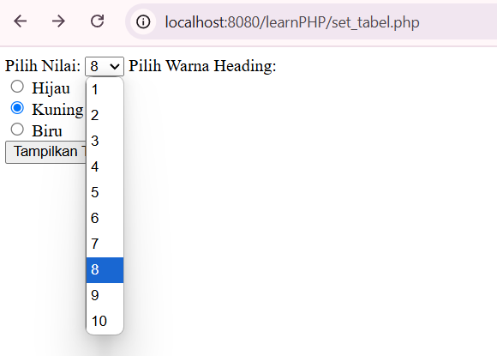
Tampil_table.php
