Computer Hardware Experiments

Lab_02: Using Port Map

Name : Student_ID:

Purpose:

To understand the basic usage of port map.

Part 1: Design a one bit half adder.

To understand one bit half adder as following:

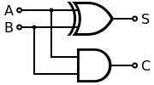

Here, 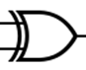 is a XOR gate, 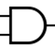is an AND gate.

You should design the XOR gate and the AND gate respectively, and then combine them to build a half adder using PORT MAP.

The adder should include the entity named “halfadder” as following:

--------------------------
entity halfadder is
Port ( A : in STD_LOGIC;
B : in STD_LOGIC;
S : out STD_LOGIC;
C : out STD_LOGIC);
end halfadder;
--------------------------

Simulate the design by using the following commands:

--------------------------
ISim > restart
ISim > put A 0
ISim > put B 1
ISim > run 10ns
ISim > put A 1
ISim > put B 1
ISim > run 10ns
ISim > put A 1
ISim > put B 0
ISim > run 10ns
ISim > put A 0
ISim > put B 0
ISim > run 10ns
ISim >
--------------------------

Part 2: Design a one bit full adder using port map and two half adders.

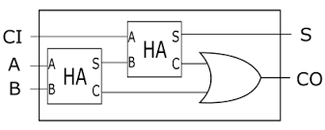

The adder should include the entity named “fulladder” as following:

--------------------------
entity fulladder is
Port ( A : in STD_LOGIC;
B : in STD_LOGIC;
Cin : in STD_LOGIC;
S : out STD_LOGIC;
Cout : out STD_LOGIC);
end fulladder;
--------------------------

Simulate the design by using the following commands:

--------------------------
ISim > restart
ISim > put A 0
ISim > put B 1
ISim > put Cin 1
ISim > run 10ns
ISim > put A 1
ISim > put B 1
ISim > put Cin 0
ISim > run 10ns
ISim > put A 0
ISim > put B 1
ISim > put Cin 0
ISim > run 10ns
ISim > put A 1
ISim > put B 1
ISim > put Cin 1
ISim > run 10ns
ISim >
--------------------------

Part 3: Write the experiment report.

The report should be composed of
- The VHDL source code;
- The simulation waveform.

