Computer Hardware Experiments

Lab_03: Digital Display and Gray Codes

Name : Student_ID:

Purpose:

To understand the basic usage of combinational statement.

In this experiment, you are going to design a digital display using when/else statement and with/select/when statement.

1. At first, you need to understand the digital display:

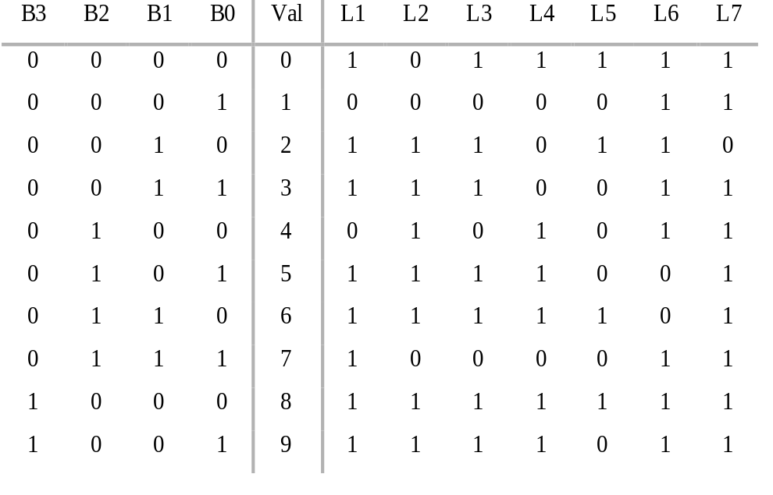
L1
L
6
L2
L3
L
7
L
4
L
5

According to the truth table above, you can design the VHDL statement to express the following digital (0~9).

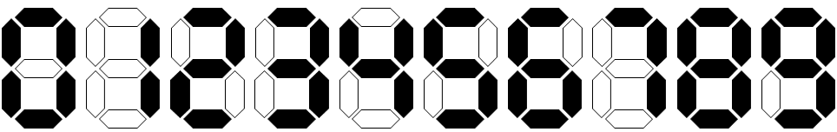

You need to test all the digital numbers and check if their corresponding LEDs are showing correctly via using the commands as below:

--------------------------
ISim > restart
ISim > put B0 0
ISim > put B1 0
ISim > put B2 0
ISim > put B3 0
ISim > run 10ns
ISim > put B0 0
ISim > put B1 0
ISim > put B2 0
ISim > put B3 1
ISim > run 10ns
……
--------------------------

--------------------------
ISim > restart
ISim > put B “0000”
ISim > run 10ns
ISim > put B “0001”
ISim > run 10ns
……
--------------------------

--------------------------
ISim > restart
ISim > put B 0 -radix dec
ISim > run 10ns
ISim > put B 1 -radix dec
ISim > run 10ns
……
--------------------------

2. The reflected binary code (RBC), also known just as reflected binary (RB) or Gray code after Frank Gray, is an ordering of the binary numeral system such that two successive values differ in only one bit (binary digit). The reflected binary code was originally designed to prevent spurious output from electromechanical switches. Today, Gray codes are widely used to facilitate error correction in digital communications such as digital terrestrial television and some cable TV systems.

You can implement the Gray code system as following table or the algorithm to iteratively generate the (N, k)-Gray code as presented (in C):

Decimal | Binary | Gray
0 | 0000 | 0000
1 | 0001 | 0001
2 | 0010 | 0011
3 | 0011 | 0010
4 | 0100 | 0110
5 | 0101 | 0111
6 | 0110 | 0101
7 | 0111 | 0100
8 | 1000 | 1100
9 | 1001 | 1101
10 | 1010 | 1111
11 | 1011 | 1110
12 | 1100 | 1010
13 | 1101 | 1011
14 | 1110 | 1001
15 | 1111 | 1000

Converting to and from Gray code
The following functions in C convert between binary numbers and their associated Gray codes. While it may seem that gray-to-binary conversion requires each bit to be handled one at a time, faster algorithms exist.^{[24]}
/*
* This function converts an unsigned binary
* number to reflected binary Gray code.
*
* The operator >> is shift right. The operator ^ is exclusive or (xor).
*/
unsigned int binaryToGray(unsigned int num)
{
return num ^ (num >> 1);
}

/*
* This function converts a reflected binary
* Gray code number to a binary number.
* Each Gray code bit is exclusive-ored with all
* more significant bits.
*/
unsigned int grayToBinary(unsigned int num)
{
unsigned int mask = num;
while (mask != 0)
{
mask = mask >> 1;
num = num ^ mask;
}
return num;
}

/*
* A more efficient version for gray codes 32 bits or fewer
* through the use of SWAR (SIMD within a register) techniques.
* It implements a parallel prefix XOR function.
*
* This function can be adapted for longer gray codes by adding steps.
* A 4-bit variant changes a binary number (abcd)2 to (abcd)2 ^ (00ab)2,
* then to (abcd)2 ^ (00ab)2 ^ (0abc)2 ^ (000a)2.
*/
unsigned int grayToBinary32(unsigned int num)
{
num = num ^ (num >> 16);
num = num ^ (num >> 8);
num = num ^ (num >> 4);
num = num ^ (num >> 2);
num = num ^ (num >> 1);
return num;
}

To use the “shift left and shift right operator”, we need to include the arith/unsigned/numeric package:

library IEEE;
use IEEE.STD_LOGIC_1164.ALL;
use ieee.std_logic_arith.all;
use ieee.std_logic_unsigned.all;
use ieee.numeric_std.all;

then, the GrayNum and BinaryNum should be defined as bit_vector,

entity GrayEncoder is
Port (BinaryNum : in bit_vector (3 downto 0);
GrayNum : out bit_vector (3 downto 0));
end GrayEncoder;

you can use “sll” and “srl” to implement the shift left and shift right operator as the below example:

GrayNum <= BinaryNum xor (BinaryNum srl 1);

You need to test all the decimal numbers (0-9) and check if their corresponding Gray codes are showing correctly via using the commands as below:

ISim > restart
ISim > put D 0 -radix dec
ISim > put D 1 -radix dec
ISim > put D 2 -radix dec
ISim > put D 3 -radix dec
ISim > put D 4 -radix dec
ISim > put D 5 -radix dec
ISim > put D 6 -radix dec
ISim > put D 7 -radix dec
ISim > put D 8 -radix dec
ISim > put D 9 -radix dec

And then, you need to write the experiment report.

The report should be composed of
- The VHDL source code;
- The simulation waveform.

