Computer Hardware Experiments

Lab_04: Accumulator

Name : Student_ID:

Purpose:

To understand the basic usage of sequential statement.

Part 1: In this part, you are going to design an accumulator using IF statement. The accumulator is written as the formula as below:

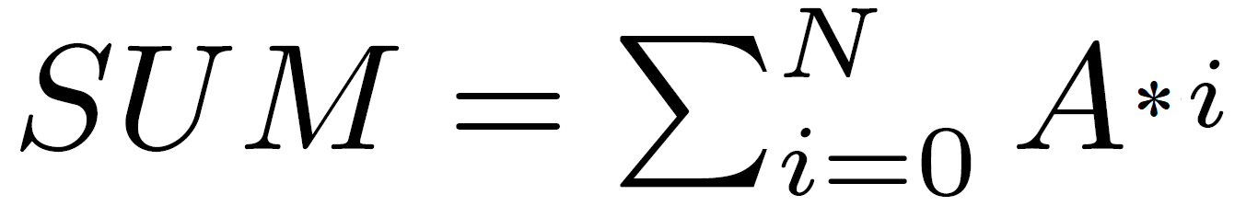

Here, A is an input signal, SUM is an output signal. A clock signal (e.g. clk) should be used. The accumulator performs one operation according to clk (clk’event and clk = ‘1’). N is set as 10 initially.

And then, you need to write the experiment report.

The report should be composed of
- The VHDL source code;
- The simulation waveform.

