**專案管理系統 HW6**

**Team member:**

105598003 劉彥麟

105598048 陳政皓

105598074 呂昭陞

目錄

1 Requirement Document 3

1.1 Change History 3

1.2 Problem Statement 4

1.3 System Context Diagram 5

1.4 Summary of System Features 5

1.5 Use Case Diagram 6

1.6 Use Cases 7

1.7 Non-functional Requirements and Constraints 15

1.8 Glossary 15

1.9 Software Environments 15

2 Domain model 16

2.1 Domain class diagram showing only concepts 16

2.2 Add Associations 17

2.3 Add Attributes 18

Measurement 19

1 Requirement Document

1.1 Change History

|  |  |  |
| --- | --- | --- |
| Revision | Description | Date |
| Iteration I | | |
| 1 | Problem statement.  The Development language.  Measurement. | Feb 24, 2017 |
| 2 | System Context Diagram Summary of system features Use case diagram Use cases Non-functional Requirements and Constraints Glossary Measurement. | Mar 14,2017 Mar 15,2017 Mar 16,2017 Mar 17,2017 |
| 3 | Domain class diagram showing only concepts  Add Associations  Add Attributes | Mar 30,2017 |
| 4 | Add Associations  Add Attributes  Logical Architecture  Use-Case Realizations with GRASP Patterns  Design Class Model | April 22,2017 |
| Iteration II | | |
| 1 | Use Case Diagram  Use Cases  Domain class diagram showing only concepts  Add Associations  Add Attributes | May 25,2017 |

1.2 Problem Statement

本軟體主要是為了讓專案管理者和開發人員可以追蹤專案進度與需求而設計。應用於各軟體開發公司或實驗室。

現今軟體的規模較複雜，軟體的需求時常改變，因此在管理與追蹤需求上會有難度，沒有一套系統可以用來追蹤與更新這些需求完成與否，導致需要花額外的心力和成本去關注專案的進度。

本軟體提供簡單的介面可以管理專案需求與測試，讓使用者可以清楚明白兩者間的關係，並且能有系統的管理專案

本軟體主要以圖形介面呈現，使用者一開始需要把專案的需求與測試項目新增至本軟體，軟體會依據使用者新增的內容，產生需求與測試的關係圖，讓使用者知道需求與測試的關係和完成狀態。

1.3 System Context Diagram

C:\Users\leo\Downloads\use case (2).png

* Manager:

Login: 登入

Management Project: 管理專案

Management Requirement: 管理需求

Management Test: 管理測試

View Project、Requirement、Test: 檢視專案、需求、測試

產生報表traceability matrix

* User:

Register、Login: 註冊、登入

View Project、Requirement、Test: 檢視專案、需求、測試

產生報表traceability matrix

* DB:

CRUD: 新增、查詢、修改、刪除

1.4 Summary of System Features

|  |  |
| --- | --- |
| Feature ID | Description |
| FEA-01 | Register |
| FEA-02 | Login |
| FEA-03 | Management Project |
| FEA-04 | Management Requirement |
| FEA-05 | Management Test |
| FEA-06 | CRUD DB |
| FEA-07 | View Project Requirement Test |
| FEA-08 | Create traceability matrix |

1.5 Use Case Diagram

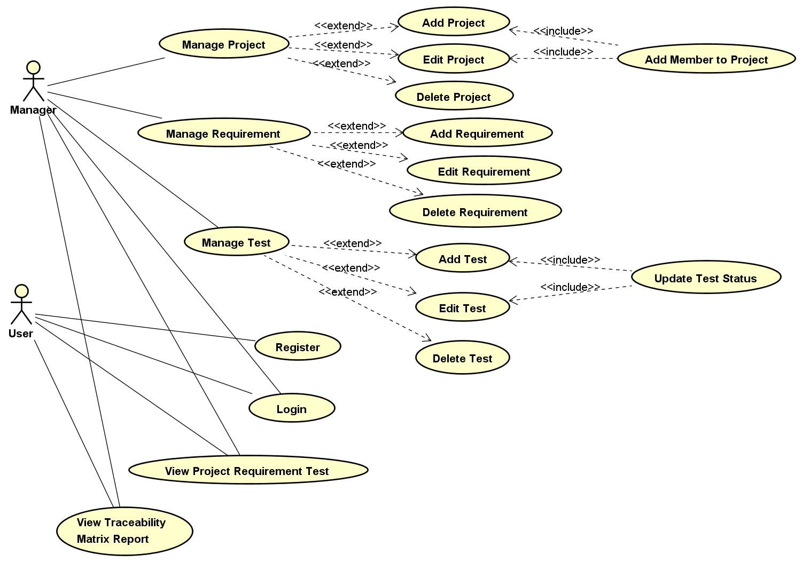

1.6 Use Cases

1.6.1Register

|  |  |
| --- | --- |
| Use Case Section | Comment |
| Use Case Name | Register Account |
| Scope | PMS Application |
| Level | user goal |
| Primary Actor | User |
| Stakeholders and Interests | User: 想要進入系統，必須先註冊帳號 |
| Preconditions | 你必須要是Team的member |
| Success Guarantee | 成功創建使用者帳號 |
| Main Success Scenario | 1. User點選註冊按鈕 2. User輸入使用者資訊 3. 系統將使用者資訊寫入資料庫 4. User完成註冊 |
| Extensions | 2a 系統偵測到使用者重覆的狀況   1. 要能跳出警告訊息要求使用者再輸入一次   3a 資料庫存取異常   1. 出現錯誤訊息視窗 |
| Special Requirements | UI友善 |
| Technology and Data Variations List | 2a 密碼格式不可以包含符號 |
| Frequency of Occurrence | 偶爾發生(第一次使用系統需要註冊時) |
| Miscellaneous | 非公司員使用這個系統，但註冊了，應該怎麼處理 |

1.6.2 Login

|  |  |
| --- | --- |
| Use Case Section | Comment |
| Use Case Name | Login Account |
| Scope | PMS Application |
| Level | user goal |
| Primary Actor | User、Manager |
| Stakeholders and Interests | User: 想要進入系統，必須先登入帳號  Manager: 想要進入系統，必須先登入帳號 |
| Preconditions | 你必須要是Team的member or leader |
| Success Guarantee | 成功登入 |
| Main Success Scenario | 1. 點選登入 2. 輸入帳號、密碼 3. 系統驗證帳號、密碼 4. 成功登入 |
| Extensions | 2a 如果輸入帳密不正確   1. 跳出警告視窗 |
| Special Requirements | UI友善 |
| Technology and Data Variations List | 2a 密碼格式不可以包含符號 |
| Frequency of Occurrence | 偶爾發生(使用系統需要登入時) |
| Miscellaneous | None |

1.6.3 Add Project

|  |  |
| --- | --- |
| Use Case Section | Comment |
| Use Case Name | Add Project |
| Scope | PMS Application |
| Level | user goal |
| Primary Actor | Manager |
| Stakeholders and Interests | Manager: 想要建立專案 |
| Preconditions | 必須是Manager，且要登入系統 |
| Success Guarantee | 能新增專案 |
| Main Success Scenario | 1. Manager登入並識別身分 2. Manager建立專案 3. Manager選擇成員進專案 4. 資料庫新增專案資料 5. 主畫面會新增一筆專案提供使用者檢視 |
| Extensions | 2a 專案名稱、描述為空或重覆   1. 跳出警告視窗提示錯誤   1.a:使用者點選確認:回到新增畫面 |
| Special Requirements | UI友善 |
| Technology and Data Variations List | None |
| Frequency of Occurrence | 經常發生(Manager新建專案的時候) |
| Miscellaneous | None |

1.6.4 Edit Project

|  |  |
| --- | --- |
| Use Case Section | Comment |
| Use Case Name | Edit Project |
| Scope | PMS Application |
| Level | user goal |
| Primary Actor | Manager |
| Stakeholders and Interests | Manager: 想要編輯專案 |
| Preconditions | 必須是Manager，且要登入系統 |
| Success Guarantee | 能編輯專案 |
| Main Success Scenario | 1. Manager登入並識別身分 2. Manager編輯專案 3. Manager編輯專案底下的成員 4. 資料庫更新專案資料 5. 主畫面會刷新專案資料提供使用者檢視 |
| Extensions | 2a 專案名稱、描述為空或重覆   1. 跳出警告視窗提示錯誤   1.a:使用者點選確認:回到編輯畫面 |
| Special Requirements | UI友善 |
| Technology and Data Variations List | None |
| Frequency of Occurrence | 經常發生(Manager編輯專案的時候) |
| Miscellaneous | None |

1.6.5 Delete Project

|  |  |
| --- | --- |
| Use Case Section | Comment |
| Use Case Name | Edit Project |
| Scope | PMS Application |
| Level | user goal |
| Primary Actor | Manager |
| Stakeholders and Interests | Manager: 想要刪除專案 |
| Preconditions | 必須是Manager，且要登入系統 |
| Success Guarantee | 能刪除專案 |
| Main Success Scenario | 1. Manager登入並識別身分 2. Manager刪除專案 3. 資料庫刪除專案資料 4. 主畫面會刷新專案資料確保專案刪除 |
| Extensions | None |
| Special Requirements | UI友善 |
| Technology and Data Variations List | None |
| Frequency of Occurrence | 經常發生(Manager刪除專案的時候) |
| Miscellaneous | None |

1.6.6 Add Requirement

|  |  |
| --- | --- |
| Use Case Section | Comment |
| Use Case Name | Add Requirement |
| Scope | PMS Application |
| Level | user goal |
| Primary Actor | Manager |
| Stakeholders and Interests | Manager: 想要建立需求 |
| Preconditions | 必須是Manager，且系統需有專案 |
| Success Guarantee | 能建立需求 |
| Main Success Scenario | 1. Manager登入並識別身分 2. Manager建立需求 3. 資料庫新增需求資料 4. 主畫面會新增需求在所屬專案下提供使用者檢視 |
| Extensions | 2a 需求名稱、描述為空或重覆  1. 跳出警告視窗提示錯誤  1.a:使用者點選確認:回到新增畫面 |
| Special Requirements | UI友善 |
| Technology and Data Variations List | None |
| Frequency of Occurrence | 經常發生(Manager新增需求的時候) |
| Miscellaneous | None |

1.6.7 Edit Requirement

|  |  |
| --- | --- |
| Use Case Section | Comment |
| Use Case Name | Edit Requirement |
| Scope | PMS Application |
| Level | user goal |
| Primary Actor | Manager |
| Stakeholders and Interests | Manager: 想要編輯需求 |
| Preconditions | 必須是Manager，且系統需有專案 |
| Success Guarantee | 能編輯需求 |
| Main Success Scenario | 1. Manager登入並識別身分 2. Manager編輯需求 3. 資料庫更新需求資料 4. 主畫面會在所屬專案下更新需求資料提供使用者檢視 |
| Extensions | 2a 需求名稱、描述為空或重覆  1. 跳出警告視窗提示錯誤  1.a:使用者點選確認:回到編輯畫面 |
| Special Requirements | UI友善 |
| Technology and Data Variations List | None |
| Frequency of Occurrence | 經常發生(Manager編輯需求的時候) |
| Miscellaneous | None |

1.6.8 Delete Requirement

|  |  |
| --- | --- |
| Use Case Section | Comment |
| Use Case Name | Delete Requirement |
| Scope | PMS Application |
| Level | user goal |
| Primary Actor | Manager |
| Stakeholders and Interests | Manager: 想要刪除需求 |
| Preconditions | 必須是Manager，且系統需有專案 |
| Success Guarantee | 能刪除需求 |
| Main Success Scenario | 1. Manager登入並識別身分 2. Manager刪除需求 3. 資料庫刪除需求資料 4. 主畫面會在所屬專案下刪除需求資料並更新畫面 |
| Extensions | none |
| Special Requirements | UI友善 |
| Technology and Data Variations List | None |
| Frequency of Occurrence | 經常發生(Manager刪除需求的時候) |
| Miscellaneous | None |

1.6.9 Add Test

|  |  |
| --- | --- |
| Use Case Section | Comment |
| Use Case Name | Add Test |
| Scope | PMS Application |
| Level | user goal |
| Primary Actor | Manager |
| Stakeholders and Interests | Manager: 想要建立測試 |
| Preconditions | 必須是Manager，且系統需有專案和需求 |
| Success Guarantee | 能新增測試 |
| Main Success Scenario | 1. Manager登入並識別身分 2. Manager新增測試 3. Manager新增測試狀態 4. 資料庫新增測試資料 5. 主畫面會在所屬專案下新增測試資料並更新畫面 |
| Extensions | 2a 測試名稱、描述為空或重覆  1. 跳出警告視窗提示錯誤  1.a:使用者點選確認:回到新增畫面 |
| Special Requirements | UI友善 |
| Technology and Data Variations List | None |
| Frequency of Occurrence | 經常發生(Manager新增測試的時候) |
| Miscellaneous | None |

1.6.10 Edit Test

|  |  |
| --- | --- |
| Use Case Section | Comment |
| Use Case Name | Edit Test |
| Scope | PMS Application |
| Level | user goal |
| Primary Actor | Manager |
| Stakeholders and Interests | Manager: 想要編輯測試 |
| Preconditions | 必須是Manager，且系統需有專案和需求 |
| Success Guarantee | 能編輯測試 |
| Main Success Scenario | 1. Manager登入並識別身分 2. Manager編輯測試 3. Manager編輯測試狀態 4. 資料庫更新測試資料 5. 主畫面會在所屬專案下更新測試資料並更新畫面 |
| Extensions | 2a 測試名稱、描述為空或重覆  1. 跳出警告視窗提示錯誤  1.a:使用者點選確認:回到編輯畫面 |
| Special Requirements | UI友善 |
| Technology and Data Variations List | None |
| Frequency of Occurrence | 經常發生(Manager編輯測試的時候) |
| Miscellaneous | None |

1.6.11 Delete Test

|  |  |
| --- | --- |
| Use Case Section | Comment |
| Use Case Name | Delete Test |
| Scope | PMS Application |
| Level | user goal |
| Primary Actor | Manager |
| Stakeholders and Interests | Manager: 想要刪除測試 |
| Preconditions | 必須是Manager，且系統需有專案和需求 |
| Success Guarantee | 能刪除測試 |
| Main Success Scenario | 1. Manager登入並識別身分 2. Manager刪除測試 3. 資料庫刪除測試資料 4. 主畫面會在所屬專案下刪除測試資料並更新畫面 |
| Extensions | None |
| Special Requirements | UI友善 |
| Technology and Data Variations List | None |
| Frequency of Occurrence | 經常發生(Manager新增測試的時候) |
| Miscellaneous | None |

1.6.12 View Project Requirement Test

|  |  |
| --- | --- |
| Use Case Section | Comment |
| Use Case Name | View Project、Requirement、Test |
| Scope | PMS Application |
| Level | user goal |
| Primary Actor | Manager、User |
| Stakeholders and Interests | Manager: 想要看到目前管理的專案，他底下的需求與測試項目、內容  User: 想要看到目前參與的專案，他底下的需求與測試項目、內容 |
| Preconditions | 必須是Manager或User，且要登入系統 |
| Success Guarantee | Manager: 看到目前管理的專案，他底下的需求與測試項目、內容  User: 看到目前參與的專案，他底下的需求與測試項目、內容 |
| Main Success Scenario | 1. 點選PMS 2. 登入並驗證 3. 看到自己所屬的專案、需求、測試列表 |
| Extensions | None |
| Special Requirements | UI友善 |
| Technology and Data Variations List | None |
| Frequency of Occurrence | 經常發生 |
| Miscellaneous | None |

1.6.13 Create traceability matrix

|  |  |
| --- | --- |
| Use Case Section | Comment |
| Use Case Name | Create traceability matrix |
| Scope | PMS Application |
| Level | user goal |
| Primary Actor | Manager、User |
| Stakeholders and Interests | Manager: 想要看到目前管理的專案，他底下的需求與測試狀況  User: 想要看到目前參與的專案，他底下的需求與測試狀況 |
| Preconditions | 必須是Manager或User，且要登入系統，至少有1個所屬專案 |
| Success Guarantee | 能看到traceability Matrix報表 |
| Main Success Scenario | 1. 點開PMS系統 2. 登入並識別身分 3. 選擇想要看到的專案報表 4. 產生追溯報表(Traceability Matrix) 5. 使用者看到報表 |
| Extensions | None |
| Special Requirements | UI友善 |
| Technology and Data Variations List | None |
| Frequency of Occurrence | 經常發生(Manager、User需要持續追蹤報表) |
| Miscellaneous | None |

1.7 Non-functional Requirements and Constraints

|  |  |  |
| --- | --- | --- |
| NFR ID | Category | Description |
| NFR‐01 | Usability | 提供友善的介面讓使用者管理專案、需求、測試 |
| NFR‐02 | Performance | DB操作時間可以在短時間內完成 |
| NFR‐03 | Performance | 更新資料後，能在短時間內刷新頁面 |
| NFR‐04 | Reliability | 確保從資料庫讀出的資料格式的正確性 |
| NFR‐05 | Reliability | 確保SQL安全性，防止SQL injection |

1.8 Glossary

|  |  |
| --- | --- |
| Item | Definition or Description |
| PMS | Project Management System(專案管理系統) |
| Traceability matrix | 雙向追溯矩陣(需求與測試狀態關係圖) |
| Manager | 專案管理者 |
| User | 專案下的員工 |
| CRUD | 資料庫新增、查詢、修改、刪除 |

1.9 Software Environments

本專案採用C#開發

2 Domain model

2.1 Domain class diagram showing only concepts

先從Use Case找出各個可能的Classes Identified

|  |  |  |  |
| --- | --- | --- | --- |
| Project | Requirement | Test | User |
| Manager | Traceability Matrix | Account | Member |
| Error Message | Internet | Requirement Description | Requirement Name |
| Project Description | Project Name | Test Description | Test Name |
| Account | Password | identity | PMS |
| Test Status |  |  |  |

根據上方找出的各個可能的Class，整理出Bad Classes

|  |  |  |  |  |
| --- | --- | --- | --- | --- |
| Attributes | Vague | Operation | Roles | Implementation Construction |
| Password | Internet | Error Message | PMS |  |
| Account |  |  | Member |  |
| Project Name |  |  | Manager |  |
| Project Description |  |  |  |  |
| Requirement Name |  |  |  |  |
| Requirement Description |  |  |  |  |
| Test Name |  |  |  |  |
| Test Description |  |  |  |  |
| identity |  |  |  |  |
| Test Status |  |  |  |  |

* Attributes：屬於某個Class的屬性
* Vague：模糊不清，可忽視
* Operation：操作步驟中的ㄧ部份
* Roles：為某角色、操作介面
* Implementation Construction：建構系統的架構

本專案適合的Class

|  |  |
| --- | --- |
| Traceability Matrix | User |
| Project | Requirement |
| Test | Model |

註: 因為在設計上會採用Model作為所有資料的操作控管，因此會有Model這個Class。

2.2 Add Associations

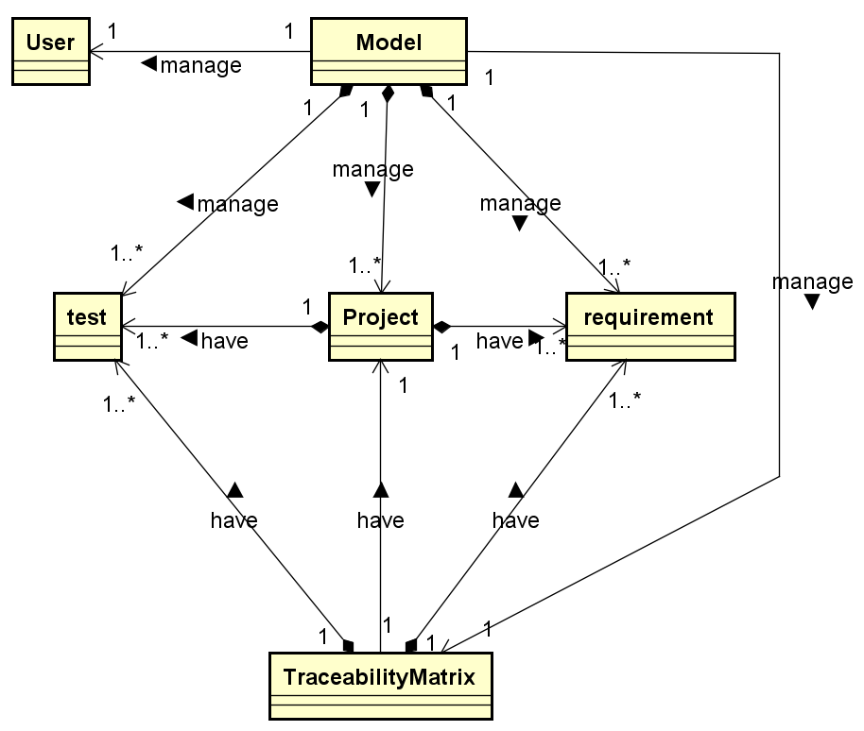

|  |
| --- |
| Relationships |
| Model管理某個User |
| Model管理某個Traceability Matrix |
| Model管理多個Project |
| Model管理多個Requirement |
| Model管理多個Test |
| Project擁有多個Requirement |
| Project擁有多個Test |
| Traceability Matrix擁有某個Project的資訊 |
| Traceability Matrix擁有某個Project的多個Requirement的資訊 |
| Traceability Matrix擁有某個Project的多個Test的資訊 |

2.3 Add Attributes

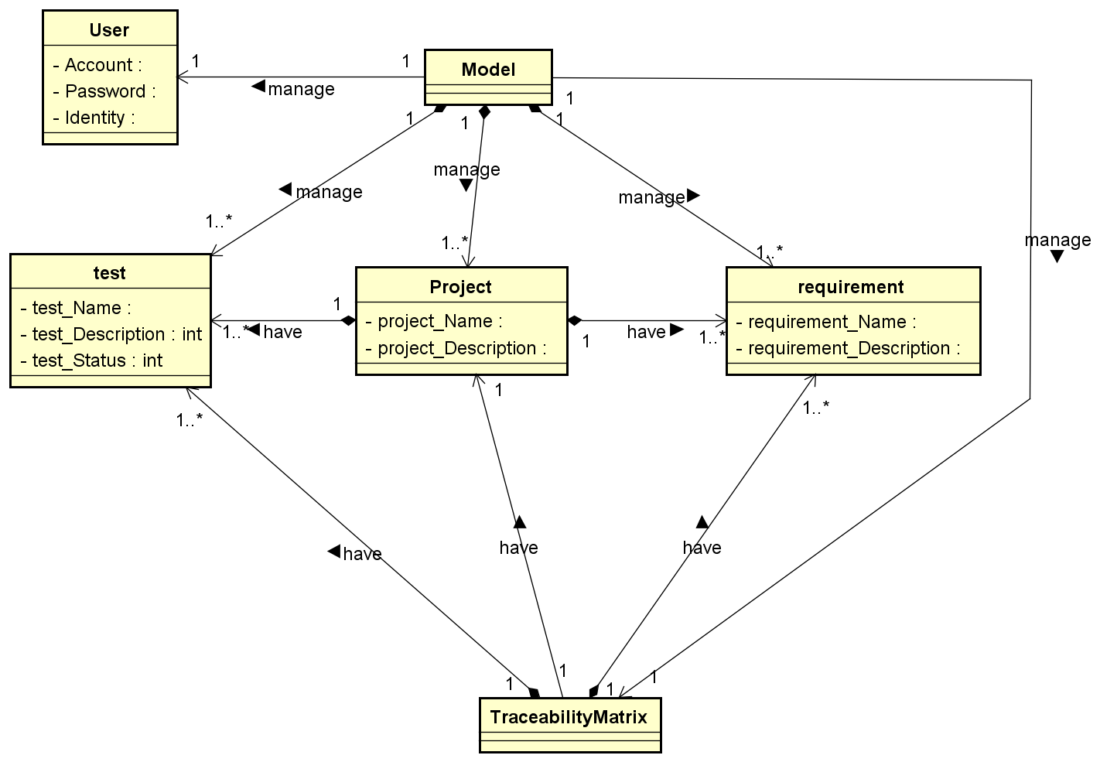

Measurement

|  |  |  |  |  |  |
| --- | --- | --- | --- | --- | --- |
| 105598003劉彥麟 | | 105598048陳政皓 | | 105598074呂昭陞 | |
| #HW1 | | | | | |
| 2017/02/24 14:30 ~ 16:30 | 2HR | 2017/02/24 14:30 ~ 16:30 | 2HR | 2017/02/24 14:30 ~ 16:30 | 2HR |
| Total | 2HR | Total | 2HR | Total | 2HR |
| #HW2 | | | | | |
| 2017/03/14 15:30 ~ 18:30 | 3HR | 2017/03/14 15:30 ~ 18:30 | 3HR | 2017/03/14 15:30 ~ 18:30 | 3HR |
| 2017/03/15 14:00 ~ 15:15 | 1.2HR | 2017/03/15 14:00 ~ 15:15 | 1.2HR | 2017/03/15 14:00 ~ 15:15 | 1.2HR |
| 2017/03/16 14:30 ~ 16:30 | 2HR | 2017/03/16 14:30 ~ 16:30 | 2HR | 2017/03/16 14:30 ~ 16:30 | 2HR |
| 2017/03/17 1030 ~ 11:30 | 1HR | 2017/03/17 10:30 ~ 11:30 | 1HR | 2017/03/17 10:30 ~ 11:30 | 1HR |
| Total | 7.2HR | Total | 7.2HR | Total | 7.2HR |
| #HW3 | | | | | |
| 2017/03/30 10:00 ~ 12:00 | 2HR | 2017/03/30 10:00 ~ 12:00 | 2HR | 2017/03/30 10:00 ~ 12:00 | 2HR |
| Total | 2HR | Total | 2HR | Total | 2HR |
| #HW4 | | | | | |
| 2017/04/21 10:00 ~ 11:00 | 1HR | 2017/04/21 10:00 ~ 11:00 | 1HR | 2017/04/21 10:00 ~ 11:00 | 1HR |
| 2017/04/21 14:00 ~ 17:00 | 3HR | 2017/04/21 14:00 ~ 17:00 | 3HR | 2017/04/21 14:00 ~ 17:00 | 3HR |
| 2017/04/22 14:00 ~ 18:00 | 4HR | 2017/04/22 14:00 ~ 18:00 | 4HR | 2017/04/22 14:00 ~ 18:00 | 4HR |
| Total | 8HR | Total | 8HR | Total | 8HR |
| #HW5 | | | | | |
| 2017/05/04  11:00~12:00 | 1HR | 2017/05/04  11:00~12:00 | 1HR | 2017/05/04  11:00~12:00 | 1HR |
| 2017/05/04  20:00~21:00 | 1HR | 2017/05/04  20:00~21:00 | 1HR | 2017/05/04  20:00~21:00 | 1HR |
| 2017/05/05  10:00~12:00 | 2HR | 2017/05/05  10:00~12:00 | 2HR | 2017/05/05  10:00~12:00 | 2HR |
| 2017/05/06  13:00~18:00 | 5HR | 2017/05/06  13:00~18:00 | 5HR | 2017/05/06  13:00~18:00 | 5HR |
| 2017/05/07  14:00~18:00 | 4HR | 2017/05/07  14:00~18:00 | 4HR | 2017/05/07  14:00~18:00 | 4HR |
| Total | 13HR | Total | 13HR | Total | 13HR |
| #HW6 | | | | | |
| 2017/05/25  10:30~12:00 | 1.5HR | 2017/05/25  10:30~12:00 | 1.5HR | 2017/05/25  10:30~12:00 | 1.5HR |
| 2017/05/25  16:30~17:30 | 1HR | 2017/05/25  16:30~17:30 | 1HR | 2017/05/25  16:30~17:30 | 1HR |
| Total | 2.5HR | Total | 2.5HR | Total | 2.5HR |