Create a short document (1-2 pages) in your github describing the data wrangling steps that you undertook to clean your capstone project data set. What kind of cleaning steps did you perform? How did you deal with missing values, if any? Were there outliers, and how did you decide to handle them? This document will eventually become part of your milestone report.

All the data used in this project is from IPUMS, which is an organization provides census and survey data from around the world integrated across time and space. The dataset (following referred as IPUMS dataset) is generated from a survey conducted in 2010 on recent college graduates. Features regarding participant’s education and occupation information were collected.
Inside IPUMS dataset, there are totally 125 variables, of which a complete list can be viewed on https://github.com/YongjiangLeoLiu/springboard_capstone_project/blob/master/data_metadata/IMPUS_dataset_feature_list.xlsx. Below is a display of ten features, giving an impression of what these variables look like:
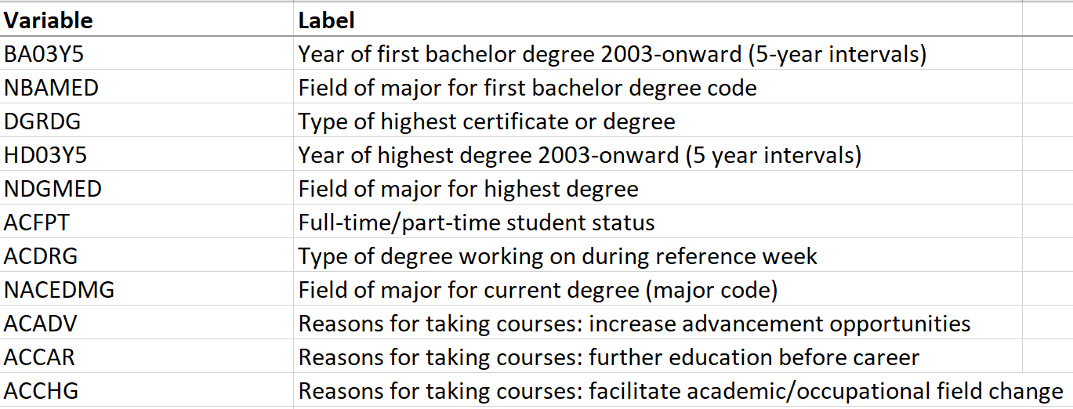
After exploring, no missing value was found inside IPUMS dataset. However, here are still 3 parts require further processing:
- “logical skip” value
- outliers
- categorical data
The reason we have “logical skip” value is because some variables included in the survey used specific number standing for “logical skip”, especially those categorical features. Let’s take ACCAR (which means reasons for taking courses: further education before career) for example. Participants can choose either 0 or 1 for this question, corresponding to “yes” and “no” separately. But if the participant never took any courses, then the best response to give should be “not applicable”, which is “logical skip” in this survey. Number 98, 99 and sometimes 9999998 are used to represent such responses.
For the second thing, there are some outliers under the feature “SALARY”. Careful analysis reveals that this is actually another form of “logical skip” or “missing value”. All outliers under column “SALARY” have a value of 999998. This is not a true numerical value. If a participant failed to give an answer of the salary questions, for whatever reason, then the system will automatically denote it as 999998.
The last thing is about the categorical data. 90% of all the features lies in this family, while the remaining such as “AGE” are numerical data. It is better to separate to two parts, as well as converting all categorical ones to dummy variables, which will help further machine learning processing.
To fix these issues, all “logical skip” values and outliers are replaced with nan value in python. Following that, IPUMS dataset is cut into two parts: numerical and categorical. All categorical features are then converted to dummy variables, with nan columns removed. After that, two parts are merged together. At last, all the observations containing any nan value (which in fact only remains under “SALARY” columns after previous processing) are deleted. This step is performed because merely 2033 rows still have nan value, which is relatively small compared to IPUMS dataset’s volume: 12274 observations. (All steps can be found here: https://github.com/YongjiangLeoLiu/springboard_capstone_project/blob/master/first_capstone_project.ipynb)
The dataset after wrangling has no nan value nor outliers, and all features are tuned properly for further machine learning training.

