Home Task

Elevators

Base

Plan an elevator system according to the following requirements:

- The building has 10 foors (including ground foor) and 5 elevators.

- Near each foor, present a green button to call an elevator
Calling an elevator

Change the “call” button to red, and change the text to “waiting”

Identify the closet elevator to the foor, and send the elevator to that foor

There's a chance all the elevators will be occupied at that moment

Do not miss any calls (queue?)

The elevator should move toward the select foor in a smooth movement

Measure the time it took the elevator to reach the designated foor

Change the elevator color to red

Elevator reached the floor

- Make a sound when the elevator reaches the foor

- Change the elevator color to green

- Wait 2 seconds before moving to the next call (If exists)

- Change the button text to “arrived” and the design according to the design below

- After the 2 seconds, change the elevator color back to black, and change the button to “call”, with the initial design

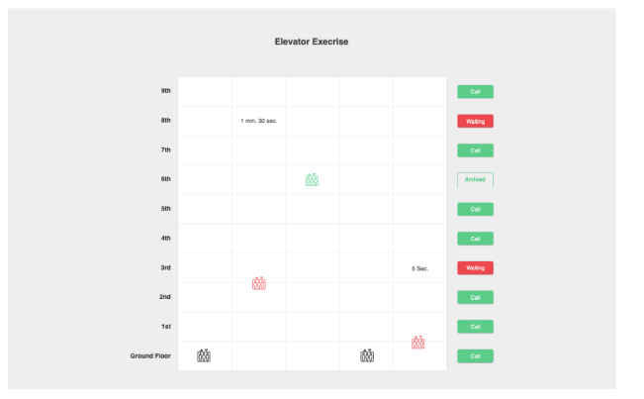

Technical

- Create a clear design infrastructure (CSS/SCSS))

- Create an entry point to the application, for your choosing

- Try to follow the design as much as possible

- Elevator SVG fle can be found here
Conclusion

- The purpose of the exrc is to test the infrastructure and the design of your code, but we the solution should also work as expected

- Please use one of the following frameworks

  - Vanilla (Native JS)

- No need to build the HTML in JS (example elem.createElement(‘div’)) permission)

Good Luck,

