<https://github.com/roberthsu2003/iot_20180901/>

CH341SE: <http://www.wch.cn/download/CH341SER_EXE.html>

# 零組件

1.R3相容控制板(內建電壓警示)  
2.Appsduino內建感測器實驗擴充版  
3.Zigbee無線通訊擴充板(RO/2 mV)  
4.Zigbee無線通訊擴充板(CO/2 mV)  
5.2路5V繼電器模組

感測器套組:  
1.藍芽模組(Master/Slave)

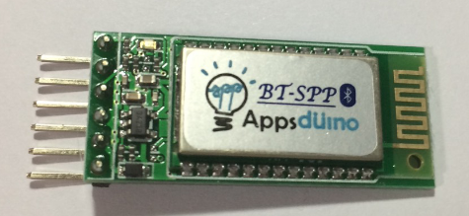  
2.串列WiFi模組

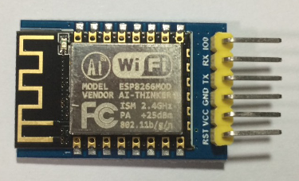  
3.Mifare RFID讀寫模組 (13.56 Mhz)讀寫模組 (Tag X2)

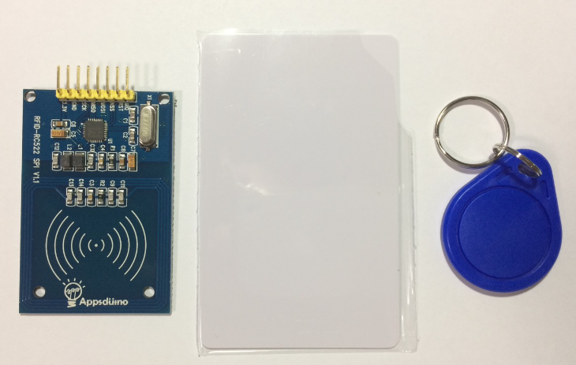  
4.I2C 1602 LCD

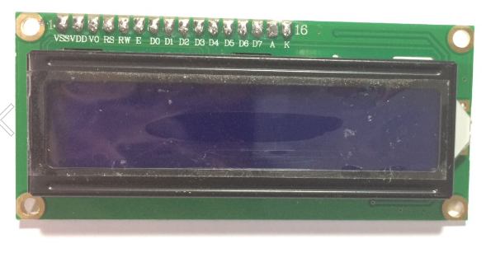  
5.I2C數位溫濕度感測模組 (I2C HTU21d)

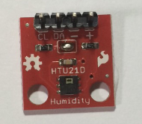  
[6.CO](https://www.google.com/url?q=http%3A%2F%2F6.CO&sa=D&usd=2&usg=AFQjCNErRBCuOKHR_NkUdG-d_AzSaYk-Ag)感測器 (MQ-7)

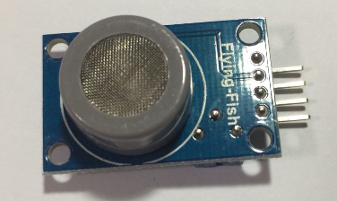  
7.煙霧感測器 (MQ-6)

## 8.PM2.5 空氣感測器 (GP2Y1014AU PM2.5)

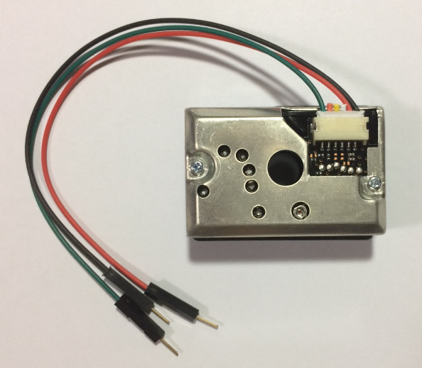  
9.聲音感測模組  
10.磁簧 Sensor  
11.風扇 5V  
12.燈座與燈泡 (E17 陶瓷燈座 與 15W 燈泡)  
13.1.8M電源線  
14.插線線材+USB線

d1 mini wifi

To support for ESP8266 chip to the Arduino environment. It lets you write sketches using familiar Arduino functions and libraries, and run them directly on ESP8266, no external microcontroller required.

*安裝Arduino

*安裝vscode

*安裝firebase tools

*設定firebase web