A fluconazole population pharmacokinetics study to improve target attainment in critically ill patients

My-Luong Vuong (Mỹ-Lượng Vương)a†, Omar Elkayala,†, Ruth Van Daelea,b,1, Jan-Willem C. Alffenaarc,d,e, Sophie L. Stockerc,e,f,g, Jason A. Robertsh,i,j, Yves Debaveyek,l, Joost Wautersm,n, Beatrijs Mertensa,b,2, Jasper M. Boonstrao,3, Indy Sandaradurap,q,r, Deborah J.E. Marriotts,t, Roger J. Brüggemannu,v, Jeroen A. Schoutenw, Raoul Bergnerx, Steven Buijky, Isabel Sprieta,b,‡, Erwin Dreesena,‡,*

a Department of Pharmaceutical and Pharmacological Sciences, KU Leuven, Leuven, Belgium  
b Pharmacy Department, University Hospitals Leuven, Leuven, Belgium c School of Pharmacy, Faculty of Medicine and Health, The University of Sydney, Sydney, Australia d Pharmacy Department, Westmead Hospital, Sydney, Australia e Institute for Infectious Diseases (Sydney ID), The University of Sydney, Sydney, Australia  
f School of Clinical Medicine, Faculty of Medicine and Health, University of New South Wales, Sydney, Australia g Department of Clinical Pharmacology and Toxicology, St. Vincent's Hospital, Sydney, Australia h University of Queensland Centre for Clinical Research (UQCCR), The University of Queensland, Brisbane, Australia i Departments of Pharmacy and Intensive Care Medicine, Royal Brisbane and Women’s Hospital, Brisbane, Australia j Division of Anaesthesiology Critical Care Emergency and Pain Medicine, Nîmes University Hospital, University of Montpellier, Nîmes, France k Department of Cellular and Molecular Medicine, KU Leuven, Leuven, Belgium l Intensive Care Unit, University Hospitals Leuven, Leuven, Belgium m Department of Microbiology, Immunology and Transplantation, KU Leuven, Leuven, Belgium n Medical Intensive Care Unit, University Hospitals Leuven, Leuven, Belgium o University of Groningen, University Medical Centre Groningen, Department of Clinical Pharmacy and Pharmacology, Groningen, The Netherlands p Centre for Infectious Diseases and Microbiology, Westmead Hospital, Sydney, Australia q Faculty of Medicine and Health, Westmead Clinical School, The University of Sydney, Sydney, Australia r Institute of Clinical Pathology and Medical Research, New South Wales Health Pathology, Westmead Hospital, Sydney, Australia s School of Clinical Medicine, St Vincent's Healthcare Clinical Campus, Faculty of Medicine and Health, UNSW Sydney, NSW, Australia  
t Clinical Microbiology and Infectious Diseases Department, St. Vincent's Hospital, Sydney, NSW, Australia  
u Radboud university medical centre, Radboud Institute for Medical Innovations, Department of Pharmacy, Nijmegen, The Netherlands v Radboudumc/CWZ Centre of Expertise in Mycology, Nijmegen, The Netherlands w Department of Intensive Care, Canisius Wilhelmina Hospital, Nijmegen, The Netherlands x Division of Rheumatology and Nephrology, Department of Medicine A, Ludwigshafen Medical Centre, Ludwigshafen, Germany y Department of Surgery, IJsseland Hospital, Capelle aan den Ijssel, The Netherlands

1 Gilead Sciences, Amsterdam, The Netherlands  
2 Pfizer, Antwerp, Belgium  
3 ICON plc, Groningen, The Netherlands

†Shared co-first authorship  
‡Shared co-senior authorship

*Corresponding author. E-mail: [erwin.dreesen@kuleuven.be](mailto:erwin.dreesen@kuleuven.be). Address: Department of Pharmaceutical and Pharmacological Sciences, KU Leuven, ON2 Herestraat 49 box 521, 3000 Leuven, Belgium. Telephone number: +32 16 37 27 53.

ORCID numbers: MLV 0000-0001-9203-6745  
OE 0000-0001-5708-9497  
RVD 0000-0002-8353-2103  
JWA 0000-0001-6703-0288  
SLS 0000-0002-2114-587X  
JAR 0000-0001-6218-435X  
YD 0000-0003-1784-8297  
JW 0000-0002-5983-3897  
BM 0000-0002-1501-3045  
JMB 0009-0006-5957-7244  
IS 0000-0002-9457-8262  
RJB 0000-0002-7618-725X  
JAS 0000-0001-9118-4420  
RB 0000-0002-7965-1273  
ISp 0000-0001-6342-0676  
ED 0000-0002-0785-2930

# List of abbreviations

BMI: body mass index; *f*AUC0-24: area under the unbound concentration–time curve for 24 hours; CKD–EPI: Chronic Kidney Disease Epidemiology Collaboration; CL: clearance; CRRT: continuous renal replacement therapy; Ctrough: trough concentration; eGFR: estimated glomerular filtration rate; FFM: fat-free mass; ICU: Intensive Care Unit; IIV: interindividual variability; IPDMA: individual patient data meta-analysis; IV: intravenous; MIC: minimal inhibitory concentration; pcVPC: prediction-corrected visual predictive check; PK: pharmacokinetics; PKPD: pharmacokinetic–pharmacodynamic; popPK: population pharmacokinetics; PTA: probability of target attainment; Q24h: every 24 hours; TDM: therapeutic drug monitoring; Vc: volume of distribution in the central compartment.

# Abstract

Background Invasive candidiasis, particularly candidaemia, is a life-threatening complication in critically ill patients. Fluconazole is the recommended step-down therapy from echinocandins for fluconazole-susceptible *Candida* spp. However, standard fluconazole dosing does not achieve adequate exposure in critically ill patients.

Objectives This study aimed to identify factors that impact fluconazole target attainment and provide a dosing regimen which ensures adequate pharmacokinetic–pharmacodynamic (PKPD) target attainment in critically ill patients.

Patients and Methods An individual patient data meta-analysis was conducted, combining fluconazole concentration data from eight published studies. We developed a population pharmacokinetics (popPK) model and used multiple imputation to handle missing covariate data. We performed Monte Carlo simulations to identify a dosing strategy with at least 90% probability of PKPD target attainment (PTA) in every patient.

Results Data from 177 critically ill patients were included. A two-compartment popPK model with linear elimination described the data best. Continuous renal replacement therapy (CRRT) status, estimated glomerular filtration rate using the Chronic Kidney Disease Epidemiology Collaboration creatinine equation, and total body weight were statistically significant covariates. However, with standard dosing, only CRRT status and total body weight were clinically relevant, as PTA dropped below 90% for all patients on CRRT, and for patients not on CRRT weighing more than 60 kg. An optimised dosing regimen considering the patient’s CRRT status and total body weight is proposed.

Conclusion We have developed a fluconazole dosing regimen that may achieve adequate population-wide PKPD target attainment in critically ill patients. External validation is awaited.

Keywords:  
Population pharmacokinetics   
Monte Carlo simulation  
Individual patient data meta-analysis

# Introduction

Invasive candidiasis, including candidaemia, remains a serious complication that most frequently occurs in patients who are immune compromised, have undergone (abdominal) surgery, or are critically ill [1]. In patients admitted to the intensive care unit (ICU), candidaemia is associated with a crude mortality rate of 42% to 47% [2-4].

Fluconazole is a triazole antifungal drug used for treating invasive candidiasis and candidaemia [5]. It is recommended as a step-down therapy from echinocandins for candidaemia caused by fluconazole-susceptible *Candida* species [6]. In clinical practice, fluconazole is frequently administered because of its safety profile, satisfactory tissue penetration, and low cost compared with other antifungal agents [6, 7]. Fluconazole is primarily excreted unchanged by the kidney (~80%), undergoing glomerular filtration and active tubular reabsorption [5]. Hepatic metabolism is minimal, with only 11% of the dose excreted as metabolites via the kidneys [5]. Protein binding is low (11–12%) [5].

The primary pharmacokinetic–pharmacodynamic (PKPD) target of fluconazole is a ratio of the area under the unbound concentration–time curve for 24 hours over the minimum inhibitory concentration (*f*AUC0-24/MIC) of 100 [8]. This corresponds to an *f*AUC0-24 of 200 mg×h/L for a MIC of 2 mg/L, which is the non-species-related susceptibility breakpoint for *Candida* [8]. Fluconazole-induced hepatotoxicity was documented in a case study, but to date, there is no evidence of concentration-dependent hepatotoxicity of fluconazole [9]. Nevertheless, concentration-dependent toxicity related to fluconazole was documented in two case reports of patients developing clonic convulsions at a trough concentration (Ctrough) of approximately 80 mg/L [10, 11].

The manufacturer-recommended fluconazole dosing regimen for invasive candidiasis is an 800 mg loading dose on day 1 followed by a 400 mg daily maintenance dose from day 2 [5]. Using the recommended dosing regimen, attainment of the PKPD target in patients admitted to the ICU is often inadequate or delayed, particularly in those who are overweight or undergoing continuous renal replacement therapy (CRRT) [12-14]. Furthermore, several population pharmacokinetics (popPK) studies performed in this vulnerable patient population showed conflicting results regarding the optimised fluconazole dosing strategy [12-15]. This could be attributed to the single-centre nature and low number of patients included in these reports.

Therefore, we performed a population pharmacokinetics analysis using data from eight published studies collected from patients receiving intravenous (IV) fluconazole. We aimed to (i) identify covariates with a clinically relevant impact on fluconazole *f*AUC0-24 target attainment and (ii) provide an optimised dosing recommendation ensuring adequate, ICU-wide target attainment.

# Material and methods

## Patient population and study design

We identified studies reporting on the plasma concentrations of IV fluconazole in patients admitted to the ICU through a literature search (PubMed) from inception to October 2022. We then contacted the authors to arrange the transfer of the individual concentration–time data upon contractual agreement. Next, we aggregated datasets for analysis. The study was approved by the Ethics Committee Research UZ / KU Leuven (S62242). Written informed consent for the secondary use of data of prospectively collected data was obtained from participants of the original studies in compliance with the approval of the (local) Ethics Committees.

## Population pharmacokinetics modelling

We developed a popPK model from the aggregated dataset to describe the fluconazole concentration–time data. One-, two-, and three-compartment models with linear elimination processes were explored. The magnitude of differences in individual PK parameters from the typical value (i.e., interindividual variability) and differences between observed and model-predicted individual concentrations (i.e., residual variability) were estimated. The variability between occasions within the same individual (interoccasion variability) was tested with two occasions defined as ≤day 7 and >day 7. We tested between-centre variability as a random effect and a fixed effect. The difference in analytical assays used among centres was tested by introducing different error models for each assay. Individual PK parameters were assumed to be log-normally distributed, which was achieved by using an exponential function. For example, the volume of distribution in the central compartment of subject *i* (Vc*i*) was calculated following this equation:

(Eq. 1)

with Vc*pop* the typical population value of Vc, *ηi* the deviation of the individual from the typical population value assuming a log-normal distribution, and *ω*2 the variance of all *ηi*.

A final model including covariate effects was built through stepwise covariate modelling (αforward = 0.05, αbackward = 0.01) [16, 17]. We assessed the covariates that are physiologically relevant to fluconazole PK. These included total body weight, body mass index (BMI), fat-free mass (FFM) at baseline (day of ICU admission), and time-varying CRRT (yes/no) and estimated glomerular filtration rate (eGFR). Among these covariates, FFM was approximated by lean body weight derived from total body weight and height [18], while eGFRwas calculated using the Chronic Kidney Disease Epidemiology Collaboration (CKD-EPI) equation without race [19].

Continuous covariates (total body weight, BMI, FFM, and eGFRCKD-EPI) were normalised to the median value in the population and introduced into the popPK model using a power function [16], exemplified as follows:

(Eq. 2)

with BW_EFF the effect of body weight on Vc*i* and the total body weight of the patient normalised to the population median value of 80 kg.

## Missing data handling

When at least one value of a variable was available in a dosing interval, we imputed the mean of the available value(s) in that dosing interval. When no value of a variable was available in a dosing interval, we employed multiple imputation. Specifically, we built a multiple imputation model including variables that were in the aggregated dataset. We used two multiple imputation techniques, the two-level method using a linear mixed model, and the predictive mean matching method when missingness was >5% and ≤5%, respectively [20]. We replaced the negative imputed values of a variable with the lowest value of that variable observed in the dataset. Multiply imputed datasets were created and independent popPK analyses were conducted for each dataset. Results were then combined using Rubin’s rules for normally distributed parameter estimates [20]. For non-normal, non-negative variance terms, log transformation was performed before pooling estimates to ensure the normality assumption holds [20]. The delta method was used to obtain the variance of these log-transformed terms [21]. The number of imputations was chosen based on the magnitude of missingness of the specific variable [20]. The 95% confidence interval of the pooled estimates, which follow the Student’s *t*-distribution, was calculated [20].

## Model selection and evaluation

We selected the most parsimonious popPK model based on a likelihood ratio test with a 5% significance level (delta objective function value ≥3.84 points, 1 degree of freedom), parameter precision (95% confidence interval), and physiological plausibility of the parameter estimates. Additionally, we used goodness-of-fit plots, including population and individual predictions versus observations, conditional weighted residuals versus time and versus population predictions, and prediction-corrected visual predictive check (pcVPC) plots (n = 1000 simulations) [16]. We used bootstrapping to acquire non-parametric estimates of uncertainty in parameter estimates (n = 2000 bootstraps) [16].

## Simulations

### Dose-finding simulations

#### Selecting dosing regimens for testing

We conducted Monte Carlo simulations using the final popPK model to evaluate various fluconazole dosing regimens. These regimens were selected based on the manufacturer's recommended standard loading and maintenance doses (800 mg on day one, then 400 mg daily) as a reference for comparison. Dose increments were based on the commercially available fluconazole IV dosage forms of 200 mg and 400 mg to avoid drug waste [5]. Considering a 200 mg increment in doses, we evaluated six loading doses ranging from 800 mg to 1800 mg on day 1 and three maintenance doses ranging from 400 mg to 800 mg daily. We also tested total body weight-based dosing (12 mg/kg on day 1, followed by 6 mg/kg daily), as suggested previously [15].

#### Creating virtual patient datasets

Virtual patients were defined exclusively by the covariates retained in the final popPK model (**Supplementary Table**). Correlation between the covariates was maintained similarly to that in the aggregated dataset. A total of 1000 simulations were performed per virtual patient.

#### Criteria for evaluating dosing regimens

A dosing regimen was considered acceptable if it achieved a 90% probability of target attainment (PTA) across the population [22]. The adequacy of the loading dose was evaluated via the PTA 24 hours after its administration (day 1). Similarly, the adequacy of the maintenance dose was evaluated via the PTA on day 14 [9]. The sufficiency of the resulting dosing regimen throughout the entire 2-week treatment period was then confirmed via its PTA on days 2 and 7.

The fluconazole AUC0-24 was calculated daily by integrating the individually predicted total fluconazole concentrations over the dosing interval using the popPK model. A fluconazole unbound fraction of 89% was used to calculate the corresponding *f*AUC0-24 [5]. An *f*AUC0-24 of 200 mg×h/L was set as the optimal PKPD target, considering the non-species specific susceptibility breakpoint of 2 mg/L [8]. In addition, an *f*AUC0-24 of 400 mg×h/L was also explored to account for “susceptible, increased exposure” non–*Candida glabrata* species (i.e., with a MIC of 4 mg/L) [8]. A Ctrough of 80 mg/L was considered as the threshold for toxicity with exposures above this value considered unacceptable [10, 11].

### Real-world population simulations

The 14-day standard and optimised dosing regimens were compared for population-level PTA and drug exposure. Therefore, we created a virtual patient population of 1000 patients to represent the real-world population in our aggregated dataset, ensuring the proportions of categorical covariates and distributions of continuous covariates matched. Specifically, we randomly sampled continuous covariates from their empirical cumulative distribution functions obtained from the aggregated dataset [23]. 1000 simulations were also performed per virtual patient.

## Software

Dataset formatting and exploration were performed using R (v4.3.3; R Core Team, Vienna, Austria) in the RStudio integrated development environment (v 2024.04.0+735; RStudio, Inc., Boston, MA, USA). We used the *tidyverse* collection of packages for this purpose while using the *mice* package to perform multiple imputation [20, 24]. NONMEM (v7.5.0; ICON Development Solutions, Gaithersburg, MD, USA) with differential equation solver ADVAN13 and the first-order conditional estimation with interaction method for parameter estimation was used for nonlinear mixed-effects modelling. All procedures were executed using the Perl-speaks-NONMEM (PsN; v5.3.0) toolkit on the Pirana modelling workbench (v21.11.1; Certara, Inc., Princeton, NJ, USA) [25]. The NONMEM control stream is available in the **Supplementary Code**.

# Results

## Data

Data from eight studies included a total of 177 ICU patients treated with IV fluconazole [12-15, 26-29]. Patient characteristics are summarised in **Table 1**. Patients contributed 1616 total fluconazole plasma concentrations, with a median of seven concentrations per patient. None of the concentrations were below the lower limit of quantification. Total body weight at ICU admission ranged from 34 kg to 142 kg, while eGFRCKD-EPI when not undergoing CRRT ranged from 7 mL/min/1.73 m2 to 213 mL/min/1.73 m2. Total body weight was missing in 2.8% of the cohort. CRRT status was available for all patients, with 19.2% of patients receiving CRRT at least once during their treatment period. An eGFRCKD-EPI was available only in 40.7% of the dosing intervals. Missing eGFRCKD-EPI data were handled with multiple imputation at the dosing interval level while missing total body weight data were handled at the patient level (*m* = 70 multiply imputed datasets). Multiple imputation performance is shown in **Fig. S1**-**S2**. The concentration–time course of the per-centre and the pooled datasets are available in **Fig. S3**-**S4**.

## Population pharmacokinetics modelling

A two-compartment popPK model with linear elimination best described the fluconazole concentration–time data (**Table 2**). Fluconazole clearance was estimated separately when a patient was on CRRT (CLon-CRRT; 1.56 L/h [10.2% relative standard error; RSE]), and when off CRRT (CLoff-CRRT; 0.633 L/h [5.4% RSE]). Interindividual variability was estimated on CLon-CRRT, CLoff-CRRT, and Vc, with a covariance relationship between CLoff-CRRT and Vc of 33.9%. A proportional error model best described the residual variability. Different analytical assays did not significantly impact the error model. The per-centre and overall goodness-of-fit plots are available in **Fig. S5-S9**.

The inclusion of the effects of baseline total body weight on Vc and time-varying eGFRCKD-EPI on CLoff-CRRT significantly improved the goodness-of-fit of the popPK model. The pooled parameter estimates of the 70 multiply imputed models and the medians of 10 random bootstrap results (2000 bootstraps in total) are available in **Table 2**. Equations 3 and 4 demonstrate how fluconazole Vcand CLoff-CRRT of patient *i* increase with total body weight and eGFRCKD-EPI, respectively:

with (Eq. 3)

with (Eq. 4)

Body weight and eGFRCKD-EPI explained 7.1% and 8.1% of the interindividual variability in Vc and CLoff-CRRT of fluconazole, respectively. The unexplained interindividual variability in Vc and CLoff-CRRT remained high, i.e., 60.5% and 49.3%, respectively.

The per-centre and pooled data pcVPC plots show a good agreement between model simulations and observed data (**Fig. S10**-**S11**). The pcVPC stratified by CRRT status is available in **Fig. S12**. Median values of the non-parametric bootstrap were in good agreement with the pooled point estimates (**Table 2**).

## Simulations

The standard loading dose did not result in clinically acceptable PTA of ≥90% when total body weight exceeded 65 kg and 30 kg, in patients off and on CRRT, respectively. Similarly, the weight-based regimen (12 mg/kg loading dose) failed to achieve adequate PTA in patients weighing less than 80 kg without CRRT and less than 120 kg with CRRT (**panel a**, **Fig. 1-2**). The statistically significant effect of eGFRCKD-EPI on CLoff-CRRT did not have a clinically relevant impact on fluconazole *f*AUC0-24 200 mg×h/L target attainment across the eGFRCKD-EPI range of 5 to 215 mL/min/1.73 m² under simulated loading doses. Moreover, using the standard maintenance dose of 400 mg, the PTA only fell slightly below 90% when eGFRCKD-EPI exceeded 195 mL/min/1.73 m2 **(Fig. 3)**. **Fig. 4-5** shows the probability of attaining the *f*AUC0-24 400 mg×h/L target versus total body weight for the simulated dosing regimens.

The optimised stratified dosing regimen is presented in **Table 3**. The proposed loading dose was determined based on the patient’s total body weight and CRRT status. The selected doses were the smallest that ensured a clinically acceptable PTA 24 hours after administration. Daily maintenance doses of 400 mg and 800 mg were adequate for achieving at least 90% PTA across the studied total body weight range, off and on CRRT, respectively (**Fig. 1-2, Fig. S13-S14**).

Real-world population simulations confirmed that the standard dosing regimen of 800 mg on day 1 followed by 400 mg thereafter did not achieve 90% PTA in the first two days, but improved to a >90% PTA from day 3 of the treatment period (**Fig. S15**). Simulation of the optimised dosing regimen resulted in >90% PTA as early as day 1 up to day 14 of treatment (**Fig. 6**, **Fig. S15**). Less than 1.2% of patients had fluconazole Ctrough of 80 mg/L or higher across the two-week treatment period. The characteristics of the real-world virtual population are shown in **Fig S16-S17**. The R code and dataset used to generate this population are in the **Supplementary Code** and **Supplementary Dataset**.

# Discussion

From our modelling and simulation results, we conclude that total body weight and CRRT status were the two factors that clinically impacted the attainment of the *f*AUC0-24 200 mg×h/L target in critically ill patients under the standard fluconazole IV dosing regimen. Therefore, we proposed a pragmatic, optimised dosing regimen with the potential to achieve a PTA of at least 90% over the entire two-week treatment course.

We performed an individual patient data meta-analysis (IPDMA), which involves merging datasets from multiple studies sharing subject populations and similar variables [30]. An IPDMA offers several advantages, including more complete information per study, a consistent analysis method for each study, the ability of conducting more complex analysis, and achieving greater statistical power [31].

The PK of fluconazole in critically ill patients was best described by a two-compartment model with first-order elimination, consistent with studies that employed a rich-sampling technique [14, 15, 32]. In contrast, several studies that relied on (trough) samples collected during routine clinical practice identified a one-compartment model [12, 13, 33]. This disparity can be attributed to the sparse sampling in clinical practice, which limits the ability to fit a two-compartment model. Total body weight not only significantly influenced Vc, but it also had a clinically relevant impact on target attainment under the standard dosing regimen (800 mg loading dose and 400 mg maintenance dose). Specifically, a higher total body weight led to a lower PTA following the loading dose of 800 mg. This finding aligns with previous popPK studies which reported that obesity is a risk factor for suboptimal exposure to fluconazole [12, 15, 34]. Although FFM may be a better surrogate for Vc of fluconazole, we found that total body weight best improved the model fit. Furthermore, total body weight is preferred over BMI and FFM in clinical practice as it does not require guessing the patient’s height [18]. Fluconazole clearance was nearly three times higher when patients were on CRRT compared with when they were off CRRT. This accelerated on-CRRT clearance may be explained by the absence of tubular reabsorption in anuric patients, as fluconazole is extensively reabsorbed when the kidney function is normal [32]. Additionally, eGFRCKD-EPI significantly impacted CLoff-CRRT in our model, which aligns with fluconazole's primary renal clearance [5]. We chose the eGFRCKD-EPI equation without race as the sole method for assessing kidney function because it is more accurate than equations like Cockcroft-Gault and performs better compared to the equation that includes race [19].

We demonstrated that eGFRCKD-EPI had no clinically relevant impact on PKPD target attainment under the proposed optimised dosing regimen, thus our dosing recommendations were not based on renal function. Despite significantly improving the goodness-of-fit of the popPK model, eGFRCKD-EPI did not affect PTA across its entire range with this optimised regimen. Our recommended maintenance dose for patients not undergoing CRRT was 400 mg q24h, aligning with the current standard. Although our simulation showed a slight decrease below the 90% PTA with this dose in patients with eGFRCKD-EPI above 195 mL/min/1.73 m², we did not recommend increasing it, as this minor reduction was based on the unlikely assumption that eGFRCKD-EPI would remain consistently above 195 mL/min/1.73 m² for 14 days. Huang *et al*. recently reported that kidney function is highly unstable in ICU patients [35].

Our study’s finding of no effect from kidney function contrasts with previous research, which suggested that increased doses are needed for patients with augmented renal clearance [12, 14]. This discrepancy probably reflects bias caused by inadequate missing data handling techniques. Unlike previous studies, we used multiple imputation which is a superior method to single imputation or complete case analysis, especially when data is missing at random (MAR) [36]. Unfortunately, despite significant evidence to the contrary, single imputation remains widely applied in pharmacometrics research. Such a method would falsely decrease the temporal variability in eGFRCKD-EPI that we observed during critical illness [35]. Multiple imputation fills in the missing data multiple times with many different plausible values, thereby accounting for the variability [20]. Although we could not identify a clinically relevant effect of eGFRCKD-EPI on PKPD target attainment, this should not be interpreted as a confirmation of the absence of a kidney function effect, but rather as a failure to identify an effect with the current dataset. Therefore, a well-designed, prospective clinical trial with an intensive data collection scheme is necessitated to validate our findings.

Our proposed dosing regimen may avoid the need to conduct TDM after being successfully confirmed in a future trial. TDM of fluconazole is not widely recommended nor implemented but advocated in rare circumstances such as for obese patients, patients on CRRT, and patients with sepsis [11]. However, fluconazole TDM is not always available, and when available, turn-around-time and costs might hamper the feasibility of routine implementation [37]. Therefore, the implementation of our recommended dosing regimen based on total body weight and CRRT status has the potential to deliver personalised dosing of fluconazole whilst simultaneously simplifying workflows. Nevertheless, in clinical centres where neither drug cost nor integration of automated dose calculation in prescribing software tools are of concern, other dosing strategies and the availability of TDM may be considered.

It is worth noting that our recommended loading dose is not the lowest effective dose. Specifically, since there are challenges in measuring accurately the total body weight of patients confined to their beds in the ICU setting, we incorporated a precautionary measure of accounting for ~5–10 kg underestimation in total body weight [38].

Our simulations also demonstrated the proposed regimen to be potentially safe (<1.2% risk of Ctrough ≥80 mg/L). As such, it is appropriate for introduction into ICUs worldwide to treat patients infected with *Candida* species with MIC ≤2 mg/L after being locally evaluated. However, for “susceptible, increased exposure” non–*Candia glabrata* species (MIC of 4 mg/L), our recommended regimen showed a poor target attainment, necessitating a much higher dose. The same is true for *C. glabrata* species with MICs up to 16 mg/L. Dose optimisation of fluconazole considering these MICs raises safety concerns, as the percentage of patients having Ctrough ≥80 mg/L will be much higher.

We acknowledge several limitations in our study. First, we did not conduct a systematic search to identify eligible studies in the literature, thus we might not have included all the published study data in our IPDMA [39]. The resource-intensive and time-consuming process of contacting authors, obtaining data, and preparing datasets for IPDMA may not always outweigh the benefits and should be seriously considered before initiation [39]. However we generated the largest IV fluconazole PK dataset in ICU patients existing to date. Second, we could not differentiate between types of CRRT as this information was not fully recorded in our dataset. Each type of CRRT has different implications for fluconazole elimination and could potentially require different dosing strategies [40]. Nevertheless, we would not likely be able to determine the impact of CRRT types due to the limited representation of CRRT in our dataset, with only 19.2% of patients having at least one CRRT session. Finally, our studied population may not be representative of and thus our study results may not be extrapolated to other patient populations. To address this issue, we included the model code in the Supplementary file, and we encourage other data owners to externally evaluate our model with their populations.

In conclusion, our popPK analysis identified total body weight and CRRT status as clinically relevant factors impacting fluconazole *f*AUC0-24 target attainment in critically ill patients under the standard dosing regimen. We proposed a stratified fluconazole dosing regimen based on these two factors to potentially ensure an ICU-wide PKPD target attainment. A prospective clinical trial with more intensive data collection is necessary to provide robust evidence supporting our optimised fluconazole dosing recommendation.

# Acknowledgements

The authors wish to thank Thi Nguyen and Sebastian Rosser from the University of Sydney for their valuable support in the modelling step of this study. The resources and services used in this work were provided by the VSC (Flemish Supercomputer Center), funded by the Research Foundation - Flanders (FWO) and the Flemish Government. Jason Roberts would like to acknowledge funding from the Australian National Health and Medical Research Council for a Centre of Research Excellence (APP2007007) and an Investigator Grant (APP2009736) as well as an Advancing Queensland Clinical Fellowship.

# Funding

My-Luong Vuong is supported by a doctoral research grant from the Research Foundation – Flanders (FWO), Belgium (grant number: 1SH6A24N). Isabel Spriet is supported by the Clinical Research Fund, University Hospitals Leuven, Belgium.

# Declaration of interest

Ruth Van Daele contributed to this work while at KU Leuven and UZ Leuven. She is currently employed at Gilead.

# Author contributions

This follows the CRediT author statement.

Conceptualisation: **MLV, OE, RVD, ISp, ED.**  
Methodology: **MLV, OE, ISp, ED.**  
Software: **MLV.**  
Formal analysis: **MLV.**  
Investigation: **MLV, OE, RVD, JWA, ED, ISp.**   
Resources: **MLV, JWA, SLS, JAR, YD, JW, BM, JMB, IS, DJEM, RJB, JAS, RB, SB, ISp, ED.**  
Data Curation: **RVD, MLV.**Writing – Original Draft: **MLV.**  
Writing – Review & Editing: **MLV, OE, RVD, JWA, SLS, JAR, YD, JW, BM, JMB, IS, DJEM, RJB, JAS, RB, SB, ISp, ED.**Visualisation: **MLV.**Supervision: **ISp, ED.**Project administration: **ISp, ED.**Funding acquisition: **MLV**, **ISp, ED.  
All authors** approved the final version for submission.

# References

[1] Cornely OA, Bassetti M, Calandra T, Garbino J, Kullberg BJ, Lortholary O, et al. ESCMID* guideline for the diagnosis and management of Candida diseases 2012: non-neutropenic adult patients. Clin Microbiol Infect. 2012;18 Suppl 7:19-37. <http://doi.org/10.1111/1469-0691.12039>.

[2] Schroeder M, Weber T, Denker T, Winterland S, Wichmann D, Rohde H, et al. Epidemiology, clinical characteristics, and outcome of candidemia in critically ill patients in Germany: a single-center retrospective 10-year analysis. Annals of Intensive Care. 2020;10:142. <http://doi.org/10.1186/s13613-020-00755-8>.

[3] Bassetti M, Giacobbe DR, Vena A, Trucchi C, Ansaldi F, Antonelli M, et al. Incidence and outcome of invasive candidiasis in intensive care units (ICUs) in Europe: results of the EUCANDICU project. Critical Care. 2019;23:219. <http://doi.org/10.1186/s13054-019-2497-3>.

[4] Sbrana F, Sozio E, Bassetti M, Ripoli A, Pieralli F, Azzini AM, et al. Independent risk factors for mortality in critically ill patients with candidemia on Italian Internal Medicine Wards. Internal and Emergency Medicine. 2018;13:199-204. <http://doi.org/10.1007/s11739-017-1783-9>.

[5] Pfizer. Summary of Product Characteristics (SmPC) Diflucan. Summary of Product Characteristics (SmPC) Diflucan. 2012.

[6] Pappas PG, Kauffman CA, Andes DR, Clancy CJ, Marr KA, Ostrosky-Zeichner L, et al. Clinical Practice Guideline for the Management of Candidiasis: 2016 Update by the Infectious Diseases Society of America. Clin Infect Dis. 2016;62:e1-50. <http://doi.org/10.1093/cid/civ933>.

[7] Grau S, Pozo JC, Romá E, Salavert M, Barrueta JA, Peral C, et al. Cost-effectiveness of three echinocandins and fluconazole in the treatment of candidemia and/or invasive candidiasis in nonneutropenic adult patients. Clinicoecon Outcomes Res. 2015;7:527-35. <http://doi.org/10.2147/ceor.S91587>.

[8] European Committee on Antimicrobial Susceptibility Testing. Fluconazole: Rationale for the clinical breakpoints, version 3.0. <https://www.eucast.org/fileadmin/src/media/PDFs/EUCAST_files/Rationale_documents/Fluconazole_RD_v3.0_final_18_02.pdf>; 2020 [accessed 29 Jan 2025].

[9] Jacobson MA, Hanks DK, Ferrell LD. Fatal acute hepatic necrosis due to fluconazole. The American Journal of Medicine. 1994;96:188-90. <http://doi.org/10.1016/0002-9343(94)90141-4>.

[10] Matsumoto K, Ueno K, Yoshimura H, Morii M, Takada M, Sawai T, et al. Fluconazole-Induced Convulsions at Serum Trough Concentrations of Approximately 80 μg/mL. Therapeutic Drug Monitoring. 2000;22:635-6. <http://doi.org/10.1097/00007691-200010000-00022>.

[11] Lewis R, Brüggemann R, Padoin C, Maertens J, Marchetti O, Groll A, et al. Triazole antifungal therapeutic drug monitoring. Sixth European Conference on Infections in Leukaemia Meeting, Sophia Antipolis, France, <https://www.ecil-leukaemia.com/images/resources/2015/5_ECIL6-Triazole-TDM-07-12-2015-Lewis-R-et-al.pdf>; 2015 [accessed 29 Jan 2025].

[12] Sandaradura I, Marriott DJE, Day RO, Norris RLG, Pang E, Stocker SL, et al. Current fluconazole treatment regimens result in under-dosing of critically ill adults during early therapy. Eur J Clin Microbiol Infect Dis. 2021;40:1521-8. <http://doi.org/10.1007/s10096-021-04201-w>.

[13] Boonstra JM, Märtson AG, Sandaradura I, Kosterink JGW, van der Werf TS, Marriott DJE, et al. Optimization of Fluconazole Dosing for the Prevention and Treatment of Invasive Candidiasis Based on the Pharmacokinetics of Fluconazole in Critically Ill Patients. Antimicrob Agents Chemother. 2021;65. <http://doi.org/10.1128/aac.01554-20>.

[14] Muilwijk EW, de Lange DW, Schouten JA, Wasmann RE, Ter Heine R, Burger DM, et al. Suboptimal Dosing of Fluconazole in Critically Ill Patients: Time To Rethink Dosing. Antimicrob Agents Chemother. 2020;64. <http://doi.org/10.1128/aac.00984-20>.

[15] Alobaid AS, Wallis SC, Jarrett P, Starr T, Stuart J, Lassig-Smith M, et al. Effect of Obesity on the Population Pharmacokinetics of Fluconazole in Critically Ill Patients. Antimicrob Agents Chemother. 2016;60:6550-7. <http://doi.org/10.1128/aac.01088-16>.

[16] Mould DR, Upton RN. Basic concepts in population modeling, simulation, and model-based drug development-part 2: introduction to pharmacokinetic modeling methods. CPT Pharmacometrics Syst Pharmacol. 2013;2:e38. <http://doi.org/10.1038/psp.2013.14>.

[17] Jonsson EN, Karlsson MO. Automated covariate model building within NONMEM. Pharm Res. 1998;15:1463-8. <http://doi.org/10.1023/a:1011970125687>.

[18] Boer P. Estimated lean body mass as an index for normalization of body fluid volumes in humans. Am J Physiol. 1984;247:F632-6. <http://doi.org/10.1152/ajprenal.1984.247.4.F632>.

[19] Sharma A, Sahasrabudhe V, Musib L, Zhang S, Younis I, Kanodia J. Time to Rethink the Current Paradigm for Assessing Kidney Function in Drug Development and Beyond. Clin Pharmacol Ther. 2022;112:946-58. <http://doi.org/10.1002/cpt.2489>.

[20] van Buuren S. Flexible Imputation of Missing Data, Second Edition. New York: CRC Press; 2018.

[21] Hosmer DW, Lemeshow S, May S. Applied Survival Analysis: Regression Modeling of Time-to-Event Data, Second Edition. New Jersey: John Wiley & Sons, Inc.; 2008.

[22] Committee for Medicinal Products for Human Use (CHMP) EMA. Guideline on the use of pharmacokinetics and pharmacodynamics in the development of antimicrobial medicinal products. United Kingdom: *European Medicines Agency*; 2016. Report No.: EMA/CHMP/594085/2015. <https://www.tga.gov.au/sites/default/files/2024-08/guideline_on_the_use_of_pharmacokinetics_and_pharmacodynamics_in_the_development_of_antimicrobial_medicinal_products_.pdf>

[23] Ramachandran KM, Tsokos CP. Chapter 5 - Statistical estimation. In: Ramachandran KM, Tsokos CP, editors. Mathematical Statistics with Applications in R (Third Edition). London: Academic Press; 2021. p. 179-251.

[24] Wickham H, Cetinkaya-Rundel M, Grolemund G. R for Data Science: Import, Tidy, Transform, Visualize, and Model Data. 2nd ed. California: O'Reilly Media; 2023.

[25] Keizer RJ, Karlsson MO, Hooker A. Modeling and Simulation Workbench for NONMEM: Tutorial on Pirana, PsN, and Xpose. CPT Pharmacometrics Syst Pharmacol. 2013;2:e50. <http://doi.org/10.1038/psp.2013.24>.

[26] Bergner R, Hoffmann M, Riedel KD, Mikus G, Henrich DM, Haefeli WE, et al. Fluconazole dosing in continuous veno-venous haemofiltration (CVVHF): need for a high daily dose of 800 mg. Nephrol Dial Transplant. 2006;21:1019-23. <http://doi.org/10.1093/ndt/gfi284>.

[27] Buijk SL, Gyssens IC, Mouton JW, Verbrugh HA, Touw DJ, Bruining HA. Pharmacokinetics of sequential intravenous and enteral fluconazole in critically ill surgical patients with invasive mycoses and compromised gastro-intestinal function. Intensive Care Med. 2001;27:115-21. <http://doi.org/10.1007/s001340000771>.

[28] Sinnollareddy MG, Roberts JA, Lipman J, Akova M, Bassetti M, De Waele JJ, et al. Pharmacokinetic variability and exposures of fluconazole, anidulafungin, and caspofungin in intensive care unit patients: Data from multinational Defining Antibiotic Levels in Intensive care unit (DALI) patients Study. Critical Care. 2015;19. <http://doi.org/10.1186/s13054-015-0758-3>.

[29] Van Daele R, Wauters J, Lagrou K, Denooz R, Hayette MP, Gijsen M, et al. Pharmacokinetic Variability and Target Attainment of Fluconazole in Critically Ill Patients. Microorganisms. 2021;9. <http://doi.org/10.3390/microorganisms9102068>.

[30] Azar M, Benedetti A, Riehm KE, Imran M, Krishnan A, Chiovitti M, et al. Individual participant data meta-analyses (IPDMA): data contribution was associated with trial corresponding author country, publication year, and journal impact factor. Journal of Clinical Epidemiology. 2020;124:16-23. <http://doi.org/10.1016/j.jclinepi.2020.03.026>.

[31] Tierney JF, Vale C, Riley R, Smith CT, Stewart L, Clarke M, et al. Individual Participant Data (IPD) Meta-analyses of Randomised Controlled Trials: Guidance on Their Use. PLoS Med. 2015;12:e1001855. <http://doi.org/10.1371/journal.pmed.1001855>.

[32] Patel K, Roberts JA, Lipman J, Tett SE, Deldot ME, Kirkpatrick CM. Population pharmacokinetics of fluconazole in critically ill patients receiving continuous venovenous hemodiafiltration: using Monte Carlo simulations to predict doses for specified pharmacodynamic targets. Antimicrob Agents Chemother. 2011;55:5868-73. <http://doi.org/10.1128/aac.00424-11>.

[33] Aoyama T, Hirata K, Hirata R, Yamazaki H, Yamamoto Y, Hayashi H, et al. Population pharmacokinetics of fluconazole after administration of fosfluconazole and fluconazole in critically ill patients. J Clin Pharm Ther. 2012;37:356-63. <http://doi.org/10.1111/j.1365-2710.2011.01297.x>.

[34] Chen L, van Rhee KP, Wasmann RE, Krekels EHJ, Wiezer MJ, van Dongen EPA, et al. Total bodyweight and sex both drive pharmacokinetic variability of fluconazole in obese adults. J Antimicrob Chemother. 2022;77:2217-26. <http://doi.org/10.1093/jac/dkac160>.

[35] Huang C-Y, Güiza F, De Vlieger G, Meyfroidt G. Daily fluctuations in kidney function in critically ill adults. Critical Care. 2022;26:347. <http://doi.org/10.1186/s13054-022-04226-3>.

[36] Johansson Å M, Karlsson MO. Comparison of methods for handling missing covariate data. Aaps j. 2013;15:1232-41. <http://doi.org/10.1208/s12248-013-9526-y>.

[37] Sandaradura I, Wojciechowski J, Marriott DJE, Day RO, Stocker S, Reuter SE. Model-Optimized Fluconazole Dose Selection for Critically Ill Patients Improves Early Pharmacodynamic Target Attainment without the Need for Therapeutic Drug Monitoring. Antimicrob Agents Chemother. 2021;65. <http://doi.org/10.1128/aac.02019-20>.

[38] Darnis S, Fareau N, Corallo CE, Poole S, Dooley MJ, Cheng AC. Estimation of body weight in hospitalized patients. QJM: An International Journal of Medicine. 2012;105:769-74. <http://doi.org/10.1093/qjmed/hcs060>.

[39] van Wijk RC, Imperial MZ, Savic RM, Solans BP. Pharmacokinetic analysis across studies to drive knowledge-integration: A tutorial on individual patient data meta-analysis (IPDMA). CPT Pharmacometrics Syst Pharmacol. 2023;12:1187-200. <http://doi.org/10.1002/psp4.13002>.

[40] Li L, Li X, Xia Y, Chu Y, Zhong H, Li J, et al. Recommendation of Antimicrobial Dosing Optimization During Continuous Renal Replacement Therapy. Front Pharmacol. 2020;11:786. <http://doi.org/10.3389/fphar.2020.00786>.

# Tables

Table 1. Patient characteristics

| **Parameter** | **Van Daele**  **et al.**  **(n = 39) [29]** | **Muilwijk**  **et al.**  **(n = 19) [14]** | **Bergner**  **et al.**  **(n = 5) [26]** | **Buijk**  **et al.**  **(n = 5) [27]** | **Sandaradura**  **et al.**  **(n = 30) [12]** | **Sinnollareddy**  **et al.**  **(n = 25) [28]** | **Alobaid**  **et al.**  **(n = 21) [15]** | **Boonstra**  **et al.**  **(n = 33) [13]** | **Overall**  **(n = 177)** |
| --- | --- | --- | --- | --- | --- | --- | --- | --- | --- |
| APACHE II, median [Q1–Q3] | 16.0 [14.0–22.0] | 18.0 [15.0–23.0] | NA | NA | NA | 22.0 [12.0–33.0] | 18.0 [17.0–21.0] | 19.0 [14.0–20.0] | 18.0 [15.0–23.0] |
| Missing, *n* (%) | 2 (5.1) | 0 (0) | 5 (100) | 5 (100) | 30 (100) | 0 (0) | 0 (0) | 6 (18.2) | 48 (27.1) |
| Age, median [Q1–Q3], years | 65.0 [57.5–70.0] | 64.0 [52.5–70.5] | 57.0 [43.0–67.0] | 53.0 [48.0–56.0] | 55.0 [44.0–66.5] | 64.0 [53.0–78.0] | 52.0 [48.0–65.0] | 60.0 [54.0–72.0] | 62.0 [50.0–70.0] |
| Body weight, median [Q1–Q3], kg | 72.0 [63.5–86.5] | 82.0 [73.0–96.5] | NA | 72.0 [65.0–80.0] | 80.0 [61.0–98.5] | 80.0 [75.0–90.0] | 85.0 [74.0–103] | 80.0 [72.0–90.0] | 80.0 [70.0–92.0] |
| Missing, *n* (%) | 0 (0) | 0 (0) | 5 (100) | 0 (0) | 0 (0) | 0 (0) | 0 (0) | 0 (0) | 5 (2.8) |
| Sex, male, *n* (%) | 26 (66.7) | 11 (57.9) | 1 (20.0) | 3 (60.0) | 18 (60.0) | 19 (76.0) | 11 (52.4) | 26 (78.8) | 115 (65.0) |
| CRRT, *n* (%) | 8 (20.5) | 6 (31.6) | 5 (100) | 0 (0) | 10 (33.3) | 5 (12.0) | 0 (0) | 0 (0) | 34 (19.2) |
| Total dosing + sampling events | 709 | 496 | 174 | 76 | 451 | 261 | 249 | 755 | 3170 |
| Fluconazole dose, median [Q1–Q3], mg, *N* | 400 [400–400], 453 | 400 [200–400], 182 | 800 [800–800], 90 | 400 [400–400], 33 | 400 [400–400], 321 | 400 [300–400], 192 | 400 [400–400], 89 | 400 [200–400], 194 | 400 [400–400], 1554 |
| Plasma samples available per patient, median [Q1–Q3], *N* | 6 [3–8], 256 | 18 [12–19], 314 | 18 [8–25], 84 | 7 [7–7], 42 | 3.50 [3.00–5.75], 130 | 3 [3–3], 69 | 8 [7–8], 160 | 14 [7–22], 561 | 7 [3–12], 1616 |
| eGFRCKD-EPI , median [Q1–Q3], mL/min/1.73 m2 | 85.5 [46.9–105] | 93.1 [60.3–105] | NA | NA | 67.7 [46.6–100] | 73.3 [25.5–110] | 101 [72.9–120] | 98.3 [71.9–111] | 82.7 [49.8–104] |
| Missing within dosing intervals, *N* (%) | 254 (35.8) | 231 (46.6) | 0 | 0 | 82 (18.2) | 15 (5.7) | 6 (2.4) | 104 (13.8) | 692 (21.8) |
| Missing between dosing intervals, N (%) | 199 (28.1) | 215 (43.3) | 174 (100) | 75 (100) | 156 (34.6) | 221 (84.7) | 222 (89.2) | 618 (81.9) | 1880 (59.3) |

APACHE II, Acute Physiology and Chronic Health Evaluation II; C: plasma concentration; CRRT:continuous renal replacement therapy; eGFRCKD-EPI:estimated glomerular filtration rate calculated using the Chronic Kidney Disease Epidemiology Collaboration equation without a race variable ; IHD: intermittent haemodialysis; n, number of patients; N, number of events (either dosing or sampling or both); NA, not available ; Q1, 1st quartile; Q3, 3rd quartile.

Table 2. Model parameter estimates

| **Parameters** | **Base model estimate (% RSE) [%shrinkage]** | **Final model pooled estimate (95% CI)** | **Bootstrap median final model (95% CI)\*** |
| --- | --- | --- | --- |
| Structural parameters |  |  |  |
| Clon-CRRT (L/h) | 1.56 (10.2) | 1.56 (1.25–1.87) | 1.58 (1.24–1.88) |
| CLoff-CRRT (L/h) | 0.633 (5.4) | 0.614 (0.548–0.679) | 0.614 (0.550–0.676) |
| eGFRCKD-EPI on CLoff-CRRT |  | 0.532 (0.131–0.933) | 0.512 (0.222–0.879) |
| Vc (L) | 38.7 (8.1) | 39.4 (33.1–45.7) | 39.0 (32.0–45.7) |
| BW on Vc |  | 0.908 (0.498–1.317) | 0.906 (0.508–1.328) |
| Q (L/h) | 13.5 (32.8) | 12.1 (3.7–20.5) | 12.0 (3.8–28.2) |
| Vp (L) | 8.66 (32.9) | 8.47 (2.73–14.20) | 8.71 (2.64–15.82) |
| Variability parameters |  |  |  |
| IIV on CLon-CRRT (%CV) | 57.9 (20.1) [58] | 57.1 (36.1–95.7) | 54.7 (31.2–90.7) |
| IIV on CLoff-CRRT (%CV) | 57.4 (8.3) [15] | 49.3 (39.5–62.1) | 49.7 (39.2–62.1) |
| IIV on Vc (%CV) | 67.6 (9.1) [15] | 60.5 (47.9–77.6) | 59.5 (45.1–75.9) |
| *Cov*(IIV on CLoff-CRRT-Vc) (%CV) | 33.9 (20.5) | 26.4 (9.4–39.3) | 27.3 (7.7–41.7) |
| Residual variability |  |  |  |
| Proportional error(%CV) | 16.9 (6.5) [8] | 16.7 (14.6–19.2) | 16.6 (14.4–18.9) |

BW, body weight; CI, confidence interval; CRRT, continuous renal replacement therapy; Clon-CRRT, clearance when patients were on CRRT; CLoff-CRRT, clearance when patients were not on CRRT; Cov, covariance; CV, coefficient of variation expressed as % CV = ×100%; eGFRCKD-EPI,estimated glomerular filtration rate (calculated using the Chronic Kidney Disease Epidemiology Collaboration equation); IIV, inter-individual variability; Q, inter-compartmental clearance; RSE, relative standard error; Vc, volume of distribution in the central compartment; Vp, volume of distribution in the peripheral compartment.

*Data are represented as the median of the 2000 bootstrap runs (200 bootstrap runs × 10 multiple imputed datasets). The median successful minimization rate for the 2000 bootstrap runs was 96.5%.

Table 3. Fluconazole dosing strategy with minimally 90% probability of *f*AUC0-24 200 mg×h/L target attainment in ICU patients.

|  |  |  |  |  |
| --- | --- | --- | --- | --- |
| **Total body weight** | **Off-CRRT** | | **On-CRRT** | |
| Loading dose  (day 1) | Maintenance dose  (from day 2) | Loading dose  (day 1) | Maintenance dose  (from day 2) |
| 30.0 kg – 60.0 kg | 800 mg q24h | 400 mg q24h | 1000 mg q24h | 800 mg q24h |
| 60.1 kg – 80.0 kg | 1000 mg q24h | 1200 mg q24h |
| 80.1 kg – 100.0 kg | 1200 mg q24h | 1400 mg q24h |
| 100.1 kg – 120.0 kg | 1400 mg q24h | 1600 mg q24h |
| 120.1 kg – 150.0 kg | 1600 mg q24h | 1800 mg q24h |

CRRT: continuous renal replacement therapy; q24h: every 24 hours.

# Figures

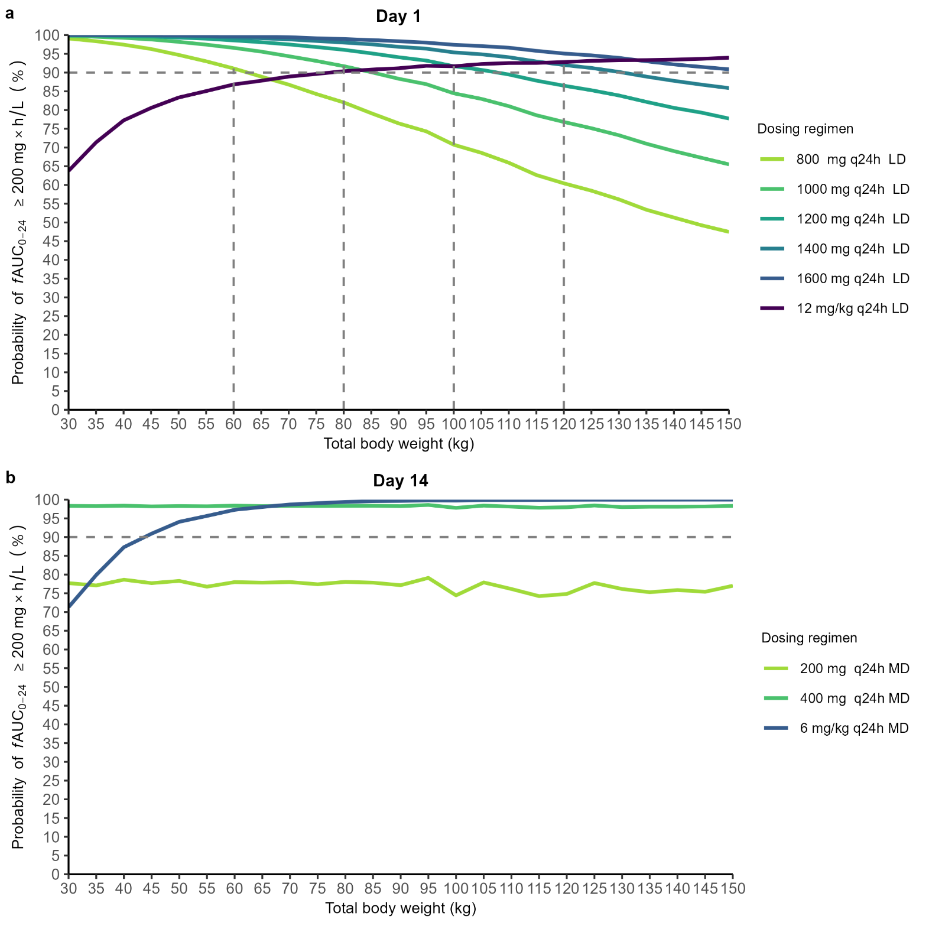

**Fig. 1**. Probability of target attainment of *f*AUC0-24 200 mg×h/L vs body weight on day 1 (a) and day 14 (b) when not on CRRT. CRRT: continuous renal replacement therapy; *f*AUC0-24: area under the unbound concentration–time curve for 24 hours; LD: loading dose; MD: maintenance dose. The dashed gray line represents the target probability of PKPD target attainment of 90%.

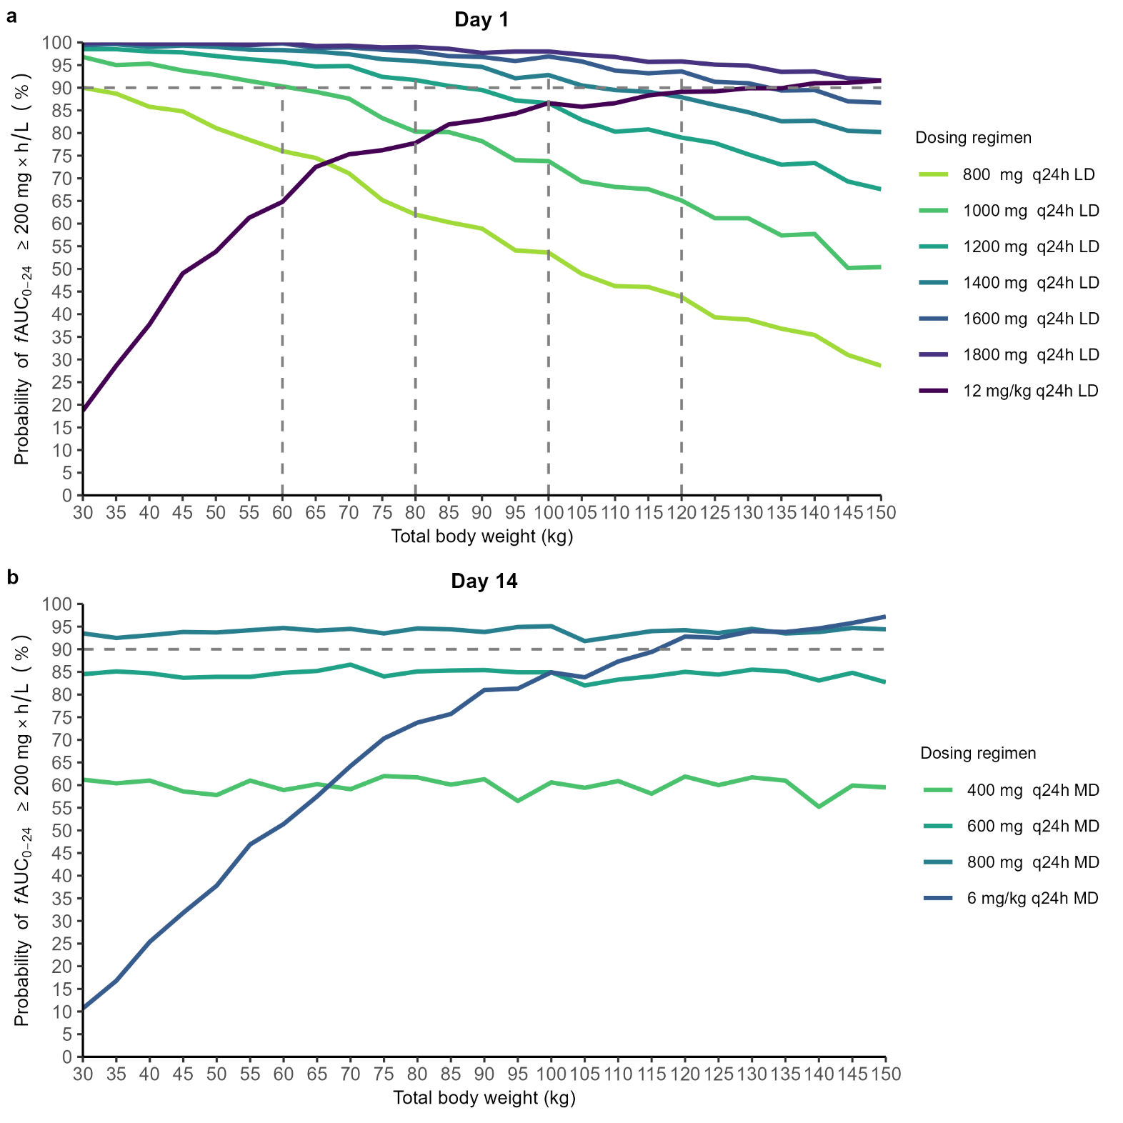

**Fig. 2**. Probability of target attainment of *f*AUC0-24 200 mg×h/L vs body weight on day 1 (a) and day 14 (b) when on CRRT. CRRT: continuous renal replacement therapy; *f*AUC0-24: area under the unbound concentration–time curve for 24 hours; LD: loading dose; MD: maintenance dose. The dashed gray line represents the target probability of PKPD target attainment of 90%.

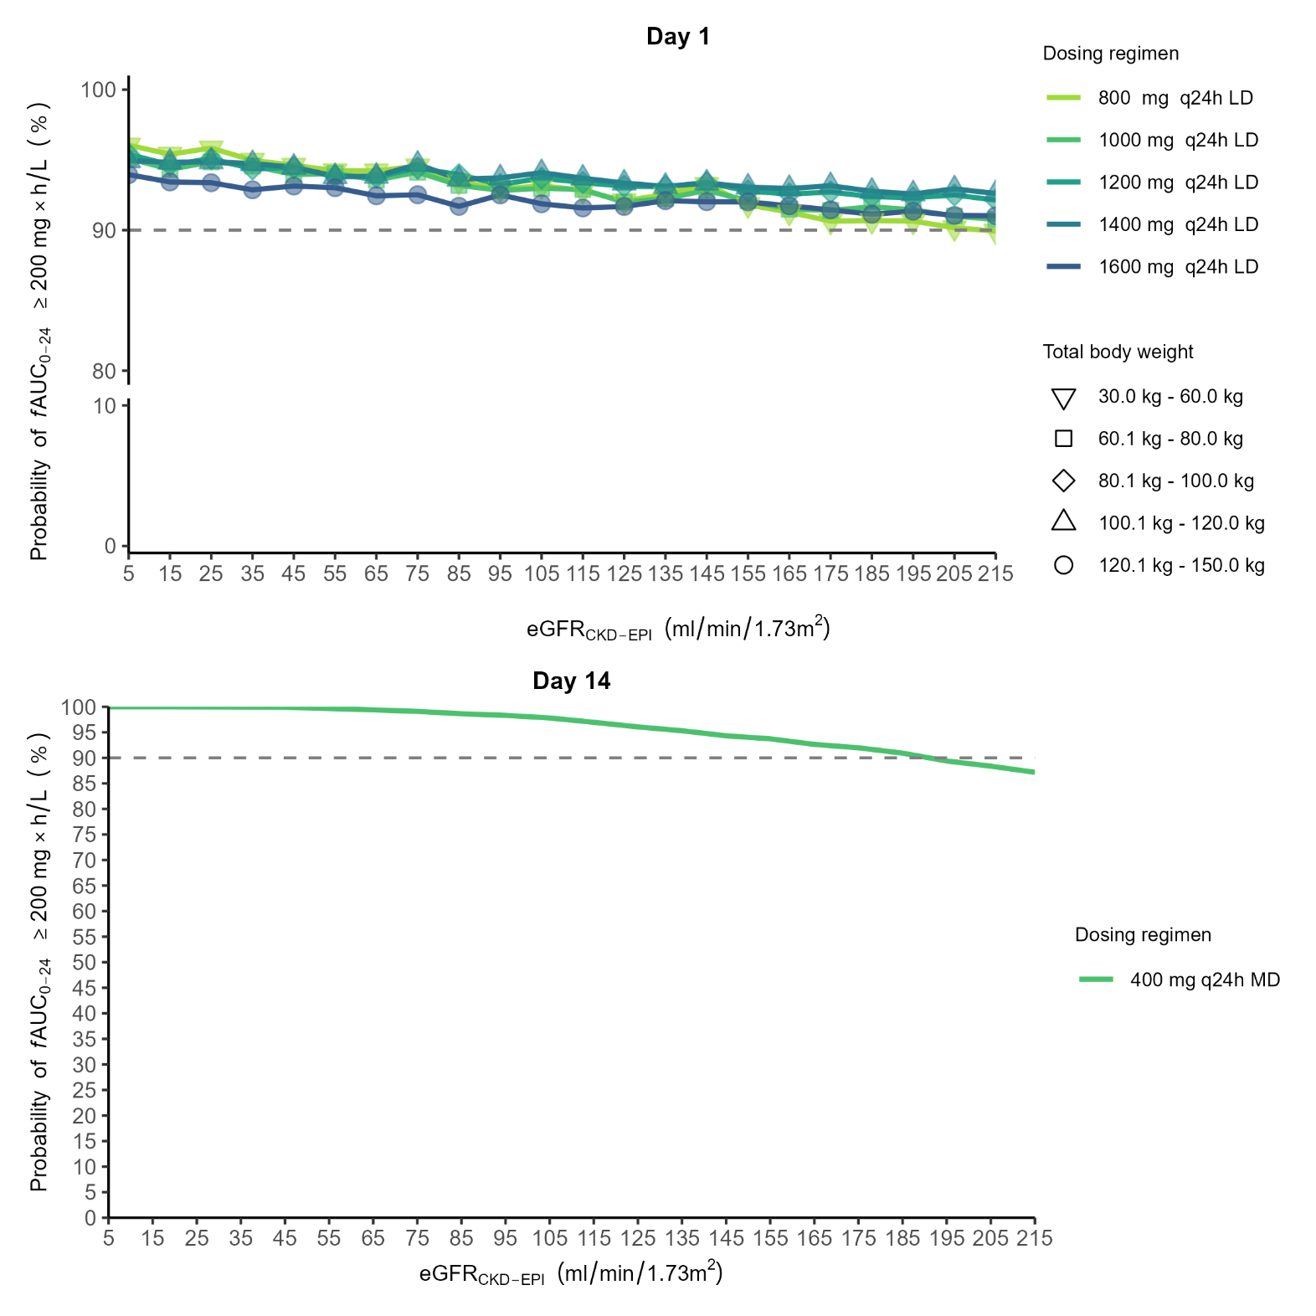

**Fig. 3**. Probability of target attainment of *f*AUC0-24 200 mg×h/L vs eGFRCKD-EPI on day 1 (a) and day 14 (b) when not on CRRT. eGFRCKD-EPI: estimated glomerular filtration rate (calculated using the Chronic Kidney Disease Epidemiology Collaboration equation). CRRT: continuous renal replacement therapy; *f*AUC0-24: area under the unbound concentration–time curve for 24 hours; LD: loading dose; MD: maintenance dose. The dashed gray line represents the target probability of PKPD target attainment of 90%.

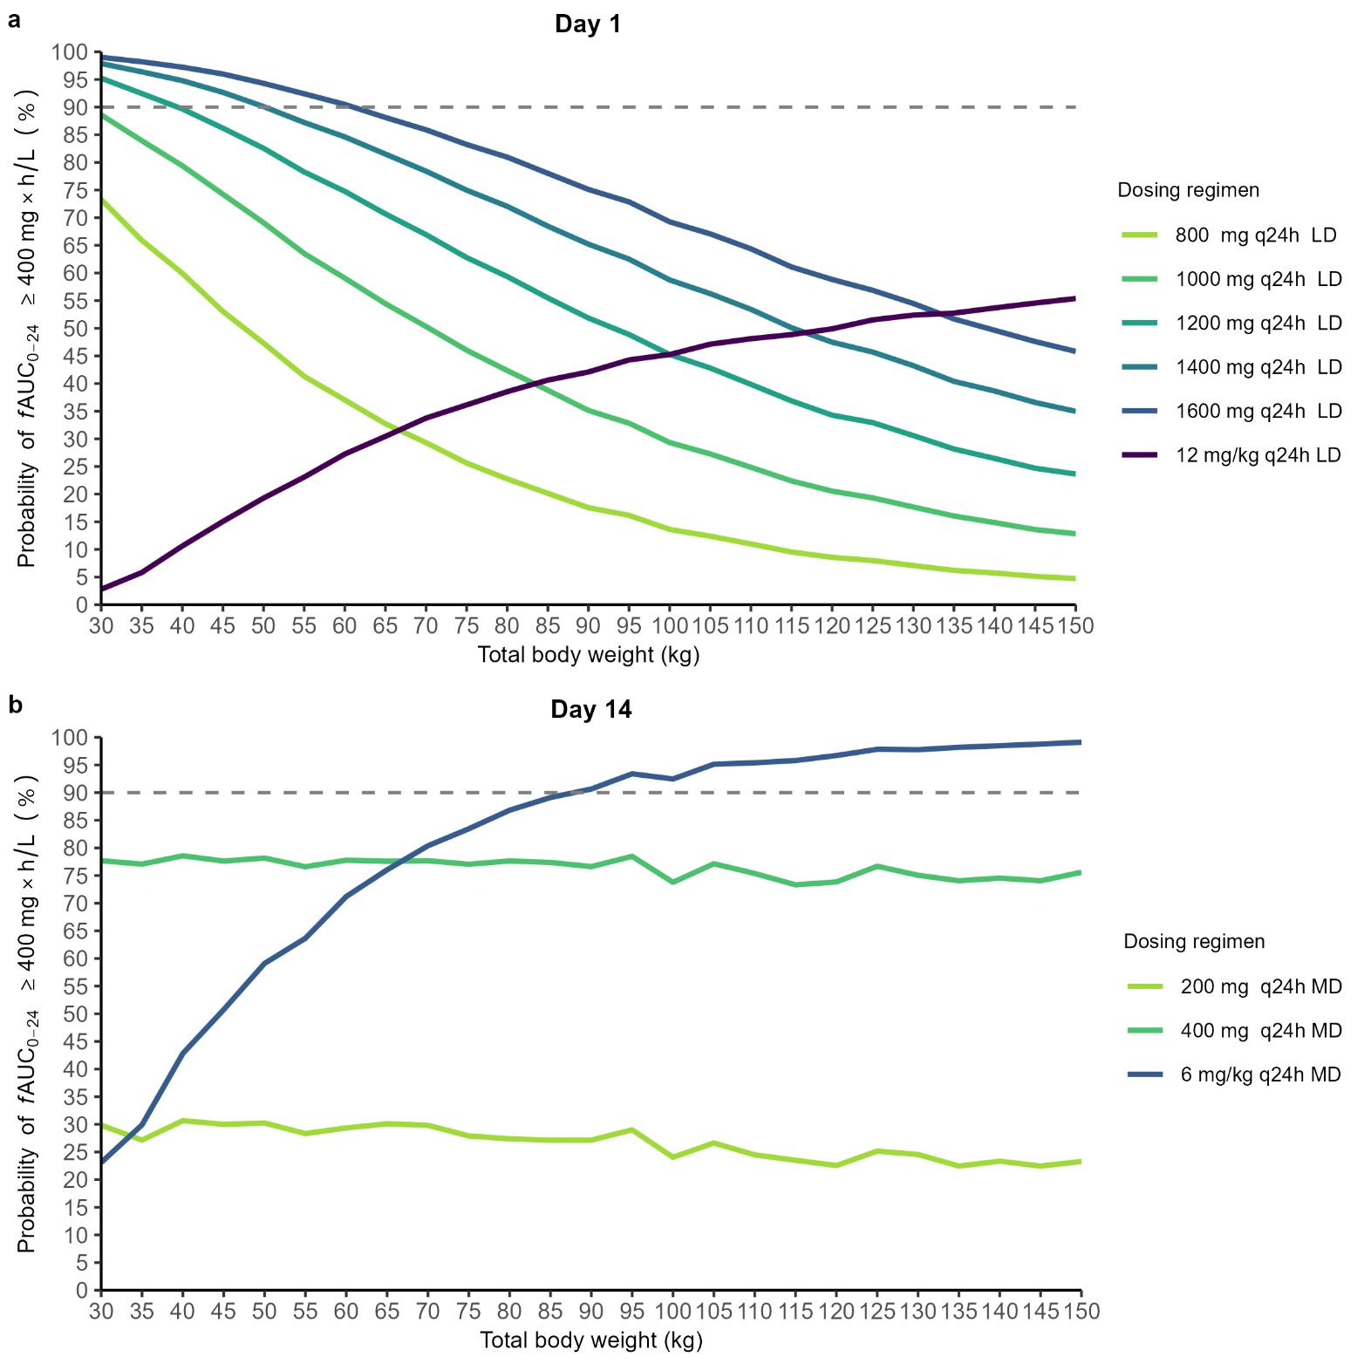

**Fig. 4**. Probability of target attainment of *f*AUC0-24 400 mg×h/L vs total body weight on day 1 (a) and day 14 (b) when not on CRRT. CRRT: continuous renal replacement therapy; *f*AUC0-24: area under the unbound concentration–time curve for 24 hours; LD: loading dose; MD: maintenance dose. The dashed gray line represents the target probability of PKPD target attainment of 90%.

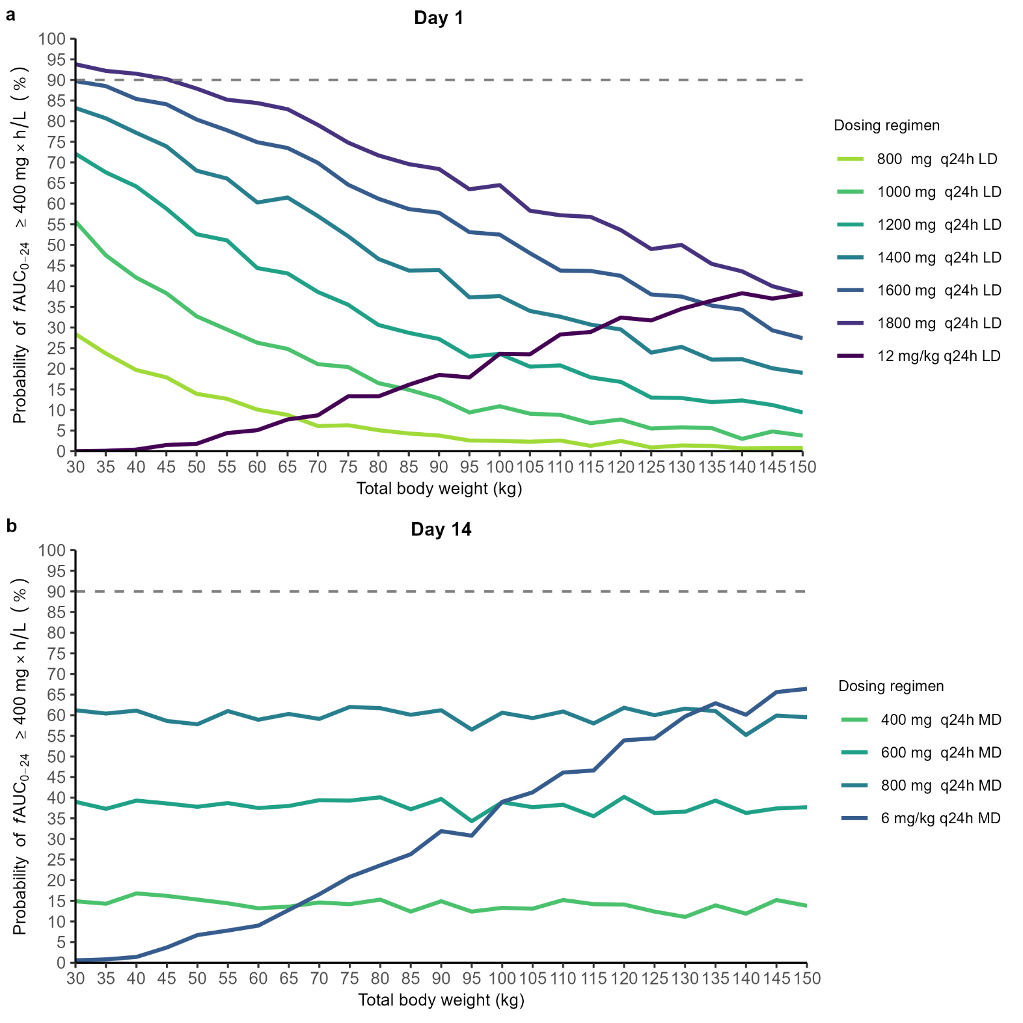

**Fig. 5**. Probability of target attainment of *f*AUC0-24 400 mg×h/L vs total body weight on day 1 (a) and day 14 (b) when on CRRT. CRRT: continuous renal replacement therapy; *f*AUC0-24: area under the unbound concentration–time curve for 24 hours; LD: loading dose; MD: maintenance dose. The dashed gray line represents the target probability of PKPD target attainment of 90%.

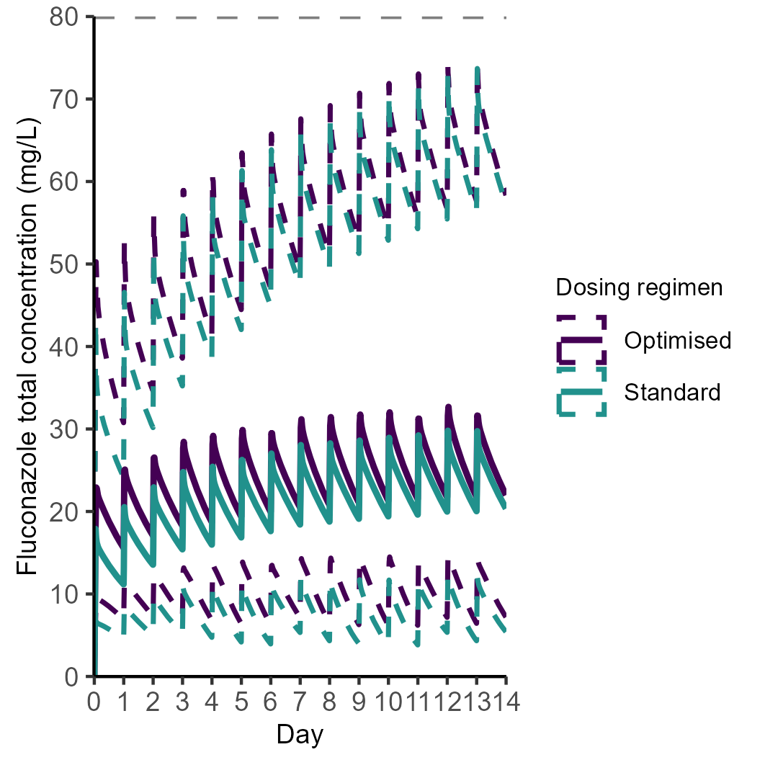**Fig. 6.** Fluconazole total concentration over time at the population level for standard and optimised dosing regimens. The concentration is represented by the median line, with dashed lines showing the range between the 5th and 95th percentiles of the population. The dashed gray line represents the threshold for fluconazole toxicity.