**Model-informed identification of a weight-based fluconazole dosing strategy aiming for improved target attainment in critically ill patients**

**My-Luong Vuong (Mỹ-Lượng Vương) a,b,†, Omar Elkayal a,†, Ruth Van Daele a,c, Jan-Willem C. Alffenaar d,e,f, Sophie L. Stocker, Jason A. Roberts g,h,i, Yves Debaveye j,k, Joost Wauters (12,13), Beatrijs Mertens (1,3), Jasper M. Boonstra (14), Indy Sandaradura (15,16,17), Roger J. Brüggemann (18,19), Jeroen A. Schouten (20), Raoul Bergner (21), Steven Buijk (22), Sebastian G. Wicha (23), Isabel Spriet (1,3)‡, Erwin Dreesen (1)‡\***

†Shared co-first authorship, ‡Shared co-senior authorship

*Corresponding author. E-mail: erwin.dreesen@kuleuven.be

a Department of Pharmaceutical and Pharmacological Sciences, KU Leuven, Leuven, Belgium

b Department of Family Medicine and Population Health, University of Antwerp, Antwerp, Belgium

c Pharmacy Department, University Hospitals Leuven, Leuven, Belgium

d The University of Sydney, Faculty of Medicine and Health, School of Pharmacy, Sydney, Australia

e Westmead Hospital, Sydney, Australia

f The University of Sydney Institute for Infectious Diseases (Sydney ID), Sydney, Australia

g University of Queensland Centre for Clinical Research (UQCCR), The University of Queensland, Brisbane, Queensland, Australia

h Departments of Pharmacy and Intensive Care Medicine, Royal Brisbane and Women’s Hospital, Brisbane 4029, Australia

i Division of Anaesthesiology Critical Care Emergency and Pain Medicine, Nîmes University Hospital, University of Montpellier, 30029 Nîmes, France

j Department of Cellular and Molecular Medicine, KU Leuven, Leuven, Belgium

k Intensive Care Unit, University Hospitals Leuven, Leuven, Belgium

l Department of Microbiology, Immunology and Transplantation, KU Leuven, Leuven, Belgium

m Medical Intensive Care Unit, University Hospitals Leuven, Leuven, Belgium

n University of Groningen, University Medical Centre Groningen, Department of Clinical Pharmacy and Pharmacology, Groningen, The Netherlands

o Centre for Infectious Diseases and Microbiology, Westmead Hospital

p Faculty of Medicine and Health, Westmead Clinical School, The University of Sydney

q Institute of Clinical Pathology and Medical Research, New South Wales Health Pathology, Westmead Hospital, Sydney, Australia

r Radboud university medical centre, Radboud Institute for Medical Innovations, Department of Pharmacy, Nijmegen, The Netherlands

s Radboudumc/CWZ Centre of Expertise in Mycology, Nijmegen, The Netherlands

t Department of Intensive Care, Canisius Wilhelmina Hospital, Nijmegen, The Netherlands

u Division of Rheumatology, Department of Medicine A, Ludwigshafen Medical Centre, Ludwigshafen, Germany

v Department of Surgery, IJsseland Hospital, Capelle aan den Ijssel, The Netherlands

w Institute of Pharmacy, University of Hamburg, Bundesstraße 45, 20146 Hamburg, Germany.

**Introduction**

Invasivecandidiasis, including candidaemia, remains a serious complication that commonly occurs in patients suffering from one or more underlying medical conditions such as immunosuppression, (abdominal) surgery or criticall illness [1]. Candidaemia is linked to a crude mortality rate of 28% and an attributable mortality rate of 11% [2]. However, in patients admitted in the intensive care unit (ICU), these rates increase sharply to 60% and 40%, respectively [3].

Fluconazole is an (old) triazole antifungal drug used for the treatment of invasive candidiasis and candidaemia [4]. It is recommended as a targeted treatment against fluconazole-susceptible species, especially those with reduced susceptibility to echinocandins, such as *Candida parapsilosis* [5]. It is frequently used due to its safety, good tissue penetration, and lower cost compared to echinocandins [5-11]. Fluconazole is mainly excreted unchanged by the kidney (~80%), undergoing glomerular filtration and, importantly, also active tubular reabsorption. It is minimally subjected to hepatic metabolism; only 11% of the dose is excreted as metabolites via the kidneys [9, 12]. Its protein binding is low (11-12%) [9].

The primary pharmacokinetic-pharmacodynamic (PKPD) target of fluconazole is a ratio of the area under the unbound concentration-time curve for 24 hours over the minimum inhibitory concentration (*f*AUC0-24/MIC) of 100 [13, 14]. This corresponds to an *f*AUC0-24 of 200 mg×h/L for a MIC of 2 mg/L, which is the susceptibility breakpoint for Candida species most frequently associated with human infection [13]. This *f*AUC0-24 value is suggested to be equivalent to the total fluconazole trough concentration (Cmin) of 7.5 mg/L, which is a more practical target in routine care for performing therapeutic drug monitoring (TDM)  [15, 16]. Fluconazole-related toxicity is recorded in only two cases who exibited clonic convulsions at Cmin of approximately 80 mg/L [17, 18].

The currently recommended fluconazole dosing regimen for invasive candidiasis – an 800 mg loading dose once a day (q.d.) on day 1 followed by 400 mg q.d. – has been shown to fail in achieving early adequate target exposure in ICU patients, particularly in those with high creatinine clearance, with high body weight, or those undergoing continuous renal replacement therapy (CRRT) [15, 19, 20]. A few population pharmacokinetics (popPK) dose-finding studies have been performed in this patient population, however, no consensus has been reached on an optimised fluconazole dosing strategy [11, 15, 19, 21]. Probably, this is due to the low number of patients included in most of these studies.

Therefore, we performed an individual patient data meta-analysis (IPDMA) using intravenous (IV) fluconazole TDM data collected from eight published studies. Our aim was to (i) develop a popPK model of fluconazole in ICU patients, (ii) identify covariates with a clinically relevant impact on fluconazole *f*AUC0-24 target attainment, and (iii) provide an optimised dosing regimen that ensures adequate target attainment in all relevant subpopulations.

**Patients and methods**

**Patient population and study design**

Medical centres that had published data on plasma concentrations of intravenous (IV) fluconazole among critically ill patients admitted to the intensive care unit (ICU) have been identified. The identification process involved searching PubMed from its inception to November 2021. The selected centres were subsequently contacted to request access to their data, and upon agreement, a data transfer agreement was sent to each. All collected datasets were then aggregated for subsequent secondary analysis. The study was approved by the Ethics Committee Research UZ / KU Leuven (S62242). All data was transferred under formal data transfer agreements. Written informed consent was obtained from all patients before participation in the studies in compliance with all applicable laws, regulations, and the approval of the (local) Ethics Committee.

**Population pharmacokinetics modelling**

A popPK model was fit to the fluconazole concentration-time data. One-, two-, and three-compartment models with linear elimination processes were explored. The magnitude of differences in individual PK parameters from the typical value, which is referred to as interindividual variability (IIV) was estimated; next to differences between observed and model-predicted concentrations, which is referred to as residual variability (RV). The PK variability between observation periods (e.g., ≤day 7 vs >day 7) was tested by introducing interoccasion variability (IOV). Between-centre variability was tested as a random effect as well as a fixed effect. Individual PK parameters were assumed to be log-normally distributed, which was achieved using an exponential function. E.g., the central volume of distribution of subject *i* (Vc*i*) was calculated following this equation:

(Eq. 1)

with the typical population value of the central volume of distribution, *ηi* the difference between the population and individual estimate, and *ω*2 the variance of all *ηi*‘s.

A final model including covariate effects was built through two-way stepwise covariate modelling (αforward=0.05, αbackward=0.01) [22]. Six covariates were considered: CRRT at a certain time point while receiving fluconazole (yes or no), body weight (BW), body mass index (BMI), fat-free mass (FFM; approximated by lean body weight derived from body weight and height using Boer’s formula), [23] and estimated glomerular filtration rate (calculated using the Chronic Kidney Disease Epidemiology Collaboration equation; eGFRCKD-EPI) [24]. BW, BMI and FFM were available at baseline (on the first day of ICU admission), eGFRCKD-EPI was included as time-varying variable, and CRRT was treated as a binary variable.

Continuous covariates were normalised to the median value in the population and introduced into the population model using a power function [25]. For instance, introducing an effect of BW on Eq. 1 normalised to the database’s median value of 80 kg in a power function can be written as followings:

(Eq. 2)

with the effect of BW on Vc*i*.

**Missing data handling**

Mean imputation and multiple imputation were used for handling missing data. Multiple imputation was conducted using 2l.pan function in mice package in R  [26]. This function employs two-level method using the linear mixed model to draw imputations  [26]. Specifically, we used the intercept-only model  [27]. The imputation was performed separately for patients who had CRRT at least once, and patients who did not have CRRT. All variables were included in each imputation model (with the exception of the variable that was being imputed) [28]. In addition, dosing occasion (indicating each dosing event), and study site were two auxiliary variables in the imputation models [28]. Multiple imputed datasets were created, and an independent popPK analysis for each of the datasets was conducted. Results were then combined using Rubin’s rules for normally distributed parameter estimates [27, 29]. For non-normal non-negative variance terms (i.e., IIV and RV), log transformation was performed before pooling their estimates to ensure normality assumption holds [30]. The delta method was utilised to obtain the variance of these log-transformed terms [31]. The number of imputations (m) was chosen based on the magnitude of missingness of the specific variable [28]. The 95% confidence interval (CI) of the pooled estimates, which follow the Student’s *t*-distribution, was calculated [27].

**Model selection and evaluation**

The most parsimonious popPK model was selected based on a likelihood ratio test (LRT) at a 5% significance level (delta objective function value [dOFV] ≥3.84 points, 1 degree of freedom [df]), precision (95% CI), and physiological plausibility of the parameter estimates. Additionally, goodness-of-fit plots including population and individual predictions versus observations, conditional weighted residuals versus time and versus population predictions, and prediction-corrected visual predictive check (pcVPC) plots (n=1000 simulations) were used [25, 32]. Bootstrapping was utilised to acquire non-parametric estimates of uncertainty in parameter estimates (n=2000 bootstraps)  [25].

**Simulations**

**Dose-finding simulations**

**Selecting dosing regimens for testing**

We conducted Monte Carlo simulations using the final popPK model to evaluate various dosing regimens for fluconazole. These regimens were selected considering the recommended standard loading and maintenance doses (800 mg q.d. and 400 mg q.d. respectively) as a reference to which other regimens were compared. The decision was also made based on the commercially available fluconazole IV dosage forms of 200 mg and 400 mg to avoid unused drug [33]. Specifically, we considered six fixed loading doses ranging from 800 mg to 1800 mg daily, and three fixed maintenance doses ranging from 400 mg to 800 mg daily, with the stepsize of 200 mg.

**Creating the virtual patient datasets**

Different virtual patient datasets were created, in which simulations were done separately for each level of (a) categorical variable(s), and each dataset contained continuous covariate(s) spanning the range of values observed in the meta-analysis dataset. Correlation between continuous covariates were taken into account in creating these datasets. A total of 1,000 simulations were performed per virtual patient.

**Criteria for evaluating dosing regimens**

Simulations were performed to identify an optimised inclusive dosing regimen. A dosing regimen was considered inclusive if it resulted in clinically acceptable target attainment along the entire covariate range. Probability of target attainment (PTA) on day 1 was used to evaluate the adequacy of the loading dose. Adequacy of the maintenance dose was selected based on PTA at day 14, as fluconazole is expected to achieve steady state by then, given its elimination half-life of about 30 hours [9]. The target attainment for dose-finding was based on simulated AUC0-24 values. These were calculated using a dummy compartment to integrate the individually predicted total fluconazole concentrations over time. A fluconazole *f*AUC0-24 of 200 mgxh/L was used as the optimal PKPD target, taking into account the non-species specific susceptibility breakpoint corresponding to 2 mg/L [18, 34, 35], and a fluconazole unbound fraction of 89% [9, 34]. We selected Cmin of 80.0 mg/L as the threshold for toxicity [15, 17]. The probability of target attainment (PTA) was evaluated at the end of days 1, 2, 7, and 14 of treatment. A PTA of ≥90% was considered clinically acceptable, as suggested by the European Medicines Agency[36].

**Population-level simulations**

Subsequently, the standard and optimised inclusive dosing regimens were compared in terms of population-level PTA and drug exposure. A population of 1,000 virtual patients was created. These patients have a similar proportion of each categorical covariate(s) level as the actual pooled dataset. Besides, continuous covariate(s) values were randomly generated from the empirical cumulative distribution of the observed values [37]. Each patient in the population was repeated in the simulation 1000 times. The proportion of the population expected to achieve clinically acceptable target attainment over a 14-day treatment course was calculated and compared between standard and optimised dosing regimens. Receiver operating characteristics (ROC) analysis was employed to confirm the absence of clinically relevant covariate effects of the optimised inclusive dosing regimen.

**Software**

Dataset formatting and exploration were performed using R (v4.3.1; R Core Team, Vienna, Austria) in RStudio integrated development environment (v2023.09.0+463; RStudio, Inc., Boston, MA, USA). The *tidyverse* collection of packages were used for this purpose, while the *mice* package was used to perform multiple imputation [27, 38]. NONMEM (v7.5.0; ICON Development Solutions, Gaithersburg, MD, USA) with differential equation solver ADVAN13 and the first-order conditional estimation with interaction method for parameter estimation was used for non-linear mixed-effects modelling. All procedures were executed using the Perl-speaks-NONMEM (PsN; v5.3.0) toolkit on the Pirana modelling workbench (v21.11.1; Certara, Inc., Princeton, NJ, USA) [39]. The NONMEM control stream and the R script for multiple imputation are available in the Supplementary Code.

**Results**

**Data**

Eight clinical centres worldwide shared data from a total of 177 ICU patients and treated with IV fluconazole [11, 15, 19-21, 40-42]. Patients’ characteristics are summarised in **Table 1**. Patients contributed 1616 total fluconazole plasma concentrations, of which 395 (24.4%) were obtained at trough. Body weight ranges from 34 to 142 kg while eGFRCKDEPI ranges from 5 to 213 mL/min/1.73 m2. eGFRCKDEPI were missing in 73.2% of the total event, in which 13.9% and 59.3% were missing within and between dosing intervals, respectively.

**Population pharmacokinetics modelling**

A two-compartment popPK model with linear elimination best described the fluconazole concentration-time data (Table 2). In this model, there were two types of clearances: clearance when a patient was on continuous renal replacement therapy (CRRT) (CLCRRT; 1.69 L/h), and clearance when a patient was not on CRRT (CLnon-CRRT; 0.634 L/h). Additionally, the model incorporated inter-individual variability (IIV) in CLCRRT, CLnon-CRRT, and the central volume of distribution (Vc), with a covariance relationship between CLnon-CRRT and Vc.A proportional error model best described the residual variability (RV). The goodness-of-fit plots are available in **Figure S1**.

Missing covariate values were handled with mean imputation within dosing intervals, and multiple imputation between dosing intervals. In total, 70 multiple imputation datasets were created. Inclusion of effects of BW on central volume of distribution and eGFRCKD-EPI on CLnon-CRRT significantly improved goodness-of-fit. The pooled parameter estimates of the 70 models as well as the medians of 10 random bootstrap results (of total 2000 bootstraps) are available in **Table 2**.

Equation 3 and 4 shows how fluconazole Vc and CLnon-CRRT of patient *i* increases with body weight and eGFRCKD-EPI:

with (Eq.3)

with (Eq.4)

Body weight and eGFRCKD-EPI explained 8.7% and 7.8% of the IIV in Vc and CLnon-CRRT of fluconazole, respectively. The unexplained IIV in Vc and CLnon-CRRT remained high (57.9% and 49.7%, respectively).

The pcVPC plots of the pooled model show a good agreement between model simulations and observed data (Fig. 1). Median values of the non-parametric bootstrap were in good agreement with the pooled point estimates (Table 2).

**Simulations**

eGFRCKDEPI did not show an impact on PTA under simulated dosing regimens when patients were not on CRRT across its whole range (5-215 ml/min/1.73m2) (Fig. 2).

Regarding body weight’s impact, the standard dosing regimen did not result in clinically acceptable PTA across the entire body weight range (30-150 kg) when patients were not on CRRT (Fig. 3) and on CRRT (Fig. 4).

The optimised inclusive dosing regimen is thus presented as in **Table 3,** which is stratified based on CRRT status and body weight. The proposed loading doses was determined by applying various body weight cut-offs. These doses were selected as the minimum values ensuring a clinically acceptable PTA on the first day within a specific range of body weights (Fig. 3-4). Regarding maintenance doses, 400 mg q.d. and 800 mg q.d. were adequate for achieving the targeted PTA on day 14 along the entire weight range, for CRRT and non-CRRT patients, respectively (Fig. 3-4).

Population-level simulations confirmed that the standard dosing regimen resulted in clinically unacceptable PTA in the first two days of the treatment period (Fig. S2). Simulating the optimised, inclusive dosing regimen resulted in clinically acceptable PTA as early as day 1 until day 14 of treatment (Fig. S2).

The percentage of patients with high fluconazole trough concentrations (Cmin ≥80 mg/L) under proposed optimised doses were minimal (<2.4% when patients were not-on CRRT, and <0.2% when patients were on CRRT) (Fig. 5). ROC analysis confirmed the clinically irrelevance of eGFRCKDEPI under standard and optimised dosing regimen at a population level, demonstrated by the area under the ROC (AUCROC) of around 0.5 from day 1 to day 14 (Fig. S3). This analysis also confirmed body weight was a clinically relevant predictor for target attainment on days 1 (AUROC 0.687 [95% CI 0.686-0.688]) and 2 (AUROC 0.633 [95% CI 0.631-0.634]) at a population level when using the standard dosing regimen (Fig. S3). This clinically relevant impact of body weight decreased sharply when the optimised dosing regimen was utilised, evidenced by AUROCs of 0.462 (0.459-0.464) and 0.539 (0.535-0.542) on day 1 and day 2.

**Discussion**

Our study aimed to investigate the popPK of IV fluconazole dosing ICU patients. We utilised data from eight clinical centres to develop a popPK model allowing to explore the impact of patient factors on fluconazole PK, exposure and target attainment. Our modelling and simulation results revealed that the standard IV dosing regimen resulted in inadequate target attainment of the *f*AUC0-24 in this population. To address this issue, we proposed a pragmatic and easy-to-implement optimised dosing regimen that was predicted to guarantee target attainment over 90% from the first day of treatment throughout a two-week course.

In our study, we employed the technique of individual patient data meta-analysis (IPDMA), which involves merging datasets from multiple studies that share subject populations and similar variables. [43] IPDMA offers several advantages, including the ability to explore subgroup analyses not investigated in the primary studies, and enhance standardisation by pooling data using consistent inclusion and exclusion criteria, as well as analysis methods [44].

The PK of fluconazole in critically ill patients were best described by a two-compartment model with first-order elimination, consistent with studies that utilised rich-sampling technique. [11, 21, 45] In contrast, several studies that relied on (trough) samples collected during routine clinical practice identified a one-compartment model. [15, 19, 46] This disparity can be attributed to the sparse sampling in clinical practice, which limits the capture of a more informative two-compartment model.

Body weight was the only clinically relevant covariate in our model, and it significantly influenced Vc. This finding aligns with a previous study and can be explained by the drug's high hydrophilicity, which causes its accumulation in the central volume, as well as its sensitivity to body weight changes  [19]. Although lean body weight (LBW) or FFM may be better surrogates for Vc for fluconazole, we found that body weight performed better in our model. Also, body weight is preferred in clinical practice due to its convenience, as it is generally available, while BMI and FFM requires additional estimation based on body weight, height and sex [23].

In addressing missing covariate information in our study, we implemented multiple imputation to tackle the significant challenge of covariate missingness. Specifically, about 75% of eGFRCKDEPI values were unavailable, a common hurdle in PK data analysis that demands careful consideration for maintaining analysis quality [47]. Unfortunately, prior studies often neglected reporting the handling technique for missing data or resorted to single-value imputation, introducing potential bias, especially when data is not missing completely at random (MCAR) [11, 15, 21, 34, 35, 48]. In contrast, multiple imputation offers unbiased estimates under conditions of either MCAR or missing at random (MAR) [48]. This unbiased estimation holds even under high shrinkage and, despite its advantages, multiple imputation remains underutilized in the field of pharmacometrics.

Our study did not identify a statistically significant impact of kidney function on model clearance, contrary to some included studies [11, 19]. This discrepancy is likely attributed to differences in handling data missingness. We advocate for the use of robust missing data handling techniques like multiple imputation, as assuming data missing completely at random (MCAR) is improbable in clinical research [28]. Moreover, a substantial amount of missing data can hinder the detection of the true effect of renal function on fluconazole popPK. Future research with intensive serum creatinine sampling is essential to re-evaluate the potential impact of kidney function on fluconazole popPK.

The optimised dosing regimen, stratified based on BW, makes the use of TDM no longer necessary. TDM of fluconazole is not widely recommended nor implemented, but advocated in rare circumstances such as for obese patients, patients on CRRT or in patients with sepsis. It is known that standard dosing is not resulting in optimal exposure in these subpopulations  [50]. However, many centres do not have access to TDM for fluconazole  [51], and when available, turn around time and cost might hamper feasibilty [34, 52]. Therefore, (easy-to-implement) stratified or group-based dosing, in which patients with similar characteristics are treated with the same optimised dose, is preferred over TDM [35].

We have developed an optimized dosing regimen that involves a loading dose determined by different body weight thresholds and a consistent maintenance dose. The rationale behind this approach is to administer the minimum effective quantity of the drug while still achieving a target attainment rate of 90% or higher. In our specific situation, the hospital bears the cost of fluconazole, which necessitates the use of the smallest effective quantity. Moreover, our study center's prescribing software automatically incorporates this dosing recommendation, reducing the workload for clinicians. However, in settings where cost or automated software is not a concern, simpler dosing strategies could be considered. For instance, a consistent loading dose for all patients or a loading dose based on a single body weight threshold. It is worth noting that our optimized loading dose is not technically the smallest effective dose, but it was chosen to ensure target attainment for patients with potentially underestimated body weight at the borderline. Given the challenges associated with accurately measuring body weight, especially in the ICU, this cautious dosing approach facilitates target attainment in such scenarios [53].

We acknowledge several limitations in our study. Firstly, we were unable to differentiate between different types CRRT due to a lack of information. Each type of CRRT has different implications for fluconazole elimination and may require different dosing strategies. [54] The majority of CRRT patients in our study were on continuous veno-venous hemodiafiltration (CVVHDF) and continuous veno-venous hemofiltration (CVVH), in which CVVHDF is believed to have a higher fluconazole clearance as fluconazole is more effectively eliminated by diffusion. [54] However, it is unlikely that we could detect significant effects of individual CRRT types due to their limited representation in our study (18% CRRT). Furthermore, different CRRT flow rates (i.e., dialysate rate and ultrafiltration rate) can result in different fluconazole clearance. [54] This piece of information is completely missing in our study. Secondly, our assumption that clearance in patients not on CRRT corresponds to their normal kidney clearance, while clearance in patients on CRRT is solely due to CRRT, may not hold true in critically ill patients with rapidly changing kidney function [55]. Thirdly, the plausibility of the missing at random assumption for our multiple imputation approach may be questioned, as our data come from different studies, each with potentially different mechanisms of missingness Moreover, the limited number of predictors available for inclusion in our imputation model makes the missing at random assumption less likely [57].

To evaluate the impact of the optimised BW-based loading regimen and the fixed maintenance dose on target attainment and clinical outcomes, a prospective clinical trial is essential. Additionally, the cost-effectiveness of the increased maintenance dose should be assessed. Intensive measurements of kidney function should be collected in this future research to robustly evaluate the effect of renal function on fluconazole popPK in critically ill patients. Furthermore, it is crucial to investigate the effect of different types of CRRT, along with flow rate information to gain better insights in this matter to guide clinical practice.

However, it is important to acknowledge limitations associated with this type of analysis, such as the possibility of bias due to the inability to obtain all identified datasets [58]. In our study, we included almost all published studies reporting on plasma concentration of IV fluconazole in critically ill patients, except for four studies of total 54 patients, for which we were unable to obtain the data despite our efforts to contact the authors. [45, 46, 59, 60] This highlights the challenge of data availability and the potential influence of data owners' preferences on releasing their own data. [58] Furthermore, the inclusion of subjects from various studies in an IPDMA may not represent a random sample of the potential participant population due to differences in geographic location, the nature of the healthcare system, etc. [61] We accounted for this by introducing centre, which indicates data coming from different sources, as a random effect (the same way we tested for IOV), as well as fixed effect by including it as a covariate. However, we did not find any significant impact, possibly due to the potential homogeneity of our pooled study population in terms of their patient characteristics.

In conclusion, our popPK analysis supports stratified dosing of fluconazole in critically ill patients based on BW and CRRT status, eliminating the need for TDM. We emphasise the importance of handling missing data appropriately in pharmacometric studies, and encourage researchers to report the missing data handling technique used. More methodologically sound methods for handling missing data, such as multiple imputation, should be utilised to ensure unbiased estimation. Future research on fluconazole popPK should aim to collect more intensive data to minimize missingness and provide robust evidence to support dosing recommendations for this drug.

**Table 1.** Patient characteristics

| Parameter | **Van Daele et al. (n=39) [20]** | **Muilwijk et al. (n=19) [11]** | **Bergner et al. (n=5) [40]** | **Buijk et al. (n=5) [41]** | **Sandaradura et al. (n=30) [19]** | **Sinnollareddy et al. (n=25) [42]** | **Alobaid et al. (n=21) [21]** | **Boonstra et al. (n=33) [15]** | **Overall (n=177)** |
| --- | --- | --- | --- | --- | --- | --- | --- | --- | --- |
| **APACHE II,** median [Q1-Q3] | 16.0 [14.0-22.0] | 18.0 [15.0-23.0] | NA | NA | NA | 22.0 [12.0-33.0] | 18.0 [17.0-21.0] | 19.0 [14.0-20.0] | 18.0 [15.0-23.0] |
| Missing, *n* (%) | 2 (5.1) | 0 (0) | 5 (100) | 5 (100) | 30 (100) | 0 (0) | 0 (0) | 6 (18.2) | 48 (27.1) |
| **Age,** median [Q1-Q3], years | 65.0 [57.5-70.0] | 64.0 [52.5-70.5] | 57.0 [43.0-67.0] | 53.0 [48.0-56.0] | 55.0 [44.0-66.5] | 64.0 [53.0-78.0] | 52.0 [48.0-65.0] | 60.0 [54.0-72.0] | 62.0 [50.0-70.0] |
| **Sex,** male, *n* (%) | 26 (66.7) | 11 (57.9) | 1 (20.0) | 3 (60.0) | 18 (60.0) | 19 (76.0) | 11 (52.4) | 26 (78.8) | 115 (65.0) |
| **CRRT,** *n* (%) | 8 (20.5) | 6 (31.6) | 5 (100) | 0 (0) | 10 (33.3) | 3 (12.0) | 0 (0) | 0 (0) | 32 (18.1) |
| **Total dosing + sampling events** | 709 | 496 | 174 | 76 | 451 | 261 | 249 | 755 | 3170 |
| **Fluconazole dose,** median [Q1-Q3], mg, *N* | 400 [400-400], 453 | 400 [200-400], 182 | 800 [800-800], 90 | 400 [400-400], 33 | 400 [400-400], 321 | 400 [300-400], 192 | 400 [400-400], 89 | 400 [200-400], 194 | 400 [400-400], 1554 |
| **Plasma samples available per patient,** median [Q1-Q3], *N* | 6 [3-8], 256 | 18 [12-19], 314 | 18 [8-25], 84 | 7 [7-7], 42 | 3.50 [3.00-5.75], 130 | 3 [3-3], 69 | 8 [7-8], 160 | 14 [7-22], 561 | 7 [3-12], 1616 |
| **Body weight,** median [Q1 - Q3], kg | 76.2 [62.0-86.9] | 83.0 [70.5-103] | NA | 72.0 [65.0-80.0] | 90.0 [64.0-105] | 80.0 [71.0-87.0] | 86.0 [74.0-103] | 81.0 [73.0-104] | 80.0 [70.0-96.0] |
| Missing, *N* (%) | 0 (0) | 0 (0) | 174 (100) | 0 (0) | 0 (0) | 0 (0) | 0 (0) | 0 (0) | 174 (5.5) |
| **eGFRCKDEPI**, median [Q1-Q3], mL/min/1.73 m2 | 85.2 [46.7-105] | 88.1 [63.4-106] | NA | NA | 67.7 [46.6-100] | 73.3 [25.5-110] | 101 [72.9-120] | 98.3 [71.9-111] | 83.4 [49.1-104] |
| Missing within dosing intervals, *N* (%) | 38 (5.3) | 225 (45.4) | 0 | 0 | 52 (11.5) | 15 (5.7) | 6 (2.4) | 104 (13.7) | 440 (13.9) |
| Missing between dosing intervals, N (%) | 199 (28.1) | 215 (43.3) | 174 (100) | 75 (100) | 156 (34.6) | 221 (84.7) | 222 (89.2) | 618 (81.9) | 1880 (59.3) |
| APACHE II, Acute Physiology and Chronic Health Evaluation II; C: plasma concentration; CRRT:continuous renal replacement therapy; Cmin: fluconazole trough concentration; eGFRCKDEPI:estimated glomerular filtration rate calculated using the Chronic Kidney Disease Epidemiology Collaboration equation without a race variable ; IHD: intermittent haemodialysis; n, number of patients; N, number of events (either dosing or sampling or both); NA, not available ; Q1, 1st quartile; Q3, 3rd quartile. | | | | | | | | | |

**Table 2**. Final model parameter estimates

| Parameter | **Pooled estimate (95% CI)** | **Bootstrap median (95% CI)\*** |
| --- | --- | --- |
| **Fixed effects** |  |  |
| CLCRRT (L/h) | 1.69 (1.43–1.96) | 1.70 (1.42–1.97) |
| CLnon-CRRT (L/h) | 0.634 (0.564–0.689) | 0.621 (0.559–0.700) |
| eGFRCKD-EPI on CLnon-CRRT | 0.48 (0.11–0.85) | 0.49 (0.21–0.82) |
| Vc (L) | 38.5 (31.9–45.2) | 38.4 (31.4–45.7) |
| BW on Vc | 1.03 (0.66–1.41) | 1.04 (0.67–1.45) |
| Q (L/h) | 12.3 (2.7–22.0) | 12.0 (4.0–28.9) |
| Vp (L) | 8.71 (2.50–14.92) | 9.03 (2.75–15.65) |
| **Random effects** |  |  |
| IIV on CLCRRT (%CV) | 44.3 (29.7–67.8) | 42.3 (26.2–65.0) |
| IIV on CLnon-CRRT (%CV) | 49.7 (40.2–62.1) | 50.0 (40.2–61.7) |
| IIV on Vc (%CV) | 57.9 (45.7–74.4) | 57.3 (44.4–73.1) |
| Cov(IIV on CLnon-CRRT-Vc) (%CV) | 28.6 (4.6–40.9) | 28.5 (12.5–44.2) |
| **Residual variability** |  |  |
| Proportional error(%CV) | 16.7 (14.6–19.1) | 16.5 (14.4–18.8) |
| BW, body weight; CI, confidence interval; CRRT, continuous renal replacement therapy; CLCRRT, clearance when patients were on CRRT; CLnon-CRRT, clearance when patients were not on CRRT; Cov, covariance; CV, coefficient of variation expressed as % CV = ×100%; [25] eGFRCKD-EPI,estimated glomerular filtration rate (calculated using the Chronic Kidney Disease Epidemiology Collaboration equation); IIV, inter-individual variability; Q, inter-compartmental clearance; Vc, volume of distribution in the central compartment; Vp, volume of distribution in the peripheral compartment.  *Data are represented as the median of the 2000 bootstrap runs (200 bootstrap runs × 10 multiple imputed datasets). The median successful minimization rate for the 2000 bootstrap runs was 96.5%. | | |

**Table 3**. Fluconazole dosing strategy with minimally 90% probability of target attainment in ICU patients.

|  |  |  |  |  |
| --- | --- | --- | --- | --- |
| Body weight | No CRRT | | CRRT | |
| Loading dose  (day 1) | Maintenance dose  (from day 2) | Loading dose  (day 1) | Maintenance dose  (from day 2) |
| 30 kg - 60 kg | 800 mg q24h | 400 mg q24h | 1000 mg q24h | 800 mg q24h |
| 61 kg – 80 kg | 1000 mg q24h | 1200 mg q24h |
| 81 kg – 100 kg | 1200 mg q24h | 1400 mg q24h |
| 101 kg – 120 kg | 1400 mg q24h | 1600 mg q24h |
| 121 kg – 140 kg | 1600 mg q24h | 1800 mg q24h |
| 141 kg – 150 kg | 1800 mg q24h |
| CRRT: continuous renal replacement therapy; q24h: every 24 hours. | | | | |

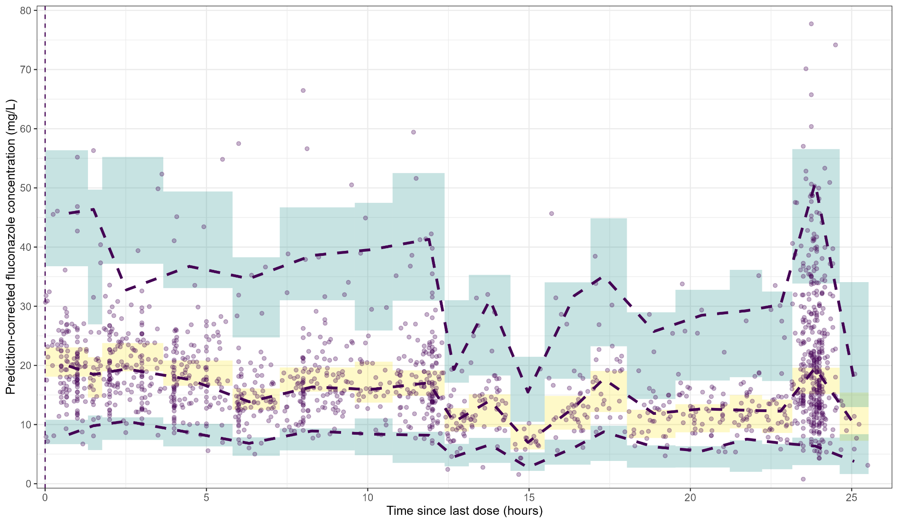

**Fig. 1**. prediction-corrected Visual Predictive Check of the predictive pooled popPK model. Purple dots represent the observed fluconazole concentrations. The horizontal dashed purple line, from top to bottom, are the 2.5th, 50th and 97.5th percentiles of the observed data, respectively. The vertical dashed purple line illustrates the start of fluconazole infusion. The green and yellow shaded areas indicate the 95% prediction intervals of the 50th and 2.5th and 97.5th percentiles, respectively, of the simulated data (n=1000).

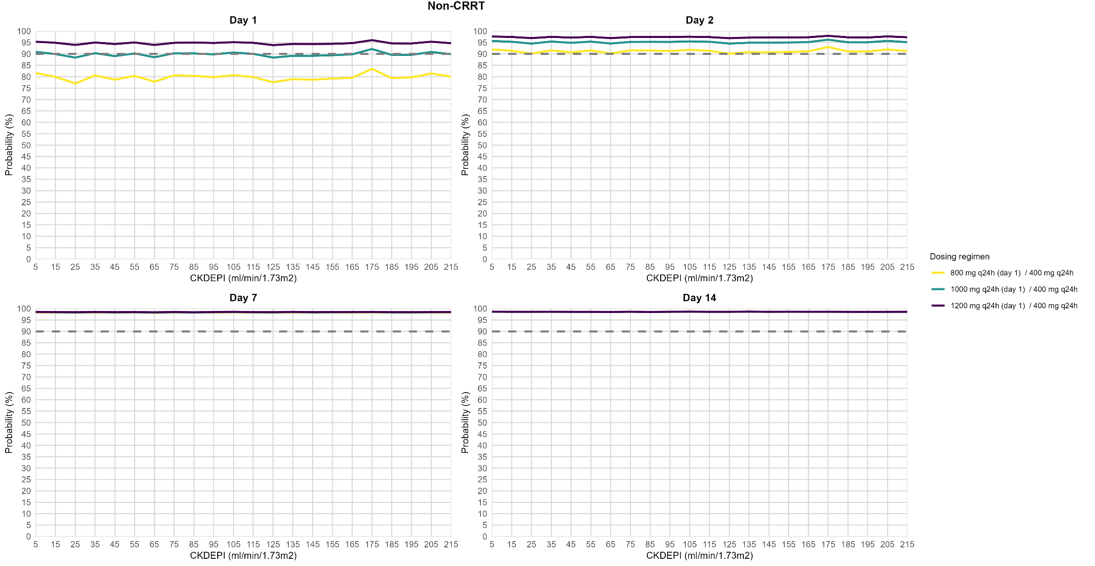

**Fig. 2**. Probability of target attainment of *f*AUC0-24 200 mgxh/L over time. CKDEPI: estimated glomerular filtration rate (calculated using the Chronic Kidney Disease Epidemiology Collaboration equation).

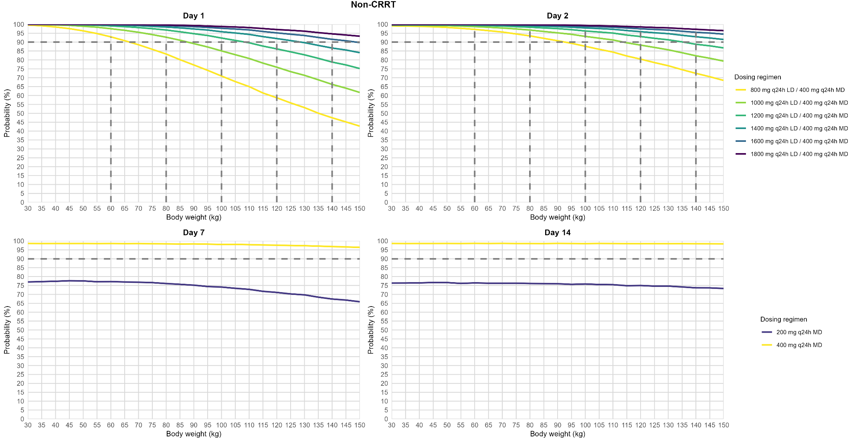

**Fig. 3**. Probability of target attainment of *f*AUC0-24 200 mgxh/L over time. CRRT: continuous renal replacement therapy.

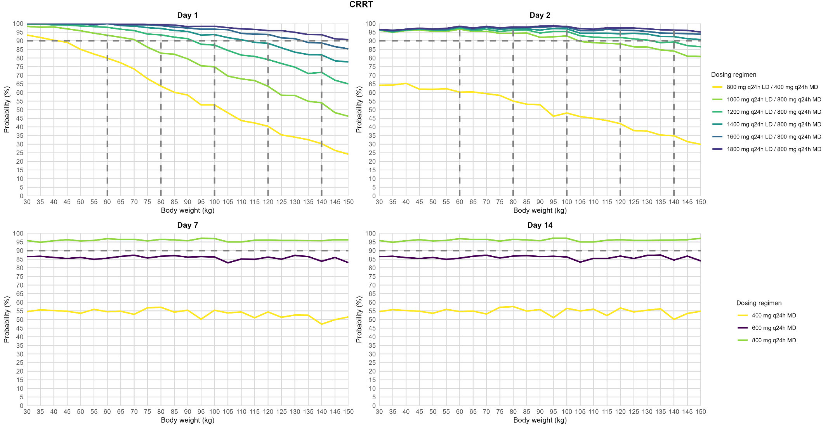

**Fig. 4**. Probability of target attainment of *f*AUC0-24 200 mgxh/L over time. CRRT: continuous renal replacement therapy.

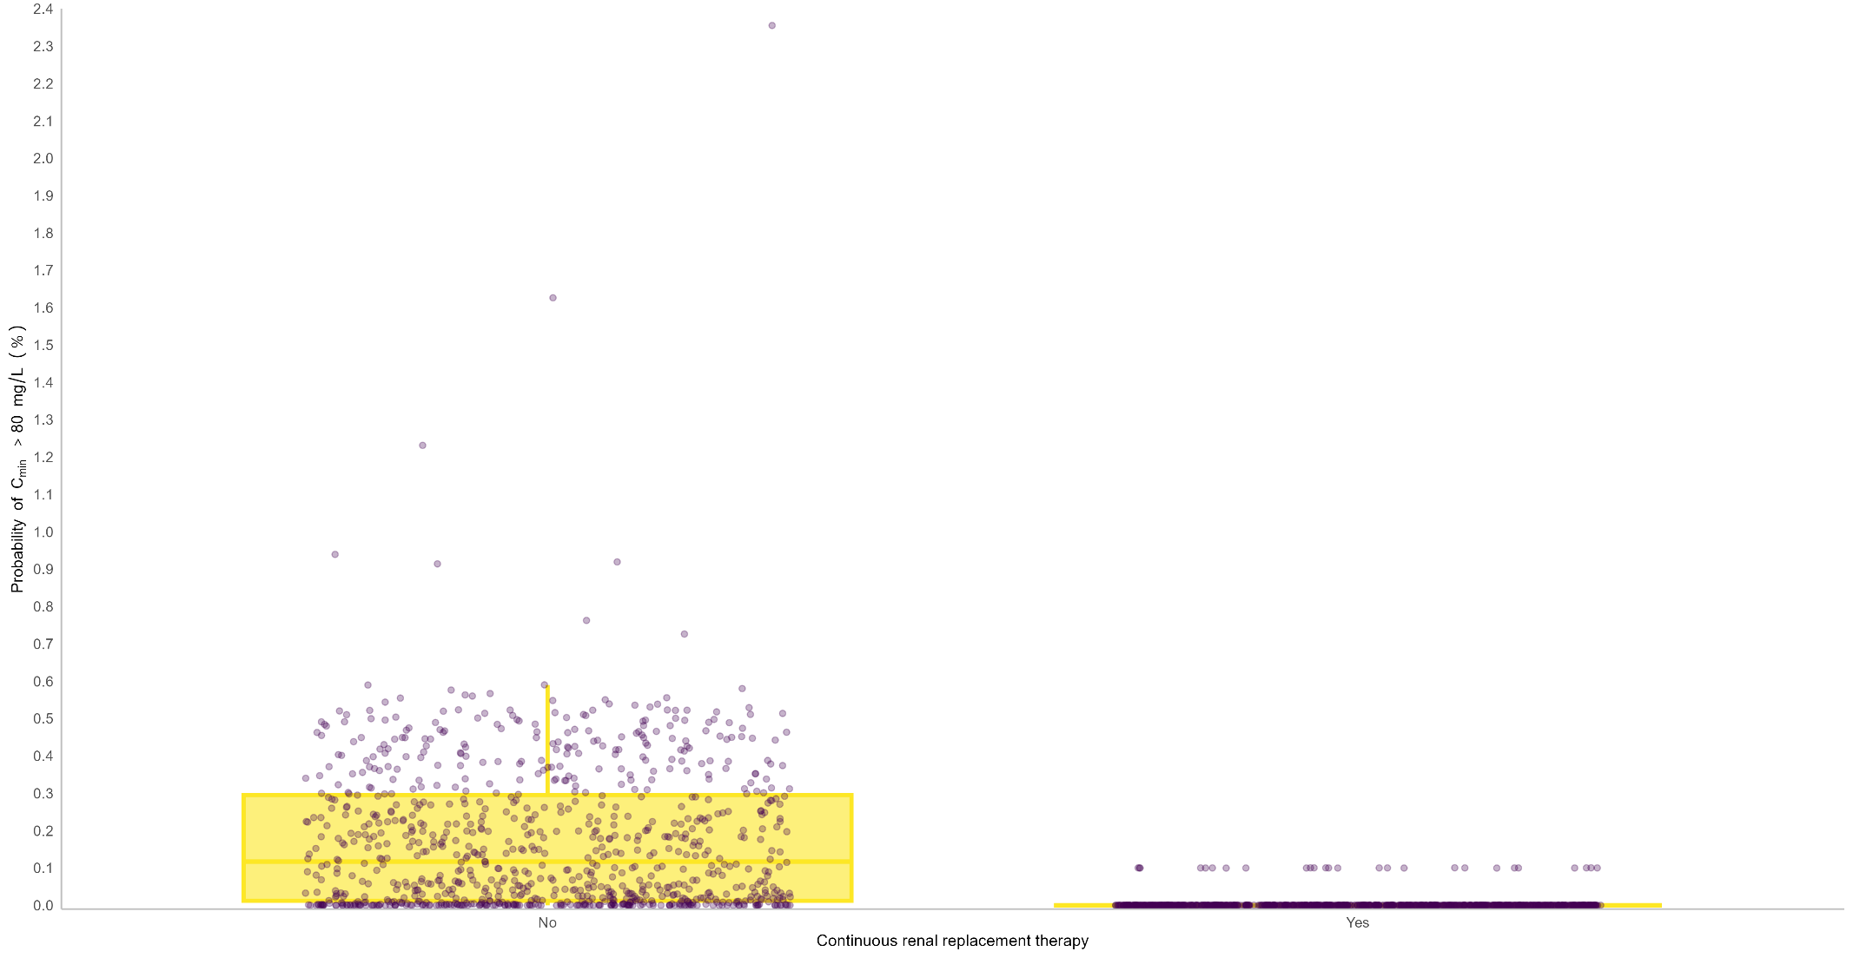

**Fig. 5**.

**References**

[1] Cornely OA, Bassetti M, Calandra T, Garbino J, Kullberg BJ, Lortholary O, et al. ESCMID* guideline for the diagnosis and management of Candida diseases 2012: non-neutropenic adult patients. Clin Microbiol Infect. 2012;18 Suppl 7:19-37. <http://doi.org/10.1111/1469-0691.12039>.

[2] Chen S, Slavin M, Nguyen Q, Marriott D, Playford EG, Ellis D, et al. Active surveillance for candidemia, Australia. Emerg Infect Dis. 2006;12:1508-16. <http://doi.org/10.3201/eid1210.060389>.

[3] Eggimann P, Garbino J, Pittet D. Epidemiology of Candida species infections in critically ill non-immunosuppressed patients. Lancet Infect Dis. 2003;3:685-702. <http://doi.org/10.1016/s1473-3099(03)00801-6>.

[4] Tissot F, Agrawal S, Pagano L, Petrikkos G, Groll AH, Skiada A, et al. ECIL-6 guidelines for the treatment of invasive candidiasis, aspergillosis and mucormycosis in leukemia and hematopoietic stem cell transplant patients. Haematologica. 2017;102:433-44. <http://doi.org/10.3324/haematol.2016.152900>.

[5] Pappas PG, Kauffman CA, Andes DR, Clancy CJ, Marr KA, Ostrosky-Zeichner L, et al. Clinical Practice Guideline for the Management of Candidiasis: 2016 Update by the Infectious Diseases Society of America. Clin Infect Dis. 2016;62:e1-50. <http://doi.org/10.1093/cid/civ933>.

[6] Debruyne D, Ryckelynck JP. Clinical pharmacokinetics of fluconazole. Clin Pharmacokinet. 1993;24:10-27. <http://doi.org/10.2165/00003088-199324010-00002>.

[7] Grau S, Pozo JC, Romá E, Salavert M, Barrueta JA, Peral C, et al. Cost-effectiveness of three echinocandins and fluconazole in the treatment of candidemia and/or invasive candidiasis in nonneutropenic adult patients. Clinicoecon Outcomes Res. 2015;7:527-35. <http://doi.org/10.2147/ceor.S91587>.

[8] Pea F, Righi E, Cojutti P, Carnelutti A, Baccarani U, Soardo G, et al. Intra-abdominal penetration and pharmacodynamic exposure to fluconazole in three liver transplant patients with deep-seated candidiasis. J Antimicrob Chemother. 2014;69:2585-6. <http://doi.org/10.1093/jac/dku169>.

[9] Pfizer. Summary of Product Characteristics (SmPC) Diflucan. Summary of Product Characteristics (SmPC) Diflucan. 2012.

[10] Wade KC, Benjamin DK, Jr., Kaufman DA, Ward RM, Smith PB, Jayaraman B, et al. Fluconazole dosing for the prevention or treatment of invasive candidiasis in young infants. Pediatr Infect Dis J. 2009;28:717-23. <http://doi.org/10.1097/INF.0b013e31819f1f50>.

[11] Muilwijk EW, de Lange DW, Schouten JA, Wasmann RE, Ter Heine R, Burger DM, et al. Suboptimal Dosing of Fluconazole in Critically Ill Patients: Time To Rethink Dosing. Antimicrob Agents Chemother. 2020;64. <http://doi.org/10.1128/aac.00984-20>.

[12] Bellmann R, Smuszkiewicz P. Pharmacokinetics of antifungal drugs: practical implications for optimized treatment of patients. Infection. 2017;45:737-79. <http://doi.org/10.1007/s15010-017-1042-z>.

[13] European Committee on Antimicrobial Susceptibility Testing. Fluconazole: Rationale for the clinical breakpoints, version 3.0, 2020. 2020.

[14] Rodríguez-Tudela JL, Almirante B, Rodríguez-Pardo D, Laguna F, Donnelly JP, Mouton JW, et al. Correlation of the MIC and dose/MIC ratio of fluconazole to the therapeutic response of patients with mucosal candidiasis and candidemia. Antimicrob Agents Chemother. 2007;51:3599-604. <http://doi.org/10.1128/aac.00296-07>.

[15] Boonstra JM, Märtson AG, Sandaradura I, Kosterink JGW, van der Werf TS, Marriott DJE, et al. Optimization of Fluconazole Dosing for the Prevention and Treatment of Invasive Candidiasis Based on the Pharmacokinetics of Fluconazole in Critically Ill Patients. Antimicrob Agents Chemother. 2021;65. <http://doi.org/10.1128/aac.01554-20>.

[16] Resztak M, Sobiak J, Czyrski A. Recent Advances in Therapeutic Drug Monitoring of Voriconazole, Mycophenolic Acid, and Vancomycin: A Literature Review of Pediatric Studies. Pharmaceutics. 2021;13. <http://doi.org/10.3390/pharmaceutics13121991>.

[17] Matsumoto K, Ueno K, Yoshimura H, Morii M, Takada M, Sawai T, et al. Fluconazole-Induced Convulsions at Serum Trough Concentrations of Approximately 80 μg/mL. Therapeutic Drug Monitoring. 2000;22:635-6.

[18] Lewis. R, Bruggemann. R, Padoin. C, Maertens. J, Marchetti. O, Groll. A, et al. Triazole Antifungal Therapeutic Drug Monitoring. In Proceedings of the ECIL 6 Meeting, Sophia Antipolis, France, 11–12 September 2015. ECIL 6 meeting. Sophia Antipolis, France.

[19] Sandaradura I, Marriott DJE, Day RO, Norris RLG, Pang E, Stocker SL, et al. Current fluconazole treatment regimens result in under-dosing of critically ill adults during early therapy. Eur J Clin Microbiol Infect Dis. 2021;40:1521-8. <http://doi.org/10.1007/s10096-021-04201-w>.

[20] Van Daele R, Wauters J, Lagrou K, Denooz R, Hayette MP, Gijsen M, et al. Pharmacokinetic Variability and Target Attainment of Fluconazole in Critically Ill Patients. Microorganisms. 2021;9. <http://doi.org/10.3390/microorganisms9102068>.

[21] Alobaid AS, Wallis SC, Jarrett P, Starr T, Stuart J, Lassig-Smith M, et al. Effect of Obesity on the Population Pharmacokinetics of Fluconazole in Critically Ill Patients. Antimicrob Agents Chemother. 2016;60:6550-7. <http://doi.org/10.1128/aac.01088-16>.

[22] Jonsson EN, Karlsson MO. Automated covariate model building within NONMEM. Pharm Res. 1998;15:1463-8. <http://doi.org/10.1023/a:1011970125687>.

[23] Boer P. Estimated lean body mass as an index for normalization of body fluid volumes in humans. Am J Physiol. 1984;247:F632-6. <http://doi.org/10.1152/ajprenal.1984.247.4.F632>.

[24] Sharma A, Sahasrabudhe V, Musib L, Zhang S, Younis I, Kanodia J. Time to Rethink the Current Paradigm for Assessing Kidney Function in Drug Development and Beyond. Clin Pharmacol Ther. 2022;112:946-58. <http://doi.org/10.1002/cpt.2489>.

[25] Mould DR, Upton RN. Basic concepts in population modeling, simulation, and model-based drug development-part 2: introduction to pharmacokinetic modeling methods. CPT Pharmacometrics Syst Pharmacol. 2013;2:e38. <http://doi.org/10.1038/psp.2013.14>.

[26] Huque MH, Carlin JB, Simpson JA, Lee KJ. A comparison of multiple imputation methods for missing data in longitudinal studies. BMC Medical Research Methodology. 2018;18:168. <http://doi.org/10.1186/s12874-018-0615-6>.

[27] Buuren Sv. Flexible Imputation of Missing Data, Second Edition: Taylor & Francis Group; 2018.

[28] Austin PC, White IR, Lee DS, van Buuren S. Missing Data in Clinical Research: A Tutorial on Multiple Imputation. Can J Cardiol. 2021;37:1322-31. <http://doi.org/10.1016/j.cjca.2020.11.010>.

[29] Rubin DB. Multiple Imputation for Nonresponse in Surveys. New York, NY: New York, NY: John Wiley & Sons, Inc.; 1987.

[30] Harel O. The estimation of R 2 and adjusted R 2 in incomplete data sets using multiple imputation. Journal of Applied Statistics. 2009;36:1109-18. <http://doi.org/10.1080/02664760802553000>.

[31] Hosmer DW, Lemeshow S, May S. Applied Survival Analysis: Regression Modeling of Time-to-Event Data, Second Edition: John Wiley & Sons, Inc.; 2008.

[32] Karlsson MO, Savic RM. Diagnosing model diagnostics. Clin Pharmacol Ther. 2007;82:17-20. <http://doi.org/10.1038/sj.clpt.6100241>.

[33] PDR. fluconazole - Drug Summary.

[34] Sandaradura I, Wojciechowski J, Marriott DJE, Day RO, Stocker S, Reuter SE. Model-Optimized Fluconazole Dose Selection for Critically Ill Patients Improves Early Pharmacodynamic Target Attainment without the Need for Therapeutic Drug Monitoring. Antimicrob Agents Chemother. 2021;65. <http://doi.org/10.1128/aac.02019-20>.

[35] Van Daele R, Debaveye Y, Lagrou K, Spriet I. Fluconazole Underexposure in Critically Ill Patients: a Matter of Using the Right Targets? Antimicrob Agents Chemother. 2021;65. <http://doi.org/10.1128/aac.00430-21>.

[36] Committee for Medicinal Products for Human Use (CHMP) EMA. Guideline on the use of pharmacokinetics and pharmacodynamics in the development of antimicrobial medicinal products. United Kingdom: European Medicines Agency; 2016.

[37] Ramachandran KM, Tsokos CP. Chapter 5 - Statistical estimation. In: Ramachandran KM, Tsokos CP, editors. Mathematical Statistics with Applications in R (Third Edition): Academic Press; 2021. p. 179-251.

[38] Wickham H, Grolemund G. R for Data Science2017. <https://r4ds.had.co.nz/>.

[39] Keizer RJ, Karlsson MO, Hooker A. Modeling and Simulation Workbench for NONMEM: Tutorial on Pirana, PsN, and Xpose. CPT Pharmacometrics Syst Pharmacol. 2013;2:e50. <http://doi.org/10.1038/psp.2013.24>.

[40] Bergner R, Hoffmann M, Riedel KD, Mikus G, Henrich DM, Haefeli WE, et al. Fluconazole dosing in continuous veno-venous haemofiltration (CVVHF): need for a high daily dose of 800 mg. Nephrol Dial Transplant. 2006;21:1019-23. <http://doi.org/10.1093/ndt/gfi284>.

[41] Buijk SL, Gyssens IC, Mouton JW, Verbrugh HA, Touw DJ, Bruining HA. Pharmacokinetics of sequential intravenous and enteral fluconazole in critically ill surgical patients with invasive mycoses and compromised gastro-intestinal function. Intensive Care Med. 2001;27:115-21. <http://doi.org/10.1007/s001340000771>.

[42] Sinnollareddy MG, Roberts JA, Lipman J, Akova M, Bassetti M, De Waele JJ, et al. Pharmacokinetic variability and exposures of fluconazole, anidulafungin, and caspofungin in intensive care unit patients: Data from multinational Defining Antibiotic Levels in Intensive care unit (DALI) patients Study. Critical Care. 2015;19.

[43] Azar M, Benedetti A, Riehm KE, Imran M, Krishnan A, Chiovitti M, et al. Individual participant data meta-analyses (IPDMA): data contribution was associated with trial corresponding author country, publication year, and journal impact factor. Journal of Clinical Epidemiology. 2020;124:16-23. <http://doi.org/10.1016/j.jclinepi.2020.03.026>.

[44] Tierney JF, Vale C, Riley R, Smith CT, Stewart L, Clarke M, et al. Individual Participant Data (IPD) Meta-analyses of Randomised Controlled Trials: Guidance on Their Use. PLoS Med. 2015;12:e1001855. <http://doi.org/10.1371/journal.pmed.1001855>.

[45] Patel K, Roberts JA, Lipman J, Tett SE, Deldot ME, Kirkpatrick CM. Population pharmacokinetics of fluconazole in critically ill patients receiving continuous venovenous hemodiafiltration: using Monte Carlo simulations to predict doses for specified pharmacodynamic targets. Antimicrob Agents Chemother. 2011;55:5868-73. <http://doi.org/10.1128/aac.00424-11>.

[46] Aoyama T, Hirata K, Hirata R, Yamazaki H, Yamamoto Y, Hayashi H, et al. Population pharmacokinetics of fluconazole after administration of fosfluconazole and fluconazole in critically ill patients. J Clin Pharm Ther. 2012;37:356-63. <http://doi.org/10.1111/j.1365-2710.2011.01297.x>.

[47] Irby DJ, Ibrahim ME, Dauki AM, Badawi MA, Illamola SM, Chen M, et al. Approaches to handling missing or "problematic" pharmacology data: Pharmacokinetics. CPT Pharmacometrics Syst Pharmacol. 2021;10:291-308. <http://doi.org/10.1002/psp4.12611>.

[48] Johansson Å M, Karlsson MO. Comparison of methods for handling missing covariate data. Aaps j. 2013;15:1232-41. <http://doi.org/10.1208/s12248-013-9526-y>.

[49] Johansson Å M, Karlsson MO. Multiple imputation of missing covariates in NONMEM and evaluation of the method's sensitivity to η-shrinkage. Aaps j. 2013;15:1035-42. <http://doi.org/10.1208/s12248-013-9508-0>.

[50] Lewis R, Brüggemann R, Padoin C, Maertens J, Marchetti O, Groll A, et al. Triazole antifungal therapeutic drug monitoring. Sixth European Conference on Infections in Leukaemia Meeting, Sophia Antipolis, France2015.

[51] Simeoli R, Dorlo TPC, Hanff LM, Huitema ADR, Dreesen E. Editorial: Therapeutic Drug Monitoring (TDM): A Useful Tool for Pediatric Pharmacology Applied to Routine Clinical Practice. Front Pharmacol. 2022;13:931843. <http://doi.org/10.3389/fphar.2022.931843>.

[52] Gómez-López A. Antifungal therapeutic drug monitoring: focus on drugs without a clear recommendation. Clin Microbiol Infect. 2020;26:1481-7. <http://doi.org/10.1016/j.cmi.2020.05.037>.

[53] Darnis S, Fareau N, Corallo CE, Poole S, Dooley MJ, Cheng AC. Estimation of body weight in hospitalized patients. QJM: An International Journal of Medicine. 2012;105:769-74. <http://doi.org/10.1093/qjmed/hcs060>.

[54] Li L, Li X, Xia Y, Chu Y, Zhong H, Li J, et al. Recommendation of Antimicrobial Dosing Optimization During Continuous Renal Replacement Therapy. Front Pharmacol. 2020;11:786. <http://doi.org/10.3389/fphar.2020.00786>.

[55] Huang C-Y, Güiza F, De Vlieger G, Meyfroidt G. Daily fluctuations in kidney function in critically ill adults. Critical Care. 2022;26:347. <http://doi.org/10.1186/s13054-022-04226-3>.

[56] Tandukar S, Palevsky PM. Continuous Renal Replacement Therapy: Who, When, Why, and How. Chest. 2019;155:626-38. <http://doi.org/10.1016/j.chest.2018.09.004>.

[57] Sterne JA, White IR, Carlin JB, Spratt M, Royston P, Kenward MG, et al. Multiple imputation for missing data in epidemiological and clinical research: potential and pitfalls. Bmj. 2009;338:b2393. <http://doi.org/10.1136/bmj.b2393>.

[58] Stewart LA, Tierney JF. To IPD or not to IPD? Advantages and disadvantages of systematic reviews using individual patient data. Eval Health Prof. 2002;25:76-97. <http://doi.org/10.1177/0163278702025001006>.

[59] Muhl E, Martens T, Iven H, Rob P, Bruch HP. Influence of continuous veno-venous haemodiafiltration and continuous veno-venous haemofiltration on the pharmacokinetics of fluconazole. Eur J Clin Pharmacol. 2000;56:671-8. <http://doi.org/10.1007/s002280000216>.

[60] Yagasaki K, Gando S, Matsuda N, Kameue T, Ishitani T, Hirano T, et al. Pharmacokinetics and the most suitable dosing regimen of fluconazole in critically ill patients receiving continuous hemodiafiltration. Intensive Care Med. 2003;29:1844-8. <http://doi.org/10.1007/s00134-003-1980-z>.

[61] Abo-Zaid G, Guo B, Deeks JJ, Debray TP, Steyerberg EW, Moons KG, et al. Individual participant data meta-analyses should not ignore clustering. J Clin Epidemiol. 2013;66:865-73.e4. <http://doi.org/10.1016/j.jclinepi.2012.12.017>.