Model-informed identification of a weight-based fluconazole dosing strategy for improved target attainment in critically ill patients

My-Luong Vuong (Mỹ-Lượng Vương)a†, Omar Elkayala,†, Ruth Van Daelea,b,1, Jan-Willem C. Alffenaarc,d,e, Sophie L. Stockerc,f,g, Jason A. Robertsh,i,j, Yves Debaveyek,l, Joost Wautersm,n, Beatrijs Mertensa,b, Jasper M. Boonstrao, Indy Sandaradurap,q,r, Roger J. Brüggemanns,t, Jeroen A. Schoutenu, Raoul Bergnerv, Steven Buijkw, Sebastian G. Wichax, Isabel Sprieta,b,‡, Erwin Dreesena,‡,*

a Department of Pharmaceutical and Pharmacological Sciences, KU Leuven, Leuven, Belgium  
b Pharmacy Department, University Hospitals Leuven, Leuven, Belgium c The University of Sydney, Faculty of Medicine and Health, School of Pharmacy, Sydney, Australia  d Westmead Hospital, Sydney, Australia e The University of Sydney Institute for Infectious Diseases (Sydney ID), Sydney, Australia f School of Clinical Medicine, Faculty of Medicine and Health, University of New South Wales, Sydney, Australia g Department of Clinical Pharmacology and Toxicology, St. Vincent's Hospital, Sydney, Australia h University of Queensland Centre for Clinical Research (UQCCR), The University of Queensland, Brisbane, Australia i Departments of Pharmacy and Intensive Care Medicine, Royal Brisbane and Women’s Hospital, Brisbane, Australia j Division of Anaesthesiology Critical Care Emergency and Pain Medicine, Nîmes University Hospital, University of Montpellier, Nîmes, France k Department of Cellular and Molecular Medicine, KU Leuven, Leuven, Belgium l Intensive Care Unit, University Hospitals Leuven, Leuven, Belgium m Department of Microbiology, Immunology and Transplantation, KU Leuven, Leuven, Belgium n Medical Intensive Care Unit, University Hospitals Leuven, Leuven, Belgium o University of Groningen, University Medical Centre Groningen, Department of Clinical Pharmacy and Pharmacology, Groningen, The Netherlands p Centre for Infectious Diseases and Microbiology, Westmead Hospital, Sydney, Australia q Faculty of Medicine and Health, Westmead Clinical School, The University of Sydney, Sydney, Australia r Institute of Clinical Pathology and Medical Research, New South Wales Health Pathology, Westmead Hospital, Sydney, Australia s Radboud university medical centre, Radboud Institute for Medical Innovations, Department of Pharmacy, Nijmegen, The Netherlands t Radboudumc/CWZ Centre of Expertise in Mycology, Nijmegen, The Netherlands u Department of Intensive Care, Canisius Wilhelmina Hospital, Nijmegen, The Netherlands v Division of Rheumatology, Department of Medicine A, Ludwigshafen Medical Centre, Ludwigshafen, Germany w Department of Surgery, IJsseland Hospital, Capelle aan den Ijssel, The Netherlands x Institute of Pharmacy, University of Hamburg, Hamburg, Germany

1 Amsterdam, The Netherlands

†Shared co-first authorship, ‡Shared co-senior authorship

*Corresponding author. E-mail: [erwin.dreesen@kuleuven.be](mailto:erwin.dreesen@kuleuven.be). Address: Department of Pharmaceutical and Pharmacological Sciences, KU Leuven, ON2 Herestraat 49 box 521, 3000 Leuven, Belgium. Telephone number: +32 16 37 27 53.

# Abstract

Background Invasive candidiasis, particularly candidaemia, is a life-threatening complication in critically ill patients, in which fluconazole is the recommended step-down therapy to echinocandins. However, current fluconazole standard dosing regimen does not achieve adequate exposure in critically ill patients with continuous renal replacement therapy and obesity.

Objectives This study aimed to develop a population pharmacokinetics (popPK) model of fluconazole, identify factors that impact target attainment, and provide a dosing regimen ensuring an adequate pharmacokinetic-pharmacodynamic (PKPD) target attainment in critically ill patients.

Patients and Methods An individual patient data meta-analysis was conducted, collecting therapeutic drug monitoring data from eight published studies. A popPK model was developed. , in whichmultiple imputation was used to handle missing covariate data. Monte Carlo simulations were conducted to identify the probability of attaining PKPD target in the population under various dosing regimens, with 90% considered to be clinically acceptable. Covariates with an impact on achiving such target in the population were considered to be clinically relevant.

Results Data from 177 critically ill patients were included in the analysis. The final popPK model was a two-compartment model with linear elimination, with continuous renal replacement therapy status, estimated glomerular filtration rate, and body weight as statistically significant covariates. In the studied range, estimated glomerular filtration rate had a clinically irrelevant impact on target attainment. An optimised dosing regimen stratified based on continuous renal replacement therapy status and body weight was proposed.

Conclusion We have developed a convenient fluconazole dosing regimen that helps achieve a population-wide PKPD target attainment in critically ill patients.

*Keywords*:

Fluconazole

Population pharmacokinetics

Monte Carlo simulation

Critically ill patients

Covariate missingness

Multiple imputation

# Introduction

Invasive candidiasis, including candidaemia, remains a serious complication that commonly occurs in patients suffering from medical conditions such as immunosuppression, (abdominal) surgery, or criticall illness [1]. Candidaemia is linked to a crude mortality rate of 28% and an attributable mortality rate of 11% [2]. However, in patients admitted to the intensive care unit (ICU), these rates increase sharply to 60% and 40%, respectively [3].

Fluconazole is an old triazole antifungal drug used for the treatment of invasive candidiasis and candidaemia [4]. It is recommended as a step-down therapy to echinocandins against fluconazole-susceptible *Candida* species, and a drug of choice for *Candida parapsilosis*[4]. It is frequently used thanks to its good safety profile, good tissue penetration, and low cost compared to echinocandins [5, 6]. Fluconazole is mainly excreted unchanged by the kidney (~80%), undergoing glomerular filtration and active tubular reabsorption [7]. Hepatic metabolism is minimal, with only 11% of the dose excreted as metabolites via the kidneys [7]. Protein binding is low (11–12%) [7].

The primary pharmacokinetic-pharmacodynamic (PKPD) target of fluconazole is a ratio of the area under the unbound concentration–time curve for 24 hours over the minimum inhibitory concentration (*f*AUC0-24/MIC) of 100 [8]. This corresponds to an *f*AUC0-24 of 200 mg×h/L for a MIC of 2 mg/L, which is the susceptibility breakpoint for *Candida* species most frequently associated with human infection [8]. Fluconazole-induced hepatotoxicity is estimated to be very low and non-dose-dependent [9, 10]. On the other hand, concentration-dependent toxicity related to fluconazole has been recorded in two case reports of patients exhibiting clonic convulsions at a trough concentration (Ctrough) of approximately 80 mg/L [11, 12].

The currently recommended fluconazole dosing regimen for invasive candidiasis is a single 800 mg loading dose on day 1 followed by 400 mg once daily from day 2 onwards. PKPD target attainment in ICU patients has been shown to be slow and inadequate, particularly in those with a high body weight and undergoing continuous renal replacement therapy (CRRT) [13]. Several population pharmacokinetics (popPK) dose-finding studies have been performed in this vulnerable patient population, however, no consensus has been reached on an optimised fluconazole dosing strategy [13-16]. This might be attributed to the low number of patients included in most of these studies.

Therefore, we performed an individual patient data meta-analysis (IPDMA) using intravenous (IV) fluconazole TDM data collected from eight published studies. Our aims were to (i) develop a popPK model of fluconazole in patients admitted to the ICU, (ii) identify covariates with a clinically relevant impact on fluconazole *f*AUC0-24 target attainment, and (iii) provide an optimised dosing recommendation ensuring adequateICU-wide target attainment.

# Material and methods

## Patient population and study design

Medical centres that had published data on plasma concentrations of intravenous (IV) fluconazole obtained in patients admitted to the intensive care unit (ICU) have been identified through a PubMed search from inception to October 2022. Authors were contacted to start a data sharing collaboration, and upon contractual agreement datasets were transferred and aggregated for subsequent analysis. The study was approved by the Ethics Committee Research UZ / KU Leuven (S62242). Written informed consent was obtained from all patients before participation in the original studies in compliance with approval of the (local) Ethics Committees.

## Population pharmacokinetics modelling

A popPK model was fit to the fluconazole concentration–time data. One-, two-, and three-compartment models with linear elimination processes were explored. The magnitude of differences in individual PK parameters from the typical value, which is referred to as interindividual variability was estimated; as well as differences between observed and model-predicted individual concentrations, which is referred to as residual variability. The PK variability between observation periods (e.g., ≤day 7 vs >day 7) was tested by introducing interoccasion variability. Between-centre variability was tested as a random effect as well as a fixed effect. The difference in analytical assays used among centres was tested by introducing different error models for each assay. Individual PK parameters were assumed to be log-normally distributed, which was achieved using an exponential function. For example, the volume of distribution in the central compartment of subject *i* (Vc*i*) was calculated following this equation:

(Eq. 1)

with Vc*pop* the typical population value of Vc, *ηi* the difference between the population and individual estimate, and *ω*2 the variance of all *ηi*.

A final model including covariate effects was built through two-way stepwise covariate modelling (αforward = 0.05, αbackward = 0.01) [17]. The five tested covariates were body weight, body mass index (BMI), and fat-free mass (FFM; approximated by lean body weight derived from body weight and height using Boer’s formula [18]) at baseline (day of ICU admission), and time-varying CRRT (yes/no) and estimated glomerular filtration rate (calculated using the Chronic Kidney Disease Epidemiology Collaboration equation; eGFRCKD-EPI [19]).

Continuous covariates (body weight, BMI, FFM, and eGFRCKD-EPI) were normalised to the median value in the population and introduced into the popPK model using a power function [20], exemplified as follows:

(Eq. 2)

with *BW_EFF* the effect of body weight on Vc*i* and the body weight of patient *i* normalised to the population median value of 80 kg.

## Missing data handling

Mean imputation and multiple imputation were used for handling missing data. Multiple imputation was conducted using a two-level method utilising a linear mixed model, and predictive mean matching method to draw imputations [21]. All variables in the final popPK model were included in the imputation model [21]. In addition, the dosing occasion (defined as the order of dosing events), the study site and the patient identifier (PID) were three auxiliary variables in the imputation models. The mix-effects imputation model has random intercept introduced by PID, and fix effects with the remaining variables [21]. The imputation was performed separately for patients who had CRRT at least once, and patients who did not have CRRT. Negative imputed values of a variable were replaced by the minimum value observed in that variable. Multiple imputed datasets were created and independent popPK analyses were conducted for each of the datasets. Results were then combined using Rubin’s rules for normally distributed parameter estimates [21]. For non-normal, non-negative variance terms, log transformation was performed before pooling estimates to ensure the normality assumption holds [21]. The delta method was utilised to obtain the variance of these log-transformed terms [22]. The number of imputations (*m*) was chosen based on the magnitude of missingness of the specific variable [21]. The 95% confidence interval (CI) of the pooled estimates, which follow the Student’s *t*-distribution, was calculated [21].

## Model selection and evaluation

The most parsimonious popPK model was selected based on a likelihood ratio test at a 5% significance level (delta objective function value ≥3.84 points, 1 degree of freedom), parameter precision (95% CI), and physiological plausibility of the parameter estimates. Additionally, goodness-of-fit plots including population and individual predictions versus observations, conditional weighted residuals versus time and versus population predictions, and prediction-corrected visual predictive check (pcVPC) plots (n = 1000 simulations) were used [20]. Bootstrapping was utilised to acquire non-parametric estimates of uncertainty in parameter estimates (n = 2000 bootstraps) [20].

## Simulations

### Dose-finding simulations

#### Selecting dosing regimens for testing

We conducted Monte Carlo simulations using the final popPK model to evaluate various fluconazole dosing regimens. These regimens were selected considering the recommended standard loading and maintenance doses (800 mg on day one followed by 400 mg daily from day 2 onwards) as a reference to which other regimens were compared. Dose eligibility was based on the commercially available fluconazole IV dosage forms of 200 mg and 400 mg to avoid drug waste [7]. Considering a 200 mg stepsize, we evaluated six fixed loading doses ranging from 800 mg to 1800 mg daily and three fixed maintenance doses ranging from 400 mg to 800 mg daily.

#### Creating virtual patient datasets

Virtual patients were defined exclusively by a set of covariates retained in the final popPK model. A virtual patient population was created considering reasonable stepsizes for the continuous covariates, spanning the range of values observed in the meta-analysis dataset. Correlation between covariates was taken into account in creating these datasets. A total of 1000 simulations were performed per virtual patient.

#### Criteria for evaluating dosing regimens

Simulations were performed to identify an optimised, inclusive dosing regimen. A dosing regimen was considered inclusive if it resulted in clinically acceptable PKPD target attainment for every virtual patient, irrespective of their place in the population distribution of covariates. A probability of target attainment (PTA) of ≥90% was considered clinically acceptable, as suggested by the European Medicines Agency[23]. The PTA of the loading dose was evaluated 24 hours (day 1) and 48 hours (day 2) after its administration. Adequacy of the maintenance dose was evaluated at day 7 and day 14 [9].

The fluconazole AUC0-24 was calculated by integrating the individually predicted total fluconazole concentrations over time using the popPK model. A fluconazole unbound fraction of 89% was considered to calculate the corresponding *f*AUC0-24 [7]. An *f*AUC0-24 of 200 mg×h/L was set as the optimal PKPD target, taking into account the non-species specific susceptibility breakpoint of 2 mg/L [8]. In addition, an *f*AUC0-24 of 400 mg×h/L was also explored to account for “susceptible, increased exposure” non–*Candida glabrata* species (i.e. MIC of 4 mg/L). A Ctrough of 80 mg/L was considered as the threshold for toxicity [11, 15].

### Real-world population simulations

The 14-day standard and identified optimised inclusive dosing regimens were compared in terms of population-level PTA, drug consumption, and drug exposure. Therefore, a population of 1000 virtual patients was created considering proportions of categorical covariates and distributions of continuous covariates to correspond to the meta-analysis dataset. Continuous covariate values were randomly generated from the empirical cumulative distribution of the observed values [24]. The population simulation was repeated 1000 times. Receiver operating characteristics (ROC) analysis was employed to confirm the absence of clinically relevant covariate effects of the optimised inclusive dosing regimen.

## Software

Dataset formatting and exploration were performed using R (v4.3.1; R Core Team, Vienna, Austria) in the RStudio integrated development environment (v2023.09.0+463; RStudio, Inc., Boston, MA, USA). The *tidyverse* collection of packages was used for this purpose, while the *mice* package was used to perform multiple imputation [21, 25]. NONMEM (v7.5.0; ICON Development Solutions, Gaithersburg, MD, USA) with differential equation solver ADVAN13 and the first-order conditional estimation with interaction method for parameter estimation was used for nonlinear mixed-effects modelling. All procedures were executed using the Perl-speaks-NONMEM (PsN; v5.3.0) toolkit on the Pirana modelling workbench (v21.11.1; Certara, Inc., Princeton, NJ, USA) [26]. The NONMEM control stream is available in the **Supplementary Code**.

# Results

## Data

Eight clinical centres worldwide shared data from a total of 177 patients treated with IV fluconazole in the ICU [13-16, 27-30]. Patient characteristics are summarised in **Table 1**. Patients contributed 1616 total fluconazole plasma concentrations, of which 395 (24.4%) were obtained at trough. Body weights at ICU admission ranged from 34 kg to 142 kg, while eGFRCKD-EPI when off CRRT ranged from 7 mL/min/1.73 m2 to 213 mL/min/1.73 m2. Body weights were missing in 5.5% of the total sampling and dosing events. 19.2% of the patients were on CRRT at least once during their treatment period. An eGFRCKD-EPI was available only in 40.7% of the dosing intervals. Missing eGFRCKD-EPI were handled with multiple imputation at the dosing interval level, while missing body weights were handled at the patient level (*m* = 70 multiple imputed datasets). The concentration–time course of the per-centre and pooled datasets are available in **Fig. S1** and **Fig. S2**.

## Population pharmacokinetics modelling

A two-compartment popPK model with linear elimination best described the fluconazole concentration–time data (**Table 2**). Clearance was estimated separately when a patient was on CRRT (CLon-CRRT; 1.70 L/h [8.2% relative standard error; RSE]), and when off CRRT (CLoff-CRRT; 0.638 L/h [5.3% RSE]). Interindividual variability was estimated on CLon-CRRT, CLoff-CRRT, and Vc, with a covariance relationship between CLoff-CRRT and Vc. A proportional error model best described the residual variability. The per-centre and overall goodness-of-fit plots are available in **Fig. S3** to **Fig. S7**.

Inclusion of effects of baseline body weight on Vc and eGFRCKD-EPI on CLoff-CRRT significantly improved the goodness-of-fit of the popPK model. The pooled parameter estimates of the 70 models as well as the medians of 10 random bootstrap results (2000 bootstraps in total) are available in **Table 2**. Equation 3 and 4 shows how fluconazole Vcand CLoff-CRRT of patient *i* increase with body weight and eGFRCKD-EPI, respectively:

with (Eq. 3)

with (Eq. 4)

Body weight and eGFRCKD-EPI explained 8.7% and 7.8% of the interindividual variability in Vc and CLoff-CRRT of fluconazole, respectively. The unexplained interindividual variability in Vc and CLoff-CRRT remained high, i.e. 57.9% and 49.7%, respectively.

The per-centre and pooled data pcVPC plots show a good agreement between model simulations and observed data (**Fig. S8** and **Fig. 9**). The pcVPC stratified by CRRT status is available in **Fig. S10**. Median values of the non-parametric bootstrap were in good agreement with the pooled point estimates (**Table 2**).

## Simulations

The statistically significant effect of eGFRCKD-EPI on CLoff-CRRT did not translate into a clinically relevant impact on fluconazole *f*AUC0-24 200 mg×h/L PTA under simulated dosing regimens across the eGFRCKD-EPI range of 5 mL/min/1.73 m2 to 215 mL/min/1.73 m2 (**Fig. 1**). Standard dosing regimen did not result in clinically acceptable PTA when body weight exceeds 65 kg and 40 kg, in patients who were off and on CRRT, respectively (**Fig. 2**, **Fig. 3**). An *f*AUC0-24 of 400 mg×h/L, corresponding to an MIC of 4 mg/L [8] versus body weight plots of the simulated dosing regimens can be found in **Fig S11-S12.**

The optimised stratified dosing regimen is presented in **Table 3**. The proposed loading doses was determined by the body weight stratum a patient is in. The corresponding doses were selected as the minimum ensuring a clinically acceptable PTA 24 hours after administration of the loading dose. Daily maintenance doses of 400 mg and 800 mg were adequate for achieving at least 90% PTA on days 7 and 14 along the studied body weight range when off and on CRRT, respectively (**Fig. 2**, **Fig. 3**). The percentage of patients with fluconazole Ctrough of 80 mg/L or higher were minimal under proposed optimised doses (<0.5% when off CRRT and <0.1% when on CRRT).

Real-world population simulations confirmed that the standard dosing regimen resulted in clinically unacceptable PTA in the first two days of the treatment period. Simulation of the optimised, inclusive dosing regimen resulted in clinically acceptable PTA as early as day 1 up to day 14 of treatment (**Fig. 4**, **Fig. S12**). Furthermore, on average, the optimised dosing regimen results in an additional fluconazole consumption of 74828.6 mg/1000 patient days, or approximately 374 defined daily dose (DDD) [31]/1000 patient days, compared to the standard dosing regimen.

The ROC analysis confirmed the clinical irrelevance of eGFRCKD-EPI under both standard and optimised dosing regimens (area under the ROC [AUROC] curve not different from 0.5 from day 1 to day 14 (**Fig. S13**). Body weight was confirmed to be a clinically relevant predictor for target attainment on day 1 (AUROC 0.687 [95% CI 0.686–0.688]) and day 2 (AUROC 0.633 [95% CI 0.631–0.634]) on standard dosing (**Fig. S14**), but became clinically irrelevant when the optimised dosing regimen was utilised [AUROC 0.462 (0.459–0.464) and 0.539 (0.535–0.542), respectively].

# Discussion

Our study aimed to investigate the popPK of IV fluconazole dosing ICU patients. We utilised data from eight clinical centres to develop a popPK model allowing to explore the impact of patient factors on fluconazole PK, exposure, and PKPD target attainment. Our modelling and simulation results revealed that the standard IV dosing regimen resulted in inadequate target attainment of the *f*AUC0-24 200 mg×h/L in this population. Therefore, we proposed a pragmatic and easy-to-implement optimised dosing regimen that was predicted to guarantee target attainment of at least 90% from the first day of treatment throughout a two-week course.

In our study, we employed the technique of individual patient data meta-analysis (IPDMA), which involves merging datasets from multiple studies that share subject populations and similar variables [32]. An IPDMA offers several advantages, including more complete information per study, a consistent analysis method for each study, the ability of conducting more complex analysis, and achiving greater statistical power [33].

The PK of fluconazole in critically ill patients was best described by a two-compartment model with first-order elimination, consistent with studies that utilised rich-sampling technique [14, 16, 34]. In contrast, several studies that relied on (trough) samples collected during routine clinical practice identified a one-compartment model [13, 15, 35]. This disparity can be attributed to the sparse sampling in clinical practice, which limits the capture of a more informative two-compartment model. Body weight was a clinically relevant covariate in our model, and it significantly influenced Vc. This finding aligns with a previous popPK study conducting in ICU patients [13]. It also makes sense physiologically as body weight is shown to be one of the main drivers of fluconazole pharmacokinetic in adults patients [14, 36]. Although LBW or FFM may be better surrogates for central volume of distribution (Vc) for fluconazole, we found that actual body weight improved the model fit most. Furthermore, body weight is preferred over BMI and FFM in clinical practice as it does not require guestimating the patient’s height [18]. Fluconazole clearance was almost 3-fold higher when patients were on CRRT as compared to when off CRRT. This accelerated on-CRRT clearance is explained by the absence of tubular reabsorption in anuric patients, whereas fluconazole is extensively reabsorbed when kidney function is normal [34].

eGFRCKD-EPI had no clinically relevant impact on PKPD target attainment, thus fluconazole dosing should not be adjusted for it. Although eGFRCKD-EPI significantly improved the goodness-of-fit of the popPK model, it did not affect PTA across the studied range. This seemingly striking observation in our study is in contrast with what some of the previously published studies concluded, where higher doses were recommended in patients with higher renal clearance, including patients with augmented renal clearance [13, 16]. This discrepancy is likely to stem from a bias caused by inadequate missing data handling techniques. Unlike previous studies, we used multiple imputation which is superior to single imputation, especially when data is missing at random [37]. Unfortunately, and against all evidence, single imputation remains widely applied in pharmacometrics research. Specifically in our case, exploratory analysis of the eGFRCKD-EPI data in our pooled dataset confirmed that single imputation with last observation carried forward or next observation carried backward would be inappropriate as it would falsely reduce the temporal variability in eGFRCKD-EPI as observed during critical illness [38]. Multiple imputation fills missing data in multiple times with many different plausible values, thereby accounting for the variability [21]. Although we could not identify a clinically relevant effect of eGFRCKD-EPI on PKPD target attainment, this should not be interpreted as a confirmation of the absence of a kidney function effect, but rather as a failure to confirm an effect with the current dataset. Despite tremendous efforts to increase the sample size, the level of data missingness remained a burden. There is a high need for a well-designed, prospective clinical trial to confirm or refute the clinical relevance of the renal function on PKPD target attainment during fluconazole therapy.

The optimised dosing regimen guarantees pharmacotherapeutic equity in a diverse population, providing adequate PKPD target attainment and makes the use of TDM no longer necessary. TDM of fluconazole is not widely recommended nor implemented, but advocated in rare circumstances such as for obese patients, patients on CRRT, in patients with sepsis [12]. However, fluconazole TDM is not always available, and when available, turn-around-time and costs might hamper feasibility of routine implementation [39]. Therefore, the implementation potential of our optimised dosing regimen based on body weight and CRRT status exceeds that of TDM.

We have developed an easy-to-implement, optimised dosing regimen that involves a single loading dose determined by body weight and CRRT status, and a maintenance dose that is only determined by CRRT status. However, we do not claim to have identified the sole dosing solution. In clinical centers where drug cost nor integration of automated dose calculation in prescribing software tools is not a concern, other dosing strategies may be considered. The luxury of TDM, dose fractionation, or higher flat dosing may be enjoyed. It is worth noting that our recommended optimised loading dose is not the lowest effective dose, but it was chosen to ensure target attainment for patients with ~5-10 kg underguestimation of their body weight. Given the challenges associated with accurately measuring body weight of patients confined to their beds in the ICU setting, we incorporated this precautionary measure [40].

The proposed regimen was also demonstrated to be safe (risk of having Ctrough ≥80 mg/L of <0.5%). Being both effective, convenient, and safe makes it an ideal dosing to be used in clinical practice in intensive care units worldwide to treat patients infected with *Candida* species of MIC ≤2 mg/L. However, with “susceptible, increased exposure” non–*Candia glabrata* species (MIC of 4 mg/L), our recommended regimen demonstrated poor target attainment, indicating the necessity of a much higher dose. The same is true for *C.glabrata* species with MICs up to 16 mg/L. This raises concerns regarding safety.

We acknowledge several limitations in our study. First, we did not conduct a systematic search to identify eligible studies in the literature, thus it is likely that we did not include all the available data in our IPDMA [41]. The resource intensive and time-consuming process of contacting authors, obtaining data, and preparing datasets for IPDMA may not always outweight the benefits and should be seriously considered before initiation [41]. Yet, we generated the largest IV fluconazole PK dataset in ICU patients existing to date. Second, we were unable to differentiate between different types CRRT due to a lack of information. Each type of CRRT has different implications for fluconazole elimination and could potentially require different dosing strategies [42]. The majority of CRRT patients in our study were on continuous veno-venous hemodiafiltration (CVVHDF) and continuous veno-venous hemofiltration (CVVH), in which CVVHDF is believed to have a higher fluconazole clearance as fluconazole is more effectively eliminated by diffusion [42]. However, due to a limited representation in our study (19.2% of patients were on CRRT at least once), we could not detect significant effects of different CRRT types. Furthermore, different CRRT flow rates (i.e., dialysate rate and ultrafiltration rate) could also impact fluconazole clearance [42]. This piece of information is completely missing in our study. Third, our assumption that clearance when on CRRT is solely due to CRRT may not hold due to the presence of residual renal clearance in these patients [38]. Finally, our study did not provide a dosing recommendation for patients on concomitant CRRT and extracorporeal membrane oxygenation (ECMO). Nevertheless, we did come to the similar conclusion as the recent study by Emmanuel et al. conducted in this patient population, in which they also suggested a fluconazole dosing regimen based on body weight [43].

In conclusion, our popPK analysis supports dose stratification of fluconazole in critically ill patients based on body weight and CRRT status, eliminating the need for TDM. We emphasise the importance of appropriately handling missing data in pharmacometrics studies, and encourage researchers to report the missing data handling technique used. Methodologically sound methods to handle missing data, such as multiple imputation, should be utilised to ensure unbiased estimation. A prospective clinical trial with more intensive data collection should be conducted to provide robust evidence supporting dosing recommendations for this drug and to validate our dosing recommendation.

**Acknowledgements**

The authors wish to thank Thi Nguyen and Sebastian Rosser from the University of Sydney for their valuable support in the modelling step of this study.

**Funding sources**

My-Luong Vuong is supported by a doctoral research grant from the Research Foundation – Flanders (FWO), Belgium (grant number: 1SH6A24N). Isabel Spriet is supported by the Clinical Research Fund, University Hospitals Leuven, Belgium.

# References

[1] Cornely OA, Bassetti M, Calandra T, Garbino J, Kullberg BJ, Lortholary O, et al. ESCMID* guideline for the diagnosis and management of Candida diseases 2012: non-neutropenic adult patients. Clin Microbiol Infect. 2012;18 Suppl 7:19-37. <http://doi.org/10.1111/1469-0691.12039>.

[2] Chen S, Slavin M, Nguyen Q, Marriott D, Playford EG, Ellis D, et al. Active surveillance for candidemia, Australia. Emerg Infect Dis. 2006;12:1508-16. <http://doi.org/10.3201/eid1210.060389>.

[3] Eggimann P, Garbino J, Pittet D. Epidemiology of Candida species infections in critically ill non-immunosuppressed patients. Lancet Infect Dis. 2003;3:685-702. <http://doi.org/10.1016/s1473-3099(03)00801-6>.

[4] Tissot F, Agrawal S, Pagano L, Petrikkos G, Groll AH, Skiada A, et al. ECIL-6 guidelines for the treatment of invasive candidiasis, aspergillosis and mucormycosis in leukemia and hematopoietic stem cell transplant patients. Haematologica. 2017;102:433-44. <http://doi.org/10.3324/haematol.2016.152900>.

[5] Pappas PG, Kauffman CA, Andes DR, Clancy CJ, Marr KA, Ostrosky-Zeichner L, et al. Clinical Practice Guideline for the Management of Candidiasis: 2016 Update by the Infectious Diseases Society of America. Clin Infect Dis. 2016;62:e1-50. <http://doi.org/10.1093/cid/civ933>.

[6] Grau S, Pozo JC, Romá E, Salavert M, Barrueta JA, Peral C, et al. Cost-effectiveness of three echinocandins and fluconazole in the treatment of candidemia and/or invasive candidiasis in nonneutropenic adult patients. Clinicoecon Outcomes Res. 2015;7:527-35. <http://doi.org/10.2147/ceor.S91587>.

[7] Pfizer. Summary of Product Characteristics (SmPC) Diflucan. Summary of Product Characteristics (SmPC) Diflucan. 2012.

[8] European Committee on Antimicrobial Susceptibility Testing. Fluconazole: Rationale for the clinical breakpoints, version 3.0. 2020.

[9] Gearhart MO. Worsening of Liver Function with Fluconazole and Review of Azole Antifungal Hepatotoxicity. Annals of Pharmacotherapy. 1994;28:1177-81. <http://doi.org/10.1177/106002809402801009>.

[10] Jacobson MA, Hanks DK, Ferrell LD. Fatal acute hepatic necrosis due to fluconazole. The American Journal of Medicine. 1994;96:188-90. <http://doi.org/https://doi.org/10.1016/0002-9343(94)90141-4>.

[11] Matsumoto K, Ueno K, Yoshimura H, Morii M, Takada M, Sawai T, et al. Fluconazole-Induced Convulsions at Serum Trough Concentrations of Approximately 80 μg/mL. Therapeutic Drug Monitoring. 2000;22:635-6.

[12] Lewis R, Brüggemann R, Padoin C, Maertens J, Marchetti O, Groll A, et al. Triazole antifungal therapeutic drug monitoring. Sixth European Conference on Infections in Leukaemia Meeting, Sophia Antipolis, France2015.

[13] Sandaradura I, Marriott DJE, Day RO, Norris RLG, Pang E, Stocker SL, et al. Current fluconazole treatment regimens result in under-dosing of critically ill adults during early therapy. Eur J Clin Microbiol Infect Dis. 2021;40:1521-8. <http://doi.org/10.1007/s10096-021-04201-w>.

[14] Alobaid AS, Wallis SC, Jarrett P, Starr T, Stuart J, Lassig-Smith M, et al. Effect of Obesity on the Population Pharmacokinetics of Fluconazole in Critically Ill Patients. Antimicrob Agents Chemother. 2016;60:6550-7. <http://doi.org/10.1128/aac.01088-16>.

[15] Boonstra JM, Märtson AG, Sandaradura I, Kosterink JGW, van der Werf TS, Marriott DJE, et al. Optimization of Fluconazole Dosing for the Prevention and Treatment of Invasive Candidiasis Based on the Pharmacokinetics of Fluconazole in Critically Ill Patients. Antimicrob Agents Chemother. 2021;65. <http://doi.org/10.1128/aac.01554-20>.

[16] Muilwijk EW, de Lange DW, Schouten JA, Wasmann RE, Ter Heine R, Burger DM, et al. Suboptimal Dosing of Fluconazole in Critically Ill Patients: Time To Rethink Dosing. Antimicrob Agents Chemother. 2020;64. <http://doi.org/10.1128/aac.00984-20>.

[17] Jonsson EN, Karlsson MO. Automated covariate model building within NONMEM. Pharm Res. 1998;15:1463-8. <http://doi.org/10.1023/a:1011970125687>.

[18] Boer P. Estimated lean body mass as an index for normalization of body fluid volumes in humans. Am J Physiol. 1984;247:F632-6. <http://doi.org/10.1152/ajprenal.1984.247.4.F632>.

[19] Sharma A, Sahasrabudhe V, Musib L, Zhang S, Younis I, Kanodia J. Time to Rethink the Current Paradigm for Assessing Kidney Function in Drug Development and Beyond. Clin Pharmacol Ther. 2022;112:946-58. <http://doi.org/10.1002/cpt.2489>.

[20] Mould DR, Upton RN. Basic concepts in population modeling, simulation, and model-based drug development-part 2: introduction to pharmacokinetic modeling methods. CPT Pharmacometrics Syst Pharmacol. 2013;2:e38. <http://doi.org/10.1038/psp.2013.14>.

[21] Buuren Sv. Flexible Imputation of Missing Data, Second Edition: Taylor & Francis Group; 2018.

[22] Hosmer DW, Lemeshow S, May S. Applied Survival Analysis: Regression Modeling of Time-to-Event Data, Second Edition: John Wiley & Sons, Inc.; 2008.

[23] Committee for Medicinal Products for Human Use (CHMP) EMA. Guideline on the use of pharmacokinetics and pharmacodynamics in the development of antimicrobial medicinal products. United Kingdom: European Medicines Agency; 2016.

[24] Ramachandran KM, Tsokos CP. Chapter 5 - Statistical estimation. In: Ramachandran KM, Tsokos CP, editors. Mathematical Statistics with Applications in R (Third Edition): Academic Press; 2021. p. 179-251.

[25] Wickham H, Grolemund G. R for Data Science2017. <https://r4ds.had.co.nz/>.

[26] Keizer RJ, Karlsson MO, Hooker A. Modeling and Simulation Workbench for NONMEM: Tutorial on Pirana, PsN, and Xpose. CPT Pharmacometrics Syst Pharmacol. 2013;2:e50. <http://doi.org/10.1038/psp.2013.24>.

[27] Bergner R, Hoffmann M, Riedel KD, Mikus G, Henrich DM, Haefeli WE, et al. Fluconazole dosing in continuous veno-venous haemofiltration (CVVHF): need for a high daily dose of 800 mg. Nephrol Dial Transplant. 2006;21:1019-23. <http://doi.org/10.1093/ndt/gfi284>.

[28] Buijk SL, Gyssens IC, Mouton JW, Verbrugh HA, Touw DJ, Bruining HA. Pharmacokinetics of sequential intravenous and enteral fluconazole in critically ill surgical patients with invasive mycoses and compromised gastro-intestinal function. Intensive Care Med. 2001;27:115-21. <http://doi.org/10.1007/s001340000771>.

[29] Sinnollareddy MG, Roberts JA, Lipman J, Akova M, Bassetti M, De Waele JJ, et al. Pharmacokinetic variability and exposures of fluconazole, anidulafungin, and caspofungin in intensive care unit patients: Data from multinational Defining Antibiotic Levels in Intensive care unit (DALI) patients Study. Critical Care. 2015;19.

[30] Van Daele R, Wauters J, Lagrou K, Denooz R, Hayette MP, Gijsen M, et al. Pharmacokinetic Variability and Target Attainment of Fluconazole in Critically Ill Patients. Microorganisms. 2021;9. <http://doi.org/10.3390/microorganisms9102068>.

[31] Methodology WCCfDS. Fluconazole ATC/DDD Index. 2023.

[32] Azar M, Benedetti A, Riehm KE, Imran M, Krishnan A, Chiovitti M, et al. Individual participant data meta-analyses (IPDMA): data contribution was associated with trial corresponding author country, publication year, and journal impact factor. Journal of Clinical Epidemiology. 2020;124:16-23. <http://doi.org/10.1016/j.jclinepi.2020.03.026>.

[33] Tierney JF, Vale C, Riley R, Smith CT, Stewart L, Clarke M, et al. Individual Participant Data (IPD) Meta-analyses of Randomised Controlled Trials: Guidance on Their Use. PLoS Med. 2015;12:e1001855. <http://doi.org/10.1371/journal.pmed.1001855>.

[34] Patel K, Roberts JA, Lipman J, Tett SE, Deldot ME, Kirkpatrick CM. Population pharmacokinetics of fluconazole in critically ill patients receiving continuous venovenous hemodiafiltration: using Monte Carlo simulations to predict doses for specified pharmacodynamic targets. Antimicrob Agents Chemother. 2011;55:5868-73. <http://doi.org/10.1128/aac.00424-11>.

[35] Aoyama T, Hirata K, Hirata R, Yamazaki H, Yamamoto Y, Hayashi H, et al. Population pharmacokinetics of fluconazole after administration of fosfluconazole and fluconazole in critically ill patients. J Clin Pharm Ther. 2012;37:356-63. <http://doi.org/10.1111/j.1365-2710.2011.01297.x>.

[36] Chen L, van Rhee KP, Wasmann RE, Krekels EHJ, Wiezer MJ, van Dongen EPA, et al. Total bodyweight and sex both drive pharmacokinetic variability of fluconazole in obese adults. J Antimicrob Chemother. 2022;77:2217-26. <http://doi.org/10.1093/jac/dkac160>.

[37] Johansson Å M, Karlsson MO. Comparison of methods for handling missing covariate data. Aaps j. 2013;15:1232-41. <http://doi.org/10.1208/s12248-013-9526-y>.

[38] Huang C-Y, Güiza F, De Vlieger G, Meyfroidt G. Daily fluctuations in kidney function in critically ill adults. Critical Care. 2022;26:347. <http://doi.org/10.1186/s13054-022-04226-3>.

[39] Sandaradura I, Wojciechowski J, Marriott DJE, Day RO, Stocker S, Reuter SE. Model-Optimized Fluconazole Dose Selection for Critically Ill Patients Improves Early Pharmacodynamic Target Attainment without the Need for Therapeutic Drug Monitoring. Antimicrob Agents Chemother. 2021;65. <http://doi.org/10.1128/aac.02019-20>.

[40] Darnis S, Fareau N, Corallo CE, Poole S, Dooley MJ, Cheng AC. Estimation of body weight in hospitalized patients. QJM: An International Journal of Medicine. 2012;105:769-74. <http://doi.org/10.1093/qjmed/hcs060>.

[41] van Wijk RC, Imperial MZ, Savic RM, Solans BP. Pharmacokinetic analysis across studies to drive knowledge-integration: A tutorial on individual patient data meta-analysis (IPDMA). CPT Pharmacometrics Syst Pharmacol. 2023;12:1187-200. <http://doi.org/10.1002/psp4.13002>.

[42] Li L, Li X, Xia Y, Chu Y, Zhong H, Li J, et al. Recommendation of Antimicrobial Dosing Optimization During Continuous Renal Replacement Therapy. Front Pharmacol. 2020;11:786. <http://doi.org/10.3389/fphar.2020.00786>.

[43] Novy E, Abdul-Aziz MH, Cheng V, Burrows F, Buscher H, Corley A, et al. Population pharmacokinetics of fluconazole in critically ill patients receiving extracorporeal membrane oxygenation and continuous renal replacement therapy: an ASAP ECMO study. Antimicrobial Agents and Chemotherapy. 2024;68:e01201-23. <http://doi.org/doi:10.1128/aac.01201-23>.

**Table 1.** Patient characteristics

| **Parameter** | **Van Daele et al. (n = 39) [30]** | **Muilwijk et al. (n = 19) [16]** | **Bergner et al. (n = 5) [27]** | **Buijk et al. (n = 5) [28]** | **Sandaradura et al. (n = 30) [13]** | **Sinnollareddy et al. (n = 25) [29]** | **Alobaid et al. (n = 21) [14]** | **Boonstra et al. (n = 33) [15]** | **Overall (n = 177)** |
| --- | --- | --- | --- | --- | --- | --- | --- | --- | --- |
| APACHE II, median [Q1–Q3] | 16.0 [14.0–22.0] | 18.0 [15.0–23.0] | NA | NA | NA | 22.0 [12.0–33.0] | 18.0 [17.0–21.0] | 19.0 [14.0–20.0] | 18.0 [15.0–23.0] |
| Missing, *n* (%) | 2 (5.1) | 0 (0) | 5 (100) | 5 (100) | 30 (100) | 0 (0) | 0 (0) | 6 (18.2) | 48 (27.1) |
| Age, median [Q1–Q3], years | 65.0 [57.5–70.0] | 64.0 [52.5–70.5] | 57.0 [43.0–67.0] | 53.0 [48.0–56.0] | 55.0 [44.0–66.5] | 64.0 [53.0–78.0] | 52.0 [48.0–65.0] | 60.0 [54.0–72.0] | 62.0 [50.0–70.0] |
| Sex, male, *n* (%) | 26 (66.7) | 11 (57.9) | 1 (20.0) | 3 (60.0) | 18 (60.0) | 19 (76.0) | 11 (52.4) | 26 (78.8) | 115 (65.0) |
| CRRT, *n* (%) | 8 (20.5) | 6 (31.6) | 5 (100) | 0 (0) | 10 (33.3) | 5 (12.0) | 0 (0) | 0 (0) | 34 (19.2) |
| Total dosing + sampling events | 709 | 496 | 174 | 76 | 451 | 261 | 249 | 755 | 3170 |
| Fluconazole dose, median [Q1–Q3], mg, *N* | 400 [400–400], 453 | 400 [200–400], 182 | 800 [800–800], 90 | 400 [400–400], 33 | 400 [400–400], 321 | 400 [300–400], 192 | 400 [400–400], 89 | 400 [200–400], 194 | 400 [400–400], 1554 |
| Plasma samples available per patient, median [Q1–Q3], *N* | 6 [3–8], 256 | 18 [12–19], 314 | 18 [8–25], 84 | 7 [7–7], 42 | 3.50 [3.00–5.75], 130 | 3 [3–3], 69 | 8 [7–8], 160 | 14 [7–22], 561 | 7 [3–12], 1616 |
| Body weight, median [Q1–Q3], kg | 76.2 [62.0–86.9] | 83.0 [70.5–103] | NA | 72.0 [65.0–80.0] | 90.0 [64.0–105] | 80.0 [71.0–87.0] | 86.0 [74.0–103] | 81.0 [73.0–104] | 80.0 [70.0–96.0] |
| Missing, *N* (%) | 0 (0) | 0 (0) | 174 (100) | 0 (0) | 0 (0) | 0 (0) | 0 (0) | 0 (0) | 174 (5.5) |
| eGFRCKD-EPI , median [Q1–Q3], mL/min/1.73 m2 | 85.5 [46.9–105] | 93.1 [60.3–105] | NA | NA | 67.7 [46.6–100] | 73.3 [25.5–110] | 101 [72.9–120] | 98.3 [71.9–111] | 82.7 [49.8–104] |
| Missing within dosing intervals, *N* (%) | 254 (35.8) | 231 (46.6) | 0 | 0 | 82 (18.2) | 15 (5.7) | 6 (2.4) | 104 (13.8) | 692 (21.8) |
| Missing between dosing intervals, N (%) | 199 (28.1) | 215 (43.3) | 174 (100) | 75 (100) | 156 (34.6) | 221 (84.7) | 222 (89.2) | 618 (81.9) | 1880 (59.3) |
| APACHE II, Acute Physiology and Chronic Health Evaluation II; C: plasma concentration; CRRT:continuous renal replacement therapy; Cmin: fluconazole trough concentration; eGFRCKD-EPI:estimated glomerular filtration rate calculated using the Chronic Kidney Disease Epidemiology Collaboration equation without a race variable ; IHD: intermittent haemodialysis; n, number of patients; N, number of events (either dosing or sampling or both); NA, not available ; Q1, 1st quartile; Q3, 3rd quartile. | | | | | | | | | |

**Table 2**. Model parameter estimates

| **Parameter** | **Base model estimate (% RSE)** | **Final model pooled estimate (95% CI)** | **Bootstrap median final model (95% CI)\*** |
| --- | --- | --- | --- |
| *Structural parameters* |  |  |  |
| Clon-CRRT (L/h) | 1.7 (8.2) | 1.69 (1.43–1.96) | 1.70 (1.42–1.97) |
| CLoff-CRRT (L/h) | 0.638 (5.3) | 0.634 (0.564–0.689) | 0.621 (0.559–0.700) |
| eGFRCKD-EPI on CLoff-CRRT |  | 0.48 (0.11–0.85) | 0.49 (0.21–0.82) |
| Vc (L) | 38.2 (9.4) | 38.5 (31.9–45.2) | 38.4 (31.4–45.7) |
| BW on Vc |  | 1.03 (0.66–1.41) | 1.04 (0.67–1.45) |
| Q (L/h) | 13.7 (40) | 12.3 (2.7–22.0) | 12.0 (4.0–28.9) |
| Vp (L) | 8.85 (37.9) | 8.71 (2.50–14.92) | 9.03 (2.75–15.65) |
| *Variability parameters* |  |  |  |
| IIV on CLon-CRRT (%CV) | 45.7 (18.3) | 44.3 (29.7–67.8) | 42.3 (26.2–65.0) |
| IIV on CLoff-CRRT (%CV) | 57.5 (8.2) | 49.7 (40.2–62.1) | 50.0 (40.2–61.7) |
| IIV on Vc (%CV) | 66.6 (10.7) | 57.9 (45.7–74.4) | 57.3 (44.4–73.1) |
| *Cov*(IIV on CLoff-CRRT-Vc) (%CV) | 37.7 (19.8) | 28.6 (4.6–40.9) | 28.5 (12.5–44.2) |
| *Residual variability* |  |  |  |
| Proportional error(%CV) | 16.8 (6.5) | 16.7 (14.6–19.1) | 16.5 (14.4–18.8) |

BW, body weight; CI, confidence interval; CRRT, continuous renal replacement therapy; Clon-CRRT, clearance when patients were on CRRT; CLoff-CRRT, clearance when patients were not on CRRT; Cov, covariance; CV, coefficient of variation expressed as % CV = ×100%; eGFRCKD-EPI,estimated glomerular filtration rate (calculated using the Chronic Kidney Disease Epidemiology Collaboration equation); IIV, inter-individual variability; Q, inter-compartmental clearance; RSE, relative standard error; Vc, volume of distribution in the central compartment; Vp, volume of distribution in the peripheral compartment.

*Data are represented as the median of the 2000 bootstrap runs (200 bootstrap runs × 10 multiple imputed datasets). The median successful minimization rate for the 2000 bootstrap runs was 96.5%.

**Table 3**. Fluconazole dosing strategy with minimally 90% probability of target attainment in ICU patients.

|  |  |  |  |  |
| --- | --- | --- | --- | --- |
| Body weight | No CRRT | | CRRT | |
| Loading dose  (day 1) | Maintenance dose  (from day 2) | Loading dose  (day 1) | Maintenance dose  (from day 2) |
| 30 kg - 60 kg | 800 mg q24h | 400 mg q24h | 1000 mg q24h | 800 mg q24h |
| 61 kg – 80 kg | 1000 mg q24h | 1200 mg q24h |
| 81 kg – 100 kg | 1200 mg q24h | 1400 mg q24h |
| 101 kg – 120 kg | 1400 mg q24h | 1600 mg q24h |
| 121 kg – 140 kg | 1600 mg q24h | 1800 mg q24h |
| 141 kg – 150 kg | 1800 mg q24h |
| CRRT: continuous renal replacement therapy; q24h: every 24 hours. | | | | |

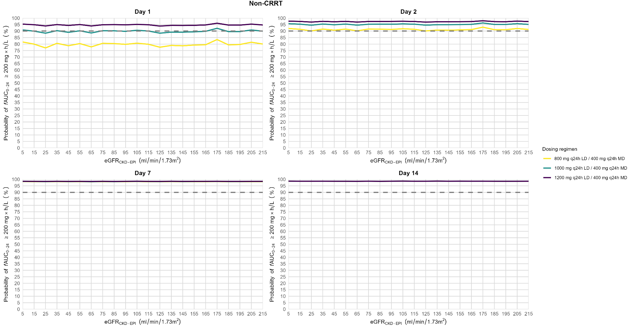

**Fig. 1**. Probability of target attainment of *f*AUC0-24 200 mg×h/L vs eGFRCKD-EPI over time when not on CRRT. eGFRCKD-EPI: estimated glomerular filtration rate (calculated using the Chronic Kidney Disease Epidemiology Collaboration equation). CRRT: continuous renal replacement therapy; *f*AUC0-24: area under the unbound concentration–time curve for 24 hours; LD: loading dose; MD: maintenance dose.

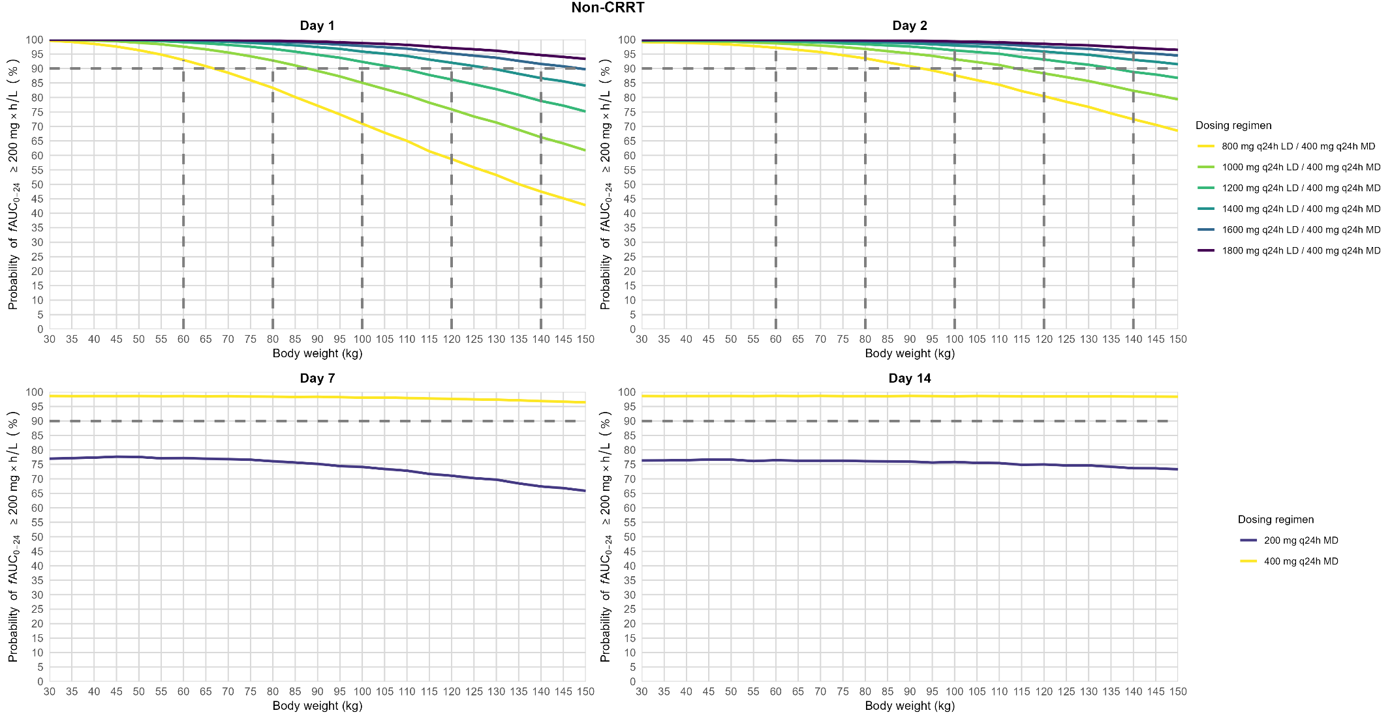

**Fig 2**. Probability of target attainment of *f*AUC0-24 200 mg×h/L vs body weight over time when not on CRRT. CRRT: continuous renal replacement therapy; *f*AUC0-24: area under the unbound concentration–time curve for 24 hours; LD: loading dose; MD: maintenance dose.

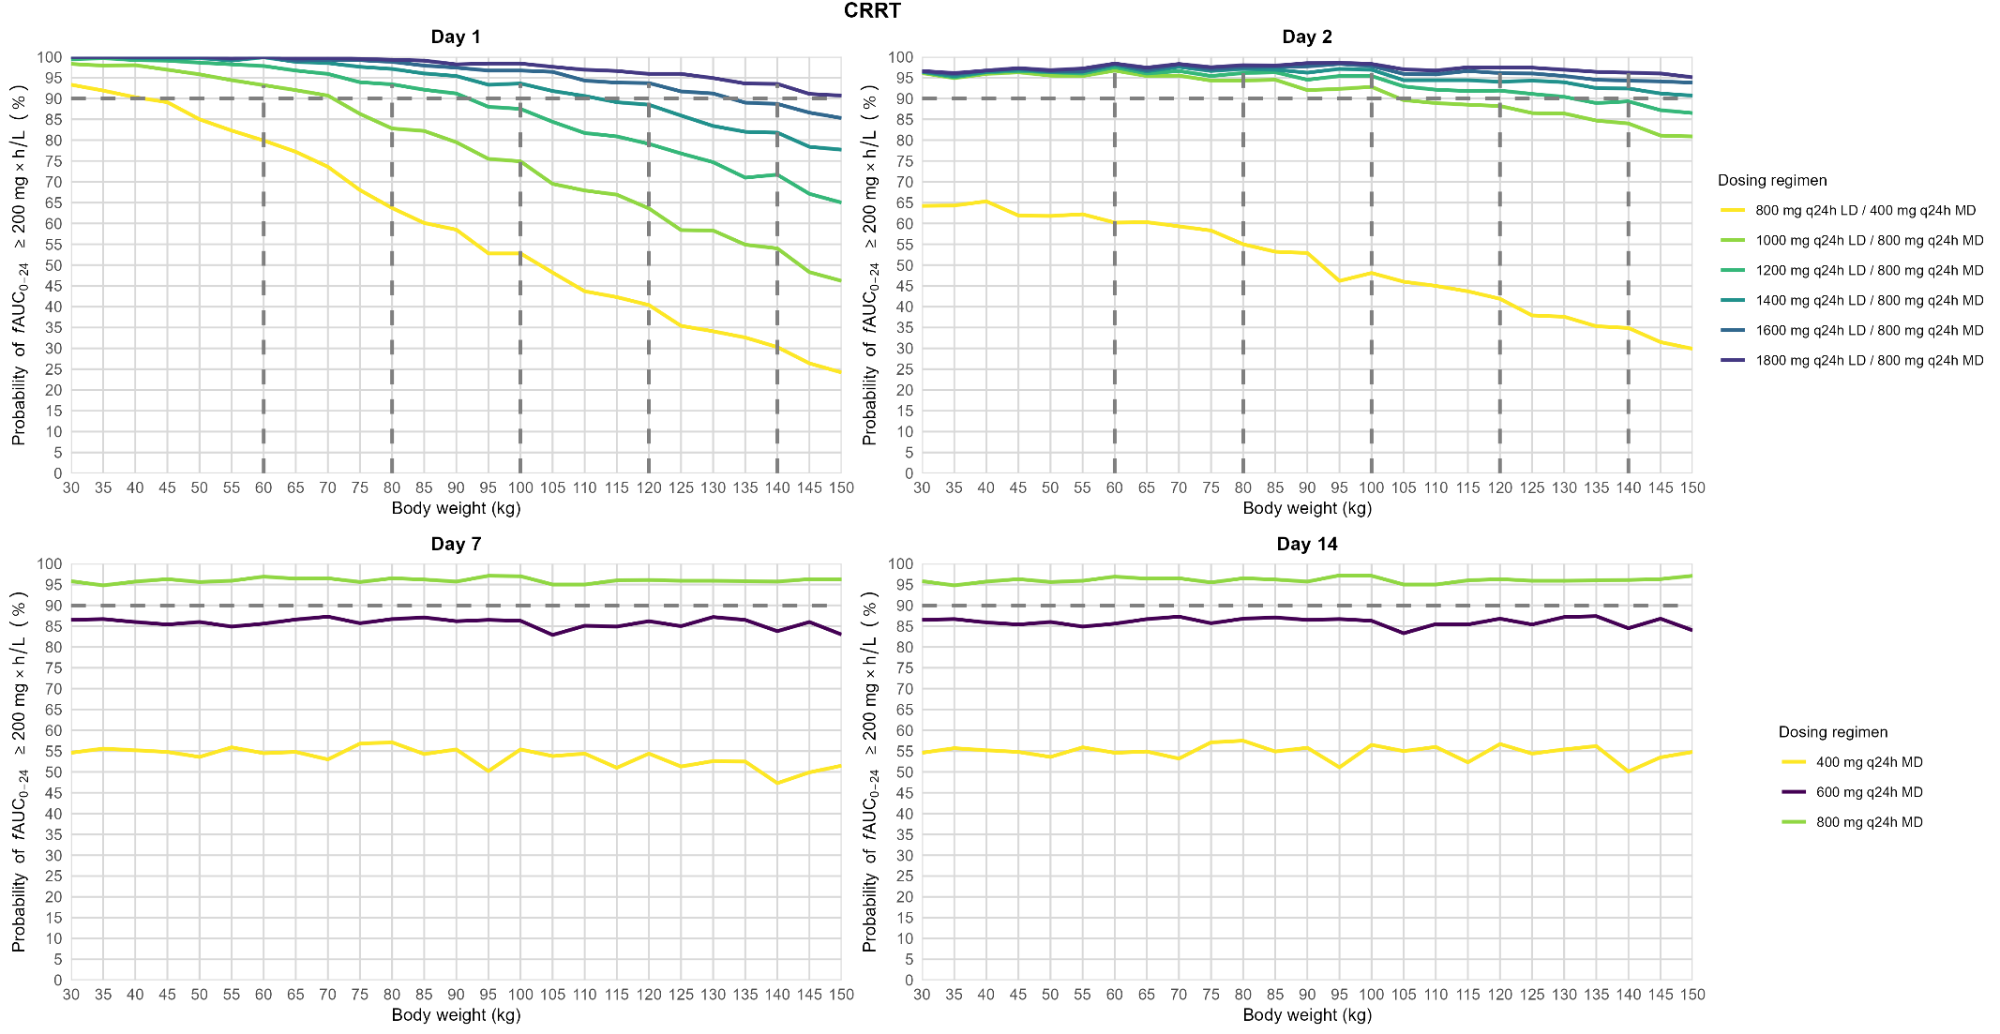

**Fig. 3**. Probability of target attainment of *f*AUC0-24 200 mg×h/L vs body weight over time when on CRRT. CRRT: continuous renal replacement therapy; *f*AUC0-24: area under the unbound concentration–time curve for 24 hours; LD: loading dose; MD: maintenance dose.

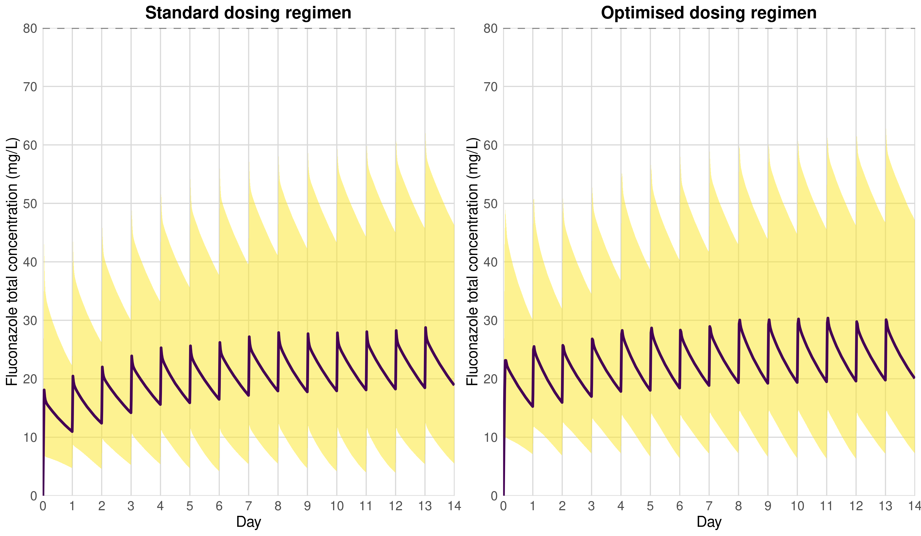**Fig. 4.** Fluconazole total concentration over time at the population level between standard and optimised dosing regimens. Concentration is represented by the median line and a ribbon showing the 90% percentile range of the population.