Quantitative drug sensitivity scoring

Statistical report

My-Luong Vuong, Erwin Dreesen 11 June 2024

# Data description

Data items

* CELLINE [integer]
  + 1: Wild Type (WT)
  + 2: R183W (Mutant)
* DRUG [integer]
  + 1: Dactolisib
  + 2: Erlotinib
* ADDITIVE [integer]
  + 1: ATUX
* ADDITIVE_CONC [numeric]
  + ATUX: 0, 3, 4.5, 6 µM
* REPEAT [integer]
  + Inter-day variability; 3-4 experimental repeats (days)
* REP [integer]
  + 1, 2, 3
  + Within-day variability; 3 replicates per 96-well plate
* DRUG_CONC [numeric]
  + Dactolisib: 0, 0.00076, 0.00229, 0.00686, 0.02058, 0.06173, 0.18519, 0.55556, 1.66667 µM
  + Erlotinib: 0, 0.02667, 0.08002, 0.24005, 0.72016, 2.16049, 6.48148, 19.44444, 58.33333 µM
* DV [numeric]
  + Dependent variable (Y-axis)
  + Cell viability
* CELLINE_DRUG_ADDITIVE
  + Option 1 for Level 1 clustering
  + 2 cell lines * 2 DRUGs * 1 ADDITIVE = 4 clusters
* CELLINE_DRUG_ADDITIVE_ADDITIVECONC
  + Option 2 for Level 1 clustering
  + 2 cell lines * 2 DRUGs * 1 ADDITIVE * 4 ADDITIVE concentrations = 16 clusters
* CELLLINE_DRUG_ADDITIVE_ADDITIVECONC_REPEAT
  + Option 3 for Level 1 clustering
  + 2 cell lines * 1 DRUG * 1 ADDITIVE * 4 ADDITIVE concentrations * 4 experimental repeats (days) = 32 clusters*
  + 2 cell lines * 1 DRUG * 1 ADDITIVE * 4 ADDITIVE concentrations * 3 experimental repeats (days) = 24 clusters*
  + In total 56 clusters
* CELLINE_NAME [character]
* DRUG_NAME [character]
* ADDITIVE_NAME [character]
* CELLINE_DRUG_ADDITIVE_NAME [character]

1512 data records.

Print screens of table; next pages.

Beginning of table:

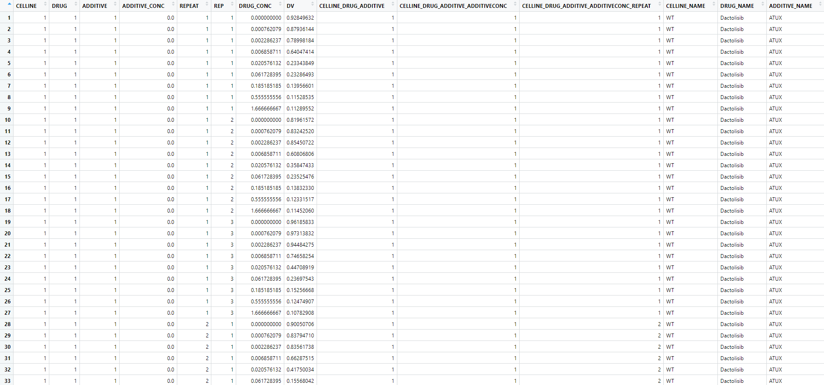

End of table:

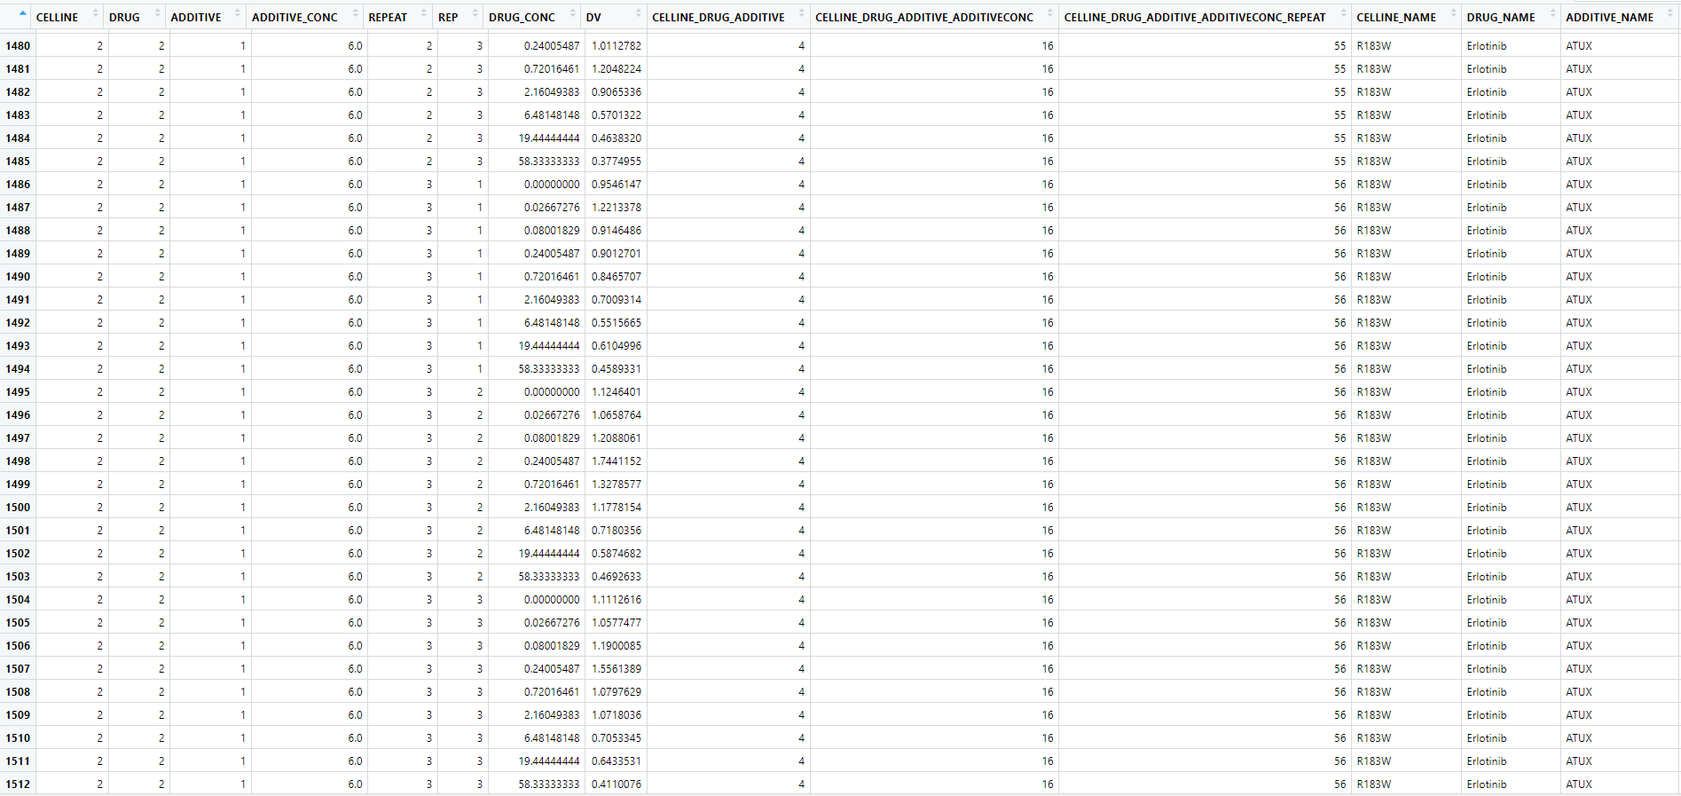

NONMEM code

;; 1. Based on: Zhigang's example

;; 2. Description: Modelling combination effect of Erlotinib and Dactolisib with ATUX

;; 3. Label: CELLINE_DRUG_ADDITIVE_ADDITIVECONC as ID

;; 4. Author: My-Luong Vuong

$SIZES LTH=9999 LVR=9999

DIMCNS=9999 DIMTMP=9999 DIMNEW=9999

; DIMVRB=9999 LIM1=9999 MAXFCN=9999 NO=9999 MAXPTHETA=9999

$PROBLEM Quantitative drug sensitivity scoring of 2 coumpounds in 2 strains

$INPUT CELLINE ; 2 cell lines: WT, R183W

DRUG ; Dactolisib, Erlotinib

ADDITIVE ; ATUX

ADDITIVECONC ; 0, 3, 4.5, 6 µM

DAY ; inter-day repeats

REP ; within-day repeats

DRUGCONC ; 0.00000, 0.00076, 0.00229, 0.00686, 0.02058, 0.06173, 0.18519, 0.55556, 1.66667, 0.02667, 0.08002, 0.24005, 0.72016, 2.16049, 6.48148, 19.44444, 58.33333

DV

DROP ; ID option 1 --- CELLINE_DRUG_ADDITIVE

ID ; ID option 2 --- CELLINE_DRUG_ADDITIVE_ADDITIVECONC ; --- Estimate parameters for each value of CELLINE_DRUG_ADDITIVE_ADDITIVECONC = combination of the covariates, with REPEAT in the IOV/RUV and REP in the RUV, or ... define CELLINE_DRUG_ADDITIVE_ADDITIVECONC as ID ...

DROP ; ID option 3 --- CELLINE_DRUG_ADDITIVE_ADDITIVECONC_DAY ; CELLINE_DRUG_ADDITIVE_ADDITIVECONC_REPEAT --- Estimate parameters for each value of CELLINE_DRUG_ADDITIVE_ADDITIVECONC (GROUPER, previous line) = combination of the covariates, with REPEAT being the IIV and REP in the RUV

DROP ; CELLINE_NAME

DROP ; DRUG_NAME

DROP ; ADDITIVE_NAME

DROP ; CELLINE_DRUG_ADDITIVE_NAME

$DATA onco_combine_therapy.csv IGNORE=@

$PRED ;;; 2 CELL LINEs

IF(CELLINE .EQ. 1) TOP_CELLINE = THETA(1) ;reference --- 1 FIX

IF(CELLINE .EQ. 1) BOTTOM_CELLINE = THETA(2) ;reference --- 1 FIX

IF(CELLINE .EQ. 1) IC50_CELLINE = THETA(3) ;reference --- 1 FIX

IF(CELLINE .EQ. 1) GAMMA_CELLINE = THETA(4) ;reference --- 1 FIX

IF(CELLINE .EQ. 2) TOP_CELLINE = THETA(5)

IF(CELLINE .EQ. 2) BOTTOM_CELLINE = THETA(6)

IF(CELLINE .EQ. 2) IC50_CELLINE = THETA(7)

IF(CELLINE .EQ. 2) GAMMA_CELLINE = THETA(8)

;;; 2 active drugs

IF(DRUG .EQ. 1) TOP_DRUG = THETA(9) ;reference --- 1 FIX

IF(DRUG .EQ. 1) BOTTOM_DRUG = THETA(10) ;reference --- 1 FIX

IF(DRUG .EQ. 1) IC50_DRUG = THETA(11) ;reference --- 1 FIX

IF(DRUG .EQ. 1) GAMMA_DRUG = THETA(12) ;reference --- 1 FIX

IF(DRUG .EQ. 2) TOP_DRUG = THETA(13) ;reference --- 1 FIX

IF(DRUG .EQ. 2) BOTTOM_DRUG = THETA(14) ;reference --- 1 FIX

IF(DRUG .EQ. 2) IC50_DRUG = THETA(15) ;reference --- 1 FIX

IF(DRUG .EQ. 2) GAMMA_DRUG = THETA(16) ;reference --- 1 FIX

;;; ADDITIVE ATUX effect

IF(ADDITIVECONC .EQ. 0) TOP_ADDITIVE = THETA(17) ; no ADDITIVE/HAP/SMAP is the same, can be pooled!

IF(ADDITIVECONC .EQ. 0) BOTTOM_ADDITIVE = THETA(18) ; no ADDITIVE/HAP/SMAP is the same, can be pooled!

IF(ADDITIVECONC .EQ. 0) IC50_ADDITIVE = THETA(19) ; no ADDITIVE/HAP/SMAP is the same, can be pooled!

IF(ADDITIVECONC .EQ. 0) GAMMA_ADDITIVE = THETA(20) ; no ADDITIVE/HAP/SMAP is the same, can be pooled!

IF(ADDITIVECONC .EQ. 3) TOP_ADDITIVE = THETA(21)

IF(ADDITIVECONC .EQ. 3) BOTTOM_ADDITIVE = THETA(22)

IF(ADDITIVECONC .EQ. 3) IC50_ADDITIVE = THETA(23)

IF(ADDITIVECONC .EQ. 3) GAMMA_ADDITIVE = THETA(24)

IF(ADDITIVECONC .EQ. 4.5) TOP_ADDITIVE = THETA(25)

IF(ADDITIVECONC .EQ. 4.5) BOTTOM_ADDITIVE = THETA(26)

IF(ADDITIVECONC .EQ. 4.5) IC50_ADDITIVE = THETA(27)

IF(ADDITIVECONC .EQ. 4.5) GAMMA_ADDITIVE = THETA(28)

IF(ADDITIVECONC .EQ. 6) TOP_ADDITIVE = THETA(29)

IF(ADDITIVECONC .EQ. 6) BOTTOM_ADDITIVE = THETA(30)

IF(ADDITIVECONC .EQ. 6) IC50_ADDITIVE = THETA(31)

IF(ADDITIVECONC .EQ. 6) GAMMA_ADDITIVE = THETA(32)

;;; inter-day variability

DAY1=0

DAY2=0

DAY3=0

DAY4=0

IF(DAY.EQ.1) DAY1=1

IF(DAY.EQ.2) DAY2=1

IF(DAY.EQ.3) DAY3=1

IF(DAY.EQ.4) DAY4=1

TVTOP = TOP_CELLINE * TOP_DRUG * TOP_ADDITIVE

TOP = TVTOP * EXP(ETA(1) + DAY1 * ETA(5) + DAY2 * ETA(6) + DAY3 * ETA(7) + DAY4 * ETA(8))

TVBOTTOM = BOTTOM_CELLINE * BOTTOM_DRUG * BOTTOM_ADDITIVE

BOTTOM = TVBOTTOM * EXP(ETA(2) + DAY1 * ETA(9) + DAY2 * ETA(10) + DAY3 * ETA(11) + DAY4 * ETA(12))

TVIC50 = IC50_CELLINE * IC50_DRUG * IC50_ADDITIVE

IC50 = TVIC50 * EXP(ETA(3) + DAY1 * ETA(13) + DAY2 * ETA(14) + DAY3 * ETA(15) + DAY4 * ETA(16))

TVGAMMA = GAMMA_CELLINE * GAMMA_DRUG * GAMMA_ADDITIVE

GAMMA = TVGAMMA * EXP(ETA(4) + DAY1 * ETA(17) + DAY2 * ETA(18) + DAY3 * ETA(19) + DAY4 * ETA(20))

IMAX = (TOP-BOTTOM)/TOP

IPRED = BOTTOM + (TOP-BOTTOM) / (1 + (((DRUGCONC) ** GAMMA)/(IC50 ** GAMMA))) + 0.00001

W = SQRT(IPRED ** 2 * SIGMA(1,1) + SIGMA(2,2))

Y = IPRED + (IPRED * EPS(1)) + EPS(2)

IRES = DV - IPRED

IWRES = IRES / W

$THETA

(1) FIX ; reference cell line WT THETA(1)

(1) FIX ; reference cell line WT

(1) FIX ; reference cell line WT

(1) FIX ; reference cell line WT

(0, 1.01) ; THETA(5)

(0, 1.13) ;

(0, 1.11) ;

(0, 1.01) ;

(1) FIX ; reference Dactolisib THETA(9)

(1) FIX ; reference Dactolisib

(1) FIX ; reference Dactolisib

(1) FIX ; reference Dactolisib

(0, 1.04) ; THETA(13)

(0, 0.409) ;

(0, 2.26) ;

(0, 0.647) ;

(0, 0.986) ; THETA(17)

(0, 0.128) ;

(0, 1.66) ;

(0, 5.38) ;

(0, 0.945) ; THETA(21)

(0, 0.135) ;

(0, 1.5) ;

(0, 4.84) ;

(0, 0.812) ; THETA(25)

(0, 0.14) ;

(0, 1.6) ;

(0, 4.54) ;

(0, 0.508) ; THETA(29)

(0, 0.127) ;

(0, 1.91) ;

(0, 3.9) ;

$OMEGA ;;; inter-experiment variability

0 FIX

0.00427

0.0355

0.00515 ;

$OMEGA BLOCK(1) 0.00912 ; inter-day variability TOP = intra-experiment variability

$OMEGA BLOCK(1) SAME

$OMEGA BLOCK(1) SAME

$OMEGA BLOCK(1) SAME

$OMEGA BLOCK(1) 0.0542 ; inter-day variability BOTTOM

$OMEGA BLOCK(1) SAME

$OMEGA BLOCK(1) SAME

$OMEGA BLOCK(1) SAME

$OMEGA BLOCK(1) 0.0524 ; inter-day variability IC50

$OMEGA BLOCK(1) SAME

$OMEGA BLOCK(1) SAME

$OMEGA BLOCK(1) SAME

$OMEGA BLOCK(1) 0.0508 ; inter-day variability GAMMA

$OMEGA BLOCK(1) SAME

$OMEGA BLOCK(1) SAME

$OMEGA BLOCK(1) SAME

$SIGMA ;;; residual variability

0.00986

0 FIX

$COVARIANCE PRINT=E UNCONDITIONAL ;MATRIX=R

$ESTIMATION METHOD=1 INTERACTION MAXEVAL=999999 POSTHOC PRINT=5 NOABORT SADDLE_RESET=1 ;NSIG=3 SIGL=9

$TABLE ID CELLINE ADDITIVE ADDITIVECONC DRUG DAY REP DRUGCONC

DV Y PRED IPRED IRES IWRES CWRES

TOP BOTTOM IC50 GAMMA

TVTOP TVBOTTOM TVIC50 TVGAMMA

IMAX ETA(1) ETA(2) ETA(3) ETA(4)

ONEHEADER NOPRINT FILE = onco_combine_therapy_out.csv

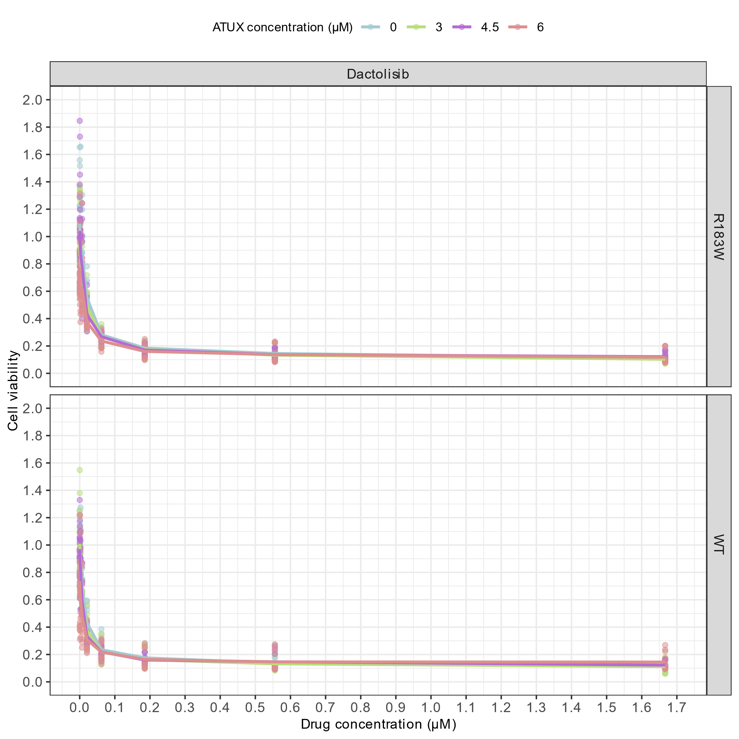

**Figure 1. Observed effect of ATUX on the response to Dactolisib in two cell lines.**

Dots represent the original data, lines indicate the median trend per ATUXconcentration.

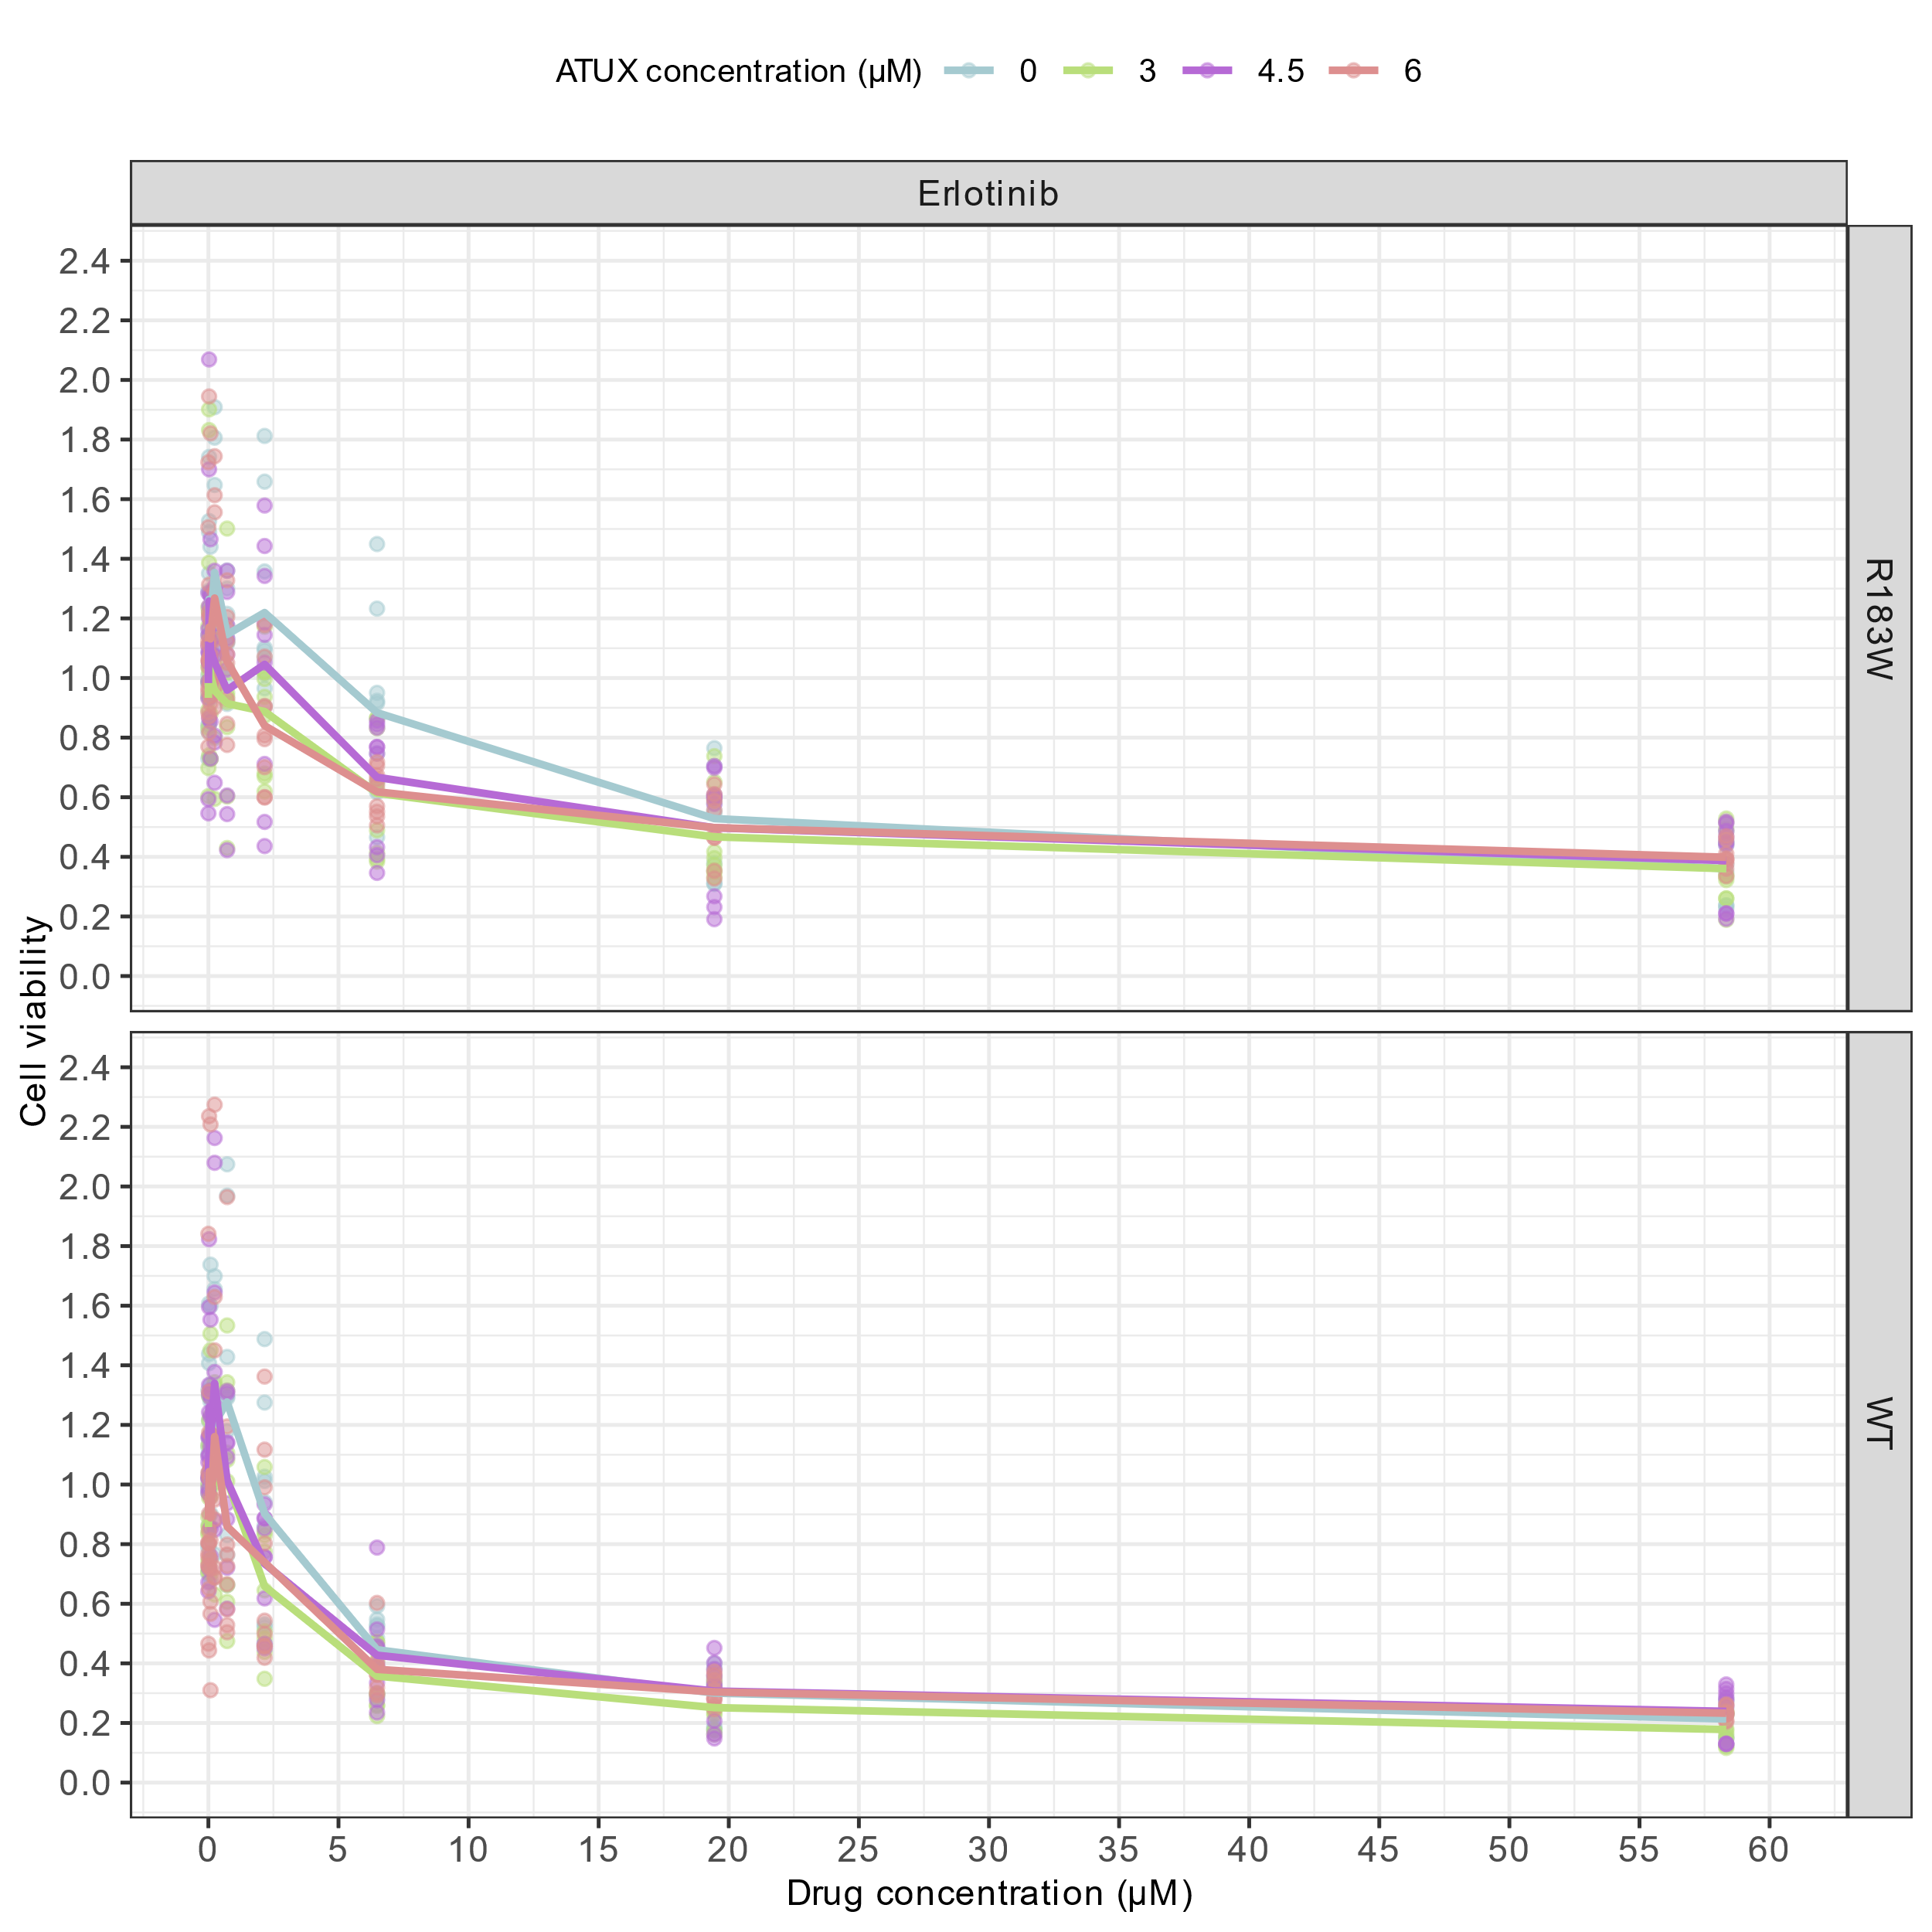

**Figure 2. Observed effect of ATUX on the response to Erlotinib in two cell lines.**

Dots represent the original data, lines indicate the median trend per ATUXconcentration.

**Table 1. Model parameters**

|  |  |  |  |  |  |  |
| --- | --- | --- | --- | --- | --- | --- |
| **EGFP, Clofarabine** *(reference)* | **No OA** | **OA=10 nM** | **Effect of WT** | **Effect of R183W** | **Effect of R179R** | **Effect of S256F** |
| TOP (RSE) | 0.930 (3.6) | 0.623 (3.7) | ×1.16 (7.3) | ×0.990 (6.4) | ×1.04 (4.8) | ×1.17 (6.7) |
| BOTTOM (RSE) | 0.0609 (1.4) | 0.060 (1.4) | ×0.991 (1.3) | ×1.00 (1.9) | ×1.03 (2.5) | ×1.12 (2.4) |
| IC50 (µM) (RSE) | 0.214 (1.0) | 0.133 (1.4) | ×1.17 (3.2) | ×1.42 (1.8) | ×1.10 (1.1) | ×1.08 (2.4) |
| GAMMA (RSE) | 4.94 (1.3) | 5.85 (1.7) | ×0.846 (3.4) | ×0.915 (2.6) | ×0.994 (3.3) | ×0.931 (3.0) |
| *Inter-experiment variability*  *%CV (RSE) [% η-shrinkage]*  TOP  BOTTOM  IC50  GAMMA | 1.4 (20) [49, 50, 61]  0 FIX  0 FIX  0 FIX | | | | | |
| Inter-day* variability  *%CV (RSE) [% η-shrinkage]*  TOP  BOTTOM  IC50  GAMMA | 11.6 (3.9) [0, 0, 0, 0, 35, 26, 66]  21.0 (9.2) [19, 55, 41, 49, 42, 55, 41]  15.6 (7.1) [46, 34, 36, 30, 0, 25, 62]  17.5 (9.3) [43, 26, 45, 49, 0, 38, 37] | | | | | |
| *Residual variability %CV (RSE) [% ε-shrinkage]*  Additive  Proportional | 0 FIX  7.06 (4.4) [7] | | | | | |

Model parameters are expressed as typical values (%relative standard deviation). CV: coefficient of variation. * Inter-day/repeat variability. First-order conditional estimation with interaction was used to estimate model parameters (NONMEM version 7.5; Icon Development Solutions, Gaithersburg, Maryland, USA). The parameter estimates with 95% confidence interval including 1 are coloured in grey. RSE: relative standard error. . -2*Ln(likelihood) = -11552.893

**Figure 2. Observed versus predicted cell viability plot.**  
The predicted cell viabilities consider the inter-experiment and inter-day variability. The red line is a locally weighted smoother.

**Figure 3. Conditional weighted residuals (CWRES) versus predicted cell viability plot.**  
The predicted cell viabilities do not consider the inter-experiment and inter-day variability. The red line is a locally weighted smoother.

**Figure 4. Predicted AUC vs observed AUC plot.** The predicted AUC do not consider the inter-experiment and inter-day variability. The observed AUCs are calculated based on the trapezoidal rule and do not consider the inter-experiment and inter-day variability (median of repeats and replicates). The red line is a locally weighted smoother. AUC: Area under the cell viability vs compound concentration curve.

**Figure 5. The effect of OA on the response to Clofarabine in five cell lines.**

Dots represent the original data, solid lines indicate the model fits. Dashed lines and bold asterisks indicate the IC50.

**Figure 6. The differential drug sensitivity score (dDSS0) versus the OA concentration in five cell lines.**

The dDSS0 is calculated by subtracting the control DSS0 (OA = 0 nM) from the DSS0 (OA = 10 nM). DSS0 is calculated as .

**Figure 7. The differential drug sensitivity score (dDSS0) when adding OA in five cell lines.**

The dDSS0 is calculated by subtracting the control DSS0 (OA = 0 nM) from the DSS0 (OA = 10 nM). DSS0 is calculated as . The boxplots represent the interquartile range of dDSS0 from 1000 Monte Carlo simulations. The Wilcoxon test is used to examine the statistical difference in dDSS0 between cell lines. The symbols (****, ***, **, *, ns) represent the significance levels of (<0.001, <0.01, <0.05, ≥0.5), respectively.