Student Name: Leo Nguyen
Student ID: 300413224
Topic: Customer Churn Prediction in Banking
- Introduction and discovery
  - Business domain
Customer retention is a concern in the banking industry because maintaining existing customer is generally more cost-effective than acquiring new ones. Therefore, understanding and predicting customer churn is necessary for improving customer relationship and maintaining long term profitability by providing them better services and turn customer’s decisions in the opposite direction.
  - Problem statement
This project objective is developing a machine learning model to predict whether a bank customer is likely to churn based on demographic, financial, and behavioral features. The key questions addressed in this analysis are:
- Can we predict customer attrition?
- What factors are most related to churn behavior?
- How can this model support business decision-making?
Predicting churn allows bank to identify churn customers early, reduce revenue loss, improve customer satisfaction.
  - Initial hypotheses
The following hypotheses were formulated:
- Customers with lower transaction activity are more likely to churn
- Customers with higher inactivity levels are more likely to leave
- Customers with fewer banking relationships have higher attrition risk
- Data Preparation and feature engineering
  - Data inventory
This dataset consists of 10,000 records and multiple numerical and categorical features mentioning their age, salary, marriage status, credit card limit, credit card category, etc. There are nearly 18 features with the target variable is Attrition_Flag.
I got this data set from a website with the URL as https://data.world/sonalnew/credit-card-customers.
  - Data processing and feature engineering
In this project, descriptive statistics were used to understand the distribution of numerical variables, including transaction counts, credit limits, and utilization ratios while we have data cleaning, data exploration and feature engineering to support this part.
With regards to data cleaning, I dropped identifier column (CLIENTNUM) and removed Naïve Bayes columns and then encoded target variable existing customer to 0 and attritted customer to 1. For data exploration, I checked missing values and duplicates, examined features distribution and identified class imbalance. As feature engineering is concerned, I created new features as
Avg_Trans_Value = Total_Trans_Amt / Total_Trans_Ct
To removed redundant feature (Avg_Open_To_Buy) due to high correlation.
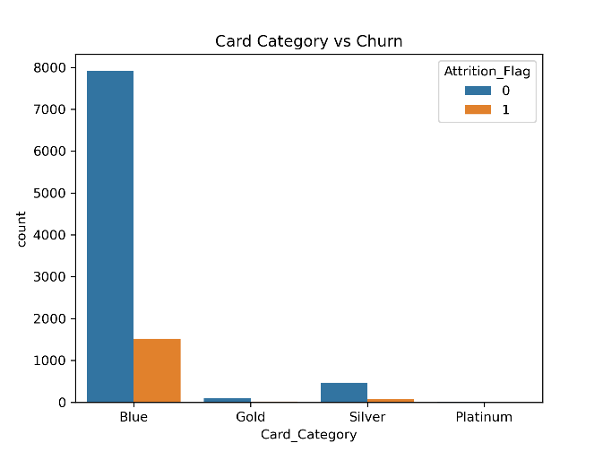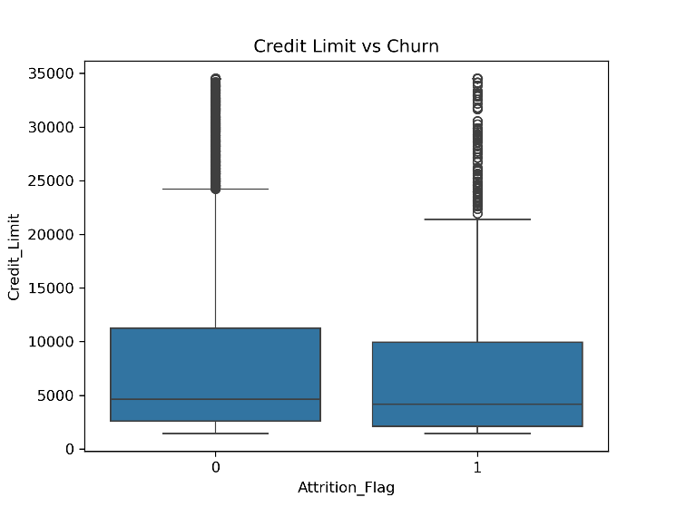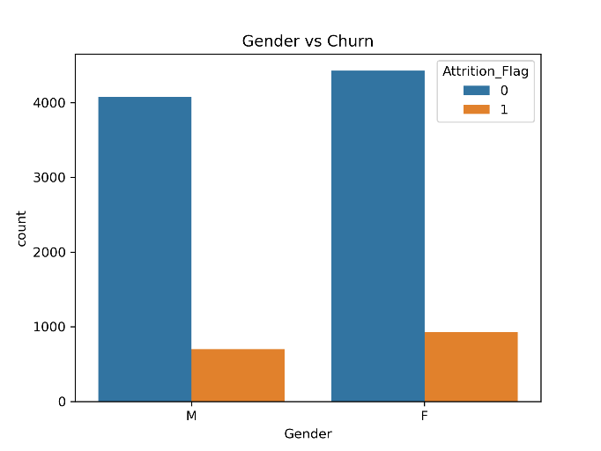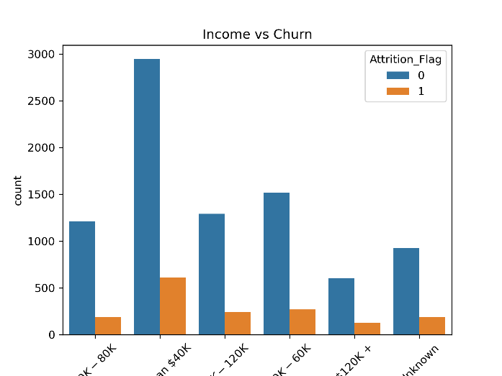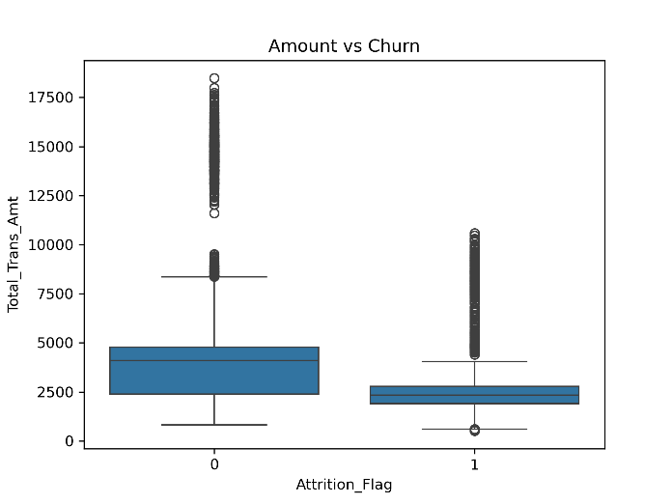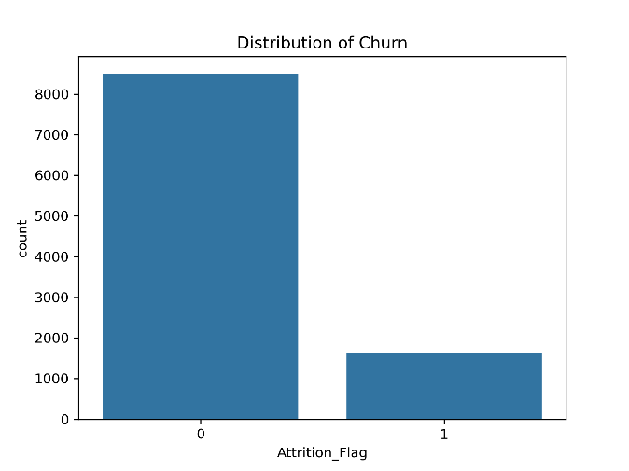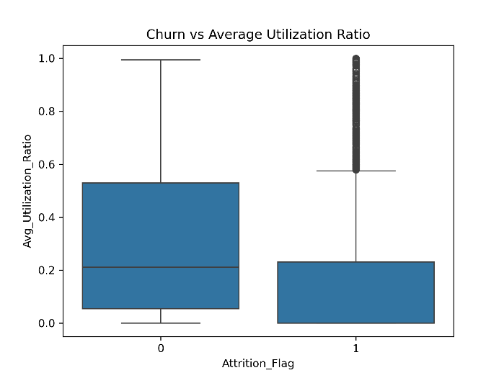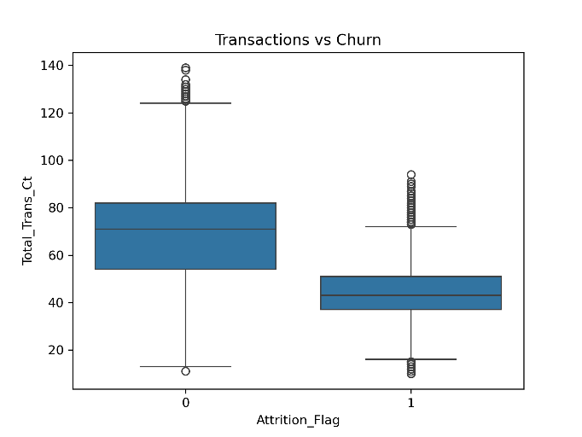
- Model Implementation
  - Machine Learning models
There are three classification models were implemented:
- Logistic Regression: provides a simple and interpretable baseline
- Random Forest: captures non-linear relationships and reduces overfitting
- XGBoost: is powerful boosting algorithm known for high performance on tabular data
- K-Nearest Neighbors: to evaluate whether customers with similar behavioral patterns exhibit similar churn tendencies
- SVM: this model has an ability to model complex non-linear decision boundaries using kernel functions.
  - Preprocessing pipeline
The problem is supervised binary classification task so a single-model workflow is sufficient. The pipeline will split train-test(80-20) where numerical features will be scaling and categorical features will be encoding.
  - Model comparison
Models were compared using accuracy, precision, recall and f1-score. In this project, f1-score was selected as the primary metric because we need to balance false positive and false negative between recall and precision.
- Result Interpretation and Implications
  - Model Performance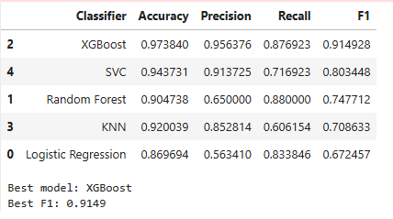
As the table shows, the best performance model is XGBoost with highest F1-score is 0.9149, indicating a strong balance between precision and recall. This suggest that model is effective in identifying churn customers while minimizing false alarms.
Although SVC achieved relatively high precision, its lower recall indicates that it missed a significant number of churn cases, making it less suitable for this problem.
With regards to Random Forest, while it achieved the highest recall, meaning it identified more churn cases, its lower precision suggests a higher number of false positives.
As the KNN model is concerned, it showed weaker performance due to its sensitive to features scaling and the high dimensionality of the data set.
Logistic Regression underperformed compared to more complex models, suggesting that the relationship between features and churn is not purely linear.
Based on the comparison, XGBoost was selected as the final model based on its F1-score and balanced performance.
  - Confusion Matrix Analysis
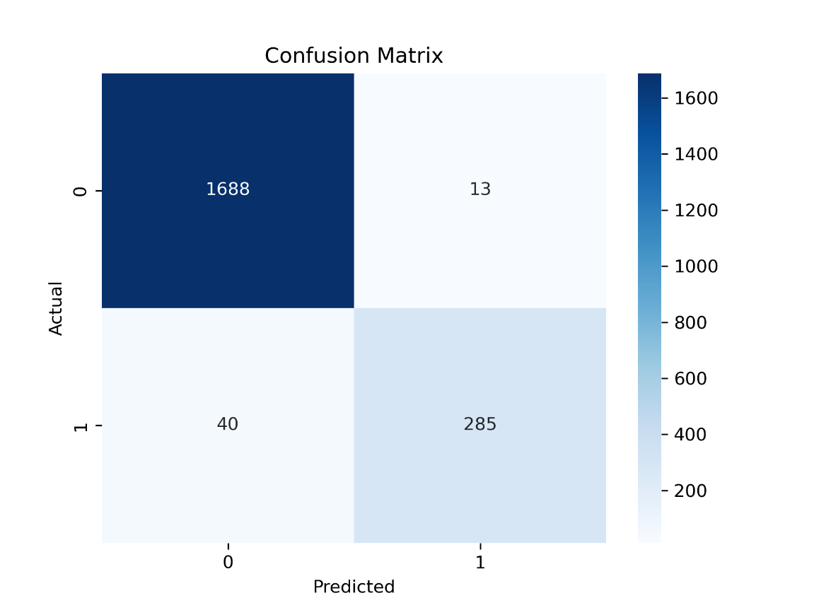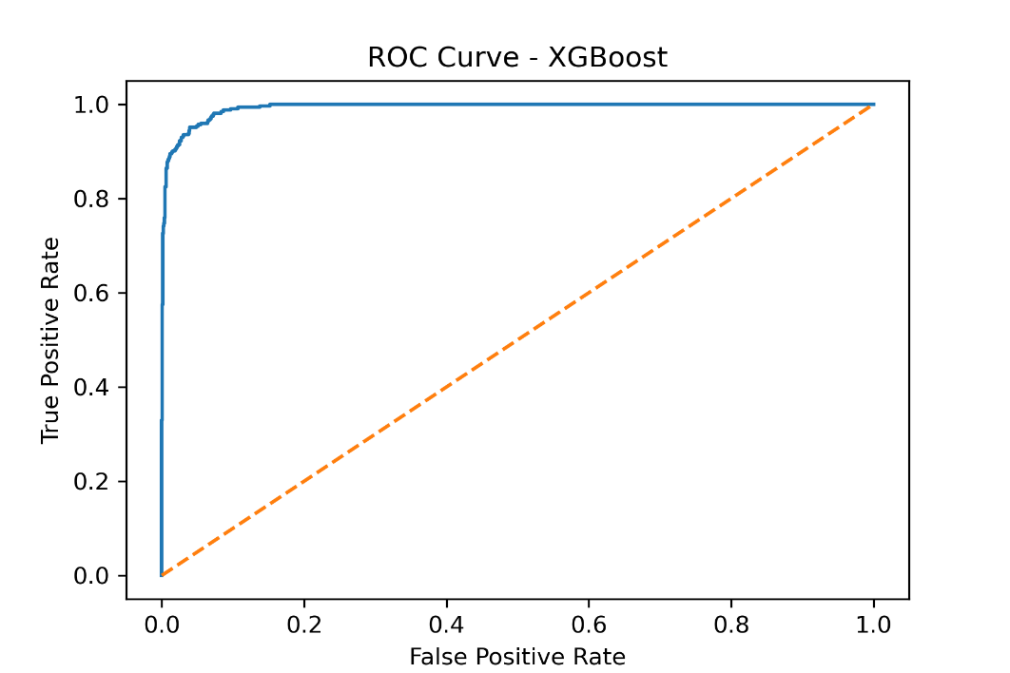
The confusion matrix shows that the number of false positives is very low ( 13 cases), indicating efficient targeting of churn prediction. However, there are 40 false negatives, which represent missed opportunities for continued customer. The model performs well on test data and predictions align with domain expectations while errore rates are acceptable for business application.
- Out-of-sample Predictions
  - New customer profiles
For testing the model, new customer profiles were created to test the real-world decision making. Customer with lower transaction activity, fewer banking relationship, and higher inactivity may be predicted as more likely to churn.
  - Predict results
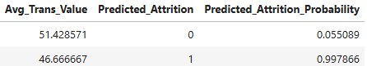
The second customer who is male and 51 years old shows the high probability to attrition. As with this result, the manager can make business and marketing plan to keep the customers.
  - Discussion
The model predicted churn probabilities for unseen customers, demonstrating its ability to generalize beyond the training data. Customers who have low transaction counts, high inactivity and fewer relationship showed higher predicted attrition risk.
- Concluding Remarks
  - Summary of analytics process
This project implemented a complete machine learning pipeline for churn prediction, including:
- Introduction and discovery
- Data cleaning and preprocessing
- Exploratory data analysis
- Feature engineering
- Model comparison
- Final model evaluation
- Out-of-sample prediction
- Concluding remarks
  - Key findings
This project identified several important findings regarding customer attrition in banking such as low customer engagement and lower activity levels are related to churn. Model comparison results indicate that non-linear models outperform linear ones, with XGBoost is the best performance model. This suggests that churn behavior is influenced by complex relationship between features. Although the model performs well, some churn cases are still missed, indicating room for improvement. Out-of-sample predictions demonstrate that the model can generalize to new data, supporting its potential use in real-world customer retention strategies.
- Video Presentation link

