Pathfinding in Ants Game

This document describes how the navigation mesh and pathfinding works in ant game.

NavMesh

The navigation mesh is a graph of nodes that each represent areas that have no obstacles. Each node is connected to nodes it is adjacent to. Obstacles in Ant Game are all rectangles, so nodes are also rectangular (RectPositional). Each node has the following property:

- RectPositional with non-zero dimensions
- Each node starts and ends at an obstacle or the bounds of the map. Both obstacles are at least as tall as each node, and have a y at least as low as the node’s y.
- Has a list of all neighboring nodes as well as the intersecting line between them
Example:
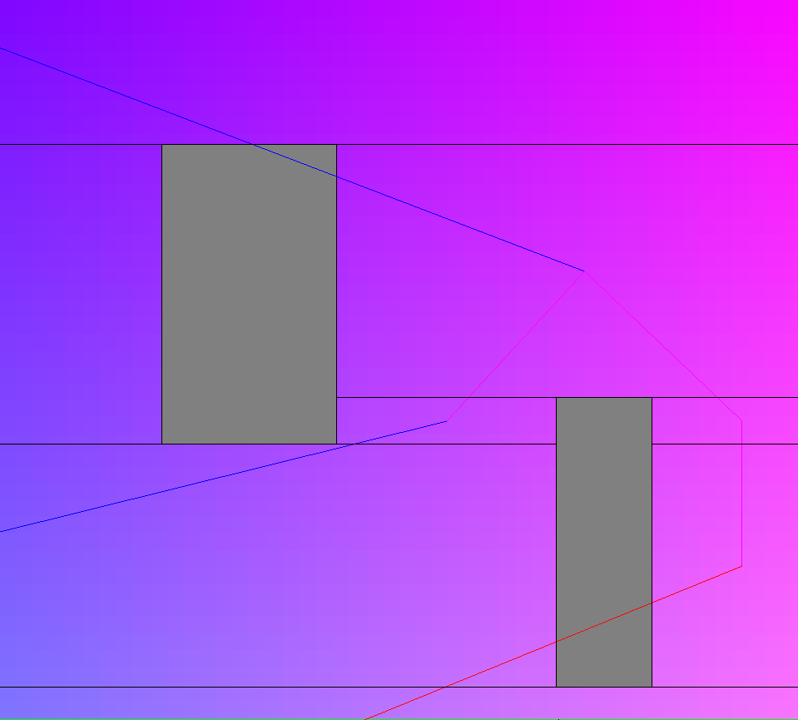

The gray rectangles are obstacles and the colored lines represent connections between nodes. This is a partial screenshot; not all connections are shown.

Generating and Adding Nodes

Generating the navmesh is roughly in O(n²log(n)), where n is the number of obstacles. It takes linear time to go through all obstacles, logarithmic time to find the overlapping node, and linear time to process each neighbor. In reality, a node only has so many neighbors, so processing neighbors is really more logarithmic.

The algorithm works by starting with one giant node that encompasses the entire mesh. As obstacles are added, nodes that take up the same space as an obstacle split. A node splitting is a O(n) operation where the original node is deleted and up to 4 new nodes, each bordering the new obstacles are made. The child nodes are made like this:
- the left-most node has the same x as the parent node, y as the obstacle, height of the obstacle, and width equal to the obstacle x – parent node x;
- the top-most node has the same x,y, and width as the parent node but a height of the obstacle y – parent node y;
- the right-most node has the same y and height of the obstacle but x = to the right edge of the obstacle and width = to the right edge of parent – right edge of obstacle;
- the bot-most node has the same x and width as the parent, y is bot edge of obstacle and height is bot edge of parent – bot edge of obstacle. This is an O(n) operation because we must go through the neighbors of the deleted node and connect the new nodes to each neighbor. We use a quadtree to find overlapping nodes in logarithmic time. Adding nodes is done via the same process. Obstacles or “negative space” are also kept track of via a quadtree.
Generating nodes in this way creates many useful properties:
- Nodes are guaranteed to begin and end with obstacles
- Intersection lines are guaranteed to have an obstacle near them rather than another node.
- All intersection lines are horizontal
- Points on the intersection lines are guaranteed to only border two nodes
- Obstacle sizes can be estimated using nodes
In hindsight, many headaches with the pathfinding algorithm could’ve been solved with this kind of generation.

What Constitutes an Obstacle?

Obstacles are terrain and structures. Basically, anything units shouldn’t be able to move over. Terrain is separate from structures because they are not targetable; they can’t be interacted with one way or another. Though not technically an obstacle, the boundaries of the navigation mesh and therefore the entire level has the same properties as an obstacle in terms of bordering navigation meshes.

Pathfinding

The Pathfinding algorithm is a variation of A*. Similar to A*, we process points in an order based on their score, which is a combination of their proximity to the goal and their distance from the starting point. The algorithm uses heuristics to estimate what point on a given node-node intersection line will be the best. The algorithm performs well and finds reasonably short distances, although there is an issue with taking unnecessary detours (moving from point A to B to C rather than A to C), which is most prominent when navigating out of a C shape structure.

Setup

Moving through a node is trivial since they are all regions with no obstacles; just take a straight path from point A to B. As a result, all the action happens at node boundaries and the meat of the algorithm is a question of what node to process on a given node-to-node intersection line. The following section details this; here, we look at the data structures involved. We use a Minheap to keep track of what point to process next based on its score as well as what node the point belongs to, so we know what nodes it neighbors. We also have an unordered map that takes a point and maps it to a paircontaining the score of the point and the point that precedes the point on the shortest known path. The first tracks the distance of the shortest path to a given point while the second tracks the point immediately preceding the given point on the shortest path.

Basic Pathfinding

At every iteration, we pop the best point from the heap and it’s corresponding node and process it. If the point happens to be in the same node as the end node, we add/update the end point to the heap with a score equal to the score of the current point and set its previous point to the current point; since the score is the sum of the distances of the point to the end and the start, it is the length of the entire path from the start to the end. Obviously, if the end point is already in the heap, we only do this if the resulting score is better than the end point’s old score. This path isn’t guaranteed to be the best path so we keep searching. If the end point is popped, the best path has been found and we can start backtracking. At any other given node, we look at all neighbors and the intersecting line. We have 3 candidate points to choose from: the two endpoints of the line (A will denote the left point, B will denote the right point) or the point on the intersection line that is in line with the current point and the end point. In more technical terms, given the line from the current point and the end point and the intersection line between two nodes, the point is the intersection point of the two lines. We then look at the score for each of these three points. The score is the sum of the shortest known distance to the point and the sum from the point to the end. Sometimes, we only do the two endpoints because the intersection point is not on the intersection line. The best of these 3 points is added to the heap in a typical A* algorithm. Once A* is finished, we backtrack using the best preceding point of each point, starting from the end point.

Pathfinding with Rectangles

Pathfinding with 2-d objects took me way too long to figure out and basically forced me to use the navigation mesh generation used today. Once done, however, all that was needed was to do regular basic pathfinding and then move points up or down depending on where obstacles were. Pathfinding with rectangles is effectively the same as with pathfinding with points except each obstacle’s dimensions are increased by “radius”, where “radius” is half the longest dimension of the moving rectangle.

Why Some of the Code Looks Weird

Detecting points on the same line and the “startEdge” boolean

There is an if statement at the beginning of the inner for-loop where we check if the current point is on the intersection point of two nodes and if so, we skip the operation. This is to prevent two nodes from constantly choosing points on their intersection. Basically, given neighbor nodes A and B, there is a chance that A will choose some point on their intersection, B will choose another point on the same intersection, then A will choose another point. These two nodes basically pass points back and forth making little progress. As a result, we simply skip the operation. We are guaranteed that doing this won’t cause us to miss out on a better point because if that were the case, node A would’ve simply chosen that point instead. The weirder part is startEdge, a boolean variable declared at the beginning of the function and used in the same if statement. Usually, simply skipping the operation is perfectly fine as it is guaranteed that if a point is on the intersection point of node A and B, either A or B will have been calculated for. This is obvious because to get to node B, we must’ve had to pass through another node. If the current point is on the intersection of node B and node A and we are currently processing node B, node A must’ve been the node we processed previously since it is the only node that could’ve pushed current point onto the heap besides node B. The only time when this isn’t true is for the starting point, in which case one the other node hasn’t been processed yet. In this case, we add the other node and the current point to the heap. We only want to do this once however; if the starting point started in node A and we then added node B and the starting point to the heap, we don’t want to then add node A back to the heap when processing node B. startEdge ensures we only do this once.

DEPRECATED. There is now a map of nodes that have been visited which easily solves this problem while also making our algorithm more efficient.

