House Price
A complete path from property data to a deployed valuation experience
Git hub link :
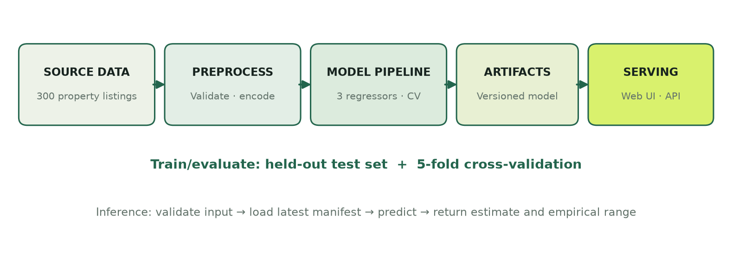
Figure 1. Project architecture from source listings through training to web and API inference.
300  SOURCE LISTINGS | 3  ALGORITHMS TESTED | 0.961  SELECTED MODEL TEST R²
  - Prepared from the supplied house_prices.csv dataset
Model artifact: 20260928T113023867477Z | Report generated: 28 September 2026
Currency values are shown in Indian rupees (INR). This is a learning project and not a professional valuation.
Contents
- 1. Executive summary
- 2. Business problem and system goals
- 3. Dataset and exploration
- 4. Data preparation and feature engineering
- 5. Algorithms and evaluation design
- 6. Results and interpretation
- 7. Deployment, API, and model versioning
- 8. Testing, limitations, and responsible use
- 9. Recommendations and next steps

1. Executive Summary
This project implements a modular machine-learning solution that estimates asking prices from property size, room counts, age, location, and property type. The workflow covers data validation, leakage-aware preprocessing, three-model comparison, cross-validation, holdout evaluation, feature interpretation, model persistence, REST serving, and an interactive Streamlit dashboard.
The supplied data contains 300 rows and 8 source columns. An 80/20 split produced 240 training records and 60 final test records. The selected estimator is Gradient Boosting, selected by mean five-fold cross-validation R² (0.981 ± 0.008). On the held-out test set it achieved R² 0.961, MAE ₹1,613,073, RMSE ₹2,353,482, and MAPE 7.2%.
A useful nuance: Random Forest scored the strongest single holdout R² in this run, while Gradient Boosting had the strongest mean CV R². The project follows its pre-declared selection rule and chooses Gradient Boosting; the holdout is reported as an independent check, not reused for selection.

2. Business Problem and System Goals

Problem statement
A homeowner, agent, or analyst needs a quick initial price reference before a more detailed appraisal. Manual comparisons are time-consuming and inconsistent. The system provides a repeatable estimate based on the patterns available in a small listing dataset, together with a rough historical-error band and comparisons to the dataset's location/property-type median.

Users and intended value
- Property researchers can test how combinations of property attributes map to the fitted model's estimate.
- Business stakeholders can compare algorithm performance and inspect which input groups the model relies on.
- Developers can use the REST API and versioned pipeline as a compact model-serving example.

Success criteria
Area | Success criterion | Implemented evidence
Data | Load and validate the supplied dataset | 300 rows checked; required columns and positive target enforced
Modeling | Compare at least three algorithms | Linear Regression, Random Forest, Gradient Boosting
Evaluation | Use multiple metrics and validation | MAE, RMSE, R², MAPE, five-fold CV
Interpretation | Explain influential inputs | Held-out permutation importance
Serving | Support browser and API predictions | Streamlit interface and FastAPI routes
Operations | Persist and identify model versions | Timestamped joblib/report and latest manifest
3. Dataset and Exploration
The source file contains 300 property records. The target is Price, in INR. Property_ID is a record identifier, not a property characteristic, and is deliberately excluded from the model to prevent arbitrary identifier patterns from influencing predictions.
Field | Mean | Std. dev. | Minimum | Median | Maximum
Area | 2,759.7 | 1,297.7 | 520 | 2,738 | 4,999
Bedrooms | 3.0 | 1.5 | 1 | 3 | 5
Bathrooms | 2.0 | 0.8 | 1 | 2 | 3
Age | 25.0 | 14.3 | 0 | 26 | 49
Price | 24,883,658.3 | 12,665,254.7 | 3,695,000 | 22,365,000 | 58,700,000
The overall median asking price is ₹22,365,000; median area is 2,738 square feet. Every required field is complete in the supplied CSV. These figures describe this sample only, not the current market across India.
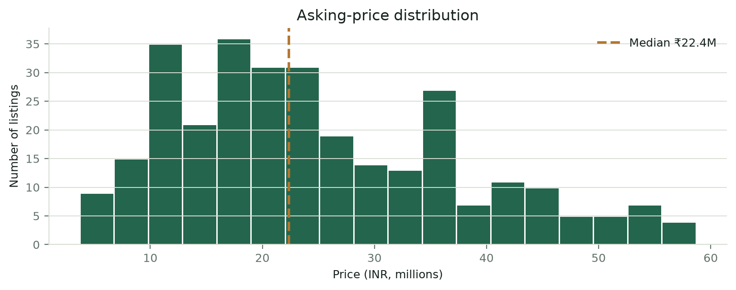
Figure 2. Distribution of asking prices. The dashed line marks the sample median.
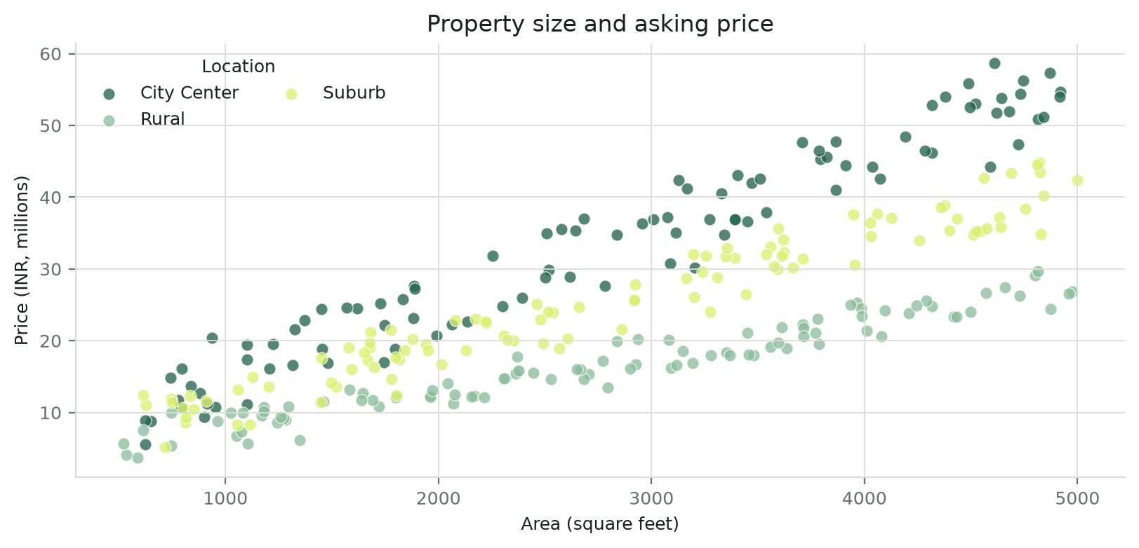
Figure 3. Area-price relationship, with points colored by location.
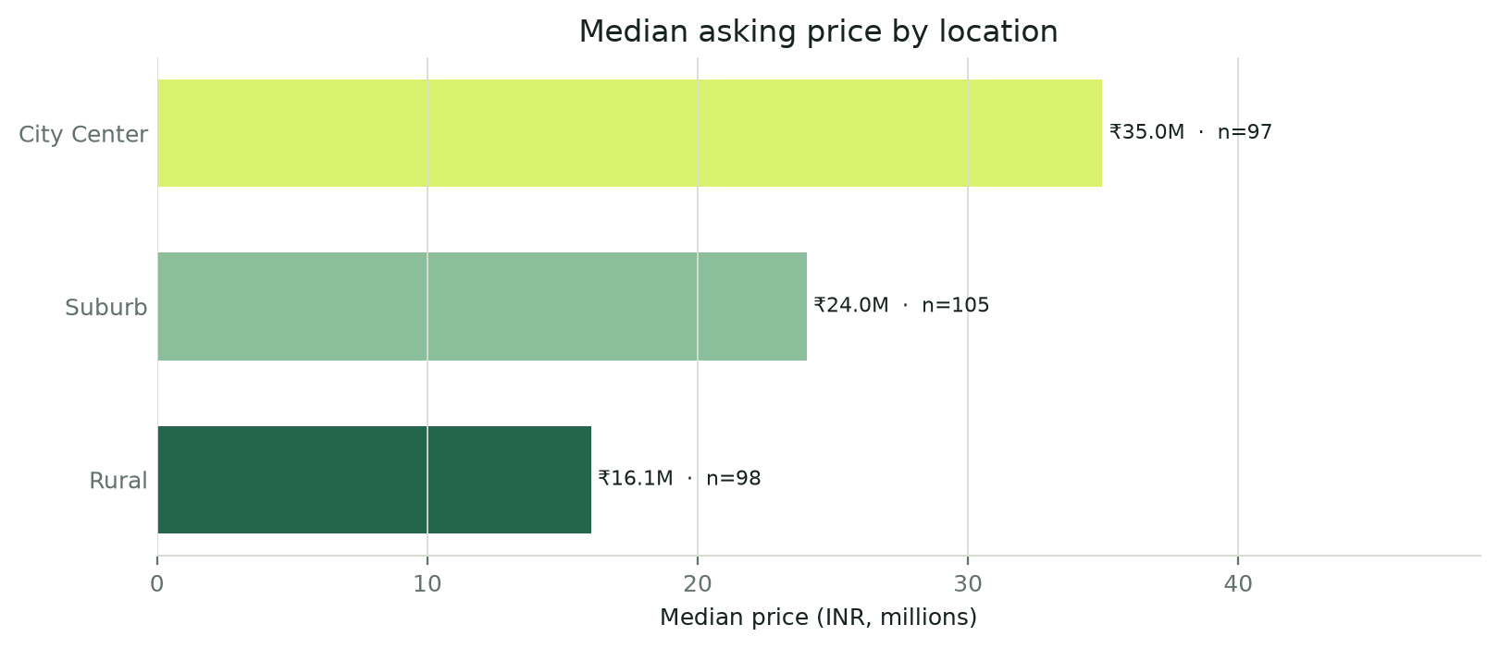
Figure 4. Median asking price by location; n gives the sample count in each group.
4. Data Preparation and Feature Engineering

Input fields
Field | Role | Treatment
Property_ID | Identifier | Excluded from predictors
Area | Numeric predictor | Median imputation, standard scaling
Bedrooms / Bathrooms / Age | Numeric predictors | Median imputation, standard scaling
Location | Categorical predictor | Most-frequent imputation, one-hot encoding
Property_Type | Categorical predictor | Most-frequent imputation, one-hot encoding
Price | Target | Positive numeric value in INR

Leakage-aware pipeline
The data is split before fitting learned transformations. Numeric median imputers and scalers, as well as categorical imputers and one-hot category vocabularies, live inside a scikit-learn Pipeline/ColumnTransformer. During cross-validation each fold fits its preprocessing only on that fold's training portion. The final model is fitted on the 240-row training partition and evaluated once on the 60-row held-out partition.

Prediction-time validation
The inference layer requires all six predictors, converts numeric inputs consistently, rejects booleans and non-finite/out-of-range values, checks integer room/age fields, and requires non-empty categorical strings. Supported numeric bounds are 100–10,000 sq ft, 1–10 bedrooms, 1–10 bathrooms, and 0–150 years. One-hot encoding ignores categories not seen in training rather than crashing, while the interactive UI offers categories present in the dataset.

Engineered representation
No handcrafted ratios or geographic lookups are added because the dataset has no coordinates, neighborhood identifiers, or reliable external metadata. The feature-engineering work is the reproducible pipeline transformation: scaled numeric inputs and one-hot categorical indicators. This avoids inventing information and keeps the interface aligned with the source schema.

5. Algorithms and Evaluation Design
Algorithm | Strengths | Trade-offs
Linear Regression | Fast, compact baseline; coefficients can be inspected | Captures only linear effects unless interactions are added
Random Forest | Ensemble of decorrelated trees; handles nonlinear splits | Less direct global explanation; can extrapolate poorly
Gradient Boosting | Sequential trees can model residual structure efficiently | Requires tuning; sensitive to data size and training choices
The split is reproducible with random seed 42. Five-fold shuffled K-fold CV is applied to training data. Model selection maximizes mean CV R². The test metrics are independent reporting metrics and do not drive this choice. MAE gives typical absolute currency error; RMSE penalizes larger misses more; R² describes variance explained relative to a mean baseline; MAPE expresses absolute error as a percentage, but may become unstable when true values approach zero.
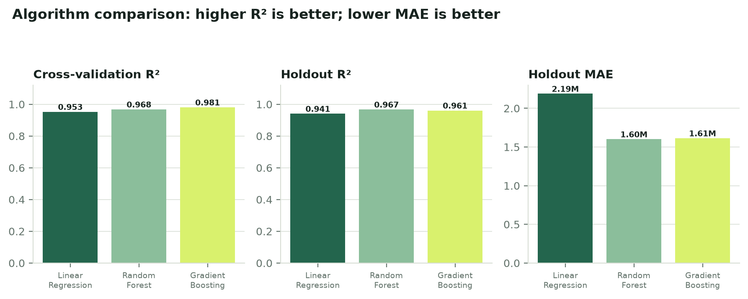
Figure 5. Cross-validation R², held-out R², and held-out MAE for all three regressors.
6. Results and Interpretation
Algorithm | CV R² mean ± SD | Test R² | Test MAE | Test RMSE | Test MAPE
Linear Regression | 0.953 ± 0.008 | 0.941 | ₹2,188,736 | ₹2,907,633 | 13.2%
Random Forest | 0.968 ± 0.006 | 0.967 | ₹1,600,348 | ₹2,158,466 | 7.2%
Gradient Boosting SELECTED | 0.981 ± 0.008 | 0.961 | ₹1,613,073 | ₹2,353,482 | 7.2%
Random Forest produced the lowest test MAE and RMSE and highest holdout R² in this particular split. Gradient Boosting achieved the highest mean CV R² and is therefore the persisted model under the configured selection criterion. This difference is a useful model-selection lesson: a single split can rank candidates differently from repeated validation. Small data makes all such estimates uncertain.
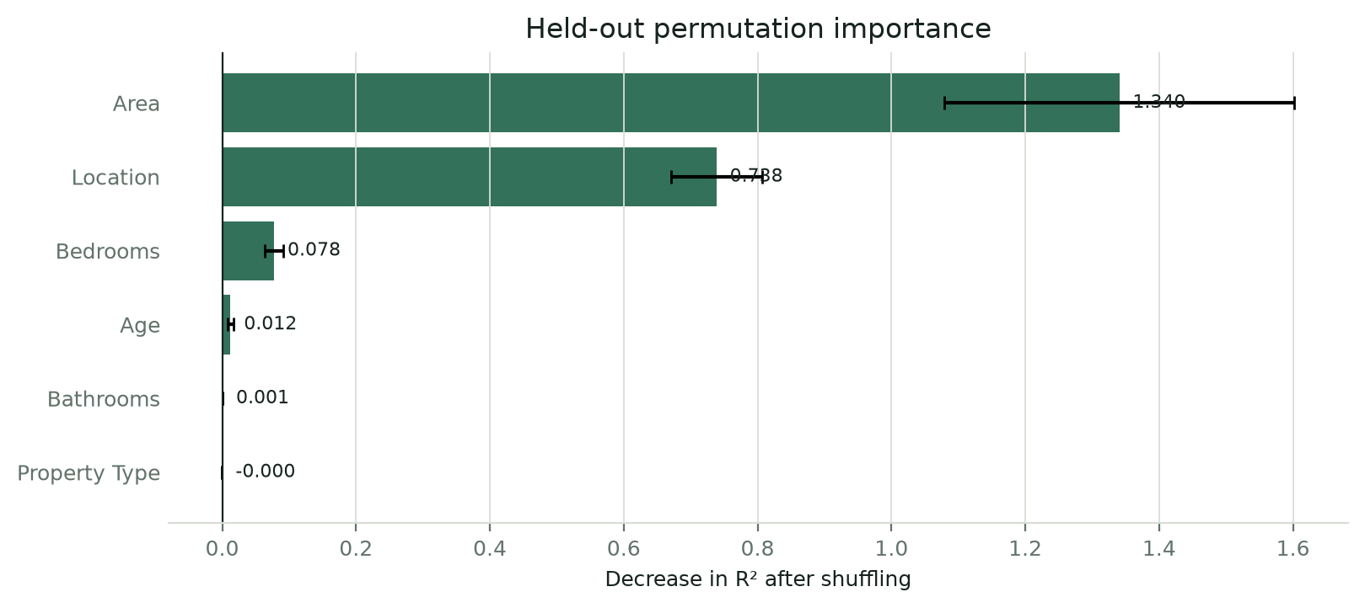
Figure 6. Permutation importance on the 60-row held-out set. Error bars show variation across shuffles.
Area ranks first: shuffling it reduced test-set R² by 1.34 on average in this calculation. Location ranks second at 0.74. Bedroom count has a smaller measured contribution, while bathroom count and property type add little conditional predictive value for this fitted model and sample.
Importance is not a percentage share of price, an estimated rupee effect, or a causal relationship. Correlated inputs can share or mask importance. A negative near-zero score is consistent with a feature contributing little beyond noise under the current test sample.

Prediction-range interpretation
The interface reports estimate ± ₹3,695,965, the 90th percentile of absolute residuals in the holdout set. This is a transparent empirical error band, not a statistically calibrated confidence interval. With 60 test records, quantile uncertainty is substantial; future coverage is not guaranteed.

Business implications
- Use the estimate as a starting point for review, not as a final list price, appraisal, loan decision, or investment recommendation.
- Area and location are the strongest information sources available in this table; data quality and location representativeness directly affect usefulness.
- A group median is a sample comparison. The app does not control for precise neighborhood, condition, amenities, transaction date, or market liquidity.

7. Deployment, API, and Model Versioning
The Streamlit interface provides a property valuation form, sample market dashboard, model comparison, and session-level estimate history export. The FastAPI service exposes GET /health and POST /predict. Both serving paths call the same validation and inference functions, reducing behavioral differences between UI and API use.
Figure 7. Runtime architecture and the shared training/inference path.

Prediction contract
Request field | Example | Meaning
Area | 1500 | Area in square feet
Bedrooms | 3 | Bedroom count
Bathrooms | 2 | Bathroom count
Age | 5 | Property age in years
Location | City Center | Location category
Property_Type | Apartment | Property type category
A successful response returns estimated_price, estimated_range_low, estimated_range_high, range_method, model_version, and algorithm. Invalid inputs return HTTP 422; unavailable model artifacts return HTTP 503. OpenAPI documentation is served at /docs.

Artifact management
Training writes a timestamped joblib pipeline (house_price_20260928T113023867477Z.joblib), a matching JSON evaluation report, and models/latest.json. The manifest points to the active model/report pair. Keep all three artifacts together during deployment. Joblib uses Python serialization and must never be used to load untrusted files.
Run from the project root: install requirements.txt, train with python -m scripts.train, launch the UI with streamlit run app/streamlit_app.py, or launch the API with python -m uvicorn app.api:app --reload.

8. Testing, Limitations, and Responsible Use
The project test suite contains nine tests covering loading the real dataset, exclusion of identifiers, valid input normalization, missing and malformed/out-of-range fields, three-model training, report/manifest persistence, and prediction response/range construction. The live API was also smoke-tested for successful health and prediction calls and a 422 invalid-input response. The browser prediction flow and responsive layout were exercised.
Limitation | Why it matters | Practical next step
Only 300 records | Split/CV scores have sampling uncertainty | Collect substantially more representative records
Listing prices, not verified transactions | Asking values can differ from sale values | Define a verified target and data provenance
Sparse location categories | Broad categories hide neighborhood differences | Use privacy-safe geographic features and enough samples
No condition/amenity/time features | Important value drivers are unobserved | Add documented, quality-controlled fields
No drift or feedback monitoring | Market relationships change over time | Track residuals, segment metrics, and data freshness
Empirical range is not calibrated | Coverage can vary by group or time | Use larger calibration data and evaluate coverage

Responsible deployment
Before business use, establish lawful data collection and retention, explain limitations to users, audit errors across relevant property and location groups, and ensure estimates do not become the sole basis for consequential decisions. The local development server has no authentication or production hardening. Production use needs access controls, logging, monitoring, resource limits, model governance, and an incident/retraining process.

9. Recommendations and Next Steps
- Expand and verify the dataset, record its source and timestamp, and distinguish asking prices from closed transactions.
- Use a time-aware validation strategy when historical transaction dates become available; keep a truly future period for evaluation.
- Test error and interval coverage by location, property type, and price band; investigate material disparities before deployment.
- Tune tree model parameters inside cross-validation and compare against a robust median/location baseline.
- Calibrate prediction intervals on a separate calibration sample and report empirical coverage with interval width.
- Add monitoring for feature distributions, prediction ranges, API failures, and newly observed labeled outcomes.

Project files
Path | Responsibility
src/data_preprocessing.py | Schema checks, feature definitions, request validation
src/model_training.py | Pipelines, model comparison, evaluation, interpretation, persistence
src/model_inference.py | Load latest artifact and produce validated estimates
app/streamlit_app.py | Interactive valuation and analytics interface
app/api.py | FastAPI health and prediction endpoints
scripts/train.py / create_report.py | Training and report-generation commands
tests/ | Focused regression tests for data, training, and inference

