# QUIZ

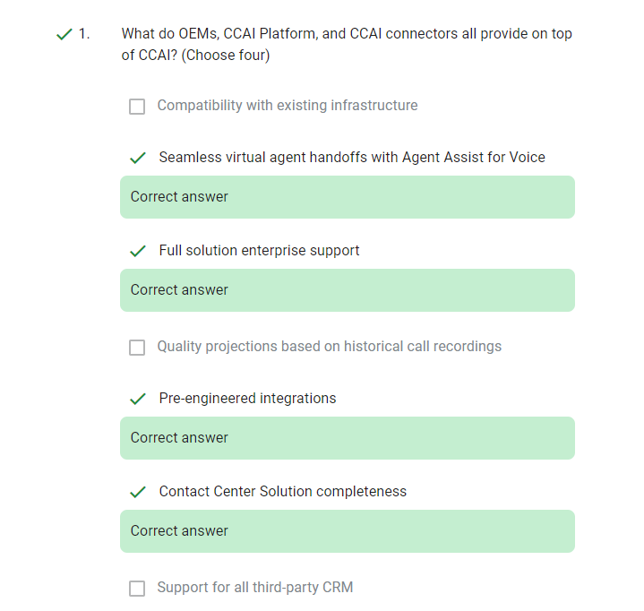

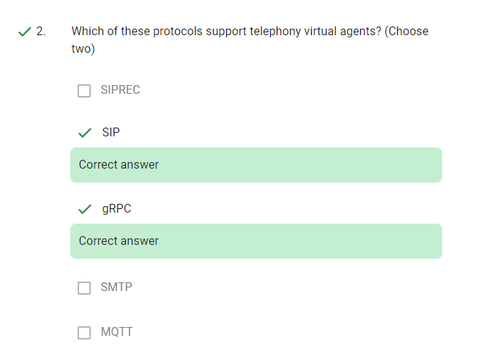

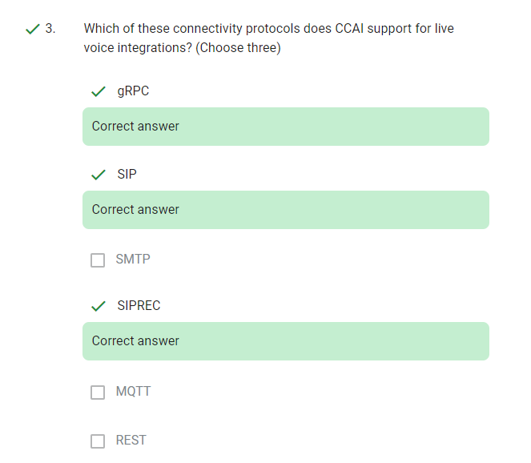

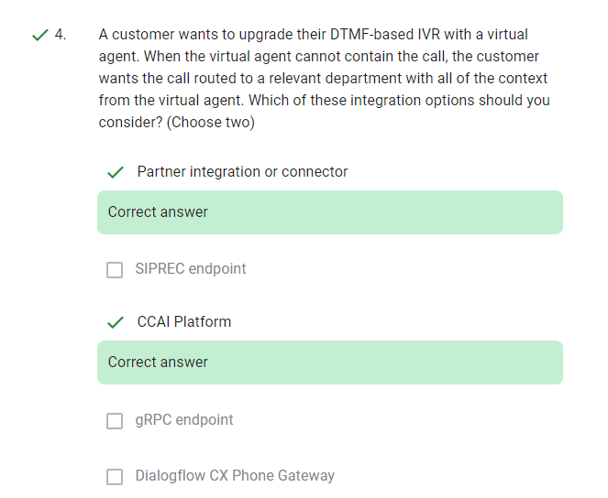

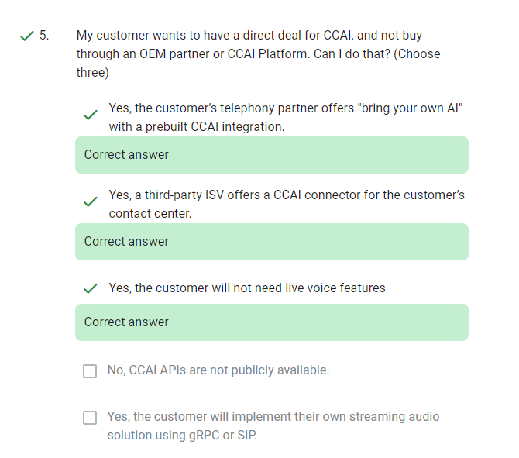

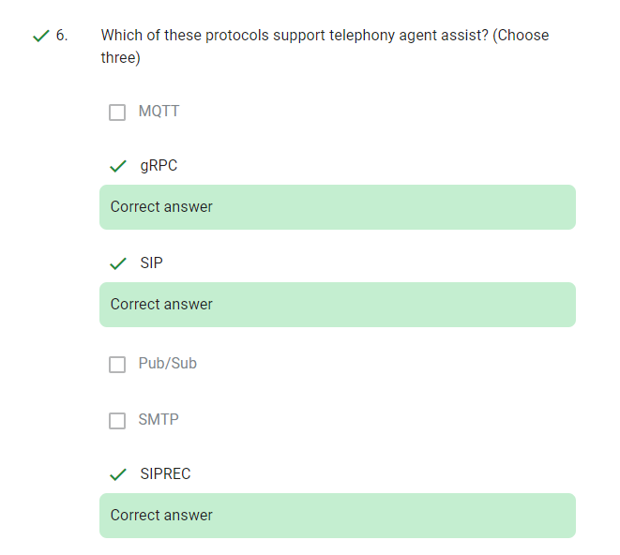

1.

Which of these protocols support telephony agent assist? (Choose three)

1. SMTP
2. SIPREC
3. gRPC
4. MQTT
5. SIP
6. Pub/Sub

2.

My customer wants to have a direct deal for CCAI, and not buy through an OEM partner or CCAI Platform. Can I do that? (Choose three)

1. No, CCAI APIs are not publicly available.
2. Yes, the customer will implement their own streaming audio solution using gRPC or SIP.
3. Yes, a third-party ISV offers a CCAI connector for the customer’s contact center.
4. Yes, the customer’s telephony partner offers "bring your own AI" with a prebuilt CCAI integration.
5. Yes, the customer will not need live voice features

3.

What do OEMs, CCAI Platform, and CCAI connectors all provide on top of CCAI? (Choose four)

1. Quality projections based on historical call recordings
2. Contact Center Solution completeness
3. Compatibility with existing infrastructure
4. Seamless virtual agent handoffs with Agent Assist for Voice
5. Full solution enterprise support
6. Support for all third-party CRM
7. Pre-engineered integrations

4.

Which of these protocols support telephony virtual agents? (Choose two)

1. MQTT
2. SIP
3. SIPREC
4. gRPC
5. SMTP

5.

A customer wants to upgrade their DTMF-based IVR with a virtual agent. When the virtual agent cannot contain the call, the customer wants the call routed to a relevant department with all of the context from the virtual agent. Which of these integration options should you consider? (Choose two)

1. Partner integration or connector
2. SIPREC endpoint
3. CCAI Platform
4. gRPC endpoint
5. Dialogflow CX Phone Gateway

6

Which of these connectivity protocols does CCAI support for live voice integrations? (Choose three)

1. gRPC
2. SIP
3. MQTT
4. SMTP
5. SIPREC
6. REST