ENVIRONMENTAL REPORT
 | Project : Ministry of health  ER# : 47  Date/Period: 17-mar-25 till 21-mar-25

HOUSEKEEPING/ENVIRONMENTAL
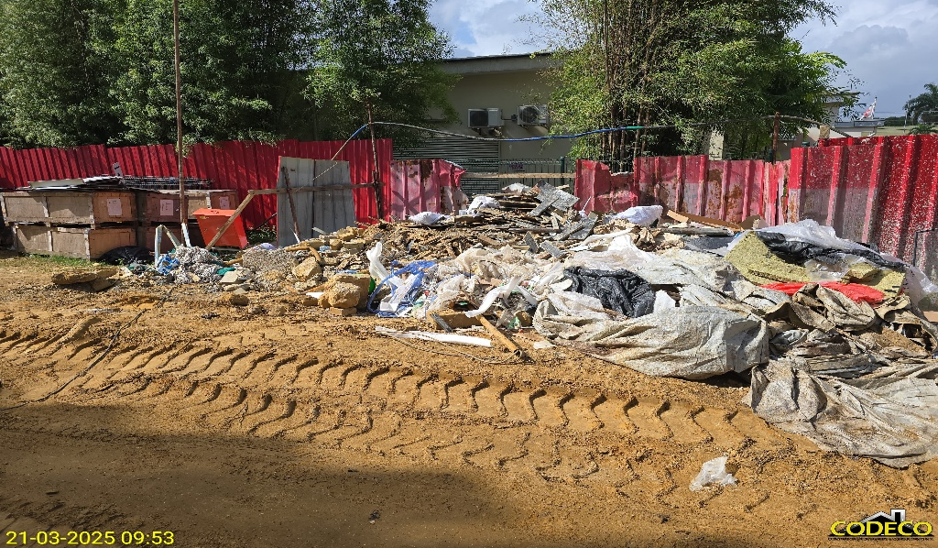 | 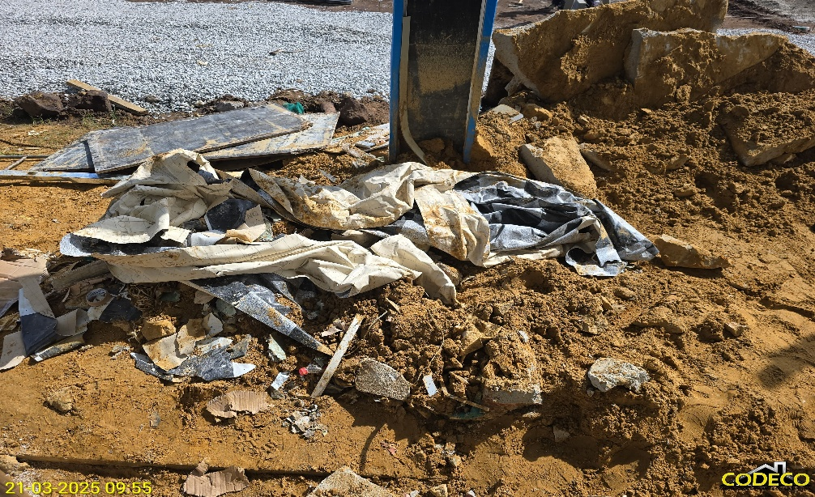 | 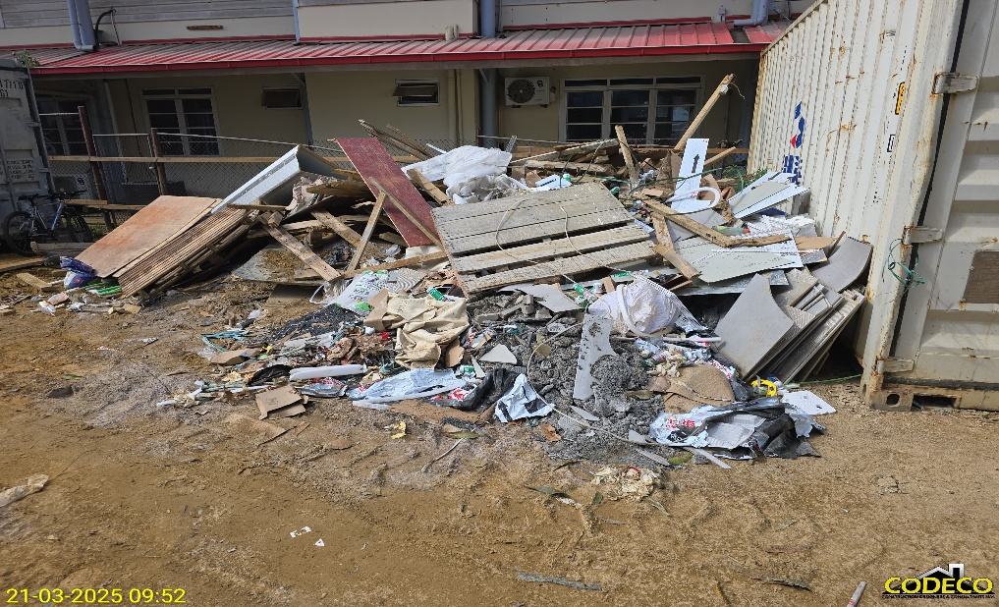
Construction debris near B1 | Construction debris near B1 | Construction debris near B1.
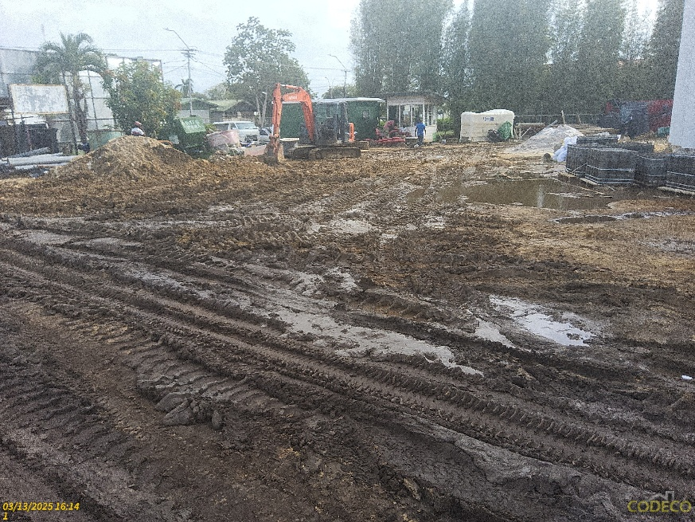 | 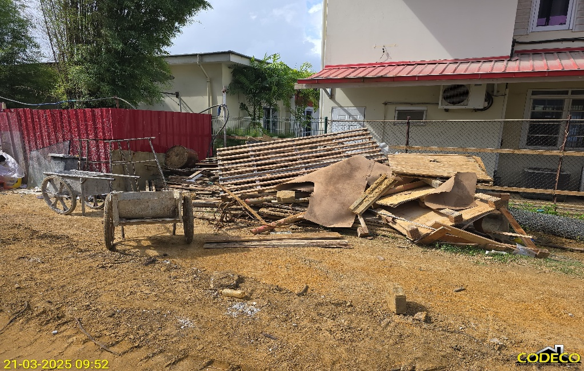
Road to the office not accesible for small cras. Leveling needed. | Construction debris near B1
Comment:
Household trash and construction debris should be thrown in separate trash bins and cleaned up optimally.
A part of the construction debris has been disposed of, but there is still some construction debris left to be disposed. Please remove all debris optimally.
Stack construction materials neatly.
We indicate the same points every month, which are not being done. As a result, the environmental invoice will be reduced.

Lost hours:

Lost hours | Reason for lost hours (no work)

 | ROLE | NAME | SIGNITURE | DATE
Supervision | Assistant Project Manager | Sandjana Anroedh |  | 21-Mar-2025
To be filled by contractor
 | ROLE | NAME | SIGNITURE | DATE
Received by Contractor

