BIGDATA 220B HOMEWORK 2

Kafka

|  |  |  |
| --- | --- | --- |
| Leo Salemann | 7/19/17 | [Leo.salemann@me.com](mailto:Leo.salemann@me.com)  Leos@uw.edu |

# Create the Kafka Topic

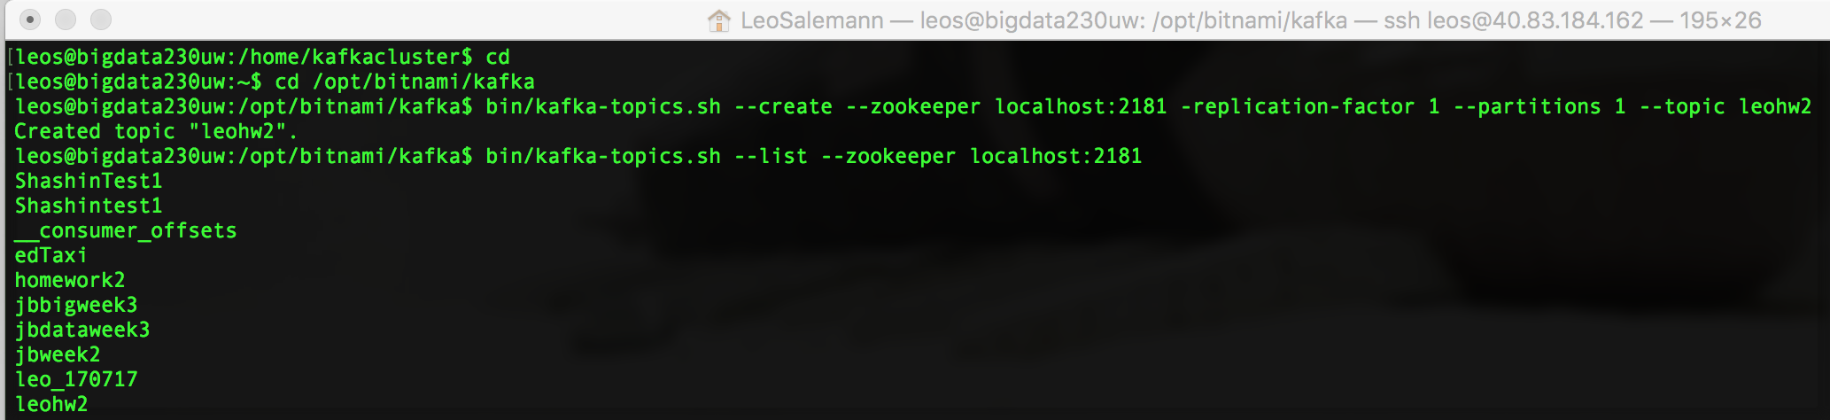

# Review the CSV, Start the Producer

# New Terminal, Start the Consumer

