Leonardo Gomez

813438698

February 15, 2018

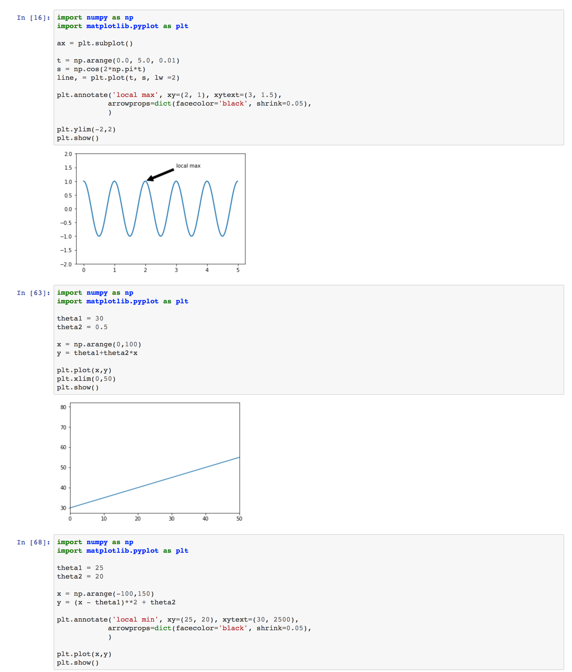CS 596 Assignment 1

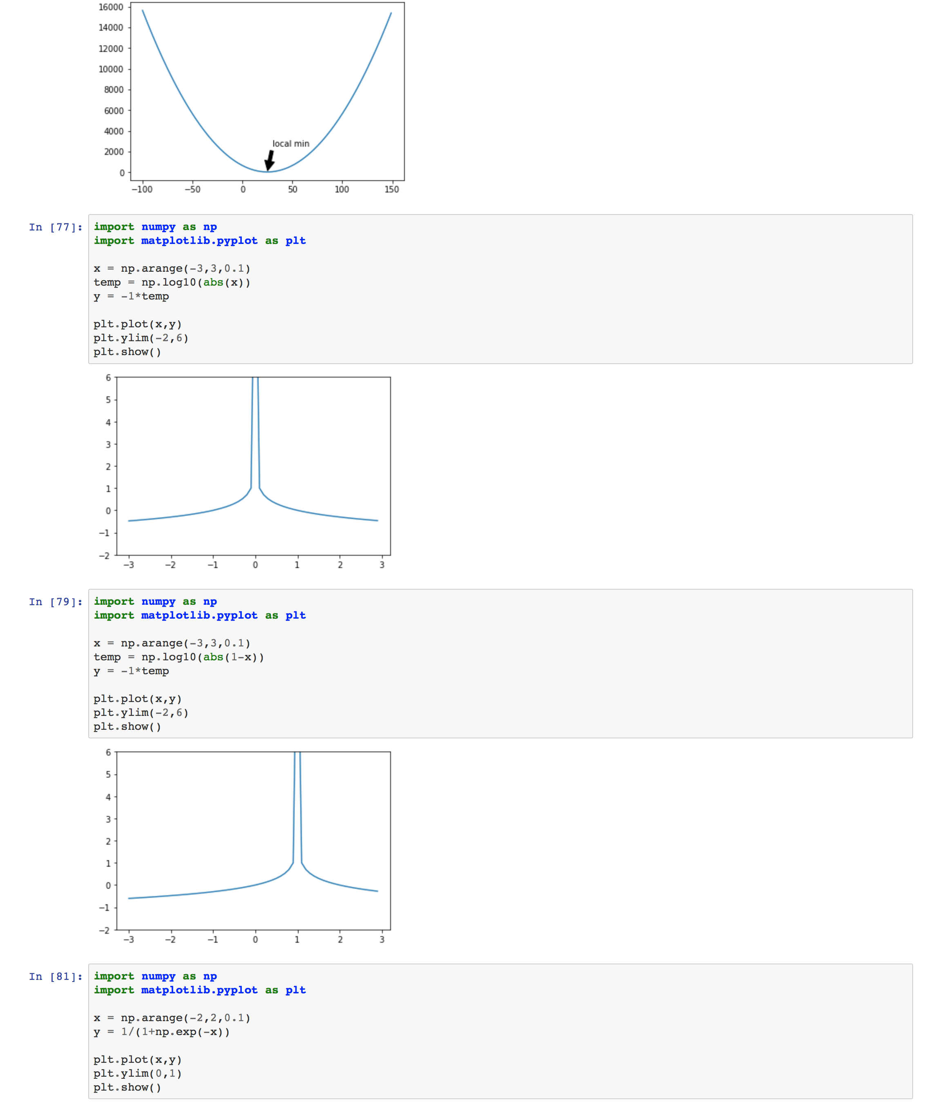

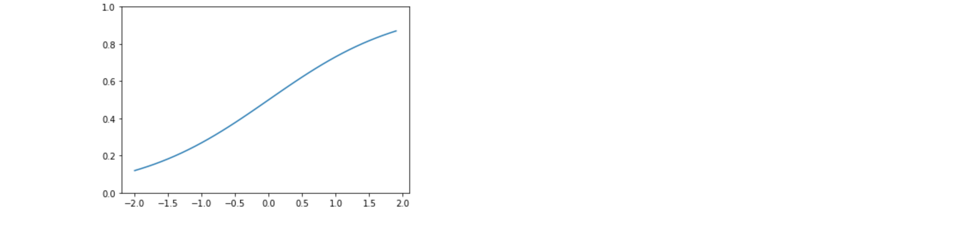**Question 2:**

1. **Supervise learning with continuous predictions:** this is because each training sample provides labels for size, number of bed rooms, number of bathrooms, and house type.
2. **Supervised learning with discrete predictions:** Bayes spam filtering, where you should flag an item as spam to refine the results
3. **Unsupervised learning with discrete results:** because we need clusters of data.

**Question 3:**

1. This problem can be solved by supervised learning that uses a single feature as predictor;
2. This problem can be solved by unsupervised learning that uses a single feature as predictor

**Question 4:**

One example that can be used human activity recognition of HAR for short. In this we can collect data from personal fitness devices which already have labels for each activity. The labels range from walking, walking upstairs, walking downstairs, sitting, standing, and laying down. Some of this data can be compared to the open datasets available provided by institutions such as University of California, MLdata.org, and deeplearning.net. The previously mention data, contains more than 10,000 records, each defined by 560 features. The labels are usually already label by the user when they exercise with their Fitbit, watch, etc. The 560 features columns are the input data of our model and represent the time and frequency domain variables obtained by the accelerometer and gyroscope signals. The goal of this is to train models to predict what type of exercise the user is doing.