DTI5175 W00 Mobile Commerce Technologies

Assignment 1: Sketch of the Planned Application

Application Title: SharEat – Don’t Waste It, Share It


Group 5
Ejaz, Raphael
Liu, Wenkang
Wei, Leo (300188723)
Younoussa, Adjmal (300203179)
Sayeed , Sarhan

Professor: Dr. Nancy Samaan
Table of Contents
1. Purpose of the Application 3
2. Main Screens 3
2.1. Login / Create Account Page 3
2.2. Home Page 4
2.3. Food Details Page 5
2.4. Post a Food Page 6
2.5. Chat Page 7
2.6. Profile Page 8
3. Why This Application Is Innovative 10
4. Summary of Advanced Features Implemented 10

Purpose of the Application
SharEat is a mobile food-sharing application designed to reduce food waste by allowing users to share extra food with nearby people. The app helps connect people who have surplus food with those who can use it. It is simple, practical, and community-oriented. Users can post available food, browse nearby offers, contact the owner, and arrange pickup easily.
The main goal of SharEat is to promote sustainability, reduce waste, and make food sharing easier and faster through a user-friendly mobile application.

Main Screens
The application contains the following main screens:
- Login / Create Account Page
- Home Page
- Food Details Page
- Post a Food Page
- Chat Page
- Profile Page

Login / Create Account Page

This page allows new users to register and existing users to log into the app securely.

Buttons and User Interaction
Login Button: allows an existing user to sign into the application.
Create Account Button: allows a new user to register an account.
Profile Photo Upload: the user may add a profile picture during account creation.

Home Page
The Home Page is the main screen of the application. It allows users to browse food posts shared by other users nearby.
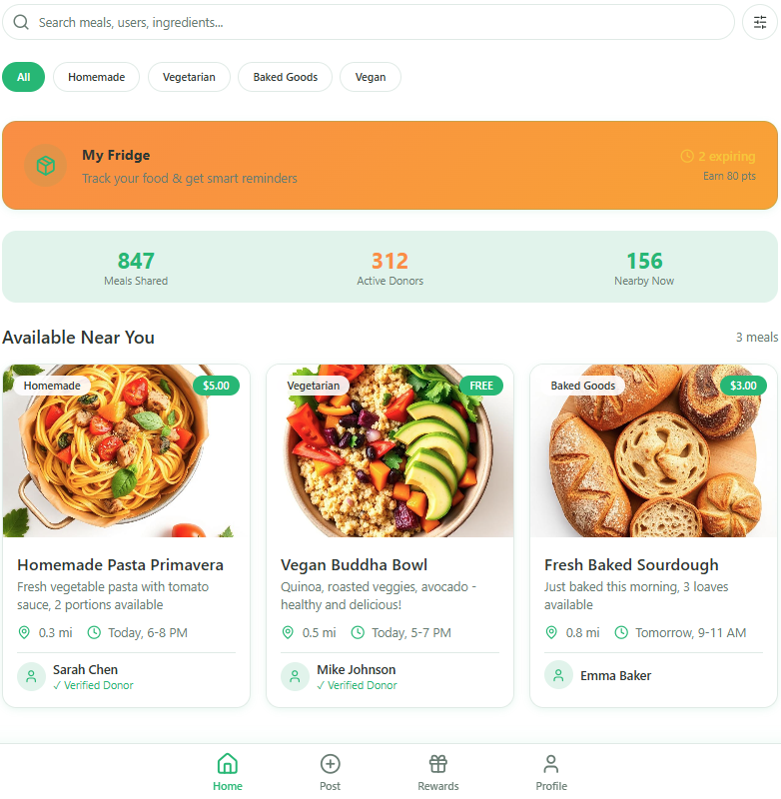
Buttons and User Interaction
Search Bar: users can type the name of a food item, such as “rice,” “pizza,” or “fruit.”
Voice Search Button: users can tap the microphone icon and say what they are looking for. The app converts speech into text and searches automatically.
Food Post Card: each card displays the food image, title, short description, distance, pickup availability. When the user taps a card, the app opens the Food Details Page.
Filter Button: users can filter food posts.
Navigation Bar: the bottom navigation bar can include: Home, Post. Chat, Profile. This helps users move easily through the app.

Food Details Page
This page shows full information about a selected food item and allows the user to contact the owner or navigate to the pickup location.
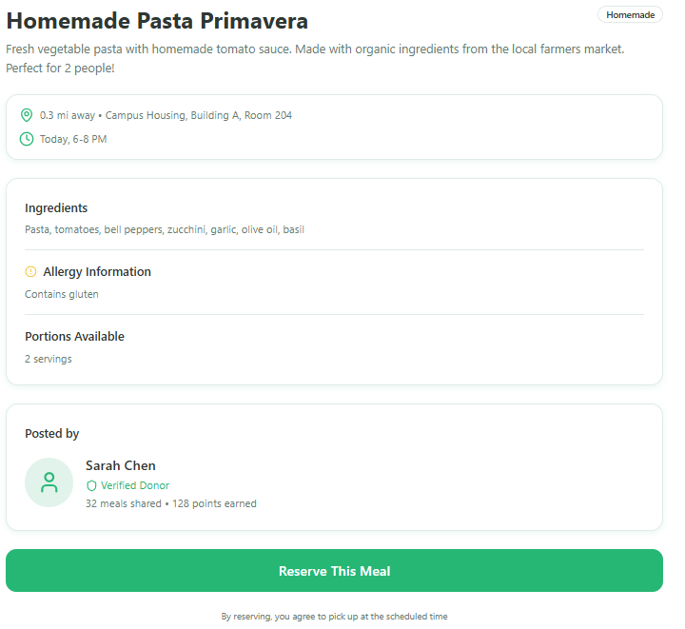
Buttons and User Interaction
Chat Button: opens the in-app chat so the user can message the owner.
Call Button: allows the user to call the owner directly.
SMS Button: allows the user to send a text message quickly.
View on Map Button: displays the pickup location using Google Maps.
Get Directions Button: opens navigation directions to the pickup location.

Post a Food Page
This page allows users to create a new food-sharing post.
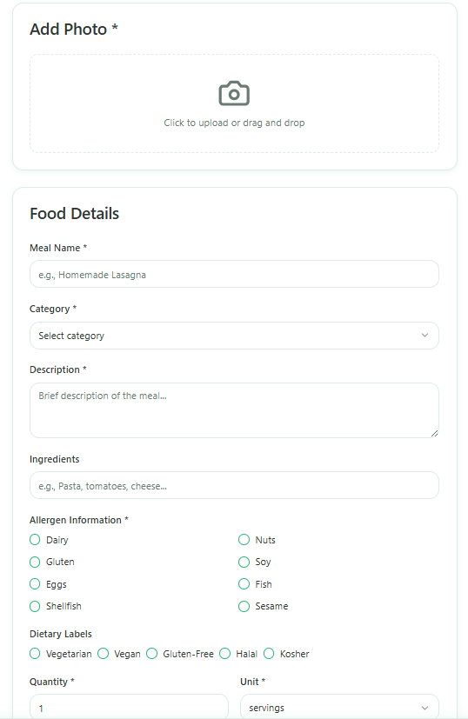
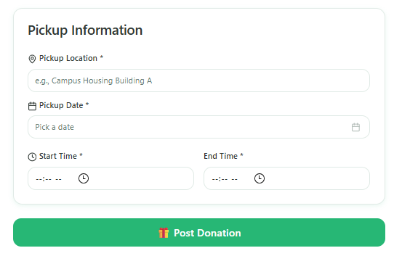
Buttons and User Interaction
Camera Button: users can take a picture directly in the app using the phone camera.
Speech-to-Text Button: users can speak instead of typing the food description, and the app converts it into text automatically.
Pickup Location Field: the user enters or selects the food pickup location.
Submit Button: uploads the post, image, and details to cloud storage so that it becomes visible to other users.

Chat Page
This page allows users to communicate inside the app after showing interest in a food item.
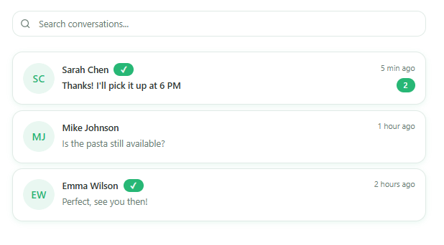
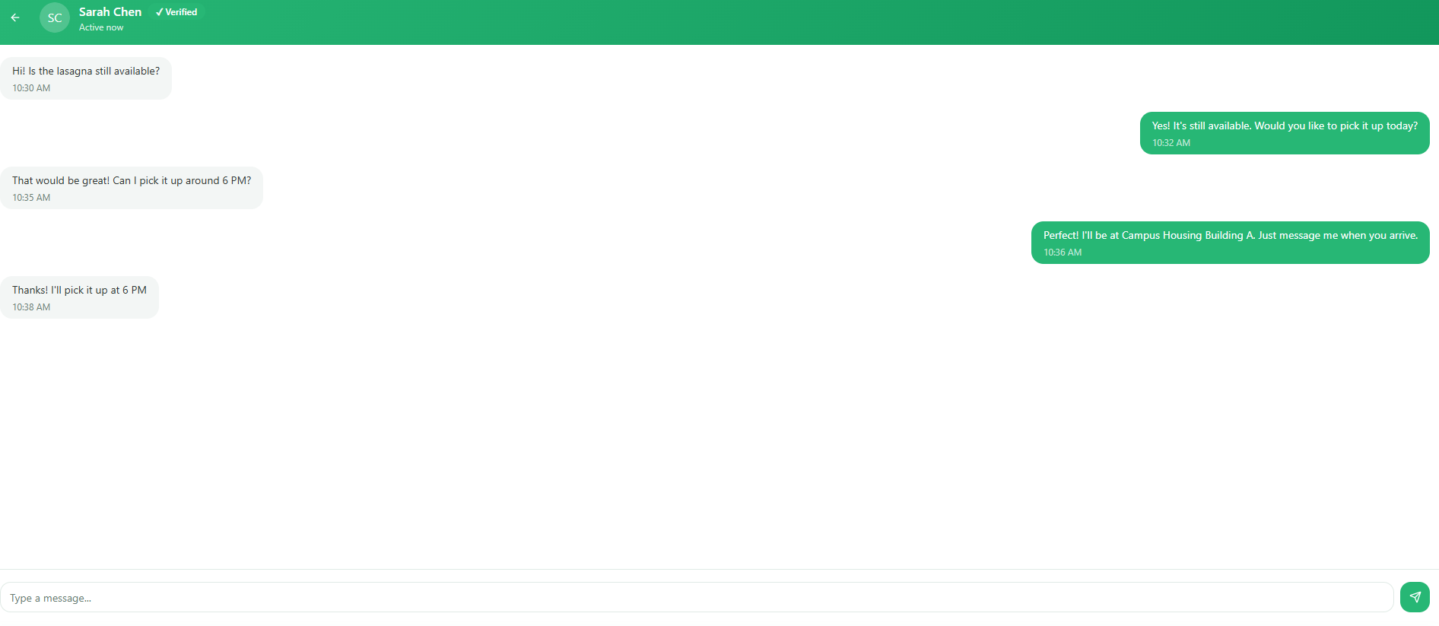
Buttons and User Interaction
Message Input Box: users type a message to the food owner.
Send Button: sends the message in real time.

Profile Page
This page allows users to manage their personal information and activity in the app.
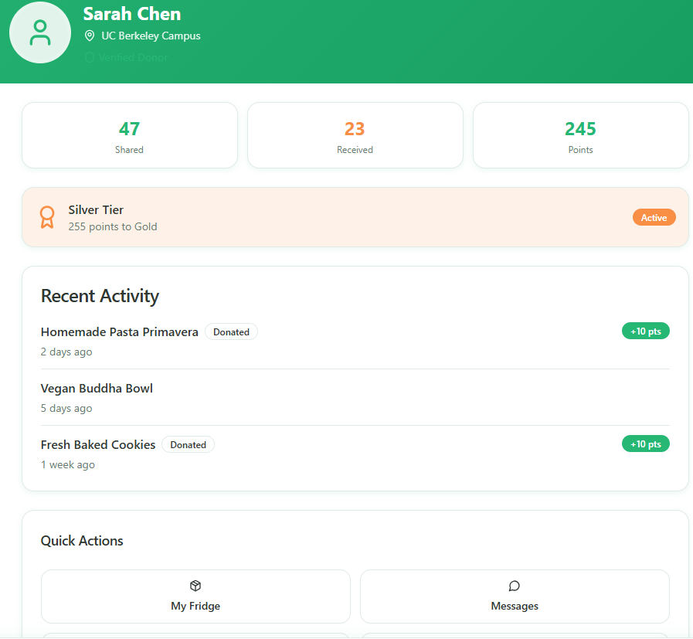
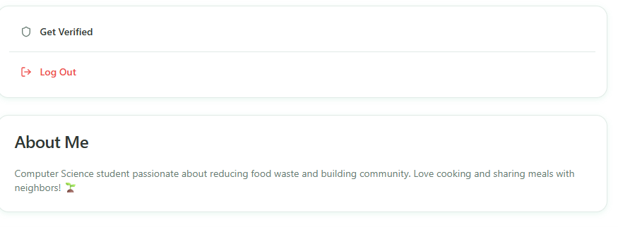
Buttons and User Interaction
Edit Profile Button: allows the user to update personal information.
My Posts Section: shows all food items posted by the user.
Logout Button: allows the user to sign out of the application.

Why This Application Is Innovative
SharEat is innovative because it combines sustainability, technology, and community support in one mobile platform. Instead of letting food go to waste, users can quickly share it with others nearby.

Summary of Advanced Features Implemented
SharEat includes the following advanced features:
- Camera Integration: users take food photos directly in the app
- Call / SMS Integration: users can directly contact the owner
- In-App Chat: users can communicate within the app
- Google Maps Integration: users can view pickup location and directions
- Cloud Storage: posts, images, and profiles are stored online
- Voice Search / Speech-to-Text: users can search or create posts using voice

