Computer Communications and Networks (COMN)
2022/23, Semester 1

Assignment 2 Results Sheet

Forename and Surname: | Ziqian Xu
Matriculation Number: | S1938615

Question 1 – Number of retransmissions and throughput with different retransmission timeout values with stop-and-wait protocol. For each value of retransmission timeout, run the experiments for 5 times and write down the average number of retransmissions and the average throughput.

Retransmission timeout (ms) | Average number of  retransmissions | Average throughput  (Kilobytes per second)
5 | 2995.0 | 72.98
10 | 1482.0 | 67.74
15 | 71.2 | 63.84
20 | 50.8 | 51.64
25 | 51.6 | 50.3
30 | 46.8 | 50.2
40 | 51.4 | 47.0
50 | 42.8 | 43.0
75 | 41.4 | 33.2
100 | 45.4 | 30.3

Question 2 – Discuss the impact of retransmission timeout value on the number of retransmissions and throughput. Indicate the optimal timeout value from a communication efficiency viewpoint (i.e., the timeout that minimizes the number of retransmissions while ensuring a high throughput).

By increasing the retransmission timeout value from 5 to 15ms, number of retransmissions drops down drastically from 4-digit to 2-digit. This is because we allow more time for communication to go through. Then for timeout from 20-100ms, the number of retransmissions remain rather stable. Since throughput keeps going down from timeout of 20-100ms (because by increasing the timeout value, communication becomes slower), speaking from a communication efficiency viewpoint, it is best to take a timeout of 20ms so that the number of retransmissions is kept low while throughput is still relatively high.

Question 3 – Experimentation with Go-Back-N. For each value of window size, run the experiments for 5 times and write down the average throughput.

 | Average throughput (Kilobytes per second)
Window Size | Delay = 5ms | Delay = 25ms | Delay = 100ms
1 | 41.4 | 14.5 | 4.6
2 | 83.0 | 27.1 | 7.9
4 | 143.6 | 52.8 | 11.2
8 | 266.4 | 101.8 | 23.4
16 | 388.4 | 137.3 | 33.8
32 | 46.2 | 182.5 | 57.6
64 | 55.6 | 267.4 | 85.6
128 | 73.8 | 92.3 | 88.6
256 | 66.4 | 82.8 | 79.2

Create a graph as shown below using the results from the above table:
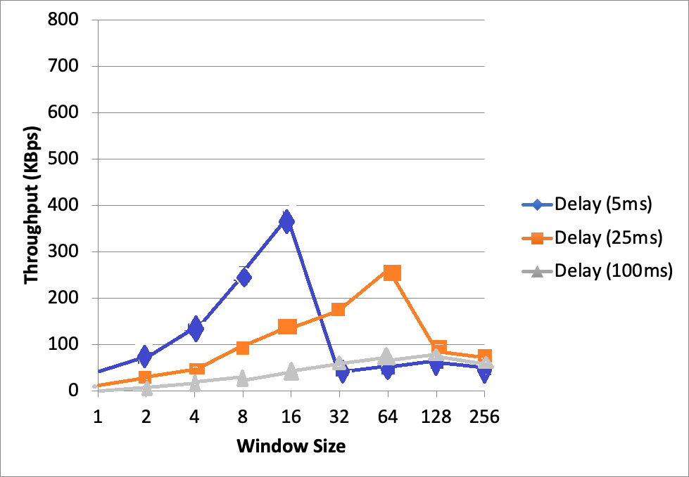

Question 4 – Discuss your results from Question 3.

I decided to use 20ms retry timeout for 5ms delay, 60ms retry timeout for 25ms delay, and 220ms retry timeout for 100ms delay. This is because two-way propagation for 5ms delay takes 10ms, 10ms takes 20ms and 100ms takes 200ms. We want to leave some space for the two-way propagation to be feasible so the retry timeout are all a little bit longer than what the two-way propagation delay is. When increasing window size from 1, throughput shows a growing trend while smaller delays starts and peaks at a higher throughput. This is due to data is clustered as a group of packets while being sent thus results in a higher transmission rate. As window size increases over the peaks, throughput drops at quite a drastic rate. This might be due to the nature of ‘going back’ when packets miss which happens more often with a larger window size. At 256 window size it can be noticed that throughput tends to be closer and closer, this is because though higher delay may cause the transmission to be slower, it is more important that they can be less overwhelmed while receiving packets.

Question 5 – Experimentation with Selective Repeat. For each value of window size, run the experiments for 5 times and write down the average throughput.

 | Average throughput (Kilobytes per second)
Window Size | Delay = 25ms
1 | 13.7
2 | 17.2
4 | 33.5
8 | 63.7
16 | 119.9
32 | 201.0

Question 6 - Compare the throughput obtained when using “Selective Repeat” with the corresponding results you got from the “Go Back N” experiment and explain the reasons behind any differences.

The throughput is similar when the window size is 1-16. As window size gets larger the throughput of selective repeat grows in a faster rate. This is because selective repeat is an optimized version of go back N. It only retransmit what is missing and ignores successfully gone-though packets instead of retransmitting a whole batch. I suppose selective repeat is more advantageous with window size even larger such as 64 and 128. However, there might be a point when the window size is too big and the buffer takes too much space, which consequentially has negative impact on the transmission throughput.

Question 7 – Experimentation with iperf. For each value of window size, run the experiments for 5 times and write down the average throughput.

 | Average throughput (Kilobytes per second)
Window Size (KB) | Delay = 25ms
1 | 6.8
2 | 14.5
4 | 24.0
8 | 50.9
16 | 70.1
32 | 73.2

Question 8 - Compare the throughput obtained when using “Selective Repeat” and “Go Back N” with the corresponding results you got from the iperf experiment and explain the reasons behind any differences.

The iperf results are relatively lower than the selective repeat and go back n results though there is still a rising trend as window size increases. Since we are using TCP options, it is supposed to be slower because TCP not only guarantees delivery of data and also guarantees that packets will be delivered in the same order in which they were sent, also uses checksum to ensure the authenticity of the data. There may be some flow control involved in TCP such as additive increase multiplicative decrease scheme (AIMD), and congestion window(CWND). These mechanisms makes TCP more reliable and flow-managed yet is comparatively slower than UDP. In real life, TCP uses 20 bytes header which is significantly larger than UDP header (8 bytes) and our header (3 bytes). This increases the transmission load and contributes to the slower speed.

