**实验一 使用VirtualMachine学习安装Ubuntu**

1. 准备工作-ubuntu下载 ubuntu官网下载

如何官网下载ubuntu？

[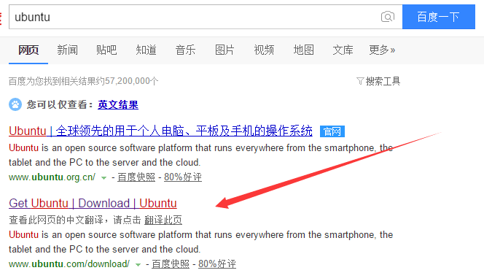](http://images2015.cnblogs.com/blog/897393/201603/897393-20160307102812522-852785089.png)

<http://www.ubuntu.com/download/>

[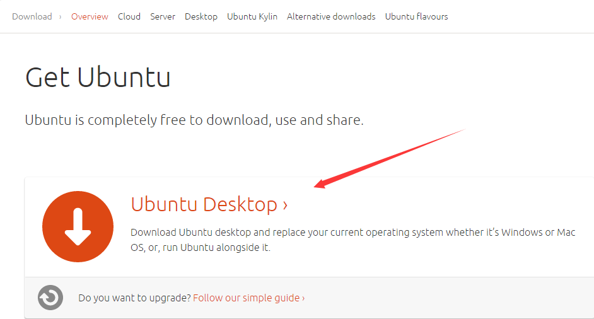](http://images2015.cnblogs.com/blog/897393/201603/897393-20160307102813288-679746463.png)

[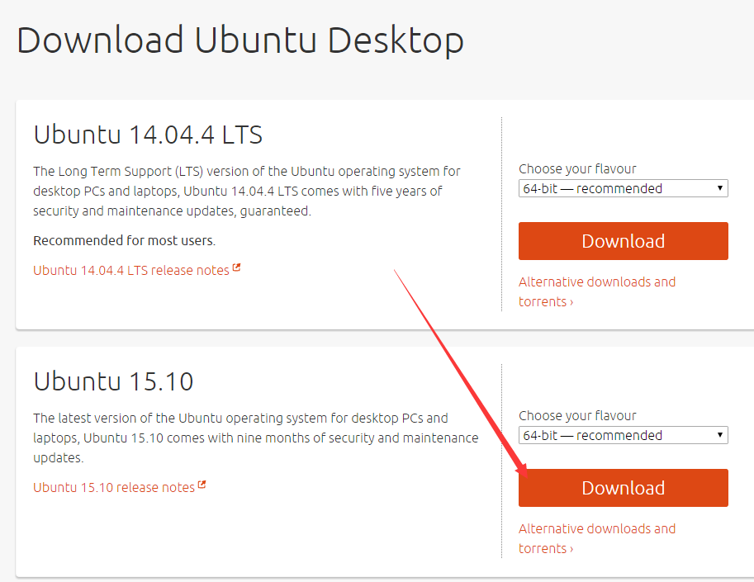](http://images2015.cnblogs.com/blog/897393/201603/897393-20160307102814069-1990049433.png)

[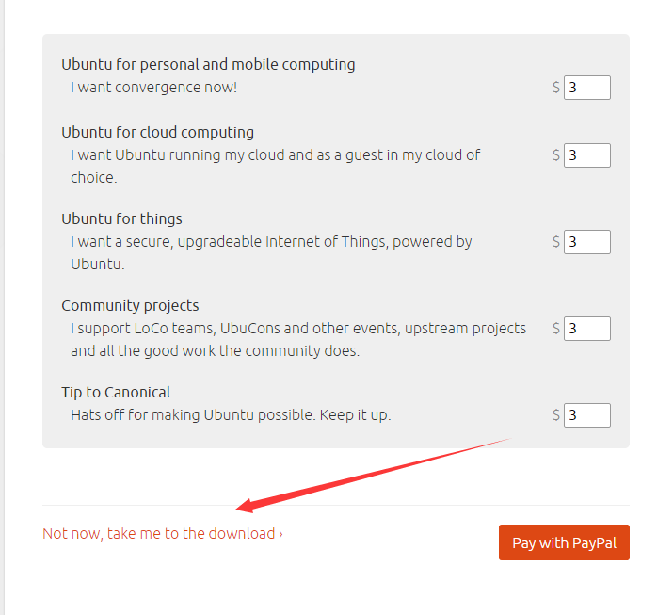](http://images2015.cnblogs.com/blog/897393/201603/897393-20160307102815116-108385552.png)

[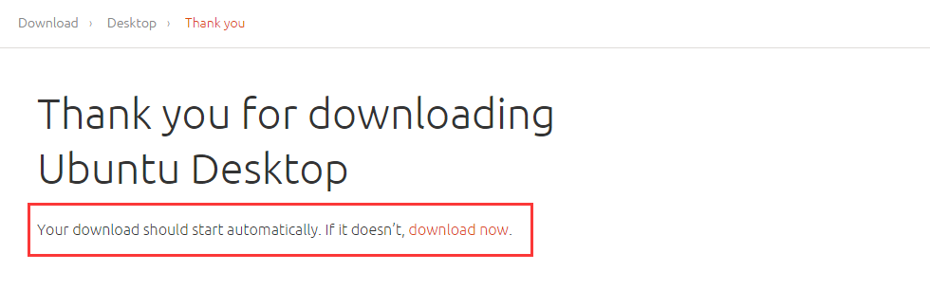](http://images2015.cnblogs.com/blog/897393/201603/897393-20160307102815804-957302348.png)

[f96ac837-7c39-448e-a83e-88a9d2a5547b](http://images2015.cnblogs.com/blog/897393/201603/897393-20160307102816413-570182479.png)

1. 创建虚拟机

[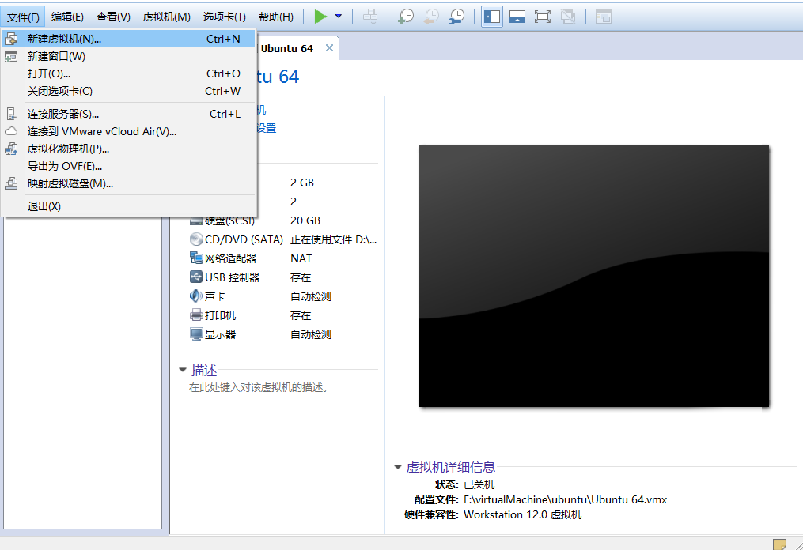](http://images2015.cnblogs.com/blog/897393/201603/897393-20160307102817007-93355484.png)

[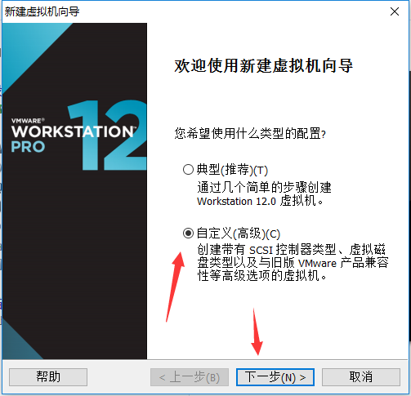](http://images2015.cnblogs.com/blog/897393/201603/897393-20160307102818382-638221668.png)

选择  自定义  然后下一步

[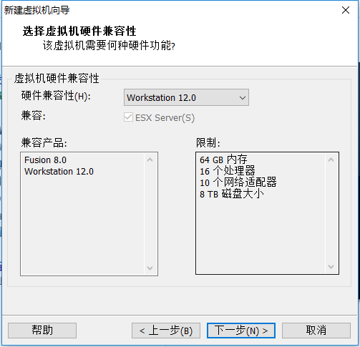](http://images2015.cnblogs.com/blog/897393/201603/897393-20160307102819272-23135680.png)

直接下一步

[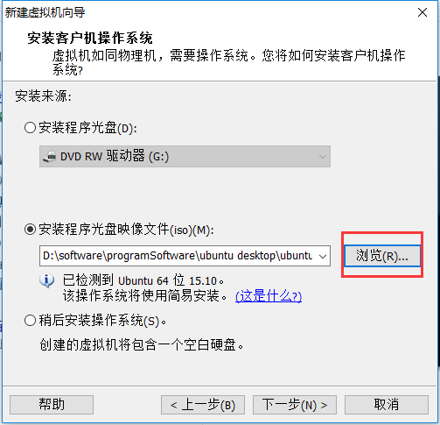](http://images2015.cnblogs.com/blog/897393/201603/897393-20160307102820007-1412176524.png)

浏览到自己的下载位置，选中

然后选择下一步

[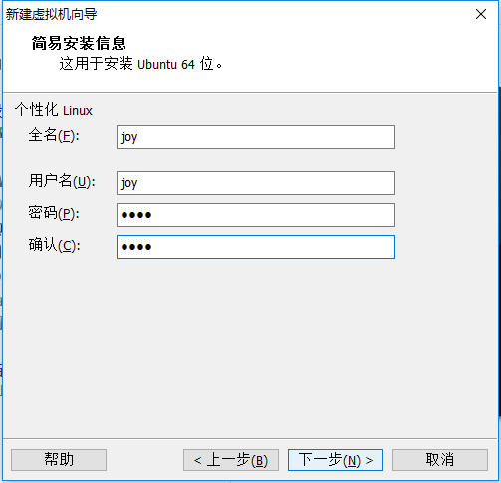](http://images2015.cnblogs.com/blog/897393/201603/897393-20160307102820585-1360861284.png)

[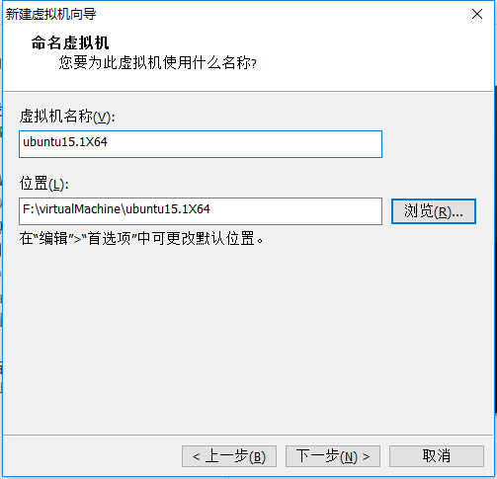](http://images2015.cnblogs.com/blog/897393/201603/897393-20160307102821257-1036847777.png)

设置好名字，选择好文件位置

点击下一步

[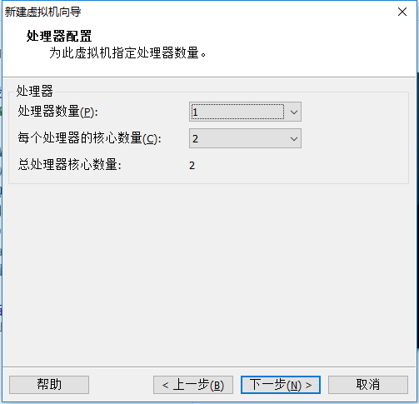](http://images2015.cnblogs.com/blog/897393/201603/897393-20160307102821929-1510705738.png)

这一步一般这样子就可以了，也可以默认的1  1  一般都可以跑起来具体的看自身电脑的配置

下一步

[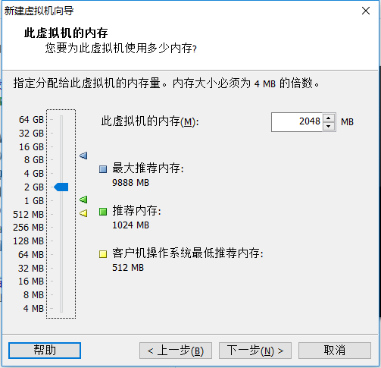](http://images2015.cnblogs.com/blog/897393/201603/897393-20160307102822663-739517366.png)

使用推荐的内存容量即可

下一步

[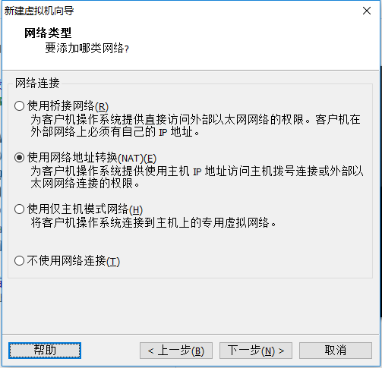](http://images2015.cnblogs.com/blog/897393/201603/897393-20160307102823225-2007770018.png)

这个类型 后续也可以修改

下一步

[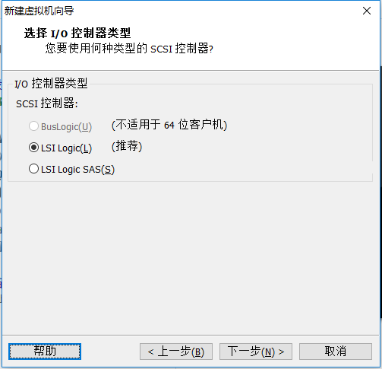](http://images2015.cnblogs.com/blog/897393/201603/897393-20160307102823772-1512650567.png)

使用默认

下一步

[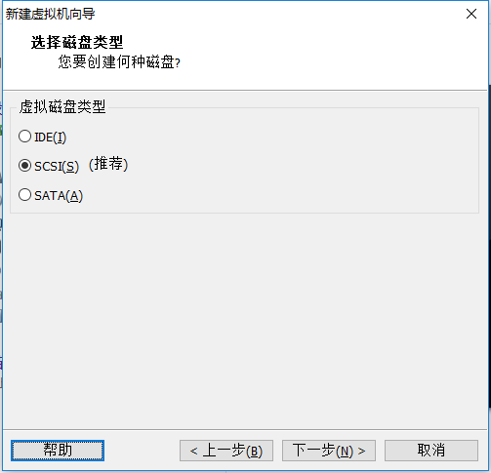](http://images2015.cnblogs.com/blog/897393/201603/897393-20160307102824366-1173664282.png)

默认

下一步

[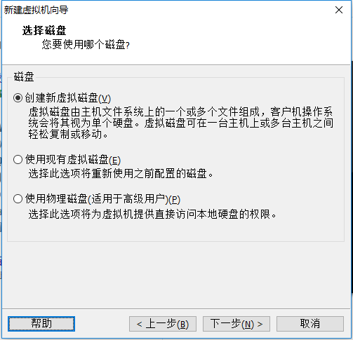](http://images2015.cnblogs.com/blog/897393/201603/897393-20160307102825054-66182995.png)

默认

下一步

[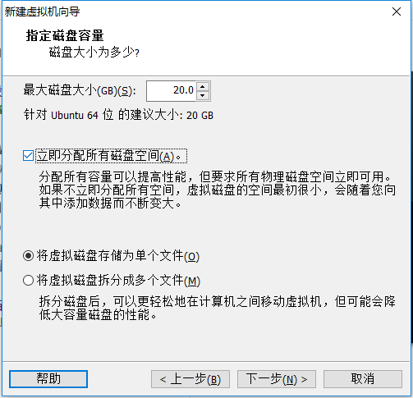](http://images2015.cnblogs.com/blog/897393/201603/897393-20160307102825741-1114800202.png)

建议立即分配、单个文件

设置之后，点“下一步”

[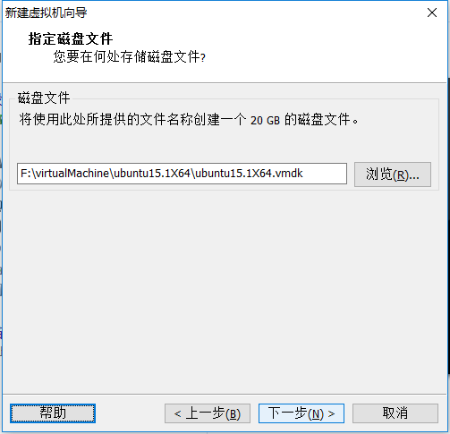](http://images2015.cnblogs.com/blog/897393/201603/897393-20160307102826491-691737380.png)

设置好位置

下一步

[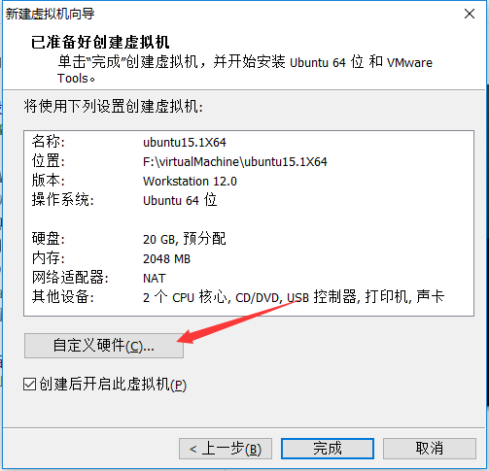](http://images2015.cnblogs.com/blog/897393/201603/897393-20160307102827272-1076081347.png)

可以自定义硬件

可以把不需要的去掉

[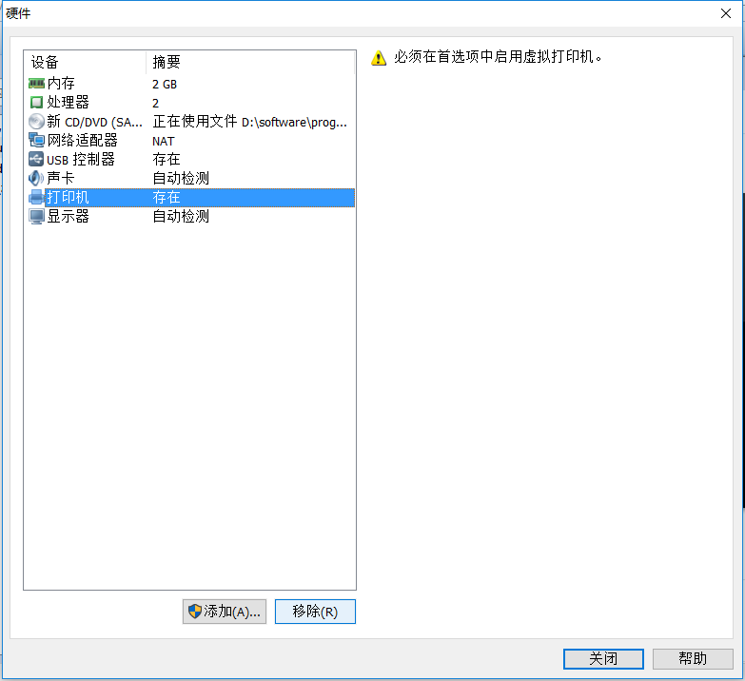](http://images2015.cnblogs.com/blog/897393/201603/897393-20160307102827897-2011733260.png)

[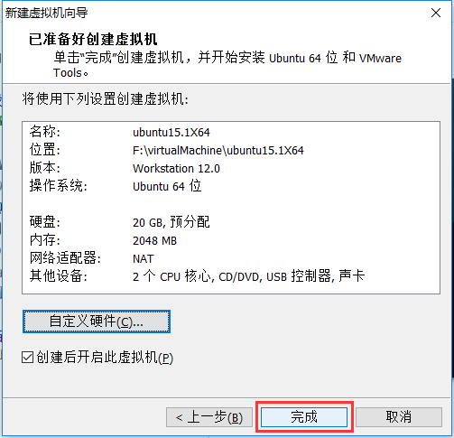](http://images2015.cnblogs.com/blog/897393/201603/897393-20160307102828507-1569789648.png)

[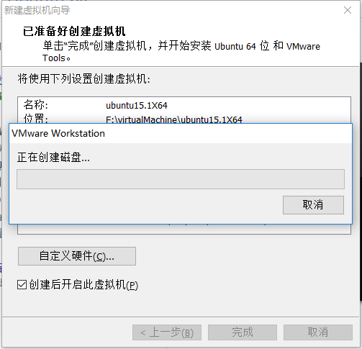](http://images2015.cnblogs.com/blog/897393/201603/897393-20160307102829085-781414597.png)

[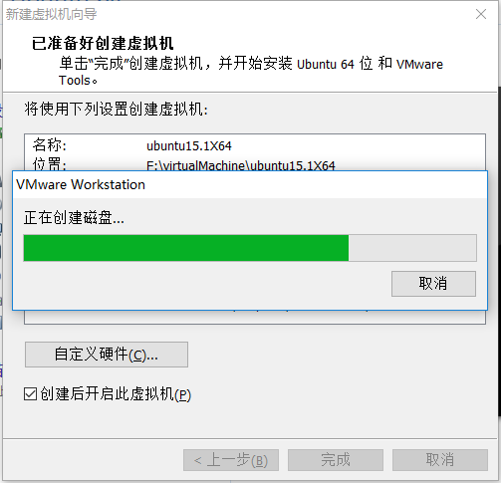](http://images2015.cnblogs.com/blog/897393/201603/897393-20160307102829647-1568132572.png)

[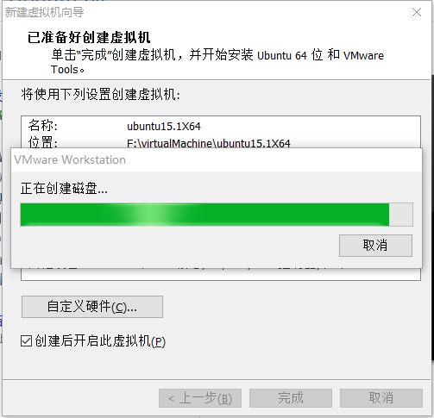](http://images2015.cnblogs.com/blog/897393/201603/897393-20160307102830210-85400948.png)

创建完成后，虚拟机自动启动，读取之前添加的光盘镜像，开始安装Ubuntu操作系统

[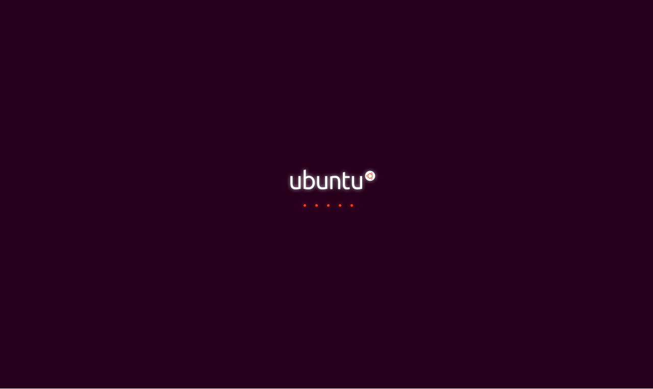](http://images2015.cnblogs.com/blog/897393/201603/897393-20160307102831788-315369113.png)

[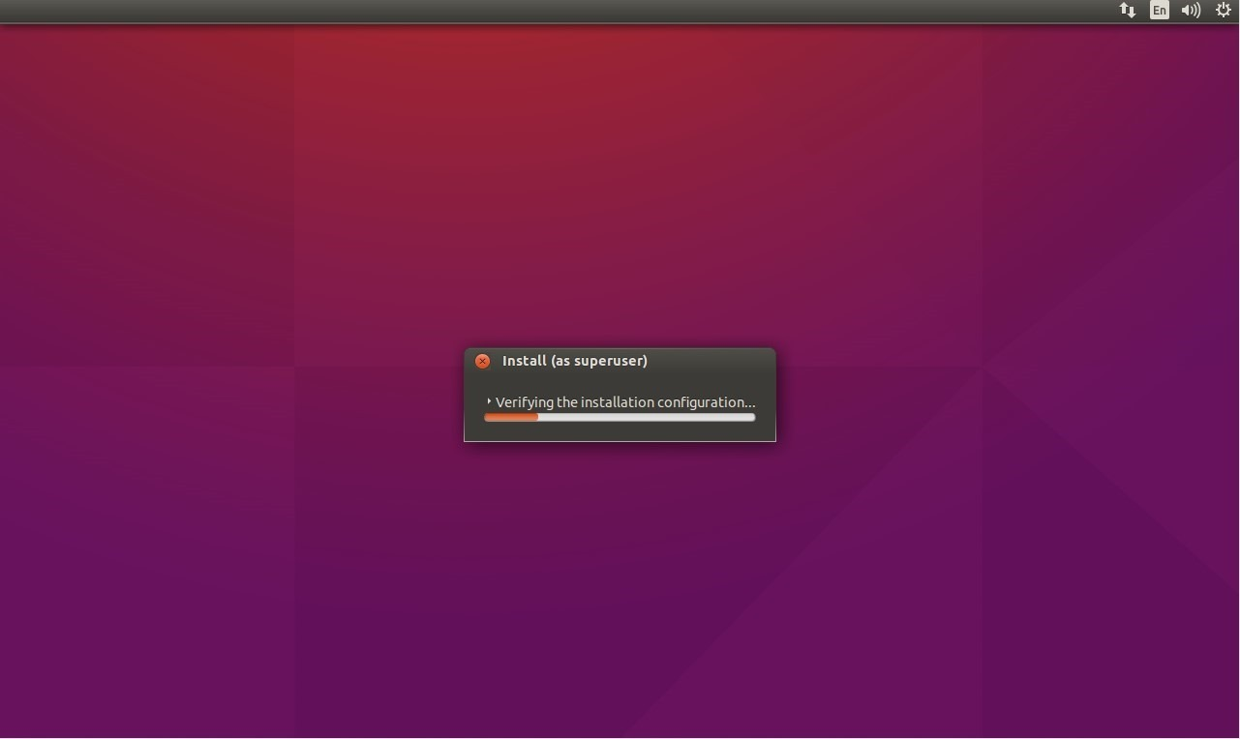](http://images2015.cnblogs.com/blog/897393/201603/897393-20160307102832429-521074968.jpg)

[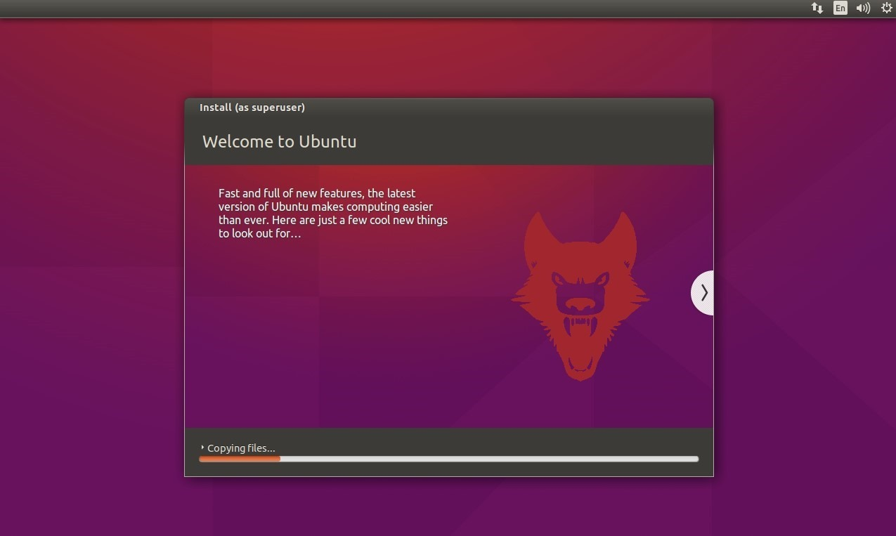](http://images2015.cnblogs.com/blog/897393/201603/897393-20160307102833069-341244529.jpg)

[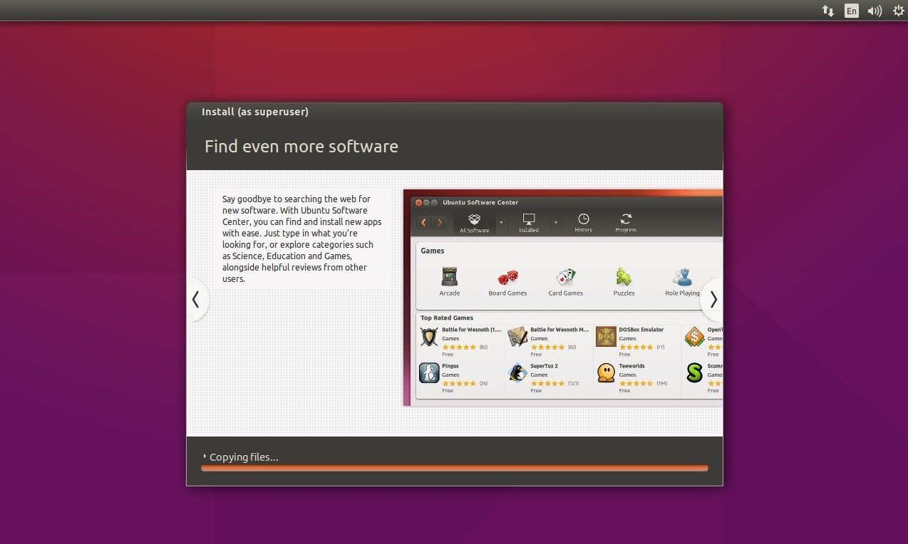](http://images2015.cnblogs.com/blog/897393/201603/897393-20160307102833835-812582458.jpg)

[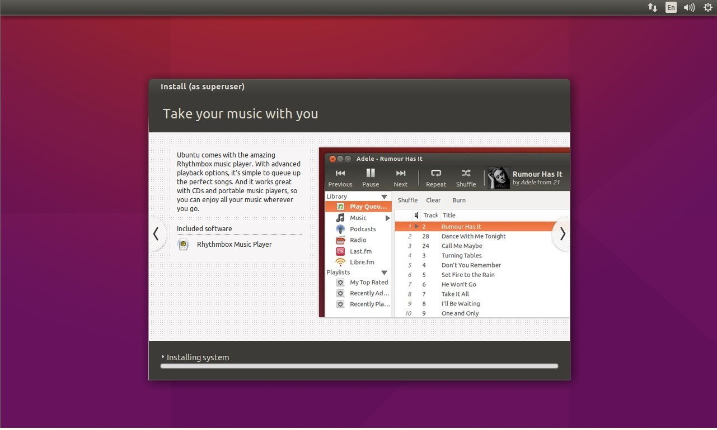](http://images2015.cnblogs.com/blog/897393/201603/897393-20160307102834975-247872721.jpg)

此时已经安装好了，输入密码进入桌面

ps:如果网络不好，上面有的过程可能需要下载很久，你可以把网络断掉，终止掉下载过程，等进入系统以后再重新更新软件

[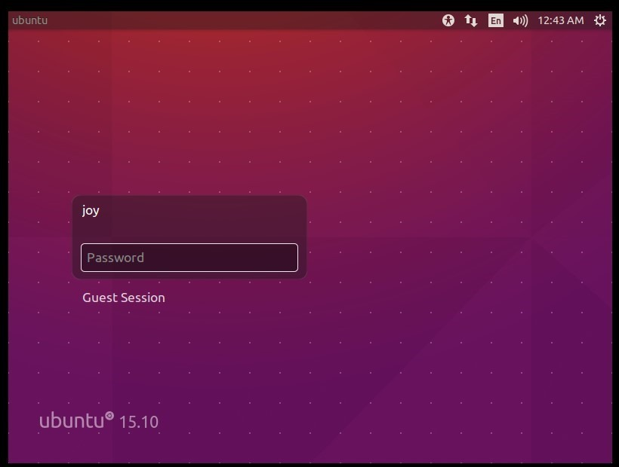](http://images2015.cnblogs.com/blog/897393/201603/897393-20160307102836116-965354174.jpg)

设置Ubuntu系统的语言为中文

[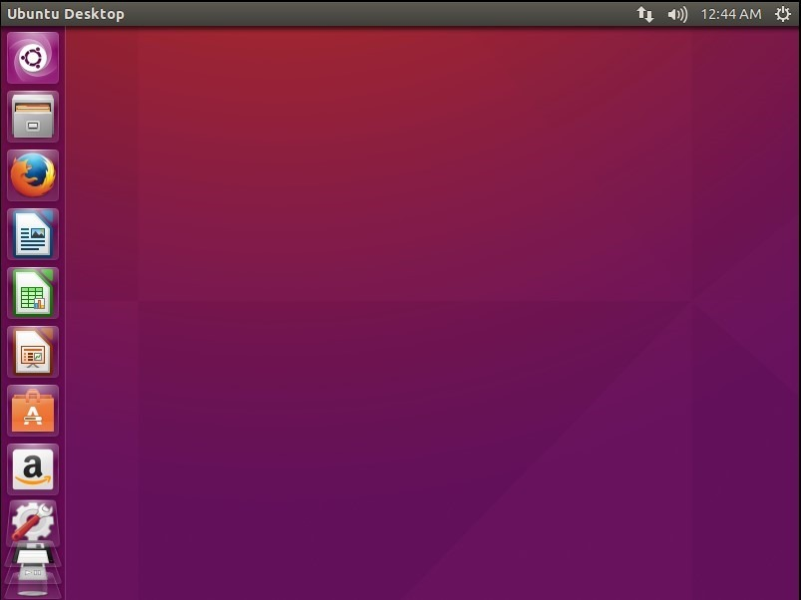](http://images2015.cnblogs.com/blog/897393/201603/897393-20160307102836804-709449132.jpg)

[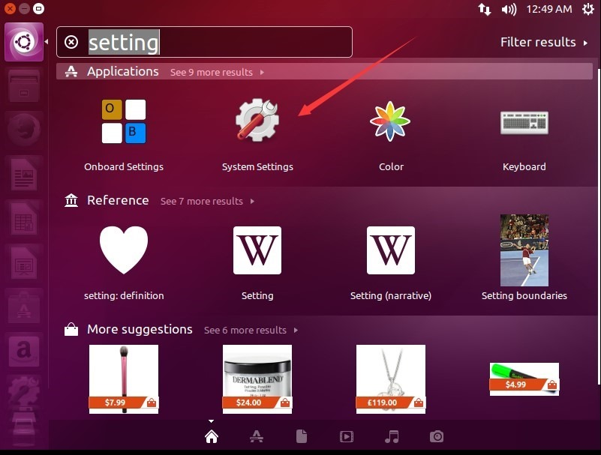](http://images2015.cnblogs.com/blog/897393/201603/897393-20160307102837522-521328045.jpg)

[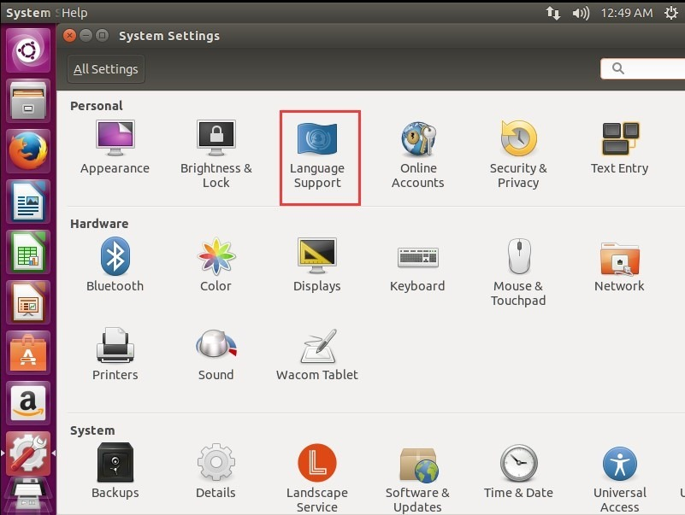](http://images2015.cnblogs.com/blog/897393/201603/897393-20160307102838507-1131119709.jpg)

[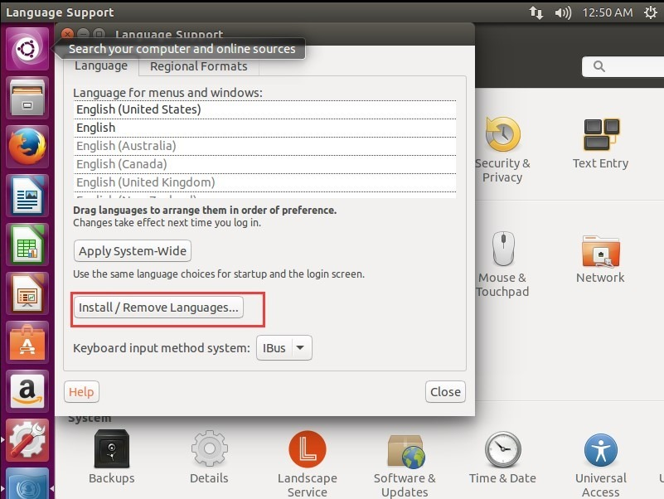](http://images2015.cnblogs.com/blog/897393/201603/897393-20160307102839429-478852464.jpg)

[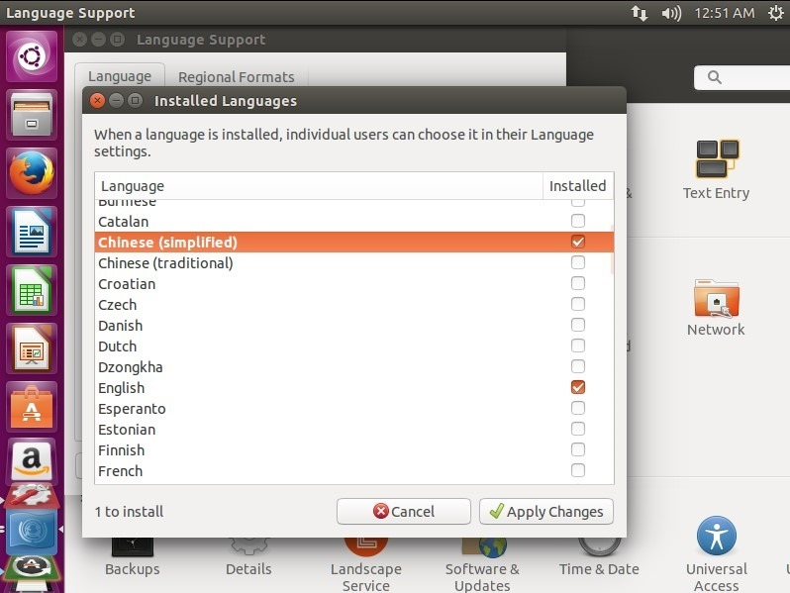](http://images2015.cnblogs.com/blog/897393/201603/897393-20160307102840632-726132217.jpg)

[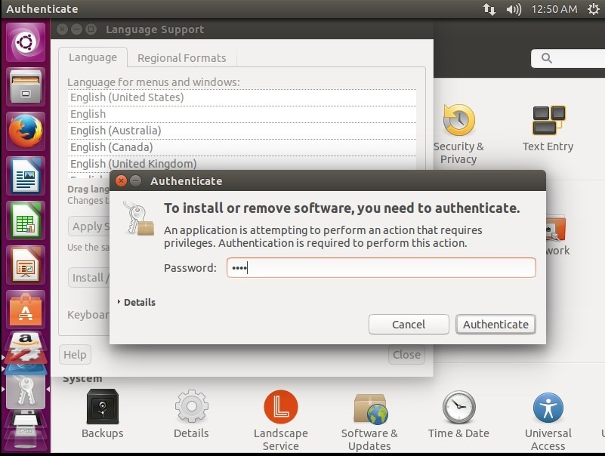](http://images2015.cnblogs.com/blog/897393/201603/897393-20160307102841413-287372324.jpg)

[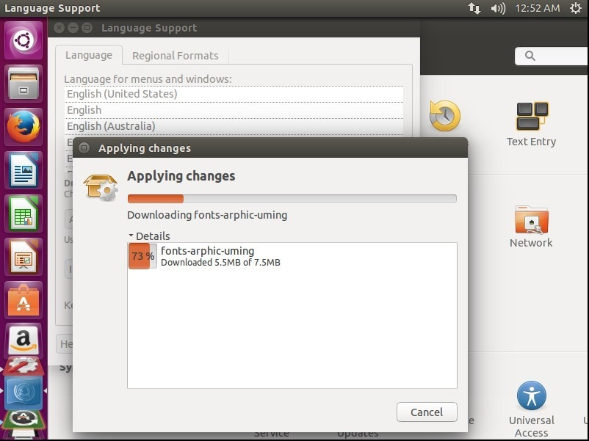](http://images2015.cnblogs.com/blog/897393/201603/897393-20160307102842304-1276951113.jpg)

[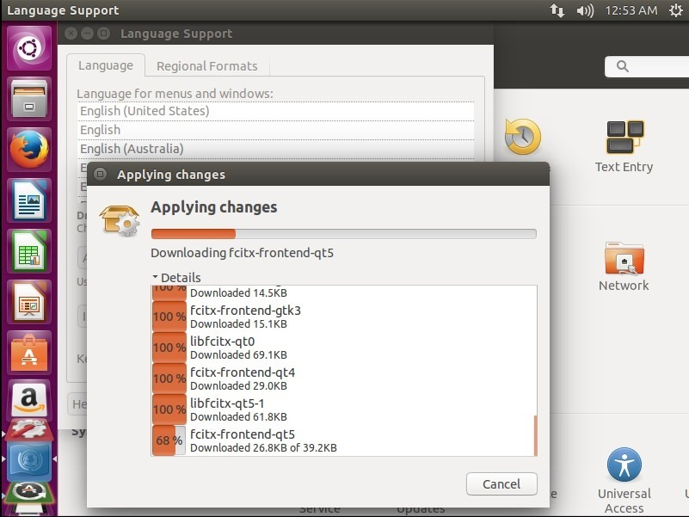](http://images2015.cnblogs.com/blog/897393/201603/897393-20160307102843444-269845949.jpg)

如何更改软件源

[7449e3fd-1afe-4e8c-aecd-01791f2e3d31](http://images2015.cnblogs.com/blog/897393/201603/897393-20160307102844397-1136559610.jpg)

[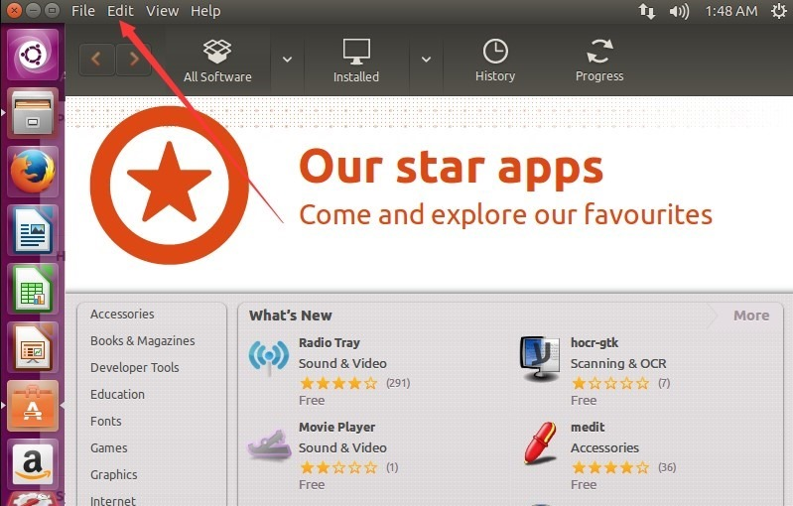](http://images2015.cnblogs.com/blog/897393/201603/897393-20160307102845116-591846272.jpg)

选择

software source

这个就是软件的下载源，选一个中国的，不行就在挨个的试试看，总有一个适合你!

[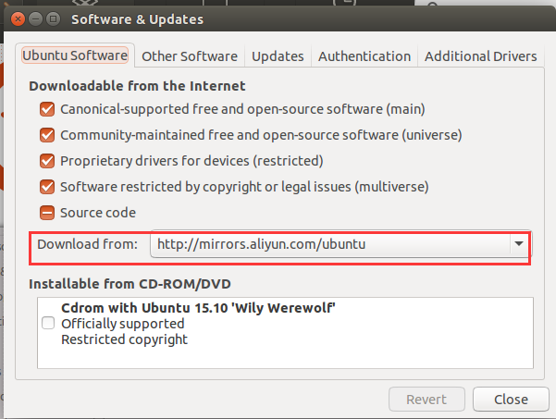](http://images2015.cnblogs.com/blog/897393/201603/897393-20160307102846210-541761901.png)

更改显示的分辨率

[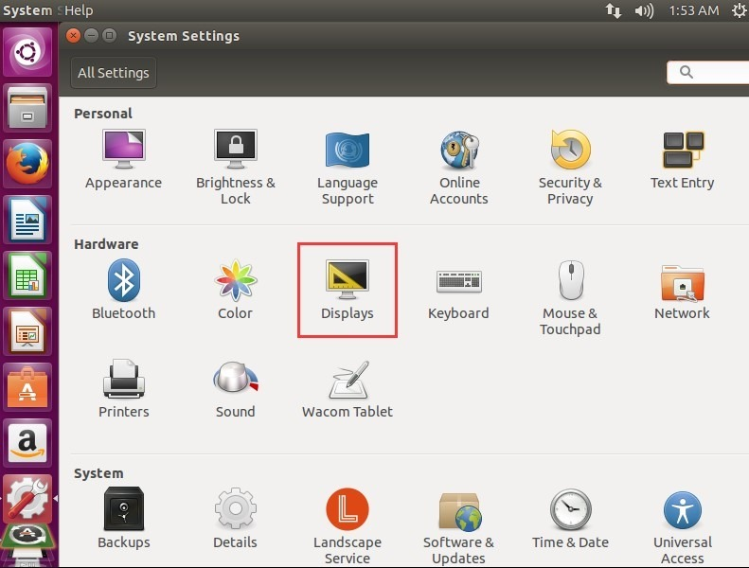](http://images2015.cnblogs.com/blog/897393/201603/897393-20160307102847038-207637965.jpg)