  - PROJECT 2

Structural vs. Behavioral ALU & Arithmetic Architecture Suite
Computer Architecture and Organization | Software-only Verilog project
Student: [Name] ID: [Student ID]
Section / instructor: [Course details]
Evidence generated: 2026-10-30

Objective and outcome
Implement the same arithmetic architecture using gate-level structural modeling and behavioral RTL, verify both against independent expectations, and compare their synthesized implementations under identical conditions.
The 8-bit suite passes all 524,288 operand/operation combinations. Smaller-width exhaustive tests, 16-bit boundary/random tests, decoder vectors, and a 37-step register/MUX/memory demonstration also pass. Both generic synthesized ALUs pass directed netlist tests.
Evidence | Saved outcome
8-bit ALU | 524,288 vectors; zero failures
Decoder | 4,224 vectors; zero failures
Integration demo | 37 steps; final registers/memory and reset checked
Generic cells | Structural 352; behavioral 309 (Yosys no-ABC flow)
Vivado FPGA timing/resources | Pending execution on a Vivado installation
The original CAO-PROJECT-2026.docx defines the project and shared 100-point rubric. The additional decoder and bus demonstration provides evidence for rubric items beyond the isolated ALU comparison.

1. Architecture and module hierarchy
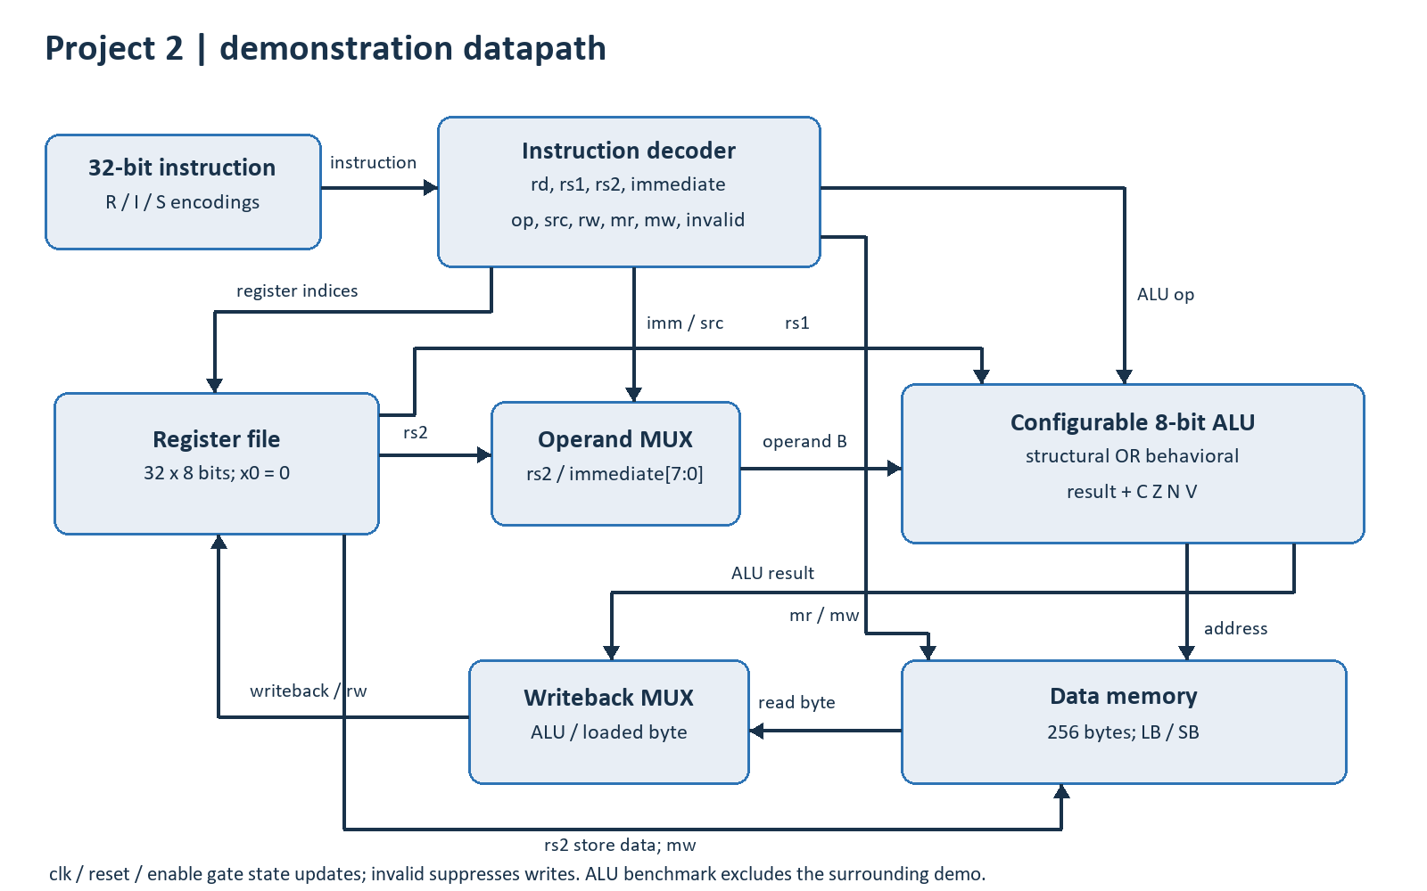
Figure 1. Decoder, registers, MUXes, configurable ALU and byte memory. Flags use CZNV order.
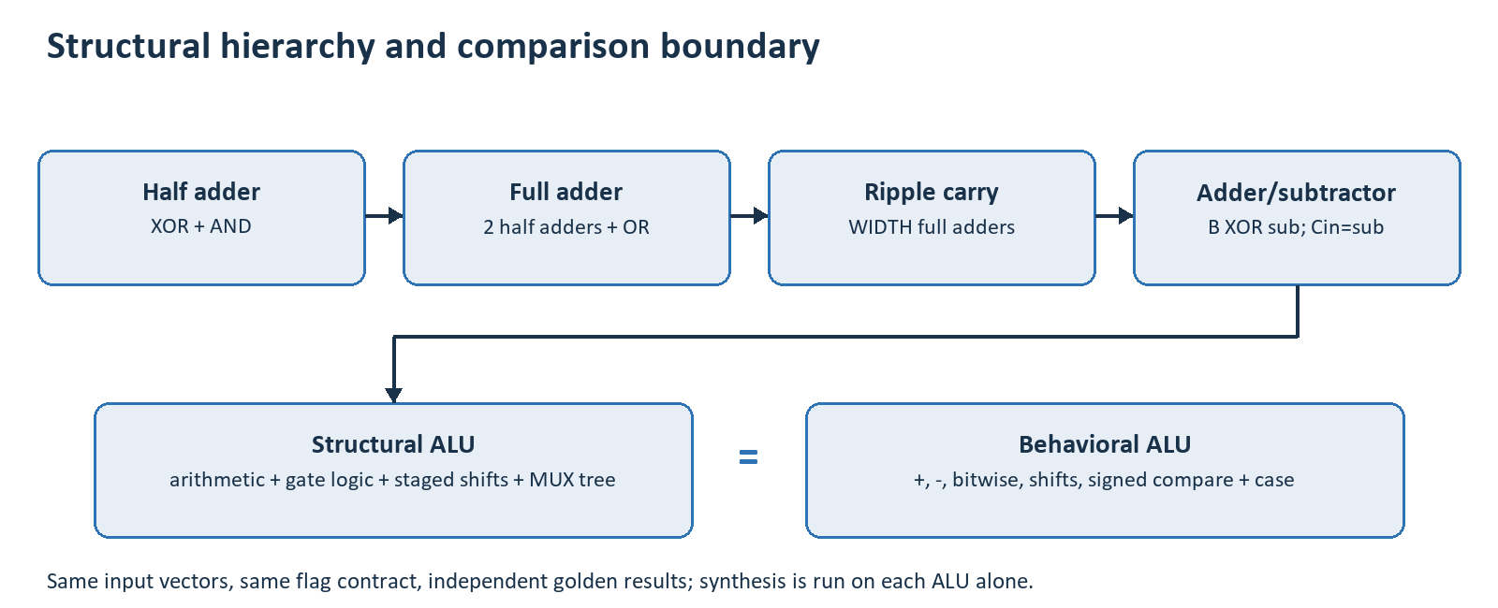
Figure 2. Structural arithmetic hierarchy and the equal-interface behavioral implementation.
Structural full adders contain two half adders and an OR gate. A WIDTH-stage carry chain adds A and B XOR sub, with sub as the initial carry. Carry into and out of the sign bit are XORed to detect signed overflow. Logic operations use gates; logical shifts use fixed shift stages selected by gate MUXes. Behavioral RTL uses complete combinational blocks and standard operators.

2. Interface and arithmetic semantics
Both ALUs accept a[WIDTH-1:0], b[WIDTH-1:0] and op[2:0], and produce result[WIDTH-1:0], carry, zero, negative and overflow. The wrapper parameter STRUCTURAL chooses the implementation at elaboration. WIDTH defaults to 8; supported widths are powers of two of at least 2, verified at 4, 8 and 16 bits.
op | Operation | Result / interpretation
0 | ADD | A + B, modulo 2^WIDTH
1 | SUB | A - B, modulo 2^WIDTH
2 | AND | Bitwise conjunction
3 | OR | Bitwise disjunction
4 | XOR | Bitwise exclusive OR
5 | SLL | Zero-fill left shift; discard high bits
6 | SRL | Zero-fill right shift
7 | SLT | Signed two's-complement comparison; result 0 or 1

Status flags
Flag | Definition
C | ADD: unsigned carry-out. SUB: 1 when A >= B (no borrow). Other operations: 0.
Z | 1 exactly when the result is zero, for every operation.
N | Most significant result bit, for every operation.
V | Signed overflow for ADD/SUB; cleared for logic, shifts and SLT.
The shift amount is the low log2(WIDTH) bits of B. For the 8-bit ALU, a shift operand of 8 selects a shift of zero. The demonstration uses this same rule, including shift-immediate instructions. Flags describe the ALU result; they are combinational outputs rather than saved processor status.
Calculation | Result | CZNV | Reason
FF + 01 | 00 | 1100 | Unsigned carry and zero
7F + 01 | 80 | 0011 | Signed positive overflow
05 - 0A | FB | 0010 | Negative result with borrow
0A - 0A | 00 | 1100 | Zero; no borrow

3. Decoder and demonstration execution
A small execution harness supplies evidence for the shared decoder and MUX rubric. It accepts a 32-bit instruction from the testbench, reads two 8-bit registers, selects register/immediate operand B, computes the ALU output and commits writes on an enabled rising edge. There are 32 registers and 256 data-memory bytes; x0 remains zero.
Encoding family | Supported instructions
R-type | ADD, SUB, AND, OR, XOR, SLL, SRL, SLT
I-type arithmetic | ADDI, ANDI, ORI, XORI, SLLI, SRLI, SLTI
I-type load | LB
S-type store | SB
The decoder extracts rd, rs1, rs2, funct3 and funct7 and validates opcode/function combinations. I/S immediates are sign-extended to 32 bits, then narrowed at the operand MUX. Byte addresses wrap modulo 256. LB writes its eight-bit byte unchanged into the eight-bit register file. These are educational datapath semantics using RISC-V encodings, not a complete RV32 implementation.
Unsupported instructions assert invalid and clear all write controls. enable=0 blocks commits without changing the combinational decode. Synchronous reset clears registers and memory and overrides enable. Nonblocking assignments are used for state; complete combinational assignments prevent latches.

Scope of the demonstration
The testbench supplies instructions directly. There is no program counter, instruction fetch, branching, pipeline, RV32 compliance claim or physical board interface. Each valid enabled instruction commits on one edge. This edge count is a property of the demonstration harness, not a performance comparison between the ALUs.
The file-driven program deliberately covers carry, signed overflow, borrowing, logic zeros, both shifts, signed comparisons, memory writes/reads, negative offsets, truncation, x0 writes, illegal instructions and disabled register/memory writes. Final state is compared against independently generated software expectations.

4. Automated verification and saved results
Tool: Icarus Verilog version 12.0 (devel) (s20150603-1539-g2693dd32b). Testbench-only assertion extensions are compiled with -g2012; the datapath sources remain synthesizable Verilog. Every run produces a process exit status, logs and source SHA-256 hashes in verification_summary.json.
Test | Coverage | Result | Runtime (s)
tb_units | 16 truth-table checks | PASS | 0.0121
tb_alu_4 | 2,048 exhaustive vectors | PASS | 0.098
tb_alu_8 | 524,288 exhaustive vectors | PASS | 48.8928
tb_alu_16 | 16,896 boundary/random vectors | PASS | 15.2138
tb_decoder | 4,224 file vectors | PASS | 0.0509
tb_top | 37 instructions + final-state/reset checks | PASS | 0.065
For widths 4 and 8, all A/B pairs are checked for all eight operations. ADD/SUB also check both standalone adder/subtractor modules. The reference converts operands to signed integers and checks signed mathematical range for overflow; it does not copy DUT carry-chain equations. Sixteen-bit testing uses an 8-by-8 boundary grid and 2,048 seeded random pairs per operation.
The decoder suite traverses all funct7/funct3 combinations in four opcode families plus all opcode values. Integration uses external .mem expectations generated by Python. Case-inequality comparisons detect unknown/high-impedance outputs as mismatches. The suite checks all 32 final register bytes and 256 final memory bytes in both styles, then checks reset clears them.
Console logging uses $display; mismatches issue $error and/or $fatal and stop the failing run. The Python runner returns a nonzero status if compilation or verification fails. External vectors use $readmemh. Exhaustive tests avoid dumping large waveforms; the directed integration run saves demo.vcd.
Runtime is measured software simulation wall time on this machine. The 8-bit ALU run advances 524,288 ns using a 1 ns testbench settle interval. This is an artificial test schedule, not a measured circuit propagation delay or hardware cycle count.

5. Annotated waveform evidence
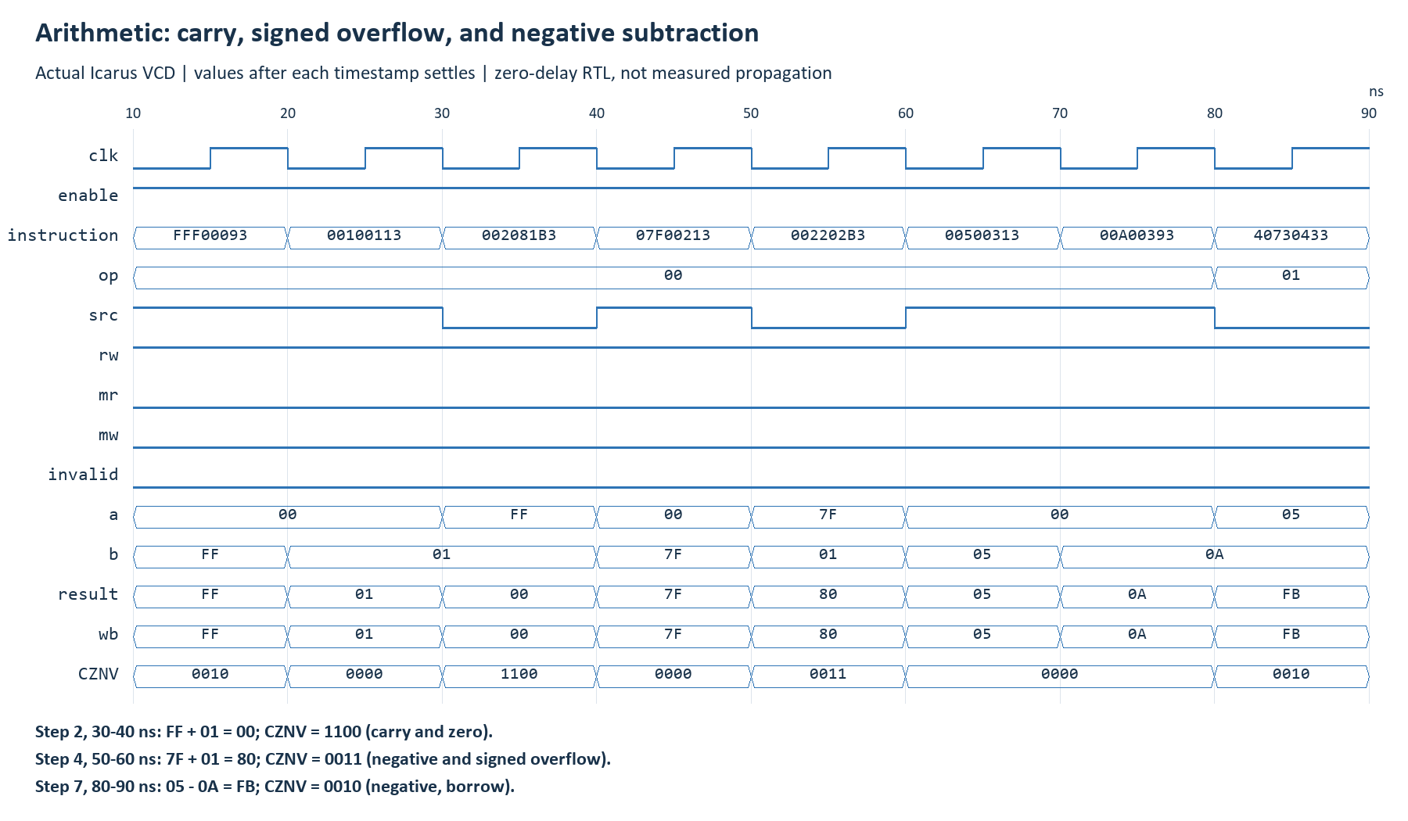
Figure 3. Arithmetic transitions from the saved VCD, annotated with carry, signed overflow and negative-result examples.
These captures are generated from actual VCD signal changes and show settled values at each timestamp. The capture highlights the document's carry/zero and negative-result examples, plus signed overflow. Testbench time intervals are chosen for readability and do not model physical propagation delay.

5. Waveform evidence: memory and control
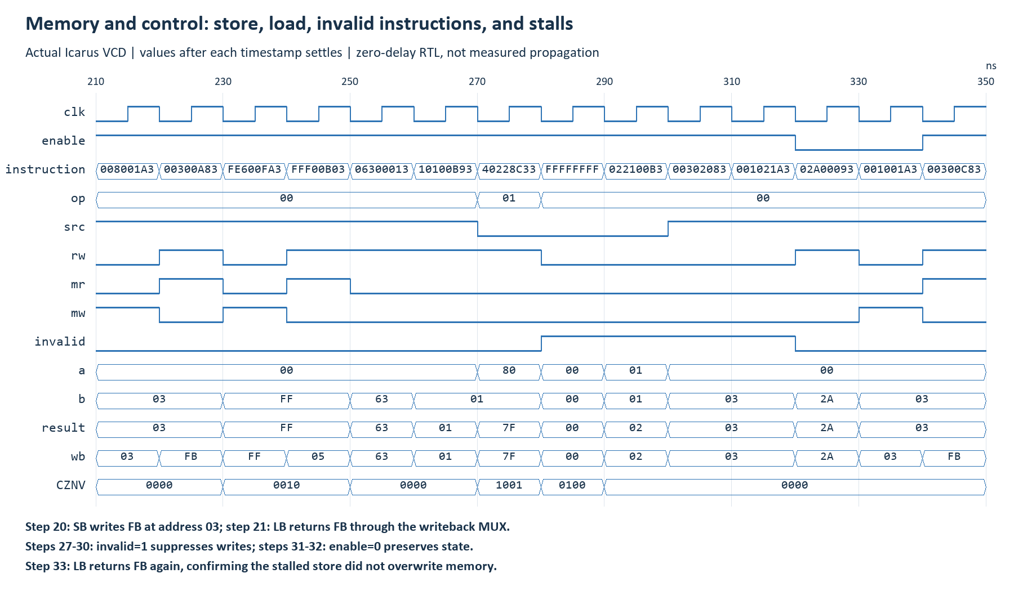
Figure 4. Actual bus/control traces around stores, loads, invalid instructions and stalls. Short bus intervals may omit labels; the CSV contains exact values.
These captures are generated from VCD signal changes, collapsed to the settled value at each timestamp. They visualize functional activity and contain no physical gate-delay model. Open docs/demo.gtkw in GTKWave for the full interactive trace. Trace rows are sampled before the committing edge, after the input settle interval.

6. Execution trace (1/2)
# | Instruction / scenario | A | B | Y | WB | CZNV
0 | ADDI x1,x0,-1 | 00 | ff | ff | ff | 0010
1 | ADDI x2,x0,1 | 00 | 01 | 01 | 01 | 0000
2 | ADD x3,x1,x2 carry/zero | ff | 01 | 00 | 00 | 1100
3 | ADDI x4,x0,127 | 00 | 7f | 7f | 7f | 0000
4 | ADD x5,x4,x2 overflow | 7f | 01 | 80 | 80 | 0011
5 | ADDI x6,x0,5 | 00 | 05 | 05 | 05 | 0000
6 | ADDI x7,x0,10 | 00 | 0a | 0a | 0a | 0000
7 | SUB x8,x6,x7 negative/borrow | 05 | 0a | fb | fb | 0010
8 | AND x9,x1,x6 | ff | 05 | 05 | 05 | 0000
9 | OR x10,x6,x7 | 05 | 0a | 0f | 0f | 0000
10 | XOR x11,x6,x6 zero | 05 | 05 | 00 | 00 | 0100
11 | SLL x12,x2,x6 | 01 | 05 | 20 | 20 | 0000
12 | SRL x13,x5,x2 | 80 | 01 | 40 | 40 | 0000
13 | SLT x14,x5,x4 | 80 | 7f | 01 | 01 | 0000
14 | ANDI x15,x1,0 zero | ff | 00 | 00 | 00 | 0100
15 | ORI x16,x0,85 | 00 | 55 | 55 | 55 | 0000
16 | XORI x17,x16,85 zero | 55 | 55 | 00 | 00 | 0100
17 | SLLI x18,x2,7 | 01 | 07 | 80 | 80 | 0010
18 | SRLI x19,x18,7 | 80 | 07 | 01 | 01 | 0000
All values in A/B/Y/WB are hexadecimal. CZNV is binary. Y is the ALU result and WB is the selected writeback bus; WB does not imply that a register write is enabled. Stores use the ALU output as an address. Unsupported or stalled rows do not commit state changes.
Source: results/execution_trace.csv is emitted by the actual Verilog simulation. Assembly descriptions are joined from vectors/program_listing.json, generated by the independent software model. The complete CSV additionally records time, instruction encoding, register indices, immediate, ALU selection and write controls.

6. Execution trace (2/2)
# | Instruction / scenario | A | B | Y | WB | CZNV
19 | SLTI x20,x8,0 | fb | 00 | 01 | 01 | 0000
20 | SB x8,3(x0) | 00 | 03 | 03 | 03 | 0000
21 | LB x21,3(x0) | 00 | 03 | 03 | fb | 0000
22 | SB x6,-1(x0) wrap address | 00 | ff | ff | ff | 0010
23 | LB x22,-1(x0) | 00 | ff | ff | 05 | 0010
24 | ADDI x0,x0,99 immutable x0 | 00 | 63 | 63 | 63 | 0000
25 | ADDI x23,x0,257 truncate immediate | 00 | 01 | 01 | 01 | 0000
26 | SUB x24,x5,x2 signed overflow | 80 | 01 | 7f | 7f | 1001
27 | invalid opcode | 00 | 00 | 00 | 00 | 0100
28 | invalid R funct7 | 01 | 01 | 02 | 02 | 0000
29 | invalid load width | 00 | 03 | 03 | 03 | 0000
30 | invalid store width | 00 | 03 | 03 | 03 | 0000
31 | stall ADDI x1,x0,42 | 00 | 2a | 2a | 2a | 0000
32 | stall SB x1,3(x0) | 00 | 03 | 03 | 03 | 0000
33 | LB x25,3(x0) verify stalled store | 00 | 03 | 03 | fb | 0000
34 | SLL zero result | 80 | 01 | 00 | 00 | 0100
35 | SRL zero result | 01 | 01 | 00 | 00 | 0100
36 | SUB zero/no borrow | 0a | 0a | 00 | 00 | 1100
All values in A/B/Y/WB are hexadecimal. CZNV is binary. Y is the ALU result and WB is the selected writeback bus; WB does not imply that a register write is enabled. Stores use the ALU output as an address. Unsupported or stalled rows do not commit state changes.
Source: results/execution_trace.csv is emitted by the actual Verilog simulation. Assembly descriptions are joined from vectors/program_listing.json, generated by the independent software model. The complete CSV additionally records time, instruction encoding, register indices, immediate, ALU selection and write controls.

7. Synthesis comparison and timing method
The saved generic comparison uses identical flattened Yosys synthesis with synth -noabc. This maps operations to generic Boolean cells before ABC optimization. It checks connectivity, rejects inferred latches and produces a functional netlist for each ALU. Both netlists pass 24 directed vectors using Icarus.
Implementation | Generic cells | Netlist test
structural | 352 | PASS
behavioral | 309 | PASS
In this flow the behavioral implementation uses 43 fewer generic logic cells, about 12.2% fewer than the structural result. Hierarchy metadata ($scopeinfo) is excluded. This is a measured outcome for the chosen tool and settings, not a claim of minimum gate count or universally better hardware. Generic cell primitives have different functions and fan-in; they are not standardized NAND-equivalent area units.
Behavioral operators expose arithmetic/comparison intent to synthesis. The structural circuit explicitly expresses a ripple chain, a signed comparison using subtract/overflow, and a MUX network; synthesis can still simplify this hierarchy. Technology mapping and optimization can change either result substantially.

Vivado method and current status
Vivado was unavailable for execution. The supplied Tcl flow targets Artix-7 xc7a35tcpg236-1 by default, synthesizes each ALU independently out of context, and applies the same 10 ns maximum input-to-output delay constraint. It reports synthesis resources, routes internal logic and exports utilization, critical-path timing, checkpoints, functional/timing netlists and SDF. No board IO buffers are included.
The flow also runs XSim post-synthesis functional tests using vendor primitive libraries. SDF export prepares optional timing simulation; it does not prove that timing simulation has been executed. Routed static timing will supply the device-specific propagation comparison. Existing generic counts must not be copied into FPGA LUT/CARRY4 columns.
The ALUs are combinational: an execution-cycle speedup is not defined here. Test-vector count, simulated time and wall runtime are reported separately. A timing-aware comparison requires the same target, constraints, tool version and optimization settings for both implementations.

8. Rubric coverage and reproduction
Category | Points | Evidence
Functional correctness | 40 | Exhaustive ALU/add-sub results and flags; R/I/S decoder; register/MUX/memory integration
Automated verification | 20 | Self-checking tb_top, .mem vectors, structured loops, independent expectations, failure exit codes
Code quality / synthesis | 20 | Parameterized hierarchy, complete combinational blocks, nonblocking state, Yosys latch/connectivity checks
Simulation / waveforms | 10 | Saved VCD/GTKWave config, annotated arithmetic and bus/control captures
Documentation / diagram | 10 | Architecture diagrams, interface contract, full trace, this report and demo guide

Reproduce the evidence
- Run python scripts/run_tests.py for the full portable suite.
- Optionally run python scripts/run_synthesis.py with Yosys/YoWASP installed for generic netlists and cell counts.
- In Vivado source scripts/create_vivado_project.tcl, then run behavioral simulation with tb_top as the top.
- Run vivado -mode batch -source scripts/vivado_compare.tcl for isolated FPGA measurements and XSim netlist checks.
- Fill in the report identity fields and attach genuine Vivado outputs if the course requires them.

Sources and conclusion
Project authority: CAO-PROJECT-2026.docx, Detailed Project Description 2, Testing Methodology and Project Grading Rubric. Tool references: Icarus installation documentation (github.com/steveicarus/iverilog); AMD UG835 write_sdf and UG900 Generating a Timing Netlist (docs.amd.com). Exact links are in README.md.
Both coding styles satisfy the same tested arithmetic contract. The delivered generic synthesis demonstrates a resource difference under stated settings. FPGA timing and resource conclusions remain pending the supplied Vivado workflow; the functional results and saved generic synthesis evidence have been executed and verified.

