TouhouRPG_Game/

│── assets/ # Game assets (art, sound, animations, etc.)

│ ├── sprites/ # 2D pixel sprites

│ │ ├── characters/ # Character sprites

│ │ ├── enemies/ # Enemy sprites

│ │ ├── bosses/ # Boss sprites

│ │ ├── projectiles/ # Bullet hell patterns

│ │ └── effects/ # Spell effects, explosions, UI

│ ├── ui/ # UI elements (buttons, menus, HUD)

│ ├── music/ # Background music & battle themes

│ ├── sfx/ # Sound effects

│ ├── animations/ # Animated sprite sheets & effects

│ └── backgrounds/ # Level backgrounds

│

│── src/ # Game source code

│ ├── engine/ # Core game engine modifications

│ ├── gameplay/ # Gameplay logic

│ │ ├── player.lua # Player movement & abilities

│ │ ├── enemies.lua # Enemy AI behavior

│ │ ├── bosses.lua # Boss AI & spell card patterns

│ │ ├── projectiles.lua # Bullet patterns & physics

│ │ ├── collision.lua # Collision detection

│ │ ├── ui.lua # UI handling

│ │ ├── inventory.lua # RPG progression & inventory system

│ │ ├── level_manager.lua # Handles level loading & transitions

│ │ └── game_state.lua # Game state & save system

│ ├── config/ # Game configuration files

│ │ ├── settings.lua # Game settings

│ │ ├── keybindings.lua # Controls configuration

│ │ └── difficulty.lua # Balance settings & AI scaling

│ ├── ai/ # AI-generated procedural elements

│ │ ├── spell_patterns.lua # AI-generated boss spell patterns

│ │ ├── level_gen.lua # AI procedural level generation

│ │ ├── balance_ai.lua # AI-assisted difficulty tuning

│ │ ├── playtest_ai.lua # Automated AI playtesting scripts

│ │ └── enemy_ai.lua # AI-driven enemy behavior

│ ├── utils/ # Utility scripts & helpers

│ ├── main.lua # Entry point for the game

│ └── init.lua # Game initialization

│

│── docs/ # Documentation

│ ├── GDD.docx # Game Design Document

│ ├── AI_Dev_Workflow.docx # AI-Driven Development Workflow

│ ├── README.md # Project overview & setup instructions

│ ├── changelog.md # Development log & updates

│ ├── tech_specs.md # Technical requirements & optimizations

│ ├── balance_notes.md # AI-generated balance reports

│ ├── bug_reports.md # Known bugs & fixes

│ └── monetization_plan.md # DLC & microtransaction strategy

│

│── tools/ # AI & development tools

│ ├── level_generator/ # AI procedural level generation scripts

│ ├── sprite_generator/ # AI-generated pixel art scripts

│ ├── ai_playtester/ # AI-assisted playtesting automation

│ ├── sound_generator/ # AI-generated music & sound effects

│ └── marketing/ # AI-generated marketing assets

│

│── test/ # Automated & manual test cases

│ ├── ai_tests/ # AI-generated playtests

│ ├── manual_tests/ # Manual test scenarios

│ ├── balance_tests/ # Balance testing scripts

│ └── bug_tracking/ # Reports & debug logs

│

│── build/ # Compiled & packaged versions of the game

│ ├── debug/ # Debug builds

│ ├── release/ # Final release builds

│ └── steam/ # Steam-ready distribution files

│

│── marketing/ # Steam & promotional content

│ ├── trailers/ # Promotional videos

│ ├── screenshots/ # Screenshots for Steam & marketing

│ ├── social_media/ # Marketing assets for social media

│ ├── store_page/ # Steam description, metadata, and pricing

│ └── press_kit/ # Press-related materials

│

└── .gitignore # Git ignore file (exclude unnecessary files)

Class diagram:

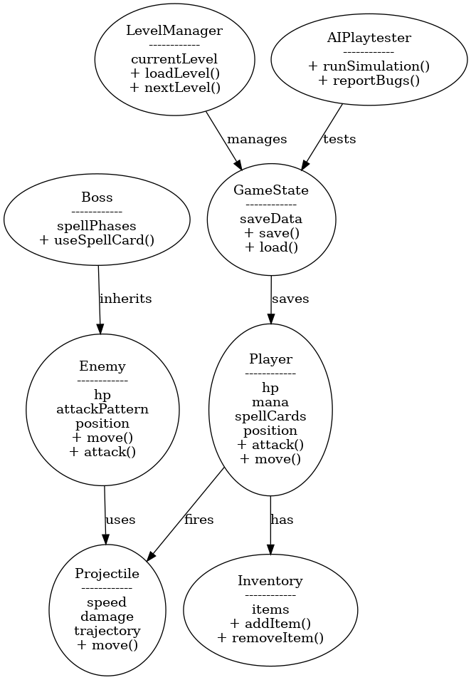

Use Case Diagram:



State Diagram:

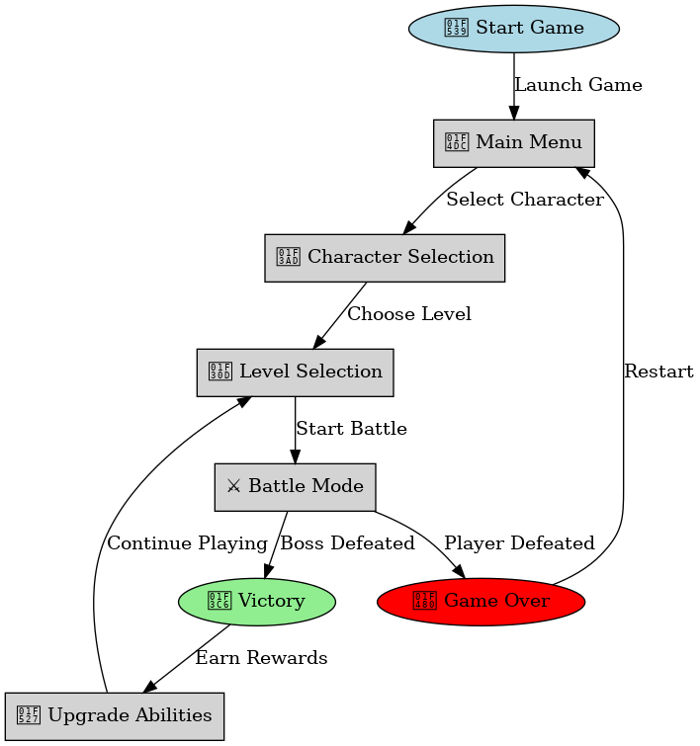

Sequence Diagram for the "Start Game":

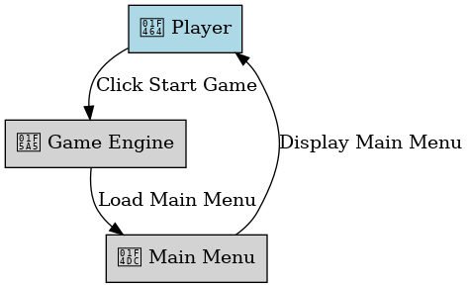

Sequence Diagram for the "Choose Character":

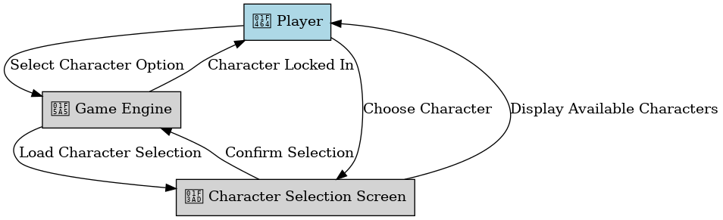

Sequence Diagram for the "Enter Battle":

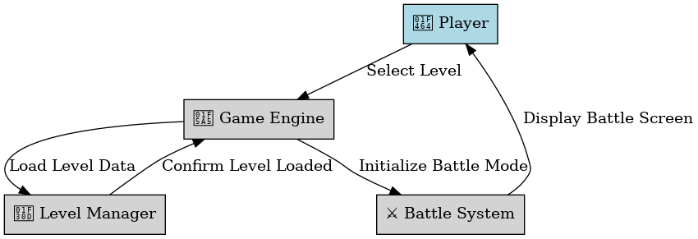

Sequence Diagram for the "Use Spell Card":

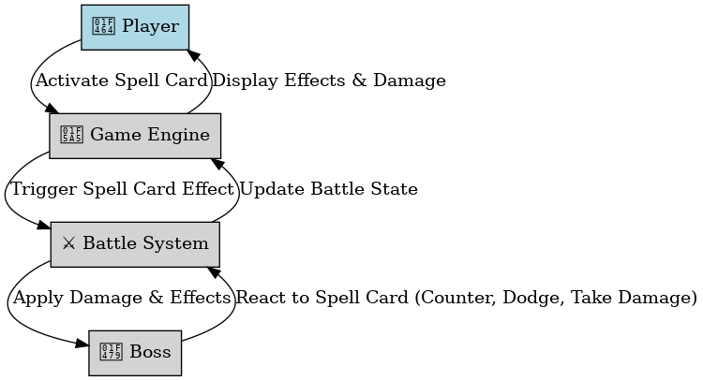

Sequence Diagram for the "Collect Power-Up":

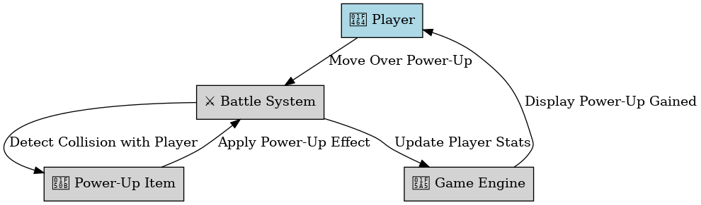

Sequence Diagram for the "Upgrade Abilities":

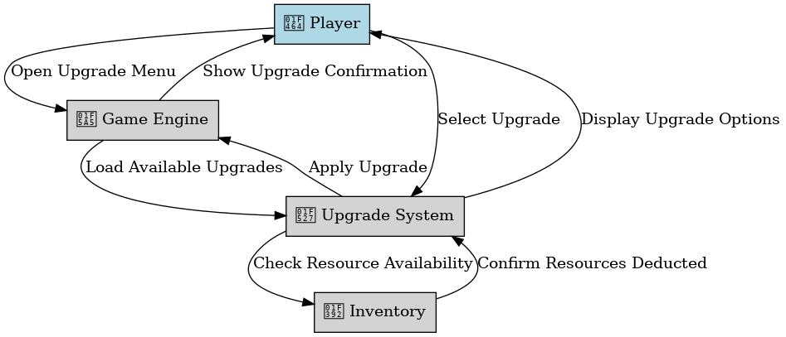

Sequence Diagram for the "Save Progress":

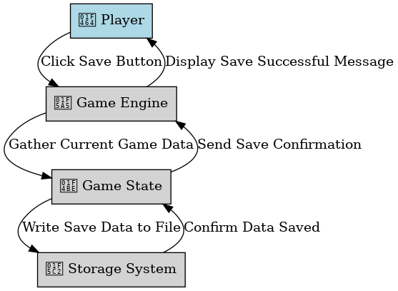

Sequence Diagram for the "Load Progress":

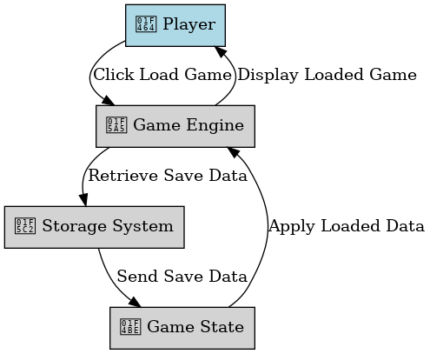

Activity Diagram:

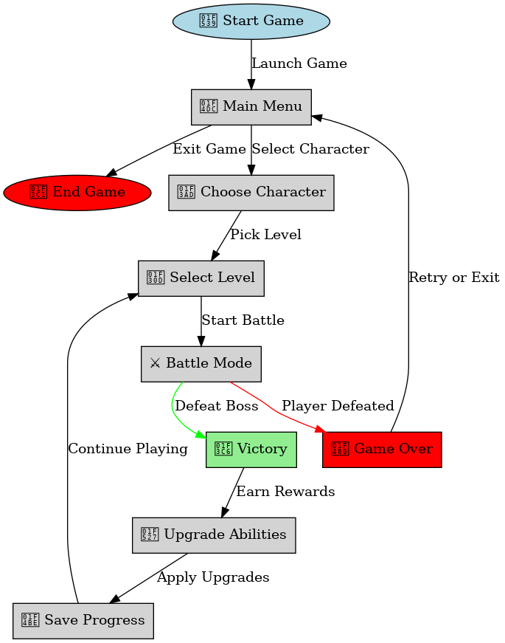

Component Diagram:

