UTC Junction Description: 1003 A4 London Rd/ Cleveland Place
Outstation SCN: X04210
Junction SCN: J04211
IP Address: 172.16.52.49
TOPAS2500 Configuration No: E60171 v6
Form Completed: 15 May 24
JUNCTION PHASING

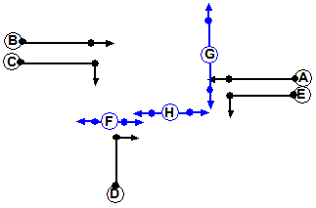
H
D
C
G
E
A

Junction Staging:
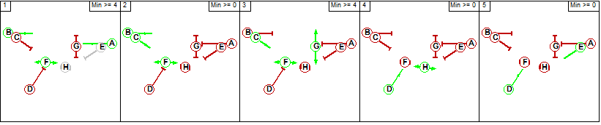

SCOOT Links:
Link SCN | Link Description
N04211A | 1003 A4 London Rd/ Cleveland Place: London Rd WB Ahead
N04211C | 1003 A4 London Rd/ Cleveland Place: London Rd EB Rt
N04211D | 1003 A4 London Rd/ Cleveland Place: Cleveland Place NB
N04211E | 1003 A4 London Rd/ Cleveland Place: London Rd WB Lft
N04211G | 1003 A4 London Rd/ Cleveland Place: London Rd EB Ahead
N04211H | 1003 A4 London Rd/ Cleveland Place: Cleveland Place NB Stopline

Interstage Values: Minimum Stage Lengths:
 | 1 | 2 | 3 | 4 | 5
1 | X | 7 | 8 | 8 | 8
2 | 5 | X | 8 | 8-9 | 8
3 | 11 | 11 | X | 11-12 | 11
4 | 11-13 | 11-13 | 11 | X | 11
5 | 6-8 | X | X | X | X
 | DD | MINS | MAXS
Stage 1 | N | 0-7 | 120
Stage 2 | Y | 7 | 120
Stage 3 | Y | 0-7 | 90
Stage 4 | Y | 7 | 90
Stage 5 | Y | 6 | 90

Bit Pattern:
1: F1 | 2: F2# | 3: F3# | 4: F4# | 5: F5# | 6: D2 | 7: D3 | 8: D4
9: D5 | 10: DX | 11: TS | 12: BF1 | 13: BF2 | 14: | 15: | 16:

1: G1 | 2: G2 | 3: G3 | 4: G4 | 5: G5 | 6: DR2 | 7: DR3 | 8: DR4
9: DR5 | 10: DF | 11: CS | 12: LF1 | 13: LF2 | 14: CF | 15: RR | 16:
17: SC1 | 18: | 19: | 20: | 21: SC2 | 22: | 23: | 24:
25: SC3 | 26: | 27: | 28: | 29: SC4 | 30: | 31: | 32:
33: SC5 | 34: | 35: | 36: | 37: SC6 | 38: | 39: | 40:
41: SC7 | 42: | 43: | 44: | 45: SC8 | 46: | 47: | 48:
49: SC9 | 50: | 51: | 52: | 53: SC10 | 54: | 55: | 56:

SCOOT Plan Line:

CY120
{F1 0}1, {F2 35, F1F2 36}2, {F3 65, F2F3+D2 66}3, {F4 79, F4F5+D5 80}4, {F5 95, F1F5 96}5
H
SCOOT Stage Minimums (For Peak plans):
SCOOT Stage | Controller Stage Change | Interstage + Stage Min | SCOOT Stage: Minimum Stage Length
1 | 5 to 1 | 8 + 7 = 15 | 15
2 | 1 to 2 | 7 + 7 = 14 | 14
3 | 1 to 3  2 to 3 | 8 + 6 = 14  8 + 6 = 14 | 14 (Fixed length)
4 | 2 to 4  3 to 4 | 9 + 7 = 16  12 + 7 = 19 | 16* (Fixed length)
5 | 4 to 5 | 11 + 4 = 15 | 18

Lags:
Controller Phase Letter | SCOOT  Link Letter | Value In Spec  (Time to Phase Gaining Green) | SLAG:  SCOOT Value  (Subtract 7) | ELAG:  SCOOT Value  (=Phase Delay)
A | A | 5 | -2 | 0
B | G | 6 | -1 | 0
C | C | 7 | 0 | 4
D | D/ H | 11 | +4 | 0
E | E | 11 | +4 | 0

Notes:

Link C closes down in a fixed length stage, so can’t optimise. If this becomes an issue, the database will need to be revised so that the SCOOT model is told it only runs in controller stage 2, and an end lag equivalent to the duration of stage 3 will need to be added. This will enable the link to optimise during stage 2.

SCOOT Data

SCOOT Region SCN: RBL
Minimum Cycle Time: 72 (69)
Maximum Cycle Time: 128
Use Sub Region Independence: N
Force Site to Double Cycle?: N

Link & Link Stage Data:
Link Letter | Link Type | Upstream Node | UNTL | MDSL | Junction SCN | UTC Green Stage No’s
A | N | N04116 | I | NA | J04211 | 1
C | E | NA | NA | NA | J04211 | 2,3
D | N | N04235 | N | NA | J04211 | 4,5
E | E | NA | NA | NA | J04211 | 1,2
G | E | NA | NA | N04115O | J04211 | 1,2
H | SE | NA | NA | NA | J04211 | 4,5

Detector Data:
Detector SCN | O.T.U SCN | Reply Bit
N04211A1 | X04110 | 29
N04211C1 | X04210 (Sc2) IO 19/ SM 63 | 29
N04211D1 | X04210 (Sc6) IO 23/ SM 59 | 41
N04211E1 | X04110 | 25
N04211G1 | X04210 (Sc1) IO 18/ SM 64 | 25
N04211H1 | X04210 (Sc9) IO 07/ SM 53 | 45

Notes:
Counters added:
D04211: London Rd EB L1 @ Margarets Hill (X04210 Sc1 N04211G1) SM 64
D04212: London Rd EB L2 @ Margarets Hill (X04210 Sc2 N04211C1) SM 63
D04213: London Rd EB @ Cleveland Bridge (X04210 Sc4 N04115O1) SM 62
D04214: Cleveland Bridge SB @ London Rd (X04210 Sc5 N04235S1) SM 60
D04215: Bathwick St NB @ Cleveland Bridge (X04210 Sc6 N04211D1) SM 59
D04216: Cleveland Place NB @ London Rd (X04210 Sc9 N04211H1) SM 53

Validation Parameters

Basic Validation Parameters:
 | A | C | D | E | G | H
SLAG | -2 | 0 | +4 | +4 | -1 | +4
ELAG | 0 | 4 | 0 | 0 | 0 | 0
JNYT | 14 | 10 | 12 | 15 | 9 | 1
QCMQ | 48 | 38 | 39 | 53 | 31 | NA
STOC | 11* was 9 | 13 | 10 | 8 | 9 | 9
CGIF | 2 | 3 | 4 | 1 | 3 | 0
SMUL  SSAT | NA | NA | NA | NA | NA | NA
FMUL  FSAT | NA | NA | NA | NA | NA | NA
OFWT | 10 | 10 | 10 | 10 | 10 | 10
DFOF  BIAS | NA | NA | NA | NA | NA | NA
CGOF  CGWT | NA | NA | NA | NA | NA | NA
LFLA  LFAL  LFEL  LFMQ | NA | NA | NA | NA | NA | NA
FORC | No | No | No | No | No | No
INSP  INCY  INOF | NA  NA  NA | Off  Off  On | NA  NA  NA | Off  Off  On | NA  NA  NA | NA  NA  NA
*4211a link det being clipped by 4211E link traffic
Pedestrian Priority Parameters: NA-Out of Scope
 | A | C | D | E | G
PEDS (2)
PLST
PUST
PPRI
PDCI
MPFR
MPWT

Bus Priority Parameters: NA-Out of Scope
 | A | C | D | E | G
BOFF
BPAN
BPFL
BERL
BDDD
BEXR
BRER
PMAX
BJNY
BJT2
BES0-BES6
BRS0-BRS6

Reduced Detection Parameters: NA-Out of Scope
 | A | C | D | E | G
RDPF
RDPL
RDFR
RDFF
JNYT

Notes:

Links D & H are needed for Cleveland Bridge as left turners skew the performance of link D because they turn off after the detector (there’s no sink detector to compensate for it). On H, they cause the opposite issue, as the vehicles that turn off cause H to see large headways between vehicles, causing it to under estimate the saturation. Between the two links, the green split is roughly right.

Link D has N04235N set up as a congestion link for the approach. The following values have been entered to add weight to this link during congested periods:
CHAN CLIF N04211D 3.

SCOOT Detection
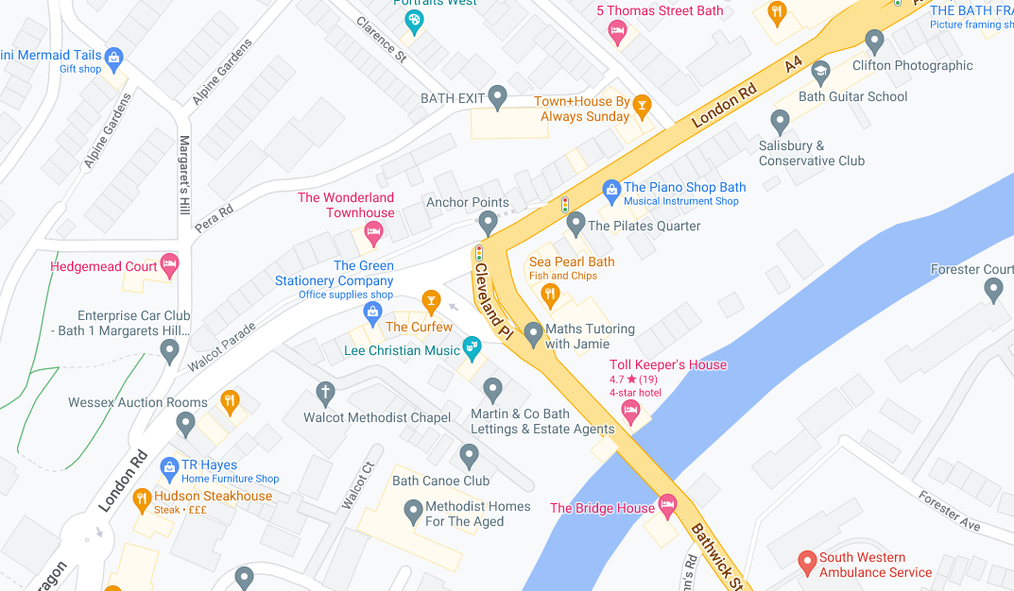
Sc6: N04211H1
Sc5: N04211D1
Sc4: N04235S1
X04210
X04110
Sc3: N04115O1
Sc2: N04211C1
Sc1: N04211G1

