UTC Junction Description: | Northgate St/ New Bond St/ High St Shuttle
Outstation SCN & Type: | Yunex Gemini 2 – X02110
Junction SCN: | J02111
IP Address: | 172.16.52.48
TOPAS2500 Configuration No: | E60126 v3
Date Form Completed: | 29/2/24
JUNCTION PHASING

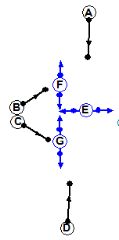

A

B

C

D

Junction Staging:
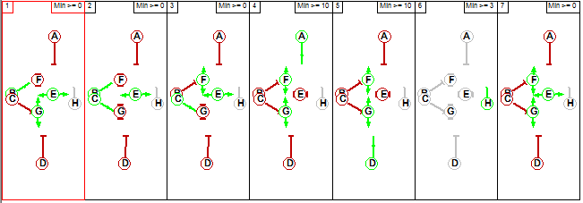
SCOOT Staging: 2, 4, 5.

SCOOT Links:
Link SCN | Link Description
N02111A | 1013 Northgate St/ New Bond St/ High St Bus Gate: Broad St SB
N02111B | 1013 Northgate St/ New Bond St/ High St Bus Gate: New Bond St EB Lft Stopline
N02111C | 1013 Northgate St/ New Bond St/ High St Bus Gate: New Bond St EB Rt Stopline
N02111D | 1013 Northgate St/ New Bond St/ High St Bus Gate: High St NB Stopline

Interstage Values: Minimum Stage Lengths:
 | 2 | 4 | 5
2 | X | 6-26 | 8-28
4 | 6-26 | X | 6-26
5 | 6-26 | 6-26 | X
 | Demand Dependent? | MINS | MAXS
Stage 2 | Y | 10 | 120
Stage 4 | Y | 10 | 120
Stage 5 | Y | 10 | 120

Bit Pattern:
1: F1# | 2: F2# | 3: F3# | 4: F4# | 5: F5# | 6: F6# | 7: F7# | 8: D1
9: D2 | 10: D3 | 11: D4 | 12: D5 | 13: D6 | 14: D7 | 15: DX | 16: TS

1: G1 | 2: G2 | 3: G3 | 4: G4 | 5: G5 | 6: G6 | 7: G7 | 8: DR1
9: DR2 | 10: DR3 | 11: DR4 | 12: DR5 | 13: DR6 | 14: DR7 | 15: DF | 16: CS
17: EV | 18: BD1 | 19: BD2 | 20: BD3 | 21: LF1 | 22: LF2 | 23: CF | 24: RR
25: SC1 | 26: | 27: | 28: | 29: SC2 | 30: | 31: | 32:
33: SC2 | 34: | 35: | 36: | 37: SC4 | 38: | 39: | 40:
41: VC1 | 42: VC2 | 43: VC3 | 44: VC4 | 45: | 46: | 47: | 48:
49: | 50: | 51: | 52: | 53: | 54: | 55: | 56:
Number of SCOOT detectors = 4

SCOOT Plan Lines:
Plan No | SCOOT Plan Line
AM Peak | CY 112 {F2+D2 0}S1, {F4+D4 36}S2, {F5+D5 72}S3
Off Peak | CY 112 {F2+D2 0}S1, {F4+D4 36}S2, {F5+D5 72}S3
PM Peak | CY 112 {F2+D2 0}S1, {F4+D4 36}S2, {F5+D5 72}S3
Evening | Local

SCOOT Stage Minimums:
SCOOT Stage | Controller  Stage Change | Interstage + MINS + Offset | SCOOT Stage: Min Stage length
1 | 5 to 2 | 6 to 26 + 10 = 16 to 36 | 36
2 | 2 to 4 | 6 to 26 + 10 = 16 to 36 | 36
3 | 4 to 5 | 6 to 26 + 10 = 16 to 36 | 36
Total (MINC): |  |  | = 108 (112)

Lags:
Controller Phase Letter | SCOOT  Link Letter | Value In Spec  (Time to Phase Gaining Green) | SLAG:  SCOOT Value  (Subtract 7) | ELAG:  SCOOT Value  (=Phase Delay)
A | A | To be measured |  | 0
B | B | To be measured |  | 0
C | C | To be measured |  | 0
D | D | To be measured |  | 0
Start lags to be measured on street due to the variability.

SCOOT Model Data

SCOOT Region SCN: | RBG
Minimum Cycle Time: | 112
Maximum Cycle Time: | 128
Use Sub Region Independence: | N
Maximum no of SCOOT Stages: | 3

Link & Link Stage Data:
Link Letter | Link Type | Upstream Node | UNTL | MDSL | Junction SCN | UTC Green Stage No’s
A | F | NA | NA | NA | J02111 | 4
B | SE | NA | NA | NA | J02111 | 2
C | SE | NA | NA | NA | J02111 | 2
D | F | NA | NA | NA | J02111 | 5

Detector Data:
Detector SCN | O.T.U SCN | SCOOT No | First Reply Bit
N02111A1 | X02110 | 1 | 25
N02111B1 | X02110 | 2 | 29
N02111C1 | X02110 | 3 | 33
N02111D1 | X02110 | 4 | 37

Notes:

N02111A1 = AR5
N02111B1 = BSL
N02111C1 = CSL
N02111D1 = AR7

D02111 = N02111A1
D02112 = N02111B1
D02113 = N02111C1
D02114 = N02111D1

Validation Parameters

Basic Validation Parameters:
 | A | B | C | D
SLAG | 5 | 5 | 5 | 5
ELAG | 0 | 0 | 0 | 0
JNYT | 1 | 1 | 1 | 1
QCMQ | NA | NA | NA | NA
STOC | 8 | 8 | 8 | 8
CGIF | 1 | 1 | 1 | 1
SMUL  SSAT | NA | NA | NA | NA
FMUL  FSAT | NA | NA | NA | NA
OFWT | 10 | 10 | 10 | 10
DFOF  BIAS | NA | NA | NA | NA
CGOF  CGWT | NA | NA | NA | NA
LFLA  LFAL  LFEL  LFMQ | NA | NA | NA | NA
FORC | S | S | S | S
INSP  INCY  INOF | N  N  N | N  N  N | N  N  N | N  N  N

Pedestrian Priority Parameters: NA – Not in scope
 | A | B | C | D
PEDS (2)
PLST
PUST
PPRI
PDCI
MPFR
MPWT

Bus Priority Parameters: NA – Not in scope
 | A | B | C | D
BOFF
BPAN
BPFL
BERL
BDDD
BEXR
BRER
PMAX
BJNY
BJT2
BES0-BES6
BRS0-BRS6

Reduced Detection Parameters: NA – Not in scope
 | A | B | C | D
RDPF
RDPL
RDFR
RDFF
JNYT

Notes:

SCOOT Detector Sketch:
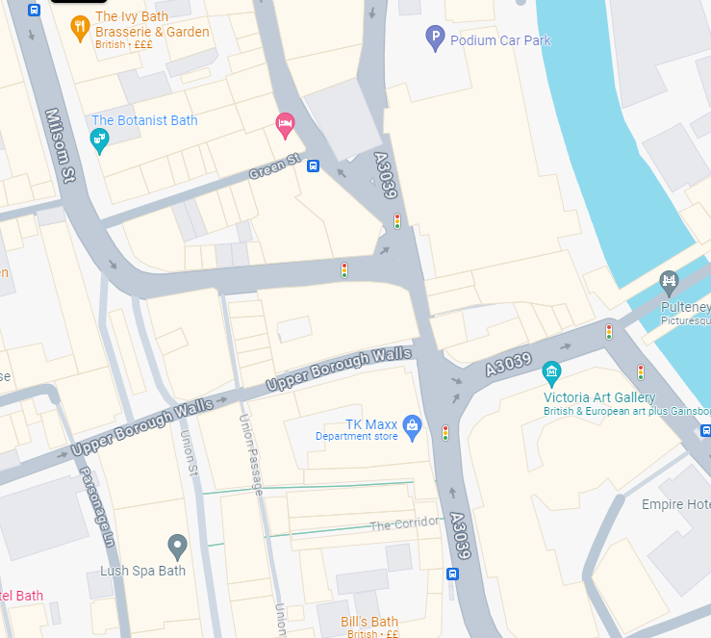
C
B
A
X02110
D
SC2: N02111B1
SC3: N02111C1
SC4: N02111D1
SC1: N02111A1
CSI.DET.IN.1 = CSI.DET.IN.1 =
CSI.DET.IN.1 = CSI.DET.IN.1 =
CSI.DET.IN.1 = CSI.DET.IN.1 =
CSI.DET.IN.1 = CSI.DET.IN.1 =

