UTC Junction Description: | London Rd/ Morrisons
Outstation SCN & Type: | Yunex Gemini 2/ X04120
Junction SCN: | J04121
IP Address: | 172.16.52.53
TOPAS2500 Configuration No: | EPR203 v4
Date Form Completed: | 17 Jan 24
JUNCTION PHASING

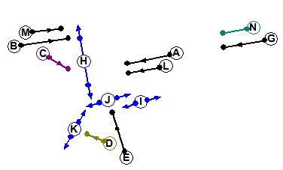
X

G
B
A

C

Y

Z
D

Junction Staging:
Str 0
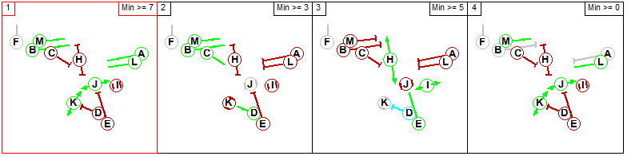
Str 1
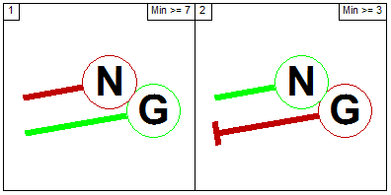

SCOOT Links:
Link SCN | Link Description
N04121A | 1062 A4 London Rd/ Morrisons Car Park Exit: London Rd WB Stopline
N04121B | 1062 A4 London Rd/ Morrisons Car Park Exit: London Rd EB
N04121C | 1062 A4 London Rd/ Morrisons Car Park Exit: London Rd EB Rt Stopline
N04121D | 1062 A4 London Rd/ Morrisons Car Park Exit: Car Park Exit Rt
N04121G | 1062 A4 London Rd/ Morrisons Car Park Exit: London Rd WB
N04121X | 1062 A4 London Rd/ Morrisons Car Park Exit: London Rd EB Ahead Stopline
N04121Y | 1062 A4 London Rd/ Morrisons Car Park Exit: Car Park Exit Rt Stopline
N04121Z | 1062 A4 London Rd/ Morrisons Car Park Exit: Car Park Exit Lft Stopline

Interstage Values: Minimum Stage Lengths:
 | 1 | 2 | 3
1 | X | 5-9 | 14
2 | X | X | 14
3 | 6-18 | 6-18 | X
 | Demand Dependent? | MINS | MAXS
Stage 1 | N | 7 | 120
Stage 2 | Y | 4 | 120
Stage 3 | Y | 7 | 120

 | Demand Dependent? | MINS | MAXS
Stage 1 | N | 7 | 120
Stage 2 | Y | 3 | 120
 | 1 | 2
1 | X | 3
2 | 5 | X

Bit Pattern:
1: F1 | 2: F2# | 3: F3# | 4: F1 | 5: F2# | 6: D2 | 7: D3 | 8: D2
9: DX | 10: TS | 11: BF1 | 12: BF2 | 13: | 14: | 15: | 16:

1: G1 | 2: G2 | 3: G3 | 4: G1 | 5: G2 | 6: DR2 | 7: DR3 | 8: DR2
9: DF | 10: CS | 11: CF | 12: LF1 | 13: LF2 | 14: RR | 15: | 16:
17: | 18: | 19: | 20: | 21: SC1 | 22: | 23: | 24:
25: SC2 | 26: | 27: | 28: | 29: SC3 | 30: | 31: | 32:
33: SC4 | 34: | 35: | 36: | 37: SC5 | 38: | 39: | 40:
41: SC6 | 42: | 43: | 44: | 45: SC7 | 46: | 47: | 48:
49: SC8 | 50: | 51: | 52: | 53: SC9 | 54: | 55: | 56:
Number of SCOOT detectors = 9

SCOOT Plan Lines:
Plan No | SCOOT Plan Line
AM Peak | CY 104 {F1 0}S1, {F2 69, F1F2 70}S2, {F3 85, F1F3 86}S3
Off Peak | CY 096 {F1 0}S1, {F2 58, F1F2 59}S2, {F3 74, F1F3 75}S3
PM Peak | CY 104 {F1 0}S1, {F2 67, F1F2 68}S2 {F3 84, F1F3 85}S3
Evening | CY 0

SCOOT Stage Minimums:
SCOOT Stage | Controller  Stage Change | Interstage + MINS + Offset | SCOOT Stage: Min Stage length
1 | 3 to 1 | 6 to 18 + 7 = 13 to 25 | 25
2 | 1 to 2 | 6 to 9 + 7 = 13 to 16 | 16
3 | 2 to 3 | 14 + 7 = 21 | 21
Total (MINC): |  |  | = 63 (64)

Lags:
Controller Phase Letter | SCOOT  Link Letter | Value In Spec  (Time to Phase Gaining Green) | SLAG:  SCOOT Value  (Subtract 7) | ELAG:  SCOOT Value  (=Phase Delay)
A | A/G |  | 3 | 0
B | B/X |  | 3 | 0
C | C |  | -2 | 0
D | Z |  | -2 | 0
E | D/Y |  | -1 | 0

SCOOT Model Data

SCOOT Region SCN: | RBL
Minimum Cycle Time: | 64
Maximum Cycle Time: | 120
Use Sub Region Independence: | N
Maximum no of SCOOT Stages: | 3

Link & Link Stage Data:
Link Letter | Link Type | Upstream Node | UNTL | MDSL | Junction SCN | UTC Green Stage No’s
A | SE | NA | NA | NA | J04121 | 1
B | N | N04115 | O | N04135O | J04121 | 1,2
C | SE | NA | NA | NA | J04121 | 2
D | E | NA | NA | NA | J04121 | 3
G | N | N04135 | I | NA | J04121 | 1
X | SE | NA | NA | NA | J04121 | 1,2
Y | SE | NA | NA | NA | J04121 | 3
Z | SE | NA | NA | N04116I | J04121 | 2,3

Detector Data:
Detector SCN | O.T.U SCN | SCOOT No | First Reply Bit
N04121A1 | X04120 | 1 | 21
N04121B1 | X04110 | 1 | 21
N04121C1 | X04120 | 6 | 241
N04121D1 | X04120 | 2 | 25
N04121G1 | X04130 | 2 | 21
N04121X1 | X04120 | 9 | 53
N04121Y1 | X04120 | 8 | 49
N04121Z1 | X04120 | 10 | 57
N04116I1 | X04120 | 4 | 33
N04135O1 | X04120 | 5 | 37

Notes:

Validation Parameters

Basic Validation Parameters:
 | A | B | C | D | G | X | Y | Z
SLAG | 3 | 3 | -2 | -1 | 3 | 3 | -1 | -2
ELAG | 0 | 0 | 0 | 0 | 0 | 0 | 0 | 0
JNYT | 1 | 15 | 2 | 5 | 33 | 1 | 1 | 1
QCMQ | NA | 51 | NA | 15 | 111 | NA | NA | 255
STOC | 7 | 8 | 8 | 18 | 7 | 9 | 9 | 9
CGIF | 2 | 3 | 2 | 1 | 2 | 3 | 1 | 1
SMUL  SSAT | NA | NA | NA | 31  88 | NA | NA | 31  88 | 31  92
FMUL  FSAT | NA | NA | 20  85 | NA | NA | NA | NA | NA
OFWT | 10 | 10 | 10 | 10 | 10 | 10 | 10 | 10
DFOF  BIAS | NA | NA | NA | NA | NA | NA | NA | NA
CGOF  CGWT | NA | NA | NA | NA | NA | NA | NA | NA
LFLA  LFAL  LFEL  LFMQ | N | N | N | N | N | N | N | N
FORC | N | N | N | N | N | N | N | N
INSP  INCY  INOF | N | N | N | ? | N | N | N | N

Pedestrian Priority Parameters: (NA – Out of scope)
 | A | B | C | D | G | X | Y
PEDS (2)
PLST
PUST
PPRI
PDCI
MPFR
MPWT

Bus Priority Parameters:
 | A | B | C | D | G | X | Y
BOFF
BPAN
BPFL
BERL
BDDD
BEXR
BRER
PMAX
BJNY
BJT2
BES0-BES6
BRS0-BRS6

Reduced Detection Parameters: (Not needed)
 | A | B | C | D | G | X | Y
RDPF
RDPL
RDFR
RDFF
JNYT

Notes:

SCOOT Detector Sketch:
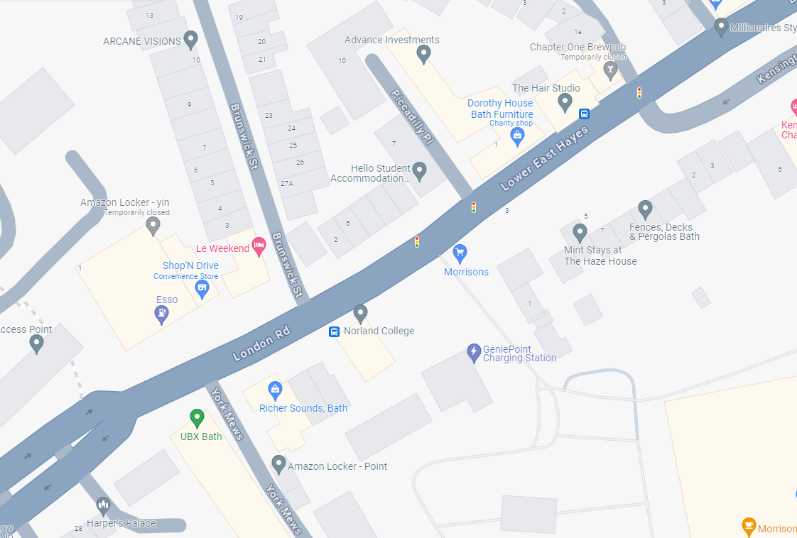
SC10: N04121Z1
SC4: N04116I1
C
SC3: Not in Use
SC6: N04121C1
CSI.DET.IN.1 = CSI.DET.IN.1 =
SC8: N04121Y1
Y
Z
CSI.DET.IN.1 = CSI.DET.IN.1 =
X04130
SC1: N04121A1
X
CSI.DET.IN.1 = CSI.DET.IN.1 =
G
A
On X04130
X04110
On X04110
SC9: N04121X1
CSI.DET.IN.1 = CSI.DET.IN.1 =
I
D
SC2: N04121D1
CSI.DET.IN.1 = CSI.DET.IN.1 =
CSI.DET.IN.1 = CSI.DET.IN.1 =
SC1: N04121B1
B
A
SC5: N04135O1
SC2: N04121G1
CSI.DET.IN.1 = CSI.DET.IN.1 =
CSI.DET.IN.1 = CSI.DET.IN.1 =
CSI.DET.IN.1 = CSI.DET.IN.1 =
CSI.DET.IN.1 = CSI.DET.IN.1 =
CSI.DET.IN.1 = CSI.DET.IN.1 =
X04120

