UTC Junction Description: 5040 A37 Wells Rd/ A39 White Post (Hallatrow)
Outstation SCN & Type: X88820 - Stratos
Junction SCN: J88821
IP Address: 172.16.53.40
TOPAS2500 Configuration No: TCT06 v1
Date Form Completed: 15/08/2022
JUNCTION PHASING

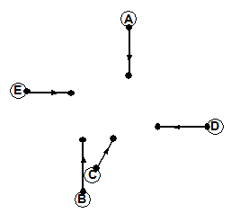
E
D
C
B
A

Junction Staging:
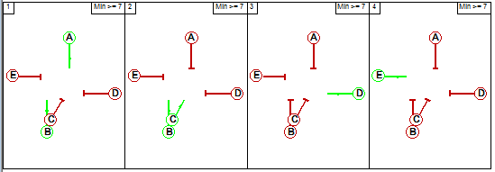

SCOOT Links:
Link SCN | Link Description
N88821A | 5040 A37 Wells Rd/ A39 White Cross (Hallatrow): A37 SB
N88821B | 5040 A37 Wells Rd/ A39 White Cross (Hallatrow): A37 NB Ahead
N88821C | 5040 A37 Wells Rd/ A39 White Cross (Hallatrow): A37 NB Rt
N88821D | 5040 A37 Wells Rd/ A39 White Cross (Hallatrow): A39 WB
N88821E | 5040 A37 Wells Rd/ A39 White Cross (Hallatrow): Car Wash Exit

Interstage Values: Minimum Stage Lengths:
 | 1 | 2 | 3 | 4
1 | X | 6 | 7 | 7
2 | 7 | X | 7 | 6
3 | 6 | 6 | X | 7
4 | 9 | 9 | 9 | X
 | DD | MINS | MAXS
Stage 1 | N | 7 | 120
Stage 2 | Y | 7 | 60
Stage 3 | Y | 7 | 90
Stage 4 | Y | 7 | 30

Bit Pattern No:
0= F1 | 1= F2 | 2= F3 | 3= F4 | 4= F5 | 5= D2 | 6= D3 | 7= D4
8= DX | 9= TS | 10=MO | 11=BF1 | 12=BF2 | 13=BF3 | 14=BF4 | 15=

0= G1 | 1= G2 | 2= G3 | 3= G4 | 4= G5 | 5= DR2 | 6= DR3 | 7= DR4
8= CS | 9= CF | 10= DF | 11= LF1 | 12= LF2 | 13= RR | 14= MR | 15= ML
16= MF | 17= | 18= | 19= | 20= | 21= | 22= | 23=
24= | 25= | 26= | 27= | 28= | 29= | 30= | 31=

SCOOT Plan Lines:
Plan No | SCOOT Plan Line
1 | {F1 0}1, {F2 0, F1/2 1}2, {F3 0+D3}3, {F4 0, F1/4 1}4

SCOOT Stage Minimums:
SCOOT Stage | Controller Stage Change | Interstage + Stage Min | SCOOT Stage: Minimum Stage Length
1 | 3 – 1  4 – 1 | 6 + 7 = 13  9 + 7 = 16 | 16
2 | 1 – 2 | 6 + 7 = 13 | 13
3 | 1 – 3  2 – 3 | 7 + 7 = 14  7 + 7 = 14 | 14
4 | 3 – 4 | 7 + 7 = 14 | 14

Lags:
Controller Phase Letter | SCOOT  Link Letter | Value In Spec  (Time to Phase Gaining Green) | SLAG:  SCOOT Value  (Subtract 7) | ELAG:  SCOOT Value  (=Phase Delay)
A | A | 9 | +2 | 0
B | B | 9 | +2 | 0
C | C | 6 | -1 | 0
D | D | 7 | 0 | 0
E | E | 7 | 0 | 0

SCOOT Data

SCOOT Region SCN: RWR
Minimum Cycle Time: 60
Maximum Cycle Time: 120
Use Sub Region Independence: N
Initial Region Cycle Time (IRCT): 120
Force Site to Double Cycle?: N

SCOOT Stage Timing Data:
SCOOT Stage | Minimum Stage Length (MINS) | Maximum Stage Length (MAXS) | Stage Change Point:
1 | 16 | 120 | 0
2 | 13 | 60 | 50
3 | 14 | 90 | 65
4 | 14 | 30 | 105

Link & Link Stage Data:
Link Letter | Link Type | Upstream Node | MDSL | UNTS | DNTS | Junction SCN | UTC Green Stage  No’s | Gains Green in Stage | Loses Green in Stage
A | E | NA | NA | NA | 1 | J88821 | 1 | 1 | 2
B | E | NA | NA | NA | 1 | J88821 | 1 | 1 | 2
C | E | NA | NA | NA | 2 | J88821 | 2 | 2 | 3
D | E | NA | NA | NA | 3 | J88821 | 3 | 3 | 4
E | E | NA | NA | NA | 4 | J88821 | 4 | 4 | 1

Detector Data:
Detector SCN | O.T.U SCN | Reply Word | Reply Mask
N88821A1 | X88820 | 2 | 0
N88821B1 | X88820 | 2 | 1
N88821C1 | X88820 | 2 | 2
N88821D1 | X88820 | 2 | 3

Notes:

Validation Parameters

Basic Validation Parameters:
 | A | B | C | D | E
SLAG | +2 | +2 | -1 | 0 | 0
ELAG | 0 | 0 | 0 | 0 | 0
JNYT | 8 | 8 | 5 | 8 | 5
QCMQ | 26 | 26 | 17 | 26 | 16
STOC | 8 | 8 | 8 | 8 | 8
CGIF | 3 | 3 | 2 | 1 | 1
SMUL  SSAT | NA | NA | NA | NA | NA
FMUL  FSAT | NA | NA | NA | NA | NA
OFWT | 10 | 10 | 10 | 10 | 10
DFOF  BIAS | NA | NA | NA | NA | NA
CGOF  CGWT | NA | NA | NA | NA | NA
LFLA  LFAL  LFEL  LFMQ | NA | NA | NA | NA | NA
FORC | NA | NA | NA | NA | NA
INSP  INCY  INOF | NA | NA | NA | NA | NA

Pedestrian Priority Parameters: NA-Out of Scope
 | A | B | C | D | E
PEDS (2)
PLST
PUST
PPRI
PDCI
MPFR
MPWT

Bus Priority Parameters:
 | A | B | C | D | E
BOFF
BPAN
BPFL
BERL
BDDD
BEXR
BRER
PMAX
BJNY
BJT2
BES0-BES6
BRS0-BRS6

Reduced Detection Parameters: NA-Out of Scope
 | A | B | C | D | E
RDPF
RDPL
RDFR
RDFF
JNYT

Notes:

SCOOT Model created for monitoring on MOVA junction only.

SCOOT Detection:
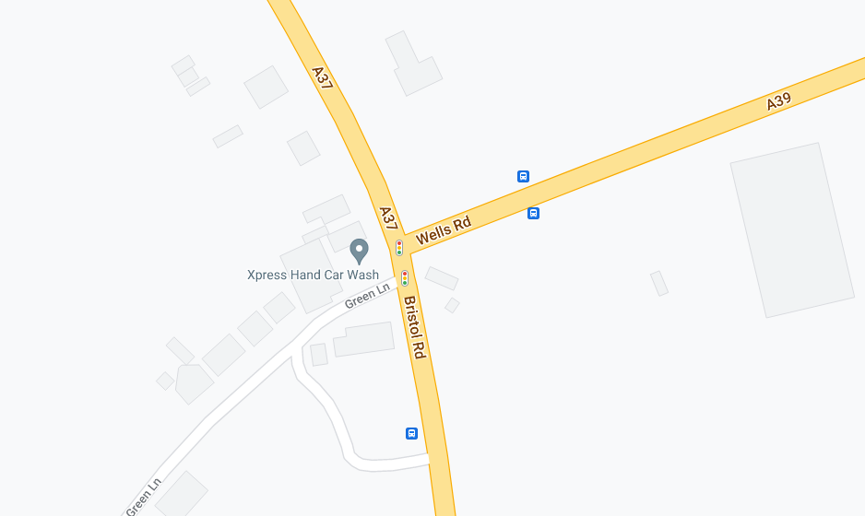
D88824
D88823
D88822
D88821
SC4: N88821D1
(DIN9)
SC3: N88821C1
(CX7)
C
SC2: N88821B1
(BIN4)
SC1: N88821A1
(AIN1)
A
E
B
D
X88820

