**ITP 303 Final Project Summary**

**INSTRUCTIONS:** Type out your answer directly below each question. If a question does not apply to your project, type in N/A. When finished, save this file as a PDF and upload it to the itpwebdev server via FileZilla. Then, add a link to this PDF in your student_page.html. Label it “Final Project Summary.”

**BASICS**

**Your name?**

Leo Deng

**What is the topic of your final project?**

A source-controlled platform for writing/textual projects

**Who is the intended audience?**

Writers looking to collaborate professionally or casually on narrative/research projects.

**Provide a brief summary of the functionalities of your project.**

The site allows users to create projects and collaborate on them with other users who are granted either the access level of maintainer or contributor. Jobs can be created and assigned to contributors for them to make changes/additions to the project in their own workspace before submitted them for review. Maintainers can review the changes made in these jobs and accept them officially. Changes relevant to the user are tracked and displayed on their homepage and project pages.

**FRONT-END**

**What is the total page count?**

About 11 distinct pages (counting all login/register as 1, not counting confirmation pages)

**List the names of any external stylesheet used in this project below.**

n/a

**List any CSS libraries/frameworks used in this project (e.g. Bootstrap) below.**

Bootstrap

**List any JavaScript libraries/frameworks used in this project below.**

n/a

**How does your project meet the Interactivity requirement?**

In project.php, hovering mouse over a project or job item will change the color of its text/background.

**BACK-END**

**Attach a screenshot of the final database diagram (just the diagram, do not include any records) below.**

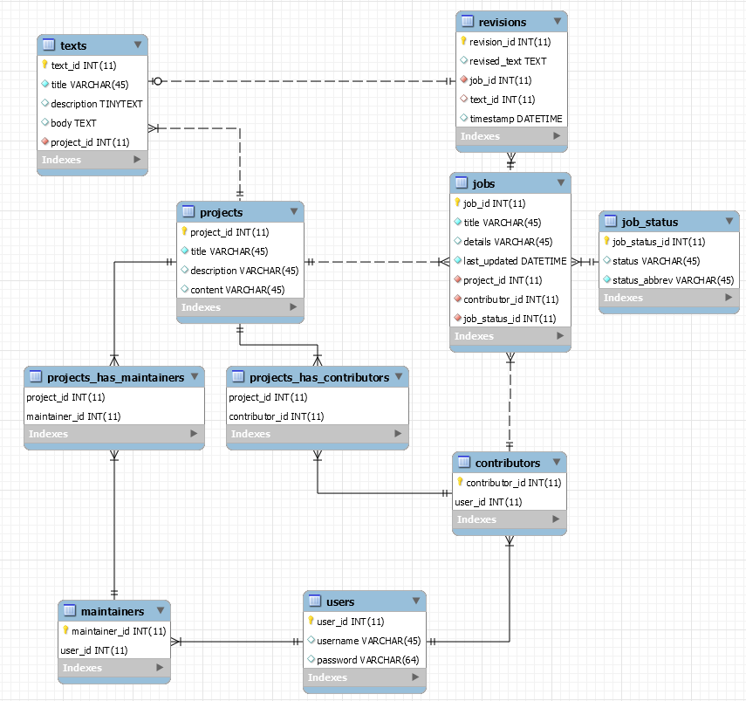

**Where in your project do you insert a record to the database (the ‘C’ in CRUD)?**

Create_job.php, create_project.php, create_text.php

**Where in your project do you search and display record(s) from the database (the ‘R’ in CRUD)?**

Sidebar.php, intertext.php, project.php, job.php, text.php. (i.e. mostly querying database for record information based on logged in user)

**Where in your project do you update and existing record(s) the database (the ‘U’ in CRUD)?**

Edit_project_info.php, revise.php, job_submit.php

**Where in your project do you delete existing record(s) from the database (the ‘D’ in CRUD)?**

Delete_text.php.

**MISC**

**What two “extra” requirements did you implement and where can they be found?**

Different user permission levels can be found implemented throughout the project. For example, only maintainers have access to directly edit a project, whereas contributors must make changes via jobs. Three different levels are unregistered (no database access), user with neither level of access (can only create project and go from there, unless another user permits them), user with maintainer access (full access to a project), user with contributor access (limited access to project).

Maintainer and contributor ids are stored in sessions when a user successfully logs in. These are used to verify whether the user has access to certain projects/features. Session is destroyed upon logout.

**If you used any APIs or JS plugins/frameworks as one of the extra requirements, list the name and a link to their documentation.**

n/a

**If your project requires any admin credentials (i.e. only admin users can access a certain page), list the credentials below.**

n/a

**Provide any other information that you think the grader/instructor should know when grading your final project below.**

For testing purposes, password to user “leodeng” is “aqua”. The password to all other existing users is the same as the username (e.g. username: “test2”, password: “test2”).

I did not have time to implement many features that I wanted to/I thought would make sense to have. While I believe I’ve met the project requirements, the site is very much still a WIP.