Food Ordering and Delivery System: Direct Chef-to-Customer Platform

1.0 System analysis
1.1 FEASIBILITY STUDY

1.1.1 Technical Feasibility
Frontend technology to use are HTML5, CSS3, JavaScript, Bootstrap, backend PHP 8.x, Laravel, database technologies to use are MySQL, SQLite, firebase for real-time data and cloud datastore, APIs such as Google Maps, Payment gateways, Servers for hosting. This system is technically feasible

1.1.2 Economic Feasibility
Initial Development Cost: $40,000
Annual Operational Cost: $27,600
Revenue: Commission, delivery fees, subscriptions
Break-even: 18 months and economically feasible

1.1.3 Schedule Feasibility
Development Timeline 6 Months it is schedule feasible

1.1.4 Operational Feasibility
High stakeholder acceptance, and clear operational requirements. This project is operationally feasible

1.2 Requirement analysis
1.2.1 requirement gathering methods
- interview
- questionnaire
- observation

1.2.2 Functional Requirements
- User Management
User registration (admin, chef, customer, traveler)
Login/logout & authentication
Profile management (update personal info, profile picture)
Role-based access control.
- Menu Management (Chef Side).
Add, edit, delete meal items
Set price, description, image, availability
Categorize meals (breakfast, lunch, dinner, snacks, etc.)
- Order Management
Browse meals and chefs
Add to cart
Place orders (single or multiple items)
Accept or reject orders
Update order status (preparing, ready, completed)
View all orders and handle disputes
View assigned orders for delivery
Update status (picked up, delivered)
- Payment & Transaction Management
Customers can make payments (online or cash on delivery)
Transaction records stored per order
Admin can view transaction reports
- Review and Rating System
Customers rate chefs/meals after delivery
Display average ratings for transparency
- Delivery Management
Assign delivery to available travelers
Real-time delivery tracking
Delivery confirmation (by traveler & customer)
- Notification System
Order status updates (email/SMS/push)
New order alerts for chefs and travelers
Admin notifications for disputes or reports
- Reports and Analytic
sales reports, user growth, chef performance
order history, earnings
completed deliveries and total earnings
- Location Management
Share current location via GPS (when using web/mobile).
Save default delivery address (home, or work).
View pickup (chef’s address) and drop-off (customer’s location).
Update delivery route status (picked up, on route, delivered).
Monitor delivery locations (map-based view for tracking).

1.2.3 Non-functional requirements
- Security
- Maintainability
- Interoperability
- Accessibility
- Accuracy
- Auditing
- Extensibility
- Reliability
- Response time
- Robustness

1.2.4 User Roles and permission
User roles, descriptions, and their tasks
Role | Description | main Tasks
Admin | Manages platform operations and verifies chefs. | Manage users (approve/block chefs/customers), manage menu categories, view reports, manage transactions, handle disputes.  View chef, traveler, and customer locations for monitoring.
Chef | Prepares and lists meals for sale. | Create/manage menu items, accept/reject orders, update meal availability, track orders, respond to customer messages.  Set pickup location (kitchen address).
Customer | Orders food from chefs. | Register/login, search food/chefs, place orders, make payments, rate/review meals, track delivery.  Allow access to GPS, confirm address, share live location on checkout.
Traveler (Delivery Person) | Picks up and delivers meals to customers. | View assigned deliveries, update order status, confirm delivery, track earnings.  Access pickup & delivery routes using GPS.

2.0 system design
1. Customer → System
Registers, browses meals, places an order.
Shares GPS location → saved to locations table.
2. System → Chef
Notifies chef about a new order.
Notifies of order + displays customer location map.
3. Chef → System
Accepts/rejects and updates status.
4. System → Traveler
Assigns order → shows pickup (chef) & delivery (customer) coordinates.
Updates delivery status using location.
5. Traveler → System
Updates pickup and delivery status.
Updates delivery status using location.
6. System → Customer
Sends real-time order and delivery updates.
Tracks delivery progress (via live map).
7. System → Admin
Tracks overall system performance and resolves disputes.

Account validation requirements
✔ Chefs must be validated before selling food
Chefs may be required to upload:
NIDA ID / Passport
Business license (optional)
Profile details (bio, specialties)
Food safety or hygiene certificate (optional)
Profile photo
✔ Travelers must be validated before delivering orders
Travelers may need to upload:
NIDA ID / Driving license
Vehicle type & number
Photo
Insurance (optional)
✔ Admin must approve or reject on-boarding
Admin reviews the documents and changes status to:
Pending
Approved
Rejected
Suspended
✔ No chef/traveler can operate unless approved.

Step 1: Customer places an order
Order recorded
Order items saved
Total calculated
Step 2: Chef prepares food
Step 3: Traveler assigned
Delivery created
Traveler earnings calculated
Step 4: Payment processed
Customer pays
Payment saved
Step 5: Earnings generated
Chef earnings calculated (after commission)
Traveler earnings calculated
Step 6: Admin dashboard shows
Total sales per chef
Total earnings per traveler
Platform revenue

Use Case Diagram

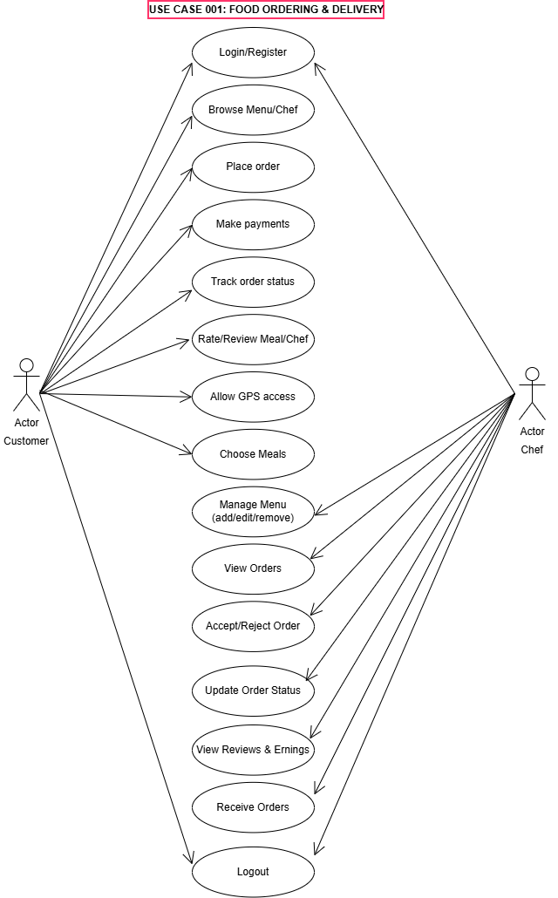
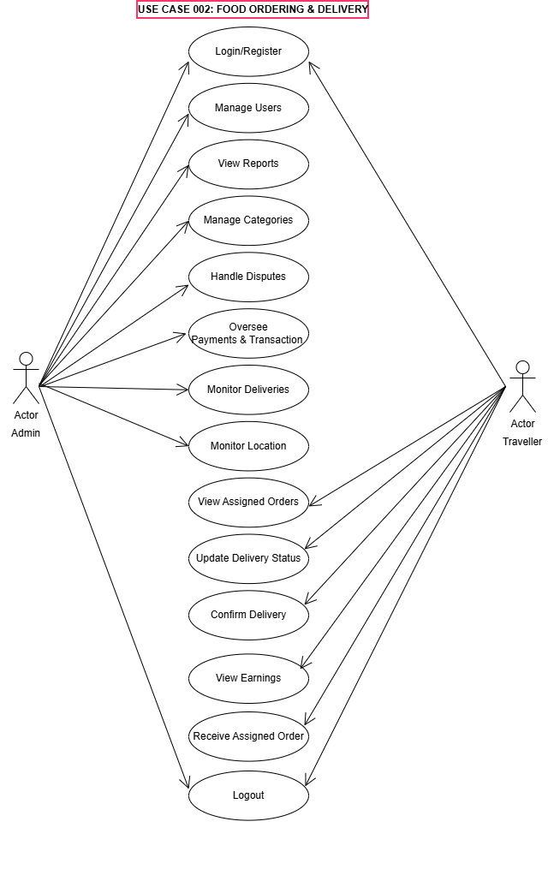

3.0 system development
Technology stack
Front end html, css, js, bootstrab
Backend php, Laravel framework
Database mysql,
sqlite, firebase for mobile app(optional) for future

Development phases

Phase 1: Foundation (Weeks 1–4)
Project setup and environment configuration
Database design and migrations
Core user authentication system
Basic admin dashboard

Phase 2: Core Features (Weeks 5–10)
Chef profile and meal management
Customer ordering system
Shopping cart and checkout
Basic payment integration

Phase 3: Delivery System (Weeks 11–14)
Traveler registration and management
Delivery assignment logic
Real-time location tracking
Order status updates

Phase 4: Advanced Features (Weeks 15–18)
Review and rating system
Notifications (Email, SMS, Push)
Advanced search and filtering
Reporting and analytics

Phase 5: Polish & Testing (Weeks 19–22)
UI/UX refinement
Performance optimization
Security hardening
User acceptance testing

Phase 6: Deployment Preparation (Weeks 23–24)
Production environment setup
Data migration planning
User documentation
Training materials

4.0 system testing
Use acceptance testing
Integration testing
Unit testing
System testing

5.0 system deployment
Acquisition and installation of required hardware and software
User training
Conversion (parallel conversion)
Documentation

6.0 system maintenance

