Medical-VLM Efficiency & Accuracy — Project Overview (a 30-minute read)
*A plain-language tour of the whole project: what we set out to do, what we found, and where it stands.
Every number here is real (from results/cascade_methods/GROUND_TRUTH_NUMBERS.md). Section pointers tell you
where to read more.*
____________________________________________________________

1. What this project is (in one paragraph)
A medical vision–language model (VLM) takes a medical image (a chest X-ray, a pathology slide) plus a
question and returns an answer. The best models are large "reasoning" models that think step by step —
accurate but slow and power-hungry (a 32-billion-parameter model takes ~28 seconds and ~6 kilojoules per
question). A small 7-billion model answers in ~0.2 seconds but is less accurate. **Our goal is efficiency:
match the big model's accuracy for far less compute* — and, separately, to improve* accuracy cheaply. The
deliverable is a paper for CVGIP 2026.

2. Key terms you'll see (the only vocabulary you need)
term | plain meaning
Cascade | Run the cheap model first; only call the expensive model on hard questions.
Gate | The rule that decides "is this question hard enough to escalate?"
Confidence / margin | How sure the model is (gap between its top-2 answer probabilities).
Think vs no-think | The big model can either emit a long reasoning trace ("think", slow) or answer directly ("no-think", fast).
Oracle gap | If you sample the model several times, how much better you'd do if you could always pick its best try.
Luck floor | Our key negative: with no training, you can't pick the best try better than random. The oracle gap is real but unreachable.
Verifier | A small trained helper that scores "is this answer correct?" and picks the best of several tries.
Best-of-N | Sample N answers, keep the one the verifier likes most.
FLOPs / latency / energy | Three ways to measure cost (math operations / wall-clock seconds / joules).
AUROC | How well a score separates right from wrong answers (0.5 = useless, 1.0 = perfect).

3. The one-sentence story
You cannot out-engineer the cascade's decision* with clever untrained tricks (they all hit the same
wall), but two things give real gains: better structure (our ACC cascade — big efficiency win) and a
little training (our verifier — big accuracy win).**
Everything below is that sentence, expanded.
____________________________________________________________

4. Result 1 — ACC: same accuracy, a fraction of the cost (the efficiency win)
The idea. The big 32B model has a fast mode (no-think) that, surprisingly, is **as good as or better
than* its slow think mode on perception questions — thinking over-thinks them. So we build a *three-tier
cascade* out of compute configurations of the same two models*:
cheap 7B (fast) → big 32B (fast / no-think) → big 32B (slow / think)
The slow think pass — the only expensive part — fires only when the two fast legs disagree (~15% of
questions). Everything else is answered fast.
The payoff (at equal accuracy, 6-benchmark average):
 | always use big-think | ACC (ours) | change
accuracy | 0.572 | 0.569 | parity
latency | 11.34 s | 2.27 s | −80%
energy | 6,319 J | 1,182 J | ~5× less
compute (FLOPs) | 100% | 52% | halved
On the 5-benchmark set the latency drops from 8.9 s to 0.44 s (−95%). And it's **never worse than the
cheap 7B on any benchmark (a safety guarantee). See Figure below; detail in paper §5.1**,
math in results/cascade_methods/METHOD_MATH.md.
figs/fig1_latency_accuracy_frontier.png
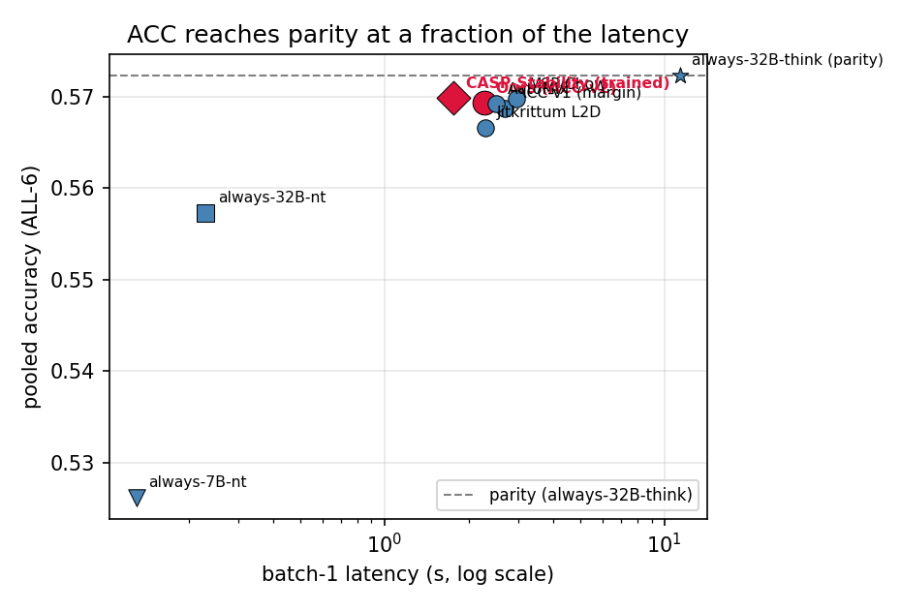
fig1_latency_accuracy_frontier.png
figs/fig2_overthinking_perbench.png
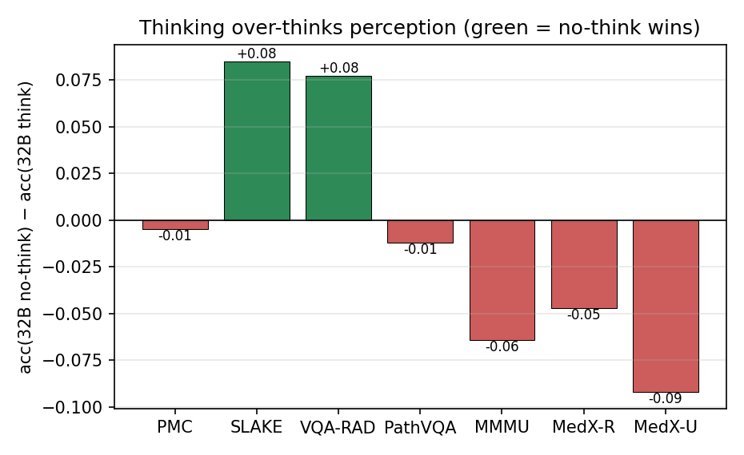
fig2_overthinking_perbench.png
Honest note. The agreement rule we use to decide when to think is not new (it's shared with prior
"agreement-based cascading"). What's new is the structure — using the big model's fast mode as a middle
tier. The title of the paper reflects this: "It's the compute configuration, not the gate."
____________________________________________________________

5. The wall — why a "smarter gate" doesn't exist (the negative that motivates everything)
We tried, exhaustively, to build a better decision rule with no extra training. Twelve different signals
(confidence, entropy, agreement, self-checking, conformal prediction, learned routers, …) **all hit the same
ceiling (AUROC ≈ 0.5–0.69). The reason: the cheap and big models fail on the same questions** (correlation
φ = 0.37) — 58% of the cheap model's mistakes the big model also gets wrong. You can tell that the cheap
model is unsure, but not whether the big model would fix it.
The same wall appears for selection: sample the model 8 times and a correct answer is often in there
(e.g., one task: 73% → 88% if you could always pick the right try), **but no untrained rule beats picking at
random — the luck floor. It even holds for bounding boxes. Detail in paper §5.2** + writeups
OPENENDED_SELECTION_LUCKFLOOR.md, RECOVERABILITY_IS_CAPACITY_BOUND.md.
A useful twist (paper §5.3): this wall looks worse than it is on multiple-choice tests, because a
single A/B/C/D letter is too coarse a signal. On open-ended (free-text) answers the same confidence signal
jumps from AUROC ~0.6 to ~0.87. So medical-VLM cascades should be tested open-ended — which is exactly
where the verifier (next) works.
____________________________________________________________

6. Result 2 — the trained verifier: breaking the luck floor (the accuracy win)
The idea. The luck floor is a property of frozen models. If we train a small helper to score
"is this candidate answer correct?", it can pick the best of N tries — and it works.
For free-text answers, the trained verifier recovers 49% of the oracle gap (averaged over 4 datasets,
and it transfers to a 5th it never saw):
dataset | cheap model | + trained verifier | best possible (oracle)
PathVQA | 0.352 | 0.441 | 0.513
Kvasir | 0.282 | 0.405 | 0.493
VQA-RAD | 0.519 | 0.611 | 0.722
SLAKE | 0.738 | 0.762 | 0.895
average | 0.413 | 0.501 | 0.592
For bounding boxes (pointing to the right place in the image), the same idea works — including on a
real chest-X-ray benchmark (MS-CXR):
task | cheap | + trained verifier | gap captured
SLAKE organs | 0.197 | 0.255 | 40%
MS-CXR chest X-ray | 0.041 | 0.232 | 78% (a 5.6× lift)
Why we trust it:
- It genuinely tells right from wrong (AUROC 0.924 at scoring individual answers — see figure), and it
uses the image (blanking the image hurts it).
- It beats an untrained version, and even beats the 5× bigger 32B model's answer.
- It's statistically significant (bootstrap confidence intervals exclude zero on both headline results).
- It's a test-time-scaling method: give it more samples, it gets better (random selection does not).
- Test-time compute beats parameters: the small 7B with the verifier (0.501) beats the big 32B's single
answer (0.444) — because, for these questions, thinking bigger barely helps but checking helps a lot.
figs/limits/fig_trained_verifier_unified.png
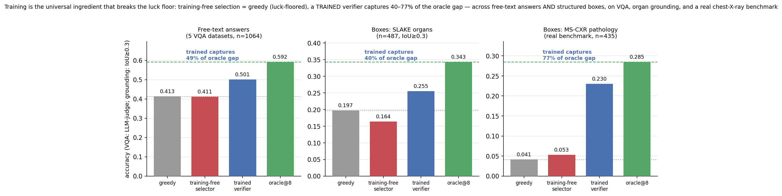
fig_trained_verifier_unified.png
figs/limits/fig_verifier_discrimination.png
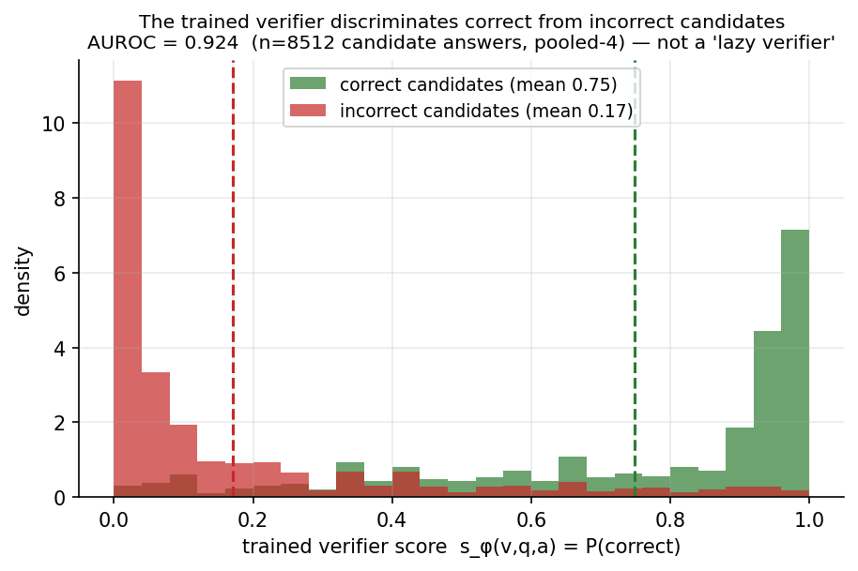
fig_verifier_discrimination.png
figs/limits/fig_verifier_scaling.png
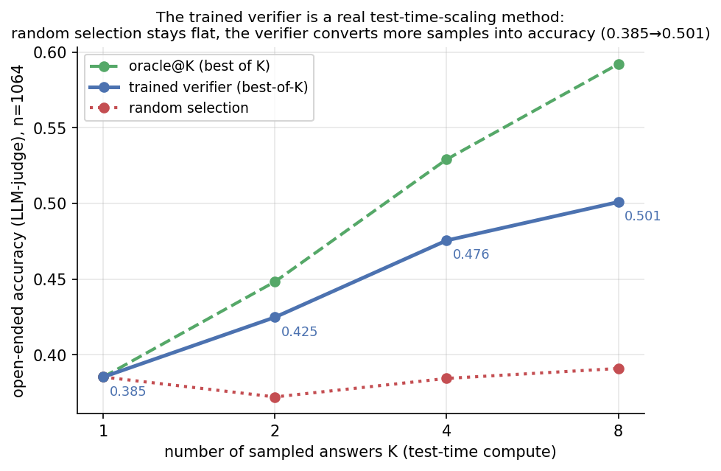
fig_verifier_scaling.png
figs/limits/fig_verifier_pareto.png
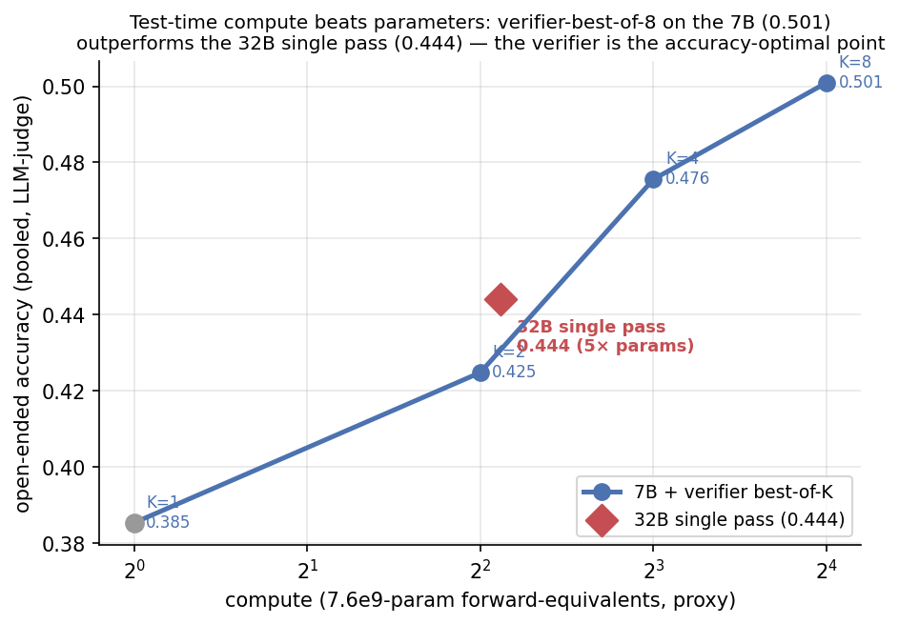
fig_verifier_pareto.png
Detail in paper §6 + writeups TRAINED_VERIFIER_RESULT.md, BOX_VERIFIER_RESULT.md. Is it novel? The
mechanism (a trained verifier for best-of-N) exists in text NLP; what's new is the **medical application +
unifying answers and boxes**, as a direct rebuttal to a recent paper ("Verification Mirage") that said
self-checking fails in medical VQA.
____________________________________________________________

7. Where the project stands
- Two solid, complementary contributions: ACC (efficiency: −80% latency, ~5× energy, at parity) and the
trained verifier (accuracy: 40–78% of the oracle gap, answers and boxes, a real benchmark).
- A thorough negative-result map (the luck floor) that makes both positives meaningful.
- Paper restructured around these two results (paper/cvgip2026_draft.md), with an IEEE PDF
(paper/cvgip2026_ieee.pdf) and this overview.
- All numbers audited against the raw result files; inconsistencies found and fixed
(INCONSISTENCIES.md, GROUND_TRUTH_NUMBERS.md).
Where to read more (in order): this file → READING_GUIDE.md (a step-by-step tour) → paper/cvgip2026_draft.md
(the full paper) → the results/cascade_methods/*.md deep-dives. Open question / next step: push the
verifier further (bigger verifier, more datasets, cross-model reuse) to strengthen the novelty.

