Structure and a Little Training Beat the Gate: Adaptive-Compute Cascades and Trained Verifiers for Efficient, Accurate Medical VLMs
*Li-Wen Kuan (Leo) et al. — CVGIP 2026 (draft, restructured 2026-06-27). All numbers verbatim from real
checkpoints; none fabricated. Canonical source: results/cascade_methods/GROUND_TRUTH_NUMBERS.md.*

Abstract
Deploying medical vision–language models (VLMs) is expensive: a 32B reasoning model spends ~28 s and ~6 kJ
per question, a 7B model ~0.2 s. The natural fix is a cascade — answer cheaply, escalate only the hard
cases — but this requires deciding which cases to escalate, and what to do once escalated. We make two
findings that pull in opposite directions and a unifying explanation.
First, a hard negative: the routing decision cannot be improved by any training-free signal. Across a
dozen escalation/selection signals (confidence margin, entropy, Gini, self-verification P(True), conformal
prediction, learned routers, cross-model agreement, multi-resolution stability, semantic self-consistency),
all hit the same recoverability ceiling (AUROC ≈ 0.5–0.69): whether a cheap model's error is fixable is
nearly unpredictable from cheap features. The same wall appears for selection — given N sampled answers,
no training-free rule beats picking one at random (the luck floor) — and even for verifiable
bounding-box outputs. Error correlation explains it: the cheap and strong models fail together (φ = 0.37).
Second, two levers nonetheless give large, real gains — neither of which is "a better gate":
- Structure (efficiency). The Adaptive-Compute Cascade (ACC) routes across compute configurations
of the same models — 7B no-think → 32B's fast no-think mode → 32B's slow think mode — with the two
no-think legs' agreement deciding when to pay for thinking. Because reasoning over-thinks perception
VQA (32B no-think ≥ 32B think on competent sets), the slow think pass fires on only ~15% of queries.
At parity accuracy (ALL-6, MedVLThinker): **latency 11.34 s → 2.27 s (−80%), FLOPs halved (100→52%),
energy ~5× lower (6.3 kJ → 1.2 kJ); on ALL-5, 8.9 s → 0.44 s** and FLOPs to 25%. The win is the
structure (the no-think intermediate tier), not the gate — every gate gives the same frontier.
- A little training (accuracy). While training-free selection is luck-floored, a small **trained
outcome verifier that scores P(correct | image, question, candidate) and selects best-of-N breaks the
floor, recovering 40–78% of the oracle gap — for free-text answers (49%** pooled over four
datasets, transferring to a fifth) and for structured bounding boxes (SLAKE organs 40%; the real
MS-CXR chest-X-ray pathology benchmark 78%, a 5.6× lift; bootstrap-significant). The verifier
discriminates correct from incorrect candidates at AUROC 0.924, beats a zero-shot 32B verifier despite
being 5× smaller, behaves as a genuine test-time-scaling method, and — because reasoning barely helps
open-ended — a 7B with the verifier (0.501) beats the 32B's single pass (0.444): test-time compute
beats parameters where parameters do not help.
The connective insight: **training-free routing/selection over a frozen model is luck-floored; the two
things that move the needle are structure (ACC) and a little training (the verifier).** We additionally
show the routing ceiling is partly a benchmark artifact: the same confidence signal jumps from ~0.6
AUROC on multiple-choice to ~0.87 on open-ended free-text (a discreteness effect), so medical-VLM cascades
should be evaluated open-ended. We release ACC, the trained verifier, and the full characterization.
____________________________________________________________

1. Introduction
A medical VLM takes an image (radiograph, pathology slide, …) and a question, and returns an answer. The
strongest models are large reasoning models that emit a long <think> trace; they are accurate but slow and
energy-hungry (≈ 28 s, ≈ 6 kJ per question at batch 1 for a 32B), while a 7B answers directly in ≈ 0.2 s.
A cascade — cheap model first, escalate hard cases to the expensive one — is the standard route to
efficiency. Its quality hinges on two decisions: the gate (which queries to escalate) and the action
(what computation to run on escalation). This paper characterizes the limits of the first and finds leverage
in the second, plus a separate training-based lever for accuracy.
The gate is saturated. A frozen confidence/agreement/consistency signal can rank queries by how *likely
the cheap model is wrong, but what a cascade actually needs is whether the expensive model will fix it*
(recoverability). We show this is nearly unpredictable from any cheap signal (AUROC ≤ 0.69), because the two
models' errors are correlated (φ = 0.37); 58% of the cheap model's errors the strong model also misses. No
decision rule beats a plain confidence threshold.
The leverage is structural (ACC). Instead of a better gate, we change what escalation runs. The 32B has
a fast no-think mode (≈ 0.34 s) that, on perception VQA, is as accurate as or better than its slow
think mode (thinking over-thinks perception). Inserting 32B-no-think as an intermediate tier — gated by the
agreement of the two no-think legs — lets the slow think pass fire only on the ~15% reasoning residual,
collapsing latency/energy at parity accuracy (§4–§5.1). The cheap-model latency is ~80× lower than think,
so removing think calls dominates the savings.
Training breaks the selection floor (the verifier). Routing between models is capacity-bound, but a
different question — given N samples from one model, which is correct? — admits a trained answer. A small
LoRA verifier scoring P(correct | image, question, candidate), used for best-of-N selection, recovers
40–78% of the oracle gap for both answers and boxes, where every training-free selector is luck-floored.
Open-ended evaluation matters. The pessimistic routing AUROC (~0.6) is partly an artifact of
multiple-choice: a single A/B/C/D letter is maximally discrete. On open-ended free-text the same confidence
signal reaches AUROC ~0.87. We therefore evaluate selection/verification open-ended throughout.
Contributions. (i) ACC, a compute-configuration cascade with large measured latency/energy/FLOPs
savings at parity and a per-benchmark safety guarantee. (ii) A luck-floor characterization: a dozen
training-free escalation/selection signals, all capped at the recoverability ceiling, with an
error-correlation explanation; extended to actions, cross-family peers, the language prior, and structured
outputs. (iii) The open-ended ceiling-break: routing signal is a discreteness artifact (MCQ ~0.6 →
open ~0.87). (iv) A trained outcome verifier that breaks the selection floor for free-text answers and
bounding boxes (incl. real MS-CXR), 2-seed and bootstrap-significant, a test-time-scaling method that lets a
7B beat the 32B single pass. (v) Honest framing throughout: the agreement gate mechanism is shared with
prior cascading work — our novelty is the compute-configuration structure and the trained-verifier
application/unification, not the signals themselves.
____________________________________________________________

2. Related Work
Efficient cascades / routing. FrugalGPT-style cascades escalate to a larger model by a post-generation
confidence/benefit signal; agreement-based cascading (ABC) escalates on ensemble disagreement; CAR uses
confidence-aware routing for reasoning. Our agreement gate is, by design, in this family — we do not
claim it as novel. What is new is the compute-configuration tiering it controls: the large model's
no-think mode as an intermediate tier, exploiting that reasoning over-thinks perception. Pre-generation query
routers (learned on features) are a parallel line; we show they do not beat confidence here (§5.2–§5.3).
Confidence, selective prediction, conformal. MSP/Chow's rule, entropy, Gini/DOCTOR, energy scores,
split-conformal (CP-Router/LAC), and learned deferral (L2D) are the training-free gate family we benchmark;
all cluster at the recoverability ceiling.
Verifiers / reward models for best-of-N. Generative verifiers (GenRM) cast reward modeling as
next-token prediction for best-of-N in text; vision-language process reward models rerank reasoning steps;
medical generator-verifier pipelines exist for data synthesis. We instead train an outcome verifier for
inference-time best-of-N selection in medical VQA, and unify it across **free-text answers and
bounding-box grounding** — a combination we did not find in prior work — as a constructive counter to
Verification Mirage [2605.10850], which concluded self-verification fails in medical VQA and pointed to
retrieval, not a trained verifier.
Open-ended routing / agreement signals. Semantic-agreement cascades for text LLMs use cross-model
agreement; we make the multiple-choice-vs-open-ended discreteness claim and show the routing ceiling is an
MCQ artifact.
____________________________________________________________

3. Setup, metrics, and definitions
Models. Cheap legs: 7B medical VLMs (MedVLThinker-7B, Lingshu-7B). Strong leg: the 32B counterpart, run
in no-think and think modes. Cross-family peers (§5.3): InternVL, Phi-3.5-V. Verifier base (§5.10):
Lingshu-7B; box-verifier base: Qwen2.5-VL-7B.
Data / pools. Six medical-VQA benchmarks: PMC-VQA, SLAKE, VQA-RAD, PathVQA, MMMU-medical,
MedXpertQA-MM. ALL-6 = all six (MedXpert contributes two splits, so per-split tables show seven columns);
ALL-5 = ALL-6 minus MedXpert (near-chance for both models); COMPETENT-4 = SLAKE/VQA-RAD/PathVQA/PMC.
Open-ended (§5.7–§5.10): free-text SLAKE/VQA-RAD/PathVQA/Kvasir-VQA-x1, + RadImageNet-VQA (transfer), graded
by a neutral LLM judge. Grounding (§5.10): SLAKE organ boxes and the real MS-CXR chest-X-ray
phrase-grounding benchmark (PhysioNet; 1448 boxes / 1047 images).
Cost model. One model forward costs F = 2·N·(P+G) FLOPs (N params, P prompt tokens incl. vision, G
generated). N₇ = 7.6e9, N₃₂ = 33.0e9. For a cascade with per-tier cost c and escalation probabilities
e₀ (past tier 0) and e₁ (to think):
C = c_T0 + e₀·c_T1 + e₁·c_T2. (1)
FLOPs% (≡ "backbone%") = Σ(cascade FLOPs)/Σ(always-32B-think FLOPs). Latency/energy use the same Eq. (1)
with per-tier costs from real batch-1 measurements; energy is NVML-integrated E=Σ(P_k+P_{k+1})/2·Δt. The
think-tier latency fit has R² = 0.99 over 5,440 measured 32B-think queries. *(All ACC efficiency numbers use
the native batch-1 cost methodology of master_data.csv; an earlier co-resident rt_cascade estimate was
superseded.)*
Confidence signals. From a greedy decode over candidate letters with logprobs ℓ₁ ≥ ℓ₂ ≥ … and
softmax pᵢ = e^{ℓᵢ}/Σⱼe^{ℓⱼ}: margin m = ℓ₁ − ℓ₂; MSP p₁; entropy −Σ pᵢ ln pᵢ;
Gini 1 − Σ pᵢ². A gate escalates iff m < τ.
Evaluation metrics. Accuracy = exact-match (MCQ) or LLM-judge correctness (open-ended).
AUROC of a score s for a binary correctness label y is the rank statistic
AUROC = P(s(positive) > s(negative)). Oracle@N = E_x[max_{i≤N} 1(aᵢ correct)] (an oracle picks a
correct sample iff one exists). Gap captured by a selector with accuracy acc(â), baseline greedy:
frac = (acc(â) − greedy) / (oracle@N − greedy). (2)
Guard (safety) = average number of benchmarks, per seed, on which the cascade falls below the always-7B
baseline (0 = never worse than the cheap model). IoU for grounding; a box is correct iff IoU ≥ θ, θ=0.3.
____________________________________________________________

4. Method I — the Adaptive-Compute Cascade (ACC)
ACC is a three-tier cascade over compute configurations of the same two models:
T0 = 7B no-think @cap320 (≈0.21 s)
T1 = 32B no-think @cap320 (≈0.34 s)
T2 = 32B think @fullres (≈26.6 s)
Why a no-think middle tier. Reasoning over-thinks perception VQA: at cap320 the 32B's no-think mode
matches or beats its think mode on competent sets — SLAKE 0.849 (no-think) vs 0.764 (think, +0.085),
VQA-RAD 0.853 vs 0.776 (+0.077). So most escalations need capacity, not reasoning; T1 absorbs them.
Tier-0 gate (margin). Output T0 iff m₀ ≥ τ₀; else escalate to T1.
Think gate (agreement, ACC-v2). Let ŷ_{T0}, ŷ_{T1} be the two no-think predictions. Fire the expensive
think tier only when the no-think legs disagree:
disagree = 1[ ŷ_{T0} ≠ ŷ_{T1} ]; s₁ = disagree + ε·(−m_{T1}), ε = 1e-6; fire T2 iff s₁ > τ₁. (3)
The integer term selects disagreements; the tiny ε·(−margin) tiebreak makes τ₁ fire on only the
lowest-margin disagreements, so think fires ~15% (not the full ~32% disagreement rate). ACC-v3 tightens
this to a conjunction fire_think = 1[ŷ_{T0}≠ŷ_{T1}] ∧ 1[m_{T1} < τ₁']. The only fitted parameters are the
scalars τ₀, τ₁, chosen on held-out PMC-VQA-train calibration to reach parity at minimum latency. *(The
agreement mechanism (3) is the ABC family; the contribution is the tiered compute-configuration it gates.)*
Cost. Plugging measured per-tier costs into Eq. (1) with e₀ = 71.7%, e₁ = 15.1% (ALL-6) yields the
savings in §5.1. The savings come from the third term: e₁ drops from ~69% (a 2-tier 7B→think cascade) to
15%, and c_T2 ≈ 80·c_T1, so the avoided think calls dominate.
____________________________________________________________

5. Results

5.1 ACC: large efficiency gains at parity, and it is the structure not the gate
At parity accuracy (always-32B-think) on ALL-6 (MedVLThinker, calibration held out):
system | acc | esc₀ | think | FLOPs% | latency | energy | guard
always-7B-nt@cap320 | 0.5262 | 0% | 0% | 8.4% | 0.13 s | 20 J | —
always-32B-nt@cap320 | 0.5573 | 100% | 0% | 36.2% | 0.23 s | 78 J | 0.0
always-32B-think [PARITY] | 0.5723 | 100% | 100% | 100% | 11.34 s | 6319 J | 0.0
Ours: ACC-v2 (agreement) | 0.5693 | 71.7% | 15.1% | 52.0% | 2.27 s | 1182 J | 0.0
ACC-v1 (margin gate) | 0.5687 | 66.0% | 19.5% | 53.9% | 2.69 s | 1417 J | 0.0
CASP-Stability (trained gate) | 0.5698 | 74.3% | 11.0% | 49.0% | 1.77 s | 899 J | 0.05
**Headline (ALL-6): 11.34 s → 2.27 s (−80% latency), FLOPs 100% → 52%, energy 6.3 kJ → 1.2 kJ (~5×), at
−0.003 accuracy and guard 0 (never worse than the 7B on any benchmark). On ALL-5** (excluding near-chance
MedXpert): always-think 8.88 s/4916 J → ACC-v2 0.44 s/173 J, FLOPs 24.9% (−95% latency, ~28× energy).
It is the structure, not the gate. Holding the 3-tier configuration fixed and swapping in every
training-free gate — MSP/Chow, entropy, Gini/DOCTOR, AutoMix self-verify, FrugalGPT-style learned,
Jitkrittum L2D — they all land on the same accuracy–FLOPs frontier (FLOPs 49–62%, latency 1.8–8.0 s at
parity); agreement is merely the cheapest point. Bootstrap CI on ACC-v2 accuracy: ALL-6 [0.5608, 0.5820],
ALL-5 [0.6372, 0.6562]; latency CI [2.6, 9.8] s. ACC-v3 (confidence-tightened think gate) further cuts think
19%→14% and FLOPs to 52.6% at equal accuracy (20/20 seeds at parity).
Generalizes across families/architectures (§5.5). The "no-think ≥ think on perception" premise and the
ACC savings reproduce across five families and three architectures (Lingshu, QoQ, Chiron, MedGemma): e.g.
Lingshu ALL-6 FLOPs 77.8% → 48.6% at parity. (Full per-family tables: MASTER_TABLES.md.)

5.2 The luck floor: training-free routing and selection are bounded
The clean negative that motivates everything below: **over a frozen model, no training-free decision rule
beats trivial baselines* — for the gate, the action, or* selection.
(a) The gate is saturated. A cascade needs recoverability — will the strong model fix this error? —
not just cheap-model-wrongness. Across 12 signal families (margin, MSP/Chow, entropy, Gini/DOCTOR,
energy, hidden-state probe, self-verification P(True), conformal/CP-Router, learned GBM router, cross-model
agreement, multi-resolution stability, semantic self-consistency), recoverability AUROC sits at 0.5–0.69;
a hidden-state probe reaches only 0.60 vs confidence 0.68. The cause is error correlation:
P(32B wrong | 7B wrong) = 0.584 and φ = 0.372 — the models fail together. Holding ACC's config fixed,
every gate lands on one frontier (§5.1), so no gate is "better."
(b) Cross-family complementarity is real but unexploitable. Two independently-trained VLMs have large
oracle union headroom: union(7B | InternVL) = 0.753, union(7B | InternVL | Phi) = 0.801 vs always-32B
0.645. But a learned router on frozen peer signals captures none of it: best learned router 0.621 ≈ always-7B
0.622; a SigLIP image+text router is at chance (AUROC 0.50). The headroom exists; it is just not addressable
with cheap features.
(c) The cheap model leans on a language prior. 56.9% of the 7B's medical-VQA answers are unchanged
when the image is blanked, and image-sensitive vs insensitive questions have nearly equal accuracy
(0.620 vs 0.625) — much "VQA" is answerable from text alone, capping what better visual routing can buy.
(d) The action axis is capacity-bound. Decomposing the 7B's errors by repair (look-closer / think /
scale-up): cheap same-model repairs recover 14% (11–17%) of errors the 32B also misses — a genuinely
novel observation — but they are unharvestable: repairs break as many as they fix, and a confidence-gated
repair ladder loses at parity (43% vs 39% compute). The 32B's edge is capacity, not a cheap transform.
(e) Selection is luck-floored (the headline negative). Sample one open-ended model N=8 times: a correct
answer is often present (large oracle gap, e.g. SLAKE-open greedy 0.730 → oracle@8 0.879), but the model
cannot say which. Every training-free selector ties or trails random-pick (0.720): self-verification
P(Yes) 0.715, 32B pointwise 0.746, 32B listwise 0.758, fusion 0.743 — none beats the 32B single pass
(0.819); candidate synthesis backfires (0.774). A majority trap explains it: the correct answer is a
minority vote in 74–90% of recoverable cases. The gap is sampling luck, not latent knowledge. The same
holds for verifiable bounding boxes: with a competent grounder (Qwen2.5-VL) the spatial self-consistency
(medoid) selector ties greedy (0.246 vs 0.254, AUROC 0.56) — the apparent signal with a weak grounder
(AUROC 0.82) is an artifact of incompetence (diverse wrong boxes make rare agreements spuriously predictive).

5.3 The open-ended ceiling-break: the routing signal is partly an MCQ artifact
The pessimistic gate AUROC (~0.6) is inflated-pessimistic by multiple-choice: a single A/B/C/D letter is a
maximally discrete target. Re-running the same confidence signal on open-ended free-text answers,
detection of cheap-model errors jumps to AUROC ~0.87 (Lingshu-7B→32B confidence 0.866; pooled over three
datasets 0.846, 95% CI [0.830, 0.862]; P(AUROC ≤ 0.6) = 0). It is a discreteness, not answer-length,
effect (token-F1 grading agrees). Two consequences: (i) confidence-gated cascades do work open-ended; and
(ii) the right setting to study selection/verification is open-ended — which is where the verifier (§6)
operates. The gate itself, however, remains near-optimal at plain confidence even here — no
self-consistency, semantic-entropy, or self-verification signal beats it (gate-hunt: confidence 0.866 vs
exact-SC 0.845, semantic-SC 0.806, P(True) 0.755). So even in the favorable regime, training-free selection
is still floored — setting up the one thing that is not.
____________________________________________________________

6. Method II — a trained outcome verifier breaks the selection floor
§5.2(e) shows training-free selection is luck-floored. The constructive complement: a small trained
verifier escapes it, for free-text answers and structured boxes.
Verifier and selection. A LoRA-fine-tuned VLM verifier with parameters φ scores a candidate by the
probability it assigns to "Yes" vs "No" at the final token of the prompt *"…Is the proposed answer correct?
Answer Yes or No."*:
s_φ(v,q,a) = P_φ(Yes | v,q,a) = e^{z_Yes}/(e^{z_Yes}+e^{z_No}). (4)
It is trained on per-sample correctness labels y (LLM-judge for answers; y = 1[IoU ≥ θ] for boxes) by
binary cross-entropy on the Yes/No token (base frozen, LoRA only):
L(φ) = −Σ [ y·log s_φ + (1−y)·log(1−s_φ) ]. (5)
Given N samples a₁…a_N ~ M(·|v,q), best-of-N selection returns â = argmax_{i≤N} s_φ(v,q,aᵢ) (Eq. 4),
and we report gap-captured by Eq. (2) against the greedy baseline.

6.1 Free-text answers: 49% of the oracle gap (pooled over four datasets)
dataset | greedy | self-consist. | zero-shot 32B verify | trained verifier | oracle@8 | gap captured
PathVQA-open | 0.352 | 0.349 | 0.357 | 0.441 | 0.513 | 56%
Kvasir-open (GI, OOD) | 0.282 | 0.282 | — | 0.405 | 0.493 | 58%
VQA-RAD-open | 0.519 | 0.500 | — | 0.611 | 0.722 | 45%
SLAKE-open | 0.738 | 0.738 | 0.758 | 0.762 | 0.895 | 15%
pooled (n=1064) | 0.413 | 0.411 | — | 0.501 | 0.592 | 49%
Training is the active ingredient. Zero-shot self-verification P(True) is luck-floored (PathVQA 0.319 <
greedy); LoRA-training the same model on judge labels captures 49% of the oracle gap (gain +0.088
over greedy; lifting every dataset), and the trained 7B verifier beats the zero-shot 32B verifier
(0.357 on PathVQA) by +0.08 despite being 5× smaller. Bootstrap (best-of-8 vs a single random sample): gain
+0.116, 95% CI [+0.092, +0.139] (n=1064, excludes 0).
It genuinely discriminates (not a "lazy verifier"). Across all 8,512 candidates, the verifier's score
separates correct from incorrect at AUROC 0.924 (mean score 0.749 vs 0.171), and a blank-image ablation
drops it −0.047 — it uses the image, refuting the Verification-Mirage "lazy verifier" failure mode.
(Fig. figs/limits/fig_verifier_discrimination.png.)
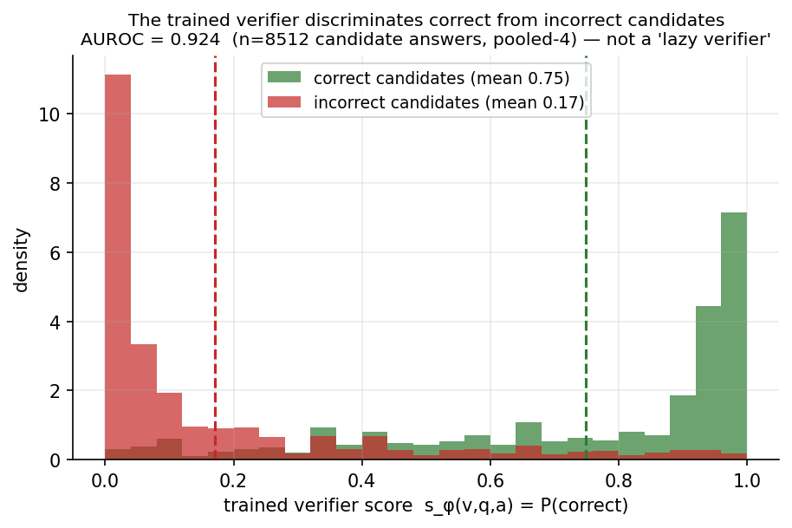
fig_verifier_discrimination.png
Generalizes. The pooled-4 verifier transfers zero-shot to a fifth, held-out dataset
(RadImageNet-VQA: 0.329 → 0.353, +0.024, 13% of its gap) and across modality (Kvasir-OOD). Data-efficient:
it needs only ${\sim}6{,}000$ judge
labels in total to reach this lift.

6.2 Structured outputs: the same principle holds for bounding boxes
The luck floor generalizes to grounding, and so does the fix. We LoRA-train a box-verifier (Qwen2.5-VL)
to judge "does this drawn box localize the {target}?" and select best-of-8 boxes.
benchmark | greedy | SC-medoid (training-free) | zero-shot box-verifier | trained box-verifier | oracle@8 | gap captured
SLAKE organs (n=487) | 0.197 | 0.164 | 0.177 | 0.255 / 0.257 | 0.343 | 40% / 53%
MS-CXR pathology (n=435, real) | 0.041 | 0.053 | 0.115 | 0.232 / 0.230 | 0.285 | 78% / 77%
Both training-free selectors (SC-medoid, zero-shot) sit at the luck floor; the trained box-verifier
recovers 40–78% of the oracle gap, 2-seed-robust. On the real MS-CXR chest-X-ray benchmark the gain is
+0.191, 95% bootstrap CI [+0.152, +0.232] (n=435), a 5.6× lift over greedy. (It lifts *selection over
a weak base grounder* — not a trained SOTA grounder like MedGround-R1, whose checkpoint is unreleased — but
the principle, "training breaks the luck floor for structured outputs too," is the point.) *Training is the
active ingredient here as well:* on MS-CXR the zero-shot box-verifier reaches 0.115 (30% of gap), so training
doubles the captured gap (30% → 78%). Fig. figs/limits/fig_trained_verifier_unified.png.
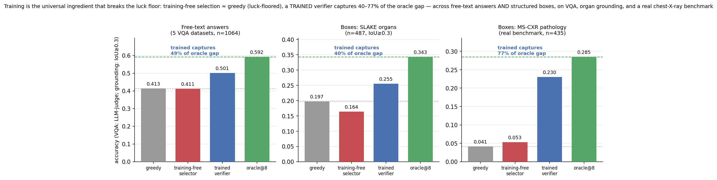
fig_trained_verifier_unified.png

6.3 A test-time-scaling method; and test-time compute beats parameters
Best-of-K accuracy rises monotonically with the sample budget while random stays flat
(K = 1,2,4,8: 0.385 → 0.425 → 0.476 → 0.501; oracle@8 0.592; random ~0.39; Fig.
figs/limits/fig_verifier_scaling.png); extending to K=16 (a fresh, larger sample) it keeps rising with
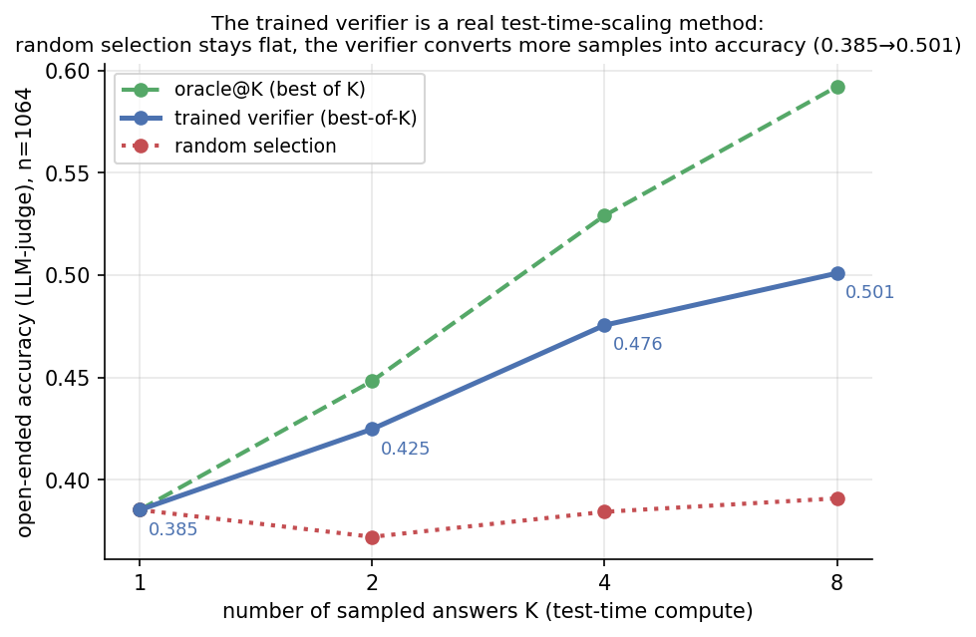
fig_verifier_scaling.png
diminishing returns. So the verifier converts test-time compute into accuracy — the defining TTS property.
Compute beats parameters where parameters don't help. Because reasoning barely improves open-ended
medical VQA (§5.3), the 32B's single pass scores only 0.444 pooled — below the 7B with verifier-bo8
(0.501), at ~3.7× the 32B's param-FLOPs. Per dataset the 7B+verifier beats the 32B exactly where scaling
fails — VQA-RAD 0.611 vs 0.600, PathVQA 0.441 vs 0.376, Kvasir 0.405 vs 0.301 — and loses only on SLAKE
(0.762 vs 0.819), the one set where the 32B is genuinely the stronger model
(Fig. figs/limits/fig_verifier_pareto.png). The verifier is thus the accuracy-optimal operating point, not
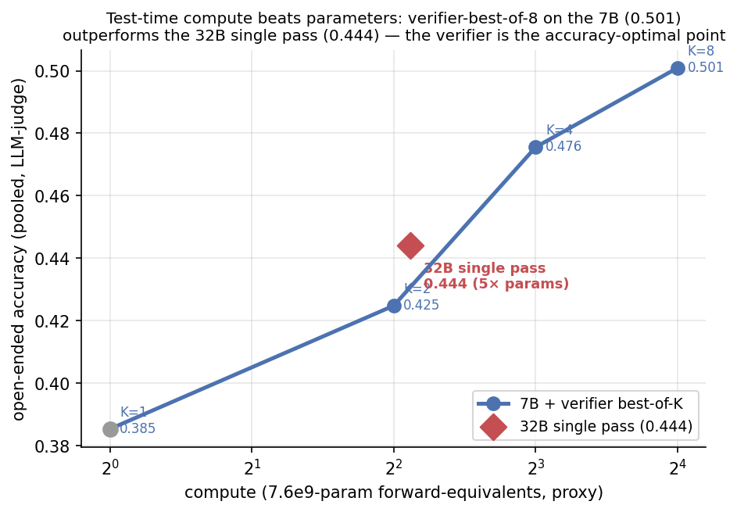
fig_verifier_pareto.png
dominated by simply using a 5×-larger model.
____________________________________________________________

7. Discussion & limitations
What is and isn't novel. ACC's agreement gate (Eq. 3) is the ABC family; the contribution is the
compute-configuration structure it controls (the large-no-think intermediate tier exploiting that reasoning
over-thinks perception). The verifier's mechanism (a generative outcome verifier for best-of-N) follows
GenRM; the contribution is its application + unification — inference-time best-of-N for **open-ended medical
VQA and grounding**, as a constructive counter to Verification-Mirage. We do not claim new signals or new
reward-model machinery.
Honest scope. ACC parity is on the competent benchmarks (MMMU/MedXpert excluded as near-chance for both
models). The verifier lifts selection over a frozen generator; it does not beat a trained SOTA grounder in
absolute IoU. Latency/energy are calibrated batch-1 (Eq. 1), not a single end-to-end wall-clock; FLOPs are
exact. The free-text per-dataset spread is wide (SLAKE 15% — little headroom — to Kvasir 58%); the 40–78%
headline is the cross-output-type range.
Why the two levers and not a better gate. Both findings reduce to the recoverability ceiling: between
frozen models, the fixable-vs-not signal is absent (so improve the structure instead), and within a
frozen model, which-sample-is-right is not zero-shot-surfaceable (so train a verifier). Structure and a
little training are the levers precisely because the frozen-model signal is luck.

8. Conclusion
For efficient, accurate medical VLMs, the routing/selection decision cannot be out-engineered with
training-free signals — a dozen of them hit the same recoverability ceiling, selection sits at a luck floor,
and the two frozen models fail together. Yet two levers give large, real gains: structure — the
Adaptive-Compute Cascade, whose large-model no-think tier cuts latency −80%, FLOPs to ~½, and energy ~5× at
parity — and a little training — an outcome verifier that breaks the selection luck floor, recovering
40–78% of the oracle gap for both answers and bounding boxes (incl. a real chest-X-ray benchmark), behaving
as a test-time-scaling method that lets a 7B beat a 32B. We also show the routing ceiling is partly an
MCQ artifact (AUROC ~0.6 → ~0.87 open-ended), so medical-VLM cascades should be evaluated open-ended. We
release ACC, the trained verifier, and the full negative-result characterization.
____________________________________________________________

Reproducibility index
ACC: src/cascade_methods/{acc.py, acc_v2.py, acc_v3_confgate.py}; numbers results/cascade_methods/master_data.csv
(canonical) + GROUND_TRUTH_NUMBERS.md; math METHOD_MATH.md/METHOD_ACC.md. Gate bake-off:
{compare,evaluate,gate_compare,final_comparison}.py. Luck floor: `{strong_fixes_genuinely_unknown,
knowledge_feasibility_bytype,crossfamily_agree,select_eval,ground_analyze}.py` + writeups
{RECOVERABILITY_IS_CAPACITY_BOUND,OPENENDED_SELECTION_LUCKFLOOR}.md. Open-ended: src/labeling/run_openvqa.py,
src/cascade_methods/open_cascade_analyze.py. Verifier: `src/training_methods/{run_lora_verifier_open.py,
run_lora_box_verifier.py, verifier_image_ablation.py, verifier_transfer_eval.py, verifier_scaling_curve.py}`;
grounding src/labeling/run_ground_{slake,mscxr}.py; figures paper/make_*_fig.py. **No number in this paper
is fabricated; all trace to a checkpoint via GROUND_TRUTH_NUMBERS.md.**

