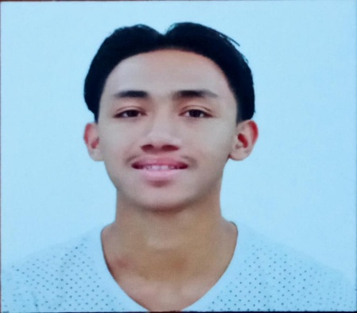

**DE LA CRUZ, lEOMAR P.**

053 PANINSINGIN TAMBO LIPA CITY

CEL#: +639460390100

leomar240230@gmail.com

**OBJECTIVES**: Seeking a position that would fit my knowledge and experiences.

**PERSONAL DATA**:

**AGE** : 19

**SEX**  : MALE

**FATHER**  : MANUEL DE LA CRUZ

**MOTHER** : ELLEN DE LA CRUZ

**RELIGION** : CATHOLIC

**NATIONALITY** : FILIPINO

**CIVIL STATUS** : SINGLE

**EDUCATIONAL BACKGROUND:**

**TERTIARY :** BATANGAS STATE UNIVERSITY

Lipa City

2021 - 20XX

**SECONDARY**  : MANILA HIGH SCHOOL

Intramuros, Manila

2018 – 2019

ST.AUGUSTINE SCHOOL OF NURSING

Mataas na Lupa, Lipa City

2019 - 2021

**PRIMARY** : PANINSINGIN ELEMENTARY SCHOOL

Paninsingin, Tambo, Lipa City

2013 – 2014

**WORKING EXPERIENCE:**

**-**NONE

**COMPETENCY SKILLS:**

* Install and Configure Computer System
* Set-up Computer Networks
* Set-up Computer Servers
* Maintain and Repair Computer Systems and Networks
* Terminate and connect electrical wiring and electronic circuits

**CHARACTER REFERENCES:**

Cel T. Morada, O.D, R.H.I.T, C.R.M.

+639153323129

*I hereby certify that the above information is true and correct with the best of my knowledge.*

**APPLICANT**