Number | KD-001
Category | Void
B-scan | 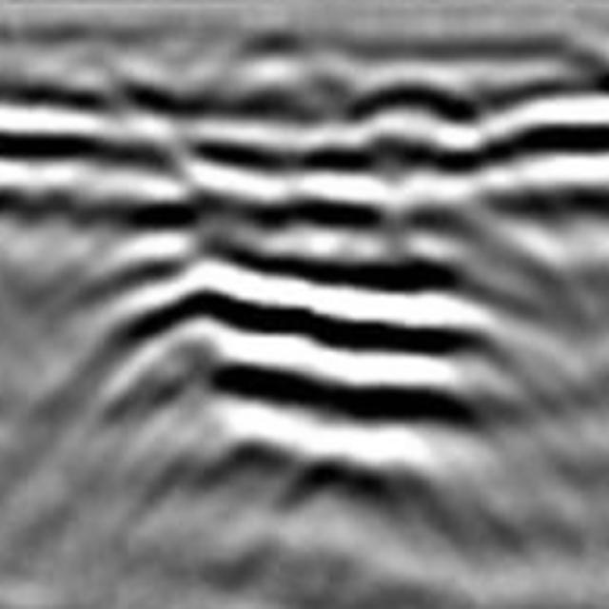
Caption | There is a GPR image. There is 1 void and 0 cracks. void1 is located in the center. Void1 has a large distribution range, strong amplitude, distinct multiple waves, and an irregular hyperbola shape.
Image of The Road Surface | 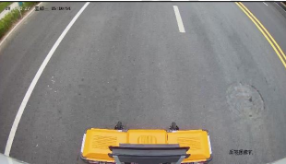
Location Information | 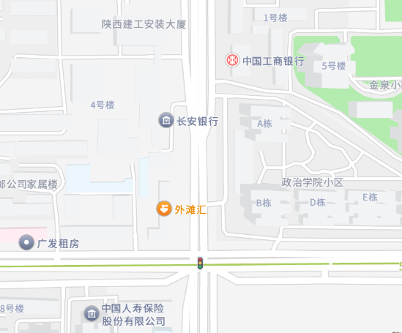
Excavation and Verification | 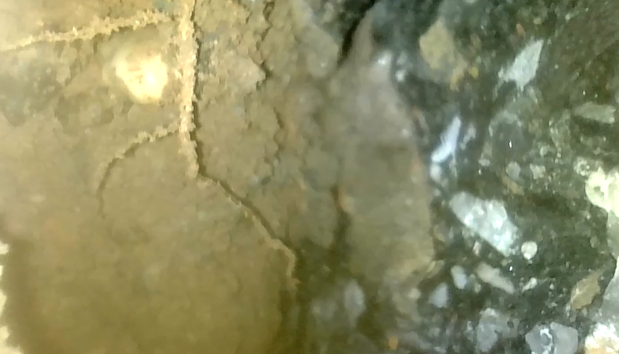  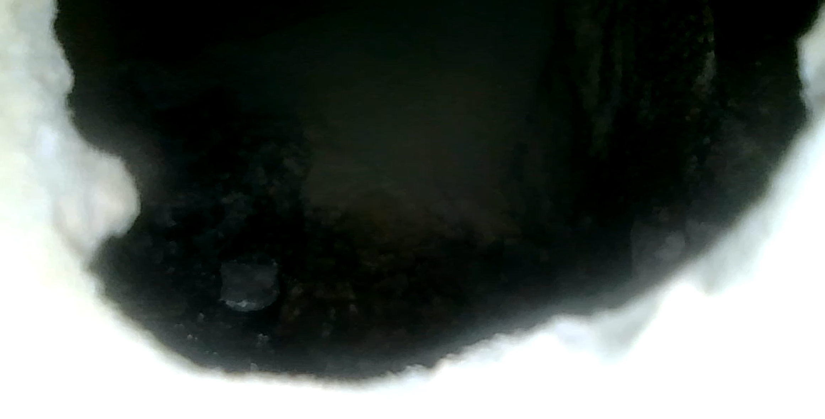

Number | LF-001
Category | Crack
B-scan | 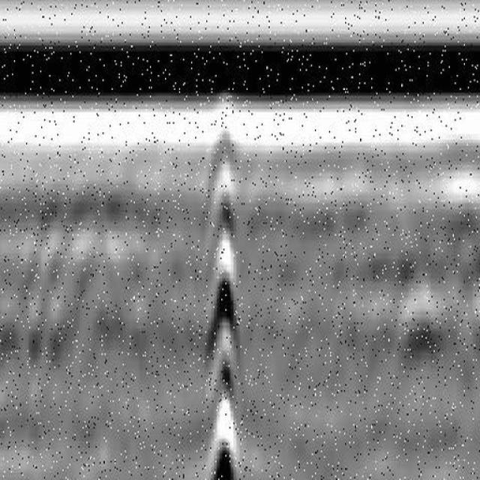
Caption | There is a GPR image. There are 0 voids and 1 crack. Crack1 is located in the center. Crack1 has a large distribution range, strong amplitude, slow attenuation, and a regular hyperbolic shape.
Image of The Road Surface | 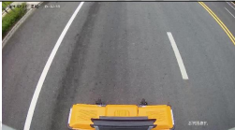
Location Information | 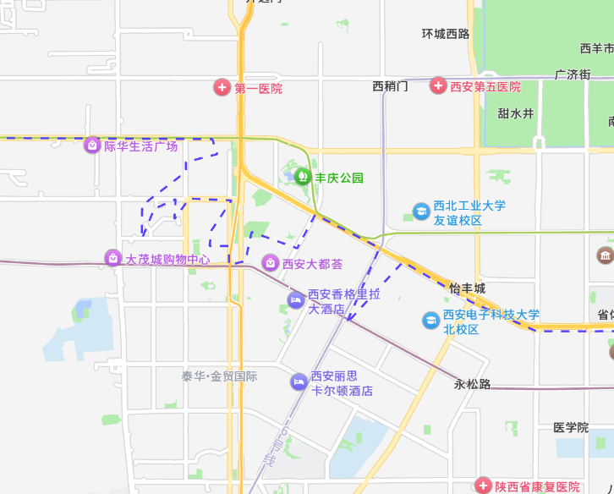
Excavation and Verification | 