C++程序设计课程设计
（2024/2025学年第二学期）

指导教师：霍戌文

班级：23计科4班
学号：2023327100056
姓名：李凯涛

任务2 快件信息管理系统

- 系统功能结构图
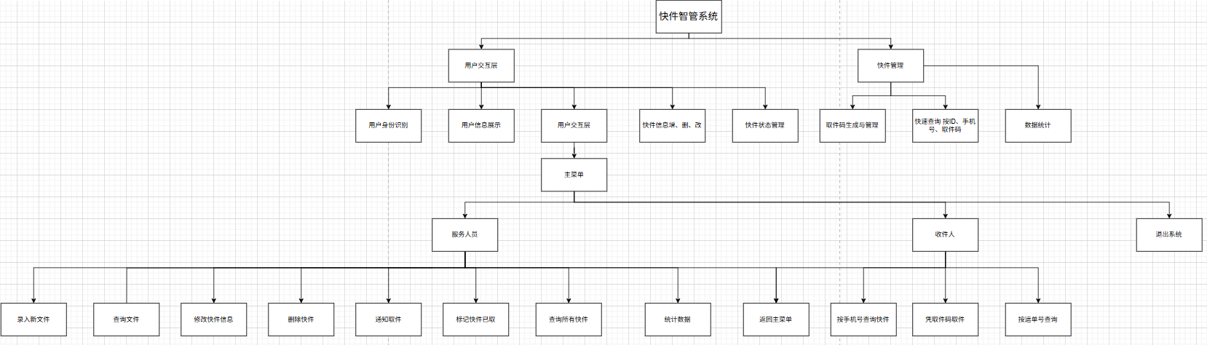

- 业务流程图
服务人员业务流程图
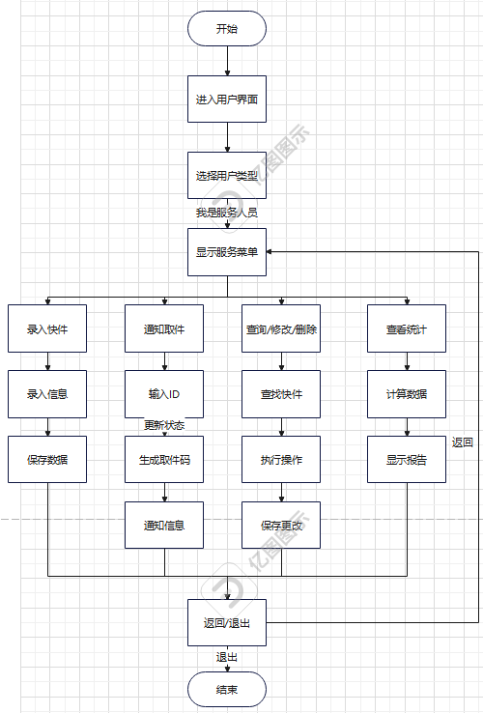
收件人业务流程
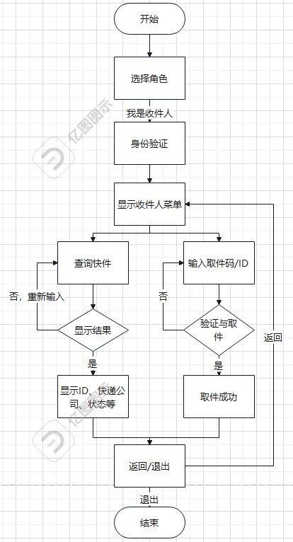
快件系统流程图
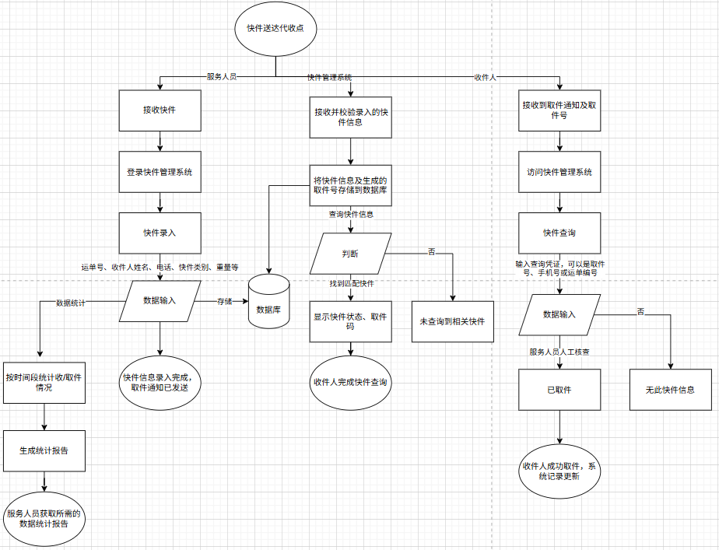
- 类的设计
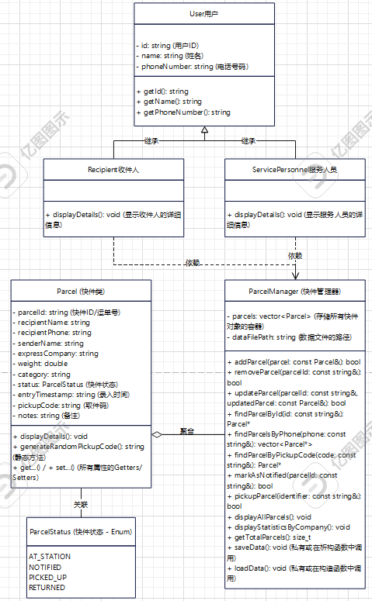

- 程序代码与说明
本系统源码共由2个源文件user. cpp、parcel. cpp、main.cpp和2个头文件user.h、parcel.h组成。
1.user.h
#pragma once
#ifndef USER_H
#define USER_H

#include <string>

// 用户基类
class User {
protected:
std::string id; // 用户ID
std::string name; // 用户姓名
std::string phoneNumber; // 用户电话号码

public:
// 构造函数
User(std::string id, std::string name, std::string phone);

// 虚析构函数（为了安全的继承）
virtual ~User() = default;

// Getters
std::string getId() const;
std::string getName() const;
std::string getPhoneNumber() const;

// Setters
void setName(const std::string& newName);
void setPhoneNumber(const std::string& newPhone);

// 纯虚函数，强制子类实现
virtual void displayDetails() const = 0;
};

// 收件人类
class Recipient : public User {
public:
// 构造函数
Recipient(std::string id, std::string name, std::string phone);

// 实现基类的纯虚函数
void displayDetails() const override;
};

// 服务人员类
class ServicePersonnel : public User {
public:
// 构造函数
ServicePersonnel(std::string id, std::string name, std::string phone);

// 实现基类的纯虚函数
void displayDetails() const override;
};

#endif // USER_H

2. parcel.h
#define _CRT_SECURE_NO_WARNINGS 1
#include <iostream>
#include <string>
#include <vector>
#include <limits> // Required for std::numeric_limits

#include "user.h"
#include "parcel.h"

void displayMenuService() {
std::cout << "\n===== 服务人员操作菜单 =====" << std::endl;
std::cout << "1. 录入新快件" << std::endl;
std::cout << "2. 查询快件 (按ID/取件码/手机号)" << std::endl;
std::cout << "3. 修改快件信息 (按ID)" << std::endl;
std::cout << "4. 删除快件 (按ID)" << std::endl;
std::cout << "5. 通知取件 (生成取件码)" << std::endl;
std::cout << "6. 标记快件为已取 (模拟后台操作)" << std::endl;
std::cout << "7. 查看所有快件" << std::endl;
std::cout << "8. 查看统计数据" << std::endl;
std::cout << "9. 返回主菜单" << std::endl;
std::cout << "请输入选项: ";
}

void displayMenuRecipient() {
std::cout << "\n===== 收件人服务菜单 =====" << std::endl;
std::cout << "1. 查询我的快件 (按手机号)" << std::endl;
std::cout << "2. 凭取件码取件" << std::endl;
std::cout << "3. 凭借运单号(ID)查询" << std::endl;
std::cout << "4. 返回主菜单" << std::endl;
std::cout << "请输入选项: ";
}

void displayMainMenu() {
std::cout << "\n===== 快件智管系统 (控制台版) =====" << std::endl;
std::cout << "1. 我是服务人员" << std::endl;
std::cout << "2. 我是收件人" << std::endl;
std::cout << "0. 退出系统" << std::endl;
std::cout << "请选择您的角色: ";
}

// 清理输入缓冲区的辅助函数
void clearInputBuffer() {
std::cin.ignore(std::numeric_limits<std::streamsize>::max(), '\n');
}

int main() {
ParcelManager manager("parcels_data.txt"); // 数据将保存在这个文件
int mainChoice, subChoice;

// 示例用户 (实际应用中会有用户登录和权限管理)
ServicePersonnel serviceStaff("S001", "张三", "13800138000");
// Recipient recipientUser("R001", "李四", "13900139000"); // 示例

do {
displayMainMenu();
std::cin >> mainChoice;
clearInputBuffer(); // 清理换行符

if (mainChoice == 1) { // 服务人员
serviceStaff.displayDetails();
do {
displayMenuService();
std::cin >> subChoice;
clearInputBuffer();

std::string id, rName, rPhone, company, category, notes, searchId, pickupCode, senderName;
double weight;

switch (subChoice) {
case 1: // 录入新快件
std::cout << "输入快件ID(运单号): "; std::getline(std::cin, id);
std::cout << "输入收件人姓名: "; std::getline(std::cin, rName);
std::cout << "输入收件人电话: "; std::getline(std::cin, rPhone);
std::cout << "输入快递公司: "; std::getline(std::cin, company);
std::cout << "输入重量(kg): "; std::cin >> weight; clearInputBuffer();
std::cout << "输入类别: "; std::getline(std::cin, category);
std::cout << "输入寄件人姓名: "; std::getline(std::cin, senderName);
std::cout << "输入备注(可选): "; std::getline(std::cin, notes);
{
Parcel newParcel(id, rName, rPhone, company, weight, category, senderName);
if (!notes.empty()) newParcel.setNotes(notes);
manager.addParcel(newParcel);
}
break;
case 2: // 查询快件
std::cout << "输入查询标识 (ID/取件码/手机号): "; std::getline(std::cin, searchId);
{
Parcel* p = manager.findParcelById(searchId);
if (p) { p->displayDetails(); break; }
p = manager.findParcelByPickupCode(searchId);
if (p) { p->displayDetails(); break; }
std::vector<Parcel*> ps = manager.findParcelsByPhone(searchId);
if (!ps.empty()) {
for (const auto* parcelPtr : ps) parcelPtr->displayDetails();
}
else {
std::cout << "未找到快件。" << std::endl;
}
}
break;
case 3: // 修改快件信息
std::cout << "输入要修改的快件ID: "; std::getline(std::cin, searchId);
{
Parcel* p_to_update = manager.findParcelById(searchId);
if (p_to_update) {
std::cout << "当前快件信息: " << std::endl;
p_to_update->displayDetails();
std::cout << "--- 输入新信息 (留空表示不修改) ---" << std::endl;
std::string new_rName, new_rPhone, new_company, new_category, new_notes_str;
std::string new_weight_str;

std::cout << "新收件人姓名 (" << p_to_update->getRecipientName() << "): "; std::getline(std::cin, new_rName);
std::cout << "新收件人电话 (" << p_to_update->getRecipientPhone() << "): "; std::getline(std::cin, new_rPhone);
std::cout << "新快递公司 (" << p_to_update->getExpressCompany() << "): "; std::getline(std::cin, new_company);
std::cout << "新重量 (" << p_to_update->getWeight() << "): "; std::getline(std::cin, new_weight_str);
std::cout << "新类别 (" << p_to_update->getCategory() << "): "; std::getline(std::cin, new_category);
std::cout << "新备注 (" << p_to_update->getNotes() << "): "; std::getline(std::cin, new_notes_str);

Parcel updatedP = *p_to_update; // 创建副本进行修改
if (!new_rName.empty()) updatedP.setRecipientName(new_rName);
if (!new_rPhone.empty()) updatedP.setRecipientPhone(new_rPhone);
if (!new_company.empty()) updatedP.setExpressCompany(new_company);
if (!new_weight_str.empty()) {
try { updatedP.setWeight(std::stod(new_weight_str)); }
catch (const std::exception& e) { std::cout << "重量格式无效，未修改。\n"; }
}
if (!new_category.empty()) updatedP.setCategory(new_category);
if (!new_notes_str.empty()) updatedP.setNotes(new_notes_str);

manager.updateParcel(searchId, updatedP);
}
else {
std::cout << "未找到ID为 " << searchId << " 的快件。" << std::endl;
}
}
break;
case 4: // 删除快件
std::cout << "输入要删除的快件ID: "; std::getline(std::cin, searchId);
manager.removeParcel(searchId);
break;
case 5: // 通知取件
std::cout << "输入要通知的快件ID: "; std::getline(std::cin, searchId);
manager.markAsNotified(searchId);
break;
case 6: // 标记快件为已取 (模拟后台)
std::cout << "输入已取件的快件ID或取件码: "; std::getline(std::cin, searchId);
manager.pickupParcel(searchId); // 使用通用取件逻辑
break;
case 7: // 查看所有快件
manager.displayAllParcels();
break;
case 8: // 查看统计数据
std::cout << "\n总快件数: " << manager.getTotalParcels() << std::endl;
std::cout << "在站快件数 (含已通知): " << manager.getParcelsAtStationCount() << std::endl;
std::cout << "已取快件数: " << manager.getPickedUpCount() << std::endl;
manager.displayStatisticsByCompany();
break;
case 9:
std::cout << "返回主菜单..." << std::endl;
break;
default:
std::cout << "无效选项，请重试。" << std::endl;
}
} while (subChoice != 9);

}
else if (mainChoice == 2) { // 收件人
std::string userPhone;
std::cout << "请输入您的手机号进行验证 (或直接操作): ";
std::getline(std::cin, userPhone);
// 简单演示，实际应有用户验证
Recipient currentRecipient("TEMP_REC", "临时收件人", userPhone);
currentRecipient.displayDetails();

do {
displayMenuRecipient();
std::cin >> subChoice;
clearInputBuffer();
std::string queryIdentifier;

switch (subChoice) {
case 1: // 按手机号查询
{
std::cout << "正在查询手机号 " << currentRecipient.getPhoneNumber() << " 的快件..." << std::endl;
std::vector<Parcel*> recipientParcels = manager.findParcelsByPhone(currentRecipient.getPhoneNumber());
if (recipientParcels.empty()) {
std::cout << "未找到与您手机号关联的待取快件。" << std::endl;
}
else {
std::cout << "找到以下快件:" << std::endl;
for (const auto* p : recipientParcels) {
p->displayDetails();
}
}
}
break;
case 2: // 凭取件码取件
std::cout << "请输入您的取件码: ";
std::getline(std::cin, queryIdentifier);
if (manager.pickupParcel(queryIdentifier)) {
std::cout << "取件成功！" << std::endl;
}
else {
// pickupParcel内部会打印错误信息
}
break;
case 3: // 凭借运单号(ID)查询
std::cout << "请输入您的运单号(快件ID): ";
std::getline(std::cin, queryIdentifier);
{
Parcel* p = manager.findParcelById(queryIdentifier);
if (p) {
// 为保护隐私，可以只显示部分信息或确认是否属于当前用户（如果手机号匹配）
if (p->getRecipientPhone() == currentRecipient.getPhoneNumber() || p->getRecipientName() == currentRecipient.getName()) {
p->displayDetails();
}
else {
std::cout << "快件信息不属于当前验证用户。" << std::endl;
}
}
else {
std::cout << "未找到该运单号的快件。" << std::endl;
}
}
break;
case 4:
std::cout << "返回主菜单..." << std::endl;
break;
default:
std::cout << "无效选项，请重试。" << std::endl;
}
} while (subChoice != 4);
}
else if (mainChoice != 0) {
std::cout << "无效角色选择，请重试。" << std::endl;
}

} while (mainChoice != 0);

std::cout << "感谢使用快件智管系统。正在退出..." << std::endl;
return 0;
}

3.user.cpp
#define _CRT_SECURE_NO_WARNINGS 1
#include "user.h"
#include <iostream>

// --- User Class Implementation ---
User::User(std::string id, std::string name, std::string phone)
: id(id), name(name), phoneNumber(phone) {}

std::string User::getId() const {
return id;
}

std::string User::getName() const {
return name;
}

std::string User::getPhoneNumber() const {
return phoneNumber;
}

void User::setName(const std::string& newName) {
name = newName;
}

void User::setPhoneNumber(const std::string& newPhone) {
phoneNumber = newPhone;
}

// --- Recipient Class Implementation ---
Recipient::Recipient(std::string id, std::string name, std::string phone)
: User(id, name, phone) {}

void Recipient::displayDetails() const {
std::cout << "收件人信息:" << std::endl;
std::cout << " ID: " << id << std::endl;
std::cout << " 姓名: " << name << std::endl;
std::cout << " 电话: " << phoneNumber << std::endl;
}
#define _CRT_SECURE_NO_WARNINGS 1
#include "user.h"
#include <iostream>

// --- User Class Implementation ---
User::User(std::string id, std::string name, std::string phone)
: id(id), name(name), phoneNumber(phone) {}

std::string User::getId() const {
return id;
}

std::string User::getName() const {
return name;
}

std::string User::getPhoneNumber() const {
return phoneNumber;
}

void User::setName(const std::string& newName) {
name = newName;
}

void User::setPhoneNumber(const std::string& newPhone) {
phoneNumber = newPhone;
}

// --- Recipient Class Implementation ---
Recipient::Recipient(std::string id, std::string name, std::string phone)
: User(id, name, phone) {}

void Recipient::displayDetails() const {
std::cout << "收件人信息:" << std::endl;
std::cout << " ID: " << id << std::endl;
std::cout << " 姓名: " << name << std::endl;
std::cout << " 电话: " << phoneNumber << std::endl;
}

// --- ServicePersonnel Class Implementation ---
ServicePersonnel::ServicePersonnel(std::string id, std::string name, std::string phone)
: User(id, name, phone) {}

void ServicePersonnel::displayDetails() const {
std::cout << "服务人员信息:" << std::endl;
std::cout << " ID: " << id << std::endl;
std::cout << " 姓名: " << name << std::endl;
std::cout << " 电话: " << phoneNumber << std::endl;
}

// --- ServicePersonnel Class Implementation ---
ServicePersonnel::ServicePersonnel(std::string id, std::string name, std::string phone)
: User(id, name, phone) {}

void ServicePersonnel::displayDetails() const {
std::cout << "服务人员信息:" << std::endl;
std::cout << " ID: " << id << std::endl;
std::cout << " 姓名: " << name << std::endl;
std::cout << " 电话: " << phoneNumber << std::endl;
}

4.parcel.cpp
#define _CRT_SECURE_NO_WARNINGS 1
#include "parcel.h"
#include <iostream>
#include <fstream>
#include <sstream>
#include <algorithm> // For std::remove_if, std::find_if
#include <random> // For random pickup code
#include <iomanip> // For std::put_time, std::get_time
#include <map> // For statistics
#include <ctime> // Required for std::time, std::localtime in Parcel::getCurrentTimestamp

// --- Helper Functions ---
std::string parcelStatusToString(ParcelStatus status) {
switch (status) {
case ParcelStatus::AT_STATION: return "在代收点"; // At collection point
case ParcelStatus::NOTIFIED: return "已通知"; // Notified
case ParcelStatus::PICKED_UP: return "已取件"; // Picked up
case ParcelStatus::RETURNED: return "已退回"; // Returned
default: return "未知状态"; // Unknown status
}
}

// --- Parcel Class Implementation ---
Parcel::Parcel(std::string id, std::string rName, std::string rPhone,
std::string company, double w, std::string cat, std::string sName)
: parcelId(id), recipientName(rName), recipientPhone(rPhone),
senderName(sName), expressCompany(company), weight(w), category(cat),
status(ParcelStatus::AT_STATION), notes("") {
entryTimestamp = getCurrentTimestamp(); // Set entry time upon creation
pickupCode = ""; // Pickup code is usually generated upon notification
}

// Getters
std::string Parcel::getParcelId() const { return parcelId; }
std::string Parcel::getRecipientName() const { return recipientName; }
std::string Parcel::getSenderName() const { return senderName; }
std::string Parcel::getRecipientPhone() const { return recipientPhone; }
std::string Parcel::getExpressCompany() const { return expressCompany; }
double Parcel::getWeight() const { return weight; }
std::string Parcel::getCategory() const { return category; }
std::string Parcel::getEntryTimestamp() const { return entryTimestamp; }
std::string Parcel::getPickupCode() const { return pickupCode; }
ParcelStatus Parcel::getStatus() const { return status; }
std::string Parcel::getNotes() const { return notes; }

// Setters
void Parcel::setRecipientName(const std::string& name) { recipientName = name; }
void Parcel::setRecipientPhone(const std::string& phone) { recipientPhone = phone; }
void Parcel::setExpressCompany(const std::string& company) { expressCompany = company; }
void Parcel::setWeight(double w) { weight = w; }
void Parcel::setCategory(const std::string& cat) { category = cat; }
void Parcel::setStatus(ParcelStatus newStatus) { status = newStatus; }
void Parcel::setPickupCode(const std::string& code) { pickupCode = code; }
void Parcel::setNotes(const std::string& newNotes) { notes = newNotes; }
void Parcel::setParcelId(const std::string& id) { parcelId = id; }
// Setter for entryTimestamp, needed for loadData
void Parcel::setEntryTimestamp(const std::string& timestamp) { entryTimestamp = timestamp; }

void Parcel::displayDetails() const {
std::cout << "----------------------------------------" << std::endl;
std::cout << "快件ID: " << parcelId << std::endl; // Parcel ID
std::cout << " 收件人: " << recipientName << " (" << recipientPhone << ")" << std::endl; // Recipient
std::cout << " 寄件人: " << senderName << std::endl; // Sender
std::cout << " 快递公司: " << expressCompany << std::endl; // Express Company
std::cout << " 重量: " << weight << " kg, 类别: " << category << std::endl; // Weight, Category
std::cout << " 状态: " << parcelStatusToString(status) << std::endl; // Status
if (!pickupCode.empty()) {
std::cout << " 取件码: " << pickupCode << std::endl; // Pickup Code
}
std::cout << " 录入时间: " << entryTimestamp << std::endl; // Entry Time
if (!notes.empty()) {
std::cout << " 备注: " << notes << std::endl; // Notes
}
std::cout << "----------------------------------------" << std::endl;
}

std::string Parcel::generateRandomPickupCode(size_t length) {
const std::string CHARACTERS = "0123456789ABCDEFGHIJKLMNOPQRSTUVWXYZ";
std::random_device random_device;
std::mt19937 generator(random_device());
std::uniform_int_distribution<> distribution(0, static_cast<int>(CHARACTERS.length() - 1));
std::string random_string;
for (size_t i = 0; i < length; ++i) {
random_string += CHARACTERS[distribution(generator)];
}
return random_string;
}

std::string Parcel::getCurrentTimestamp() {
auto t = std::time(nullptr);
std::tm tm_snapshot;
localtime_s(&tm_snapshot, &t); // Use localtime_s for safety
std::ostringstream oss;
oss << std::put_time(&tm_snapshot, "%Y-%m-%d %H:%M:%S");
return oss.str();
}

// --- ParcelManager Class Implementation ---
ParcelManager::ParcelManager(const std::string& filePath) : dataFilePath(filePath) {
loadData();
}

ParcelManager::~ParcelManager() {
saveData();
}

bool ParcelManager::addParcel(const Parcel& parcel) {
if (findParcelById(parcel.getParcelId()) != nullptr) {
std::cerr << "错误: 快件ID " << parcel.getParcelId() << " 已存在!" << std::endl; // Error: Parcel ID ... already exists!
return false;
}
parcels.push_back(parcel);
std::cout << "信息: 快件 " << parcel.getParcelId() << " 已成功录入。" << std::endl; // Info: Parcel ... successfully added.
saveData(); // Save after adding
return true;
}

bool ParcelManager::updateParcel(const std::string& parcelIdToUpdate, const Parcel& updatedParcelDetails) {
for (auto& parcel : parcels) {
if (parcel.getParcelId() == parcelIdToUpdate) {
// Preserve some fields if not explicitly changed by updatedParcelDetails
std::string originalPickupCode = parcel.getPickupCode();
// ParcelStatus originalStatus = parcel.getStatus(); // Status changes should be through specific methods
std::string originalEntryTimestamp = parcel.getEntryTimestamp(); // Entry timestamp should not change

parcel = updatedParcelDetails; // Apply updates

// Restore fields that should not be overwritten by a generic update
parcel.setEntryTimestamp(originalEntryTimestamp);
if (updatedParcelDetails.getPickupCode().empty() && !originalPickupCode.empty()) {
parcel.setPickupCode(originalPickupCode);
}
// Note: Status should ideally be updated via markAsNotified, pickupParcel etc.
// If updatedParcelDetails comes with a status, it will be set.

std::cout << "信息: 快件 " << parcelIdToUpdate << " 信息已更新。" << std::endl; // Info: Parcel ... information updated.
saveData(); // Save after updating
return true;
}
}
std::cerr << "错误: 未找到快件ID " << parcelIdToUpdate << " 进行更新。" << std::endl; // Error: Parcel ID ... not found for update.
return false;
}

bool ParcelManager::removeParcel(const std::string& parcelId) {
auto it = std::remove_if(parcels.begin(), parcels.end(),
[&](const Parcel& p) { return p.getParcelId() == parcelId; });
if (it != parcels.end()) {
parcels.erase(it, parcels.end());
std::cout << "信息: 快件 " << parcelId << " 已删除。" << std::endl; // Info: Parcel ... deleted.
saveData(); // Save after removing
return true;
}
std::cerr << "错误: 未找到快件ID " << parcelId << " 进行删除。" << std::endl; // Error: Parcel ID ... not found for deletion.
return false;
}

bool ParcelManager::markAsNotified(const std::string& parcelId) {
Parcel* parcel = findParcelById(parcelId);
if (parcel) {
if (parcel->getStatus() == ParcelStatus::AT_STATION) {
parcel->setPickupCode(Parcel::generateRandomPickupCode());
parcel->setStatus(ParcelStatus::NOTIFIED);
std::cout << "信息: 快件 " << parcelId << " 已生成取件码 " << parcel->getPickupCode() << " 并标记为已通知。" << std::endl; // Info: Parcel ... pickup code ... generated and marked as notified.
std::cout << " 模拟通知: 短信已发送至 " << parcel->getRecipientPhone() // Simulated notification: SMS sent to ...
<< "，取件码为 " << parcel->getPickupCode() << std::endl; // , pickup code is ...
saveData(); // Save after state change
return true;
}
else {
std::cerr << "错误: 快件 " << parcelId << " 当前状态为 " << parcelStatusToString(parcel->getStatus()) << "，无法标记为已通知。" << std::endl; // Error: Parcel ... current status is ..., cannot be marked as notified.
return false;
}
}
std::cerr << "错误: 未找到快件ID " << parcelId << "。" << std::endl; // Error: Parcel ID ... not found.
return false;
}

Parcel* ParcelManager::findParcelById(const std::string& parcelId) {
for (auto& parcel : parcels) {
if (parcel.getParcelId() == parcelId) {
return &parcel;
}
}
return nullptr;
}

Parcel* ParcelManager::findParcelByPickupCode(const std::string& pickupCode) {
if (pickupCode.empty()) return nullptr;
for (auto& parcel : parcels) {
// Only find if it's not already picked up or returned
if (parcel.getPickupCode() == pickupCode &&
(parcel.getStatus() == ParcelStatus::NOTIFIED || parcel.getStatus() == ParcelStatus::AT_STATION)) {
return &parcel;
}
}
return nullptr;
}

std::vector<Parcel*> ParcelManager::findParcelsByPhone(const std::string& recipientPhone) {
std::vector<Parcel*> found;
for (auto& parcel : parcels) {
// Only find if it's not already picked up or returned
if (parcel.getRecipientPhone() == recipientPhone &&
(parcel.getStatus() == ParcelStatus::AT_STATION || parcel.getStatus() == ParcelStatus::NOTIFIED)) {
found.push_back(&parcel);
}
}
return found;
}

bool ParcelManager::pickupParcel(const std::string& identifier) {
Parcel* parcelToPickup = nullptr;

parcelToPickup = findParcelByPickupCode(identifier);

if (!parcelToPickup) {
std::vector<Parcel*> phoneMatches = findParcelsByPhone(identifier);
if (phoneMatches.size() == 1) {
parcelToPickup = phoneMatches[0];
}
else if (phoneMatches.size() > 1) {
std::cout << "找到多个与手机号 " << identifier << " 关联的快件，请输入快件ID或取件码进行取件:" << std::endl; // Multiple parcels found for phone ..., please enter Parcel ID or Pickup Code:
for (const auto* p : phoneMatches) {
p->displayDetails(); // Display details to help user choose
}
return false;
}
}

if (!parcelToPickup) {
parcelToPickup = findParcelById(identifier);
// Check if this ID belongs to a parcel that is AT_STATION or NOTIFIED
if (parcelToPickup && (parcelToPickup->getStatus() != ParcelStatus::AT_STATION && parcelToPickup->getStatus() != ParcelStatus::NOTIFIED)) {
parcelToPickup = nullptr; // Not a valid parcel to pickup by ID if already picked/returned
}
}

if (parcelToPickup) {
// Parcel must be AT_STATION (and then auto-notify) or NOTIFIED to be picked up
if (parcelToPickup->getStatus() == ParcelStatus::AT_STATION) {
// Auto-notify if picked up by ID/Phone before formal notification
parcelToPickup->setPickupCode(Parcel::generateRandomPickupCode()); // Generate code if not present
std::cout << "信息: 快件 " << parcelToPickup->getParcelId() << " (状态: 在站) 生成取件码 " << parcelToPickup->getPickupCode() << std::endl; // Info: Parcel ... (Status: At Station) generated pickup code ...
}

if (parcelToPickup->getStatus() == ParcelStatus::AT_STATION || parcelToPickup->getStatus() == ParcelStatus::NOTIFIED) {
parcelToPickup->setStatus(ParcelStatus::PICKED_UP);
std::cout << "信息: 快件 " << parcelToPickup->getParcelId() << " 已成功取出。" << std::endl; // Info: Parcel ... successfully picked up.
saveData(); // Save after state change
return true;
}
else {
std::cerr << "错误: 快件 " << parcelToPickup->getParcelId()
<< " 当前状态为 " << parcelStatusToString(parcelToPickup->getStatus())
<< "，无法取出。" << std::endl; // Error: Parcel ... current status is ..., cannot be picked up.
return false;
}
}

std::cerr << "错误: 未找到与 '" << identifier << "' 匹配的可取快件。" << std::endl; // Error: No matching pickable parcel found for ...
return false;
}

bool ParcelManager::markAsReturned(const std::string& parcelId) {
Parcel* parcel = findParcelById(parcelId);
if (parcel) {
if (parcel->getStatus() == ParcelStatus::AT_STATION || parcel->getStatus() == ParcelStatus::NOTIFIED) {
parcel->setStatus(ParcelStatus::RETURNED);
std::cout << "信息: 快件 " << parcelId << " 已标记为已退回。" << std::endl; // Info: Parcel ... marked as returned.
saveData(); // Save after state change
return true;
}
else {
std::cerr << "错误: 快件 " << parcelId << " 当前状态为 " << parcelStatusToString(parcel->getStatus()) << "，无法标记为已退回。" << std::endl; // Error: Parcel ... current status is ..., cannot be marked as returned.
return false;
}
}
std::cerr << "错误: 未找到快件ID " << parcelId << "。" << std::endl; // Error: Parcel ID ... not found.
return false;
}

void ParcelManager::displayAllParcels() const {
if (parcels.empty()) {
std::cout << "当前没有快件记录。" << std::endl; // No parcel records currently.
return;
}

std::cout << "\n系统中共有 " << parcels.size() << " 个快件记录:" << std::endl; // There are ... parcel records in the system:
for (const auto& parcel : parcels) {
parcel.displayDetails();
}
}

void ParcelManager::displayParcelsByStatus(ParcelStatus status) const {
std::vector<std::reference_wrapper<const Parcel>> filteredParcels;
for (const auto& parcel : parcels) {
if (parcel.getStatus() == status) {
filteredParcels.push_back(std::cref(parcel));
}
}

if (filteredParcels.empty()) {
std::cout << "没有" << parcelStatusToString(status) << "状态的快件。" << std::endl; // No parcels with status ...
return;
}

std::cout << "\n状态为 " << parcelStatusToString(status) << " 的快件共有 " << filteredParcels.size() << " 个:" << std::endl; // Parcels with status ... : ... total:
for (const auto& parcel_ref : filteredParcels) {
parcel_ref.get().displayDetails();
}
}

void ParcelManager::generateStatistics() const {
if (parcels.empty()) {
std::cout << "当前没有快件记录，无法生成统计信息。" << std::endl; // No parcel records, cannot generate statistics.
return;
}

std::map<ParcelStatus, int> statusCounts;
for (const auto& parcel : parcels) {
statusCounts[parcel.getStatus()]++;
}

std::map<std::string, int> companyCounts;
for (const auto& parcel : parcels) {
companyCounts[parcel.getExpressCompany()]++;
}

std::cout << "\n===== 快件统计信息 =====" << std::endl; // Parcel Statistics
std::cout << "总快件数: " << parcels.size() << std::endl; // Total parcels

std::cout << "\n按状态统计:" << std::endl; // Statistics by status:
for (const auto& pair : statusCounts) {
std::cout << " " << parcelStatusToString(pair.first) << ": " << pair.second
<< " (" << std::fixed << std::setprecision(2) << (pair.second * 100.0 / parcels.size()) << "%)" << std::endl;
}

std::cout << "\n按快递公司统计:" << std::endl; // Statistics by express company:
for (const auto& pair : companyCounts) {
std::cout << " " << pair.first << ": " << pair.second
<< " (" << std::fixed << std::setprecision(2) << (pair.second * 100.0 / parcels.size()) << "%)" << std::endl;
}
std::cout << "======================" << std::endl;
}

void ParcelManager::loadData() {
std::ifstream file(dataFilePath);
if (!file.is_open()) {
// std::cerr << "警告: 无法打开数据文件 " << dataFilePath << "，将创建新文件。" << std::endl; // Warning: Cannot open data file ..., a new file will be created.
// It's normal if the file doesn't exist on first run.
return;
}

parcels.clear();
std::string line;

while (std::getline(file, line)) {
std::istringstream iss(line);
std::string id_str, rName_str, rPhone_str, sName_str, company_str, cat_str, entryTimestamp_str, pickupCode_str, notes_str;
std::string weight_str; // Read weight as string first for robustness
double weight_val;
int statusInt;

// Format: ID|RecipientName|RecipientPhone|SenderName|ExpressCompany|Weight|Category|StatusInt|EntryTimestamp|PickupCode|Notes
if (std::getline(iss, id_str, '|') &&
std::getline(iss, rName_str, '|') &&
std::getline(iss, rPhone_str, '|') &&
std::getline(iss, sName_str, '|') &&
std::getline(iss, company_str, '|') &&
std::getline(iss, weight_str, '|') && // Read weight as string
std::getline(iss, cat_str, '|') &&
(iss >> statusInt) && iss.ignore() && // Read status as int
std::getline(iss, entryTimestamp_str, '|') &&
std::getline(iss, pickupCode_str, '|') &&
std::getline(iss, notes_str)) { // Notes is the last field, can be empty

try {
weight_val = std::stod(weight_str); // Convert weight string to double
}
catch (const std::invalid_argument& ia) {
std::cerr << "警告: 无效的重量值 '" << weight_str << "' 在行: " << line << ". 跳过此记录。" << std::endl; // Warning: Invalid weight value ... in line: ... Skipping this record.
continue;
}
catch (const std::out_of_range& oor) {
std::cerr << "警告: 重量值超出范围 '" << weight_str << "' 在行: " << line << ". 跳过此记录。" << std::endl; // Warning: Weight value out of range ... in line: ... Skipping this record.
continue;
}

Parcel parcel(id_str, rName_str, rPhone_str, company_str, weight_val, cat_str, sName_str);
parcel.setStatus(static_cast<ParcelStatus>(statusInt));
parcel.setEntryTimestamp(entryTimestamp_str); // Crucial: Set the loaded timestamp
parcel.setPickupCode(pickupCode_str);
parcel.setNotes(notes_str);

parcels.push_back(parcel);
}
else {
if (!line.empty()) { // Avoid warning for empty lines at EOF
std::cerr << "警告: 数据文件行格式错误: " << line << std::endl; // Warning: Data file line format error: ...
}
}
}
file.close();
if (parcels.size() > 0) {
std::cout << "信息: 已从 " << dataFilePath << " 加载 " << parcels.size() << " 个快件记录。" << std::endl; // Info: Loaded ... parcel records from ...
}
}

void ParcelManager::saveData() const {
std::ofstream file(dataFilePath);
if (!file.is_open()) {
std::cerr << "错误: 无法打开数据文件 " << dataFilePath << " 进行写入。" << std::endl; // Error: Cannot open data file ... for writing.
return;
}

for (const auto& parcel : parcels) {
file << parcel.getParcelId() << "|"
<< parcel.getRecipientName() << "|"
<< parcel.getRecipientPhone() << "|"
<< parcel.getSenderName() << "|"
<< parcel.getExpressCompany() << "|"
<< parcel.getWeight() << "|"
<< parcel.getCategory() << "|"
<< static_cast<int>(parcel.getStatus()) << "|"
<< parcel.getEntryTimestamp() << "|"
<< parcel.getPickupCode() << "|"
<< parcel.getNotes() << std::endl;
}
file.close();
// std::cout << "信息: 已将 " << parcels.size() << " 个快件记录保存到 " << dataFilePath << "。" << std::endl; // Info: Saved ... parcel records to ... (can be too verbose)
}

// Implementation of new statistics methods
size_t ParcelManager::getTotalParcels() const {
return parcels.size();
}

size_t ParcelManager::getParcelsAtStationCount() const {
size_t count = 0;
for (const auto& parcel : parcels) {
if (parcel.getStatus() == ParcelStatus::AT_STATION ||
parcel.getStatus() == ParcelStatus::NOTIFIED) {
count++;
}
}
return count;
}

size_t ParcelManager::getPickedUpCount() const {
size_t count = 0;
for (const auto& parcel : parcels) {
if (parcel.getStatus() == ParcelStatus::PICKED_UP) {
count++;
}
}
return count;
}

void ParcelManager::displayStatisticsByCompany() const {
std::map<std::string, int> companyStats;
if (parcels.empty()) {
std::cout << "当前没有快件记录可供统计快递公司。" << std::endl; // No parcel records to statistics by company.
return;
}
for (const auto& parcel : parcels) {
companyStats[parcel.getExpressCompany()]++;
}

std::cout << "\n快递公司收件统计:" << std::endl; // Parcel statistics by express company:
for (const auto& pair : companyStats) {
std::cout << " " << pair.first << ": " << pair.second << " 件" << std::endl; //件: items/parcels
}
}

5.main.cpp
#define _CRT_SECURE_NO_WARNINGS 1
#include <iostream>
#include <string>
#include <vector>
#include <limits> // Required for std::numeric_limits

#include "user.h"
#include "parcel.h"

void displayMenuService() {
std::cout << "\n===== 服务人员操作菜单 =====" << std::endl;
std::cout << "1. 录入新快件" << std::endl;
std::cout << "2. 查询快件 (按ID/取件码/手机号)" << std::endl;
std::cout << "3. 修改快件信息 (按ID)" << std::endl;
std::cout << "4. 删除快件 (按ID)" << std::endl;
std::cout << "5. 通知取件 (生成取件码)" << std::endl;
std::cout << "6. 标记快件为已取 (模拟后台操作)" << std::endl;
std::cout << "7. 查看所有快件" << std::endl;
std::cout << "8. 查看统计数据" << std::endl;
std::cout << "9. 返回主菜单" << std::endl;
std::cout << "请输入选项: ";
}

void displayMenuRecipient() {
std::cout << "\n===== 收件人服务菜单 =====" << std::endl;
std::cout << "1. 查询我的快件 (按手机号)" << std::endl;
std::cout << "2. 凭取件码取件" << std::endl;
std::cout << "3. 凭借运单号(ID)查询" << std::endl;
std::cout << "4. 返回主菜单" << std::endl;
std::cout << "请输入选项: ";
}

void displayMainMenu() {
std::cout << "\n===== 快件智管系统 (控制台版) =====" << std::endl;
std::cout << "1. 我是服务人员" << std::endl;
std::cout << "2. 我是收件人" << std::endl;
std::cout << "0. 退出系统" << std::endl;
std::cout << "请选择您的角色: ";
}

// 清理输入缓冲区的辅助函数
void clearInputBuffer() {
std::cin.ignore(std::numeric_limits<std::streamsize>::max(), '\n');
}

int main() {
ParcelManager manager("parcels_data.txt"); // 数据将保存在这个文件
int mainChoice, subChoice;

// 示例用户 (实际应用中会有用户登录和权限管理)
ServicePersonnel serviceStaff("S001", "张三", "13800138000");
// Recipient recipientUser("R001", "李四", "13900139000"); // 示例

do {
displayMainMenu();
std::cin >> mainChoice;
clearInputBuffer(); // 清理换行符

if (mainChoice == 1) { // 服务人员
serviceStaff.displayDetails();
do {
displayMenuService();
std::cin >> subChoice;
clearInputBuffer();

std::string id, rName, rPhone, company, category, notes, searchId, pickupCode, senderName;
double weight;

switch (subChoice) {
case 1: // 录入新快件
std::cout << "输入快件ID(运单号): "; std::getline(std::cin, id);
std::cout << "输入收件人姓名: "; std::getline(std::cin, rName);
std::cout << "输入收件人电话: "; std::getline(std::cin, rPhone);
std::cout << "输入快递公司: "; std::getline(std::cin, company);
std::cout << "输入重量(kg): "; std::cin >> weight; clearInputBuffer();
std::cout << "输入类别: "; std::getline(std::cin, category);
std::cout << "输入寄件人姓名: "; std::getline(std::cin, senderName);
std::cout << "输入备注(可选): "; std::getline(std::cin, notes);
{
Parcel newParcel(id, rName, rPhone, company, weight, category, senderName);
if (!notes.empty()) newParcel.setNotes(notes);
manager.addParcel(newParcel);
}
break;
case 2: // 查询快件
std::cout << "输入查询标识 (ID/取件码/手机号): "; std::getline(std::cin, searchId);
{
Parcel* p = manager.findParcelById(searchId);
if (p) { p->displayDetails(); break; }
p = manager.findParcelByPickupCode(searchId);
if (p) { p->displayDetails(); break; }
std::vector<Parcel*> ps = manager.findParcelsByPhone(searchId);
if (!ps.empty()) {
for (const auto* parcelPtr : ps) parcelPtr->displayDetails();
}
else {
std::cout << "未找到快件。" << std::endl;
}
}
break;
case 3: // 修改快件信息
std::cout << "输入要修改的快件ID: "; std::getline(std::cin, searchId);
{
Parcel* p_to_update = manager.findParcelById(searchId);
if (p_to_update) {
std::cout << "当前快件信息: " << std::endl;
p_to_update->displayDetails();
std::cout << "--- 输入新信息 (留空表示不修改) ---" << std::endl;
std::string new_rName, new_rPhone, new_company, new_category, new_notes_str;
std::string new_weight_str;

std::cout << "新收件人姓名 (" << p_to_update->getRecipientName() << "): "; std::getline(std::cin, new_rName);
std::cout << "新收件人电话 (" << p_to_update->getRecipientPhone() << "): "; std::getline(std::cin, new_rPhone);
std::cout << "新快递公司 (" << p_to_update->getExpressCompany() << "): "; std::getline(std::cin, new_company);
std::cout << "新重量 (" << p_to_update->getWeight() << "): "; std::getline(std::cin, new_weight_str);
std::cout << "新类别 (" << p_to_update->getCategory() << "): "; std::getline(std::cin, new_category);
std::cout << "新备注 (" << p_to_update->getNotes() << "): "; std::getline(std::cin, new_notes_str);

Parcel updatedP = *p_to_update; // 创建副本进行修改
if (!new_rName.empty()) updatedP.setRecipientName(new_rName);
if (!new_rPhone.empty()) updatedP.setRecipientPhone(new_rPhone);
if (!new_company.empty()) updatedP.setExpressCompany(new_company);
if (!new_weight_str.empty()) {
try { updatedP.setWeight(std::stod(new_weight_str)); }
catch (const std::exception& e) { std::cout << "重量格式无效，未修改。\n"; }
}
if (!new_category.empty()) updatedP.setCategory(new_category);
if (!new_notes_str.empty()) updatedP.setNotes(new_notes_str);

manager.updateParcel(searchId, updatedP);
}
else {
std::cout << "未找到ID为 " << searchId << " 的快件。" << std::endl;
}
}
break;
case 4: // 删除快件
std::cout << "输入要删除的快件ID: "; std::getline(std::cin, searchId);
manager.removeParcel(searchId);
break;
case 5: // 通知取件
std::cout << "输入要通知的快件ID: "; std::getline(std::cin, searchId);
manager.markAsNotified(searchId);
break;
case 6: // 标记快件为已取 (模拟后台)
std::cout << "输入已取件的快件ID或取件码: "; std::getline(std::cin, searchId);
manager.pickupParcel(searchId); // 使用通用取件逻辑
break;
case 7: // 查看所有快件
manager.displayAllParcels();
break;
case 8: // 查看统计数据
std::cout << "\n总快件数: " << manager.getTotalParcels() << std::endl;
std::cout << "在站快件数 (含已通知): " << manager.getParcelsAtStationCount() << std::endl;
std::cout << "已取快件数: " << manager.getPickedUpCount() << std::endl;
manager.displayStatisticsByCompany();
break;
case 9:
std::cout << "返回主菜单..." << std::endl;
break;
default:
std::cout << "无效选项，请重试。" << std::endl;
}
} while (subChoice != 9);

}
else if (mainChoice == 2) { // 收件人
std::string userPhone;
std::cout << "请输入您的手机号进行验证 (或直接操作): ";
std::getline(std::cin, userPhone);
// 简单演示，实际应有用户验证
Recipient currentRecipient("TEMP_REC", "临时收件人", userPhone);
currentRecipient.displayDetails();

do {
displayMenuRecipient();
std::cin >> subChoice;
clearInputBuffer();
std::string queryIdentifier;

switch (subChoice) {
case 1: // 按手机号查询
{
std::cout << "正在查询手机号 " << currentRecipient.getPhoneNumber() << " 的快件..." << std::endl;
std::vector<Parcel*> recipientParcels = manager.findParcelsByPhone(currentRecipient.getPhoneNumber());
if (recipientParcels.empty()) {
std::cout << "未找到与您手机号关联的待取快件。" << std::endl;
}
else {
std::cout << "找到以下快件:" << std::endl;
for (const auto* p : recipientParcels) {
p->displayDetails();
}
}
}
break;
case 2: // 凭取件码取件
std::cout << "请输入您的取件码: ";
std::getline(std::cin, queryIdentifier);
if (manager.pickupParcel(queryIdentifier)) {
std::cout << "取件成功！" << std::endl;
}
else {
// pickupParcel内部会打印错误信息
}
break;
case 3: // 凭借运单号(ID)查询
std::cout << "请输入您的运单号(快件ID): ";
std::getline(std::cin, queryIdentifier);
{
Parcel* p = manager.findParcelById(queryIdentifier);
if (p) {
// 为保护隐私，可以只显示部分信息或确认是否属于当前用户（如果手机号匹配）
if (p->getRecipientPhone() == currentRecipient.getPhoneNumber() || p->getRecipientName() == currentRecipient.getName()) {
p->displayDetails();
}
else {
std::cout << "快件信息不属于当前验证用户。" << std::endl;
}
}
else {
std::cout << "未找到该运单号的快件。" << std::endl;
}
}
break;
case 4:
std::cout << "返回主菜单..." << std::endl;
break;
default:
std::cout << "无效选项，请重试。" << std::endl;
}
} while (subChoice != 4);
}
else if (mainChoice != 0) {
std::cout << "无效角色选择，请重试。" << std::endl;
}

} while (mainChoice != 0);

std::cout << "感谢使用快件智管系统。正在退出..." << std::endl;
return 0;
}

- 运行结果与分析
- 登录页面
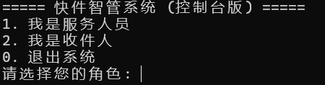
2. 服务人员操作界面
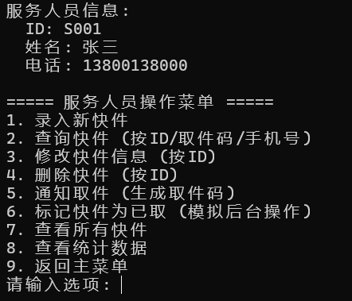
3. 收件人操作界面
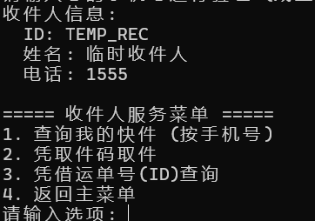
4.代收点服务人员能将快件信息录入系统
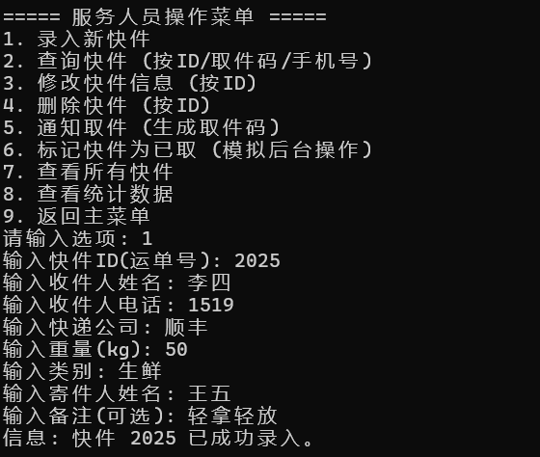
5. 收件人可查询自己的快件信息，并凭借取件号、手机号或运单编号取件
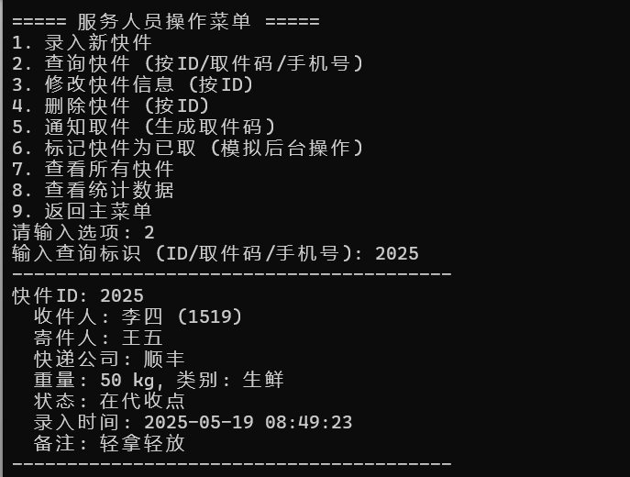
6.提供修改信息的功能
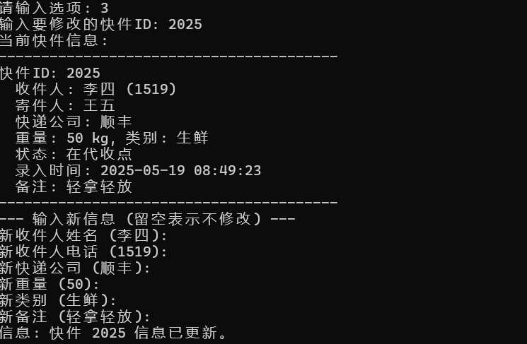
7.删除快件功能
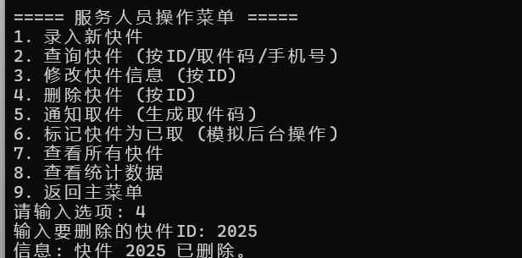
8.生成取件码功能
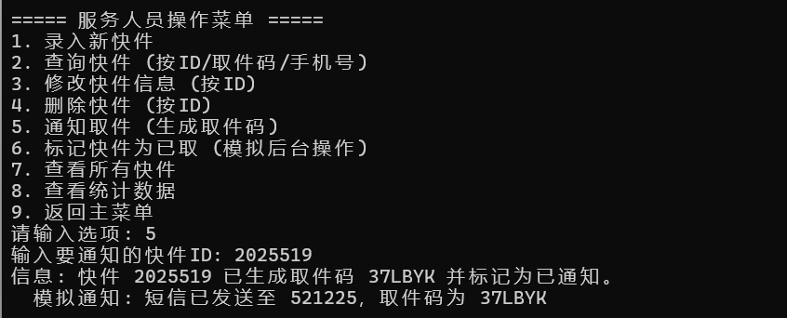
9.标记快件为取件（模拟后台操作）
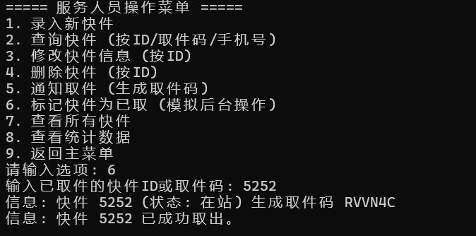
10.为代收地点提供查询功能
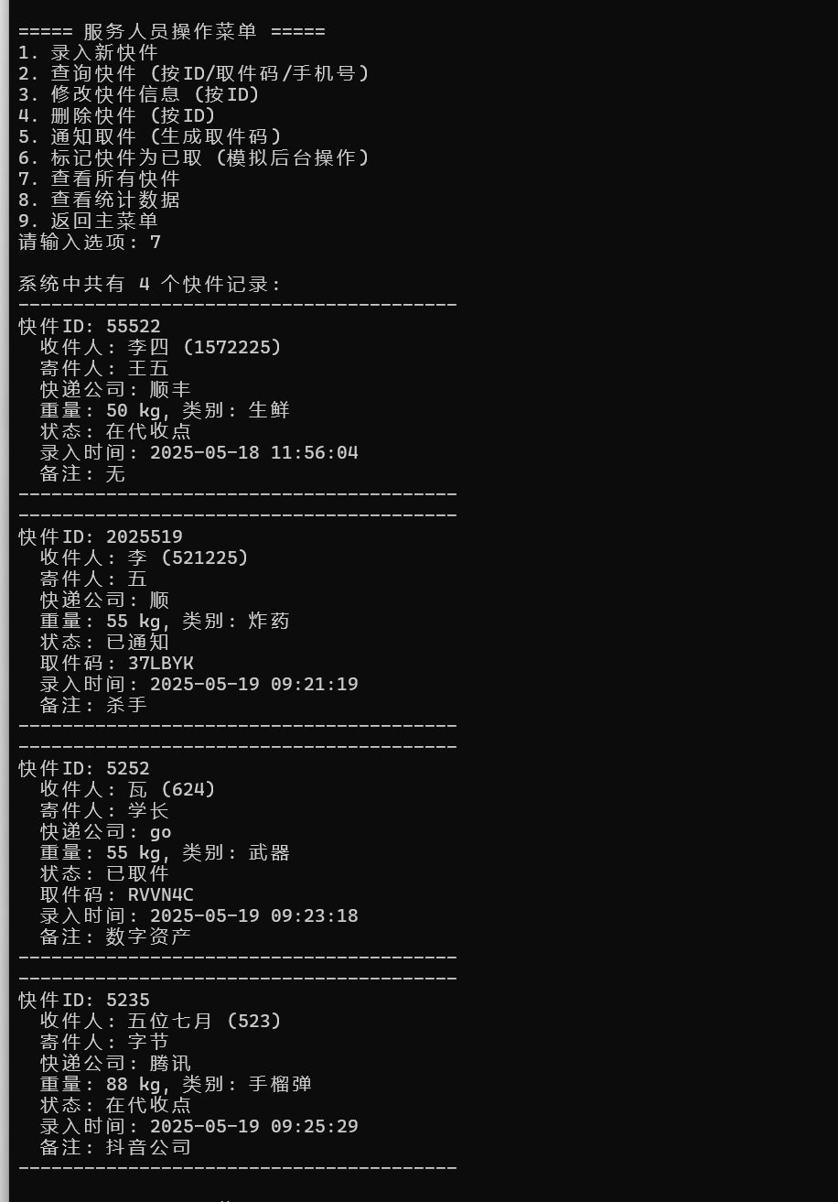
11.统计所有快递的情况
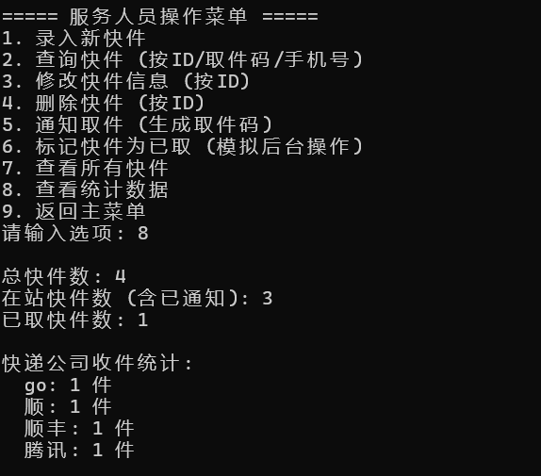
12. 收件人可查询自己的快件信息，并凭借取件号、手机号或运单编号取件
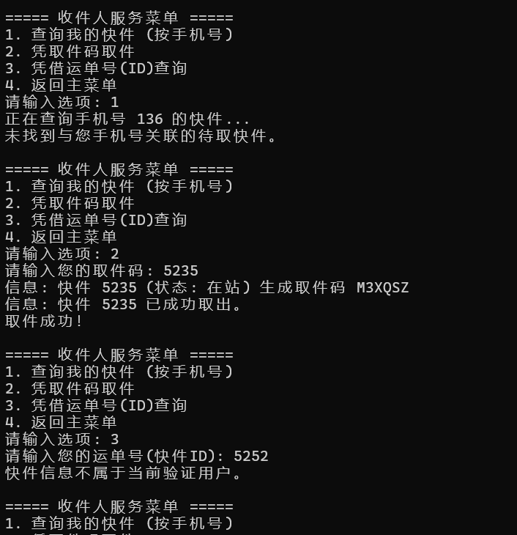

- 总结
本项目旨在设计并实现快件管理系统。主要目的是为代收点服务人员提供一个便捷，以有效管理快件信息，提高工作效率。实验的核心目标包括：
- 实现服务人员安全登录系统功能。
- 开发快件信息的完整管理功能，包括录入、查询（按多种条件）、修改、删除。
- 实现快件状态的流转管理，如通知收件人取件（自动生成取件码）、标记快件为已取件。
- 确保快件数据的持久化存储，使得系统在退出并重新登录后，历史数据（如收件、取件结果）不丢失。
快件信息管理模块（服务人员界面）上，项目使用ListView控件以列表形式清晰展示所有快件的关键信息，如快件ID、收件人、电话、状态、取件码等。在ListView中选中某个快件时，其详细信息会自动填充到左侧的编辑区域，方便查看和修改。允许服务人员修改已录入快件的信息（除ID、录入时间等关键标识外），并更新到系统和数据文件。提供删除选定快件的功能，并有确认提示，删除后数据将从系统和文件中移除。对选中的“在站”快件，可生成唯一的取件码，并将其状态更新为“已通知”。服务人员可通过输入取件码或快件ID，将对应快件的状态更新为“已取件”，并记录取件时间。
所有快件信息（包括其状态和取件码等）均保存在本地文本文件（parcels_data.txt）中。系统启动（登录成功后）时自动从该文件加载历史数据。在进行添加、修改、删除、状态变更等操作后，系统会自动将更新后的数据保存回文件，确保了数据的持久性和一致性，即使系统退出再登录，收件、取件结果也不会丢失。
实现技术与方法上，采用了面向对象的设计思想，定义了Parcel类封装快件的属性和基本操作，ParcelManager类负责管理快件对象的集合、业务逻辑处理（如增删改查、状态变更）以及数据持久化。通过一个全局的ParcelManager实例作为前后端交互的桥梁。前端的用户操作触发后，调用该实例的公共方法来处理数据。
经过测试，系统基本达到了预期的功能目标，服务人员可以通过正确的凭据登录系统快件的录入、显示（ListView）、选中加载、修改和删除功能均可正常工作。通知取件操作能够为选定快件生成取件码并更新状态；标记取件操作能够正确更新快件状态。搜索功能可以根据输入条件筛选快件列表。数据持久化机制有效，关闭程序后重新打开，之前的快件数据和状态能够正确加载和保留。界面元素基本布局合理，用户可以进行各项操作。
本次实验成功构建快件管理系统。通过这个项目，我进一步巩固了C++面向对象设计和文件操作的知识。尽管当前系统已具备基本可用性。 我们可以进一步优化界面布局，增加更友好的错误提示和用户引导。我们可以根据任务书要求，增加收件人查询界面、更详细的数据统计功能（如图表展示）、批量操作等。对于更复杂的GUI应用，可以考虑使用如MFC、Qt等更高级的GUI框架，以提高开发效率和界面的现代化程度。
总的来说，本次实验是一次宝贵的学习经历，为后续更复杂的软件项目开发打下了良好的基础。

