M QUERY

## = Table.Distinct(Source)

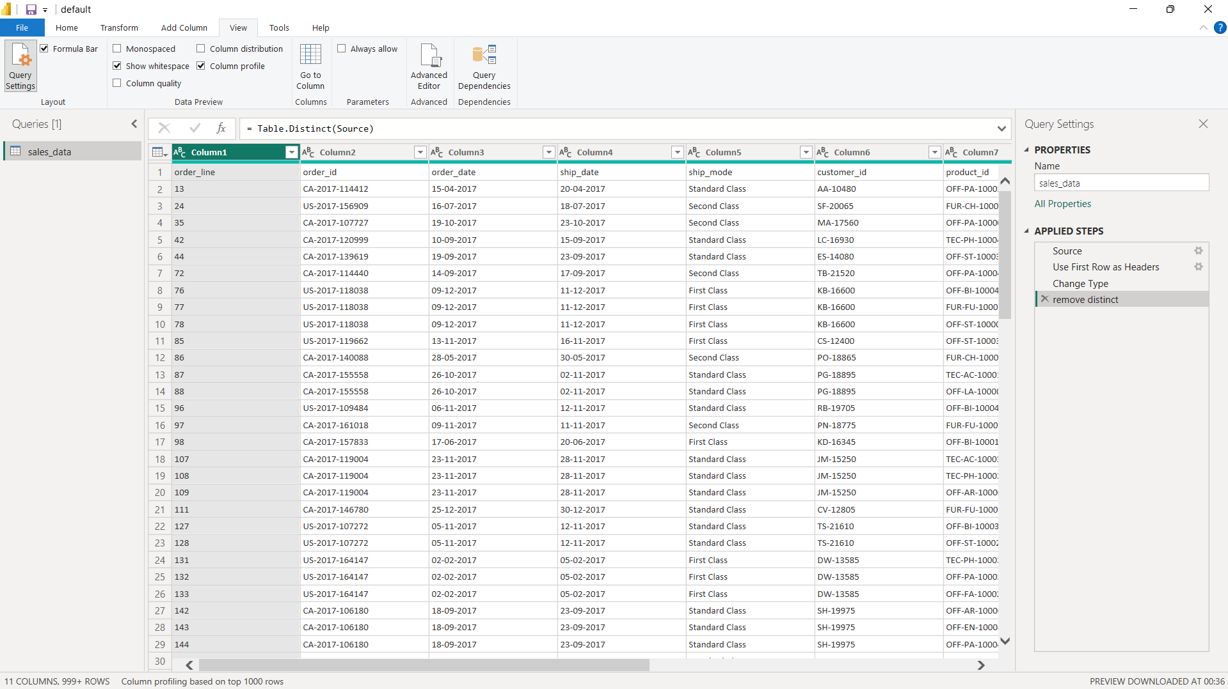**Table.Distinct(Source)** is a fundamental function in Power Query that removes duplicate rows from a table. All columns are considered when determining duplicates.

**Table.Distinct(Source)** query has now successfully removed all the duplicate rows from the table

1. = Table.PromoteHeaders

**Table.PromoteHeaders** is used in Power Query to transform the first row of a table into column headers. This is particularly useful when dealing with data sources that don't explicitly define column headers, such as CSV files without headers or certain database queries.

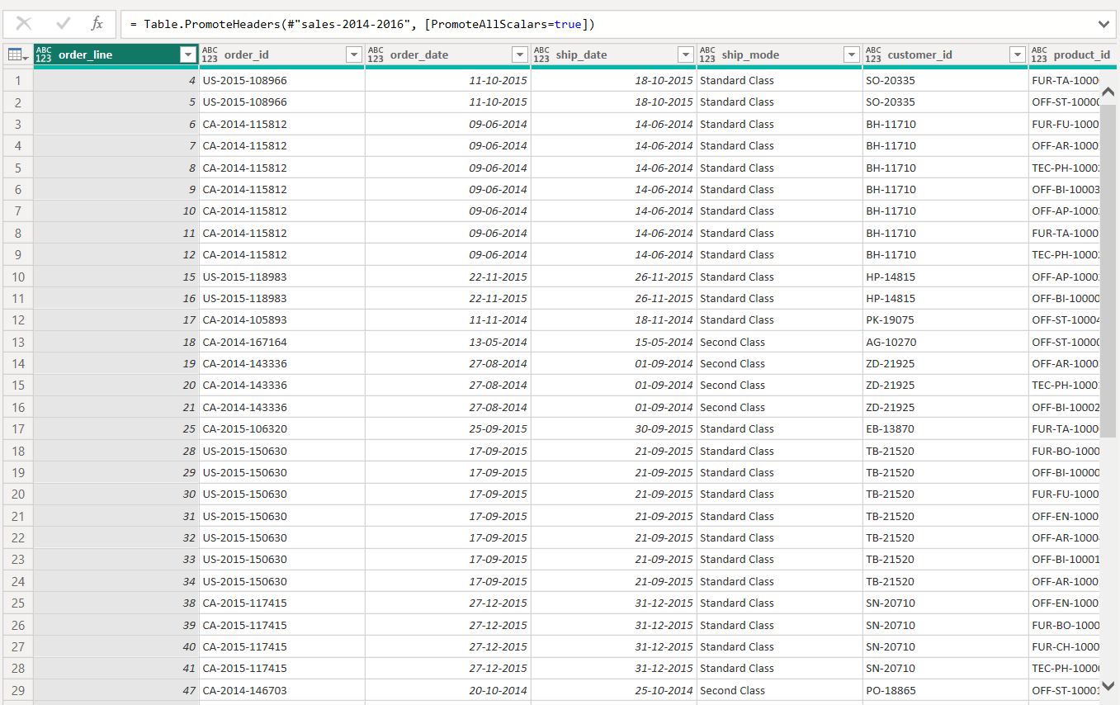

**Table.PromoteHeaders**  has now successfully set first as a header for the each of the columns