The Economics of Money, Banking, and Financial Markets
The Economics of Money, Banking, and Financial Markets 1
Part 1 Introduction 4
Ch1 Why Study Money, Banking, and Financial Markets? 4
Ch2 An Overview of the Financial System 7
Appendix to Chapter 2: Financial Market Instruments 10
Ch3 What Is Money? 14
Part 2 Financial Markets 14
Ch4 Understanding interest rates (i.r.) 14
Appendix to Chapter 4 Measuring Interest Rates: Duration 16
Ch5 The Behavior of Interest Rates 17
Ch6 The Risk and Term Structure of I.R. 19
Ch7 The Stock Market, the Theory of Rational Expectations, and the Efficient Market Hypothesis 22
Part 3 Financial Institutions 25
Ch8 An Economic Analysis of Financial Structure 25
Ch9 Banking and the Management of Financial Institutions 29
Appendix 1 to Ch9: Duration gap analysis 34
Appendix 2 to Ch9:Measuring Bank Performance 35
Ch10 Bank Industry: Structure and Competition 37
Ch11 Economic Analysis of Banking Regulation 40
Ch12 Nonbank Finance 42
Ch13 Financial Derivatives 43
Part 4 Central Banking and Conduct of Monetary Policy 44
Ch14 Structure of Central Banks and the Federal Reserve System 44
Ch15 Multiple Deposit Creation and the Money Supply Process 48
Ch16 Determinants of Money Supply 49
Appendix1 to Chapter 16 : The M2 Money Multiplier 51
Appendix2 to Chapter 16 : Expanding Behavior of The Currency Ratio 51
Ch17 Tools of Monetary Policy 52
Ch18 Conduct of Monetary Policy: Goals and Targets 53
Part 5 Int~l Finance and Monetary Policy 55
Ch19 The Foreign Exchange Market 55
Ch20 Int~l Financial System 60
Ch21 Monetary Policy Strategy: The Int~l Experience 64
Part 6 Monetary Theory 68
Ch22 The Demand for Money 68
Ch23 The Keynesian Framework and the ISLM Model 71
Ch24 Monetary and Fiscal Policy in the ISLM Model 72
Ch25 Aggregate Demand and Supply Analysis 73
Ch26 Transmission Mechanism of Monetary Policy: The Evidence 74
Ch27 Money and Inflation 74
Ch28 Rational Expectations: Implications for Policy 74

Part 1 Introduction

Ch1 Why Study Money, Banking, and Financial Markets?
A security (also called a financial instrument) is a claim on the issuer’s future income or assets (any financial claim or piece of property that is subject to ownership). A bond is a debt security that promises to make payments periodically for a specified period of time.
A common stock (typically just called a stock) represents a share of ownership in a corporation. It is a security that is a claim on the earnings and assets of the corporation.
Note: The definition of bond used throughout this book is the broad one in common use by academics, which covers
short- as well as long-term debt instruments. However, some practitioners in financial markets use the word bond to describe only specific long-term debt instruments such as corporate bonds or U.S. Treasury bonds.

Historical charts of various stock indexes over differing
time periods. http://stockcharts.com/charts/historical/

“Black Monday”, October 19, 1987.
Stock prices have been extremely volatile. After the market rose in the 1980s, on “Black Monday,” October 19, 1987, it experienced the worst one-day drop in its entire history, with the Dow Jones Industrial Average (DJIA) falling by 22%. From then until 2000, the stock market experienced one of the great bull markets in its history, with the Dow climbing to a peak of over 11,000. With the collapse of the high-tech bubble in 2000, the stock market fell sharply, dropping by over 30% by 2002.

Financial intermediaries are institutions that borrow funds from people who have saved and in turn make loans to others.
Money, also referred to as the money supply, is defined as anything that is generally accepted in payment for goods or services or in the repayment of debts.

www.federalreserve.gov General information, monetary policy, banking system, research, and economic data of the Federal Reserve.
Here is the Analytic framework used to study money, banking, and financial markets:
• A simplified approach to the demand for assets
• The concept of equilibrium
• Basic supply and demand to explain behavior in financial markets
• The search for profits.
• An approach to financial structure based on transaction costs and asymmetric information
• Aggregate supply and demand analysis

Websites: www.aw.com/mishkin
http://www.forecasts.org/
www.federalreserve.gov/releases/

Ch2 An Overview of the Financial System
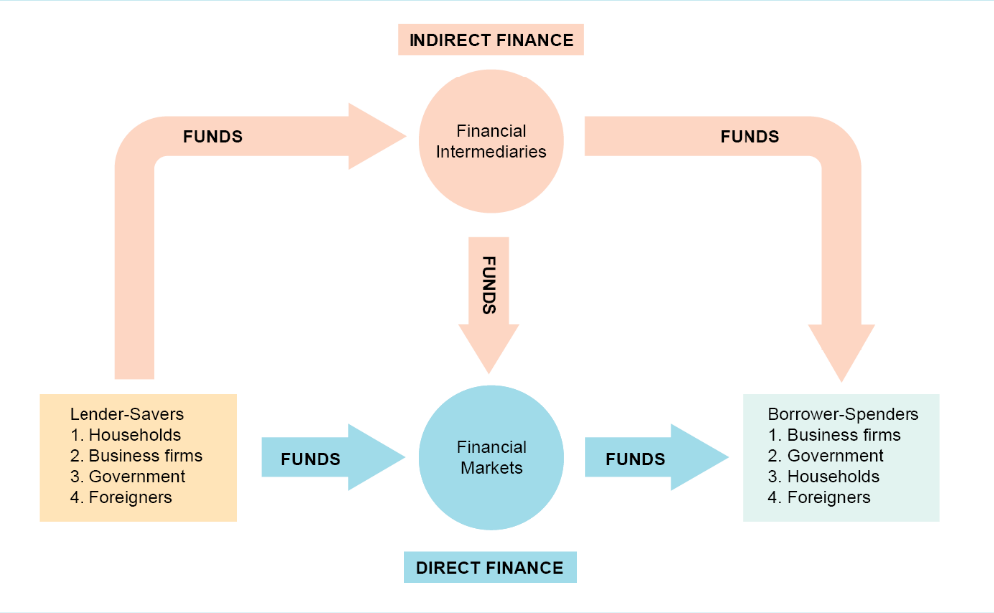

In direct finance (the route at the bottom of the above figure), borrowers borrow funds directly from lenders in financial markets by selling them securities (also called financial instruments), which are claims on the borrower’s future income or assets. Securities are assets for the person who buys them but liabilities (IOUs or debts) for the individual or firm that sells (issues) them.

http://stockcharts.com/def/servlet/Favorites.CServlet?obj=msummary&cmd=show&disp=SXA This site contains
historical stock market index charts for many countries
around the world.

The second method of raising funds is by issuing equities, such as common stock, which are claims to share in the net income (income after expenses and taxes) and the assets of a business. The main disadvantage of owning a corporation’s equities rather than its debt is that an equity holder is a residual claimant; that is, the corporation must pay all its debt holders before it pays its equity holders. The advantage of holding equities is that equity holders benefit directly from any increases in the corporation’s profitability or asset value because equities confer ownership rights on the equity holders. Debt holders
do not share in this benefit, because their dollar payments are fixed.

Securities brokers and dealers are crucial to a well-functioning secondary market. Brokers are agents of investors who match buyers with sellers of securities; dealers link buyers and sellers by buying and selling securities at stated prices.

http://quote.yahoo.com/m2?u Major world stock indices, with charts, news, and components.

The process of indirect finance using financial intermediaries, called financial intermediation, is the primary route for moving funds from lenders to borrowers.
Indeed, although the media focus much of their attention on securities markets, particularly the stock market, financial intermediaries are a far more important source of financing for corporations than securities markets are.

Why Financial Intermediaries?
- Transaction costs ( Economies of scale, liquidity services)
- Risk sharing
- asymmetric information(adverse selection, moral hazard)
when businesses go looking for funds to finance their activities, they usually obtain them indirectly through financial intermediaries and not directly from securities markets.*

Financial Intermediaries
1.Depository institutions, which we refer to as banks throughout this text for simplicity, include commercial banks and the so-called thrift institutions (thrifts): savings and loan associations, mutual savings banks, and credit unions.
2. Contractual savings institutions, insurance companies and pension funds
3. Investment intermediaries.inance companies, mutual funds, and money market mutual funds.

Reasons for regulating financial system
- To increase information available to investors
- To ensure soundness of financial intermediaries. Restrictions on Entry. Disclosure. Restrictions on Assets and Activities. Deposit Insurance. Limits on Competition. Restrictions on Interest Rates.

Appendix to Chapter 2: Financial Market Instruments
Money Market Instruments
United States Treasury Bills. These short-term debt instruments of the U.S. government are issued in 3-, 6-, and 12-month maturities to finance the federal government.
Negotiable Bank Certificates of Deposit. A certificate of deposit (CD) is a debt instrument, sold by a bank to depositors, that pays annual interest of a given amount and at maturity, pays back the original purchase price. Before 1961, CDs were nonnegotiable;
that is, they could not be sold to someone else and could not be redeemed from the bank before maturity without paying a substantial penalty. In 1961, to make CDs more liquid and more attractive to investors, Citibank introduced the first negotiable CD in large denominations (over $100,000) that could be resold in a secondary market.
Commercial Paper. Commercial paper is a short-term debt instrument issued by large banks and well-known corporations, such as General Motors and AT&T. Before the 1960s, corporations usually borrowed their short-term funds from banks, but since then they have come to rely more heavily on selling commercial paper to other financial intermediaries and corporations for their immediate borrowing needs; in other
words, they engage in direct finance.
Banker’s Acceptances. These money market instruments are created in the course of carrying out international trade and have been in use for hundreds of years. A banker’s acceptance is a bank draft (a promise of payment similar to a check) issued by a firm, payable at some future date, and guaranteed for a fee by the bank that stamps it “accepted.”
Repurchase Agreements. Repurchase agreements, or repos, are effectively short-term loans (usually with a maturity of less than two weeks) in which Treasury bills serve as collateral, an asset that the lender receives if the borrower does not pay back the loan.
Federal (Fed) Funds. These are typically overnight loans between banks of their deposits at the Federal Reserve.
Capital Market Instruments
Stocks. Stocks are equity claims on the net income and assets of a corporation. Their value of $11 trillion at the end of 2002 exceeds that of any other type of security in the capital market. The amount of new stock issues in any given year is typically quite
small—less than 1% of the total value of shares outstanding.
Mortgages. Mortgages are loans to households or firms to purchase housing, land, or other real structures, where the structure or land itself serves as collateral for the loans. The federal government plays an active role in the mortgage market via the three government agencies—the Federal National Mortgage Association (FNMA, “Fannie Mae”), the Government National Mortgage Association (GNMA, “Ginnie Mae”), and the Federal Home Loan Mortgage Corporation (FHLMC, “Freddie Mac”)
Corporate Bonds. These are long-term bonds issued by corporations with very strong credit ratings. The typical corporate bond sends the holder an interest payment twice
a year and pays off the face value when the bond matures.
U.S. Government Securities. These long-term debt instruments are issued by the U.S.Treasury to finance the deficits of the federal government.
U.S. Government Agency Securities. These are long-term bonds issued by various government agencies such as Ginnie Mae, the Federal Farm Credit Bank, and the Tennessee Valley Authority to finance such items as mortgages, farm loans, or power generating equipment. Many of these securities are guaranteed by the federal government. They function much like U.S. government bonds and are held by similar parties.
State and Local Government Bonds. State and local bonds, also called municipal bonds, are long-term debt instruments issued by state and local governments to finance expenditures on schools, roads, and other large programs.
Consumer and Bank Commercial Loans. These are loans to consumers and businesses made principally by banks, but—in the case of consumer loans—also by finance companies.

Ch3 What Is Money?
Economists define money (also referred to as the money supply) as anything that is generally accepted in payment for goods or services or in the repayment of debts.

www.federalreserve.gov/paymentsys.htm This site reports on the Federal Reserve’s policies regarding payments systems.

Part 2 Financial Markets

Ch4 Understanding interest rates (i.r.)
www.bloomberg.com/markets/ Under “Rates & Bonds,” you can access information on key interest rates, U.S. Treasuries, Government bonds, and municipal bonds.

Yield to Maturity(internal rate of return) the most accurate measure of interest rates; the yield to maturity is what economists mean when they use the term interest rate. the interest rate that equates the present value of payments received from a debt instrument with its value today.1 Because the concept behind the calculation of the yield to maturity makes good economic sense, economists consider it the most accurate measure of interest rates.
In terms of the timing of their payments, there are four basic types of credit market instruments.
1. A simple loan, which we have already discussed, in which the lender provides the borrower with an amount of funds, which must be repaid to the lender at the maturity date along with an additional payment for the interest.
2. A fixed-payment loan, also called a fully amortized loan
3. A coupon bond pays the owner of the bond a fixed interest payment (coupon payment) every year until the maturity date, when a specified final amount (face value or par value) is repaid. A coupon bond is identified by three pieces of information. First is the corporation or government agency that issues the bond. Second is the maturity date of the bond. Third is the bond’s coupon rate.
- A discount bond is also called a zero-coupon bond.

Three interesting facts are illustrated by Table 1:
1. When the coupon bond is priced at its face value, the yield to maturity equals the coupon rate.
2. The price of a coupon bond and the yield to maturity are negatively related; that is, as the yield to maturity rises, the price of the bond falls. As the yield to maturity falls, the price of the bond rises.
3. The yield to maturity is greater than the coupon rate when the bond price is below its face value.

A consol or a perpetuity is a perpetual bond with no
maturity date and no repayment of principal.

Current yield. Yield on a discount basis.
Interest-rate risk .Reinvestment risk.
TIPS(treasury inflation protection securities)
indexed bonds

Appendix to Chapter 4 Measuring Interest Rates: Duration
DUR = ${\sum_{t=1}^{n}{t}\frac{{CP}_{t}}{{\left(1+i\right)}^{t}}}/{\sum_{t=1}^{n}{\frac{{CP}_{t}}{{\left(1+i\right)}^{t}}}}$
Duration is a weighted average of the maturities of the cash payments.
$$\%∆P≈-DUR×\frac{∆i}{1+i}$$
To summarize, our calculations of duration for coupon bonds have revealed four facts:
1. The longer the term to maturity of a bond, everything else being equal, the greater its duration.
2. When interest rates rise, everything else being equal, the duration of a coupon bond falls.
3. The higher the coupon rate on the bond, everything else being equal, the shorter the bond’s duration.
4. Duration is additive: The duration of a portfolio of securities is the weighted average of the durations of the individual securities, with the weights reflecting the proportion of the portfolio invested in each.

Ch5 The Behavior of Interest Rates
Theory of Asset Demand. Determinants: Wealth, Expected returns, risk, liquidity.

The asset market approach for understanding behavior in financial markets—which emphasizes stocks of assets rather than flows in determining asset prices—is now the dominant methodology used by economists, because correctly conducting analyses in terms of flows is very tricky, especially when we encounter inflation.3

Loanable Funds Framework, demand and supply of for Bonds
Determinants of demand: wealth, expected returns,
expected inflation, risk, liquidity
Determinants of supply: profitability of
investment, expected inflation, government activity

The liquidity preference framework, supply and demand in the market for money, by John Maynard Keynes
Demand determinants: Income, Price Level
Supply determinants: Money supply

See Lawrence J. Christiano and Martin Eichenbaum, “Identification and the Liquidity Effect of a Monetary Policy Shock,” in Business Cycles, Growth, and Political Economy, ed. Alex Cukierman, Zvi Hercowitz, and Leonardo Leiderman (Cambridge, Mass.: MIT Press, 1992), pp. 335–370
Eric M.Leeper and David B. Gordon, “In Search of the Liquidity Effect,” Journal of Monetary Economics 29
(1992): 341–370; Steven Strongin, “The Identification of Monetary Policy Disturbances: Explaining the Liquidity Puzzle,” Journal of Monetary Economics 35 (1995): 463–497.
Adrian Pagan and John C.Robertson, “Resolving the Liquidity Effect,” Federal Reserve Bank of St. Louis Review 77 (May-June 1995): 33–54; and Ben S. Bernanke and Ilian Mihov, “Measuring Monetary Policy,” Quarterly Journal of Economics 113, 3 (August 1998), pp. 869–902.

Ch6 The Risk and Term Structure of I.R.
Risk Structure of Interest Rates
The four attributes of a bond that influences its interest rate are its risk of default, liquidity, income tax considerations.

A plot of the yields on bonds with differing terms to maturity but the same risk, liquidity, and tax considerations is called a yield curve, and it describes the term structure of interest rates for particular types of bonds.
Yield curves can be classified as upward-sloping, flat, and downward-sloping (the last sort is often referred to as an inverted yield curve).

Term Structure of I.R. Yield curve
*There are three facts to be explained.
1.I.R.s on bonds of different maturities move together over time.
2.When short-term i.r. are low ,yield curves are more likely to have an upward slope, and vice visa.
3.Yield curves almost always slope upward.

*Expectations Theory
The expectations theory of the term structure states the following commonsense proposition: The interest rate on a long-term bond will equal an average of short-term interest rates that people expect to occur over the life of the long-term bond.
The key assumption behind this theory is that buyers of bonds do not prefer bonds of one maturity over another.
It can explain fact 1 and fact 2.

*Segmented Markets Theory
As the name suggests, the segmented markets theory of the term structure sees markets for different-maturity bonds as completely separate and segmented. The interest rate for each bond with a different maturity is then determined by the supply of and demand for that bond with no effects from expected returns on other bonds with other maturities.
The key assumption in the segmented markets theory is that bonds of different maturities are not substitutes at all.
It can explain fact 3.

*Liquidity Premium Theory
The liquidity premium theory of the term structure states that the interest rate on a long-term bond will equal an average of short-term interest rates expected to occur over the life of the long-term bond plus a liquidity premium (also referred to as a term premium) that responds to supply and demand conditions for that bond.
The liquidity premium theory’s key assumption is that bonds of different maturities are substitutes, which means that the expected return on one bond does influence the expected return on a bond of a different maturity, but it allows investors to prefer
one bond maturity over another.
It can explain all the three facts.

Evidence on the Term Structure
More recent research shows that the term structure contains quite a bit of information for the very short run (over the next several months) and the long run (over several years but is unreliable at predicting movements in interest rates over the intermediate term(the time in between).

Ch7 The Stock Market, the Theory of Rational Expectations, and the Efficient Market Hypothesis
http://stocks.tradingcharts.com Access detailed stock quotes, charts, and historical stock data.

Computing the price of common stock
- The One-Period Valuation Model.
- The Generalized Dividend Valuation Model.
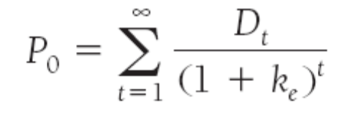
- The Gordon Growth Model.(Dividend has a constant rate of growth.)
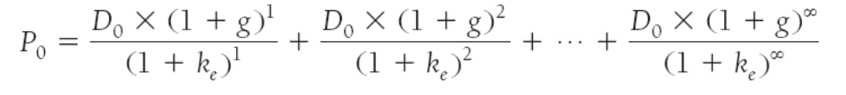
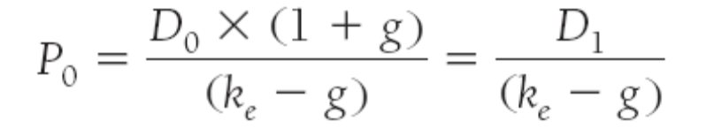

Adaptive expectation suggests that changes in expectations will occur slowly over time as past data changes.
The Theory of Rational Expectations: Expectation will be identical to optimal forecasts(the best guess of the future) using all the available information. (But keep in mind that even through a rational expectation equals optimal forecast using all the available information ,a prediction based on it may not always be perfectly accurate.)
Implications of the theory:
- If there is a change in the way a variable moves ,the way in which expectations of this variable are formed will changes as well.
- The forecast errors of expectations will on average be zero and cannot be predicted ahead of time.

In all efficient markets, all Unexploited profit opportunity will be eliminated.
Not everyone in a financial market must be well informed about a security or have rational expectations for its price to be driven to the point that at which the efficient markets condition holds.
(Weak-form efficiency, semistrong-form, strong-form)

Evidence on the EMH
Early Study(in favor of the EMH, it means that they cannot beat/outperform the market)
- The performance of Investment analyst and Mutual funds;
- Random-walk behavior of stock prices;
- Technique analysis;
Recent study:(a few cracks, anomalies)
- Small-firm effect;
- January effect;
- Market overreaction;
- Excessive volatility;
- Mean reversion;

Part 3 Financial Institutions

Ch8 An Economic Analysis of Financial Structure
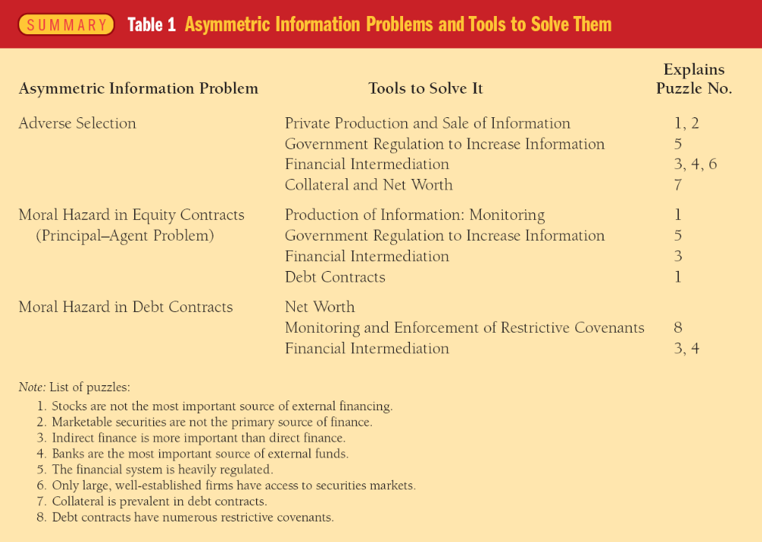
Table 1 Asymmetric Information Problems and Tools to Solve Them
#Eight facts(puzzles)
1. Stocks are not the most important source of external
financing of business.
2. Issuing marketable debt and equity securities is not the primary way in which businesses finance their operations.
3. Indirect finance, which involves the activities of financial intermediaries, is many more times important than direct finance ,in which businesses raise funds directly in the financial markets.
4. Banks are the most important source of external sources used to finance the business activities.
5. The financial system is among the most heavily regulated sectors of the economy.
6. Only large ,well-established corporations have easy access to security markets to finance their activities.(pecking order hypothesis)
7. Collateral is a prevalent feature of debt contracts for both households and businesses.
8. Debt contracts typically are extremely complicated legal documents that place substantial restrictions on the behavior of the borrower.(restrictive covenant)

FIGURE 3 Sequence of Events in U.S. Financial Crises The solid arrows trace the sequence of events in a typical financial crisis; the dotted arrows show the additional set of events that occur if the crisis develops into a debt deflation.
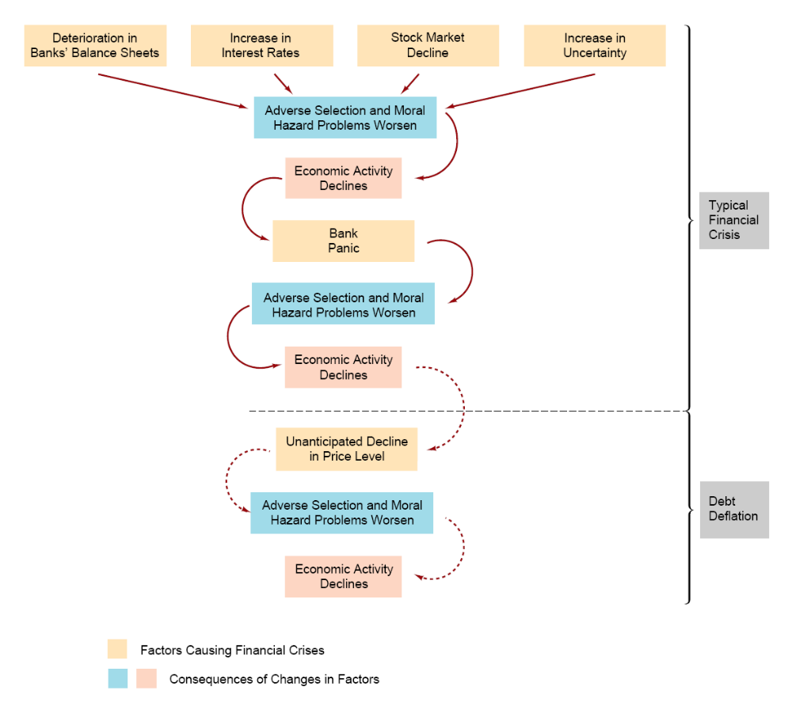

FIGURE 4 Sequence of Events in the Mexican, East Asian, and Argentine Financial Crises The arrows trace the sequence of events during the financial crisis.
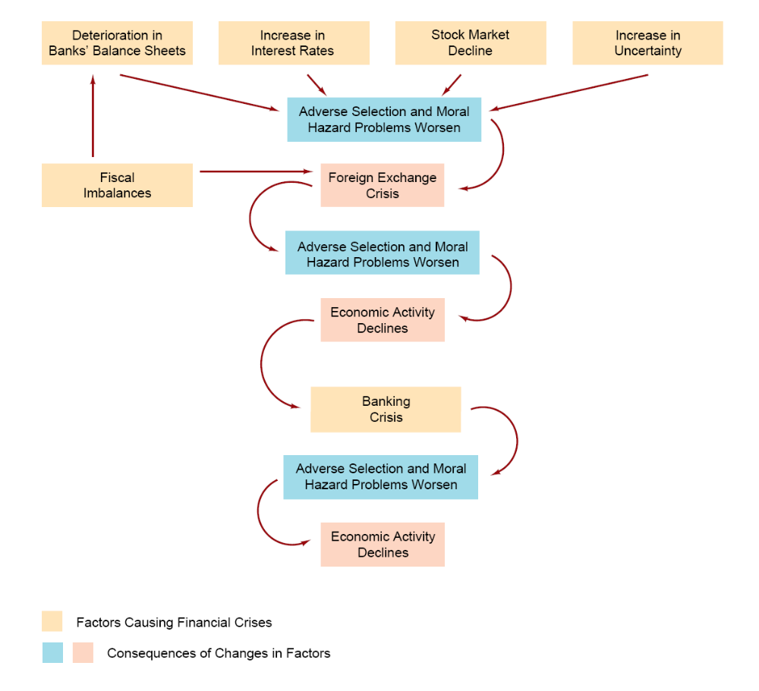

Ch9 Banking and the Management of Financial Institutions
Balance sheet:
Total Assets = Total Liabilities + Capital
Balance sheet of all commercial banks
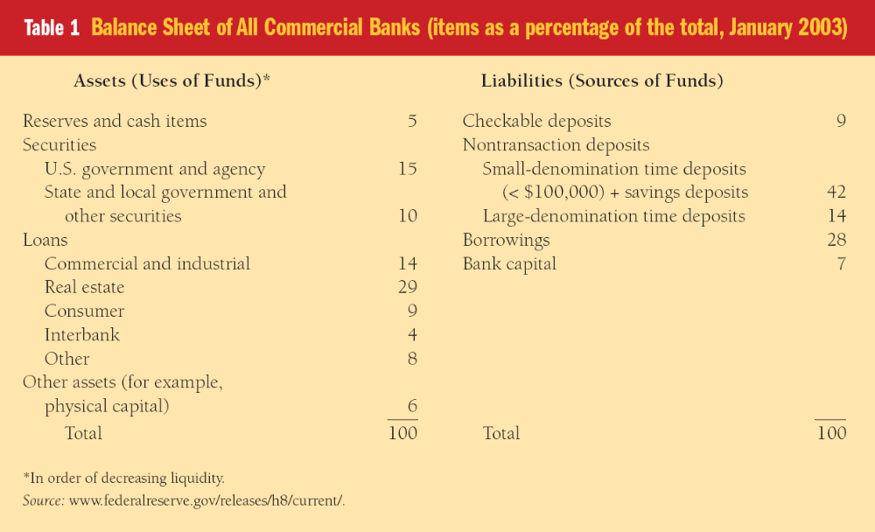

Banking Management:
1 Liquidity management
2 Asset management
3 Liabilities management
4 Capital adequacy management

Liquidity management
When a deposit outflow occurs, holding excess reserves allows the bank to escape the costs of (1) borrowing from other banks or corporations, (2) selling securities, (3) borrowing from the Fed, or (4) calling in or selling off loans. Excess reserves are insurance against the costs associated with deposit outflows. The higher the costs associated with deposit outflows, the more excess reserves banks will want to hold.
Capital adequacy management
Banks have to make decisions about the amount of capital they need to hold for three reasons. First, bank capital helps prevents bank failure, a situation in which the bank cannot satisfy its obligations to pay its depositors and other creditors and so goes out of business. Second, the amount of capital affects returns for the owners (equity holders) of the bank. And third, a minimum amount of bank capital (bank capital requirements) is required by regulatory authorities.
A basic measure of bank profitability is the return on assets (ROA), the net profit after taxes per dollar of assets:
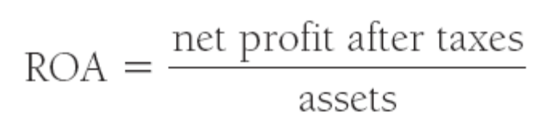
However, what the bank’s owners (equity holders) care about most is how much the bank is earning on their equity investment. This information is provided by the other basic measure of bank profitability, the return on equity (ROE), the net profit after taxes per dollar of equity (bank) capital:
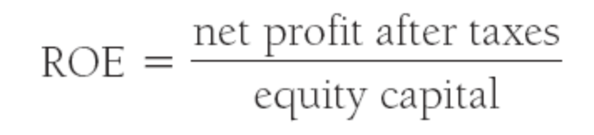
This relationship is determined by the so-called equity multiplier (EM), which is the amount of assets per dollar of equity capital:
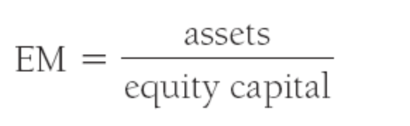
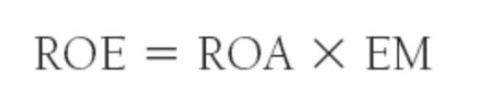
Given the return on assets, the lower the bank capital, the higher the return for the owners of the bank.

Application: Strategies for Managing Bank Capital
To lower the amount of capital relative to assets and raise the equity multiplier, you can do any of three things: (1) You can reduce the amount of bank capital by buying back some of the bank’s stock. (2) You can reduce the bank’s capital by paying out higher dividends to its stockholders, thereby reducing the bank’s retained earnings. (3) You can keep bank capital constant but increase the bank’s assets by acquiring new funds—say, by issuing CDs—and then seeking out loan business or purchasing more securities with these new funds. Because you think that it would enhance your position with the stockholders, you decide to pursue the second alternative and raise the dividend on the First National Bank stock.
To raise the amount of capital relative to assets, you now have the following three choices: (1) You can raise capital for the bank by having it issue equity (common stock). (2) You
can raise capital by reducing the bank’s dividends to shareholders, thereby increasing retained earnings that it can put into its capital account. (3) You can keep capital at the same level but reduce the bank’s assets by making fewer loans or by selling off securities and then using the proceeds to reduce
its liabilities. Suppose that raising bank capital is not easy to do at the current time because capital markets are tight or because shareholders will protest if their dividends are cut. Then you might have to choose the third alternative and decide to shrink the size of the bank.

#Management credit risk:
1 Screening and monitoring. Screening, Specializing in lending, and Monitoring and enforcement of restrictive covenants;
2 Long-Term customer relationship;
3 Loan commitments;
4 Collateral and compensating balances;
5 Credit rationing

Managing Interest-Rate Risk
Gap and duration analysis. Macaulay’s duration.

Off-balance-sheet activities

VAR (the value at risk)

Appendix 1 to Ch9: Duration gap analysis
$${DUR}_{gap}={DUR}_{a}-\frac{L}{A}{DUR}_{l}$$
$$\frac{∆NW}{A}={-DUR}_{gap}×\frac{∆i}{1+i}$$
$∆NW$ Change in the market value of net worth

Appendix 2 to Ch9:Measuring Bank Performance
ROA,ROE,NIM(net interest margin)
NIM=(interest income –interest expenses)/assets

Table 1 Income Statement for All Federally Insured Commercial Banks, 2002
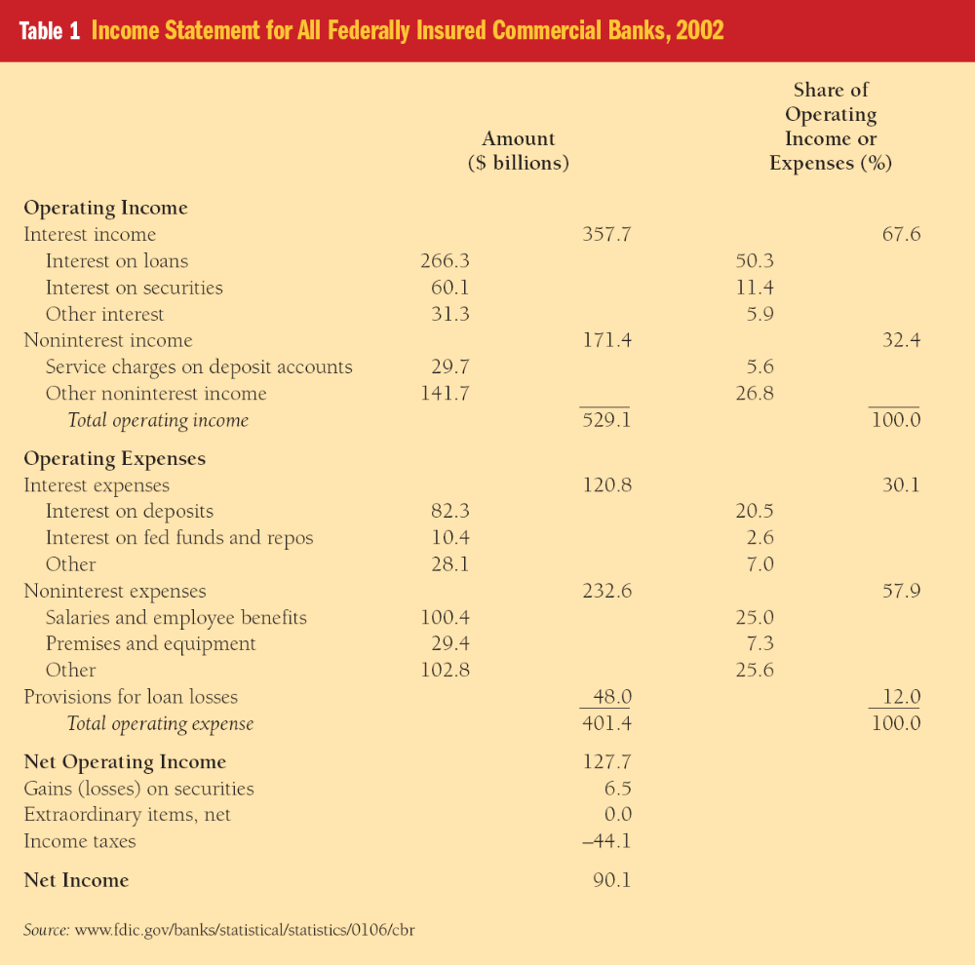

Table 2 Measures of Bank Performance, 1980–2002
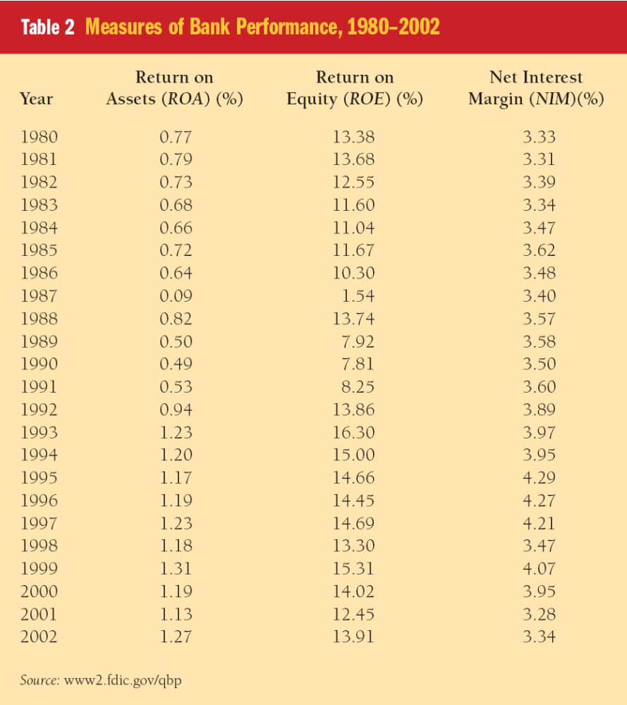

Ch10 Bank Industry: Structure and Competition
Financial Innovation
Innovation is result of search for profits
Response to Changes in Demand
Major change is huge increase in interest-rate risk starting in 1960s
Example: Adjustable-rate mortgages
Response to Changes in Supply
Major change is improvement in computer technology
1. Increases ability to collect information
2. Lowers transactions costs

Branching Regulations
Branching Restrictions: McFadden Act and Douglas Response to Branching Restrictions
- Bank Holding Companies
- Nonbank Banks Not subject to branching regulations, but loophole closed in 1987
3. Automated Teller Machines

Bank Consolidation and Nationwide Banking
Cons:
1. Fear of decline of small banks and small business lending
2. Rush to consolidation may increase risk taking
Pros:
1. Community banks will survive
2. Increase competition
3. Increased diversification of bank loan portfolios: lessens likelihood of failures

Separation of Banking and Other Financial Service Industries
Erosion of Glass-Steagall
Fed, OCC, FDIC, allow banks to engage in underwriting activities
Gramm-Leach-Bliley Financial Services Modernization Act of 1999: Repeal of Glass-Steagall
1. Allows securities firms and insurance companies to purchase banks.
2. Banks allowed to underwrite insurance and engage in real estate activities.
Banking insitutions become larger and more complex

IBFs, international banking facilities.

Ch11 Economic Analysis of Banking Regulation
Eight basic categories of banking regulation:
1 the government safety net,
2 restrictions on bank asset holdings,
3 capital requirement,
4 chartering and bank examination,
5 assessment of risk management,
6 disclosure requirement,
7 consumer protection,
8 and restrictions on competition

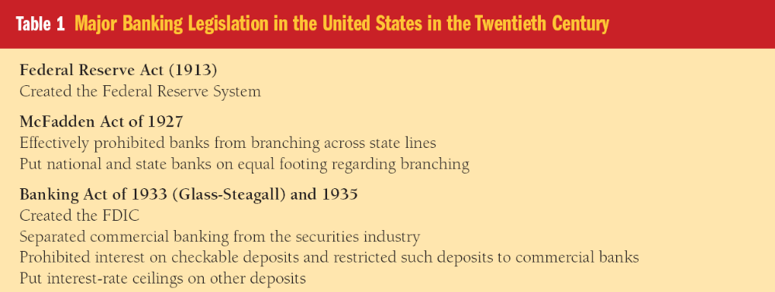
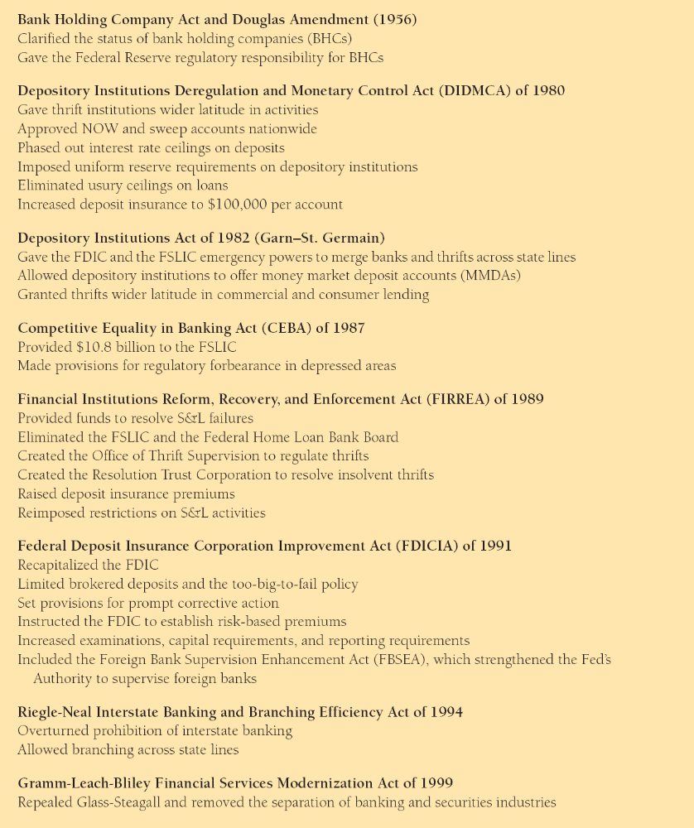
Table 1 Major Banking Legislation in the United States in the Twentieth Century

Ch12 Nonbank Finance
Table 1 Relative Shares of Total Financial Intermediary Assets, 1960–2002 (percent)
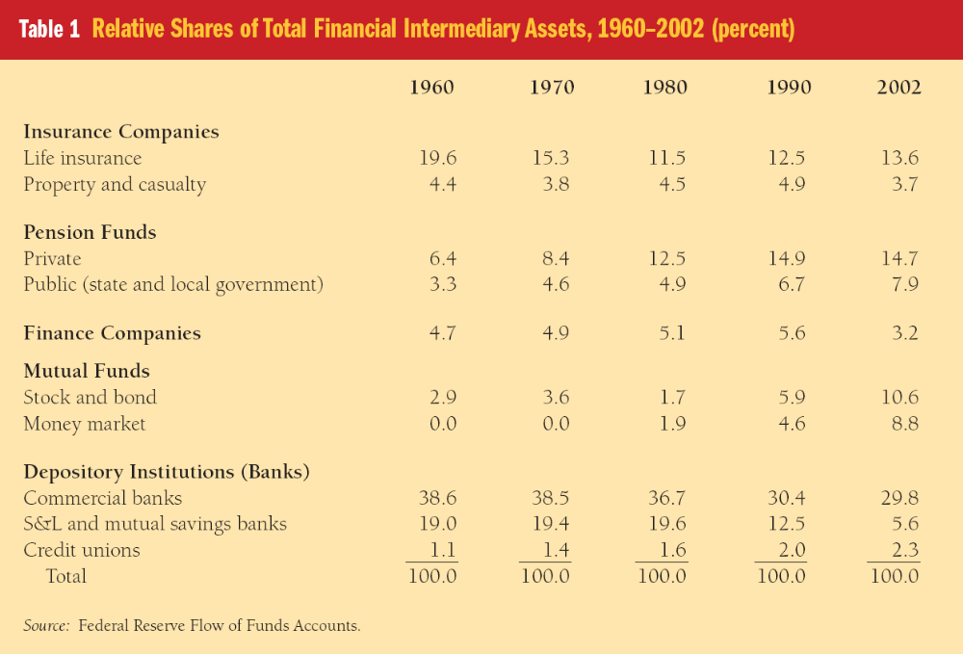

Ch13 Financial Derivatives
Financial Futures Markets
Margin requirement: A sum of money that must be kept in an account (the margin account) at a brokerage firm.
Initial margin: when a position is first opened is usually only 5% to 10% of the total value of contract
Maintenance margin：the minimum amount of equity that the account may have and is usually set at 75% to 80% of the initial margin
clearinghouse
marked to market: Repriced and settled in the margin account at the end of every trading day to reflect any change in the value of the futures contract.
daily settlement

Part 4 Central Banking and Conduct of Monetary Policy

Ch14 Structure of Central Banks and the Federal Reserve System

FIGURE 1 Formal Structure and Allocation of Policy Tools in the Federal Reserve
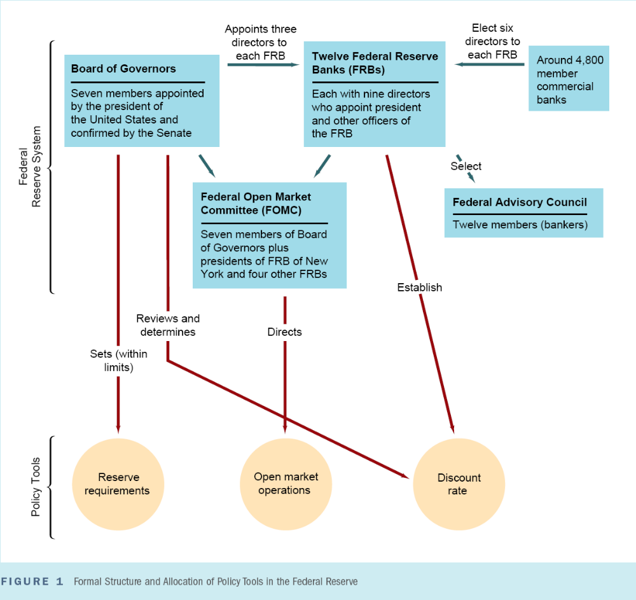

FIGURE 2 Federal Reserve System


FIGURE 3 Informal Power Structure of the Federal Reserve System
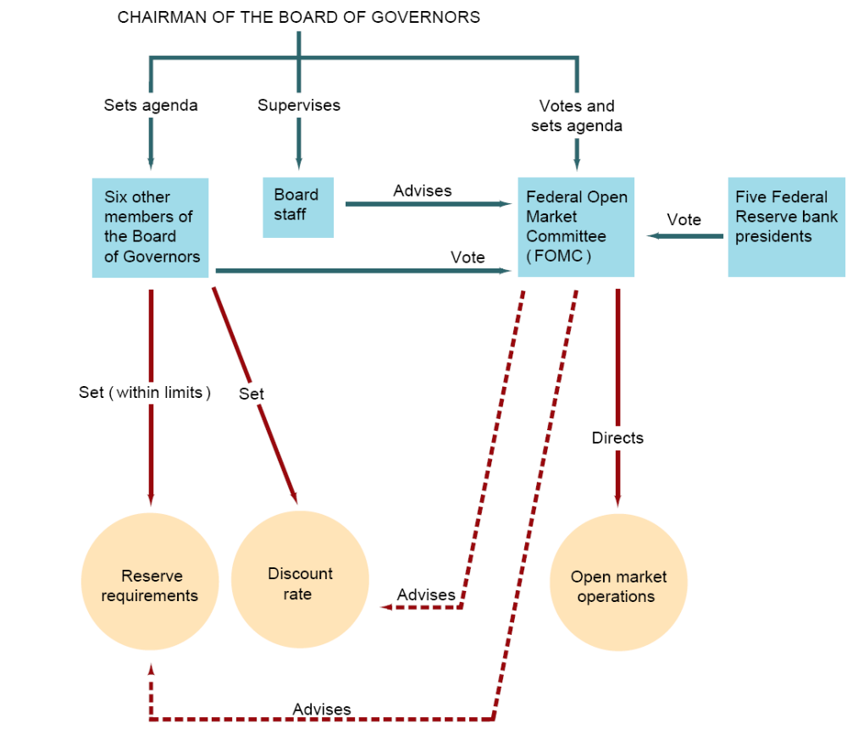

www.federalreserve.gov/pubs/frseries/frseri.htm Information on the structure of the Federal Reserve System.
www.federalreserve.gov/otherfrb.htm Addresses and phone numbers of Federal Reserve banks, branches, and RCPCs and links to the main pages of the 12 reserve banks and Board of
Governors.
www.federalreserve.gov/bios/1199member.pdf Lists all the members of the Board of Governors of the Federal Reserve since its inception.
www.federalreserve.gov/fomc Find general information on the FOMC, its schedule of meetings, statements, minutes, and transcripts; information on its members, and the “beige book.”

Stanley Fischer, who was a professor at MIT and then the Deputy Managing Director of the International Monetary Fund, has defined two different types of independence of central banks: instrument independence, the ability of the central bank to set monetary policy instruments, and goal independence, the ability of the central bank to set the goals of monetary policy.

Ch15 Multiple Deposit Creation and the Money Supply Process
www.federalreserve.gov/boarddocs/rptcongress/annual01/default.htm See the most recent Federal Reserve financial statement.

MB = R + C; monetary base, or high-powered money

Required reverses(RR), excess reverses(ER), required reserve ratio(r) .
Open market operation: sale, and purchase.

Simple deposit multiplier
∆D = ∆R / r
Such that: ER = 0

Ch16 Determinants of Money Supply
Money multiplier, m = (c + 1)/(c + r + e)
1 R = RR + ER = (r + e) * D
required reverses(RR) r = RR / D
excess reverses(ER) e = ER / D
checkable deposit(D)
2 MB = C + R = (c + r + e) * D
Monetary base(MB)
Currency in circulation(C) c = C / D
3 M = C + D = (c + 1) * D
Money(M1)
4 m = M / MB = (c + 1)/(c + r + e)

we split the monetary base into two components: one
that the Fed can control completely and another that is less tightly controlled. The less tightly controlled component is the amount of the base that is created by discount loans from the Fed. The remainder of the base (called the nonborrowed monetary base) is under the Fed’s control, because it results primarily from open market operations. The nonborrowed monetary base is formally defined as the monetary base minus discount loans from the Fed:
MB = MB_{n} +DL
Nonborrowed monetary base(MB_{n)},
discount loans(DL)

Over long periods, the primary determinant of movements in the money supply is the nonborrowed monetary base MB_{n} , which is controlled by Federal Reserve open market operations.
For shorter time periods, the link between the growth rates of the nonborrowed monetary base and the money supply is not always close, primarily because the money multiplier m experiences substantial short-run swings that have a major impact on the growth rate of the money supply.

Appendix1 to Chapter 16 : The M2 Money Multiplier
M2 = C+ D + T + MMF. Time deposits.
MMF, primarily money market mutual fund shares and money market deposit accounts, plus overnight purchase agreements and overnight Eurodollars.
M2 = (1 + c + t + mm)/(r + e + c)*MB

Appendix2 to Chapter 16 : Expanding Behavior of The Currency Ratio
Theory of Asset Demand. (ch5)
Determinants: Wealth, Expected returns, risk, liquidity.

Ch17 Tools of Monetary Policy
FIGURE 1 Equilibrium in the Market for Reserves Equilibrium occurs at the intersection of the supply curve R_{s} and the demand curve R_{d} at point 1 and an interest rate of i_{ff}* .
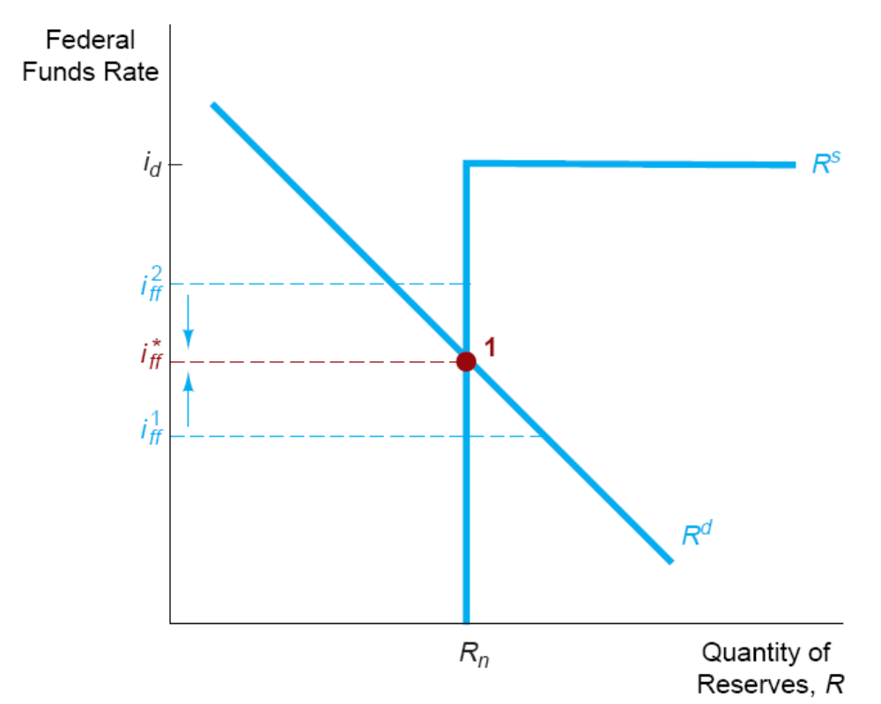

Ch18 Conduct of Monetary Policy: Goals and Targets
www.federalreserve.gov/pf/pf.htm Review what the Federal Reserve reports as its primary purposes and functions.

Six basic goals are continually mentioned by personnel at the Federal Reserve and other central banks when they discuss the objectives of monetary policy:
1 high employment,
2 economic growth,
3 price stability,
4 interest-rate stability,
5 stability of financial markets,
6 stability in foreign exchange markets.

After deciding on its goals for employment and the price level, the central bank chooses a set of variables to aim for, called intermediate targets. Therefore, it chooses another set of variables to aim for, called operating targets, or alternatively instrument targets,

Taylor rule
Federal funds rate target = inflation rate + equilibrium real fed funds rate + 1/2 (inflation gap) + 1/2 (output gap)

Part 5 Int~l Finance and Monetary Policy

Ch19 The Foreign Exchange Market
www.ny.frb.org/Pihome/addpub/usfxm Get detailed information about the foreign exchange market in the United States.
http://quotes.ino.com/chart/ Go to this web site and click on “Foreign Exchange” to get
market rates and time charts for the exchange rate of the U.S. dollar to major world
currencies.

There are two kinds of exchange rate transactions. The predominant ones, called spot transactions, involve the immediate (two-day) exchange of bank deposits. Forward
transactions involve the exchange of bank deposits at some specified future date. The spot exchange rate is the exchange rate for the spot transaction, and the forward exchange rate is the exchange rate for the forward transaction.

The starting point for understanding how exchange rates are determined is a simple idea called the law of one price: If two countries produce an identical good, and transportation costs and trade barriers are very low, the price of the good should be the same throughout the world no matter which country produces it.
One of the most prominent theories of how exchange rates are determined is the theory of purchasing power parity (PPP). It states that exchange rates between any two currencies will adjust to reflect changes in the price levels of the two countries.

Factors That Affect Exchange Rates in the Long Run
1,In the long run, a rise in a country’s price level (relative to the foreign price level) causes its currency to depreciate, and a fall in the country’s relative price level causes its currency to appreciate.
2, Increasing trade barriers cause a country’s currency to appreciate in the long run.
3, Increased demand for a country’s exports causes its currency to appreciate in the long run; conversely, increased demand for imports causes the domestic currency to depreciate.
4, In the long run, as a country becomes more productive relative to other countries, its currency appreciates.
The trick to figuring out what long-run effect a factor has on the exchange rate is to remember the following: If a factor increases the demand for domestic goods relative to foreign goods, the domestic currency will appreciate, and if a factor decreases the relative demand for domestic goods, the domestic currency will depreciate.

The key to understanding the short-run behavior of exchange rates is to recognize that an exchange rate is the price of domestic bank deposits (those denominated in the domestic currency) in terms of foreign bank deposits (those denominated in the foreign currency). Because the exchange rate is the price of one asset in terms of another, the natural way to investigate the short-run determination of exchange rates is through an asset market approach that relies heavily on the theory of asset demand developed in Chapter 5. As you will see, however, the long-run determinants of the exchange rate we have just outlined also play an important role in the short-run asset market approach.
Earlier approaches to exchange rate determination emphasized the role of import and export demand. The more modern asset market approach used here does not emphasize the flows of purchases of exports and imports over short periods, because these transactions are quite small relative to the amount of domestic and foreign bank deposits at any given time. For example, foreign exchange transactions in the United States each year are well over 25 times greater than the amount of U.S. exports and imports. Thus over short periods such as a year, decisions to hold domestic or foreign assets play a much greater role in exchange rate determination than the demand for exports and imports does.

interest parity condition
i^{D} =i^{F} –(E^{e}_{t+1} - E_{t}) / E_{t}
R^{D} = R^{F}
This equation is called the interest parity condition, and it states that the domestic interest rate equals the foreign interest rate minus the expected appreciation of the domestic currency.

Our analysis of the effect of an increase in the money supply on the exchange rate is not yet over—we still need to look at what happens to the exchange rate in the long run. A basic proposition in monetary theory, called monetary neutrality, states that in the long run, a one-time percentage rise in the money supply is matched by the same one-time percentage rise in the price level, leaving unchanged the real money supply and all other economic variables such as interest rates.
The phenomenon we have described here in which the exchange rate falls by more in the short run than it does in the long run when the money supply increases is called exchange rate overshooting. It is important because, as we will see in the following application, it can help explain why exchange rates exhibit so much volatility.

Ch20 Int~l Financial System
Central banks regularly engage in international financial transactions called foreign exchange interventions in order to influence exchange rates. In our current international financial
arrangement, called a managed float regime (or a dirty float), exchange rates fluctuate from day to day, but central banks attempt to influence their countries’ exchange rates by buying and selling currencies.
A central bank’s purchase of domestic currency and corresponding sale of foreign assets in the foreign exchange market leads to an equal decline in its international reserves and the monetary base.
A central bank’s sale of domestic currency to purchase foreign assets in the foreign exchange market results in an equal rise in its international reserves and the monetary base.

The intervention we have just described, in which a central bank allows the purchase or sale of domestic currency to have an effect on the monetary base, is called an unsterilized foreign exchange intervention. But what if the central bank does not
want the purchase or sale of domestic currency to affect the monetary base? All it has to do is to counter the effect of the foreign exchange intervention by conducting an offsetting open market operation in the government bond market. A foreign exchange intervention with an offsetting open market operation that leaves the monetary base unchanged is called a sterilized foreign exchange intervention.
An unsterilized intervention in which domestic currency
is sold to purchase foreign assets leads to a gain in international reserves, an increase in the money supply, and a depreciation of the domestic currency.

http://research.stlouisfed.org/fred/data/exchange.html This web site contains exchange rates, balance of payments, and trade data.

The balance of payments is a bookkeeping system for recording all receipts and payments that have a direct bearing on the movement of funds between a nation (private sector and government) and foreign countries.
Here we examine the key items in the balance of payments that you often hear about in the media.
The current account shows international transactions that involve currently produced goods and services. The difference between merchandise exports and imports, the net receipts from trade, is called the trade balance.
Another important item in the balance of payments is the capital account, the net receipts from capital transactions.
The sum of the current account and the capital account equals the official reserve transactions balance.
Current account + capital account
=net change in government international reserves

Before World War I, the world economy operated under the gold standard, meaning that the currency of most countries was convertible directly into gold.
As the Allied victory in World War II was becoming certain in 1944, the Allies met in Bretton Woods, New Hampshire, to develop a new international monetary system to promote world trade and prosperity after the war. In the agreement worked out among the Allies, central banks bought and sold their own currencies to keep their exchange rates fixed at a certain level (called a fixed exchange rate regime). The agreement lasted from 1945 to 1971 and was known as the Bretton Woods system.
The Bretton Woods agreement created the International Monetary Fund (IMF), headquartered in Washington, D.C., which had 30 original member countries in 1945 and currently has over 180. The Bretton Woods agreement also set up the International Bank for Reconstruction and Development, commonly referred to as the World Bank, also headquartered in Washington, D.C., which provides long-term loans to help developing countries build dams, roads, and other physical capital that would contribute to their economic development.

Ch21 Monetary Policy Strategy: The Int~l Experience
A central feature of monetary policy strategies in all countries is the use of a nominal anchor (a nominal variable that monetary policymakers use to tie down the price level such as the inflation rate, an exchange rate, or the money supply) as an intermediate target to achieve an ultimate goal such as price stability.
A more subtle reason for a nominal anchor’s importance is that it can limit the time-consistency problem, in which monetary policy conducted on a discretionary, day-by-day basis leads to poor long-run outcomes.

Targeting the exchange rate is a monetary policy strategy with a long history. It can take the form of fixing the value of the domestic currency to a commodity such as gold, the key feature of the gold standard described in Chapter 20. More recently, fixed exchange-rate regimes have involved fixing the value of the domestic currency to that of a large, low-inflation country like the United States or Germany (called the anchor country). Another alternative is to adopt a crawling target or peg, in which a currency is allowed to depreciate at a steady rate so that the inflation rate in the pegging country can be higher than that of the anchor country.
Exchange-rate targeting has several advantages. First, the nominal anchor of an exchange-rate target directly contributes to keeping inflation under control by tying the inflation rate for internationally traded goods to that found in the anchor country.
Second, an exchange-rate target provides an automatic rule for the conduct of monetary policy that helps mitigate the time-consistency problem.
Third, an exchange-rate target has the advantage of simplicity and clarity, which makes it easily understood by the public.
Despite the inherent advantages of exchange-rate targeting, there are several serious criticisms of this strategy. The problem (as we saw in Chapter 20) is that with capital mobility the targeting country no longer can pursue its own independent monetary policy and so loses its ability to use monetary policy to respond to domestic shocks that are independent of those hitting the anchor country. Furthermore, an exchange rate target means that shocks to the anchor country are directly transmitted to the targeting country, because changes in interest rates in the anchor country lead to a corresponding change in interest rates in the targeting country.
A second problem with exchange-rate targets is that they leave countries open to speculative attacks on their currencies.

One solution to the problem of lack of transparency and commitment to the exchange rate target is the adoption of a currency board, and another is dollarization.

In many countries, exchange-rate targeting is not an option, because either the country (or bloc of countries) is too large or because there is no country whose currency is an obvious choice to serve as the nominal anchor. Exchange-rate targeting is therefore clearly not an option for the United States, Japan, or the European Monetary Union. These countries must look to other strategies for the conduct of monetary policy, one of which is monetary targeting.
A major advantage of monetary targeting over exchange-rate targeting is that it enables a central bank to adjust its monetary policy to cope with domestic considerations.
It enables the central bank to choose goals for inflation that may differ from those of other countries and allows some response to output fluctuations.
Given the breakdown of the relationship between monetary aggregates and goal variables such as inflation, many countries that want to maintain an independent monetary policy have recently adopted inflation targeting as their monetary policy regime. New Zealand was the first country to formally adopt inflation targeting in 1990, followed by Canada in 1991, the United Kingdom in 1992, Sweden and Finland in 1993, and Australia and Spain in 1994. Israel, Chile, and Brazil, among others, have also adopted a form of inflation targeting.
Inflation targeting involves several elements: (1) public announcement of medium-term numerical targets for inflation; (2) an institutional commitment to price stability as the primary, long-run goal of monetary policy and a commitment to achieve the inflation goal; (3) an information-inclusive strategy in which many variables and not just monetary aggregates are used in making decisions about monetary policy; (4) increased transparency of the monetary policy strategy through communication with the public and the markets about the plans and objectives of monetary policymakers; and (5) increased accountability of the central bank for attaining its inflation objectives.

Part 6 Monetary Theory

Ch22 The Demand for Money

A central question in monetary theory is whether or to what extent the quantity of money demanded is affected by changes in interest rates.

Developed by the classical economists in the nineteenth and early twentieth centuries, the quantity theory of money is a theory of how the nominal value of aggregate income is determined. Because it also tells us how much money is held for a given amount of aggregate income, it is also a theory of the demand for money. The most important feature of this theory is that it suggests that interest rates have no effect on the demand for money.

http://cepa.newschool.edu/het /profiles/fisher.htm A brief biography and summary of the writings of Irving Fisher.

The clearest exposition of the classical quantity theory approach is found in the work of the American economist Irving Fisher, in his influential book The Purchasing Power of Money, published in 1911. The concept that provides the link between M and P *Y is called the velocity of money (often reduced to velocity), the rate of turnover of money; that is, the average number of times per year that a dollar is spent in buying the total amount of goods and services produced in the economy.
V = P * Y / M
By multiplying both sides of this definition by M, we obtain the equation of exchange, which relates nominal income to the quantity of money and velocity:
M * V = P * Y
Fisher’s view that velocity is fairly constant in the short run transforms the equation of exchange into the quantity theory of money, which states that nominal income is determined solely by movements in the quantity of money。
Movements in the price level result solely from changes in the quantity of money.

http://www-gap.dcs.st-and.ac.uk/~history/Mathematicians/Keynes.html A brief history of John Maynard Keynes.
The General Theory of Employment, Interest, and Money

Friedman’s Modern Quantity Theory of Money
In 1956, Milton Friedman developed a theory of the demand for money in a famous article, “The Quantity Theory of Money: A Restatement.”12 Although Friedman frequently refers to Irving Fisher and the quantity theory, his analysis of the demand for money is actually closer to that of Keynes than it is to Fisher’s.
Like his predecessors, Friedman pursued the question of why people choose to hold money. Instead of analyzing the specific motives for holding money, as Keynes did, Friedman simply stated that the demand for money must be influenced by the same factors that influence the demand for any asset. Friedman then applied the theory of asset demand to money.

Ch23 The Keynesian Framework and the ISLM Model
In the media, you often see forecasts of GDP and interest rates by economists and government agencies. At times, these forecasts seem to come from a crystal ball, but economists
actually make their predictions using a variety of economic models. One model widely used by economic forecasters is the ISLM model, which was developed by Sir John Hicks in 1937 and is based on the analysis in John Maynard Keynes’s influential book The General Theory of Employment, Interest, and Money, published in 1936.1 The ISLM model explains how interest rates and total output produced in the economy (aggregate output or, equivalently, aggregate income) are determined, given a fixed price level.

http://research.stlouisfed.org/fred/index.html Information about the macroeconomic variables discussed in this chapter.

Keynes’s analysis explains two things: (1) why aggregate output is at a certain level (which involves understanding what factors affect each component of aggregate demand) and (2) how the sum of these components can add up to an output smaller than the economy is capable of producing, resulting in less than full employment of resources.

Ch24 Monetary and Fiscal Policy in the ISLM Model

http://cepa.newschool.edu/het/essays/keynes/hickshansen.htm A detailed discussion of ISLM analysis.
http://web.mit.edu/rigobon/www/Pdfs/islm.pdf Visit this web site for an additional discussion of factors that cause shifts in the LM curve.
www.worldbank.org.ru/wbimo/islmcl/islmcl.html The World Bank has designed an animated ISLM model that lets you set various parameters and observe the results.

Ch25 Aggregate Demand and Supply Analysis
The first building block of aggregate supply and demand analysis is the aggregate demand curve, which describes the relationship between the quantity of aggregate output demanded and the price level when all other variables are held constant.
Monetarists (led by Milton Friedman) view the aggregate demand curve as downward-sloping with one primary factor that causes it to shift—changes in the quantity of money. Keynesians (followers of Keynes) also view the aggregate demand curve as
downward-sloping, but they believe that changes in government spending and taxes or in consumer and business willingness to spend can also cause it to shift.

www.bls.gov/data/home.htm The home page of the Bureau of Labor Statistics lists information on unemployment and price levels.

www.whitehouse.gov/fsbr/esbr.html The White House sponsors an economic statistics briefing room that reports a wide variety of interesting data dealing with the state of the economy.

Ch26 Transmission Mechanism of Monetary Policy: The Evidence

Ch27 Money and Inflation
www.bls.gov/cpi/ The home page of the Bureau of Labor Statistics, which reports inflation numbers.

Ch28 Rational Expectations: Implications for Policy

