**CAT 2-**

**DUE ON 17/11/2024**

Question One

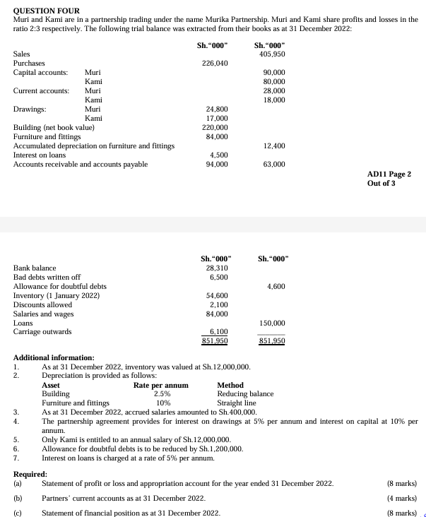

Question TWO

