## **December 2020 selection**

## 

#### **Numarine 37 XP** **Numarine 26 XP** Year 2020 Year 2018

Price 11.490.000 € Price 3.390.000 €

### **Azimut 80 Princess S78** Year 2018 Year 2019 Price 3.100.000 € Price 3.500.000 €

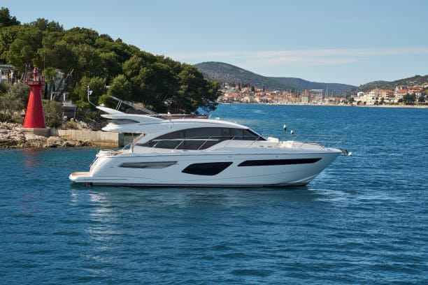

### **Princess F55 Fairline Phantom 50** Year 2018 Year 2007 Price 1.150.000 € Price 315.000 €

### **Fairline Targa 45 GT Fairline Targa 48** Year 2020 Year 2017 Price 500.000 € Price 695.000 €

### **Azimut Atlantis 43 Pershing 46** Year 2017 Year 2007 Price 380.000 € Price 279.000 €

### **Sealine 33 C Ferretti 43** Year 2019 Year 1998 Price 250.000 € Price 120.000 €

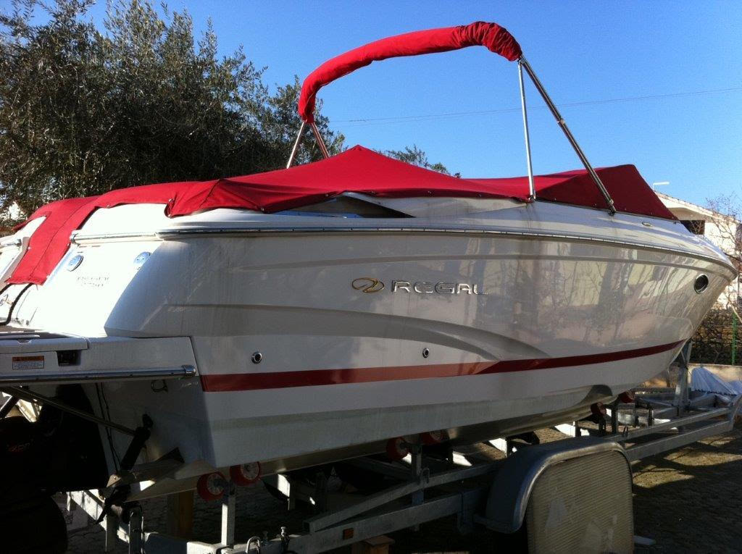

### **Regal 2750 Bayliner VR5** Year 2009Year 2017Price 34.100 € Price 37.000 €