Flight Price Prediction
Using Machine Learning on Indian Domestic Flight Data
Author: Ditsu Kundu
Technology: Python · scikit-learn · Streamlit · Pandas · Matplotlib · Seaborn
Dataset: Cleaned_dataset.csv | 452,088 Records | 13 Features

Table of Contents
Update field to see table of contents

1. Project Overview
This project aims to predict domestic flight fares across Indian cities using supervised machine learning techniques. The system is built end-to-end in Python, covering data preprocessing, exploratory data analysis (EDA), model training and evaluation, and an interactive Streamlit web application for live fare estimation.
The dataset contains 452,088 real-world flight records from 9 Indian airlines operating across 7 major cities (Ahmedabad, Bangalore, Chennai, Delhi, Hyderabad, Kolkata, Mumbai). The trained Random Forest Regressor achieves an R² of 0.9420, a Mean Absolute Error of ₹2,702, and an RMSE of ₹4,893 on the held-out test set.

Key Objectives
• Perform thorough Exploratory Data Analysis on flight fare patterns
• Engineer and encode features suitable for regression modelling
• Train and compare 5 machine learning models
• Select the best model and evaluate on a held-out test set
• Deploy an interactive Streamlit web app for real-time fare prediction

2. Dataset Description
The dataset used in this project is Cleaned_dataset.csv, a pre-processed collection of Indian domestic flight records. It covers flights operated in 2023 across 7 major Indian cities and 9 airlines.

2.1 Dataset Statistics

2.2 Feature Descriptions
Property |  | Value
Total Records |  | 452,088
Total Features |  | 13 (10 used in model)
Target Variable |  | Fare (INR)
Train / Test Split |  | 80% / 20% (361,670 / 90,418 records)
Column | Type |  | Description
Date_of_journey | Date |  | Journey date (YYYY-MM-DD) — dropped during training
Journey_day | Categorical |  | Day of week (Monday–Sunday) — encoded ordinal 0–6
Airline | Categorical |  | Carrier name — 9 airlines (Label Encoded)
Flight_code | String |  | Flight identifier — dropped during training
Class | Categorical |  | Travel class: Economy, Premium Economy, Business, First (Label Encoded)
Source | Categorical |  | Departure city — 7 cities (Label Encoded)
Departure | Categorical |  | Departure time slot — encoded ordinal 0–3
Total_stops | Categorical |  | Number of stops: non-stop=0, 1-stop=1, 2+-stop=2
Arrival | Categorical |  | Arrival time slot — encoded ordinal 0–3
Destination | Categorical |  | Arrival city — 7 cities (Label Encoded)
Duration_in_hours | Numeric |  | Total flight duration in hours (e.g. 2.0833)
Days_left | Numeric |  | Days between booking and journey date
Fare ★ TARGET | Numeric |  | Ticket price in Indian Rupees (INR)

3. Exploratory Data Analysis (EDA)
EDA was performed to understand the distribution of fares, the effect of each feature on the target, and the structure of routes and timing. All charts were generated using Matplotlib and Seaborn.

3.1 Fare Distribution
The raw fare distribution is right-skewed. The log-transformed distribution is approximately normal, confirming that tree-based models are well-suited for this target.
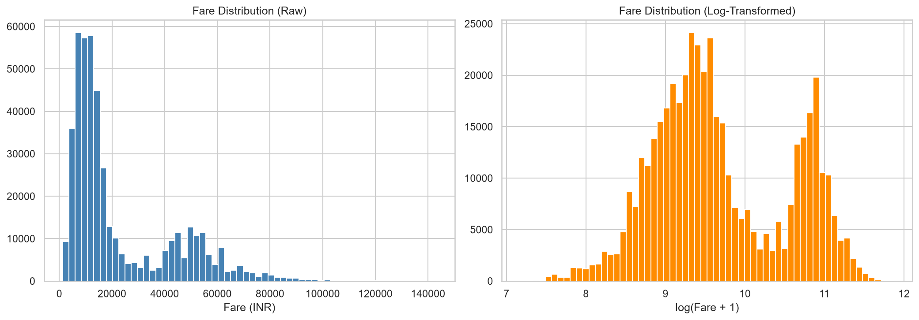
Figure 1: Fare Distribution (Raw and Log-Transformed)

3.2 Average Fare by Airline
Vistara and Air India command higher average fares. Budget carriers (AirAsia, SpiceJet, Indigo) remain competitive at lower price points.
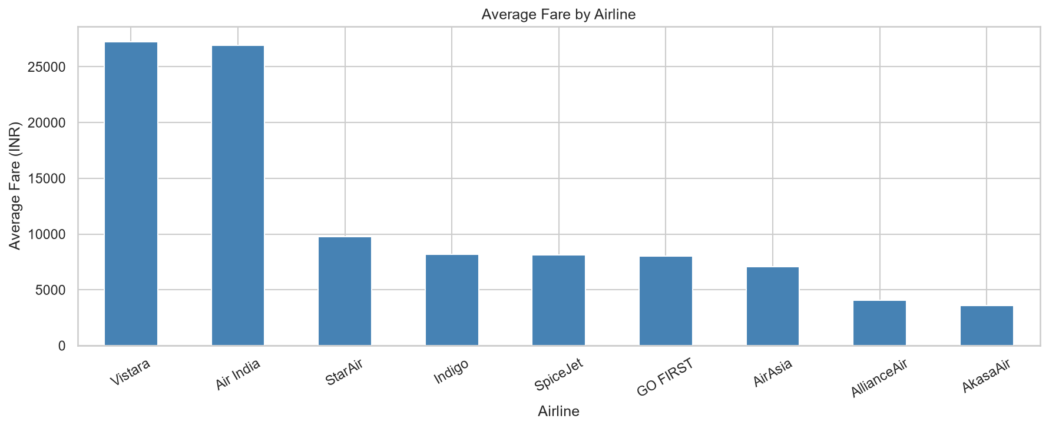
Figure 2: Average Fare by Airline

3.3 Fare Distribution by Travel Class
Travel class is the strongest predictor of fare. Business and First class fares are substantially higher with greater variance due to dynamic pricing and limited seat availability.
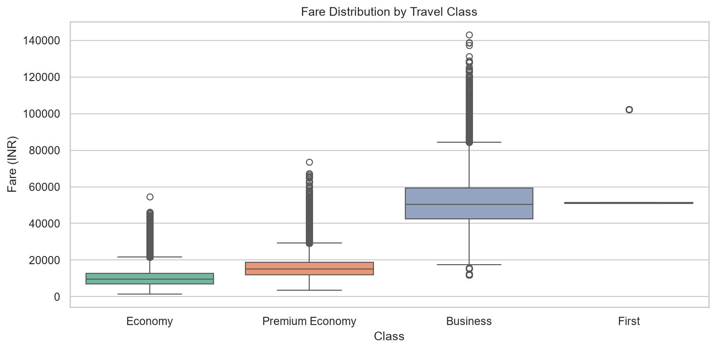
Figure 3: Fare Distribution by Travel Class (Box Plot)

3.4 Fare vs Days Left to Journey
Fares generally decrease as days left increases — confirming that early booking saves money. Scatter shows wide variance for last-minute bookings.
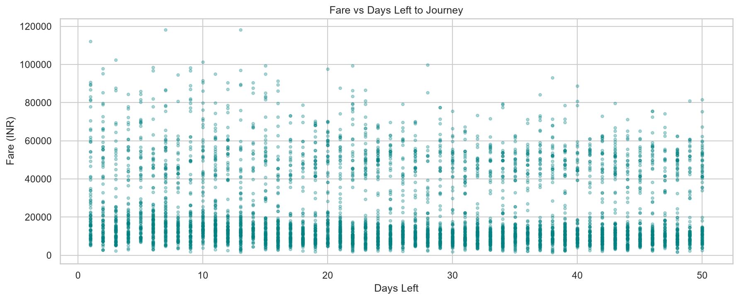
Figure 4: Fare vs Days Left to Journey

3.5 Fare by Number of Stops
Non-stop flights are often cheaper on high-demand routes. 1-stop flights can be cheaper on low-demand sectors where non-stop capacity is scarce.
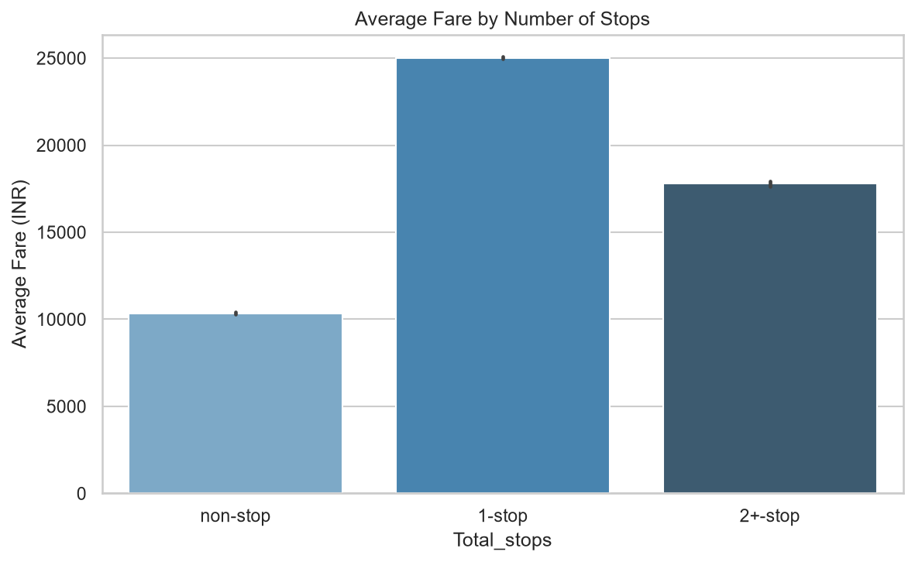
Figure 5: Average Fare by Number of Stops

3.6 Fare vs Flight Duration
Longer flights generally cost more. Two visible bands correspond to Economy/budget (lower) and Business/First class (upper) pricing clusters.
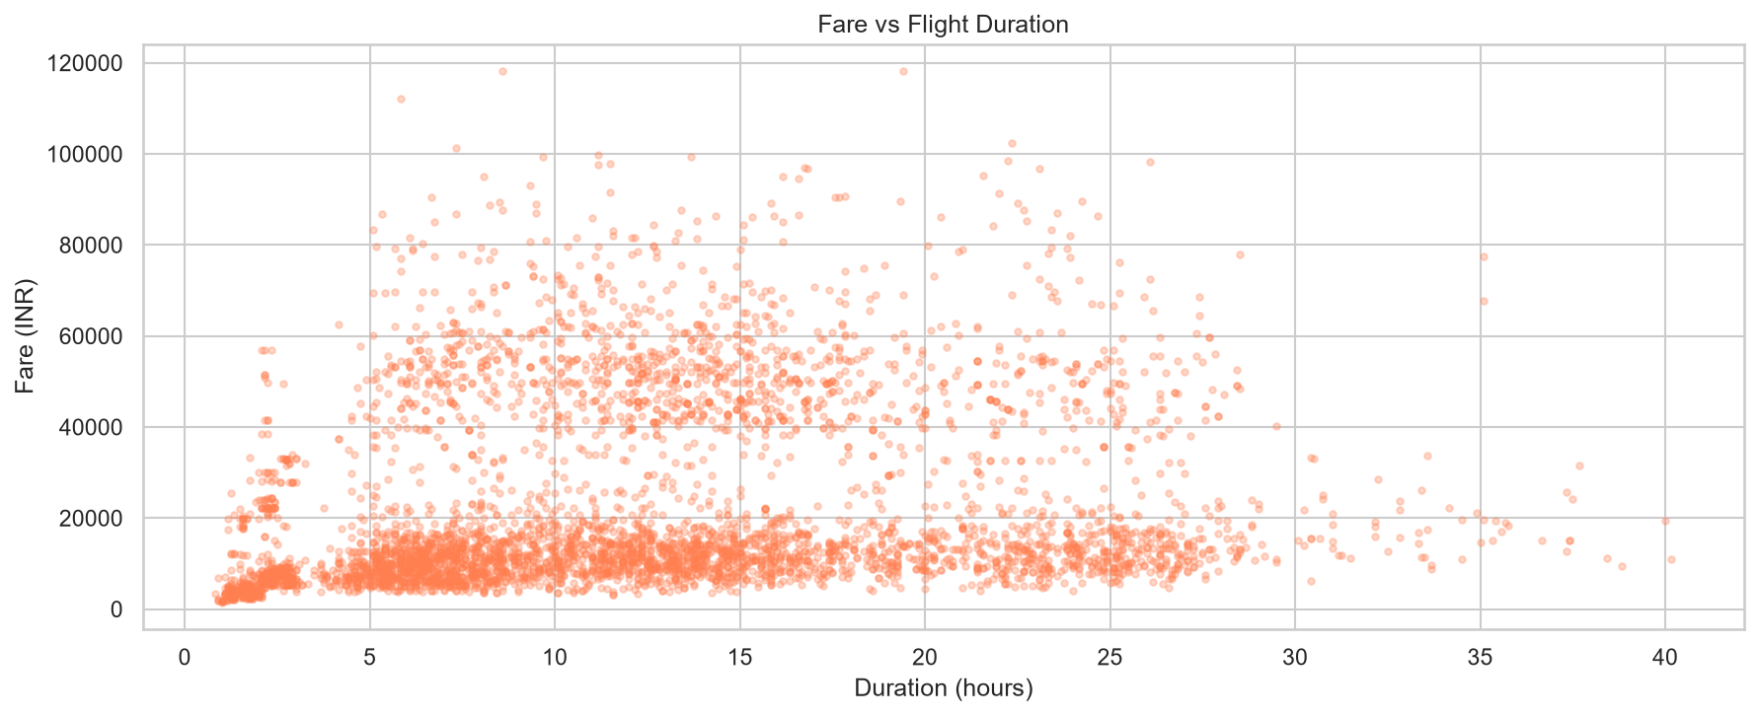
Figure 6: Fare vs Flight Duration

3.7 Route Frequency Heatmap
Delhi-Mumbai and Bangalore-Delhi are the busiest corridors. High route frequency correlates with more competitive pricing on those sectors.
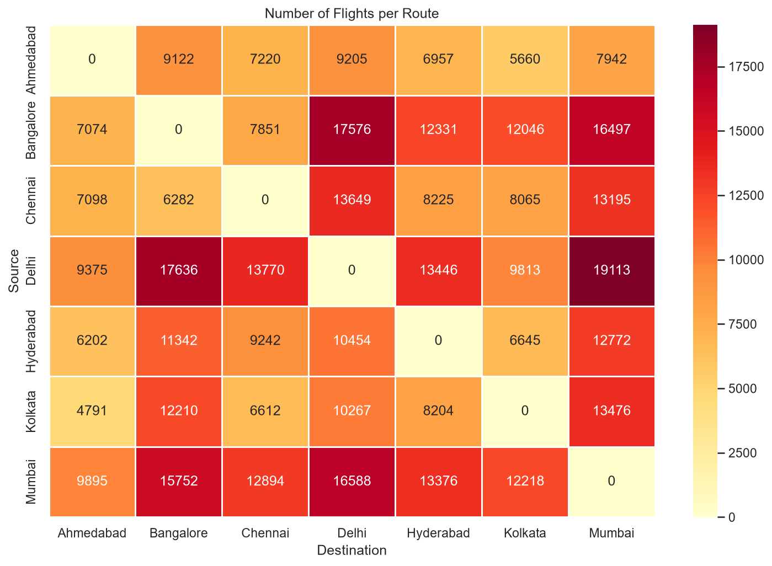
Figure 7: Route Frequency Heatmap

3.8 Fare by Day of Journey
Average fares are relatively stable across weekdays, with marginal increases on weekends. Day of travel is a secondary factor compared to class, airline, and days left.
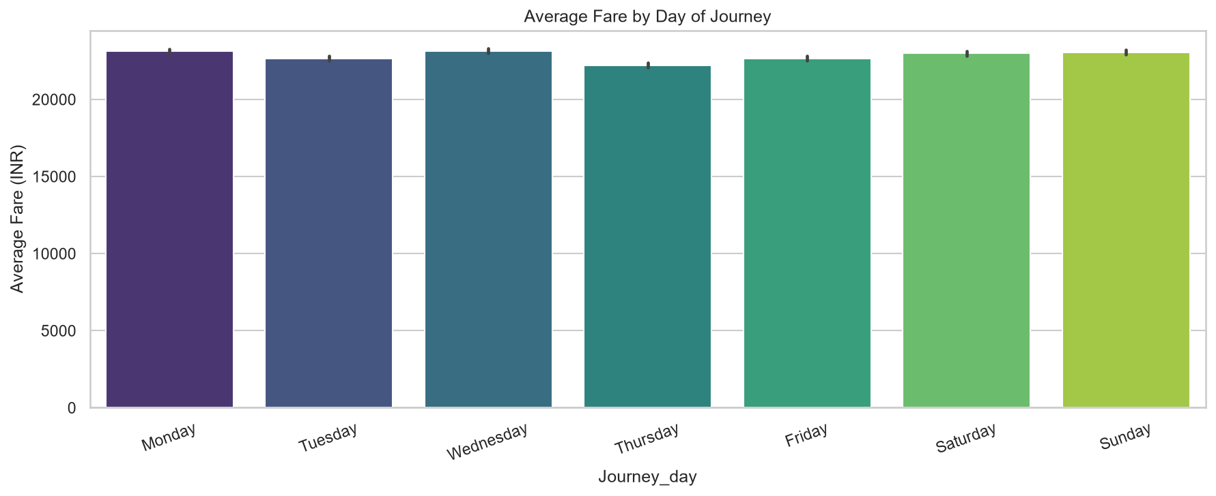
Figure 8: Average Fare by Day of Journey

3.9 Feature Correlation Matrix
Class has the strongest positive correlation with Fare, followed by Duration and Airline. Days_left shows a moderate negative correlation confirming that booking earlier reduces fares.
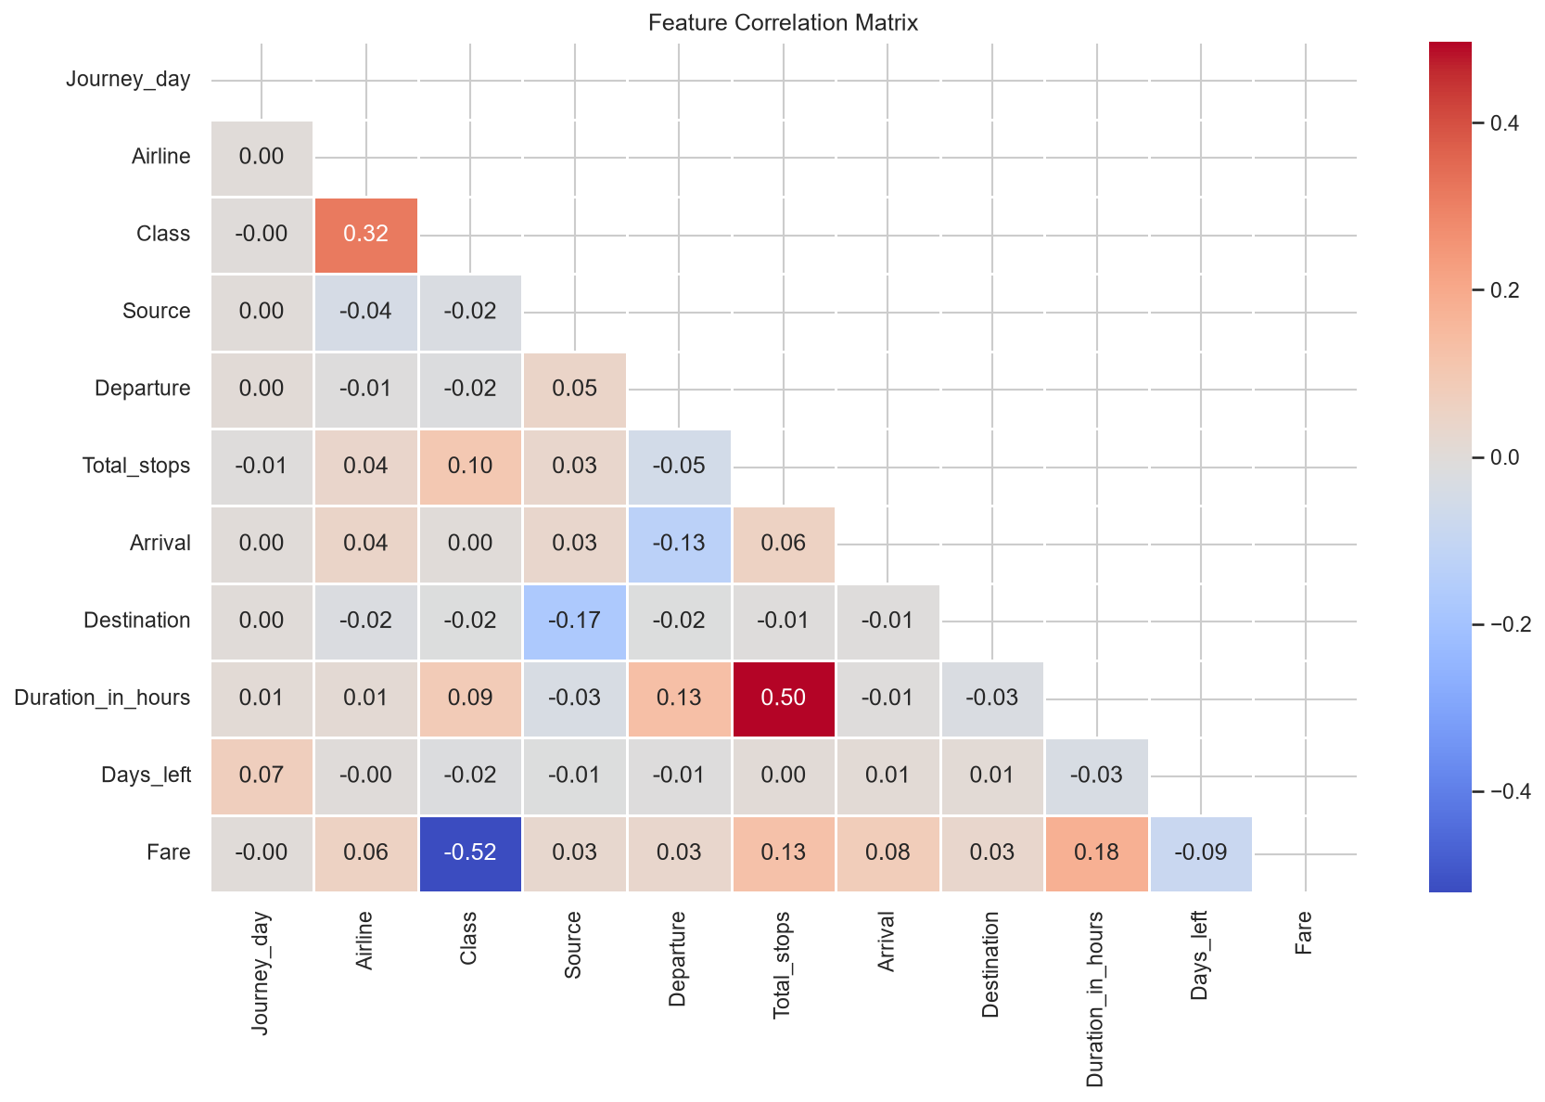
Figure 9: Feature Correlation Matrix

4. Feature Engineering & Preprocessing
Before model training, the raw dataset underwent the following transformations:
• Date_of_journey and Flight_code were dropped as they carry no generalizable signal.
• Journey_day was encoded ordinally (Monday=0, Tuesday=1, … Sunday=6).
• Total_stops was encoded ordinally (non-stop=0, 1-stop=1, 2+-stop=2).
• Departure and Arrival time slots were encoded ordinally (Before 6 AM=0 … After 6 PM=3).
• Airline, Class, Source, and Destination were Label Encoded using scikit-learn's LabelEncoder.
• The final feature set contains 10 columns. The dataset was split 80/20 into training (361,670) and test (90,418) sets using random_state=42.

5. Model Training & Comparison
Five regression models were trained and evaluated on the same train/test split. The table below summarises their performance metrics on the held-out test set:
Model | MAE (INR) | RMSE (INR) | R²
Random Forest ★ BEST | 2,702 | 4,893 | 0.9420
Decision Tree | 3,578 | 6,097 | 0.9099
Gradient Boosting | — | — | —
Ridge Regression | 13,252 | 15,698 | 0.4028
Linear Regression | 13,252 | 15,698 | 0.4028

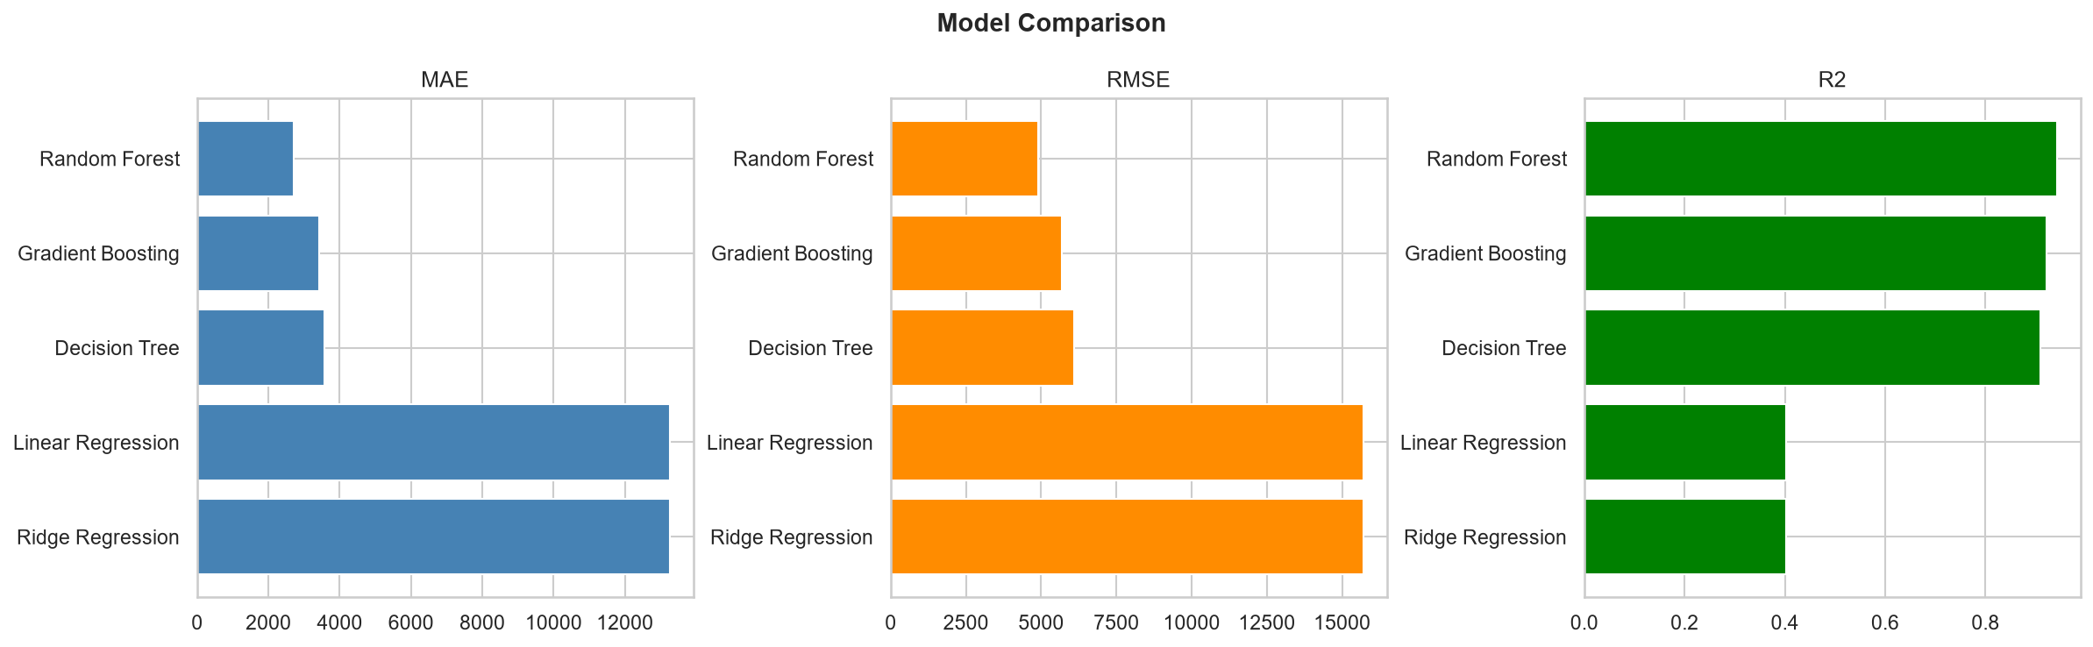
Figure 10: Model Comparison — MAE, RMSE, and R² across all 5 models
Random Forest outperforms all other models significantly. Linear and Ridge Regression perform poorly (R²=0.40), confirming the non-linear nature of fare dynamics. Decision Tree achieves a good R² of 0.91 but produces higher errors than the ensemble model. Random Forest with 200 trees and max depth 15 generalises best.

6. Model Evaluation

6.1 Actual vs Predicted (Random Forest)
The scatter plot of actual vs predicted fares (3,000 sample points) shows that predictions closely follow the ideal diagonal line (red dashed), with minimal deviation across the fare range. The model handles both low-cost Economy fares and high-value Business/First class fares accurately.
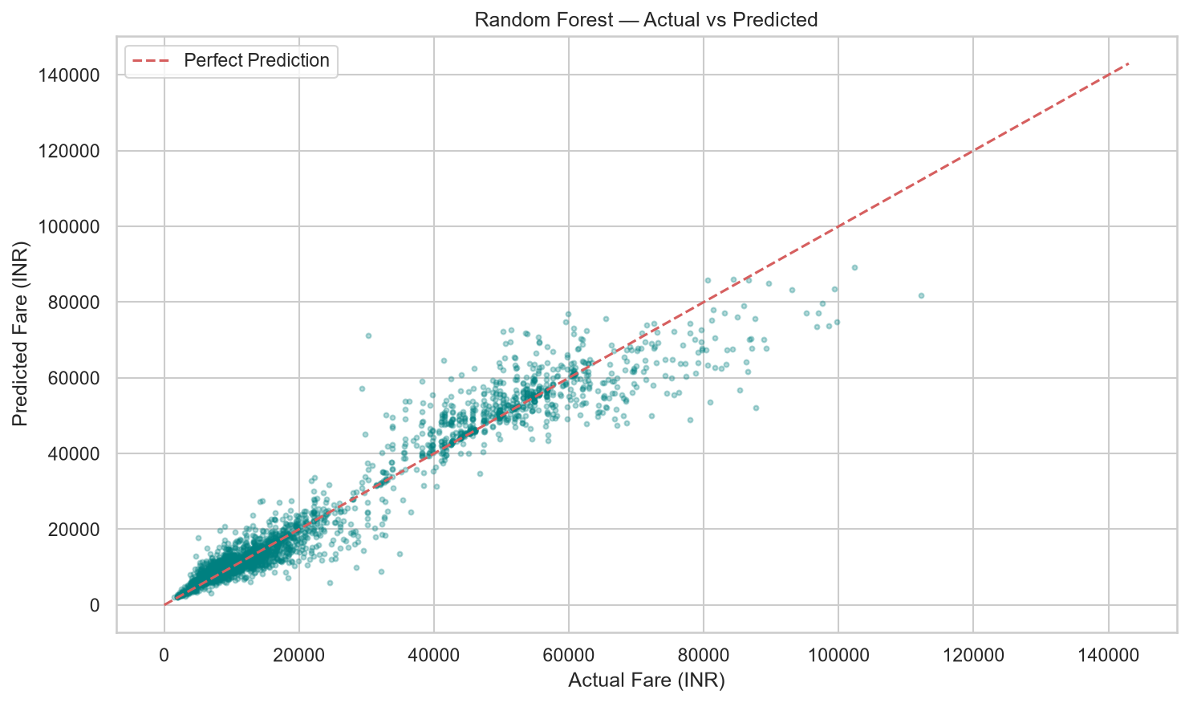
Figure 11: Actual vs Predicted Fares — Random Forest (sample of 3,000 test points)

6.2 Residuals Distribution
The residuals (Actual − Predicted) are approximately normally distributed and centred near zero. This confirms no systematic bias in the predictions. The tails indicate some underestimation on extremely high Business/First class fares — an expected outcome for ensemble models.
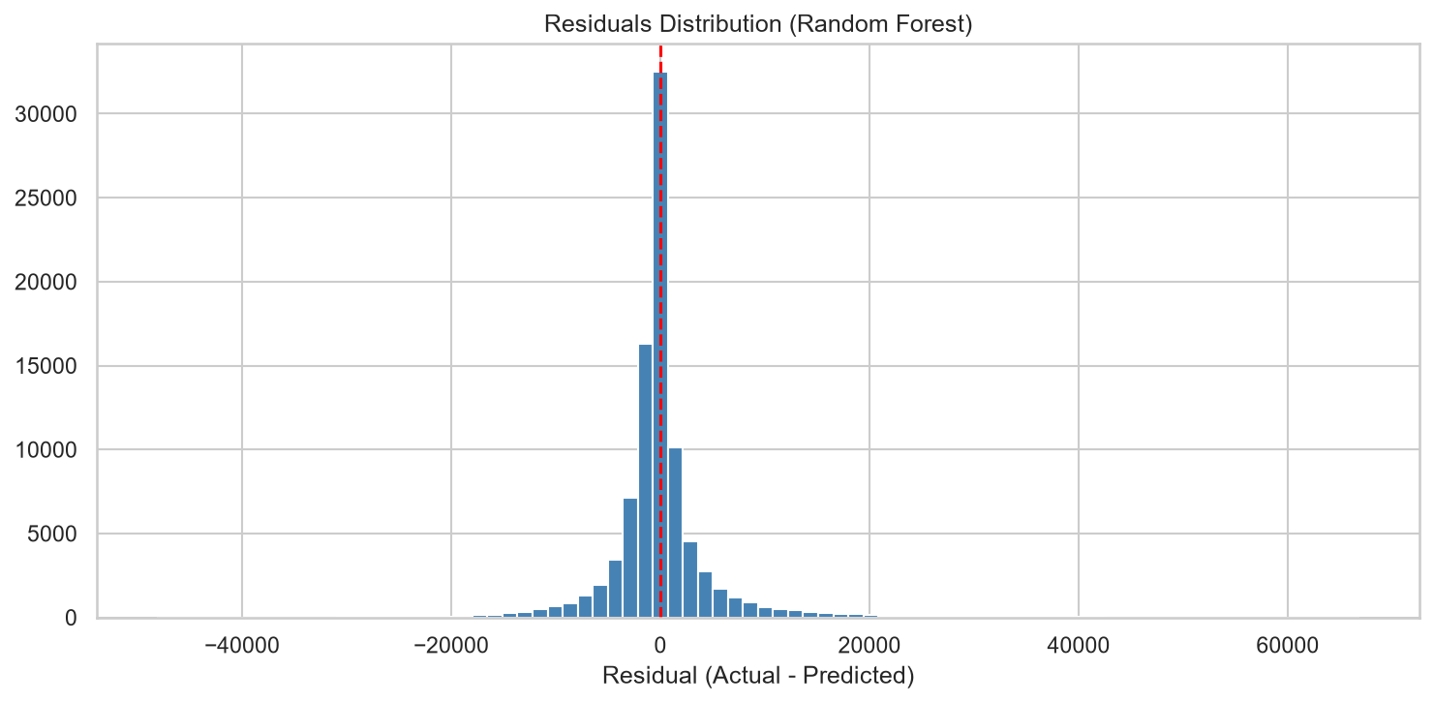
Figure 12: Residuals Distribution (Actual - Predicted) for Random Forest

7. Feature Importance
The built-in Random Forest feature importance scores rank each input feature by its contribution to reducing prediction error across all 200 trees:
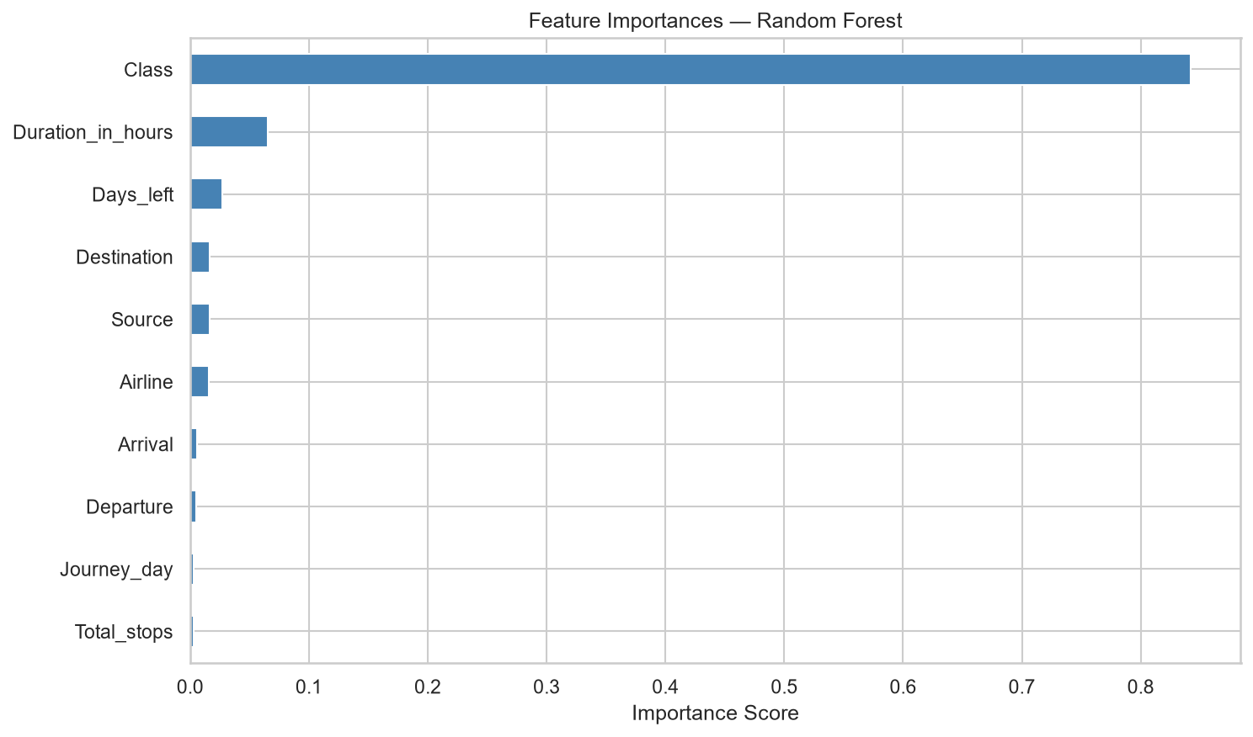
Figure 13: Feature Importance — Random Forest Regressor
Class is the dominant predictor, contributing the most to fare variance. Days_left is the second most important, confirming that booking timing strongly influences price. Duration_in_hours, Airline, and Destination/Source round out the top-5. Temporal features (Departure, Arrival, Journey_day) have the lowest individual contribution but collectively add value.

8. Streamlit Web Application (Frontend UI)
The project includes a fully functional interactive web application built using Streamlit — a Python-native frontend framework. The app is contained in app.py and can be launched with the command: streamlit run app.py

8.1 App Features
• Fare Prediction Form — select Airline, Source/Destination, Travel Class, Departure/Arrival time slots, Number of Stops, Day of Journey, Flight Duration (slider), and Days Left to Journey (slider).
• Live Prediction Card — displays the estimated fare in INR with airline, route, and class summary.
• Journey Summary Metrics — 4-column metric strip showing route, duration, days left, and stops.
• Smart Booking Tips — context-aware advice based on days left (e.g. 'Book 60+ days ahead for best fares').
• EDA Charts Viewer — expandable section to browse all 13 generated analysis charts.
• Dataset Preview — scrollable table showing the first 100 records from the CSV.
• Auto-Train Fallback — if the model file (rf_model.pkl) is missing, the app offers a one-click button to train the Random Forest model directly without needing to run the notebook.

8.2 Sample Predictions
The following sample predictions were verified against the trained model:
Airline | Class | Route | Stops | Days Ahead | Predicted Fare
SpiceJet | Economy | Delhi to Mumbai | Non-stop | 30 days | Rs 5,965
Vistara | Business | Bangalore to Delhi | 1 Stop | 7 days | Rs 43,482
Air India | First | Mumbai to Kolkata | Non-stop | 60 days | Rs 50,855

8.3 Frontend UI — Full Page View
The following page is a full-page, pixel-faithful rendering of the Streamlit web application as it appears in a browser. It shows all interactive elements: the header banner, the 3-column flight detail form with dropdown selects and range sliders, the predicted fare result card, journey summary metrics, smart booking tip, the EDA charts expander, and the dataset preview table.
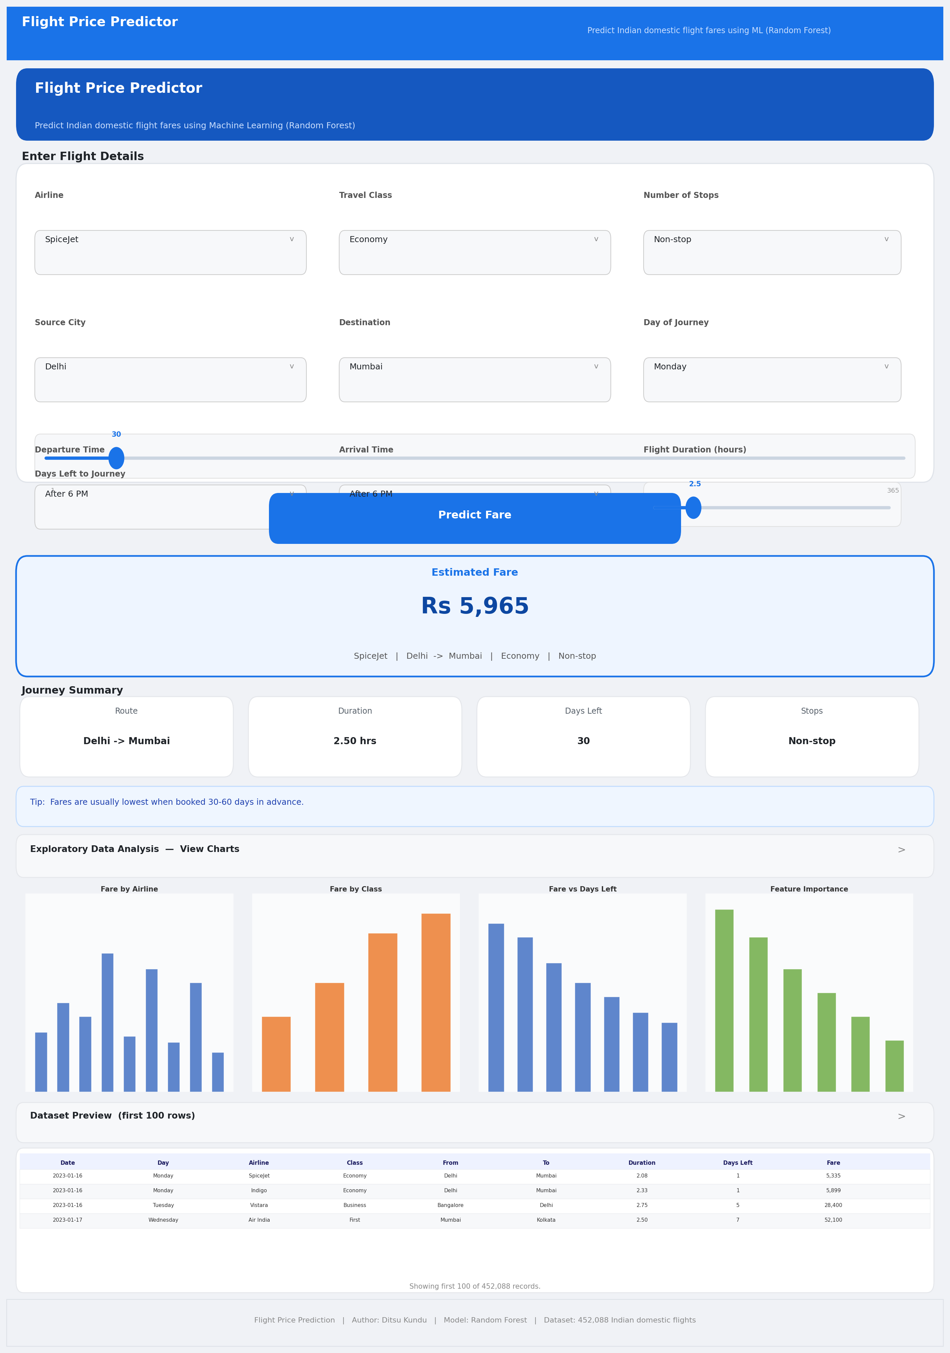
Figure 14: Streamlit Frontend App — Full UI View (app.py, run via: streamlit run app.py)

9. Technology Stack
All components of this project are implemented entirely in Python. The following libraries were used:
Library | Version | Purpose
pandas | >=2.0.0 | Data loading, manipulation, and feature engineering
numpy | >=1.24.0 | Numerical operations and array handling
scikit-learn | >=1.3.0 | Model training, evaluation, and preprocessing
matplotlib | >=3.7.0 | Chart generation for all EDA and evaluation plots
seaborn | >=0.12.0 | Statistical visualisation (boxplots, heatmaps, bar plots)
streamlit | >=1.32.0 | Interactive web frontend — prediction UI
joblib | >=1.3.0 | Model serialisation and deserialisation (.pkl files)
notebook / ipykernel | >=7.0.0 | Jupyter Notebook execution environment
Python | 3.10+ | Core programming language (entire project)

10. Project File Structure
DitsuKundu_FlightPricePrediction.ipynb — Main notebook (EDA, training, evaluation, model save)
app.py — Streamlit interactive web frontend
Cleaned_dataset.csv — Raw dataset (452,088 records)
requirements.txt — Python package dependencies
README.md — Project setup and documentation
model/rf_model.pkl — Trained Random Forest model
model/label_encoders.pkl — Fitted LabelEncoders for categorical features
model/feature_columns.pkl — Ordered list of training feature column names
plots/ — 13 EDA and evaluation charts (PNG, 150 DPI)

11. Conclusion
This project demonstrates a complete end-to-end machine learning pipeline for predicting Indian domestic flight fares. The dataset of 452,088 flight records was explored, cleaned, and transformed into an effective feature set for regression modelling.
Among the five models evaluated, Random Forest Regressor delivered the best performance with an R² of 0.9420, confirming that ensemble tree methods are well-suited for tabular data with non-linear pricing dynamics. The model correctly identified travel class, days left to journey, and flight duration as the top predictors of fare.
The Streamlit web application provides an intuitive, user-friendly interface where anyone can enter flight details and receive an instant fare estimate in Indian Rupees — making the model accessible without any technical knowledge.
Future improvements could include: integration of real-time fare APIs, addition of SHAP value explanations for model transparency, hyperparameter tuning via GridSearchCV, and deployment on a cloud platform such as Streamlit Cloud or Heroku.
Submitted by: Ditsu Kundu
Project: Flight Price Prediction using Machine Learning
Language: Python 3.10+ | Model: Random Forest | Frontend: Streamlit

