**Action Logger Overview**

Action Logger is a standalone component of the Apromore project, which aims at capturing and recording all the user interactions with IT systems in the form of UI logs. Currently the tool covers Excel and Chrome web browser applications. It consists of two plugins, each listening to the corresponding application and the actual logging component that receives the information about preformed actions in the form of JSON objects, converts it into format suitable for process mining tools and saves it in the UI log in CSV format. In addition, there is also a clipboard listener component that is running on the backend and records all the copying events. The architecture of a tool is presented in Fig. 1:

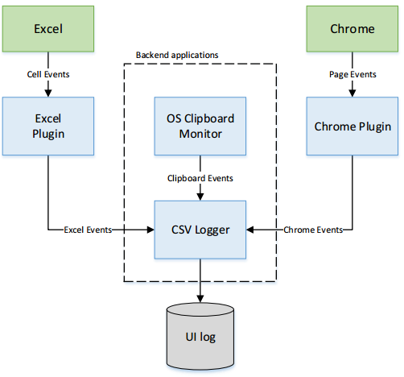

Fig. 1. Architecture of a tool

The tool is publicly available at <https://github.com/apromore/RPA_UILogger> and can be downloaded from <https://github.com/apromore/RPA_UILogger/releases>.

**Installation (also available at** [**https://youtu.be/YQlD44Z2v6A**](https://youtu.be/YQlD44Z2v6A)**)**

1. Install Node.js (<https://nodejs.org/en/>)
2. Download the newest version of Action Logger (<https://github.com/apromore/RPA_UILogger/releases>)
3. Unzip the downloaded file

To install Chrome plugin:

1. Open the browser and navigate to chrome://extensions
2. Turn on Developer Mode at the right top corner of the page
3. Select “*Load unpacked”* option and pick folder RPA_UILogger-*version*/PassiveListener
4. The Chrome plugin should appear on the right top corner of a browser
5. Check in the box in the plugin in order to set it in the recording mode

To install Excel plugin:

1. Navigate to *RPA_UILogger_version* folder
2. Right click *Excel_Addin* folder, select *Properties* -> *Sharing* -> *Share* -> *Share*
3. Copy the URL of the shared folder
4. Open Excel, go to *File* -> *Options* -> *Trust Center* -> *Trust Center Settings* -> *Trusted Add-in Catalogs*
5. Insert the copied URL into “Catalog URL” field and click “*Add catalog”*
6. Tick the “*Show in Menu”* box, then click “*OK*”
7. Select *Insert* -> *My Add-Ins* -> *Shared Folder* -> *Excel Passive Listener*

To run the logger:

1. Navigate to *RPA_UILogger_version* folder
2. Run *start_windows.bat* script (or start_linux.sh on Unix Operating systems)
3. In the opened console, specify the user ID and press ENTER
4. All the required dependencies will be installed
5. There will be two consoles opened – one for Excel listener and another for Chrome
6. The Excel plugin starts recording when you see “*Compiled successfully*” message
7. The Chrome plugin and the logging component starts recording when you see “*Action logger now recording*” message in another console window
8. The Chrome listener runs on <http://localhost:8080>
9. The Excel listener runs on <http://localhost:3000>
10. In Excel go to *Home* -> *Show Taskpane*, if the Excel listener is running, you should be able to see the content of a page <http://localhost:3000> on the right hand side of Excel
11. Make sure both plugins are set in recording mode by ticking the corresponding checkboxes
12. The generated UI log is available at *RPA_UILogger_version/append_http* folder and is named *logs.csv*
13. The Action Logger appends all the new events to logs.csv file, so in case you want to generate a new log, rename the *logs.csv* file or take it out from the directory

**Use Case (available at** [**https://youtu.be/SvPuOdWfByc**](https://youtu.be/SvPuOdWfByc)**)**

We will demonstrate the Action Logger in practice by recording the task of transferring the data from Excel spreadsheet to a form of a web-based information system.

We created an Excel spreadsheet and populated it with the users’ contact data (full name, date of birth, phone number and email).

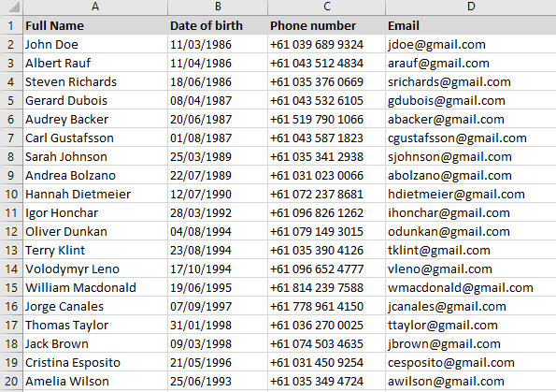

Fig. 2. Extract from an Excel spreadsheet containing users’ contact data

We used Zoho Online Form Builder to generate the following form:

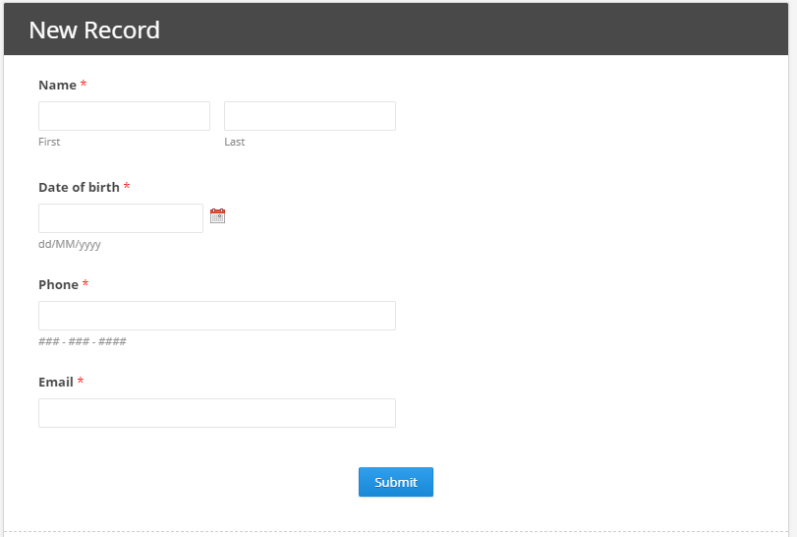

Fig. 3. Web form

Let us run the Action Logger and record the copying of the first entry in Excel spreadsheet. The following UI log will be generated:

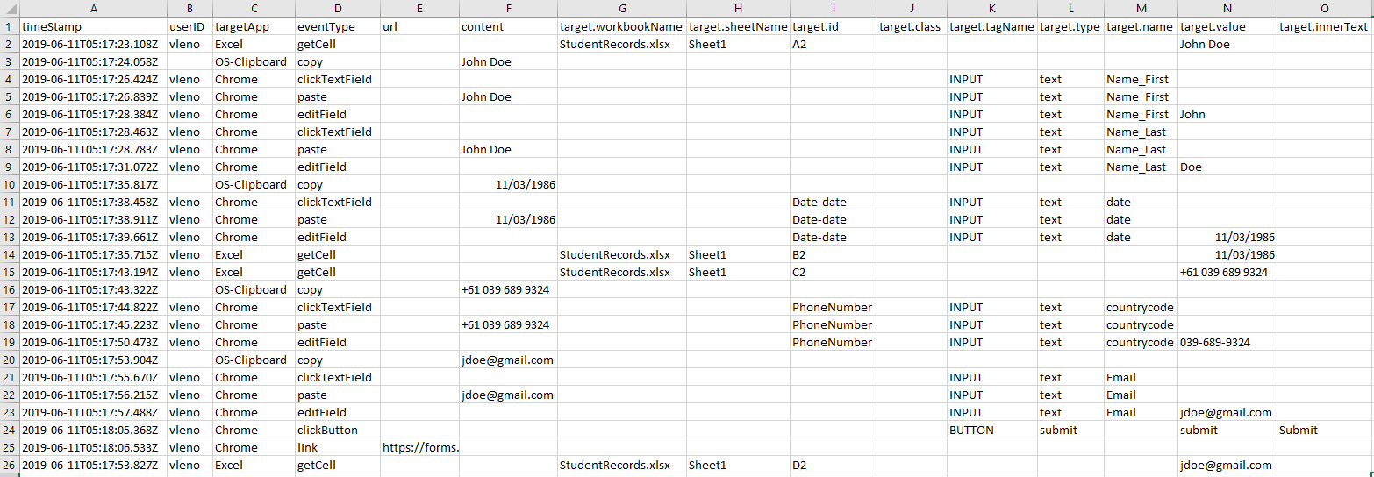

Fig. 4. Generated UI log

The generated log is unordered and contains operational system events related to clipboard. This log can be optimized by applying semantic filterer, the auxiliary tool that we developed for the action logger. This tool is available at <https://github.com/apromore/RPA_SemFilter>. To get filtered log perform the following set of commands:

1. Put the target UI log in the same folder with RPA_SemFilter.exe file
2. Select the log and drop it onto RPA_SemFilter.exe
3. The tool will automatically remove all redundant events and generate the file *targetLog_filtered.csv*

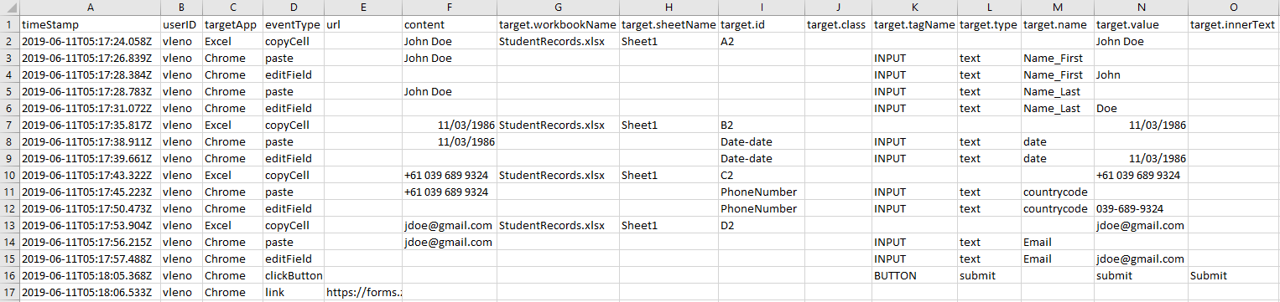

Fig. 5. Simplified UI log

Finally, we can build a model that describes a process recorded in the log. We will use the Apromore tool to do this.

1. Go to the cloud-based version of Apromore available at <http://apromore.cis.unimelb.edu.au/>
2. Select *Discover* -> *CSV Importer -> Import File*
3. Select a corresponding UI log
4. Assign the following roles to the attributes:

* timeStamp – End timestamp (use the following parsing format: “yyyy-MM-dd'T'HH:mm:ss.SSS”)
* eventType – Activity
* userID – Case ID (at this moment the Action Logger does not assign events to specific case)

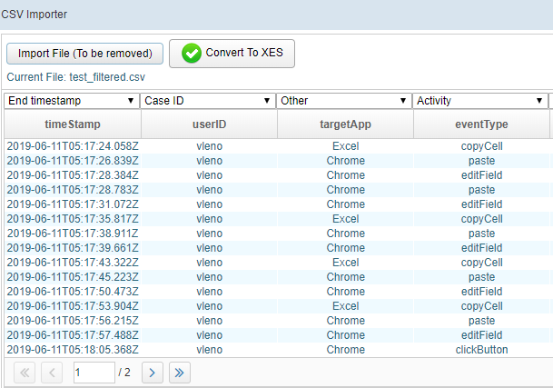

Fig. 6. Importing the generated UI log

1. Select *Convert to XES*
2. The corresponding file of XES format will be created and can be found in the currently active folder
3. Double click on the generated XES file to see the preview of a discovered model

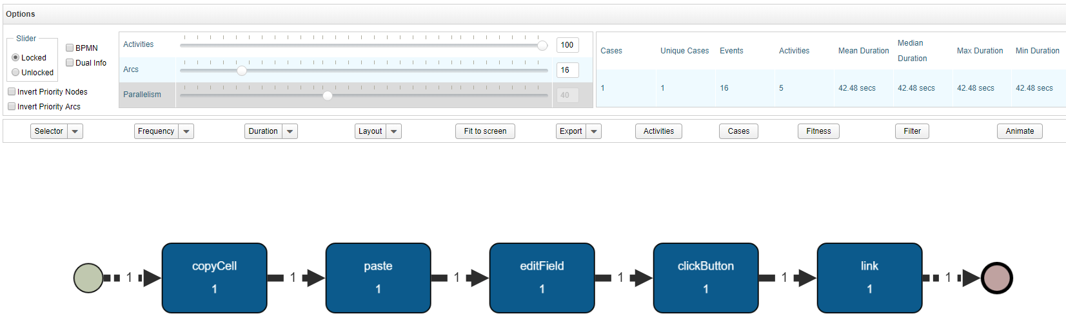

Fig. 7. The model discovered from the generated UI log

1. Currently the case frequency is displayed. You can switch to cumulative frequency by selecting *Frequency -> Cumulative*

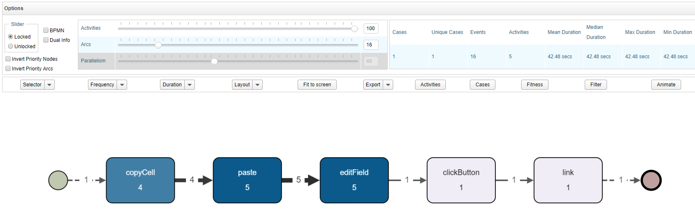

Fig. 8. The discovered model showing cumulative frequency

1. You can look at the full model by moving the Arcs slider to maximum

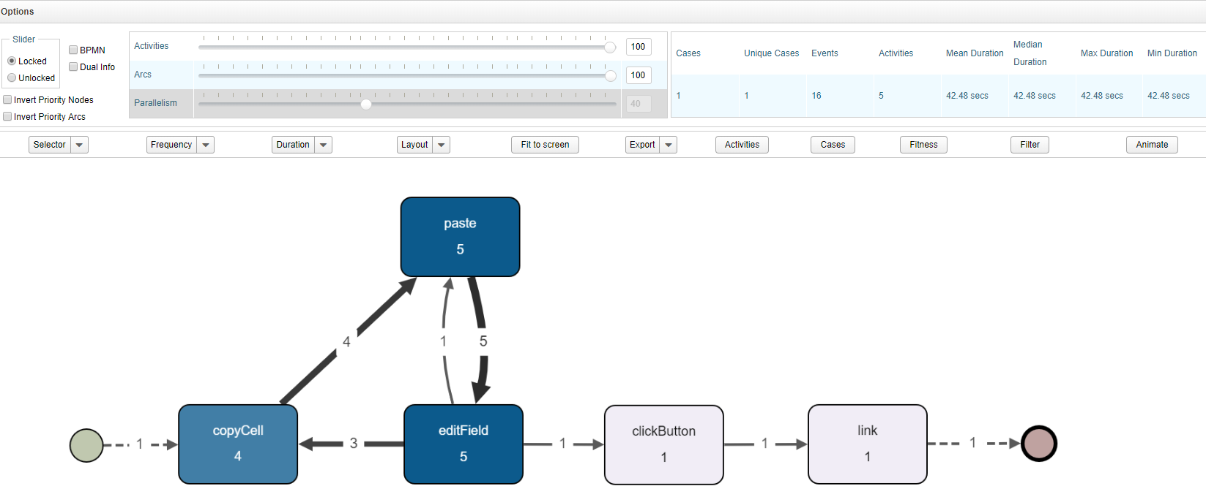

Fig. 9. The discovered model showing all the arcs in a process