**Lab Report:**

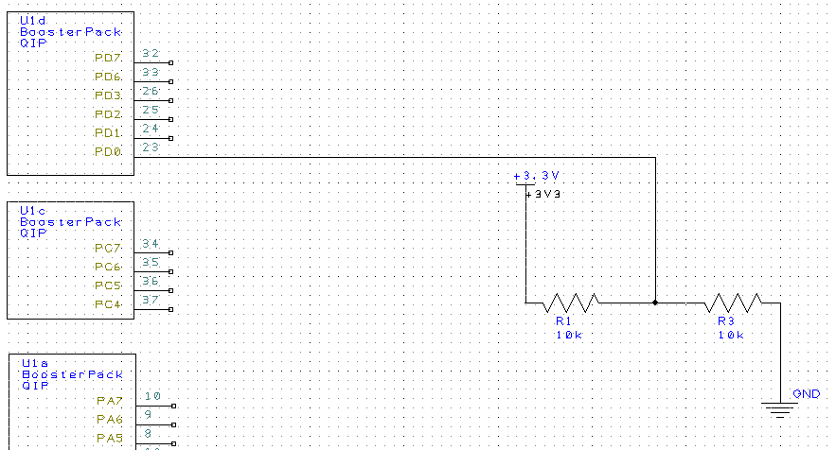

Analysis and Discussion:

1. The Domain Name Server (DNS) is a hierarchical naming system for devices and resources that are associated with the internet or any private network. It contains information associated, most prominently IP addresses, with the domain names of the participating devices and resources. This is necessary since users prefer using domain names to access network resources while devices access network resources via IP addresses.
2. Transmission control protocol (TCP) and universal datagram protocol (UDP) are the two type of IP traffic. TCP is connection based, where a connection is established between two devices and data can be sent bidirectionally. UDP is connectionless, which means that one device sends a load of packets to another at the end of which the relationship is terminated. TCP arranges data packets in the order specified, whereas UDP has not ordering protocol. TCP checks for errors and error recovery. If an error occurs the erroneous packet is resent from the source. While UDP attempts error checking it does not carry out error recovery and the erroneous packets are simply discarded. Therefore, TCP has a greater reliability. TCP is a heavier protocol than UDP. Consequently, TCP should be used when reliability of transmission is critical while time and resources are less critical. Whereas, UDP should be used when you need fast, efficient communication while reliability is not critical. UDP may be useful for games or for servers answering a large number of small queries.