1. Objectives
2. Implement a system that connects to the internet via an IEEE 802.11 – Wifi module, CC3100
3. Use DNS to convert name to IP address
4. Configure a smart object that can retrieve data from a weather server using TCP
5. Design a smart object that can store data onto an internet server using TCP
6. Implement a web server to log data from your smart object
7. Hardware design

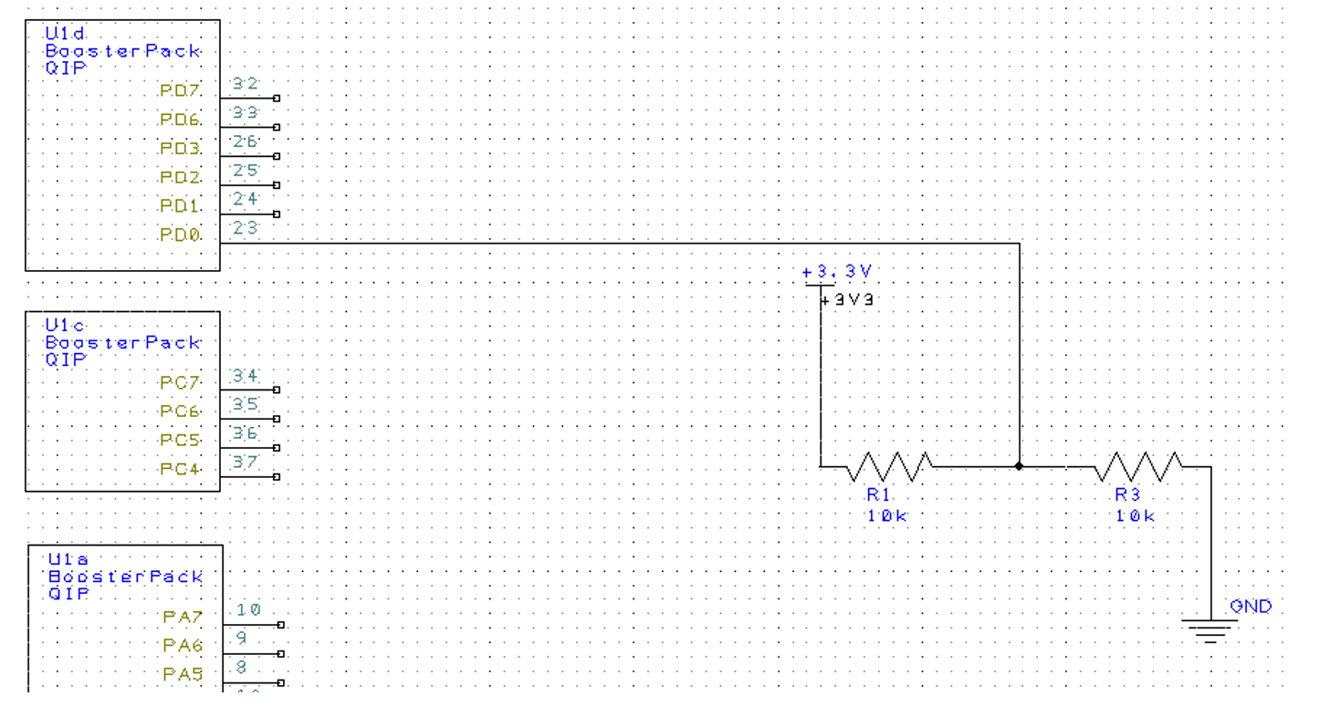

1. Software Design

Turned in via Github

1. Measurement Data
2. Percentage of lost packets: due to the nature of TCP, it’s 0%
3. openweather.org: min is 208, max is 308, average is 216.8 (all in ms)
4. my server: min is 252, max is 652, average is 380.8 (all in ms)
5. Analysis and Discussion:
6. The following steps have to happen:
   1. Use DNS to “translate” the host name into the destination IP address.
   2. Create a client socket and connect to server in order to send TCP
   3. Use the same socket to wait and receive TCP from the server.
   4. Close the socket
7. The Domain Name Server (DNS) is a hierarchical naming system for devices and resources that are associated with the internet or any private network. It contains information associated, most prominently IP addresses, with the domain names of the participating devices and resources. This is necessary since users prefer using domain names to access network resources while devices access network resources via IP addresses.
8. Transmission control protocol (TCP) and universal datagram protocol (UDP) are the two type of IP traffic. TCP is connection based, where a connection is established between two devices and data can be sent bidirectionally. UDP is connectionless, which means that one device sends a load of packets to another at the end of which the relationship is terminated. TCP arranges data packets in the order specified, whereas UDP has not ordering protocol. TCP checks for errors and error recovery. If an error occurs the erroneous packet is resent from the source. While UDP attempts error checking it does not carry out error recovery and the erroneous packets are simply discarded. Therefore, TCP has a greater reliability. TCP is a heavier protocol than UDP. Consequently, TCP should be used when reliability of transmission is critical while time and resources are less critical. Whereas, UDP should be used when you need fast, efficient communication while reliability is not critical. UDP may be useful for games or for servers answering a large number of small queries.