# 2024-ISGB33-Laboration-2-LeonFredriksson

Torsdag den 28 november 2024

## 1)

### 1.1 Kod

db["listingsAndReviews"].find({beds: { $gt: 3 },"address.country": "Portugal", price: { $lt: 75 }})

### 1.2 Resultat

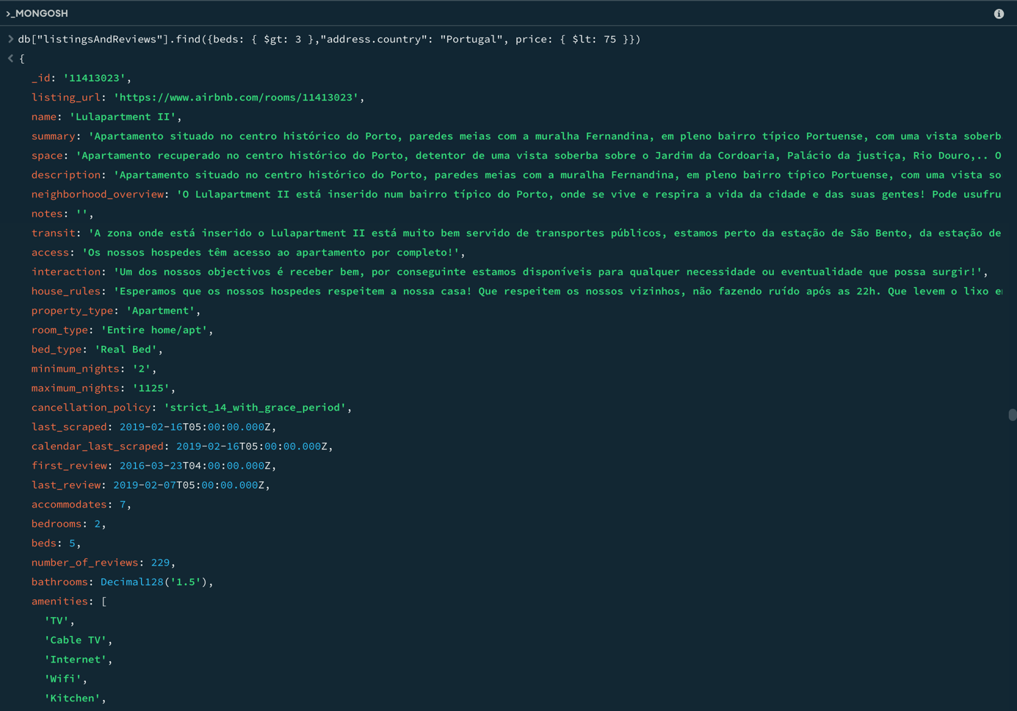

## 2)

### 2.1 Kod

db["listingsAndReviews"].find({"review_scores.review_scores_cleanliness": {$gt: 8}}, {name:1, summary:1, "address.country":1, price:1, _id:0}).sort({price:1})

### 2.2 Resultat

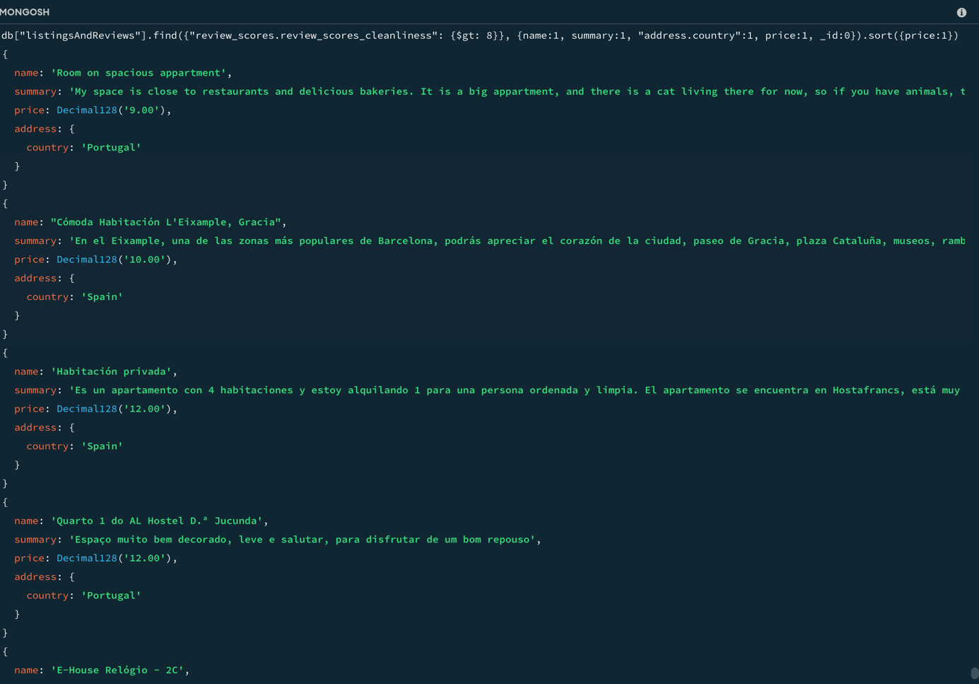

## 3)

### 3.1 Kod

db["listingsAndReviews"].updateOne({“description”:{$regex: "mountain view", $options: “i”}}, {$set:{price:90}})

### 3.2 Resultat

## 4)

### 4.1 Kod

db["listingsAndReviews"].updateMany({“address.country”: “Turkey”}, {$set:{isactive:false}})

### 4.2 Resultat

## 5)

### 5.1 Kod

db["listingsAndReviews"].deleteMany({$expr:{$lt:[{$add: ["$review_scores.review_scores_accuracy", "$review_scores.review_scores_cleanliness", "$review_scores.review_scores_checkin", "$review_scores.review_scores_communication", "$review_scores.review_scores_location", "$review_scores.review_scores_value"]},21]}})

### 5.2 Resultat

