Liens sur les défauts optiques 1
Calcul des lentilles 1
Lentille plan-convexe de 1500 mm de focale: 2
Objet à l'infini, dépoli à 1.5m de la lentille 2
Objet à 6m de la lentille, dépoli à 2m de la lentille 4
Fournisseurs de lentilles 7
efforttechnology : chinois avec qui j'ai déjà travaillé 7
Autres, à voir 7
Demande type pour lentille plano-convexe 7
optics-online.com : design en ligne et bureau de design 8
Calcul d'un "Best-form Lens" de focale 1500 mm à 0.6 µm, et de diamètre 154mm 9
Calcul d'un "Achromatic doublet Lens" de focale 1500 mm à 0.6 µm, et de diamètre 154mm 15
Triplet de Cooke 18

_____________________________________________________________________________________________________

Liens sur les défauts optiques
Aberrations géométriques (sphérique, coma, chromatique):
https://fr.wikipedia.org/wiki/Aberration_g%C3%A9om%C3%A9trique

On peut réduire les aberrations chromatiques avec un doublet achromatique:
https://fr.wikipedia.org/wiki/Doublet_achromatique

Aplanétisme:
https://fr.wikipedia.org/wiki/Aplan%C3%A9tisme
https://fr.wikipedia.org/wiki/Aplanat
https://en.wikipedia.org/wiki/Rapid_Rectilinear
Très intéressant: description des systèmes Rapid Rectilinear et Aplanat qui seraient certainement une bonne solution mais probablement difficile à réaliser et chère:
https://www.johnloomis.org/eop601/notes/history/rapid/rapid.html
Sauvé et commenté dans Rapid.Rectilinear.and.Aplanat.pdf

https://www.photonics.com/Articles/Understanding_Lenses_Aplanats_and_Achromats/a22346

Lentilles asphériques:
https://fr.wikipedia.org/wiki/Lentille_asph%C3%A9rique

Matériaux utilisés pour les verres optiques:
https://sydor.com/material-category/optical-glass/
Les plus communs sont
SCHOTT N-BK7
Ohara S-BSL 7

https://sunex.com/2019/07/25/material-guide/

Calcul des lentilles

Le milieu extérieur est supposé être d'indice 1.
Vergence: 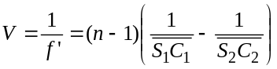, les indices 1 et 2 sont relatifs au 1er et au 2ème dioptre, 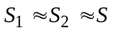, noté O par habitude (centre de la lentille).

Ouverture :

Lentille plan-convexe de 1500 mm de focale:
planno lens :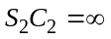
BK7:
Optical index: n = 1.5168
Abbe number: 64.17

f ' = 1.5 m
Rayon de courbure de la face convexe: 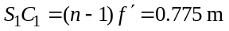

Pour afficher les caractéristiques de la lentille: cliquer sur la lentille pour qu'elle apparaisse en vert, et regarder l'onglet Design:
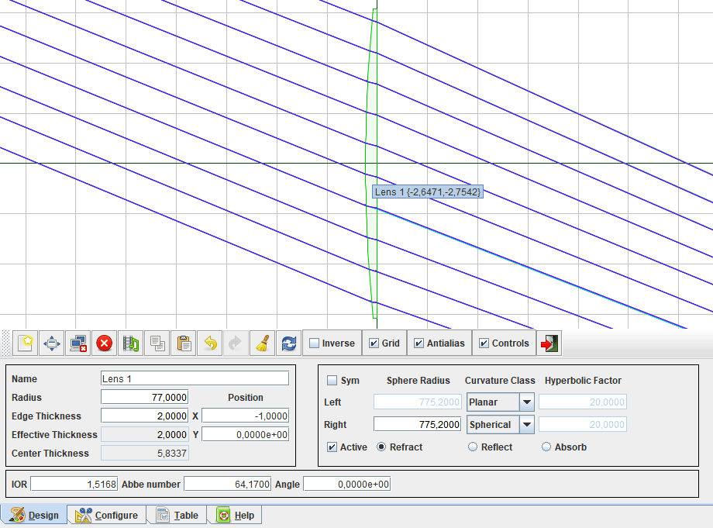

Objet à l'infini, dépoli à 1.5m de la lentille
Sans dispersion, ça converge bien à 1500mm:
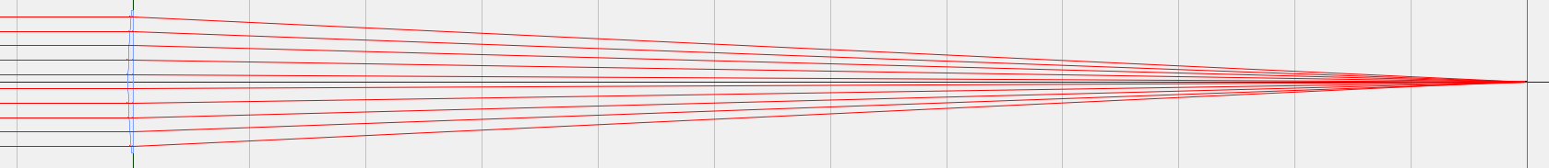
Avec dispersion:
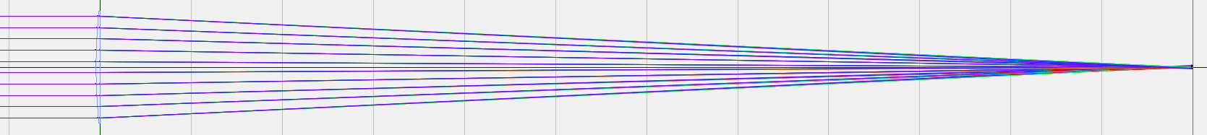

A 20°, on voit que ce n'est pas la dispersion qui importe, mais bien l'aplanétisme, qui pourrait probablement être réduit avec une lentille asphérique.
Mais on voit aussi que même si on arrivait à corriger l'aplanétisme, on aurait de forts problèmes de profondeur de champ avec des lentilles aussi grandes.
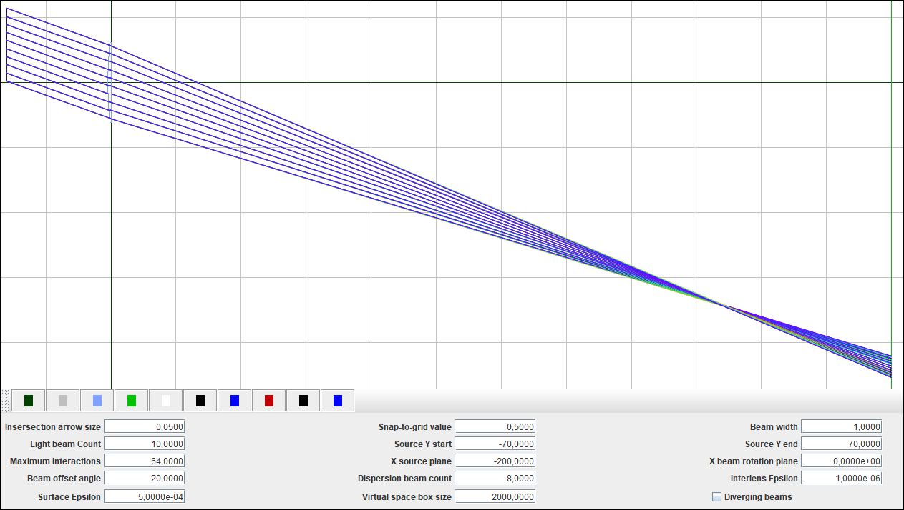

# OpticalRayTracer 9.6
# http://arachnoid.com/OpticalRayTracer
# 2023.11.30 22:26:23 CET

program {
antialias = true
askBeforeDeleting = true
beamAngle = 20,000000
beamCount = 10
beamWidth = 1
clipboardGraphicXSize = 1280
colorArrow = -2147483393
colorBaseline = -16760832
colorBeam = -4194304
colorGrid = 1086374080
colorHighBackground = -1
colorLensOutline = 276865279
colorLensSelected = 268484608
colorLightSource = -16776961
colorLowBackground = -16777216
colorTerminator = -16777216
decimalPlaces = 4
defaultWindowHeight = 600
defaultWindowWidth = 900
dispScale = 0,001141
dispersionBeams = 8
divergingSource = false
helpScrollPos = 0
interLensEpsilon = 1,000000e-06
intersectionArrowSize = 0,050000
inverse = false
maxIntersections = 64
selectedComponent = 1
selectedTab = 0
showControls = true
showGrid = true
snapValue = 0,500000
surfEpsilon = 5,000000e-04
tableLineLimit = 500
virtualSpaceSize = 2000,000000
windowX = 100
windowY = 100
xBeamRotationPlane = 0,000000e+00
xBeamSourceRefPlane = -200,000000
xOffset = 807,384316
yEndBeamPos = 70,000000
yOffset = -150,611616
yStartBeamPos = -70,000000
}

object {
active = true
angle = 0,000000e+00
centerThickness = 5,833654
dispersion = 64,170000
function = 0
ior = 1,516800
leftCurvature = 3
leftSphereRadius = 775,200000
leftZValue = 20,000000
lensRadius = 77,000000
name = Lens 1
rightCurvature = 0
rightSphereRadius = 775,200000
rightZValue = 20,000000
symmetrical = false
thickness = 2,000000
xPos = -1,000000
yPos = 0,000000e+00
}

object {
active = true
angle = 0,000000e+00
centerThickness = 0,100000
dispersion = 64,170000
function = 2
ior = 1,516800
leftCurvature = 3
leftSphereRadius = 900,000000
leftZValue = 20,000000
lensRadius = 900,000000
name = Terminal Plane
rightCurvature = 3
rightSphereRadius = 900,000000
rightZValue = 20,000000
symmetrical = true
thickness = 0,100000
xPos = 1500,000000
yPos = 0,000000e+00
}

Objet à 6m de la lentille, dépoli à 2m de la lentille
Un objet sur l'axe, à 6 m de la lentille, sera net sur l'écran disposé à 2 m de la lentille:

Mais en bord de champ (22° d'inclinaison à 6 m devant la lentille), l'image se forme bien avant le dépoli, et ce ne sera pas net sur le dépoli:
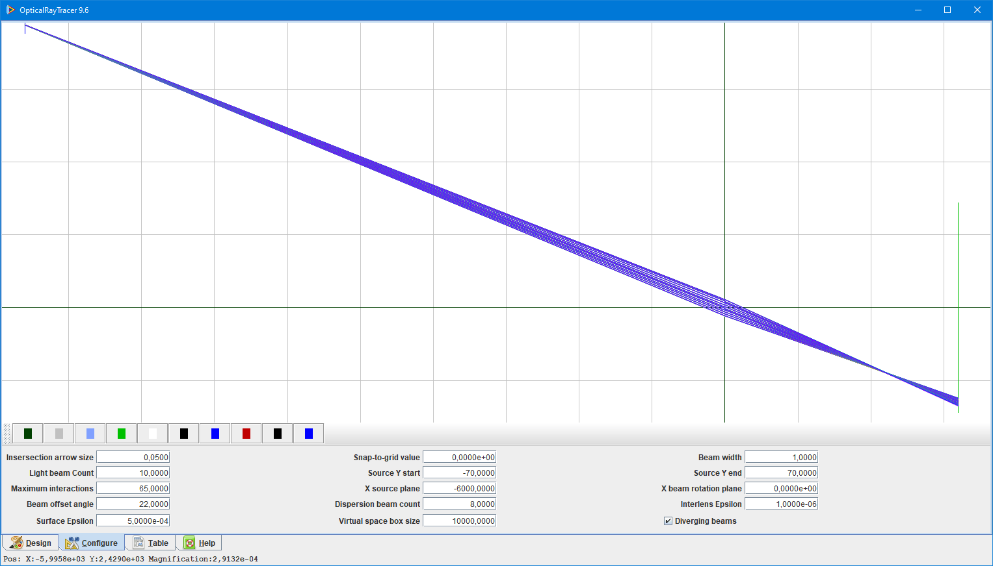

Sans rien changer, ce sera net sur le dépoli pour des sujets à 2.7 m devant la lentille:
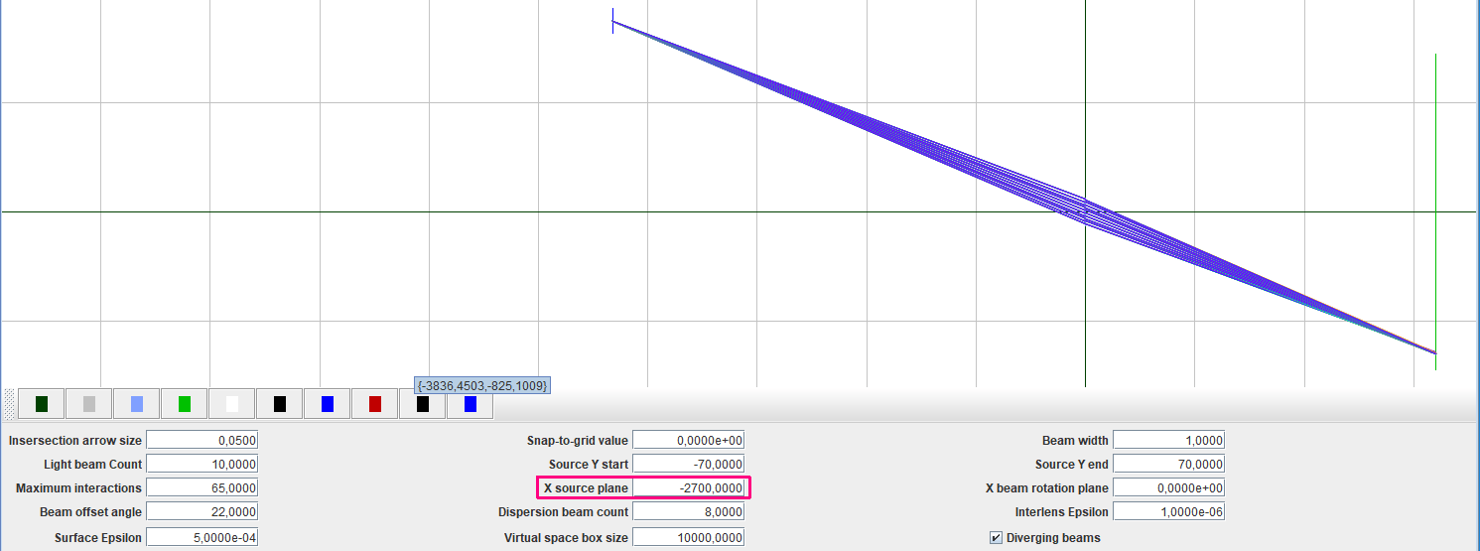

# OpticalRayTracer 9.6
# http://arachnoid.com/OpticalRayTracer
# 2023.11.30 18:29:16 CET

program {
antialias = true
askBeforeDeleting = true
beamAngle = 22,000000
beamCount = 10
beamWidth = 1
clipboardGraphicXSize = 1280
colorArrow = -2147483393
colorBaseline = -16760832
colorBeam = -4194304
colorGrid = 1086374080
colorHighBackground = -1
colorLensOutline = 276865279
colorLensSelected = 268484608
colorLightSource = -16776961
colorLowBackground = -16777216
colorTerminator = -16777216
decimalPlaces = 4
defaultWindowHeight = 600
defaultWindowWidth = 900
dispScale = 2,913155e-04
dispersionBeams = 8
divergingSource = true
helpScrollPos = 0
interLensEpsilon = 1,000000e-06
intersectionArrowSize = 0,050000
inverse = false
maxIntersections = 65
selectedComponent = 1
selectedTab = 0
showControls = true
showGrid = true
snapValue = 0,000000e+00
surfEpsilon = 5,000000e-04
tableLineLimit = 500
virtualSpaceSize = 10000,000000
windowX = 100
windowY = 100
xBeamRotationPlane = 0,000000e+00
xBeamSourceRefPlane = -6000,000000
xOffset = -1961,237578
yEndBeamPos = 70,000000
yOffset = 729,350269
yStartBeamPos = -70,000000
}

object {
active = true
angle = 0,000000e+00
centerThickness = 5,833654
dispersion = 64,170000
function = 0
ior = 1,516800
leftCurvature = 3
leftSphereRadius = 775,200000
leftZValue = 20,000000
lensRadius = 77,000000
name = Lens 1
rightCurvature = 0
rightSphereRadius = 775,200000
rightZValue = 20,000000
symmetrical = false
thickness = 2,000000
xPos = -1,000000
yPos = 0,000000e+00
}

object {
active = true
angle = 0,000000e+00
centerThickness = 0,100000
dispersion = 64,170000
function = 2
ior = 1,516800
leftCurvature = 3
leftSphereRadius = 900,000000
leftZValue = 20,000000
lensRadius = 900,000000
name = Terminal Plane
rightCurvature = 3
rightSphereRadius = 900,000000
rightZValue = 20,000000
symmetrical = true
thickness = 0,100000
xPos = 2000,000000
yPos = 0,000000e+00
}

Fournisseurs de lentilles

efforttechnology : chinois avec qui j'ai déjà travaillé
Pour deux projets de recherche, je me suis fait fabriquer en Chine des lentilles sur mesure à très bas prix chez
https://efforttechnology.en.ecplaza.net/
https://efforttechnology.en.alibaba.com/
- en 2016, 2 lentilles de 100 mm de diamètre, 35$ chaque lentille, 40$ de port
- en 2018, 2 lentilles de 95 mm et 58 mm de diamètre, 136$ le tout (50$ de port compris)

Autres, à voir
Depuis la page
https://efforttechnology.en.ecplaza.net/products
si on clique sur le lien
All Types of Optical Glass - Custom Aspheric Lenses
on arrive sur Cimcoop :
Cimcoop est à Sofia (Bulgarie)
Ils semblent limités à 100 mm de diamètre
https://cimcoop.com/optics/spherical-lenses/
https://cimcoop.com/contacts/ : visio zoom de 30 min pour expliquer les besoins

Depuis la page :
https://efforttechnology.en.ecplaza.net/contact
si on clique sur le lien
Plano-Convex, Biconcave, Plano-Concave, Cylindrical Lenses
on arrive sur
https://eksmaoptics.com/optical-components/lenses/
Wide selection of Spherical lenses made of N-BK7, UVFS or CaF2 optical materials, Apherical lenses made of N-BK7, UVFS or S-LAH64 optical materials, Cylindrical and Conical (Axicon) lenses made of N-BK7 and UVFS. Lenses forms plano-convex, plano-concave, biconvex, biconcave, plano-convex cylindrical and plano-concave cylindrical. Focal lengths vary from -5000 to +10000 mm.
Other specific material, size and anti-reflection (AR) coated lenses are available under custom request. Most of the lenses are available ex-stock for fast off-the-shelf delivery.

https://ardoptics.com

https://www.jenoptik.com/sites/france

Demande type pour lentille plano-convexe
We need a simple (but rather big) lens:
Diameter 154 mm
Focal 1500 mm
A plano-convex lens should be fine
Material : BK7, or if you have another option with some low dispersion glass
If made with BK7, the radius of curvature of the convex diopter should be about 775 mm

It should be looking like that (the grid squares have 25mm sides):
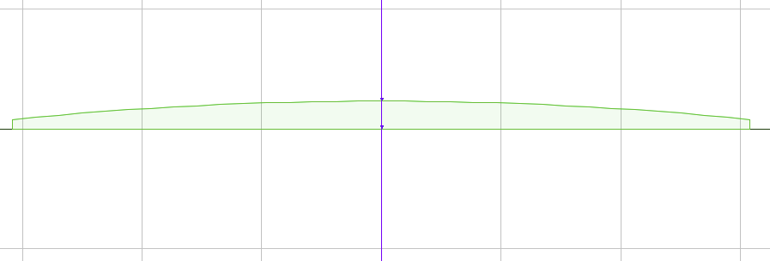

Can you tell me
1) if you can build such lens ?
2) which material can you use for the lens?
3) what would be the price for the lens ?

==========================================================================

Envoyé le 20/11/2023 sur
https://efforttechnology.en.ecplaza.net/contact

Dear Yu Jing,

We have been in contact some years ago, and you made for me several nice personalized lenses.

I presently need a simple (but rather big) lens:
Diameter 154 mm
Focal 1500 mm
A plano-convex lens should be fine
Material : BK7, or if you have another option with some low dispersion glass
If made with BK7, the radius of curvature of the convex diopter should be about 775 mm.

Can you tell me
1) if you can build such personalized lens ?
2) which material can you use for the lens?
3) what would be the price for the lens (in BK7, and if you have, in some low dispersion material)?

Best regards,
Gerard TAYEB
email: gerard.tayeb@fresnel.fr
Post code: 13013
City: Marseille
Country: France
Telephone number: +33 6 71 46 28 09
________________________________________________

Confirm Your Email Address
We sent an email to gerard.tayeb@fresnel.fr.
Your inquiry has been saved and will be sent after confirming your email adddress.
Please check your email box to activate your account.
Having problem receiving email?

optics-online.com : design en ligne et bureau de design
https://www.optics-online.com/Custom/optical_design_page.asp

https://www.optics-online.com/mnp.asp
Meniscus lens, aplanatic

https://www.optics-online.com/lensprimer.asp : bonnes notions sur les lentilles et les défauts optiques

https://www.optics-online.com/lensprimer2.asp :
bonnes notions sur
- Multi-element lenses,
- Achromatic doublets,
- Cooke triplet lenses : apparemment une bonne solution pour Camera Obscura
- Custom lenses : There is no universal lens design for all applications. To achieve the best performance/cost trade-offs, many applications will require custom lens designs. The goal of a custom lens design is to reach an acceptable performance level for the intended application while minimizing the cost.

https://www.optics-online.com/designer1.asp
Permet de réaliser facilement un design à choisir parmi les types suivants :
- Plano-convex lens
- Bi-convex lens
- Plano-concave lens: a lens element with one flat surface and the other concave. This lens has negative focal length.
- Bi-concave lens: a lens element with two concave surfaces of equal radius. This element has negative focal length.
- Achromatic doublet lens: a doublet lens free of axial chromatic aberration, 3rd order spherical and coma aberration.
- "Best-form" lens: a single lens element free of 3rd order spherical aberrations for distance object.
- Aplanatic meniscus lens: a lens element that increases the relative aperture (or lowering the f/#) of another lens without introducing additional spherical aberrations and coma.

Calcul d'un "Best-form Lens" de focale 1500 mm à 0.6 µm, et de diamètre 154mm
A partir de https://www.optics-online.com/designer1.asp
Pour comparer à une lentille plan convexe

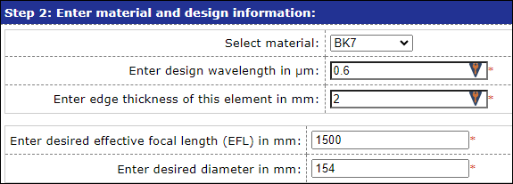
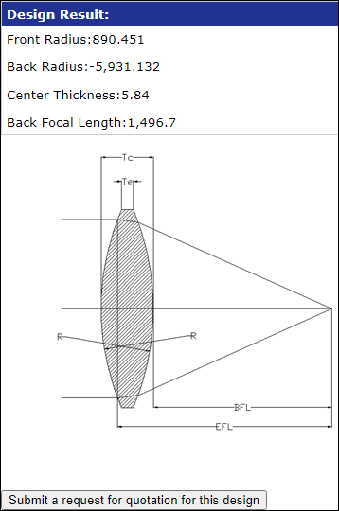

Visuellement, ça diffère assez peu d'une lentille plan convexe :
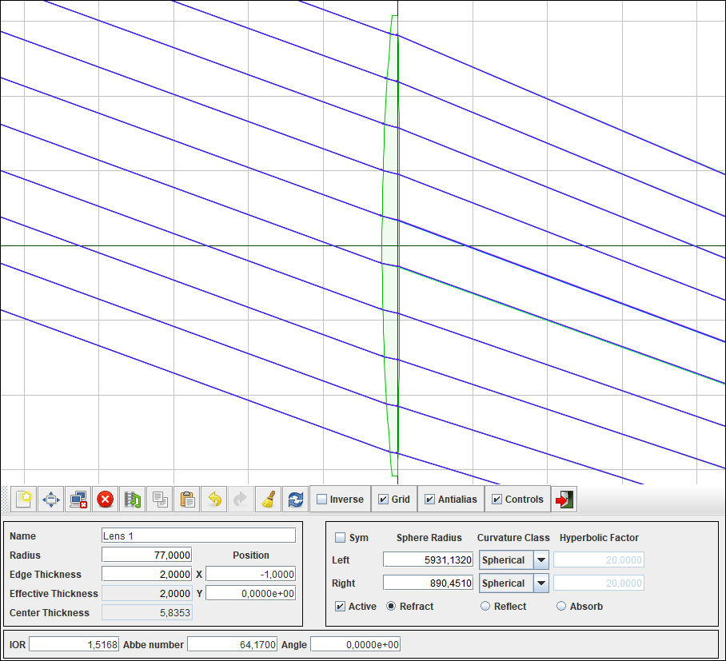

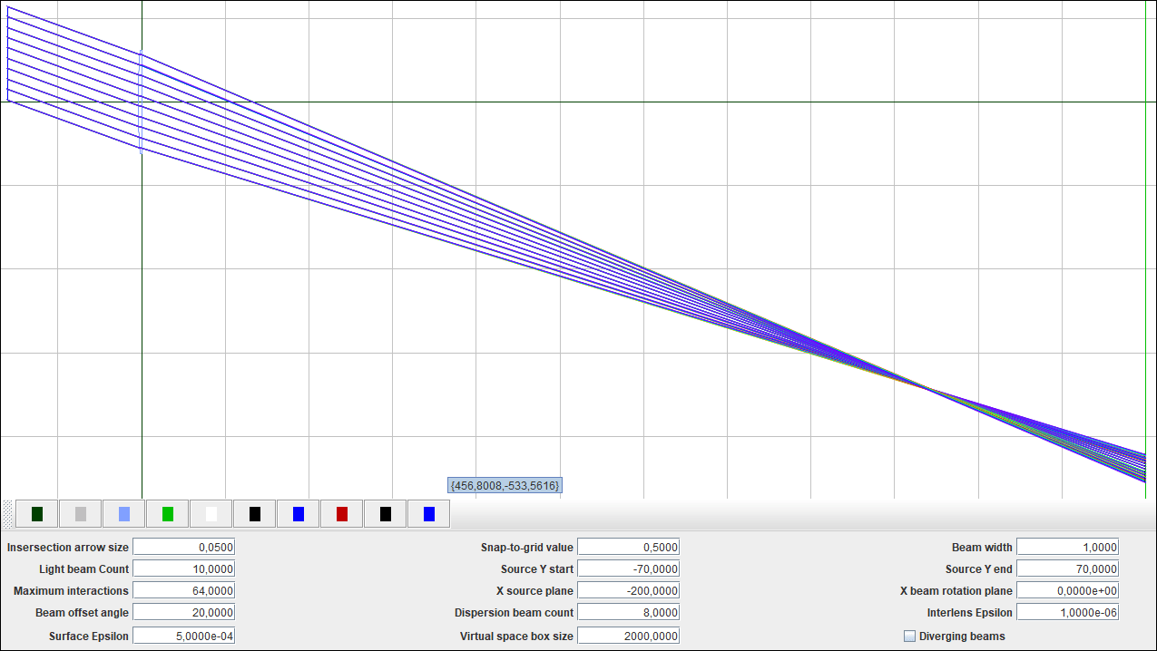

Zoom sur le point de focalisation avec la Best-form lens :
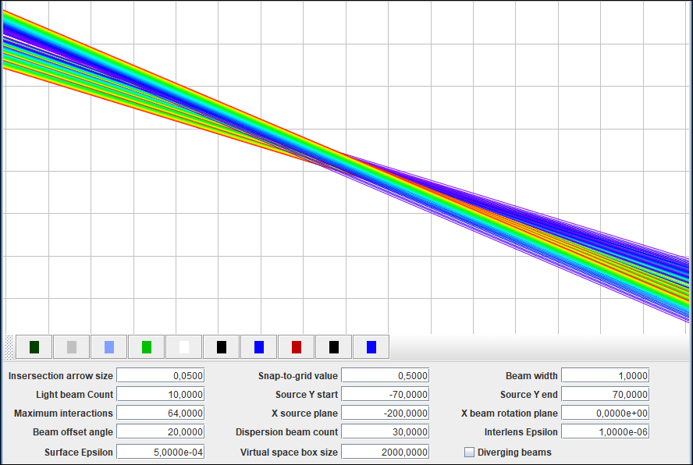

Idem avec la lentille plan-convexe: c'est très similaire. Je ne vois guère l'intérêt de cette "Fest-form lens":
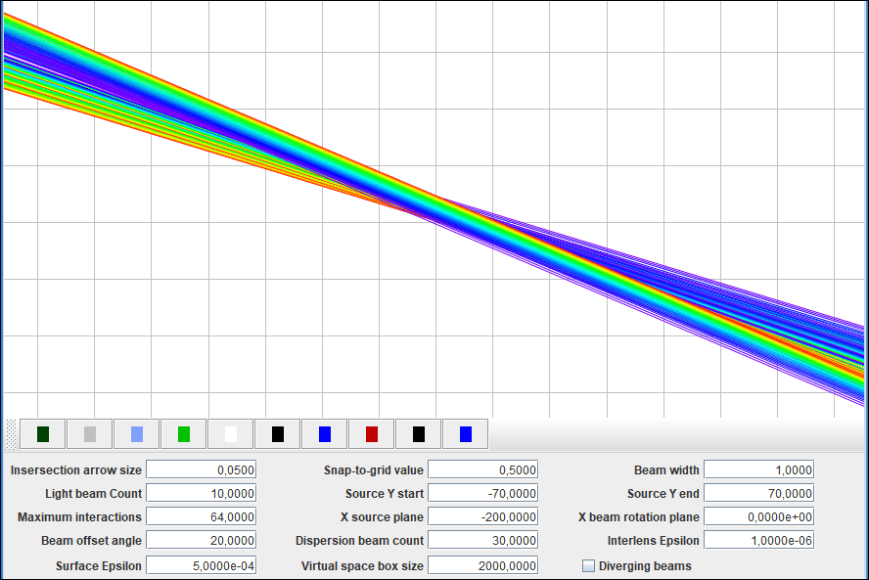

# OpticalRayTracer 9.6
# http://arachnoid.com/OpticalRayTracer
# 2023.11.30 22:51:49 CET

program {
antialias = true
askBeforeDeleting = true
beamAngle = 20,000000
beamCount = 10
beamWidth = 1
clipboardGraphicXSize = 1280
colorArrow = -2147483393
colorBaseline = -16760832
colorBeam = -4194304
colorGrid = 1086374080
colorHighBackground = -1
colorLensOutline = 276865279
colorLensSelected = 268484608
colorLightSource = -16776961
colorLowBackground = -16777216
colorTerminator = -16777216
decimalPlaces = 4
defaultWindowHeight = 600
defaultWindowWidth = 900
dispScale = 8,697566e-04
dispersionBeams = 8
divergingSource = false
helpScrollPos = 0
interLensEpsilon = 1,000000e-06
intersectionArrowSize = 0,050000
inverse = false
maxIntersections = 64
selectedComponent = 1
selectedTab = 0
showControls = true
showGrid = true
snapValue = 0,500000
surfEpsilon = 5,000000e-04
tableLineLimit = 500
virtualSpaceSize = 2000,000000
windowX = 100
windowY = 100
xBeamRotationPlane = 0,000000e+00
xBeamSourceRefPlane = -200,000000
xOffset = 999,778671
yEndBeamPos = 70,000000
yOffset = -138,630385
yStartBeamPos = -70,000000
}

object {
active = true
angle = 0,000000e+00
centerThickness = 5,835300
dispersion = 64,170000
function = 0
ior = 1,516800
leftCurvature = 0
leftSphereRadius = 5931,132000
leftZValue = 20,000000
lensRadius = 77,000000
name = Lens 1
rightCurvature = 0
rightSphereRadius = 890,451000
rightZValue = 20,000000
symmetrical = false
thickness = 2,000000
xPos = -1,000000
yPos = 0,000000e+00
}

object {
active = true
angle = 0,000000e+00
centerThickness = 0,100000
dispersion = 64,170000
function = 2
ior = 1,516800
leftCurvature = 3
leftSphereRadius = 900,000000
leftZValue = 20,000000
lensRadius = 900,000000
name = Terminal Plane
rightCurvature = 3
rightSphereRadius = 900,000000
rightZValue = 20,000000
symmetrical = true
thickness = 0,100000
xPos = 1500,000000
yPos = 0,000000e+00
}

Calcul d'un "Achromatic doublet Lens" de focale 1500 mm à 0.6 µm, et de diamètre 154mm
A partir de https://www.optics-online.com/designer1.asp
Un peu par curiosité, car selon https://www.optics-online.com/lensprimer2.asp les doublets achromatiques sont mauvais quand on travaille hors axe.

Design, avec un flint F2 :
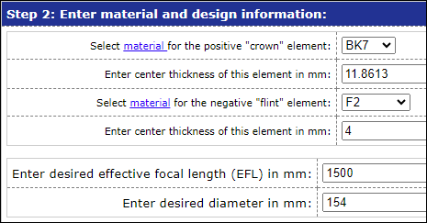

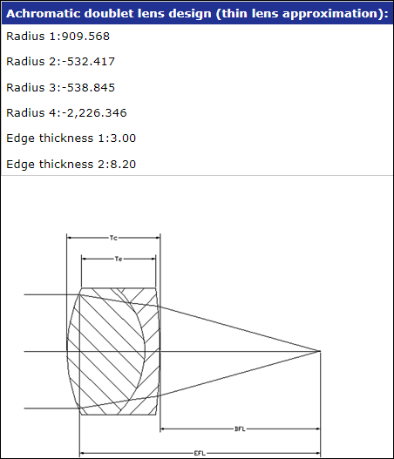

https://sunex.com/2019/07/25/material-guide/

BK7: General purpose optical glass, the most common type
Optical index: n = 1.5168
Abbe number: 64.17

F2: General purpose optical flint glass
Optical index: n = 1.62004
Abbe number: 36.37

J'obtiens un tracé de rayons aberrant. Erreur probable quelque part :
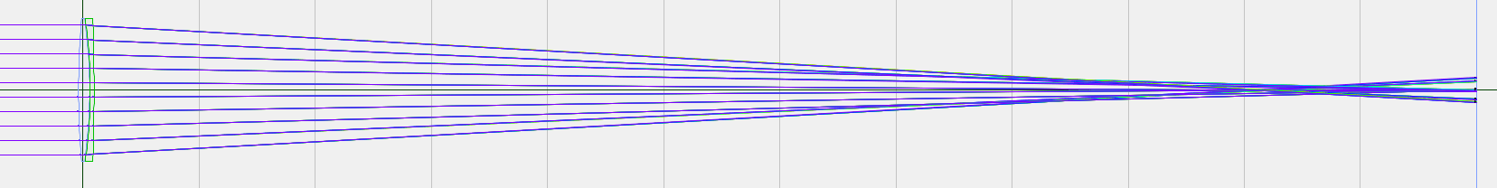

# OpticalRayTracer 9.6
# http://arachnoid.com/OpticalRayTracer
# 2023.12.01 00:27:34 CET

program {
antialias = true
askBeforeDeleting = true
beamAngle = 0,000000e+00
beamCount = 40
beamWidth = 1
clipboardGraphicXSize = 1280
colorArrow = -2147483393
colorBaseline = -16760832
colorBeam = -4194304
colorGrid = 1086374080
colorHighBackground = -1
colorLensOutline = 276865279
colorLensSelected = 268484608
colorLightSource = -16776961
colorLowBackground = -16777216
colorTerminator = -16777216
decimalPlaces = 4
defaultWindowHeight = 708
defaultWindowWidth = 900
dispScale = 0,032429
dispersionBeams = 8
divergingSource = false
helpScrollPos = 4918
interLensEpsilon = 1,000000e-06
intersectionArrowSize = 0,050000
inverse = false
maxIntersections = 64
selectedComponent = 2
selectedTab = 0
showControls = true
showGrid = true
snapValue = 0,500000
surfEpsilon = 5,000000e-04
tableLineLimit = 500
virtualSpaceSize = 2000,000000
windowX = 129
windowY = 38
xBeamRotationPlane = 0,000000e+00
xBeamSourceRefPlane = -200,000000
xOffset = 16,725345
yEndBeamPos = 70,000000
yOffset = 49,945010
yStartBeamPos = -70,000000
}

object {
active = true
angle = 0,000000e+00
centerThickness = 0,100000
dispersion = 59,000000
function = 2
ior = 1,520000
leftCurvature = 3
leftSphereRadius = 900,000000
leftZValue = 20,000000
lensRadius = 900,000000
name = Terminal Plane
rightCurvature = 3
rightSphereRadius = 900,000000
rightZValue = 20,000000
symmetrical = true
thickness = 0,100000
xPos = 1500,000000
yPos = 0,000000e+00
}

object {
active = true
angle = 0,000000e+00
centerThickness = 11,862528
dispersion = 64,170000
function = 0
ior = 1,516800
leftCurvature = 0
leftSphereRadius = 532,417000
leftZValue = 20,000000
lensRadius = 77,000000
name = Thorlabs AC508-075-A E-BAF11
rightCurvature = 0
rightSphereRadius = 909,568000
rightZValue = 20,000000
symmetrical = false
thickness = 3,000000
xPos = 0,000000e+00
yPos = 0,000000e+00
}

object {
active = true
angle = 0,000000e+00
centerThickness = 4,001994
dispersion = 36,370000
function = 0
ior = 1,620000
leftCurvature = 0
leftSphereRadius = 2226,346000
leftZValue = 20,000000
lensRadius = 77,000000
name = Achromat de optics-online.com
rightCurvature = 0
rightSphereRadius = -538,845000
rightZValue = 20,000000
symmetrical = false
thickness = 8,200000
xPos = 6,500000
yPos = 0,000000e+00
}

Triplet de Cooke
Selon https://www.optics-online.com/lensprimer2.asp :
To achieve good performance both on- and off-axis, more complex lens forms are required. Cooke triplet is a well-know lens form that provides good imaging performance over a field of view of +/- 20-25 degrees. Many consumer grade film cameras use lenses of this type.
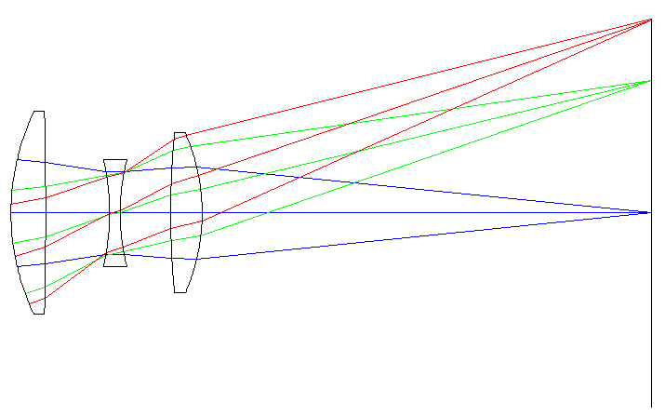
https://fr.wikipedia.org/wiki/Triplet_de_Cooke

https://www.lomography.fr/magazine/351746-un-objectif-revolutionnaire-l-histoire-du-cooke-triplet

